Visual
Short description of the project:

Visual is an application used for visualization of graphs and algorithms that operate on them. In the beginning, the main window is shown to the user. Some randomly generated graph will be displayed in that window. User can than add new elements: nodes or branches, or even delete them. Furtehermore, the User can decide wheather he wants to work with directed or undirected graph. All the changes are authomatically visible in the main window when the User selects an option. Then, when the User is happy with the graph that was created, he can choose the algorithm that will be run then and the output of the said algorithm will be displayed in the main window.

UML diagrams:
Use cases
• Input Graph:
◦ Insert elements
◦ Delete elements
• Graph settings:
◦ Edge direction
◦ Visual appearance
• Running an algorithm

Use case diagram of the main program: Input graph (made by Sanja Nedeljkovic)
Description: The user starts the application, and inputs data about the Graph they want to visualize
by using the visual elements provided by the environment or typing required data.
Actors: The User
Preconditions: The application is running.
Postconditions: The input is saved internally.
Main scenario:
1. Until the user is done with Graph input, the following steps are repeated:
1.1 If the user wants to insert an element:
1.1.1 The “Insert elements” use case starts.
1.1.2 The algorithms are enabled.
1.2. If the user wants to delete an element:
1.2.1 The “Delete elements” use case starts.
1.2.2 If all the elements are deleted, the algorithms are disabled.
Alternative scenarios:
• Application exit: If User exists the application, any input or changes will be lost.
Additional information: The default direction of the Graph is set to undirected.

Sequence diagram of the main program:
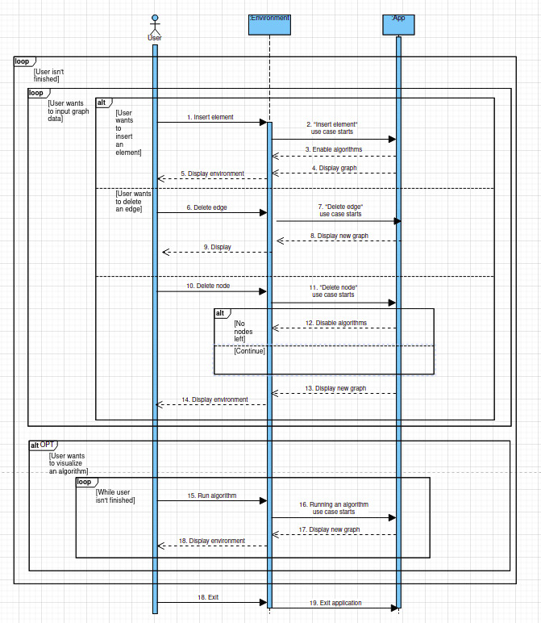

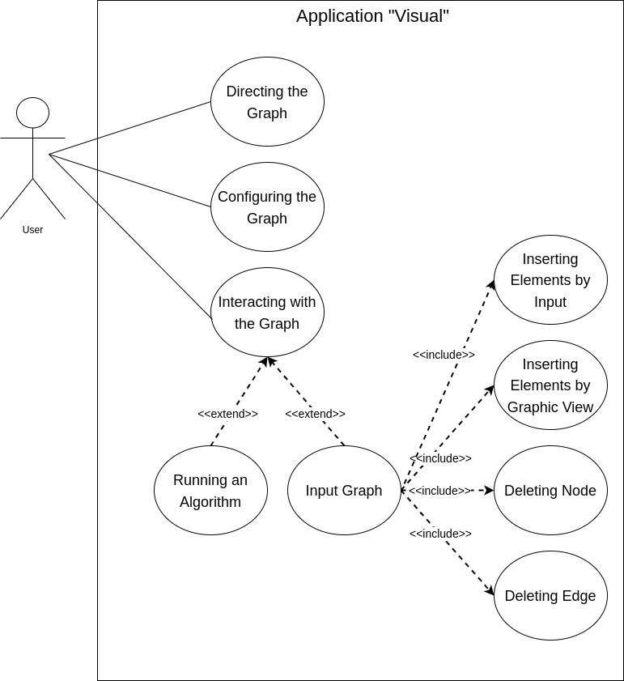

Use case diagram: Graph settings-directing the graph (made by Vladimir Knezevic)
Description: The user can choose the direction of the edges of the Graph, the size of the nodes of
the Graph, as well as the color of the background, edges and nodes.
Actors: The User
Preconditions: The application is running.
Postconditions: The direction input is saved internally. The colors of the scene and the size of the
nodes are set as chosen.
Main scenario:
1. Edge direction selection
1.1 If the “Directed” button is clicked
1.1.1 If it was previously selected, no change occurs.
1.1.2 If “Undirected” button was previously selected, the application is informed of the change
and saves it internally.
1.1.2.1 If edges exist on the graphic view, they are redrawn with an arrow pointing accordingly.
1.1.2.2 Every edge added while the button is active, is drawn as described.
1.2 The “Undirected” button is clicked
1.2.1 If it was previously selected, no change occurs.
1.2.2 If “Directed” button was previously selected, the application is informed of the change and
saves it internally.
1.2.2.1 If edges exist on the graphic view, they are redrawn without an arrow.
1.2.2.2 Every edge added while the button is active, is drawn as described.
Alternative scenarios:
• Application exit: If User exists the application, any input or changes will be lost.
• Bad input: If the user inputs a Node radius greater than 30, a window error message
will occur.
Additional information: There can not exists unidrected and directed edges simultaneously in a
Graph. Node radius is set to 20 by default.

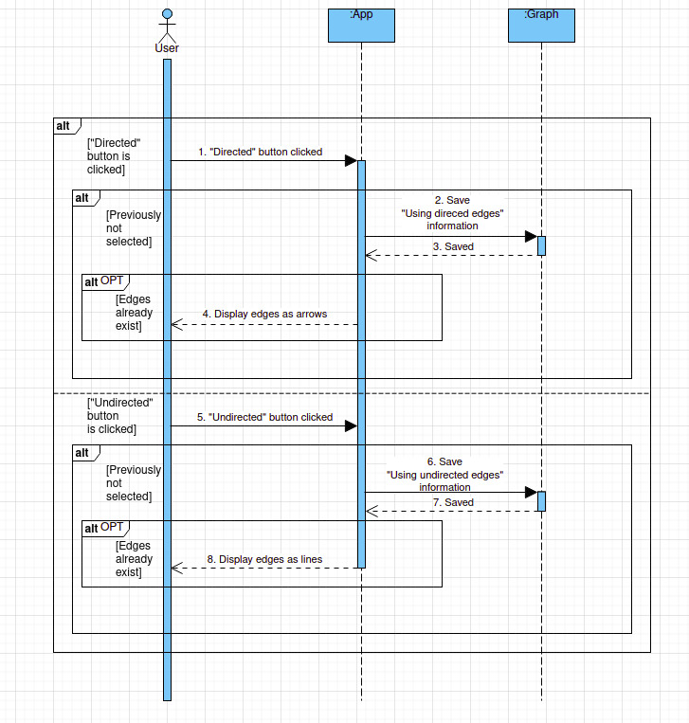
Sequence diagram of graph config use case:

Use case diagram: config the graph (made by Mina Cerovic)
Description: The user can change the size of the nodes of the Graph, as well as the color of the
background, edges and nodes.

Actors: The User

Preconditions: The application is running.

Postconditions: The colors of the scene and the size of the nodes are set and saved as chosen.

Main scenario:
1. The “Config” tab is clicked.
1.1 The user is given a list of changeable components, with the fields filled with current
settings:
• Node radius: with an input field. The field accepts only positive numbers, with the
maximum being 30. The user is informed of this by mouse hover on the field label.
• Node background: with a list field, containing possible colors.
• Node color: with a list field, containing possible colors.
• Edge color: a list field, containing possible colors.
1.2. By clicking the “OK” button, the user saves the changes and the scene is colored
accordingly.

Alternative scenarios:

• Application exit: If User exists the application, any input or changes will be lost and
all the settings will be reverted to default.
• Bad input: If the user inputs a Node radius greater than 30, a window error message
will occur.

Additional information: Node radius is set to 20 by default.
Sequence diagram of the config view use case:
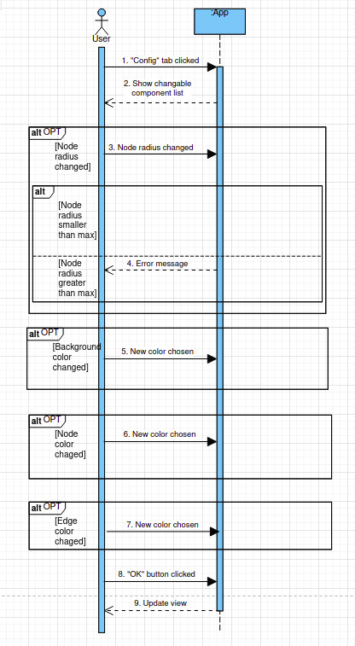

Use case diagram: Running the algorithm (made by Mina Cerovic)
Description: After creating a Graph, the user chooses one of the given algorithms. Application runs
the selected algorithm and shows it step by step on the graphic view.
Actors: The User
Preconditions: The Graph data has been input and saved.
Postconditions: Steps of the algorithm are shown.
Main scenario:
1. User selects one of the algorithms.
2. User clicks on ‘Run’ button.
3. Application runs the selected algorithm on created Graph:
3.1 If there are steps in executed algorithm, application has to show them.
3.1.1 While the algorithm runs:
3.1.1.1 Application colors nodes and edges as they are used in the algorithm.
3.2 Application shows message about the result.
4. If User clicks on ‘Reset’ button, steps and messages are deleted:
4.1 Application reverts the graph back to its default colors
4.2 Application deletes the shown message
Alternative scenarios:
• Application exit: If User exists the application, any input or changes will be lost.
• Interruption: If the User interacts with the application, the ‘Reset’ button scenario
should occur.
Additional information: None

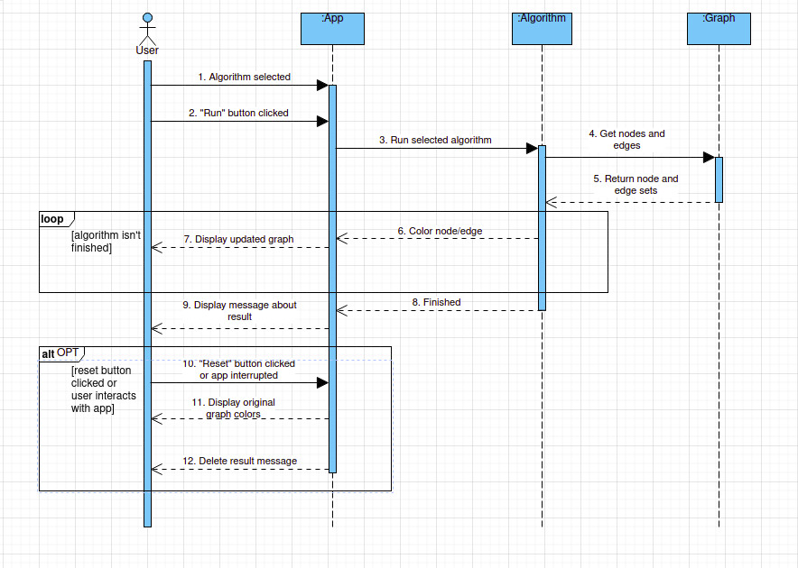
Sequence diagram for use case running the algorithm:
Use case diagram: edge deletion (made by Djordje Milosevic)

Description: The User deletes requested edges.

Actors: The User

Preconditions: The edges set is not empty.

Postconditions: The set of edges of the Graph is changed.

Main scenario:
1. User inputs the names of the two adjacent nodes that are connected by the edge they
want to delete in the appropriate field.
1.1 User clicks "Delete edge" button.
1.2. The edge is deleted from the edge set and removed from the graphic view.
2. User right-clicks on the edge that he wants to delete.
2.1. User chooses "Delete edge" option.
2.2. The edge is deleted from the edge set and removed from the graphic view.

Alternative scenarios:

• Warning message display: If there is no existing edges, the warning message will
be displayed.
Additional information: None.

Sequence diagram for use case: edge deletion:
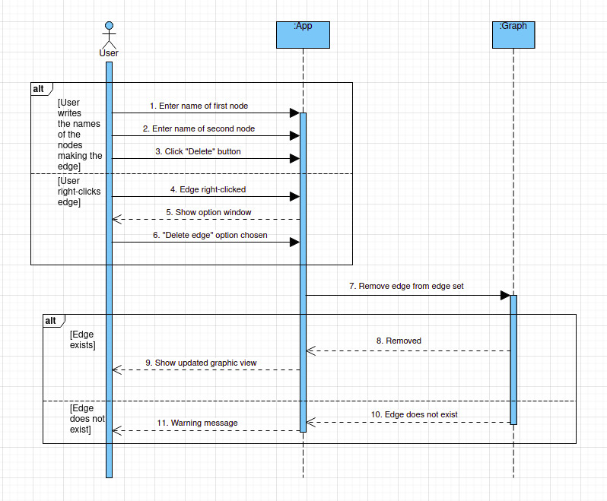
Use case diagram: node deletion (by Vladimir Knezevic)

Description: The User deletes requested nodes. By doing so, directly connected edges are deleted
as well.
Actors: The User
Preconditions: The nodes set is not empty.
Postconditions: The set of nodes and set edges of the Graph are changed.
Main scenario:
1.User can delete the node using multiple ways:
1.1 User writes in the name of the node that they want to delete in the appropriate field.
1.1.1 User clicks "Delete node" button.
1.1.2. The node is deleted from the node set and removed from the graphic view.
1.1.2.1 If there are edges connected to the node, they are deleted from the edge set and removed from the graphic view.
1.2. User right-clicks on the node that he wants to delete.
1.2.1. User chooses "delete node" option.
1.2.2. The node is deleted from the node set and removed from the graphic view.
1.2.2.1 If there are edges connected to the node, they are deleted from the edge set and removed from the graphic view.
Alternative scenarios:
• Warning message display: If there is no existing nodes, the warning message will
be displayed.
Additional information: None.

Sequence diagram for use case node deletion:
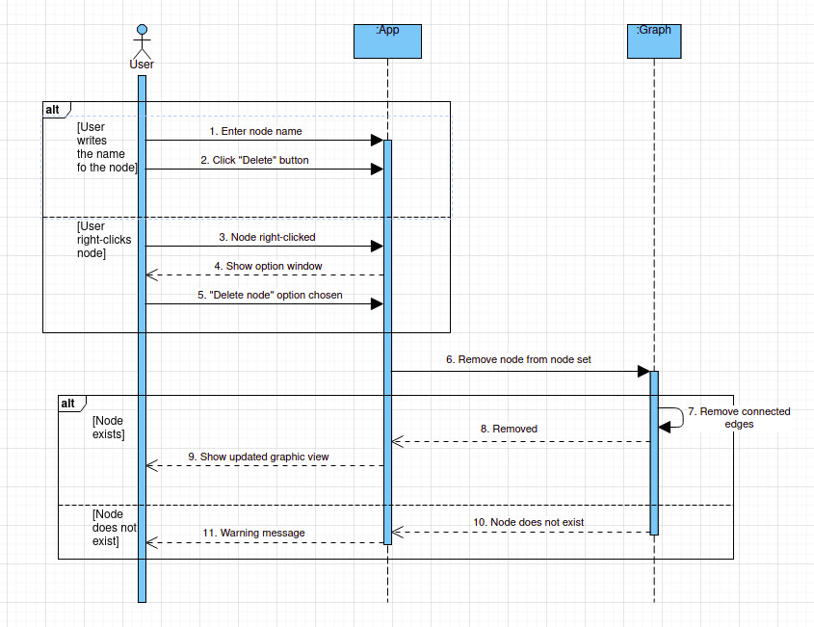

Use case diagram: inserting elements via keyboard (made by Andjela Damnjanovic and Sanja Nedeljkovic)

Description: The User enters the names of the nodes and the weight of the edge connecting them, which are then drawn in the graphic view window. The node is always drawn the same, while the edge visualization depends on cases.

Actors: The User

Preconditions: The application is running and the desired direction of the Graph is chosen.

Postconditions: The input is saved internally, the set of edges is changed, while the set of nodes changes if the user chose to draw the node that was not in the list prior to that moment and the changes are drawn in the graphic view window accordingly.

Main scenario:
1 If the user enters just the name of the first node.
1.1 User clicks the “Add” button.
1.2 The node entered by the User can already exist
1.2.1 If the node does not exits, it is added to the set of nodes and it is shown in graphic view. It is drawn as a circle, positioned in a way that it doesn’t overlap other nodes, if there is a node in near proximity to the node being drawn. Skip to 2
1.2.2 If the node is already in the set of nodes, nothing happens in the graphic view, but the message is shown to the user. Skip to 1
2 If the user enters just the name of the first node and the name of the second node.
2.1 User clicks the “Add” button.
2.2.1 If neither no the nodes that are not in the set of nodes are added to it and all of the added objects are added to the graphic view. The nodes are drawn as described in 1.2.1 and 1.2.2
2.2.2.1 If there is no edge connecting them, the non-weighted edge is added to the set of edges and is drawn accordingly, depending on the direction of the graph (See Graph Settings use case).
2.2.2.2 Otherwise, If a directed connection between these two nodes already exists, nothing happens.
3 User enters the name of the first node, the name of the second node, and the weight of the edge.
3.1 User clicks the “Add” button.
3.2 Both nodes are added to the set of nodes and a weighted edge is added to the set of edges, and all three objects are added to the graphic view. The nodes are drawn as described in 1.2. The edge is drawn with its corresponding weight above it.
3.2.1 The same as 2.2.1 and 2.2.2, except now the edge is weighted and should be drawn as described in 3.2.

Alternative scenarios:
- Application exit: If User exists the application, any input or changes will be lost.
- Wrong data type: If User inputs weight of an edge as non-integer, or zero, an error message is shown.
- Exceeding the limit: If the User wants to add more nodes than currently supported, an error message is shown.
- Drawing a loop: If the User tries to create a loop, an error message is shown.

Additional information:
- The default weight of an edge is 1.
- Adding negative edges is possible, but will disable some algorithms.

Sequence diagram for use case inserting elements via keyboard:
(diagram made by Vladimir Knezevic)
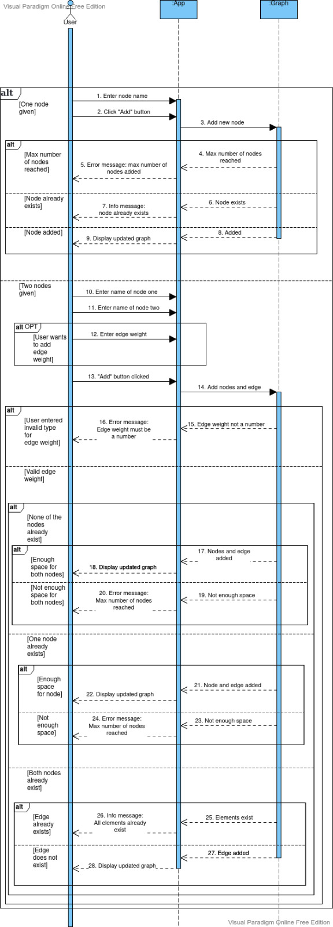

Use case diagram: inserting elements via gui (made by Andjela Damnjanovic)

Description: The User enters the names of the nodes and the weight of the edge connecting them, which are then drawn in the graphic view window. The node is always drawn the same, while the edge visualization depends on cases.

Actors: The User

Preconditions: The application is running and the desired direction of the Graph is chosen.

Postconditions: The input is saved internally, the set of edges is changed, while the set of nodes changes if the user chose to draw the node that was not in the list prior to that moment and the changes are drawn in the graphic view window accordingly.

Main scenario:
1 User right-clicks on the graphic view window.
2 Than, the User can choose between adding a node and adding an edge to the graph.
2.1 If the User selects the “Add node” option:
2.1.1 The User can name the node by entering its name.
2.1.1.1 If they choose not to, the node will be named with the first unused positive integer (that will be converted to string). Skip to 2.1.2
2.1.1.2 Otherwise, the node is named as the User requested. Skip to 2.1.2
2.1.2 The node is drawn as described in 1.2 of the Insert element using keyboard use case.
2.2 the User selects the “Add edge” option.
2.2.1 User clicks on the node from which they want the edge to start.
2.2.2 The line is drawn following the cursor.
2.2.3 The User clicks on the node on which they want the edge to end.
2.2.3.1 If the edge already exists, nothing happens in the graphic view, but the message is shown to the User. Skip to 1
2.2.3.2 Otherwise, the edge is drawn accordingly, depending on the direction of the graph (See Graph Settings use case). Skip to 2.2.5
2.2.5 The User can add weight to the edge.
2.2.5.1 If they choose not to, the weight will be set to 1. Skip to 2.2.6
2.2.5.2 Otherwise, the edge weight is set to the number the User requested. Skip to 2.2.6
2.2.6 The edge is added to the edges set.

Alternative scenarios:
- Application exit: If User exists the application, any input or changes will be lost.
- Wrong data type: If User inputs weight of an edge as non-integer, or zero, an error message is shown.
- Exceeding the limit: If the User wants to add more nodes than currently supported, an error message is shown.
- Drawing a loop: If the User tries to create a loop, an error message is shown.

Additional information:
- The default weight of an edge is 1.
- Adding negative edges is possible, but will disable some algorithms.

Spetial requests: /

Sequence diagram for use case inserting via gui:
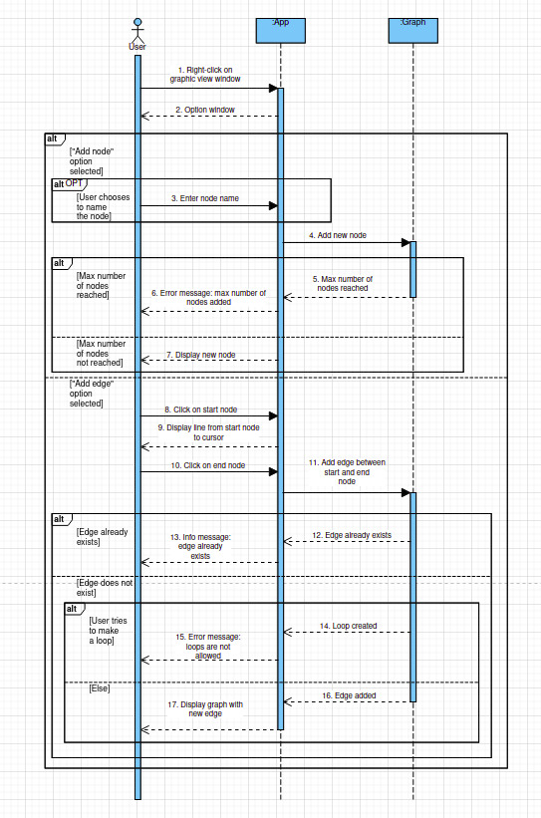

UML class diagram: (made by Andjela Damnjanovic)
