Visual
Short description of the project:

Visual is an application used for visualization of graphs and algorithms that operate on them. In the beginning, the main window is shown to the user. User can add new elements: nodes and edges, or even delete them, or the graph can be opened from a .graph file or .json file. Furthermore, the User can decide whether he wants to work with directed or undirected graph. All the changes are automatically visible in the main window when the User selects an option. Then, when the User is happy with the graph that was created, he can choose the algorithm that will be run then and the output of the said algorithm will be displayed in the main window. Also, the User can save the graph that was created as .graph or .json file.

UML diagrams:
Use cases
• Input Graph:
◦ Insert elements (using keyboard, gui, or opening the file)
◦ Delete elements (deleting edges or/and nodes)
• Graph settings:
◦ Edge direction
◦ Visual appearance
• Running an algorithm

Diagram of the use cases:

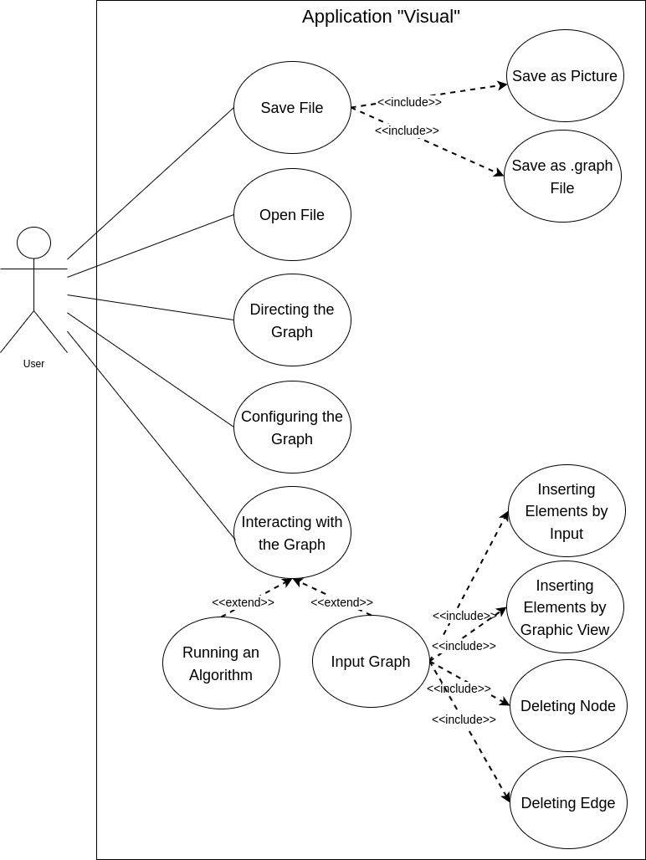

Use case diagram of the main program: Input graph using environment
Description: The user starts the application, and inputs data about the Graph they want to visualize
by using the visual elements provided by the environment or typing required data.
Actors: The User
Preconditions: The application is running.
Postconditions: The input is saved internally.
Main scenario:
1. Until the user is finished with using the app:
1.1 Until the User is done with Graph input, the following steps are repeated
1.1.1 If the user wants to insert an element:
1.1.1.1 The “Insert elements” use case starts (inserting elements via gui, insert elements via keyboard and input graph from file).
1.1.1.2 The algorithms are enabled.
1.1.2 If the user wants to delete an element:
1.1.2.1 The “Delete elements” use case starts (edge deletion and node deletion).
1.1.2.2 When all the elements are deleted, the algorithms are disabled.
1.2 Running an algorithm case starts. Return to 1.1.
Alternative scenarios:/

Additional information: The default direction of the Graph is set to undirected.

Sequence diagram for the main program can be found below:
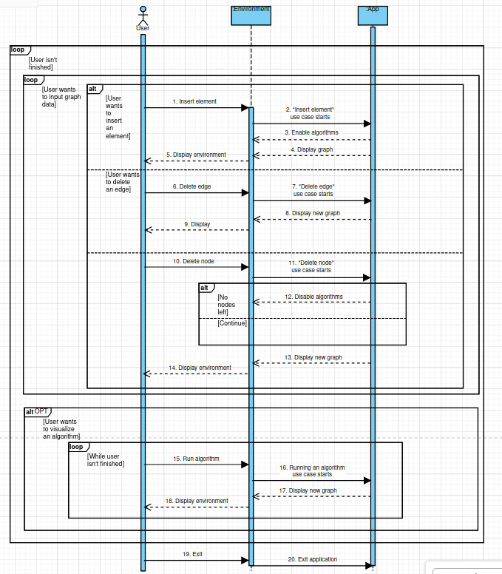
------------------------------------------------------------------------------------------------------------------------
Use case diagram of the main program: Input graph from file
Description: The user starts the application, and chooses the file with Graph they want to visualize.
Actors: The User
Preconditions: The application is running.
Postconditions: The file is loaded, all the settings are set and input is saved internally. The graph is shown in the Main Window.
Main scenario:
1. The User clicks openFile icon that is positioned on the toolbar or in main menu
2. The Home directory is opened
3. The User chooses file with .graph extension they want to open and load the graph from
4. When the file has been chosen, the graph is drawn in the MainWindow.

Alternative scenarios:
- File was not chosen: If the file was not chosen, nothing happens and the User can continue.
Additional information: The default direction of the Graph is set to undirected.I f the scene was not empty before the file is opened, everything that was located on the scene will be deleted and the new graph will then be drawn.

Sequence diagram for this use case:
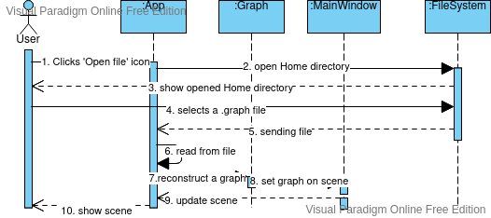

-------------------------------------------------------------------------------------------------------
Use case diagram: Graph settings-directing the graph
Description: The user can choose the direction of the edges of the Graph.
Actors: The User
Preconditions: The application is running.
Postconditions: The direction input is saved internally. The previous Graph is deleted.
Main scenario:
1. Selecting directionality of the graph
1.1 If the “directed” button is clicked
1.1.1 If it was previously selected, no change occurs.
1.1.2 If “Undirected” button was previously selected, the window pops up and asks the User if they want to switch to undirected graph.
1.1.2.1 If the answer is ‘yes’, the application is informed of the change and saves it internally. Formerly added nodes and edges are deleted.
1.1.2.2 Otherwise, no changes occur.
1.2 The “Undirected” button is clicked
1.2.1 If it was previously selected, no change occurs.
1.2.2 If “Directed” button was previously selected
1.2.2.1 If the answer is ‘yes’, the application is informed of the change and saves it internally. Formerly added nodes and edges are deleted.
1.2.2.2 Otherwise, no changes occur.
Alternative scenarios:/
Additional information: There can not exists unidrected and directed edges simultaneously in a
Graph.

Sequence diagram for said use case can be found below:
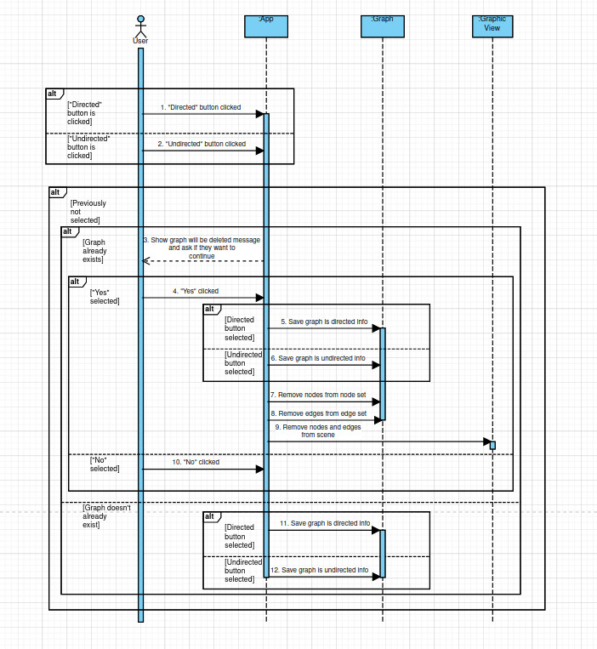

-------------------------------------------------------------------------------------------------------------------

Use case diagram: config the graph
Description: The user can change the size of the nodes of the Graph, as well as the color of the
background, edges and nodes.

Actors: The User

Preconditions: The application is running.

Postconditions: The colors of the scene and the size of the nodes are set and saved as chosen.

Main scenario:
1. The “Config” tab is clicked.
2. The list of changeable components appears with the fields filled with current settings:
• Node radius: with an input field. The field accepts only positive numbers in range from 50 to 150.
• Background color: with a list field, containing possible colors.
• Node color: with a list field, containing possible colors.
• Edge color: a list field, containing possible colors.
3. By clicking the “Save” button, the user saves the changes and the scene is colored
accordingly.

Alternative scenarios:

Additional information: The default settings are as follows: Node radius is set to 50, edge color is set to black, background color is set to off white and node color is set to white. It is not possible to set node radius below or above the values that were described in the step 2.

Sequence diagram for said use case can be found below:

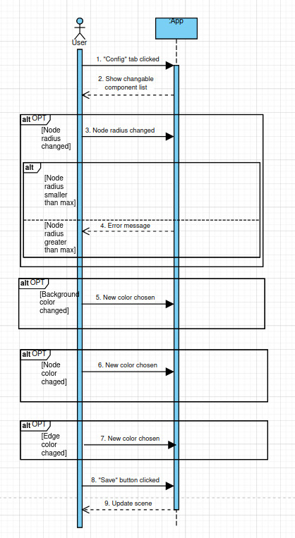

------------------------------------------------------------------------------------------
Use case diagram: Running the algorithm
Description: After creating a Graph, the user chooses one of the given algorithms. Application runs
the selected algorithm and shows it step by step on the graphic view.
Actors: The User
Preconditions: The Graph data has been input and saved.
Postconditions: Steps of the algorithm are shown.
Main scenario:
1. The User selects ‘Algorithm’ tab that is located on the right side of the screen.
2. The User selects one of the algorithms.
3. User clicks on ‘Run’ button.
4. Application runs the selected algorithm on created Graph:
4.1 While the algorithm runs:
4.1.1 Application colors nodes and edges as they are used in the algorithm.
4.2 Application shows message about the result.
5. If User clicks on ‘Reset’ button, steps and messages are deleted:
5.1 Application reverts the graph back to its default colors
5.2 Application deletes the shown message
Alternative scenarios:/
Additional information: None

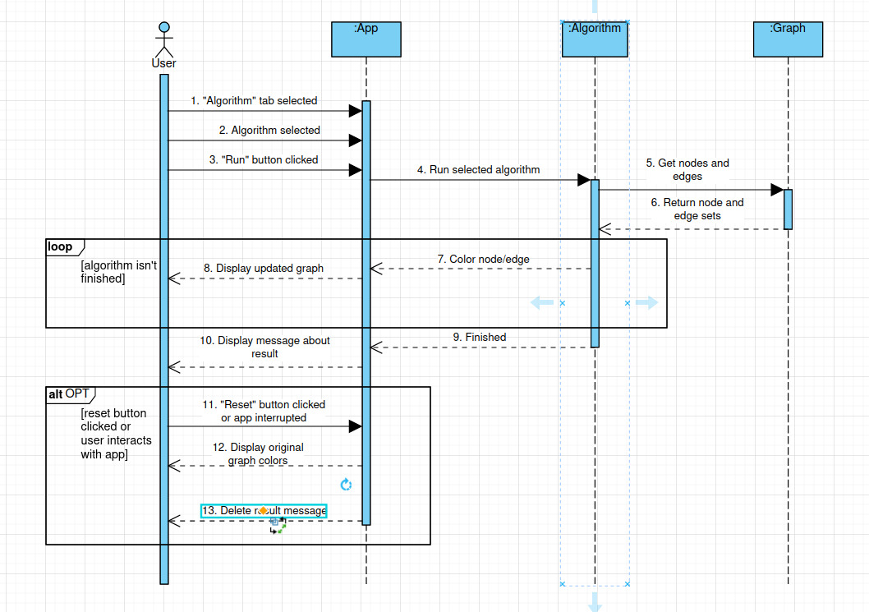
Sequence diagram for said use case:

------------------------------------------------------------------------------------------------------------------------
-----------------------------------------------------------------------------------------
Use case diagram: edge deletion using environment

Description: The User deletes requested edges.

Actors: The User

Preconditions: The application is running and the edge set is not empty.

Postconditions: The set of edges of the Graph is changed and the requested edge is removed from the MainWindow.

Main scenario:
1. The User clicks on the ‘Delete’ tab that is located on the right side of the screen.
2. The User clicks on the edge they want to delete.
3. The selected edge is now removed from the edge set.
4. The selected edge is also removed from the Main Window and from the list of edges that is displayed on the left side of the screen.

Alternative scenarios:/

Additional information: None.

Sequence diagram for said use case:
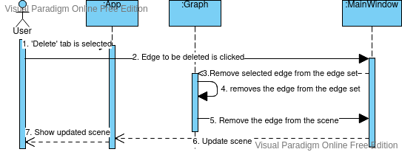
------------------------------------------------------------------------------------------------------------------------

Use case diagram: node deletion using the environment

Description: The User deletes requested nodes. By doing so, directly connected edges are deleted
as well.
Actors: The User
Preconditions: The application is running and the nodes set is not empty.
Postconditions: The set of nodes and set edges of the Graph are changed.
Main scenario:
1.The User clicks on ‘Delete’ tab that is located on the right side of the screen.
2. The User clicks on the node they want to delete.
3. The node that should be deleted is found in the node set.
4. The edges that connect selected node to other nodes in this graph are deleted from the edge set.
5. The edges are deleted from the main window.
5. Selected node is removed from the set of nodes.
6. Selected node is removed from the Main Window, as well as the list that is located on the left side of the screen.
Alternative scenarios:/
Additional information: None.

Sequence diagram for said use case:
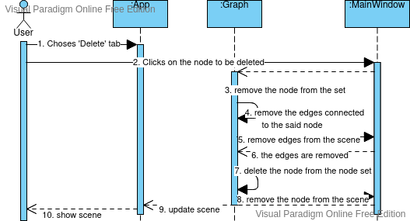

------------------------------------------------------------------------------------------------------------------------

Use case diagram: inserting elements via keyboard

Description: The User enters the names of the nodes and the weight of the edge connecting them, which are then drawn in the graphic view window. The node is always drawn the same, while the edge visualization depends on cases.

Actors: The User

Preconditions: The application is running and the desired direction of the Graph is chosen.

Postconditions: The input is saved internally, the set of edges is changed, while the set of nodes changes if the user chose to draw the node that was not in the list prior to that moment and the changes are drawn in the graphic view window accordingly.

Main scenario:
1. The User enters the name of the first node, the name of the second node, and the weight of the edge.
2. User clicks the “Add” button.
2.1 The elements that the User entered are drawn
2.1.1 If neither of nodes is in the node set, these nodes are added to the set of nodes, and a weighted edge is added to the set of edges, and all three objects are added to the graphic view and all three elements are added to the graphic view. The nodes are drawn as circles. The edge is drawn depending on the directionality of the graph (arrow for directed and line for undirected) connecting centers of said nodes, with the number indicating its weight above the edge. Skip to 1.
2.1.2 If one of the nodes already exists, we add and draw only the second node and weighted edge. The edge is drawn as described in and the nodes are drawn as described in 2.1.1. The weight is drawn above the edge. Skip to 1.
2.1.3 If both nodes already exist
2.1.3.1 If there is no edge connecting them, the weighted edge is added to the set of edges and is drawn accordingly, depending on the direction of the graph (See Graph Settings use case). The edge is drawn as described in 2.1.1 and the nodes are drawn as described in 2.1.1. The weight is drawn above the edge. Skip to 1.
2.1.3.2 Otherwise, if a directed connection between these two nodes already exists, nothing happens in the graphic view, but the message is shown to the User. Skip to 1.

Alternative scenarios:
- Wrong data type: If User inputs weight of an edge as non-integer, or zero, an error message is shown.
- Exceeding the limit: If the User wants to add more nodes than currently supported, an error message is shown.
- Drawing a loop: If the User tries to create a loop, an error message is shown.

Additional information:
- The default weight of an edge is 1.
- Adding negative edges is possible, but will disable some algorithms.

Sequence diagram for said use case can be found on the page below:
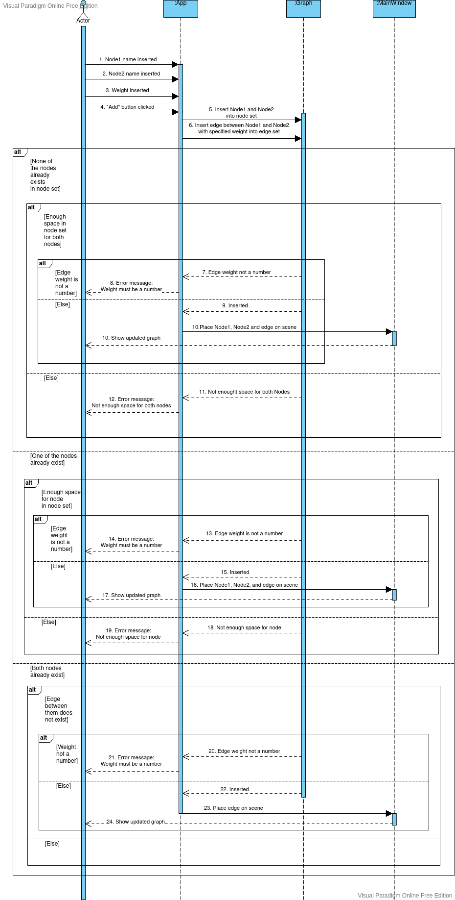

------------------------------------------------------------------------------------------------------------------------

Use case diagram: inserting elements via gui

Description: The User clicks on the random place on the Main Window and the node is drawn on the place that was clicked. If the user wants to draw an edge connected to the nodes, that can be done by clicking first on the node from which the edge is drawn and then clicking on the node to which the edge is drawn.

Actors: The User

Preconditions: The application is running and the desired direction of the Graph is chosen.

Postconditions: The input is saved internally, the set of edges is changed, while the set of nodes changes if the user chose to draw the node that was not in the list prior to that moment and the changes are drawn in the graphic view window accordingly.

Main scenario:
1. The User clicks ‘Draw’ tab that is located on the right side of the screen.
2. The User chooses the element which they want to create:
2.1 If the User wants to draw a node
2.1.1 The User clicks on the random blank space on the graphic view.
2.1.2The window pops up and asks User to enter the name of the node they want to create.
2.1.3 The User enters the name of the node
2.1.4 The node with the name the User chose is added to the nodeset.
2.1.5 The node is also drawn on the spot where the User clicked. The radius and the color of the node are set to the colors checked in the ‘Config’ tab.
2.2 The User wants to draw an edge
2.2.1 If the User wants to draw an edge they click on the node they want to start the edge from
2.2.2 The User then clicks on the node they want to connect the edge to
2.2.3 The edge with weight 1 is added to the edge set.
2.2.4 The edge is also drawn in the graphic view with according to the directionality of the graph. The weight is drawn above the edge.
2.2.4.1 If the graph is undirected, the edge is drawn as the line connecting two nodes.
2.2.4.2 If the graph is directed, the edge is drawn as a line with an arrow exiting the first and entering the second node.

Alternative scenarios:
- Wrong data type: If User inputs weight of an edge as non-integer, or zero, an error message is shown.
- Exceeding the limit: If the User wants to add more nodes than currently supported, an error message is shown.
- Drawing a loop: If the User tries to create a loop, an error message is shown.

Additional information:
- The default weight of an edge is 1.
- Adding negative edges is possible, but will disable some algorithms.

Special requests: /

Sequence diagram for said use case:
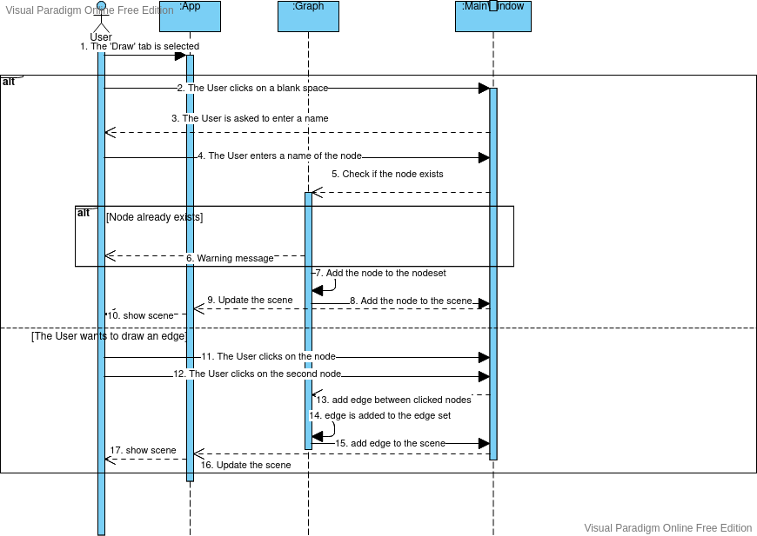
------------------------------------------------------------------------------------------------------------------------

The component diagram for the application:
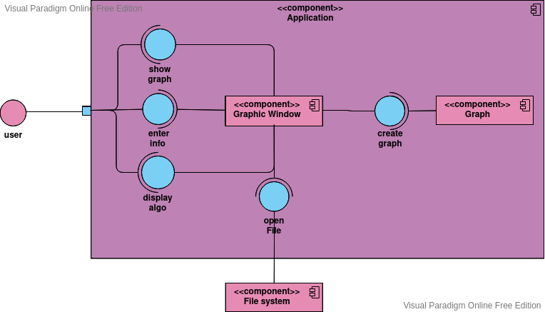
------------------------------------------------------------------------------------------------------------------------

UML class diagram for the program:
