**Project Setup & Execution Report**

***Automation Framework for Incode Test Task by Djordje Mihailovic***

**Overview**

This report provides comprehensive instructions for setting up and executing the test automation framework developed for this test task. The framework is built using Java, Selenium WebDriver, and Cucumber with JUnit, following standard industry practices for web application testing.

**System Requirements**

**Required Software**

* **Java Development Kit (JDK) 21**
* **Maven 3.8+**
* **Chrome** (latest versions recommended)
* **Git** (optional, for version control)
* **IntelliJ IDEA** ( My IDE of choice for Java projects, other IDEs could be used )

**Installation & Setup**

After the installation of required software, open your IDE and run the following commands:

1. **Clone/Download the Project**

Run the following commands in your IDEs terminal:

*git clone <repository-url>  
 cd IncodeTestTask*After they are done, the project should be available locally on your machine.

1. **Install Dependencies**

Run the following commands in your IDEs terminal:

*mvn clean install -DskipTests*

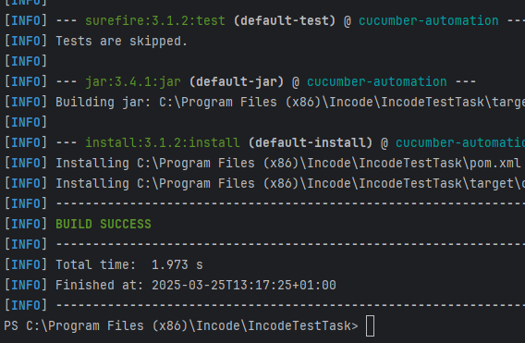

This will let the Maven build the project and handle all dependencies, after it is done you are all set on importing this project!

1. **Project Structure Overview**
   * src/main/java: Contains all test code
     + Features: Cucumber feature files with test scenarios
     + Helpers: Utility classes
     + Page: Page Object Model classes
     + Runner: Cucumber test runner configuration
     + Steps: Step definitions for Cucumber
2. **Configuration**
   * Config file is located in /data; it holds the information about browser and environment that is used when running tests locally

**Running Tests**

**Command Line Execution**

Now that all is set you can run tests in a few different ways;

Run the tests with the tag I created for this assignment with Maven from command line:

*mvn test "-Dcucumber.filter.tags=@AutomationAssignment"*

This tells Maven to execute tests with the tagged with @*AutomationAssignment*

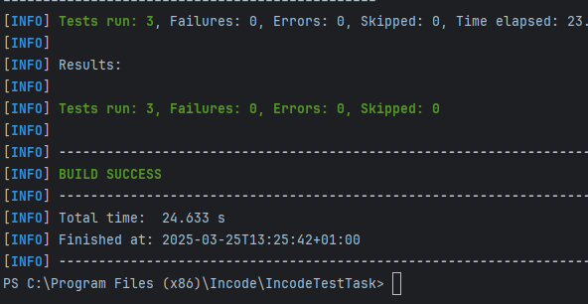

**IDE Execution**

**via CucumberRunner**

1. Navigate to src/main/java/Runner/CucumberRunner.java
2. Right-click and select "Run CucumberRunner"
3. This will run all the tests set in accordance with this runner

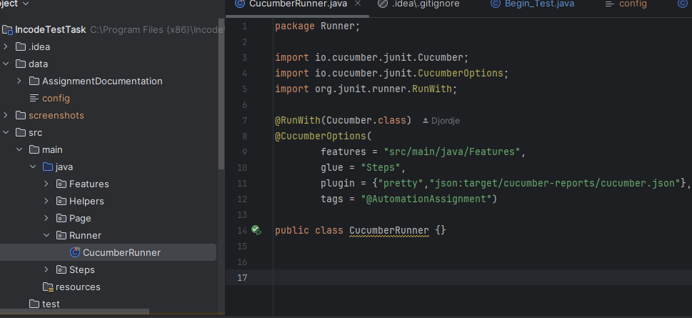

**Individually, from .feature file**

1. Navigate to src/main/java/Features/AutomationTests
2. Open a .feature file
3. Click on Play button to the left of the Scenario that you want to execute

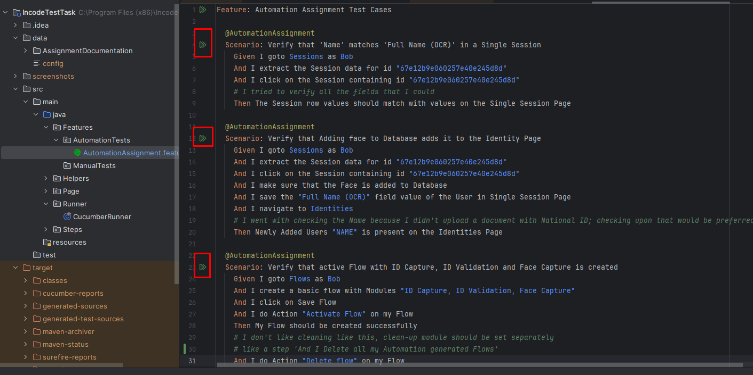

**Example Test Execution**

When the test(s) begin to execute, in the Run window( usually on) the bottow of your IDE you will see a detailed overview of the steps and the test itself; If they passed or failed, time for execution, messages that are triggered by them etc;

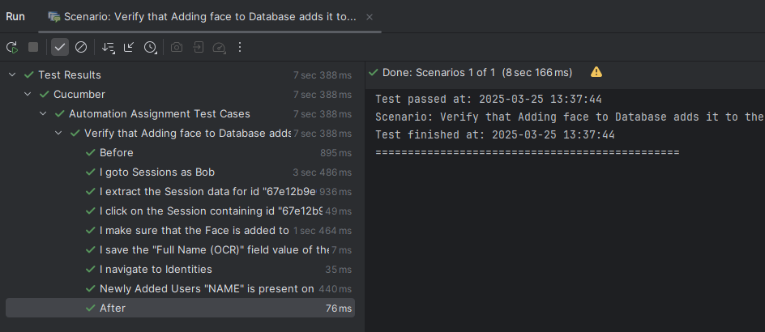

**Reports & Logs**

* **Cucumber Reports**: Generated in target/cucumber-reports after test execution
* **Screenshots**: Captured automatically on test failure
* **Logs**: Standard output and error logs available during execution

**Setup Future ( possible ) Improvements**

* Implement local parallel test execution using ThreadLocal WebDriver
* Extend support for additional browsers/platforms