**OAD 2017/2018**

**OADTurk**

Assignment 2

Group 6

Aleksandar Stojicic Aleksa Pandurevic

Stefan Gajanovic Djordje Rajic

Amir Mujacic Nikola Balac

***November 9, 2017***

**Task 1**

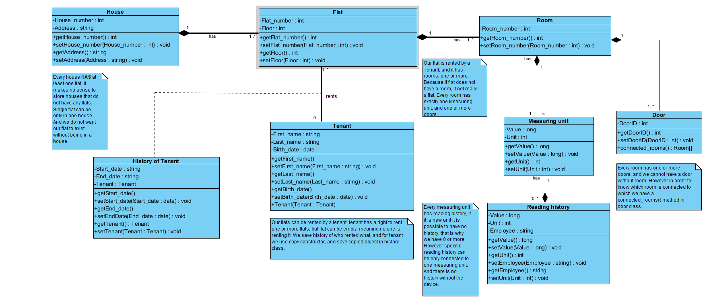

Figure 1: House Model

**Task 2**

**2.1 OADTurk Introduction**

OADTurk is a learning environment based on human computation, that can be used by users. This software is central environment for the administration of learning applications(LAs). Learning applications are central components of OADTurk. Our goal is to make increasing number of learning applications. The two main parts of OADTurk are: “OADTurk User Community” and “OADTurk Environment”.

**2.2 Project utilization**

The customers can use OADTurk for multiple reasons. One of the most important is participating in different learning applications. Every user can choose different learning units. For every different LAs user has possibility to participate in different type of exams. There is also possibility for every user to apply for “creator”.

**2.3 Target Audience**

The target audience for our software is actually every person who wants to acquire new knowledge. OADTurk is also very helpful for students during their studies. Human computation offers every person to learn their learning units on efficient way.

**2.4 The most important OADTurk Use Cases (with priority)**

|  |  |
| --- | --- |
| **Use Cases:** | **Priority** |
| Registration | High |
| Sign In | High |
| Sign Out | High |
| Applying for Creator | Average |
| Participating in exams | Average |
| Users Learning Applications | High |
| Adding Creators | Low |
| Managing user’s requests | Average |
| Managing user’s account | Average |
| Creating exams | Average |
| Creating Learning Application | Low |
| Changing personal info | High |
| Defining categories | Low |

**2.4.1 Description of Use Cases**

|  |  |
| --- | --- |
| Use Case: **Registration** | Priority: **High** |
| *Description*  Performing registration for OADTurk application. | |
| *Scenario 1*  A user enters their registration credentials. Then presses button “Register”. Dialog “The authentication E-Mail has been sent to your address. Please verify it and try Signing in” is shown. | |
| *Scenario 2*  A user enters their registration credentials. Then presses button “Sign in”. He will be then redirected to the welcome tab. | |

|  |  |
| --- | --- |
| Use Case: **Log In** | Priority: **High** |
| *Description*  Log in into OADTurk application. | |
| *Scenario 1*  A user enters their credentials. Then presses button “Sign in”. Upon successful authentication the user  shall be redirected to the OADTurk tab. | |
| *Scenario 2*  A user enters their wrong credentials. Then presses button “Sign in”. Because of the wrong authentication the user can not be redirected to the OADTurk tab. | |

|  |  |
| --- | --- |
| Use Case: **Log Out** | Priority: **High** |
| *Description*  Sign out from OADTurk application. | |
| *Scenario 1*  A user presses button “log out” and will be redirected to welcome tab. | |

|  |  |
| --- | --- |
| Use Case: **Users** **Learning Applications** | Priority: **High** |
| *Description*  A user is enabled to switch over different Learning Applications. | |
| *Scenario 1*  A user can choose different Learning Application. For every Learning Application users got different questions to solve. After choosing appropriate answer, the user will be click on the button “Submit”. | |

|  |  |
| --- | --- |
| Use Case: **Changing personal info** | Priority: **High** |
| *Description*  Changing personal info of the user. | |
| *Scenario 1*  A user enters their registration credentials additionally with new password. Then presses button “Save”. If the old password was correct, new password will be successfully created. | |
| *Scenario 2*  A user enters their registration credentials with wrong old password. Then presses button “Save”. Because of the wrong old password, the user can not be enabled to change password. | |

|  |  |
| --- | --- |
| Use Case: **Applying for Creator** | Priority: **Average** |
| *Description*  Every user is enabled to apply for creator. | |
| *Scenario 1*  A user is still creator and is enabled to create new Learning Applications, which must be confirmed by admin. | |
| *Scenario 2*  A user applies for creator, and wait for admins to evaluate his request. | |

|  |  |
| --- | --- |
| Use Case: **Participating in exams** | Priority: **Average** |
| *Description*  Every user has a possibility to participate in exams. | |
| *Scenario 1*  A user wants to participate in an exam, but he is unregistered. By a click on a button “Register”, he can be registered and then to participate in an exam. | |
| *Scenario 2*  A user is registered and by a click on a button “Start”, he will be redirected to new tab with questions. | |

**2.5 Use Case Diagram**

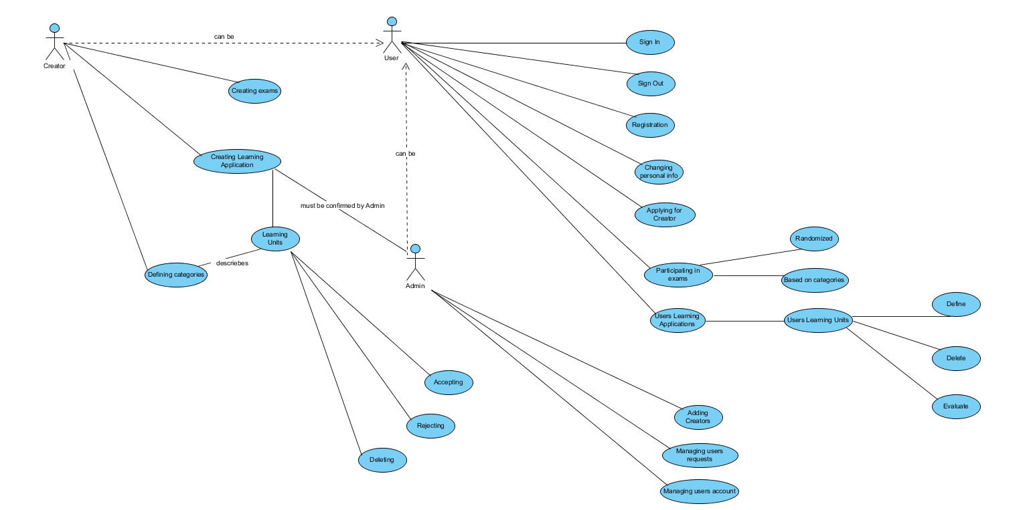

Figure 2: Use Case Diagram in Visual Paradigm

**2.6 UML analysis class diagram**

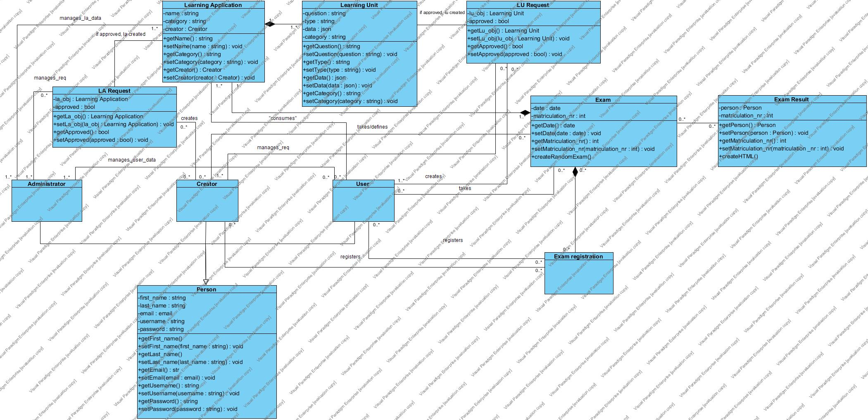

Figure 3: UML analysis class diagram in Visual Paradigm

**2.7 Project plan**

|  |  |
| --- | --- |
| What | Who |
| Project Plan | Aleksandar |
| Infrastructure | Stefan, Amir |
| Houses Model | Djordje, Aleksa |
| Testing | Nikola |
| Submission document | Aleksandar |
| GUI | Stefan, Amir |
| Use Case Diagram | Aleksandar |
| UML analysis class diagram | Djordje, Aleksa |
| Screenshots | Nikola |

**2.8 Screenshots**

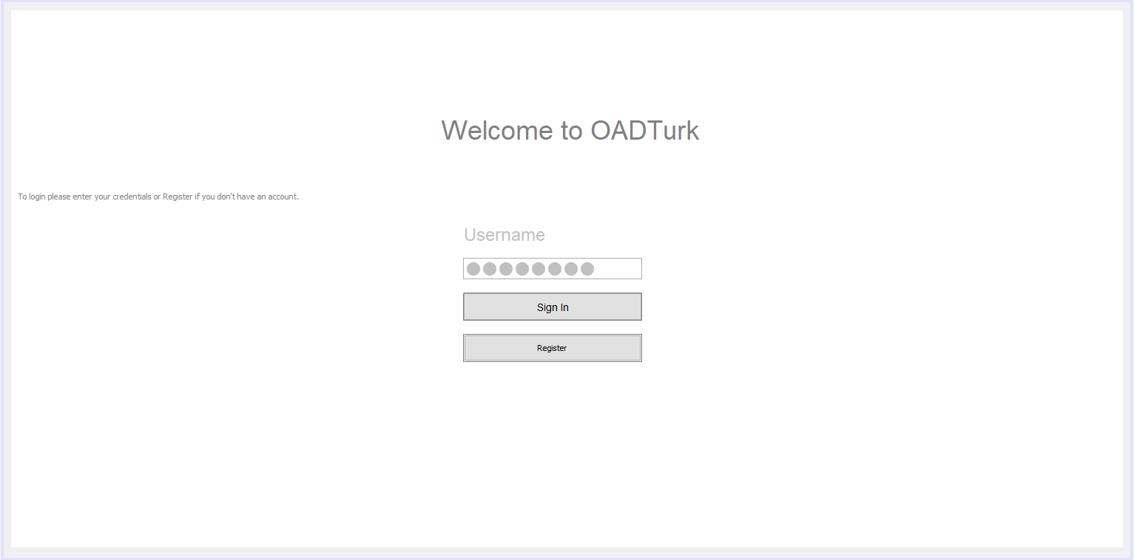

Figure 4: The start page includes the Sign in and registration areas in the middle of screen.

User can insert his user name and password in order to sign in or click on register window to create new account.

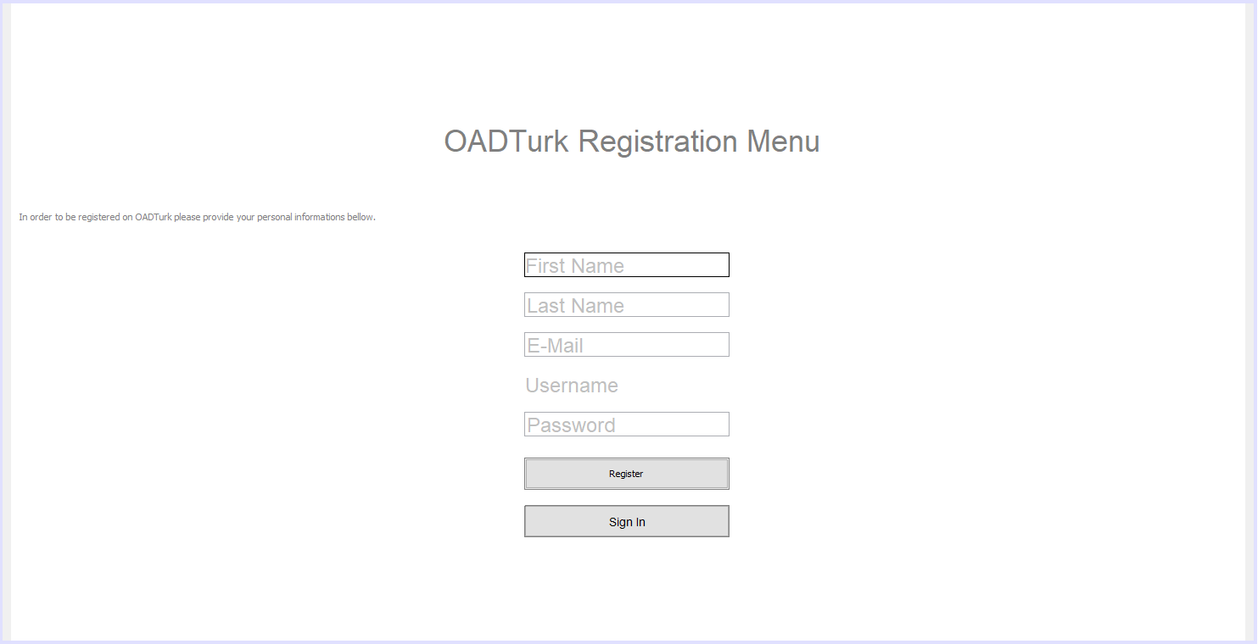

Figure 5: Registration menu contains fields such as: First Name, Last Name, E-Mail, User name and Password, located in the middle of the screen. Filling out required information’s and clicking on the register window will complete the registration process. Sign in window is located at the bottom of the screen.

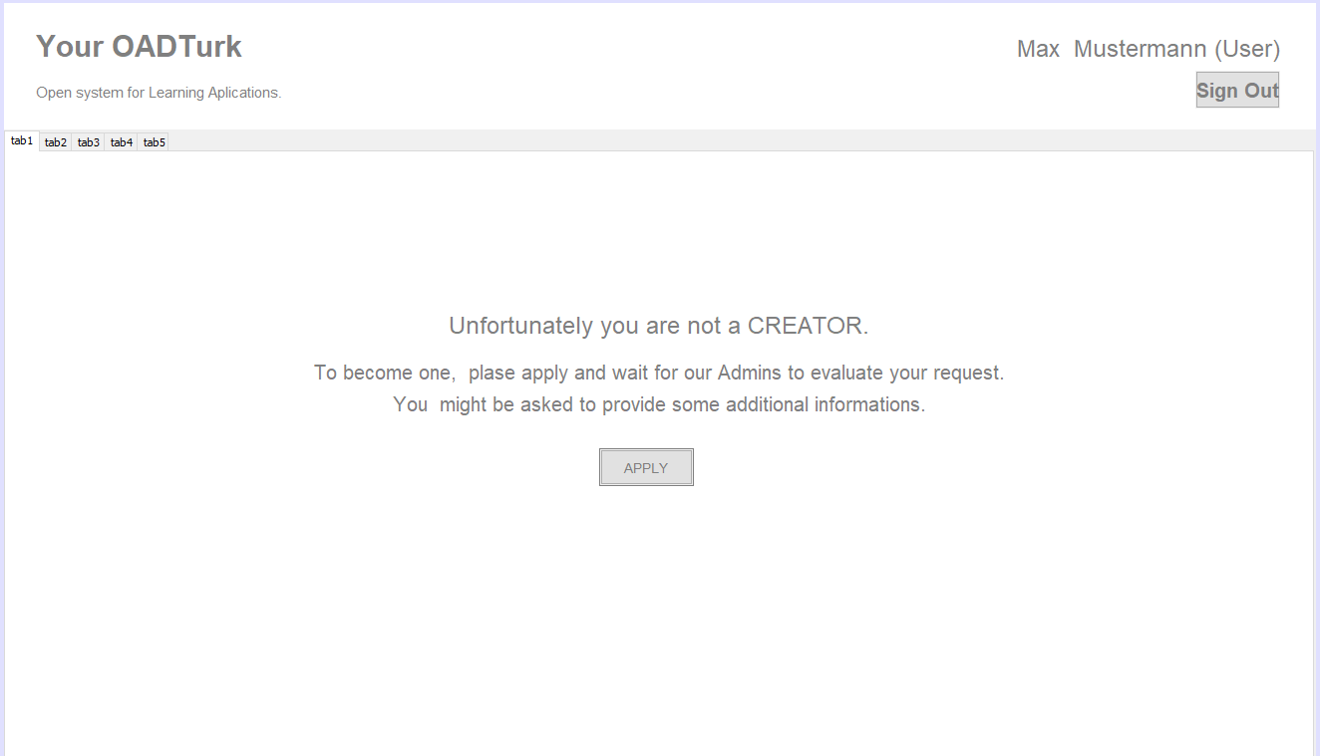

Figure 6: Only administrators are allowed to create new content. User can send request to become creator by clicking on apply button. User information and option to sign out are located in the top right of the screen.

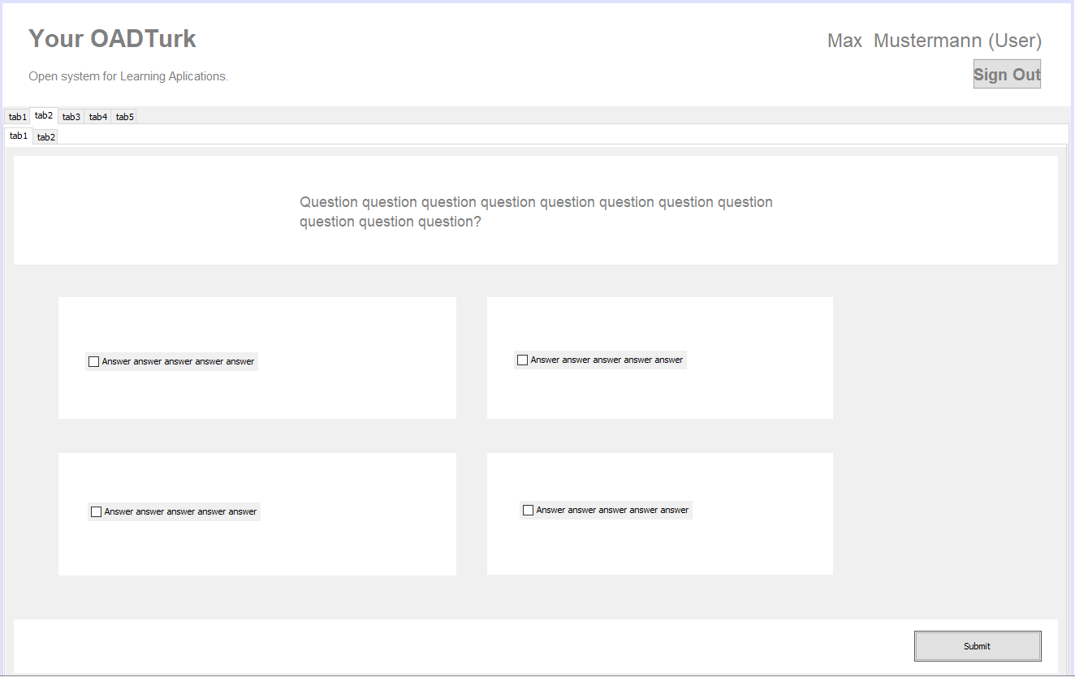

Figure 7: Four possible answers are located under the question window. In order to answer the question, user has to check one of the boxes located at the beginning of each answer and click on submit window in the bottom left.

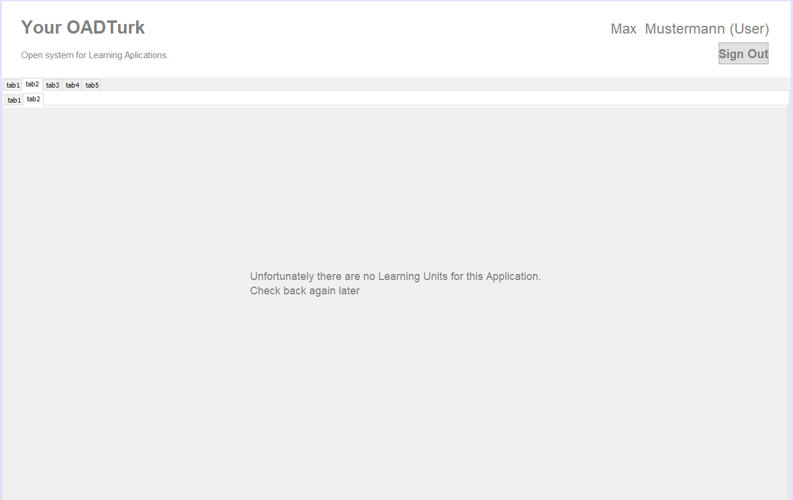   
Figure 8: Message displaying that there are currently no learning units available.

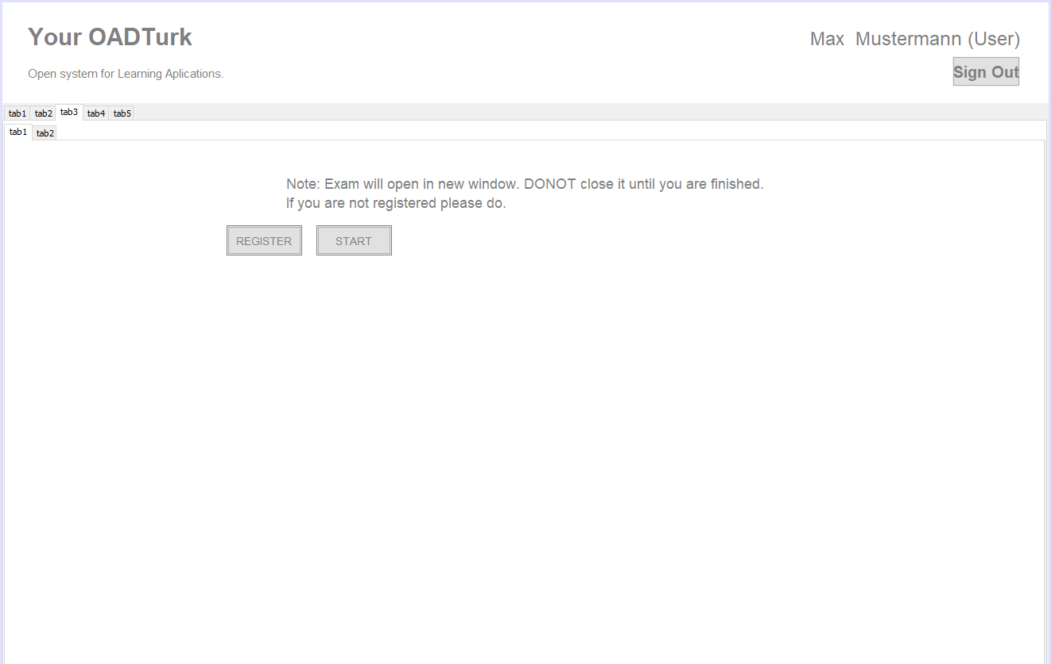

Figure 9: In order to participate in the exam, user has to be registered. Exam will be opened in a new window after clicking on the start.

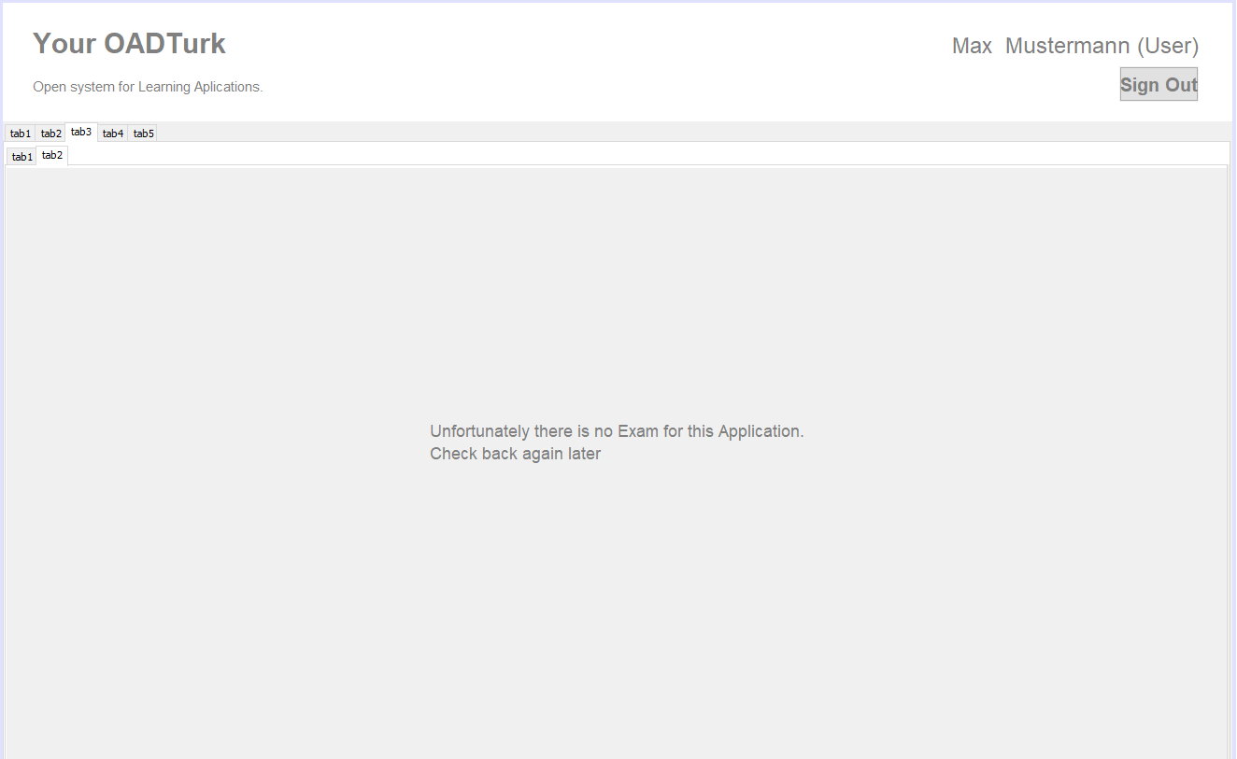

Figure 6: Message displaying that there is currently no exam available.

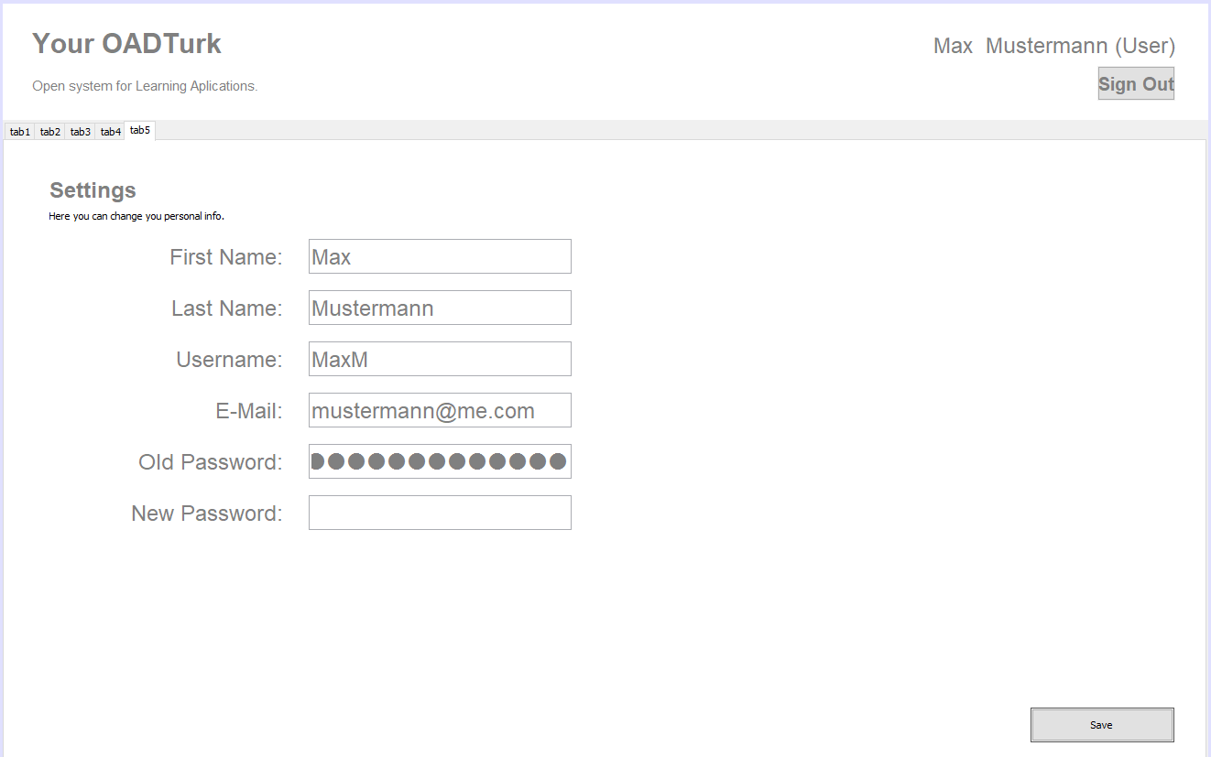

Figure 7: Settings menu allows user to change his personal information and password required to sign in. Information will be updated after clicking save button in the bottom left of the screen.

**Our team**

|  |  |
| --- | --- |
| NAME | ResponBilities |
| Stefan Gajanovic | Development |
| Amir Mujacic | Development |
| ALeksa Pandurevic | Testing |
| Djordje RajIC | Usability |
| NIkola Balac | Analysis |
| Aleksandar Stojicic | Manager |