Sunio, Deither John I. October 11, 2019

Progon Ms. Jen Arroyo

**FLOWCHARTS**

Flowcharting is a tool developed in the computer industry, for showing the steps involved in a process. A flowchart is a diagram made up of boxes, diamonds and other shapes, connected by arrows - each shape represents a step in the process, and the arrows show the order in which they occur. Flowcharting combines symbols and flowlines, to show figuratively the operation of an algorithm.

Process improvement starts with an understanding of the process, and flowcharting is the first step towards process understanding.

When do we use Flowcharts?

* Planning a new project
* Documenting a process
* Modeling a business process
* Managing workflow
* Auditing a process
* Mapping computer algorithms
* Data management
* Chemical and process engineering

Flow charts are an **important** tool for the improvement of processes. By providing a graphical representation, they help project teams to identify the different elements of a process and understand the interrelationships among the various steps.

****Different Types of Flow-charting Symbols

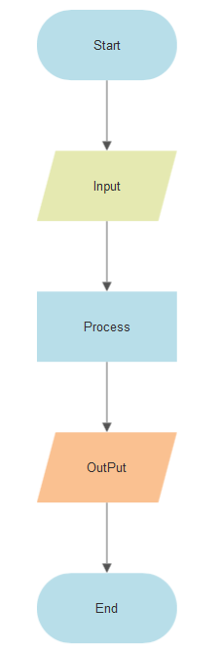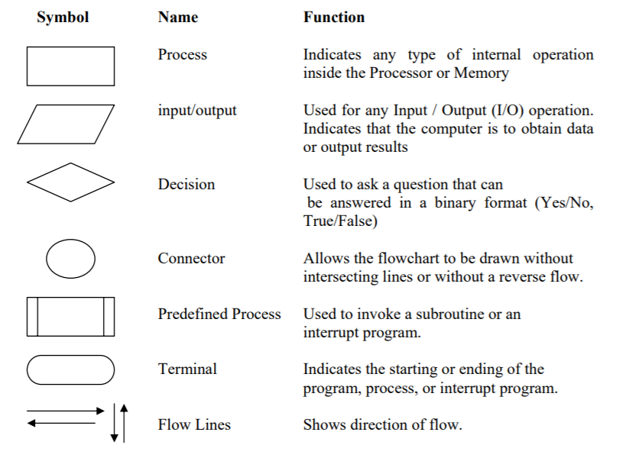

**PSEUDOCODES**

Pseudocode is one of the tools that can be used to write a preliminary plan that can be developed into a computer program. Pseudocode is a generic way of describing an algorithm without use of any specific programming language syntax. It is, as the name suggests, pseudo code —it cannot be executed on a real computer, but it models and resembles real programming code, and is written at roughly the same level of detail.



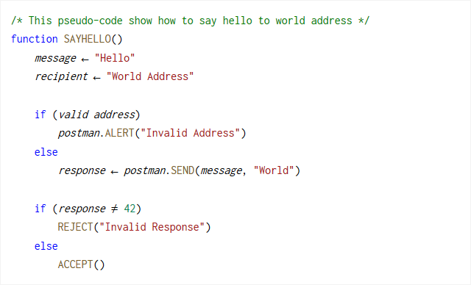

**Pseudo codes is** an efficient key principle of an algorithm. It **is used** in planning an algorithm with sketching out the structure of the program before the actual coding takes place. It cannot be compiled or run like a regular program. **Pseudocode** can be written how you want. But some companies use specific **pseudocode** syntax to keep everyone in the company on the same page. Syntax is a set of rules on how to use and organize statements in a programming language.

Sources:

<https://www.quora.com/What-are-the-main-uses-for-a-flowchart>

<http://ceng.eskisehir.edu.tr/emrekacmaz/bil158/Algorithms3.pdf>

<https://scuola-gabryportal.com/charts_rm.php>

<https://github.com/tobiasbu/jekyll-pseudocode-b>