SUNIO, DEITHER JOHN I. November 05, 2019

PROGCON Professor: Ms Jen Aroyo

**FLOWGORITHM**

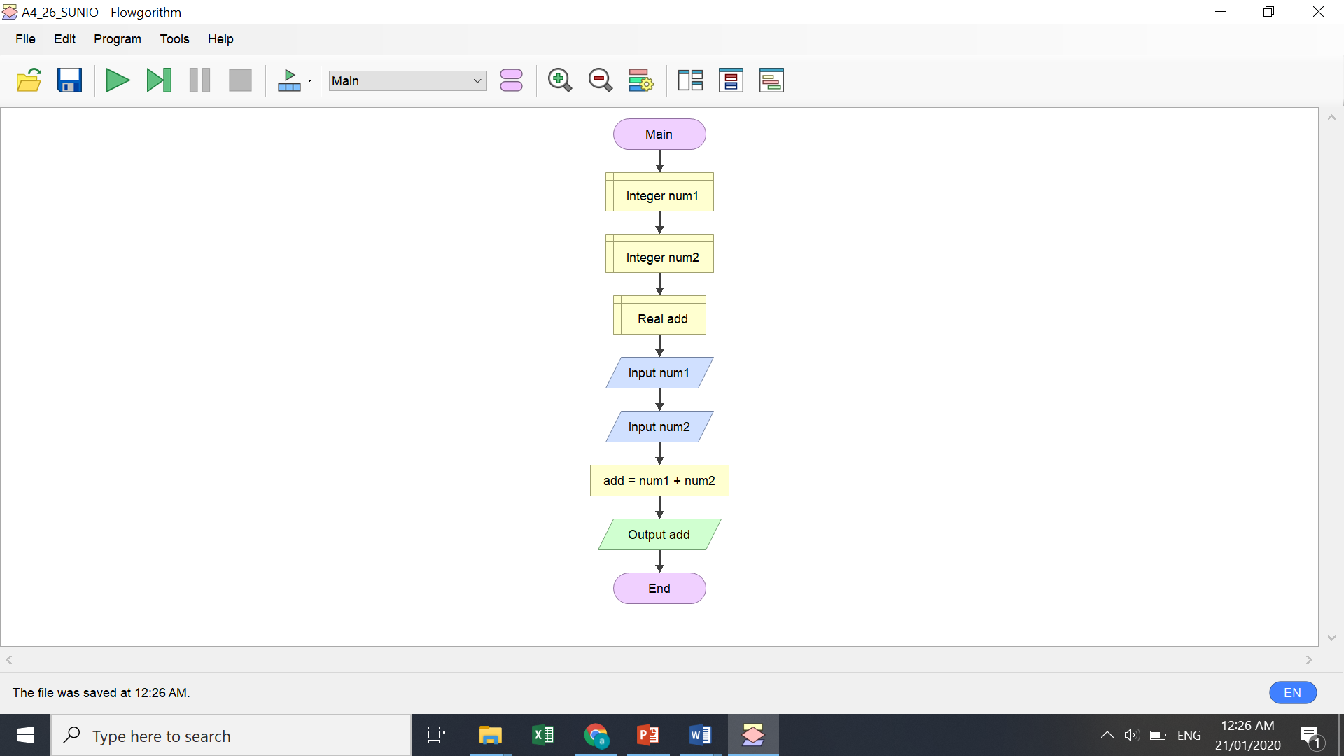

Discussion: Using the Flowgorithm adding two numbers, first I put declare to give the integer number 1 and 2, next is put the real add then input the two numbers. Add the num 1 and num 2 and the answer is on the output add after the answer end.

Discussion: In solving the area of circle using radius and diameter, first insert declare and put real radius, variable, diameter and lastly is the real answer. Insert declare and put string response and string yes, next is insert output ask if “do you have a value of radius and diameter. Insert input response, and next insert if to create and true of false. For the false I enter the diameter and to solve use the “area= To Fixed (pi*(diameter^2,) 2) and the area of a circle with diameter last end.