[Cái nút](https://www.gwtproject.org/javadoc/latest/com/google/gwt/user/client/ui/Button.html)

https://www.gwtproject.org/doc/latest/images/Button.png

[ĐẩyNút](https://www.gwtproject.org/javadoc/latest/com/google/gwt/user/client/ui/PushButton.html)

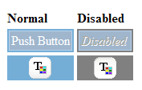

[Nút radio](https://www.gwtproject.org/javadoc/latest/com/google/gwt/user/client/ui/RadioButton.html)

https://www.gwtproject.org/doc/latest/images/RadioButton.png

[hộp kiểm](https://www.gwtproject.org/javadoc/latest/com/google/gwt/user/client/ui/CheckBox.html)

https://www.gwtproject.org/doc/latest/images/CheckBox.png

[Bảng chọn ngày](https://www.gwtproject.org/javadoc/latest/com/google/gwt/user/datepicker/client/DatePicker.html)

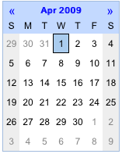

[Nút bật tắt](https://www.gwtproject.org/javadoc/latest/com/google/gwt/user/client/ui/ToggleButton.html)

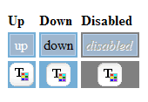

[Hộp văn bản](https://www.gwtproject.org/javadoc/latest/com/google/gwt/user/client/ui/TextBox.html)

https://www.gwtproject.org/doc/latest/images/TextBox.png

[Mật KhẩuHộp Văn Bản](https://www.gwtproject.org/javadoc/latest/com/google/gwt/user/client/ui/PasswordTextBox.html)

https://www.gwtproject.org/doc/latest/images/PasswordTextBox.png

[Vùng văn bản](https://www.gwtproject.org/javadoc/latest/com/google/gwt/user/client/ui/TextArea.html)

https://www.gwtproject.org/doc/latest/images/TextArea.png

[siêu liên kết](https://www.gwtproject.org/javadoc/latest/com/google/gwt/user/client/ui/Hyperlink.html)

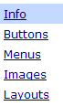

[hộp danh sách](https://www.gwtproject.org/javadoc/latest/com/google/gwt/user/client/ui/ListBox.html)

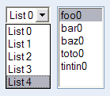

[Danh sách di động](https://www.gwtproject.org/javadoc/latest/com/google/gwt/user/cellview/client/CellList.html)

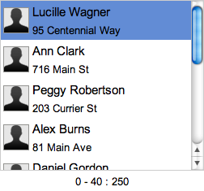

[Thanh menu](https://www.gwtproject.org/javadoc/latest/com/google/gwt/user/client/ui/MenuBar.html)

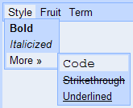

[Cây](https://www.gwtproject.org/javadoc/latest/com/google/gwt/user/client/ui/Tree.html) , [CellTree](https://www.gwtproject.org/javadoc/latest/com/google/gwt/user/cellview/client/CellTree.html)



[Hộp đề xuất](https://www.gwtproject.org/javadoc/latest/com/google/gwt/user/client/ui/SuggestBox.html)

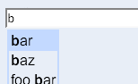

[Phong phúVăn bảnKhu vực](https://www.gwtproject.org/javadoc/latest/com/google/gwt/user/client/ui/RichTextArea.html)

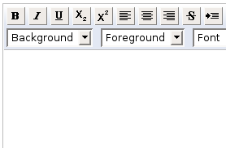

[FlexTable](https://www.gwtproject.org/javadoc/latest/com/google/gwt/user/client/ui/FlexTable.html) , [Grid](https://www.gwtproject.org/javadoc/latest/com/google/gwt/user/client/ui/Grid.html) và [CellTable](https://www.gwtproject.org/javadoc/latest/com/google/gwt/user/cellview/client/CellTable.html)

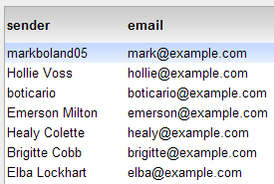

[trình duyệt di động](https://www.gwtproject.org/javadoc/latest/com/google/gwt/user/cellview/client/CellBrowser.html)

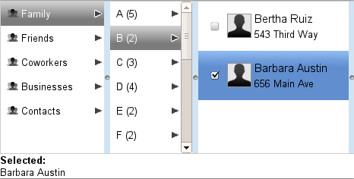

[thanh tab](https://www.gwtproject.org/javadoc/latest/com/google/gwt/user/client/ui/TabBar.html)

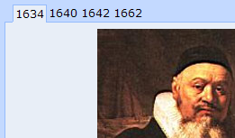

[Hộp thoại](https://www.gwtproject.org/javadoc/latest/com/google/gwt/user/client/ui/DialogBox.html)

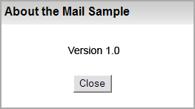

**tấm**

[Cửa sổ bật lên](https://www.gwtproject.org/javadoc/latest/com/google/gwt/user/client/ui/PopupPanel.html)

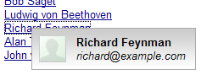

[StackPanel](https://www.gwtproject.org/javadoc/latest/com/google/gwt/user/client/ui/StackPanel.html) và [StackLayoutPanel](https://www.gwtproject.org/javadoc/latest/com/google/gwt/user/client/ui/StackLayoutPanel.html)[*](https://www.gwtproject.org/doc/latest/RefWidgetGallery.html#LayoutPanelNote)

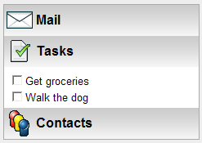

[Bảng điều khiển ngang](https://www.gwtproject.org/javadoc/latest/com/google/gwt/user/client/ui/HorizontalPanel.html)

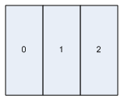

[DọcBảng điều khiển](https://www.gwtproject.org/javadoc/latest/com/google/gwt/user/client/ui/VerticalPanel.html)

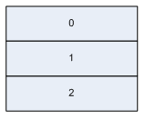

[Bảng điều khiển lưu lượng](https://www.gwtproject.org/javadoc/latest/com/google/gwt/user/client/ui/FlowPanel.html)

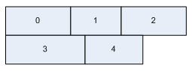

[Bảng phân chia theo chiều dọc](https://www.gwtproject.org/javadoc/latest/com/google/gwt/user/client/ui/VerticalSplitPanel.html)

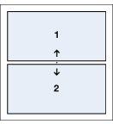

[Bảng điều khiển chia ngang](https://www.gwtproject.org/javadoc/latest/com/google/gwt/user/client/ui/HorizontalSplitPanel.html)

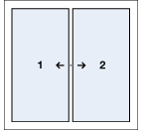

[SplitLayoutPanel](https://www.gwtproject.org/javadoc/latest/com/google/gwt/user/client/ui/SplitLayoutPanel.html)[*](https://www.gwtproject.org/doc/latest/RefWidgetGallery.html#LayoutPanelNote)

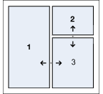

[DockPanel](https://www.gwtproject.org/javadoc/latest/com/google/gwt/user/client/ui/DockPanel.html) và [DockLayoutPanel](https://www.gwtproject.org/javadoc/latest/com/google/gwt/user/client/ui/DockLayoutPanel.html)[*](https://www.gwtproject.org/doc/latest/RefWidgetGallery.html#LayoutPanelNote)

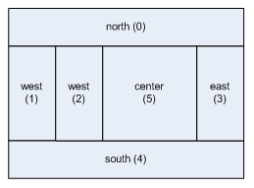

[TabPanel](https://www.gwtproject.org/javadoc/latest/com/google/gwt/user/client/ui/TabPanel.html) và [TabLayoutPanel](https://www.gwtproject.org/javadoc/latest/com/google/gwt/user/client/ui/TabLayoutPanel.html)[*](https://www.gwtproject.org/doc/latest/RefWidgetGallery.html#LayoutPanelNote)

