根据XML协议
二进制：（可参照下图例）
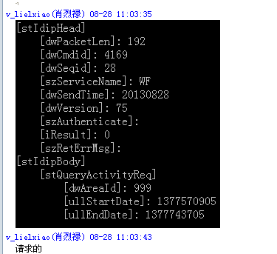
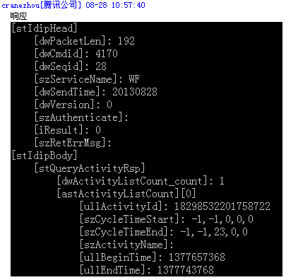
---------------------------------------------------------------------------------------------------------------------

JSON:(可参照下面例子)
请求应该是这样子：
response={
"head" : {
"PacketLen" : null,
"Cmdid" : 4107,
"Seqid" : 1234,
"ServiceName" : "SMZT",
"SendTime" :20130812 ,
"Version" :3 ,
"Authenticate" : "",
"Result" :0 ,
"RetErrMsg" : ""
},
"body" :
{
"AreaId" : 1
}
}

返回串：
response={
"head" :
{
"PacketLen" : null,
"Cmdid" : 4108,
"Seqid" :1234 ,
"ServiceName" : "SMZT",
"SendTime" :20130812 ,
"Version" : 1,
"Authenticate" : "",
"Result" :0 ,
"RetErrMsg" : ""
},
"body" :
{
"NoticeList_count" :1 ,
"NoticeList" : [ {
"AreaId" : 1,
"NoticeId" : "1",
"NoticeContent" : "\u60f3\u77e5\u9053\u795e\u9b54\u4e4b\u5854\u7684\u6700\u65b0\u52a8\u6001\uff0c\u5173\u6ce8\u6211\u4eec\u5427\uff01\r\n\r\n\u5fae\u535a: http://weibo.com\/TowerOfSaviors\r\n\u5fae\u4fe1ID:shenmozhita",
"Time" : 1363586405 } ]
}
}

