**Doğukan ŞENER 20160808048**   **Akdeniz Üniversitesi-CSE**

REPORT OF THE APARTMENT MANAGEMENT SYSTEM

**Problem**

People have difficulty in accessing information about the their apartment where they are living.

People have to meet with the manager to solve their problem or get information by hand.

People can not check the expenses without comminucate with menager. Also they have to ask to details for expenses

**Purpose-Solution**

So, how can we solve that problems?

* Firstly, we give them a space to see hires from admins or requests from users and everybody can use the request are to share own ideas.
* Secondly, we have a table which is due page so they can see payment information which is related with all residents.
* In additionly, admins can update datas directly which are about due expense or user information.
* So hold datas different table in our data base and display them with related pages.
* We hold each user at one door number so we can say every resident must be have 1 user account and all accounts can be manage by admins.
* For safety admins can not delete own account if you can modify them selves or anothers.

**Content of The Website**

We can easily say, that site is make the informing and displaying for users and admins. The abstract is based on transparent data sharing.

For users: They can see the own payments or apartment expenses.

For admins: They can see all request and share all hires created by Management.

**The Programming Languages Used and Applications**

Html (Not a programming language)

Css (Not a programming language)

İn additioanly used bootstrap classes

Javascript

Php

MySql

Atom (Editor for html and php)

Xampp

Ophera (as a browser)

Spotify (as motivation coach)

**What are our tables**

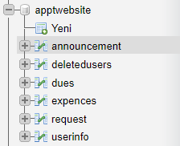

Announcement display table

Get users table when a user deleted

User payment status

Expence information and current balance

Request display table

User information table

These table related with own pages. We handle form and tables with those data base tables. So when you do some changes on your web site there will be also changing on the data base. Everything updated at the same time. We use sql queries multiple time and line to process everything at the 1 condition to solve possible problems.

In these tables id’s will be primary and doornumber will be unique for you. So, each doornumber has own resident and each resident can do own process. We handle that problem holding current user id name etc. When you open the login page and login the main page using your own id key. You can see top right your name will display on that corner. When you write as an user on request page and then it will display with your name.

-So let’s look class and case diagram

**Class Diagram**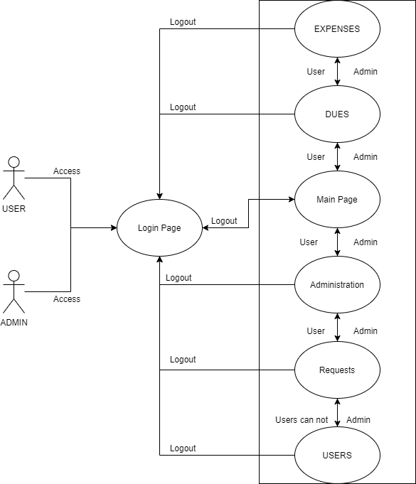

**Use-Case Diagram**

