CommStatV2.3 Overview V1.1

CommStatV2.3 adds three features to CommstatV2.
- “Click to View” StatReps. Selecting a map pin or a StatRep in the main view of CommStat will launch a window that displays the selected StatRep. Additionally if there is a Brevity script in the StatRep, CommStatV2.3 will unpack it and display it in a dedicated window. The StatRep can be displayed and saved as an HTML file.
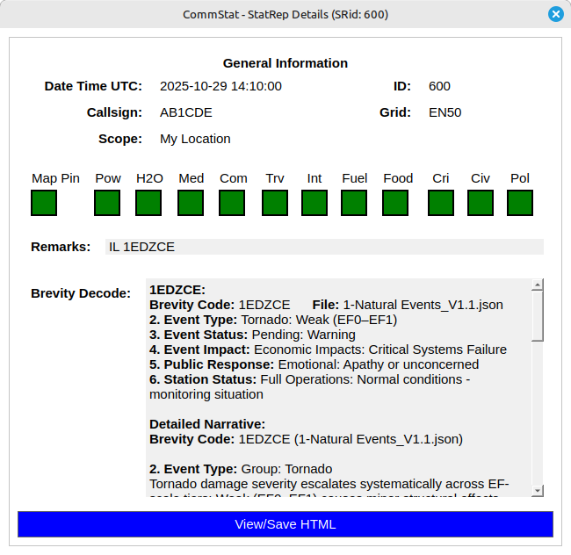
- GridFinder can be launched via a button in the Grid field of the statrep. This allows you to search for a grid and paste it in to your StatRep.
- Brevity1.0 can now be launched via a button in the Remarks field.
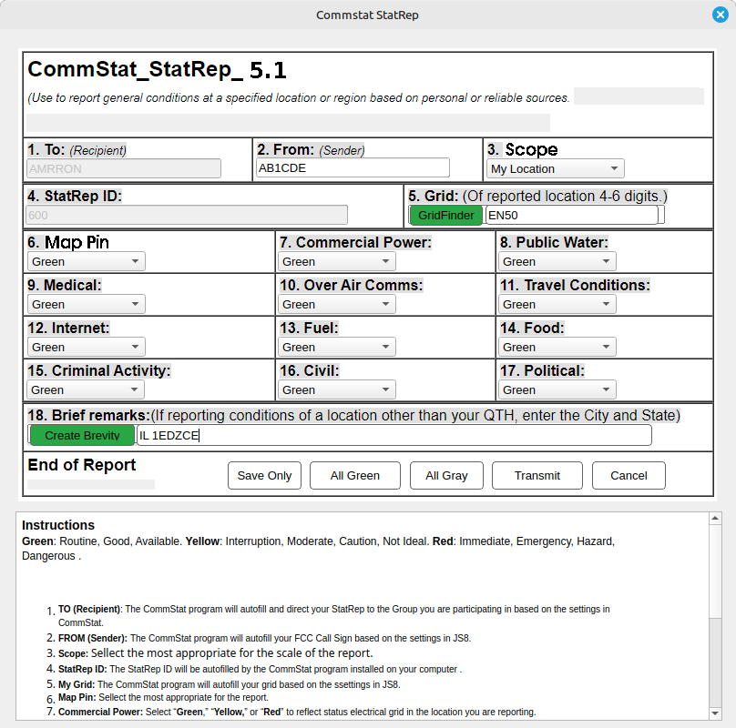
Upgrade CommStatV2.0 to 2.3 Instructions
CommStat2.3 provides upgrade files to upgrade CommStat2.0.
- Requirements
  - CommStatone installed and tested
  - CommStatV2.0 files added to original CommStatone and tested
- Upgrade CommStat2.0 to 2.3
  - Download and unzip CommStat2.3 files
  - Copy and paste the unzipted individual files into the active commstatone directory.
  - Run commstatone. You are good to go.

