**DIGITAL MARKETING ASSIGNMENT**



BE-Computer Science and Engineering

Vivekanandha College of Technology for Women

Namakkal-637205

**NM id:** B56C9E8BAE1468AB2B947D19261630AF **Submitted by:**

ATHIRA NAGARAJAN au613020104009

* **BRAND NAME:**

SPECIAL BIRIYANI

* **LOGO:**



* **CATEGORY:**

Food

1. **Create a blog or website using Blogspot and WordPress.**

Blogspot:https://newtamilmobilephones.blogspot.com/2023/09/m obile-phones-cell-phones-have-affected.html

WordPress: [https://mobilephones9790.liveblog365.com](https://mobilephones9790.liveblog365.com/)

1. **Create a New Facebook Business Page and Post one social Media poster**

Business Page Link:

<https://www.facebook.com/profile.php?id=61550845066171>

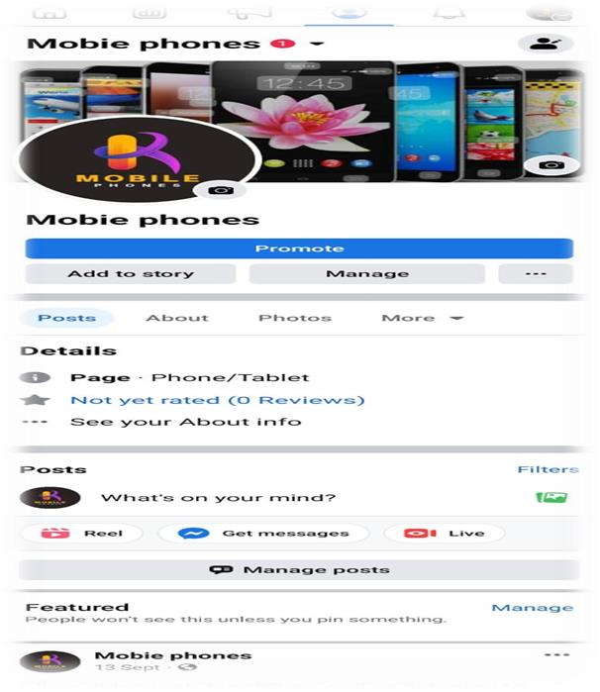

Social media poster:



1. **Social media advertisement poster using Canva**



1. **E-mail newsletter using Mail Chimp or Canva**

