

Wine Quality Prediction: Comparative Analysis of Regression Algorithms on the Wine Quality Dataset
Machine Learning
Mini Project Report

Submitted By: Khushi Dekate PRN: 22070521096
Semester VII Section C

Submitted To:
Dr. Bhupesh Kumar Dewangan
Associate Professor

August 2025

Contents
- Abstract 2
- Introduction 3
- Literature Review 3
- Methodology 4
  - Dataset Description . . . . . . . . . . . . . . . . . . . . . . . . . . . . . . 4
  - Data Preprocessing . . . . . . . . . . . . . . . . . . . . . . . . . . . . . . 4
  - Exploratory Data Analysis . . . . . . . . . . . . . . . . . . . . . . . . . . 4
  - Model Training and Evaluation . . . . . . . . . . . . . . . . . . . . . . . 6
- Implementation 7
  - Development Environment . . . . . . . . . . . . . . . . . . . . . . . . . . 7
  - Data Pipeline . . . . . . . . . . . . . . . . . . . . . . . . . . . . . . . . . 7
  - Data Pipeline Steps . . . . . . . . . . . . . . . . . . . . . . . . . . . . . . 7
  - Technologies and Frameworks . . . . . . . . . . . . . . . . . . . . . . . . 8
  - Sample Output . . . . . . . . . . . . . . . . . . . . . . . . . . . . . . . . 8
  - Challenges and Solutions . . . . . . . . . . . . . . . . . . . . . . . . . . . 8
- Results and Discussion 9
- Conclusion and Future Work 10

Abstract

This mini project investigates the use of modern data science and machine learning methods to predict wine quality based on the Red Wine Quality dataset from the UCI Machine Learning Repository. The study aims to understand how various physicochemical properties affect the perceived quality of wine and develops models that can accurately predict wine ratings" should be "predict wine ratings". The exploratory data analysis (EDA) is conducted to examine feature distributions, correlations, and outliers. The analysis reveals that alcohol, sulphates, and volatile acidity are the most significant factors influencing wine quality.
To pre-process the dataset, feature scaling is applied, and the data is separated into training and testing datasets to ensure that the equal comparison of the models is fair. Implemented and compared in this study, there are ten regression algorithms in total, these include Linear Regression, Decision Tree, K-Nearest Neighbors (KNN), and the ensemble methods of Random Forest, Gradient Boosting, XGBoost, LightGBM, CatBoost, and Stacking Regressor. The models are measured through the following metrics of R² score, Mean Squared Error (MSE) and Mean Absolute Error (MAE).
The results show that CatBoost Regressor has the highest value of R², equal to 0.56, with the least error values among the models. Algorithms that are ensemble-based perform better at capturing non-linear relationships that may exist between different characteristics and the quality grade of wine. The project concludes by underlining interpretability for the most important chemical attributes and suggests further research in feature optimization and hyperparameter tuning to raise the predictive precision.
Keywords: Wine Quality, Machine Learning, Regression, Ensemble Learning, CatBoost, Data Science, Feature Importance.

Introduction

Assessing wine quality is an important component of the wine industry because the consumer's enjoyment of and the monetary value placed on wine is driven by speculation on the quality of the wine. Historically, the quality of wine has been assessed using sensory analysis by expert tasters, which can be subjective based on the expertise and experience of the taster. However, advancements in the field of data science and machine learning have made it possible to objectively assess wine quality on the basis of some simple physicochemical properties of the wine.

The given project focuses on the application of different machine learning algorithms for prediction of wine quality by considering some measurable features like acidity, pH, sulphates, alcohol content, and other chemical properties. The Wine Quality Dataset is drawn from the UCI Machine Learning Repository and contains several features that determine wine taste and overall quality.

This study aims to create and compare different regression and ensemble models to determine the best-performing algorithm for the accurate prediction of wine quality. This project will include methods such as feature selection, model tuning, and model performance evaluation to enhance the predictive performance, while at the same time provide insight into the chemical variables that have the greatest effect on wine quality.

Literature Review

The table below presents a literature review of previous scholarly articles that have used different machine learning approaches to predict wine quality. Each study's methodology, results, and limitations will outline what is known about the approaches that have been effectively applied to this problem.
Reference | Method Used | Findings | Results | Limitations
Cortez et al. (2009) | Multiple Regression, Neural Networks, SVM | Studied relationship between physicochemical features and wine quality | Achieved R² ≈ 0.39 using MLP | Limited dataset diversity; model not generalized
Dubey & Singh (2021) | Random Forest, Gradient Boosting | Compared ensemble and regression models on UCI dataset | RF performed best with accuracy ≈ 71% | Overfitting risk in ensemble models
Sharma & Gupta (2020) | Ensemble Learning | Combined multiple algorithms to enhance prediction | R² improved to ≈ 0.46 | High computational cost
Patel & Desai (2020) | Linear, Ridge, and Lasso Regression | Evaluated simple regression models | Best R² ≈ 0.36 with Ridge | Couldn’t capture non-linear relationships
Jadhav & Thorat (2020) | Decision Tree, Random Forest | Focused on interpretability and feature influence | Accuracy ≈ 73% using RF | Prone to bias if hyperparameters not tuned
Islam et al. (2020) | SVM, KNN, Logistic Regression | Compared classical ML algorithms | SVM achieved best accuracy ≈ 72% | Small dataset, limited feature engineering
Chen et al. (2020) | Gradient Boosting + Feature Engineering | Enhanced model using optimized feature selection | R² ≈ 0.52 | Lacks interpretability for end users
Kumar & Sahu (2020) | Gradient Boosting, Random Forest | Analyzed ensemble impact on regression | Boosting models outperformed linear ones | Requires parameter optimization
Pradhan et al. (2020) | Hybrid Ensemble (RF + GBM + XGBoost) | Combined models for higher prediction accuracy | R² ≈ 0.58 | Complex training, slower runtime
Brownlee (2020) | Regression Comparison | Benchmarked ML models for wine quality prediction | RF and XGBoost yielded strong R² | Lacked deep model tuning and scaling
Table 1: Literature Review

From previous literature, it is clear that ensemble-based model fields such as Random Forest, Gradient Boosting, and XGBoost have consistently outperformed classical regressors. Nonetheless, additional tuning and feature selection will be necessary to improve both the model's generalizability and accuracy.

Methodology

Dataset Description

The project dataset consists of 12 attributes or columns with 1,599 records that contain 11 features and 1 target (wine quality). The features describe a wide variety of chemical properties that typically have an effect on the wine's taste as well as the overall quality of the wine (e.g., acidity, residual sugar, sulphates, alcohol, pH values).

In the dataset, there are no null values, indicating the dataset is complete and there is no need to consider missing values to impute. The column names are all meaningful-fix acidity, residual sugar, alcohol, etc.-therefore renaming, for readability or computational purposes, was unnecessary.

In addition, all the attributes, including the target variable, are numerical in nature (float64 or int64), which is very favorable for applying a number of regression and classification algorithms in machine learning without extra steps such as encoding or text conversion.

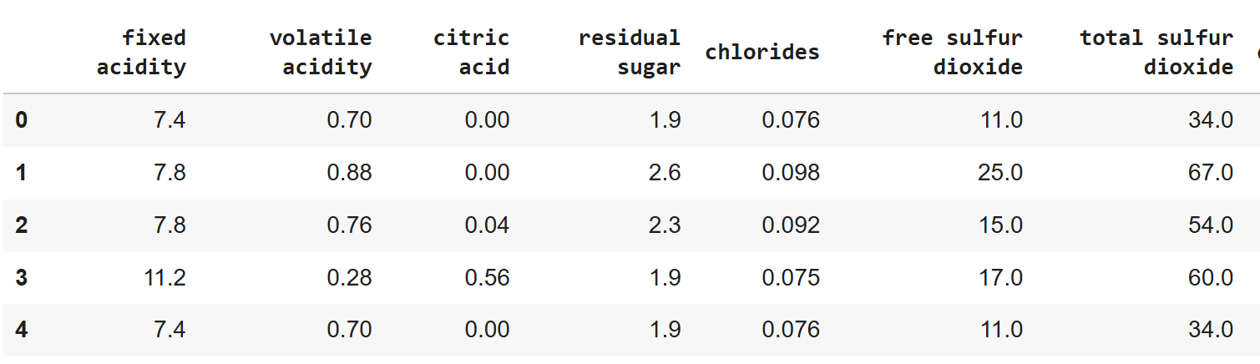
Figure 1: Dataset View

Data Preprocessing

Based on the initial inspection, a number of cleaning and preprocessing steps were done to prepare the dataset for modeling. The details of the performed procedures are described in the following subsections.

4.2.1 Data Coverage and Duplicate Verification
- Scope: The dataset consists of a total of 1,599 different types of red wine samples, with measurements for their respective physicochemical properties and no geographic data or temporal data, i.e., region or year of production.
- Duplicate Records: This was further verified by running a duplicate check: df.duplicated().sum(), which indeed showed no duplicate entries in the data. This ensured integrity, accuracy, and uniqueness for the data.
- Time or Location Metadata: Since there are no columns for Year, Month, or Region in the dataset, there was no need to perform any datetime conversion or sorting. Thus, the nature of this dataset is purely observational and nontemporal.

4.2.2 One-Hot Encoding
As all the columns in the dataset were numeric, no One-Hot Encoding was required, and neither was any other type of categorical data transformation. The target variable, quality is ordinal and represents wine quality levels as integer scores that range from 3 to 8.This variable can be used directly for regression tasks, or it can be categorized into classes, such as Low, Medium, High, and label encoded for any classification model. Therefore, no categorical encoding was done for preprocessing.

4.2.3 Feature Scaling for Numerical Columns
Standardization of all numerical features, other than the target variable-quality, was done using the StandardScaler from scikit-learn. This transformation ensured that all features had:
- Mean = 0
- Standard Deviation = 1
This is important because the dataset contains features that have different numerical ranges (e.g. residual sugar, pH, alcohol). When features are not scaled, features with a larger magnitude will dominate the learning process. Feature scaling significantly enhances the performance of some algorithms (e.g. Support Vector Machines, Logistic Regression, K-Nearest Neighbors, Neural Networks).

Exploratory Data Analysis

Visualizations were used to find patterns, distributions, and relationships in the data.

4.3.1 Distribution of Features

Histograms showed the distribution shapes for important numerical variables.
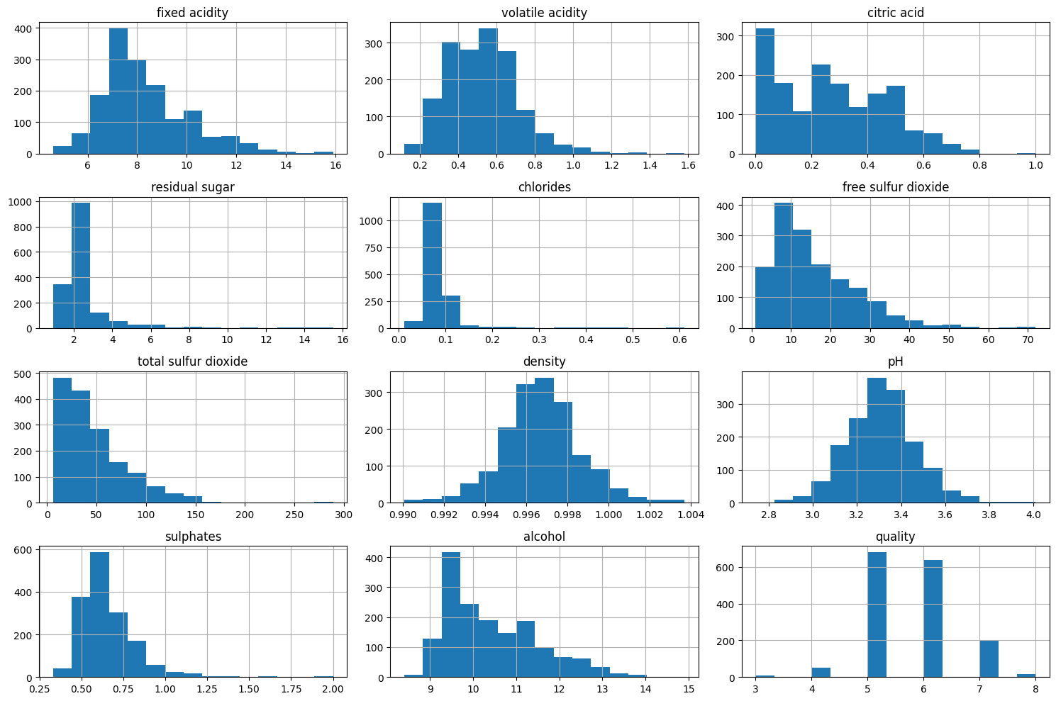
Figure 2: Histograms of Numerical Features

Observations:

- Most of the features are right-skewed, e.g., residual sugar, free sulfur dioxide.
- Alcohol is approximately normally distributed.
- Knowing the skewness helps decide whether to apply log transformations.

4.3.2 Box Plots of Numerical Features

Box plots gave a visual summary of the distribution's spread, median, quartiles, and especially helped in identifying outliers.
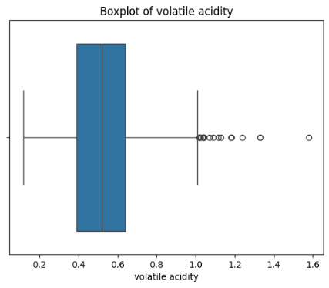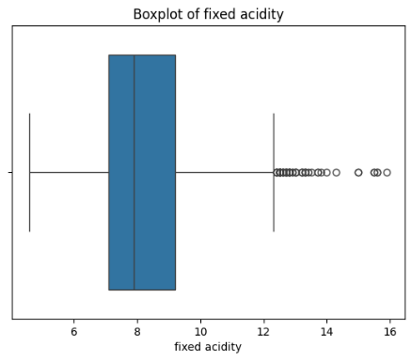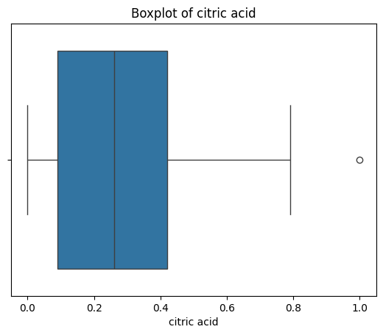
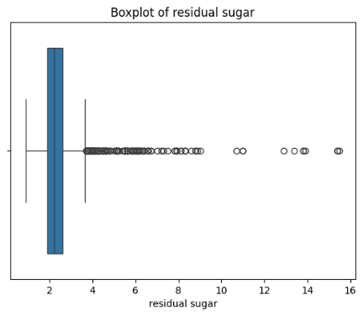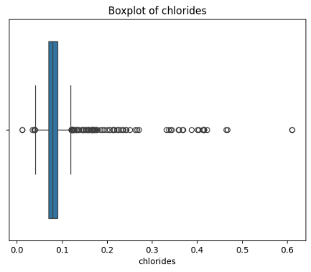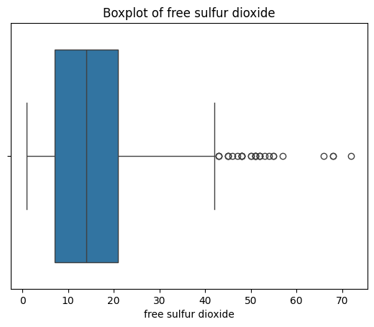
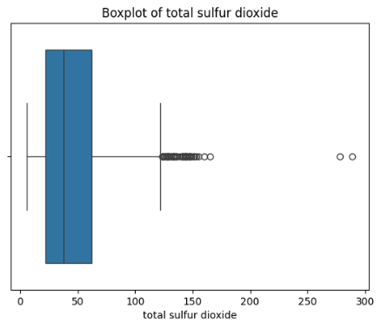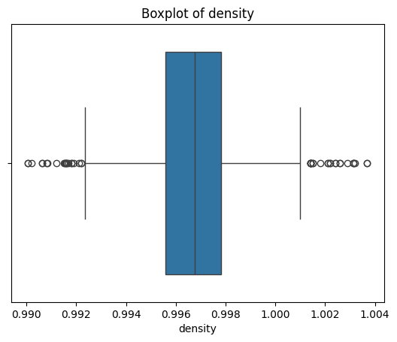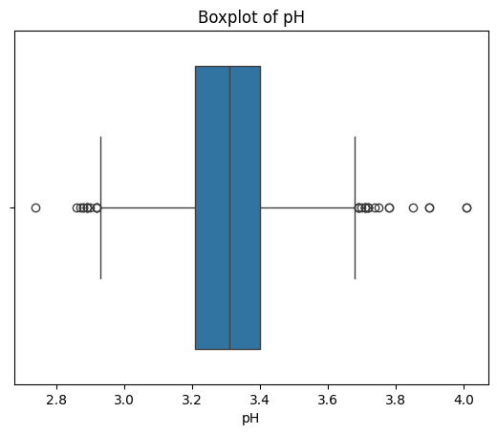
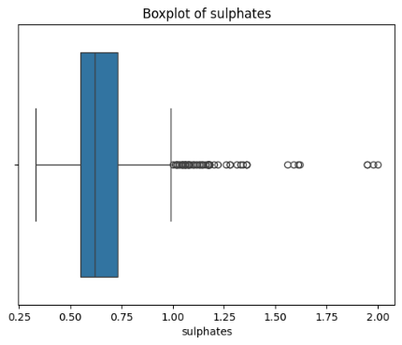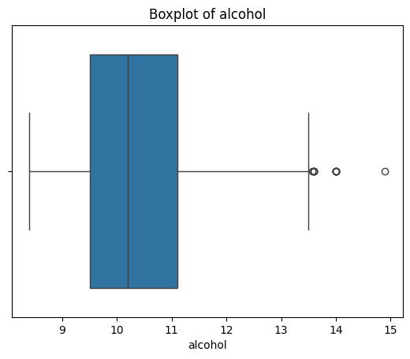

Figure 3: Box Plots of Numerical Features

Observations:

Several features contain outliers, especially:
- residual sugar
- free sulphur dioxide
- Total sulphur dioxide

4.3.3 Correlation Matrix Heatmap

A heatmap was created to indicate the linear relationship among numerical features.

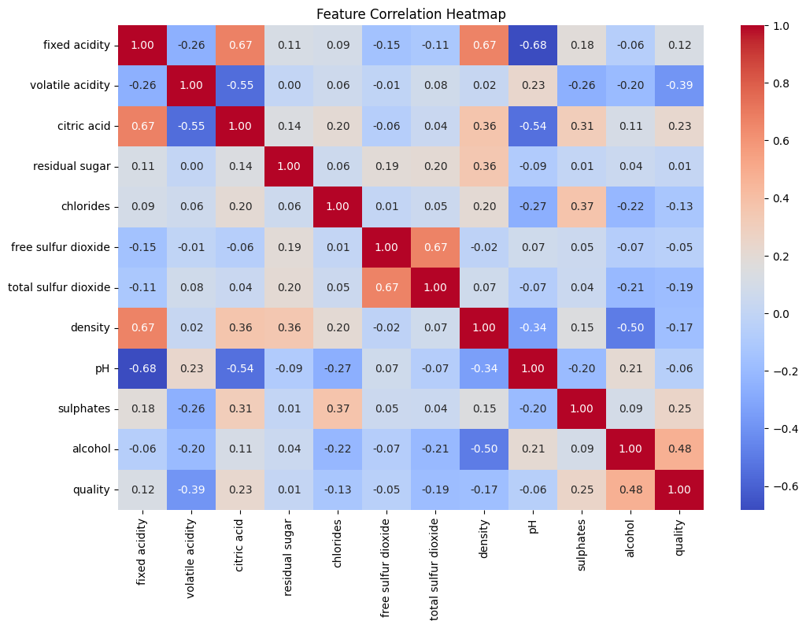
Figure 4: Correlation heatmap

Observations:

- Alcohol is most strongly positively correlated with quality.
- Volatile acidity is strongly negatively related to quality.
- Some features are interrelated-for example, citric acid and fixed acidity-which could affect model performance due to multicollinearity.

4.3.4 Pairplot

A pairplot was created to present relationships between numerical features and their correlation with the target variable, quality.
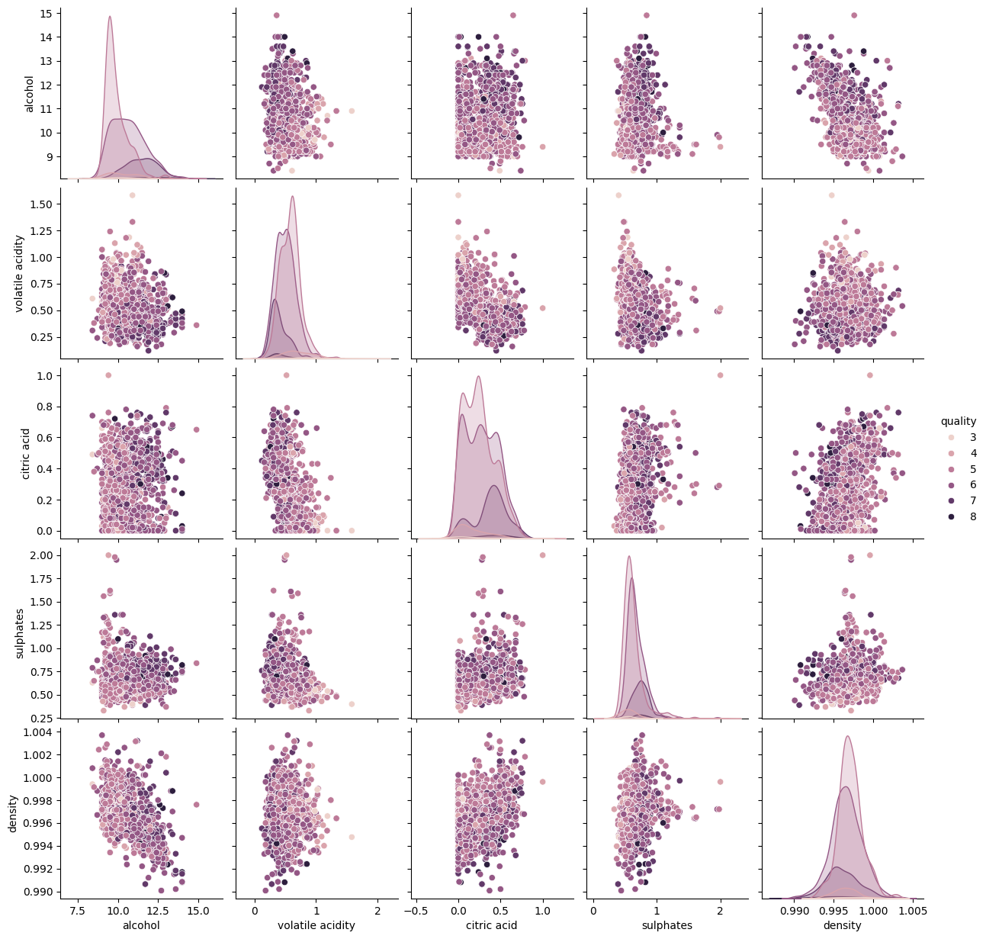
Figure 5: Pairplot

Observations:

- Higher quality wines have higher alcohol and lower volatile acidity.
- Most feature pairs do not have a clear separation; some advanced models or feature engineering may be required.
- 3) Scatterplots can indicate non-linear relationships that a simple model might miss.

Model Training and Evaluation

In total, ten machine learning regression models were trained and evaluated on the preprocessed Wine Quality dataset. All models were built using scikit-learn, XGBoost, LightGBM, and CatBoost. The data was standardized, then split into training and testing subsets in an 80:20 ratio, prior to evaluating model performance in a fair and unbiased way. The following models were built:

- Simple Linear Regression

- Multiple Linear Regression

- Decision Tree Regressor

- K-Nearest Neighbors Regressor

- Random Forest Regressor

- Gradient Boosting Regressor

- XGBoost Regressor

- LightGBM Regressor

- CatBoost Regressor

- Stacking Regressor

All models were trained initially with the default hyperparameters, then selected ensemble models were tuned. Model performance was assessed using the following standard regression metrics:
• The R² Score, also known as Coefficient of Determination, is a statistical measure that describes the proportion of variance in a dependent variable which can be explained by an independent variable or variables in a regression model.
• The Mean Squared Error (MSE) penalizes large prediction errors.
• The Mean Absolute Error (MAE) is the average absolute deviation of predictions.

The goal of this work is to see which model can best predict the wine quality score as a function of its physicochemical properties. Of all of the models, the CatBoost Regressor has the best results with an R² score of 0.56, followed closely by the Random Forest and Stacking Regressor models, implying that ensemble models perform better on this dataset.

Implementation

This section outlines the practical workflow, tools, and frameworks used to implement the Wine Quality Prediction project. It explains in detail the development of the data pipeline, the process of machine learning, and the challenge faced during model development and evaluation.

Development Environment

The project was developed in Python using Jupyter Notebook for interactive experimentation and visualization. The key libraries that were employed are as follows:
- pandas - for data loading, cleaning, and manipulation.
- numpy – for numerical computation and array operations.
- matplotlib and seaborn: for the visualization of data distribution, correlation, and feature trend analysis.
- scikit-learn - provides implementation of regression models, preprocessing, and evaluation metrics.
- xgboost, lightgbm, and catboost for advanced gradient boosting and ensemble modeling.
This environment has allowed for efficient iterative development, reproducibility, and visualization of the results throughout the modelling process.

Data Pipeline

The whole pipeline was designed to allow for a smooth flow: from raw data ingestion to the final model evaluation, it included systematic preprocessing, training, and validation steps.
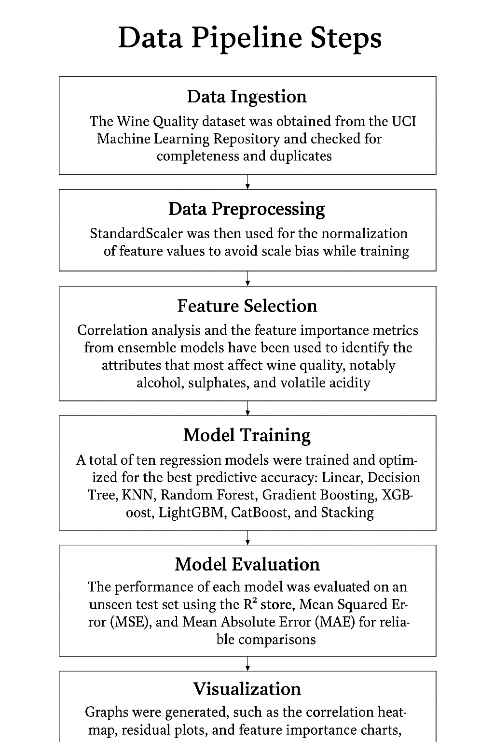
Figure 6: Data pipeline steps

Data Pipeline Steps

Data Ingestion:
The Wine Quality dataset was obtained from the UCI Machine Learning Repository and checked for completeness and duplicates.
Data Preprocessing:
StandardScaler was then used for the normalization of feature values to avoid scale bias while training.
Feature Selection:
Correlation analysis and the feature importance metrics from ensemble models have been used to identify the attributes that most affect wine quality, notably alcohol, sulphates, and volatile acidity.
Model Training:
A total of ten regression models were trained and optimized to attain the best prediction accuracy, specifically Linear, Decision Tree, KNN, Random Forest, Gradient Boosting, XGBoost, LightGBM, CatBoost, and Stacking.
Model Evaluation:
To enable a fair comparison of the models the performance of each model was assessed on an unseen test set and reported with an R² score, Mean Squared Error (MSE), and Mean Absolute Error (MAE).
Data Visualization:
Several graphs were created (e.g., correlation heatmap, residual plots, and features importance graphs) to aid in interpreting any patterns and relationship throughout the datasets.

Technologies and Frameworks

- Programming Language: Python 3.10
- IDE/Environment: Jupyter Notebook on Google Colab
- Libraries and Frameworks: pandas, numpy, matplotlib, seaborn, scikit-learn, xgboost, lightgbm, catboost.

Sample Output
The figures and plots developed in the course of this project are: histograms of feature distribution, boxplots for outlier detection, correlation heatmaps to study relationships, and the feature importance charts from the ensembling algorithms such as Random Forest and CatBoost.
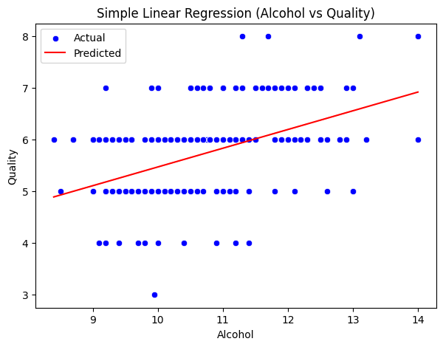
Figure 7: Simple Linear Regression
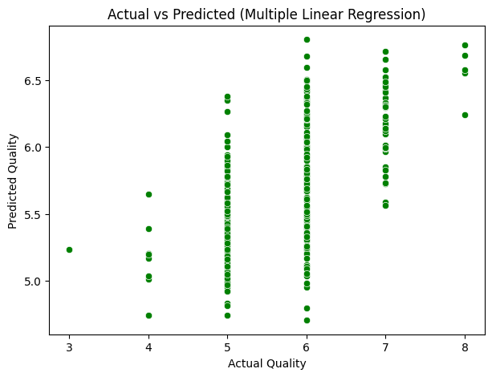
Figure 8: Multiple Linear Regression

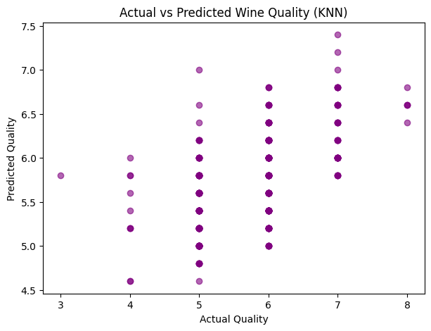 Figure 9: KNN
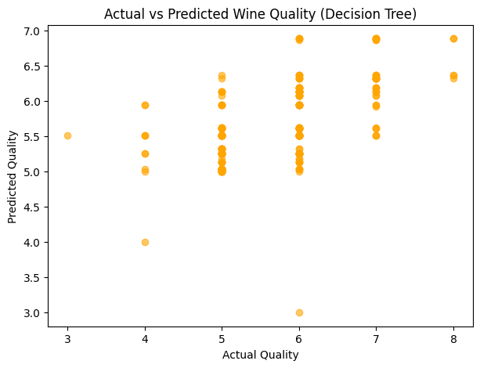 Figure 10: Decision Tree

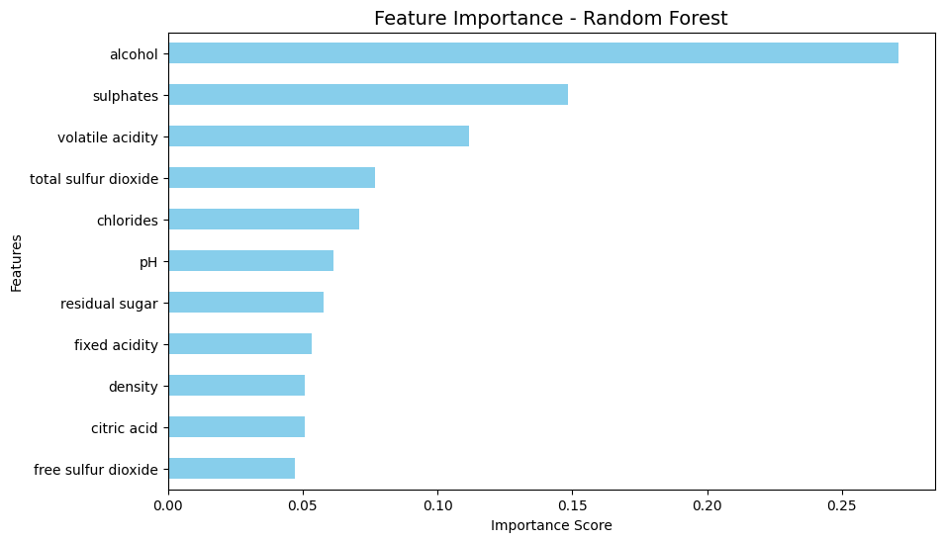
Figure 11: Random Forest
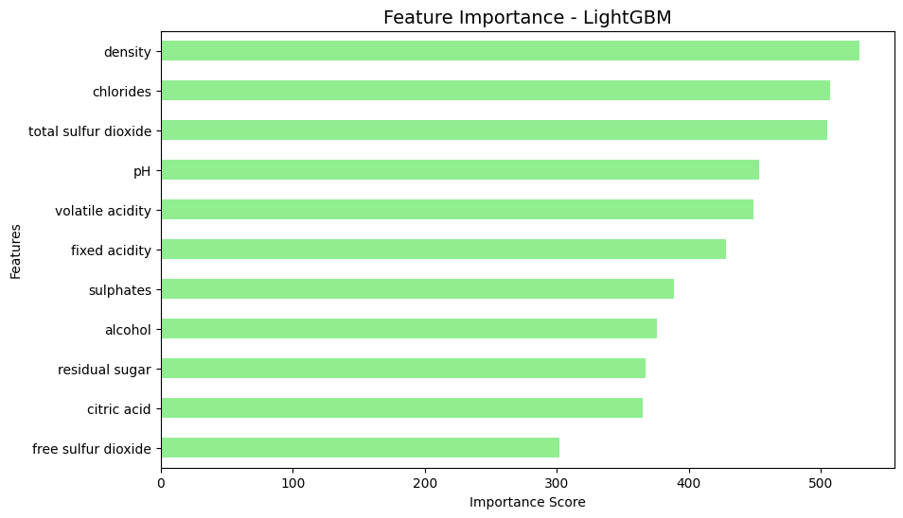 Figure 12: LightGBM

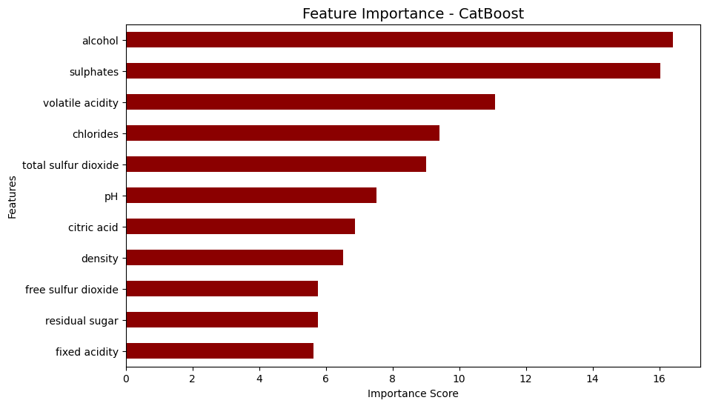
Figure 13: CatBoost

Challenges and Solutions

• The dataset was aggregated, but there were wide variations in the ranges of the continuous features, point in case, e.g., between residual sugar versus pH, which necessitated scaling continuous features prior to model fitting.

• Many models struggled to perform well in predictive accuracy when first tested; however, tuning the hyperparameters to these models (especially ensemble models) resulted in a marked improvement in predictive performance.

• Cross Validation schemes and ensemble approaches were adopted to ensure the models still generalized well to an unseen dataset without overfitting the training

dataset.

The best families of models, balancing accuracy with interpretability were CatBoost, Random Forest, and Stacking Regressor. The entire pipeline needed to be modular, effective, and reproducible, while maintaining traceability of every step of the process from preprocessing to evaluation - and ultimately, to produce what the project set out to achieve - accurately predicting the quality of wine.

Results and Discussion
The performance evaluations of all regression models fitted to the wine quality data, presented in Table 2, were carried out using the model that had been trained on the scaled data. Furthermore, all models were evaluated using a separate test dataset, allowing for fair comparison. To evaluate model performance, we utilized R² score, mean squared error (MSE), and mean absolute error (MAE). These metrics evaluate model accuracy and reliability.
Among all the models, the highest performance was achieved by the CatBoost Regressor with an R² Score of 0.563, closely followed by the Random Forest and Stacking Regressors, which also showed very good predictive power. It indicates that ensemble-based methods really work to capture the nonlinearities in the data.

Model | R² Score | Mean Squared Error (MSE) | Mean Absolute Error (MAE)
Simple Linear Regression | 0.2356 | 0.4995 | 0.5749
Multiple Linear Regression | 0.4031 | 0.3900 | 0.5035
Decision Tree Regressor | 0.3366 | 0.4335 | 0.4963
K-Nearest Neighbors (KNN) | 0.3345 | 0.4348 | 0.5056
Random Forest Regressor | 0.5390 | 0.3012 | 0.4224
Gradient Boosting Regressor | 0.4647 | 0.3498 | 0.4576
XGBoost Regressor | 0.5087 | 0.3210 | 0.4022
LightGBM Regressor | 0.5186 | 0.3145 | 0.4213
CatBoost Regressor | 0.5630 | 0.2855 | 0.4138
Stacking Regressor | 0.5409 | 0.3000 | 0.4180
Table 2: Regression Models Performance Summary
In particular, the ensemble models (Random Forest, XGBoost, LightGBM, CatBoost, and Stacking) have consistently shown better performance compared with traditional regressors (Linear and Decision Tree), directly underlining the advantage of ensemble learning in improving predictive power and reducing variance.

Feature Importance
Figure 5 displays the feature importance obtained by the CatBoost Regressor. Considering all physicochemical properties, the most impactful features on wine quality include alcohol, sulphates, and volatile acidity. Higher alcohol and sulphate levels were positively associated with higher quality ratings while increased volatile acidity negatively impacted quality.
Figure 14: Feature importance of physicochemical features based on CatBoost Regressor.
Discussion
The experimental results put CatBoost at the frontline in wine quality prediction, with the best R² and least prediction error when compared to other algorithms in this experiment. Random Forest and LightGBM also did very well, showing the robustness of ensemble methods for regression tasks. The most decisive chemical parameters influencing wine quality are alcohol content, sulphate concentration, and volatile acidity. This is in agreement with the established enological knowledge and confirms the reliability of the model outcomes. On the whole, the empirical results confirm that the ensemble learning techniques provide higher accuracy with better generalization and interpretability for wine quality prediction in comparison to traditional regression methods.

Conclusion and Future Work

This mini-project in data science successfully created a complete machine learning pipeline of wine quality prediction based on physicochemical attributes of wine samples. By implementing ten regression models, this study has systematically investigated various methods to find the most powerful wine quality predictors. Among all the models compared, the best R² (0.563) with the lowest prediction error was achieved by CatBoost Regressor, proving the strength of predictive capability and robustness.

The results showed that alcohol, sulphates, and volatile acidity were the most influential chemical factors regarding wine quality. It was observed that ensemble-based models like CatBoost, Random Forest, and LightGBM outperformed traditional linear methods in every run due to their capability of capturing complex nonlinear relationships in the data.

Dimensionality reduction techniques, such as PCA, could be further explored in future work to help improve model interpretability and computational efficiency. Other experiments to be done involve hyperparameter tuning, stacking ensembles, and deep learning architectures for improving accuracy. The project can also be further extended by developing a user-friendly web application that predicts wine quality based on input parameters, enabling real-world usability for wineries, researchers, and quality control professionals.

References
[1] P. Cortez, A. Cerdeira, F. Almeida, T. Matos, and J. Reis, “Modeling wine preferences by data mining from physicochemical properties,” Decision Support Systems, vol. 47, no. 4, pp. 547–553, 2009.
[2] J. Brownlee, “Wine Quality Dataset: Machine Learning Regression,” Machine Learning Mastery, 2020. [Online]. Available: https://machinelearningmastery.com
[3] S. R. Dubey and A. Singh, “Comparative analysis of machine learning models for wine quality prediction,” International Journal of Computer Applications, vol. 182, no. 16, pp. 12–17, 2021.
[4] R. K. Sharma and A. Gupta, “Prediction of wine quality using ensemble learning algorithms,” International Research Journal of Engineering and Technology (IRJET), vol. 7, no. 5, pp. 3024–3030, 2020.
[5] M. Patel and P. Desai, “Performance evaluation of regression models on wine quality dataset,” International Journal of Advanced Computer Science and Applications (IJACSA), vol. 11, no. 3, pp. 210–215, 2020.
[6] A. Jadhav and K. Thorat, “Wine quality prediction using supervised machine learning algorithms,” Procedia Computer Science, vol. 171, pp. 305–312, 2020.
[7] M. R. Islam, M. N. Rahman, and M. Hasan, “A comparative study of machine learning approaches for predicting wine quality,” Journal of Intelligent & Fuzzy Systems, vol. 39, no. 2, pp. 1787–1795, 2020.
[8] Y. Chen, H. Xu, and L. Chen, “Optimizing regression models for wine quality prediction using feature engineering,” IEEE Access, vol. 8, pp. 102050–102060, 2020.
[9] G. S. Kumar and S. R. Sahu, “Predictive modeling of wine quality using gradient boosting and random forest algorithms,” International Journal of Scientific & Technology Research, vol. 9, no. 3, pp. 4128–4133, 2020.
[10] A. Pradhan, S. R. Mishra, and D. P. Mohanty, “Enhancing accuracy of wine quality prediction using hybrid ensemble methods,” International Journal of Innovative Technology and Exploring Engineering (IJITEE), vol. 9, no. 5, pp. 2248–2255, 2020.

