🏥 Medical Triage Expert System

This document provides a comprehensive overview of the Medical Triage Expert System, a sophisticated tool designed to assist in the preliminary triage of patients based on their symptoms. The system leverages a rulebased expert system to provide recommendations and find nearby medical facilities.

Overview and Purpose
The Medical Triage Expert System is a web-based application that allows users to input their symptoms and receive a preliminary triage assessment. The system classifies the urgency of the situation into three levels (RED, YELLOW, GREEN), suggests a mode of transport, and provides a rationale for its recommendation. It also integrates with a location service to find nearby hospitals.
The primary purpose of this system is to:
Provide rapid, preliminary triage advice to individuals.
Help users understand the potential severity of their symptoms.
Facilitate quick access to information about nearby medical facilities.
Demonstrate the application of a CLIPS-based expert system in a real-world scenario.
Disclaimer: This tool is for informational purposes only and is not a substitute for professional medical advice, diagnosis, or treatment.

System Architecture
The system is built on a modular architecture that separates the user interface, the application logic, the expert system core, and data storage.

Architecture Diagram
The following diagram illustrates the flow of information and control within the system:

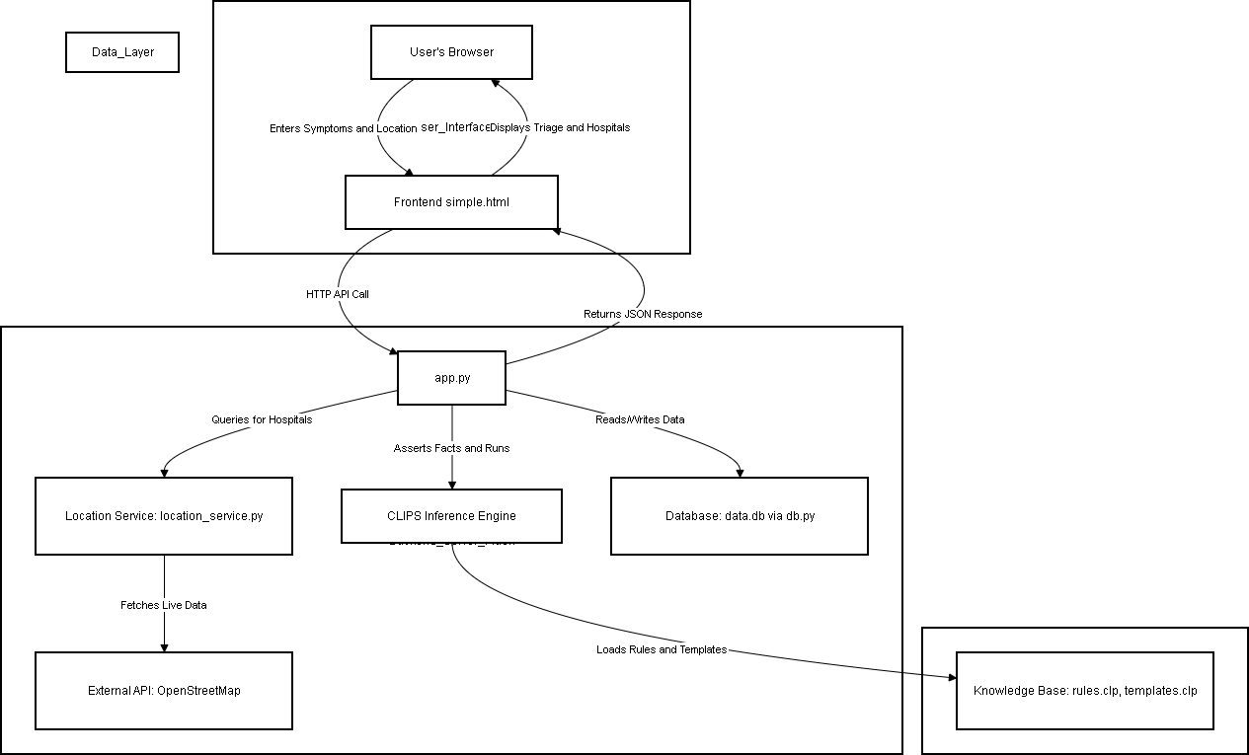

Components
Frontend (simple.html): A single-page web interface where the user inputs their symptoms, age, and location. It communicates with the backend via AJAX requests.
Backend (app.py): A Flask application that serves the frontend, handles API requests, and orchestrates the interaction between the other components.
CLIPS Inference Engine (clipspy): The core of the expert system. It uses the rules defined in the knowledge base to reason about the patient's data.
Knowledge Base (knowledge_base/): Contains the rules.clp and templates.clp files, which define the logic and data structures for the expert system.
Location Service (location_service.py): A module responsible for finding nearby hospitals using the OpenStreetMap API.
Database (db.py, data.db): A SQLite database used to store symptoms, diseases, rules, and hospital information.

Features
Rule-Based Triage: Employs a sophisticated set of over 100 rules to analyze patient symptoms. Age-Stratified Logic: The rules are categorized by age group (from pediatrics to geriatrics) for more accurate assessments.
Dynamic Hospital Search: Fetches real-time hospital and clinic data from OpenStreetMap, making it functional in any location.
Clear Recommendations: Provides a triage level (RED, YELLOW, GREEN), a recommended mode of transport, and a clear rationale.
RESTful API: Exposes endpoints for triage, hospital search, and administrative functions.

Screenshots
Here is a series of screenshots showcasing the user interface of the expert system.
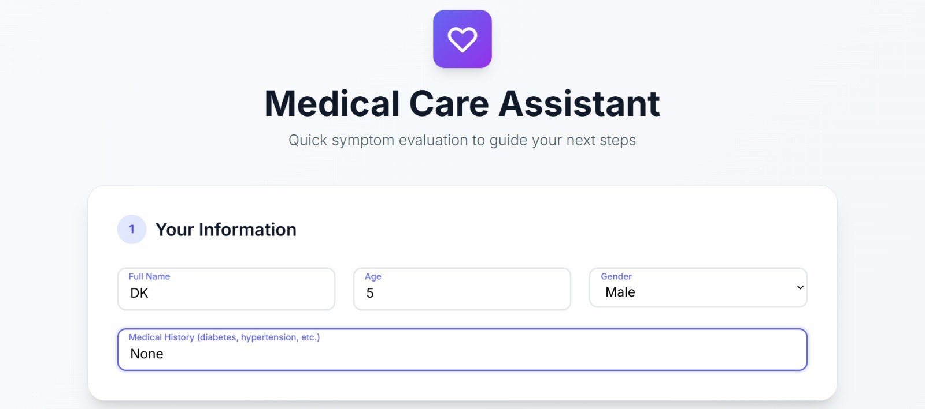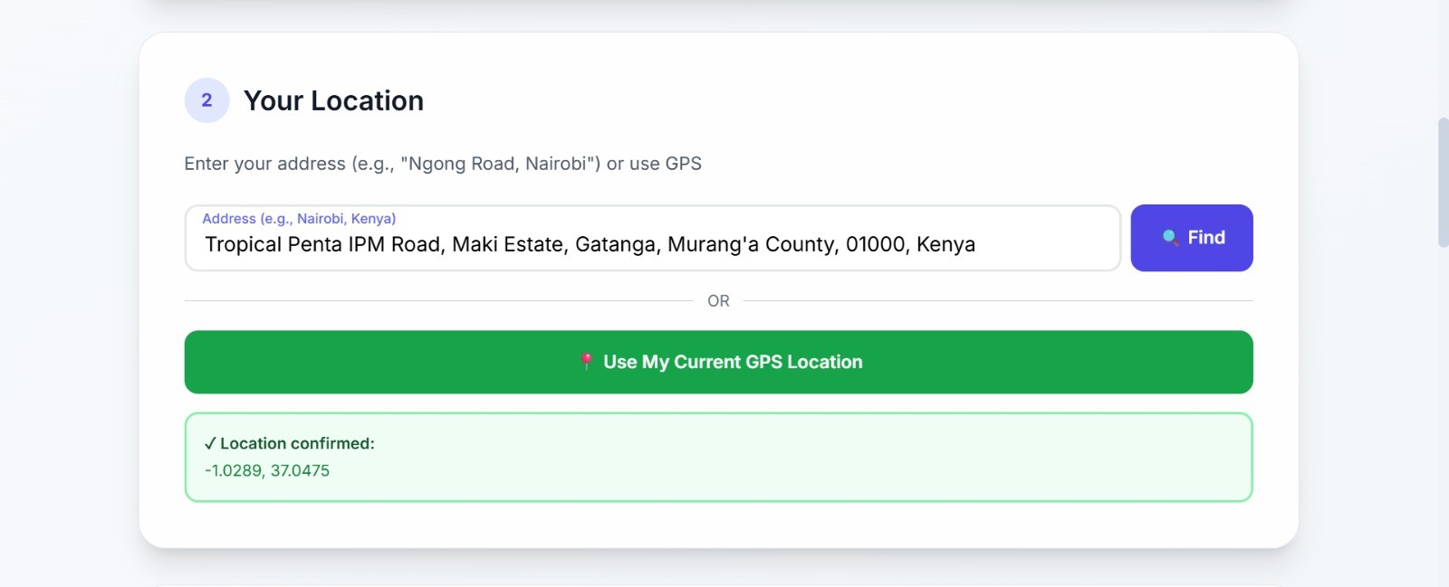
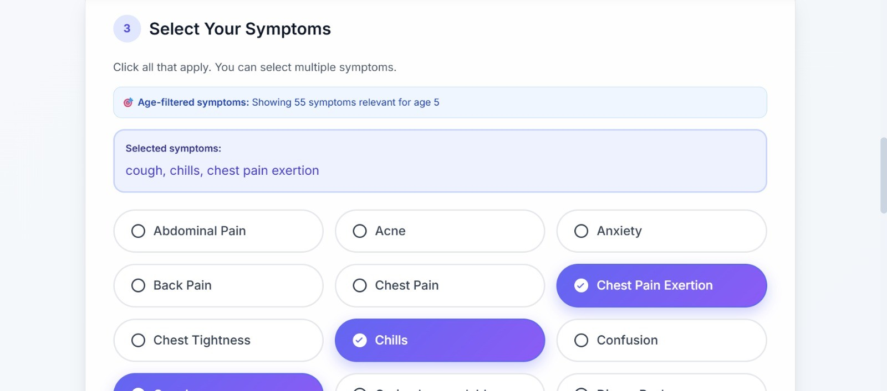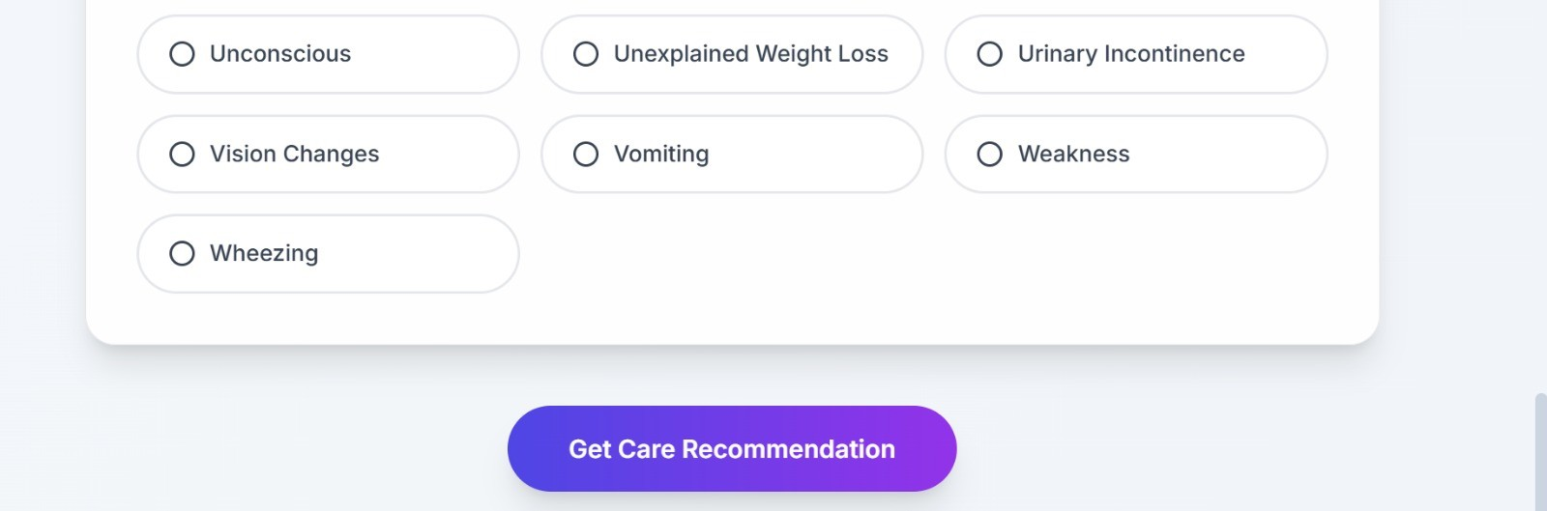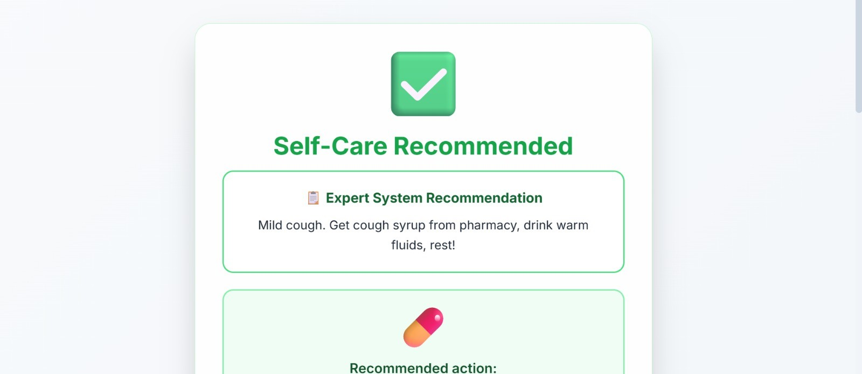
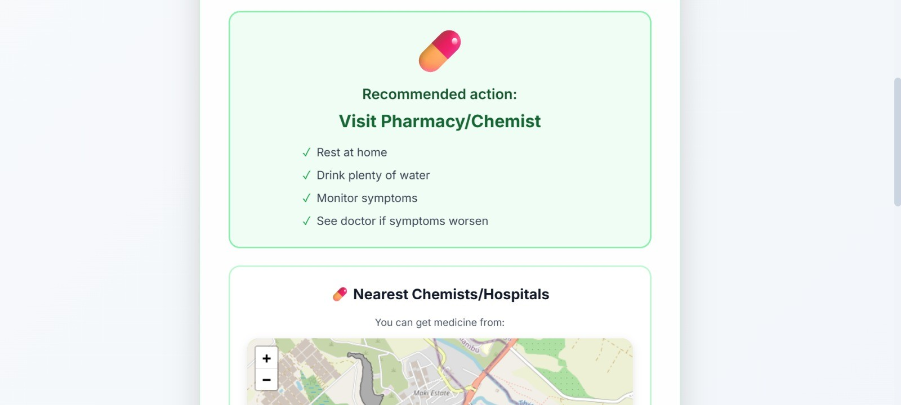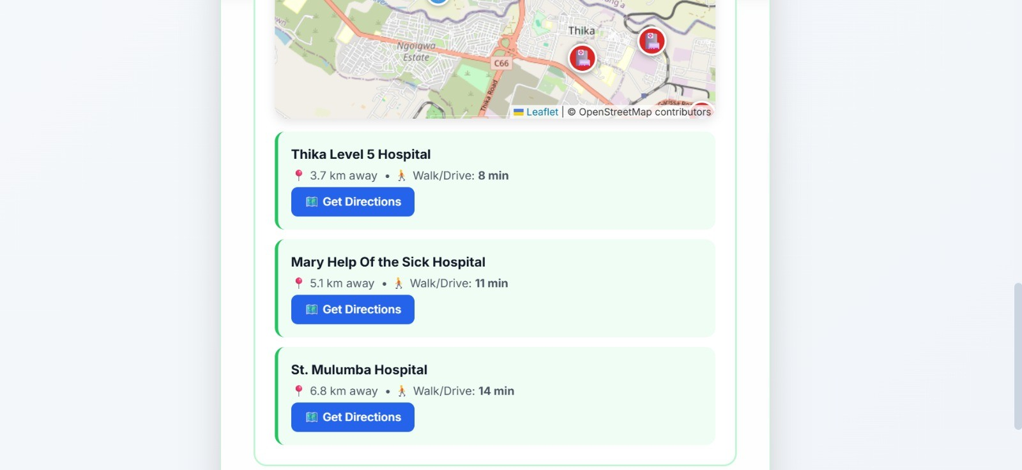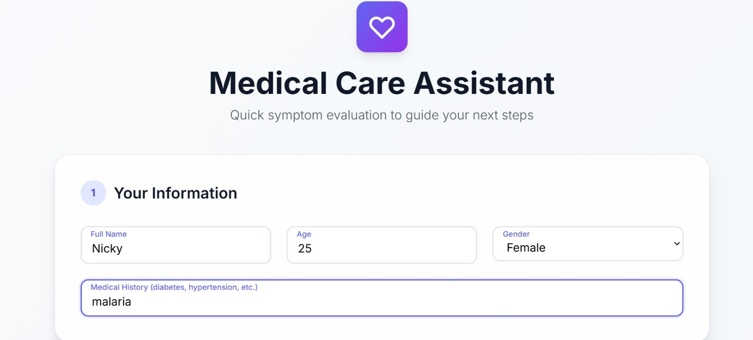
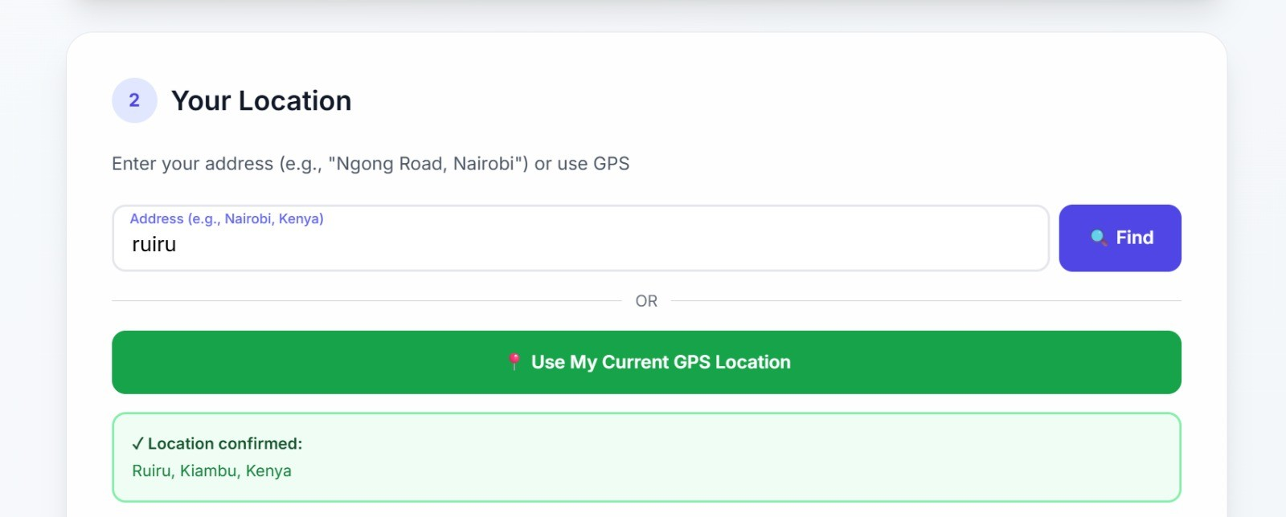
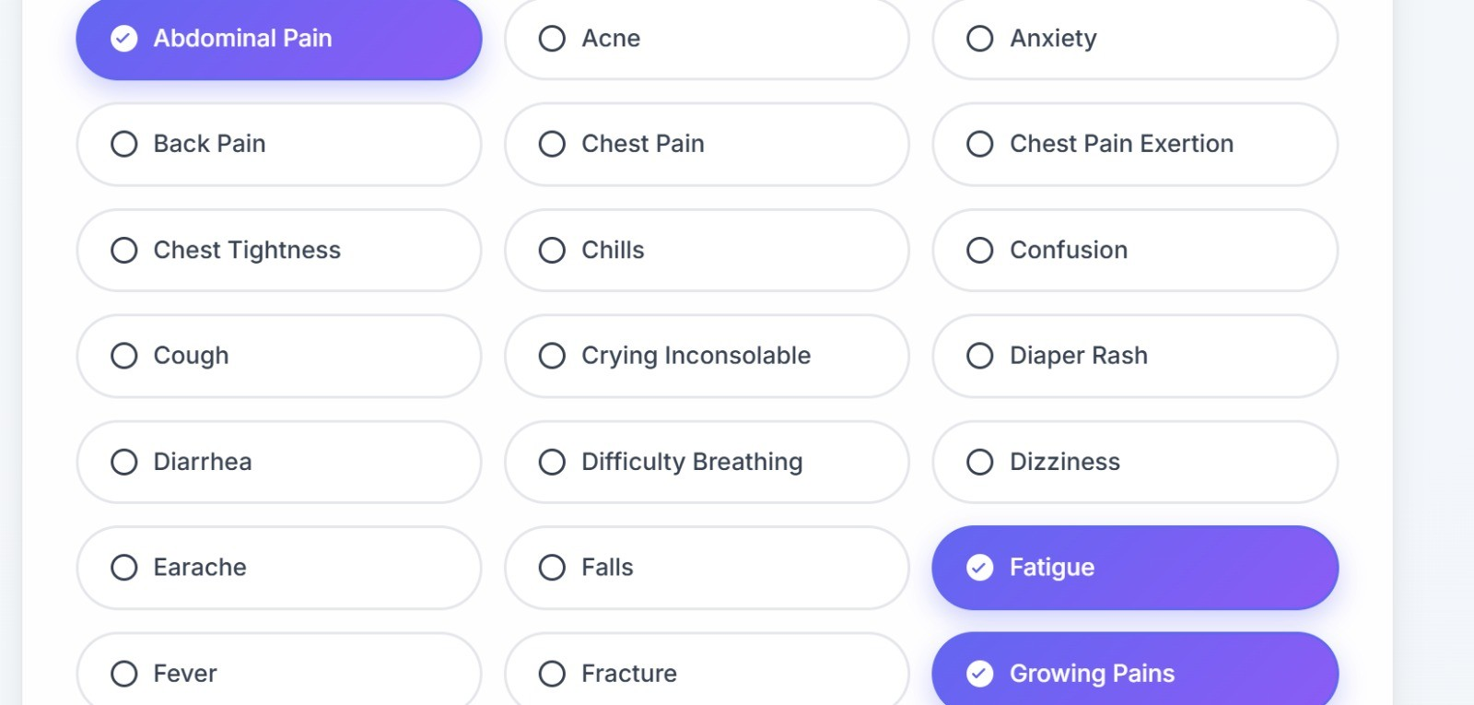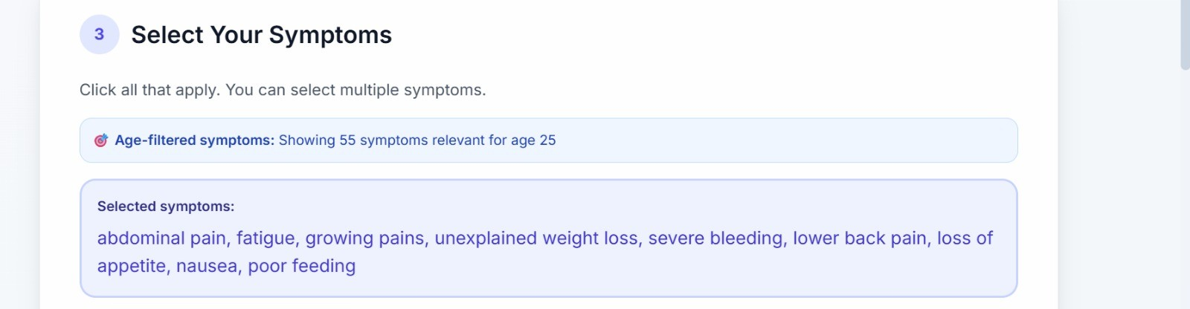
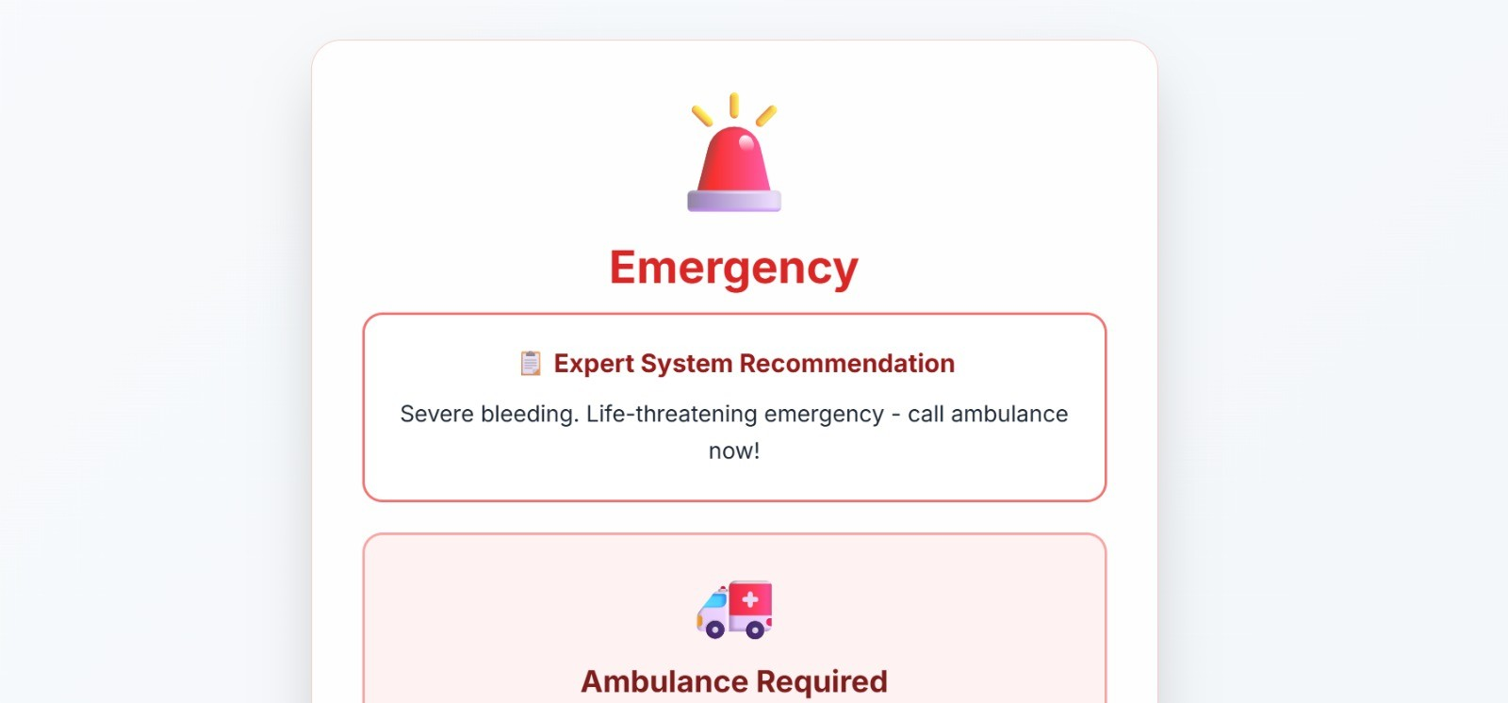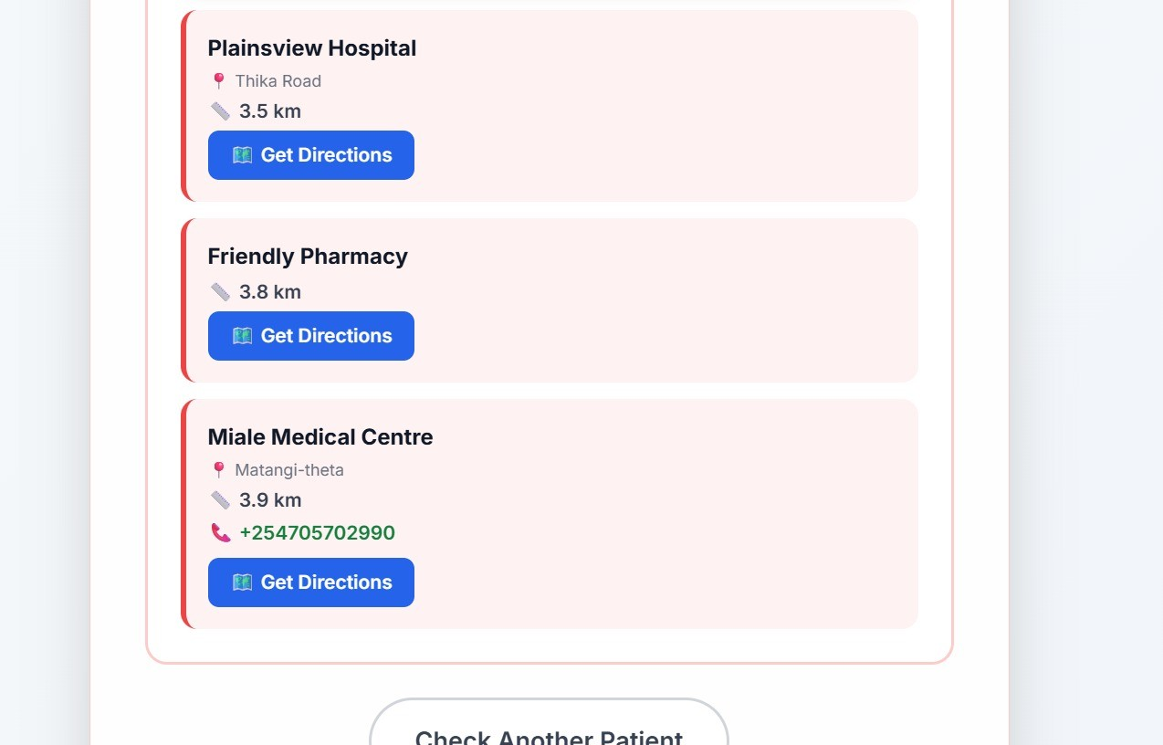

Rule Screenshots
To illustrate the structure and content of some of the CLIPS rules, here are screenshots of selected rules from the knowledge base:

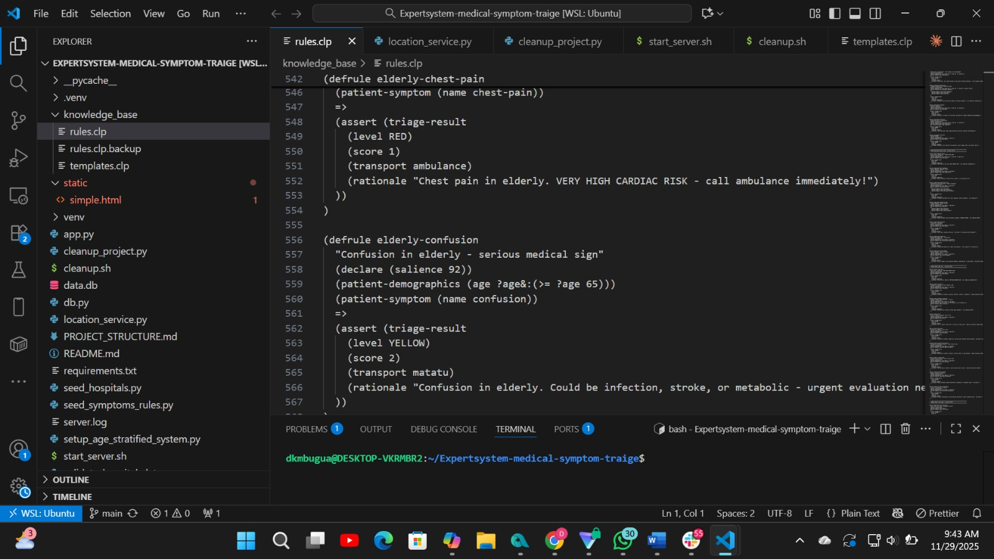

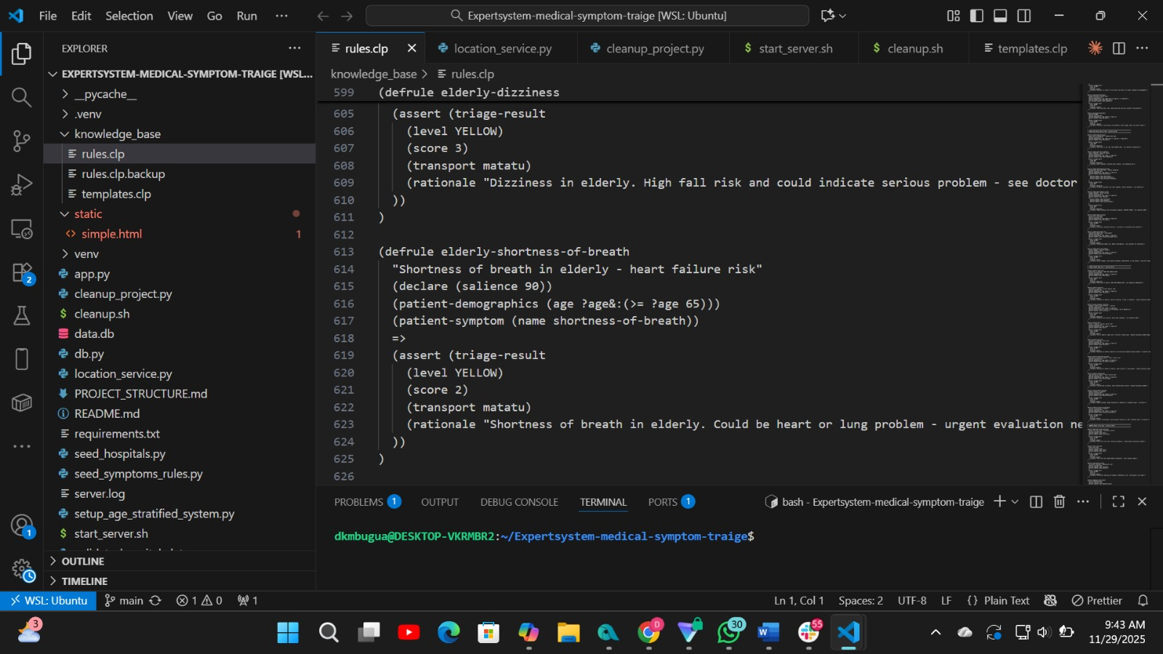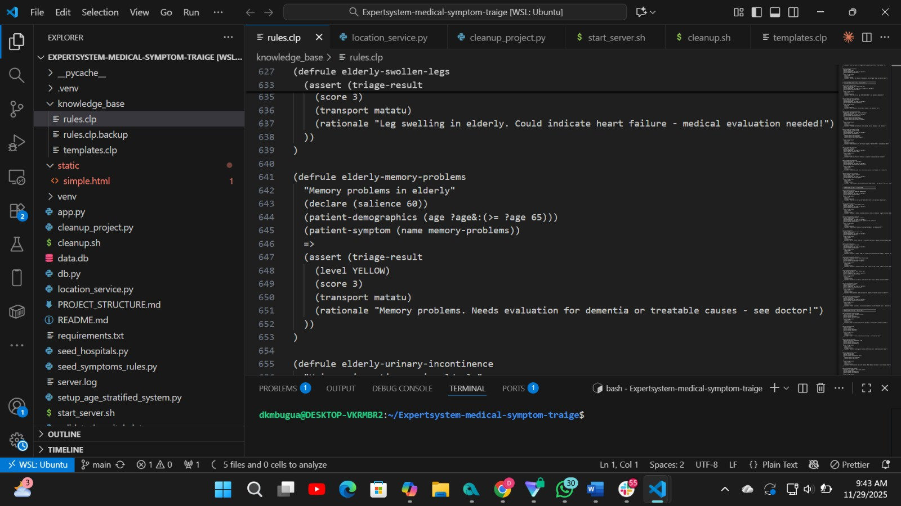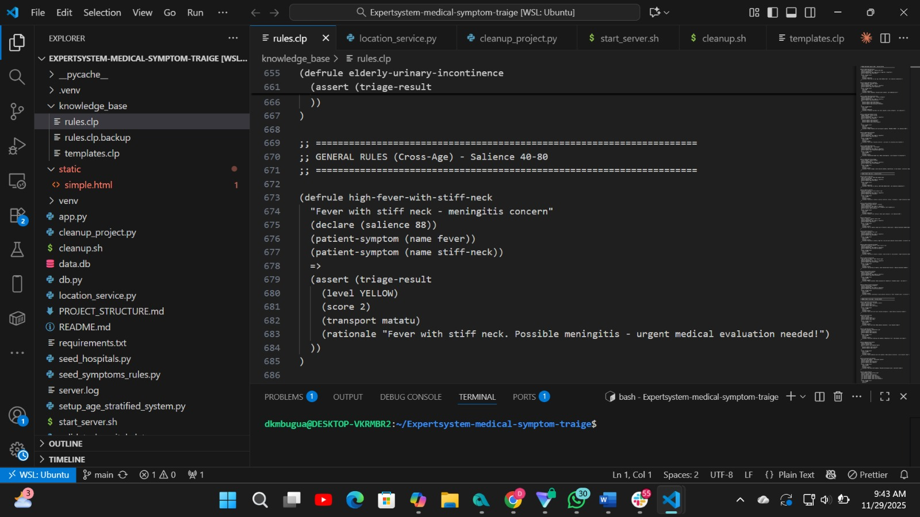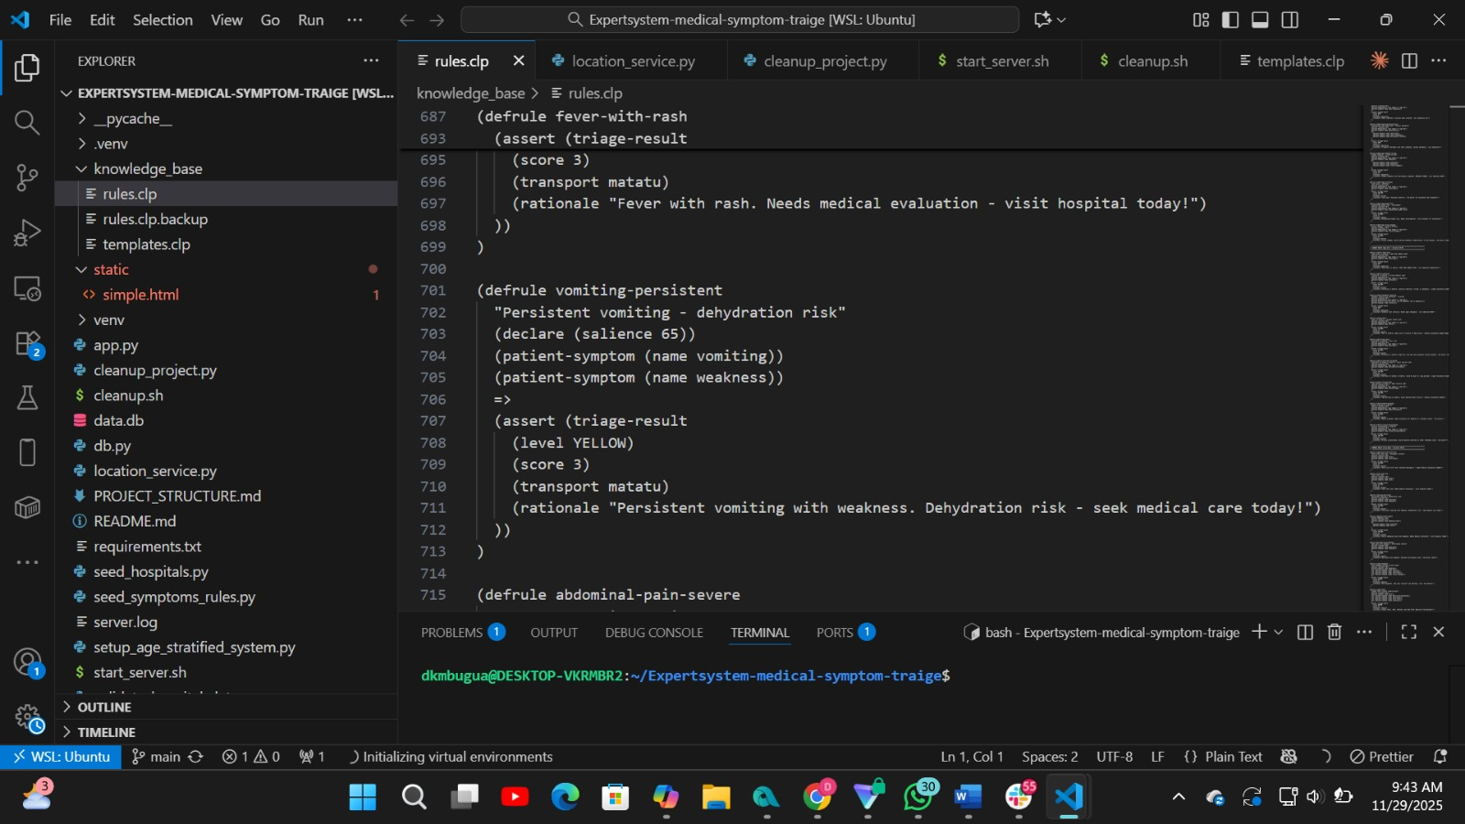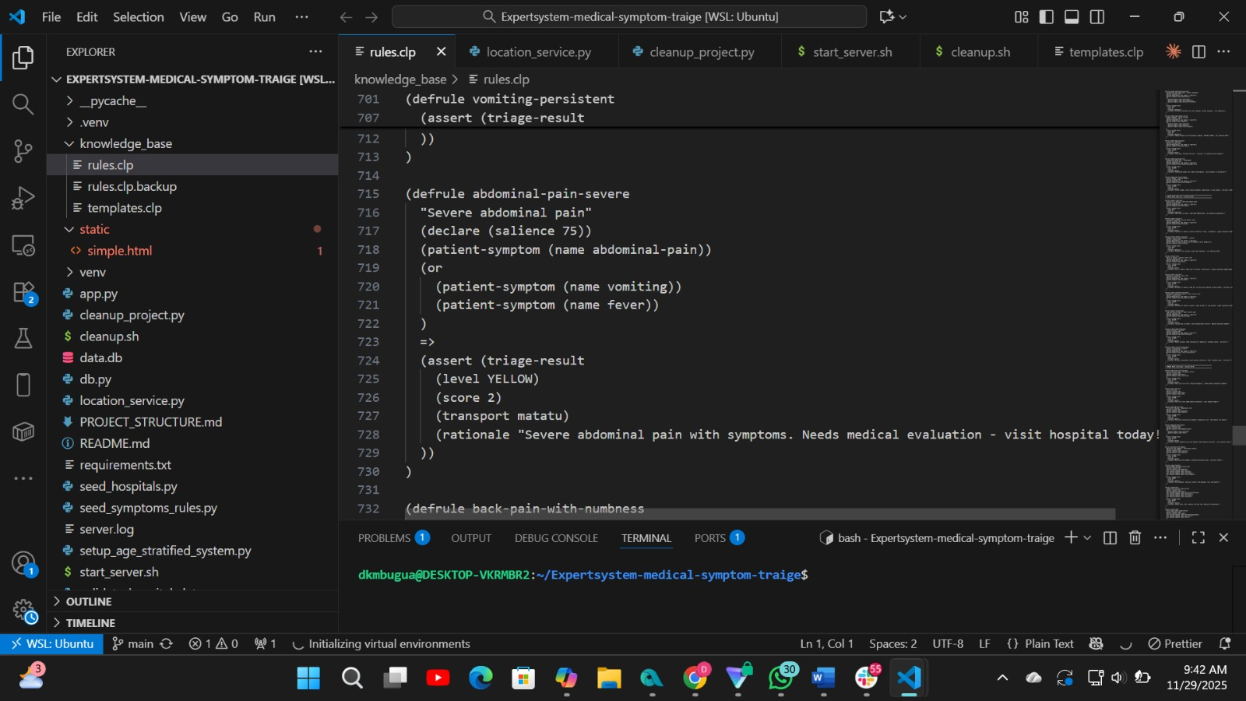

Technology Stack
Component Technology/Library
Backend Framework
Flask
Component Technology/Library
Expert System | clipspy
Database | SQLite
API Communication | REST (JSON)
Frontend | HTML, CSS, JavaScript
CORS Handling | flask-cors
Geocoding OpenStreetMap (Nominatim)

Knowledge Base
The brain of the expert system resides in the knowledge_base directory. It consists of two main file types:

Templates (templates.clp)
This file defines the data structures (similar to structs or classes) that the expert system uses. Key templates include:
patient-demographics: Stores age and gender.
patient-history: Stores medical history. patient-symptom: Represents a single symptom. triage-result: Holds the output of the reasoning process.

Rules (rules.clp)
This file contains the production rules that the CLIPS engine uses to make decisions. The rules are structured using a (defrule ...) syntax.
Structure of a Rule:
(
defrule <rule-name
>

"A descriptive comment about the rule's purpose."

(declare (salience <priority>))

; LHS (Left-Hand Side): Conditions to match in the working memory

(patient-demographics (age ?a&:(< ?a 10)))

(patient-symptom (name fever))

=> ; Arrow separating conditions from actions

; RHS (Right-Hand Side): Actions to take when conditions are met

(assert (triage-result (level YELLOW) (rationale "...")))

)

Salience
:
Determines the priority of the rule. Higher salience means the rule is considered first.
LHS: The "IF" part of the rule. It consists of patterns that are matched against the facts in the working memory.
RHS: The "THEN" part of the rule. It contains actions to perform, such as asserting a new fact (e.g., a triage-result).
The rules are organized by age group and clinical severity, from critical emergencies (salience 100) down to minor issues (salience < 40).

Setup and Installation
Follow these steps to set up and run the project locally.

Prerequisites
Python 3.x pip (Python package installer)

Installation Steps
1. Clone the Repository (if you haven't already):
git
clone
<repository-url>

cd
Expertsystem-medical-symptom-traige

2
.
Create and Activate a Virtual Environment:
Windows:
python -m venv venv

.\venv\Scripts\activate

macOS/Linux:
python3 -m venv venv

source
venv/bin/activate

- Install Dependencies:
pip install -r requirements.txt

- Initialize the Database: The database is initialized automatically when the application starts. You can also run the seeding scripts to populate it with initial data:

python seed_symptoms_rules.py

python seed_hospitals.py

Usage

Running the Application
Using the Start Script (Recommended on macOS/Linux):
bash start_server.sh

Running Manually:
python app.py

The application will be available at http://127.0.0.1:5000.

Accessing the Frontend
Open your web browser and navigate to: http://127.0.0.1:5000/static/simple.html API Endpoints
The system exposes a set of RESTful API endpoints for programmatic access.
POST /triage: Submits patient data and returns a triage assessment.
Body: { "age": 30, "symptoms": "headache, fever", "history": "none" } POST /api/nearest-hospitals: Finds hospitals near a given location.
Body: { "latitude": -1.286389, "longitude": 36.817223, "limit": 5 } GET /api/symptoms: Lists all available symptoms.
GET /api/rules: Lists all triage rules from the database.

Relation to Core Expert System Concepts
Based on the provided class notes, this project serves as a practical, real-world implementation of a classic expert system. Here’s how its components directly map to the fundamental concepts:
Expert
System Project Implementation
Concept

The knowledge_base/rules.clp file is a classic example of a knowledge base. It stores Knowledge the domain expertise (medical triage logic) as a set of Production Rules (IF-THEN
Base statements). This declarative knowledge is completely separate from the application's control flow.
Expert
System Project Implementation
Concept
Inference  Engine | The clipspy library integrated into app.py provides the inference engine. It is responsible for applying the reasoning mechanism to the facts and rules. Specifically, it performs forward-chaining: starting with the initial facts (symptoms) and applying rules to deduce a conclusion (the triage result).
Working  Memory  (Blackboard) | For each triage request, app.py creates a temporary, isolated CLIPS environment. The patient's data (age, symptoms, history) are asserted into this environment as facts. This session-specific collection of facts serves as the Working Memory or Blackboard, holding the state for a single reasoning process.
User  Interface | The static/simple.html file provides a straightforward user interface for communicating with the expert system, allowing a non-expert to input data and receive a recommendation.
Explanation  Subsystem | The system provides a basic but effective explanation facility. The rationale that is returned with every triage result explains why a particular decision was made (e.g., "Chest pain at your age. HIGH CARDIAC RISK - call ambulance immediately!"). This is a key characteristic of expert systems.
Knowledge While the project does not have a graphical interface for knowledge acquisition, the API
Acquisition endpoints in app.py (/api/rules, /api/publish-rules) provide a programmatic way Subsystem to add, modify, and manage the rules in the knowledge base, serving a similar function.
This project is a Diagnosis-type expert system application, as it infers a potential situation (the triage level) from a given set of data (symptoms).

