WeatherPy Homework 6

David Kreitzer

Intro Comments:

* Created 592 cities using citipy
* API Request made at
  + Timestamp('2018-09-27 12:56:50.455636')
* 62 of the cities created did NOT return a valid temperature and were not used for the analysis.
* 530 of the cities DID return a valid temperature, only these 530 cities were used for the analysis.
* CSV Files of both the 592 city list and 530 city list were created.

**Observations:**

**Temperature vs. Latitude:**

1. As expected the temperatures were higher closer to the equator.
2. The temperatures with negative latitude cities were greater than positive latitude cities. My assumption is this has to do with the tilted axis of the earth and changing of seasons:
   1. Negative Latitude Cities – Spring Season – temperatures are rising
   2. Positive Latitude Cities – Fall Season – temperatures are dropping
3. I was very disappointed that I could not find a free API/source that could add in the altitude for each of the cities. I would have run some separate visualizations breaking down (binning) the latitude and adding in altitude to understand the difference, if any.

*Note: weather map was provided by www.intellicast.com*

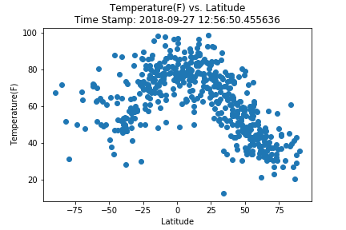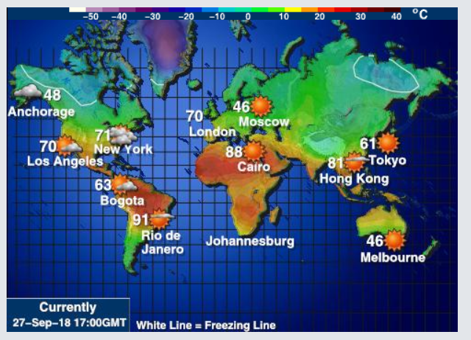

**Cloudiness vs. Latitude**

1. There does not appear to be any significant impact on the % of cloudiness based on a city’s latitude.
2. Cities cloudiness seem to be impacted more by the movement of large weather systems, which are comprised of clouds, than by the latitude.

*Note: Cloudiness map was provided by www.accuweather.com*

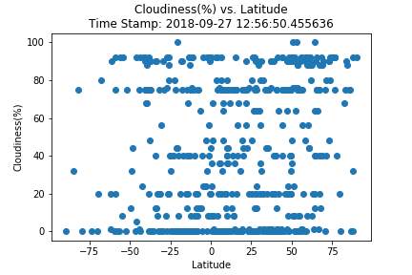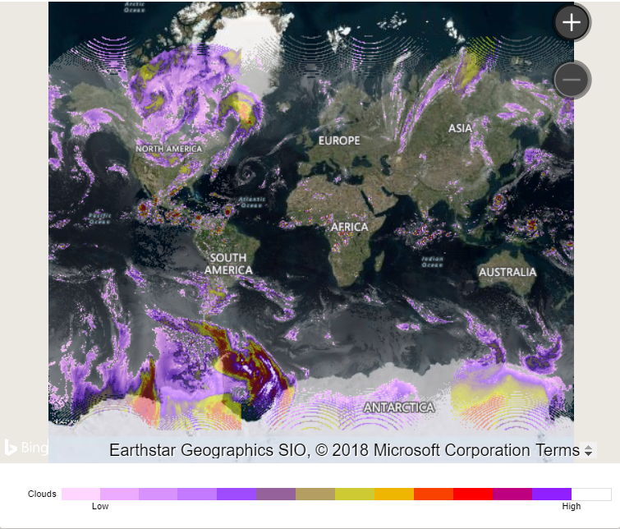

**Wind Speed vs. Latitude**

1. Wind speeds to not appear to be directly impacted by the latitude alone.
2. It appears that wind speeds are influenced more by geography and weather systems than by latitude.
3. There was one outlier that I kept in the data set, it’s for the city Paamiut located on the south western tip of Greenland. Upon further investigation, Paamiut is being impacted by a significant weather storm!

*Note: Maps were source from https://earth.nullschool.net*

