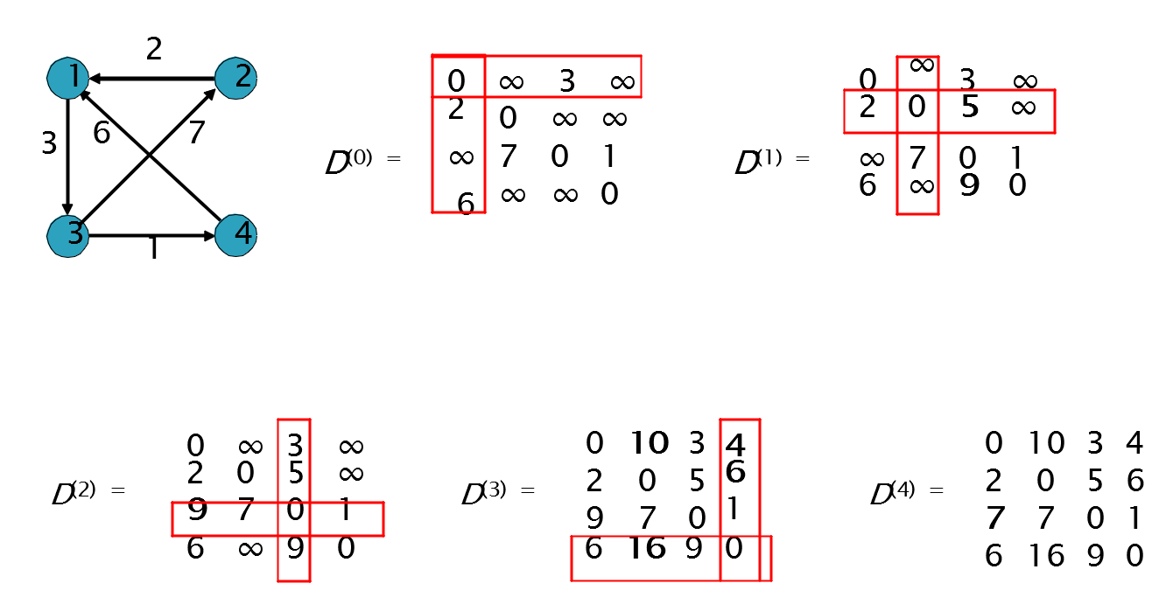
Floyd’s Algorithm Problem, finding shortest path between all pairs of vertices
The matrices rows are of vertices 1-4, same with columns, the diagonals are 0’s as it represents the distance of a vertex to itself

