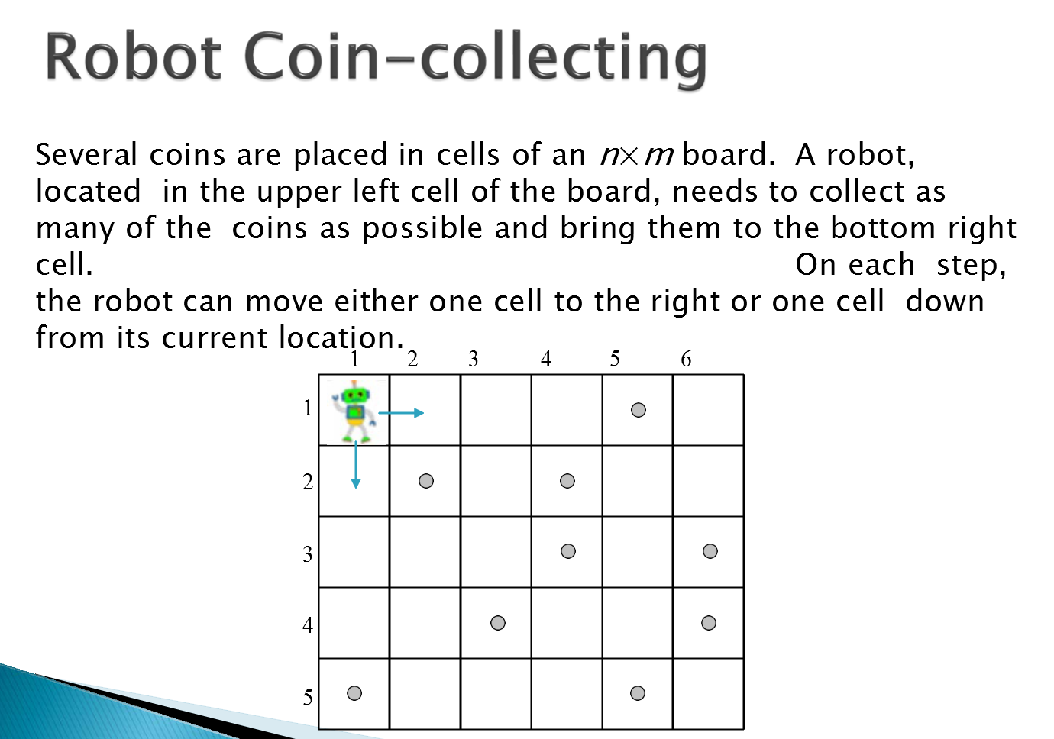

Table showing the max number of coins for each cell

1 2 3 4 5 6
1 | 0 | 0 | 0 | 0 | 1 | 1
2 | 0 | 1 | 1 | 2 | 2 | 2
3 | 0 | 1 | 1 | 3 | 3 | 4
4 | 0 | 1 | 2 | 3 | 3 | 5
5 | 1 | 1 | 2 | 3 | 4 | 5

