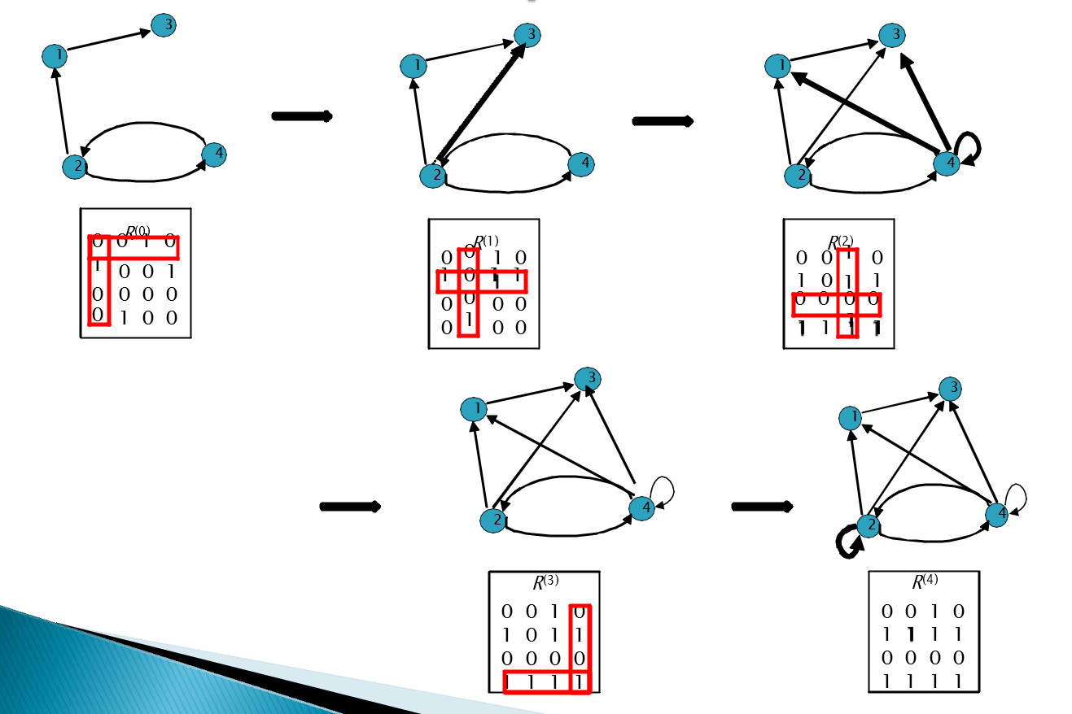
Warshall’s Algorithm
Problem
At vertex 1 we can see that (2,1) and (1,3) both equal to 1 so we know there’s a connection from vertex2 to vertex3, (2,3) = 1, we change that value in matrix and add the connection on graph
We then repeat with subsequent rows and columns

