**Maarten de wolf, Kim van Gageldonk and Damian Leijten**

**BarrocIT**

**Plan of approach**



|  |  |  |
| --- | --- | --- |
| Group 5 RIO4-MED2A | | Versie: 1.0 |
|  | | Date: 11-09-2015  Te Breda |
| Name Members: | Maarten de Wolf, Kim van Gageldonk, Damian Leijten | |
| Klas | RIO4-MED2A | |
| Groepsnaam | Group 5 | |
| Organisatie | Radius College | |
| Opdrachtgever | BarrocIT | |

Content

1. Backgrounds 2

2. Goals 2

3. Project Assignments 2

4. Projectactivities 3

5. Projectboundaries 4

6. Products 5

7. Quallity 5

8. Projectorganisation 5

9. Planning 6

10. Risks 8

# 1. Backgrounds

|  |  |
| --- | --- |
| **Organisation:** | Radius College |
| **Client:** | BarrocIT |
| **Location:** | Terheidenseweg 350 |
| **Projectgroup:** | Maarten de Wolf, Kim van Gageldonk, Damian Leijten |
| **Why?:** | For the project of BarrocIT |

# 2. Goals

We are performing this project commissioned by BarrocIT

* Inception Phase
  + Ordering and getting information
  + Functionel Design
* Elaboration Phase
  + Technical Design
* Construction Phase
  + Construction Phase
  + Test Phase
* Transition Phase
  + Test Phase

# 3. Project Assignments

|  |  |
| --- | --- |
| **Name project:** | PC4U |
| **Client:** | BarrocIT |
| **approved by:** | Fedde van Gils |
| **Ecxecuted by:** | Maarten de Wolf, Kim van Gageldonk, Damian Leijten |

During this project we have to convert three separate databases into one big database so there will be no miss communication between customers and employees.

# 4. Projectactivities

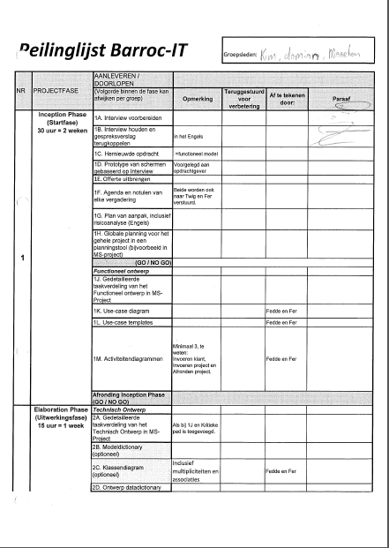

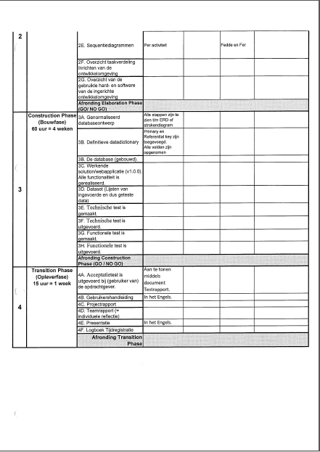

# 5. Projectboundaries

It will we one big database which will feel like three separate databases, this is because there is restricted access to the departments. But if one departments changes something in the database all departments will have this change so miss communication will be prevented. Because of this no customers.

* We will deliver the application with an empty database, it is their job to transfer all the data.
* Once we delivered the application we will give 6 months support for free, after 6 months they will have to pay again for our services.
* We won’t host the application
* We give them the login and server we won’t come and bring and install the application.
* After the application is finished it has been accepted we won’t change it for free.
* We will make a manual for the application we will not teach you how to use it.

Start date: 07-09-2015

End date: End period 5

# 6. Products

* Plan of approach

*Here we show how we are going to make this application*

* Hour registration

*Here we show how much time has gone in the application*

* Subscription of the project instructions en the feasibility

*Here we check what the feasibility of the project is*

* Acceptationtest

*This is a test we make, we let other people use our application and test it. This will show us if our application is working good*

* Reflection rapport

*Here we show how the cooperation has gone between the employees.*

* Comprehensive web application

*This is the web application.*

* Material and recources list

*Here we show what we need for the application.*

* Planning

*Here we show how long we approximately will be working on the application.*

* Technical test

*Here we check if our specifications of our application are correct.*

* Functional test

*Here we check if all of our functions work correctly.*

* Usecase diagrams

*Here we check all of our actors and which passive actors we need for the application*

* Renewed instruction

*Here we have a summary of our interview, the old situation and the new situation, functional and none functional requirements. As last a small summary of all the deparments.*

# 7. Quallity

Within all the milestone we check if the quality is still good enough for the product. By making some tests and let other people test the application. At the end of each lesson we check if we finished what we should have done, if that is the case nothing happens and we come back the next day. If that doesn’t happen then we are going to see what we have to do more the next day so we will still be on schedule. When a product is finished we check if the quality is good enough for our product, otherwise we will change our application so it does fit the standards. We let people test our application so we know our quality is still good enough. When a product is finished and we think it fits the standards we will ask our client to check it. We use Github, Sublime Text 3 git and PHPStorm.

# 8. Projectorganisation

We are available at:

Monday: 8:40-12:40

Tuesday: 9:40-12:40

Wednesday: 8:40-12:40

Thursday: 8:40-12:20

Friday: 8:40-12:40

Lead developer: Damian Leijten

Back end developer: Damian Leijten

Front end developer: Kim van Gageldonk

Database manager: Maarten de Wolf

Version Manager: Maarten de Wolf

# 9. Planning

Zie planning ms-project

# 10. Risks

Interne risks:

Not enouch Knowledge

GitHub “crash”

External risks:

Unclear project lines

No cooperation of the client