Report on Gun Murders

Derek Lam

9/1/2019

## R Markdown

This is an R Markdown document. Markdown is a simple formatting syntax for authoring HTML, PDF, and MS Word documents. For more details on using R Markdown see <http://rmarkdown.rstudio.com>.

When you click the **Knit** button a document will be generated that includes both content as well as the output of any embedded R code chunks within the document. You can embed an R code chunk like this:

summary(pressure)

## temperature pressure   
## Min. : 0 Min. : 0.0002   
## 1st Qu.: 90 1st Qu.: 0.1800   
## Median :180 Median : 8.8000   
## Mean :180 Mean :124.3367   
## 3rd Qu.:270 3rd Qu.:126.5000   
## Max. :360 Max. :806.0000

## Including Plots

You can also embed plots, for example:

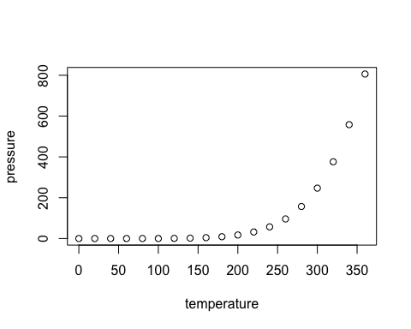

Note that the echo = FALSE parameter was added to the code chunk to prevent printing of the R code that generated the plot.