#1 SQL statement

SELECT *

FROM cwurData

Where year = "2015" AND world_rank <= 50;

Code in R

#1. Use read.csv( ) function to read ‘cwur.csv’ into R. Save your dataset in a variable called ‘university’.

university <- read.csv(file = "cwur.csv", head=TRUE, sep=",")

#2. Use str( ) function to view the columns and corresponding data types.

str(university)

#3. Create a bar chart that shows the distribution of universities among different countries.

barchart <-university$country

table(barchart)

barplot(table(barchart),

xlab = "Countries",

ylab = "Number of Universities")

#4. Create a scatter plot between ‘quality of education’ and ‘world rank’.

plot(university$world_rank, university$quality_of_education,

main = "Correlation",

ylab = "quality of education", xlab = "world rank")

#5. Create a scatter plot between ‘score’ and ‘world rank’.

plot(university$score, university$world_rank,

main = "Correlation",

ylab = "world rank", xlab = "score")

#6. Create a box plot grouped by countries, i.e., single box plot is shown for each country.

boxplot(university$score~university$country, data = university,

xlab = "country", ylab= "score")

4. Create a scatter plot between ‘quality of education’ and ‘world rank’.

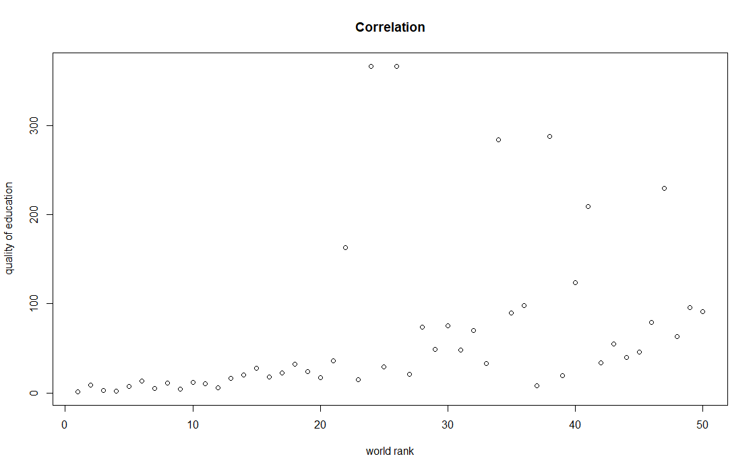

5. Create a scatter plot between ‘score’ and ‘world rank’.

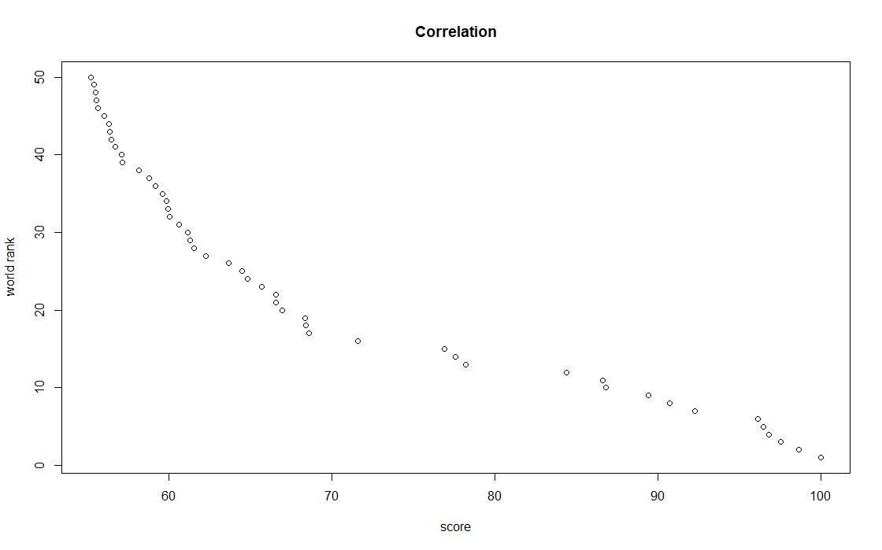

6. Create a box plot grouped by countries, i.e., single box plot is shown for each country.

