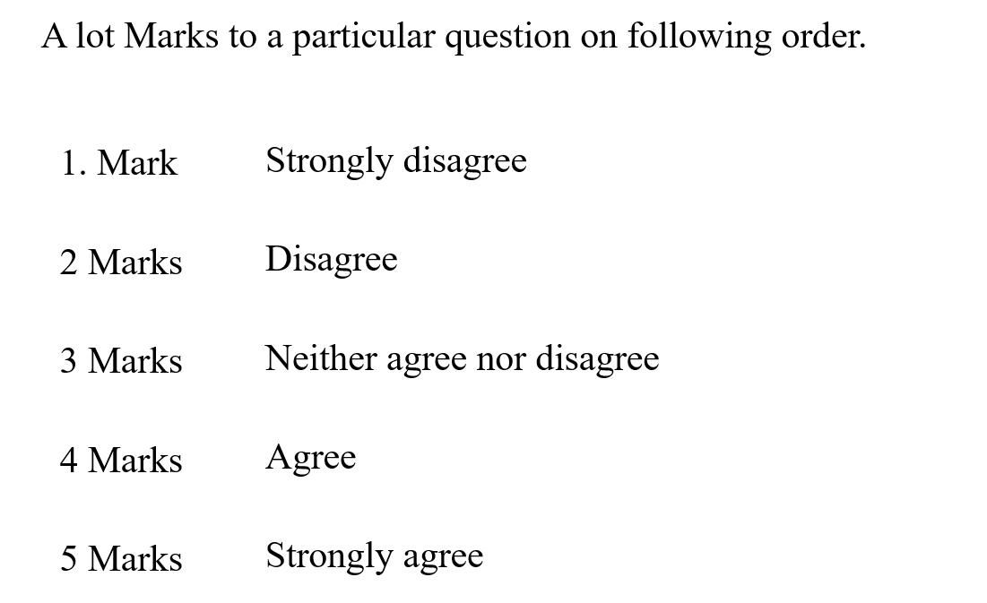

* On the whole I am satisfied with myself. - 4
* At times I think I am no good at all. - 2
* I feel that I have a number of good qualities. -3
* I am able to do things as well as most other people. -4
* I feel I do not have much to be proud of. - 2
* I certainly feel useless at times. - 1
* I feel that I am person of worth, at least the equal of others. -4
* I wish I could have more respect for myself. - 5
* All in all, I am inclined to believe that I am a failure. - 3
* I take a positive attitude toward myself. - 5
* I can always manage to solve difficult problems if I try hard enough. - 4
* If someone opposes me, I can find the means and ways to get what I want.-5
* It is easy for me to stick to my aims and accomplish my goals.-4
* I can speak in front of the many people easily. -3
* I can remain calm when facing difficulties because I can rely on my coping abilities.-5
* When I speak, I always think that am I saying right or wrong…. -4
* I feel relaxed when I find myself alone. -2
* I can usually handle whatever comes my way. -4
* I believe that I am more intelligent than most individuals.- 3
* Given time, I can figure out any complicated intellectual task. - 4
* I enjoy playing games that involve thinking or solving puzzles. - 5
* I don’t enjoy discussing complex issues. - 1
* feel that I can make friends with almost anyone. - 4
* I never miss out opportunities that come to my way. -4
* I’ve never had difficulty finding ways to express myself. -3