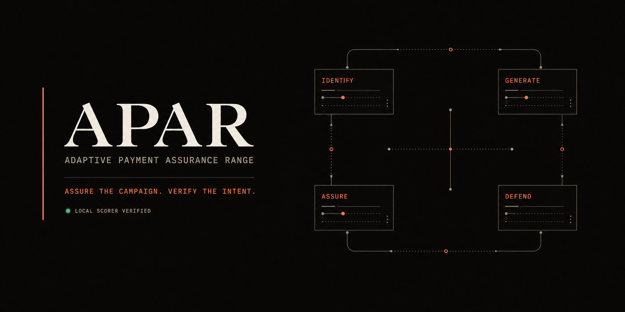
SOLUTION WALKTHROUGH
APAR
Adaptive Payment Assurance Range
Assure the campaign. Verify the intent. Promote only the evidence.
APAR is a pre-production assurance range that turns emerging GenAI-enabled payment threats into bounded synthetic campaigns, executes them through rail-correct lifecycles, compares defenses, verifies delegated intent, and preserves a human-controlled promotion boundary.

Team | LedgerPeLabs
Track | AI Defense Lab for Payment Security
Competition | Mastercard Innovation Challenge 2026
Submission date | 31 August 2026

1. Executive summary
Generative AI does not create a new payment rail; it changes attacker speed, personalization, coordination, and autonomy. APAR therefore evaluates fraud as a campaign and a control-system problem rather than as isolated transaction classification. The system closes the loop from threat evidence to simulation, defense comparison, failure discovery, and governed promotion evidence.
Competition fit
APAR directly implements Identify, Generate, and Defend, then adds an assurance layer so the evidence is causal, reproducible, tamper-evident, and suitable for human review.

Evaluation area | APAR response | Demonstrable proof
Attack diversity | Evidence-backed threat registry | 20 typed threat cards; four executable families
Simulation fidelity | Stateful rail and ledger execution | Card, A2A, and agentic adapters; lifecycle and conservation tests
Detection efficacy | Calibrated graph-aware ensemble | Four-arm comparison and exact portable-model replay
Novelty | Campaign assurance plus intent integrity | Adaptive search, TrustVerifier, and content-addressed evidence
Feasibility | Shadow-mode adoption path | CPU scorer, selective actions, capacity gates, and human promotion

Team LedgerPeLabs
The competition team brings together product, engineering, fraud-defense, and research perspectives.
- Dylan Moraes
- Anuj Sharma
- Dhananjay Joshi
- Rahul Biradar

2. Identify: emerging GenAI-enabled payment threats
APAR separates observed threat evidence from modeled GenAI capability changes. Each threat card records the affected rail, attack stages, observables, confidence, provenance, simulation support, and safety classification. This prevents an LLM-generated idea from silently becoming a factual claim.
The implemented deep-dive portfolio contains four campaign families:
- AI-personalized APP scams with mule-network convergence and staged cash-out.
- Adaptive card-testing and card-not-present bursts that vary pacing, amounts, and reuse.
- Synthetic merchant, identity, refund, dispute, and payout abuse across lifecycle stages.
- Agentic-payment intent abuse: mandate violation, cart mutation, merchant substitution, replay, and token-scope abuse.
The broader registry also covers credential compromise, deepfake-assisted social engineering, multilingual personalization, onboarding abuse, cross-channel coordination, and autonomous reconnaissance. Executable depth is deliberately bounded so every scenario remains reviewable and safe.
Executable family | Payment context | Campaign structure
APP scam and mule | A2A | Victim persuasion -> authorized transfer -> convergence -> cash-out
Card testing CNP | Card | Low-value probes -> retry adaptation -> merchant/device burst
Synthetic merchant/refund | Card | Onboarding -> authorization -> refund/dispute -> payout
Agentic intent abuse | Agentic | Mandate or cart mutation -> authority verification -> payment attempt

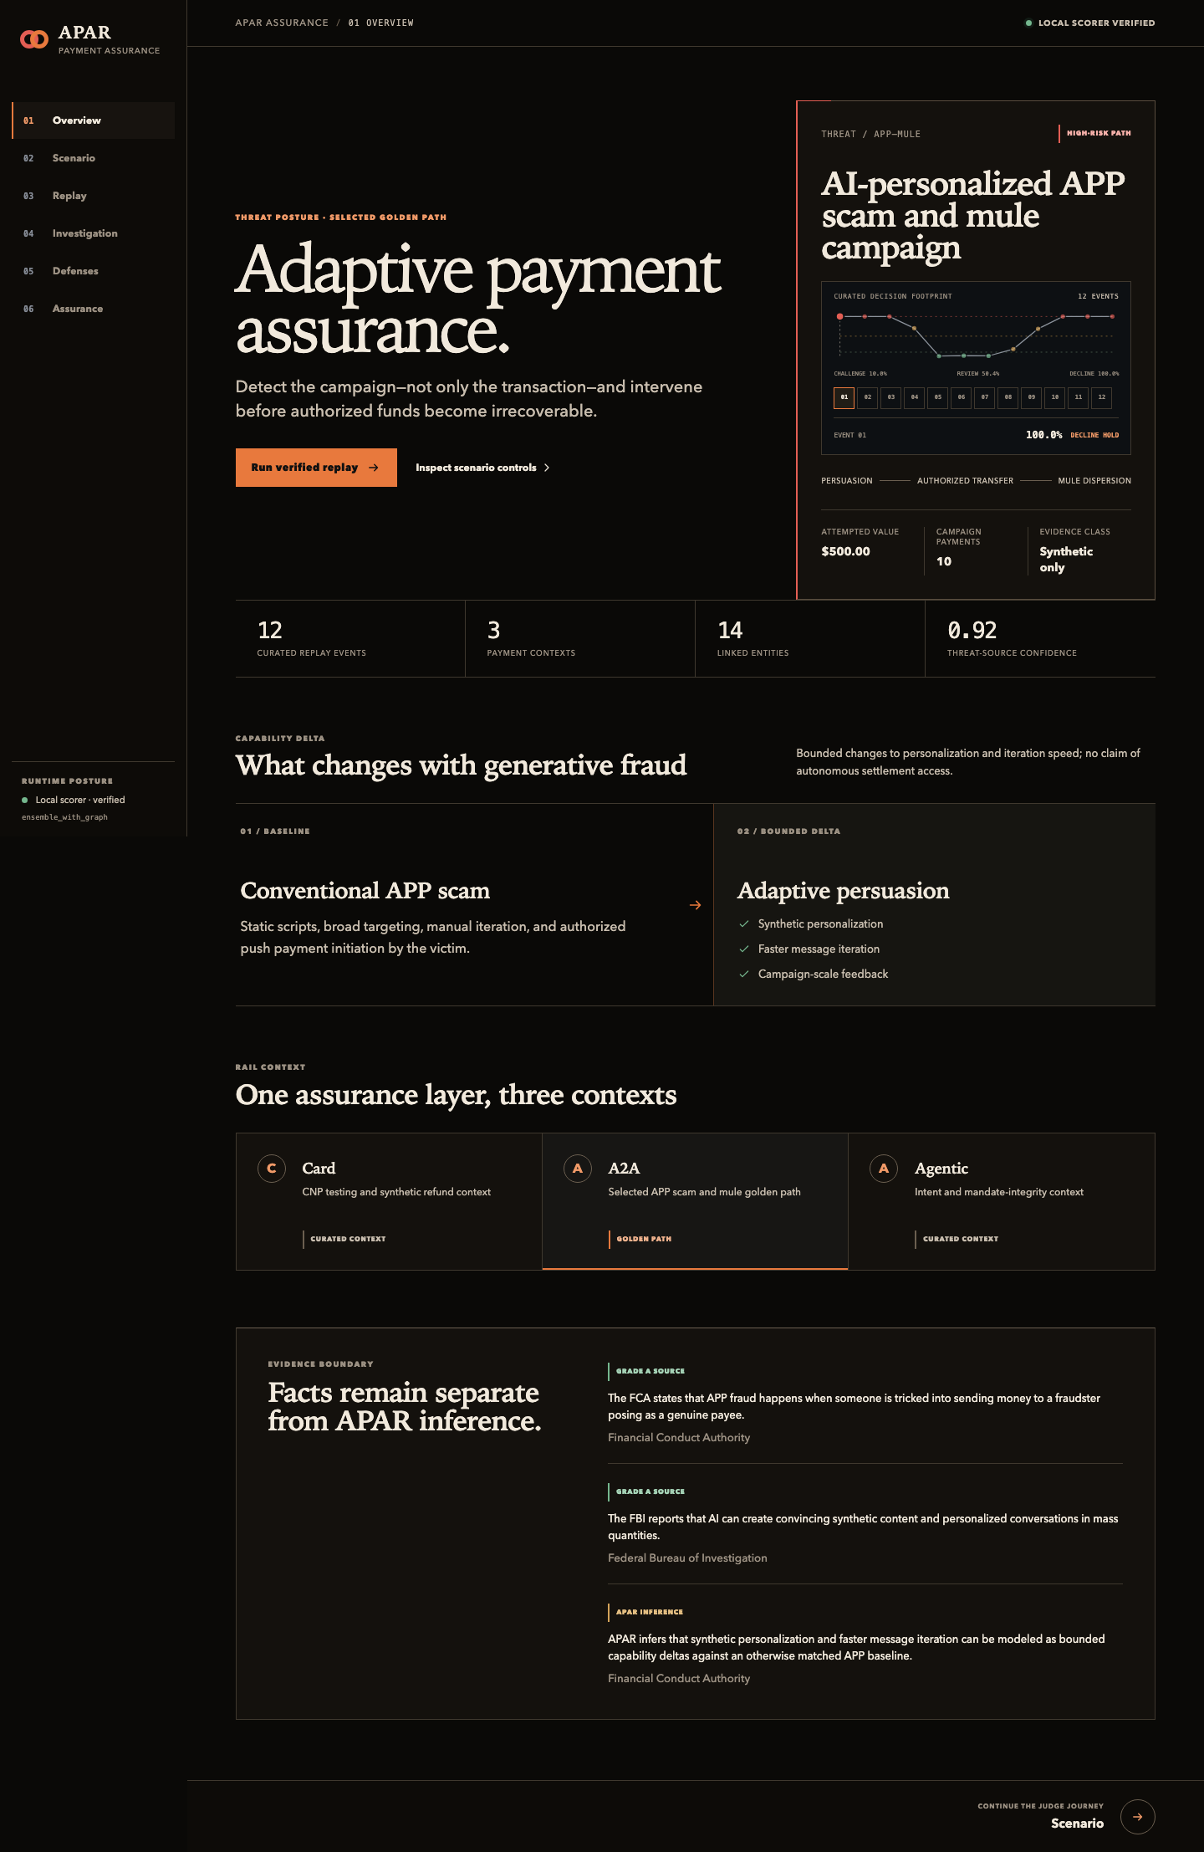
APAR Overview: sourced threat framing and the closed Identify-Generate-Defend-Assure loop.

3. Generate: high-fidelity synthetic campaigns
Fraud cases are not hand-authored rows. The production corpus path runs PopulationGenerator -> CampaignGenerator -> SimulationEngine -> rail adapter -> events -> ledger -> validated evidence -> decision rows. The event-to-row projection preserves concrete event IDs, amounts, rails, lifecycle states, and decision-time availability.

Fidelity controls
- Explicit authorization, transfer, settlement, refund, reversal, and recovery states.
- Separate event, ingestion, feature, and decision timestamps; future data is excluded.
- Ledger conservation and lifecycle dependencies; failed or reversed value cannot fund cash-out.
- Benign novelty including retries, shared devices, travel, missing fields, and changing channel use.
- Bounded attacker budgets, declared feedback, hidden validity constraints, and deterministic replay manifests.
The generator is useful because it produces campaign structure and operational edge cases, not just statistically similar independent rows. The resulting data supports both model training and stress testing.
Simulator contract | Preserved evidence | Why it matters
Causal time | Event, ingestion, feature, and decision clocks | Prevents future information from reaching a decision
Rail lifecycle | Authorization, transfer, settlement, refund, reversal | Matches payment-state ownership and recovery semantics
Economic validity | Opening balances, postings, dependencies | Prevents impossible cash-out and value creation
Campaign identity | Actors, counterparties, edges, source event IDs | Supports graph features and linked investigation cases
Replay | Seed, manifest, config, hashes | Makes scenarios deterministic and tamper-evident

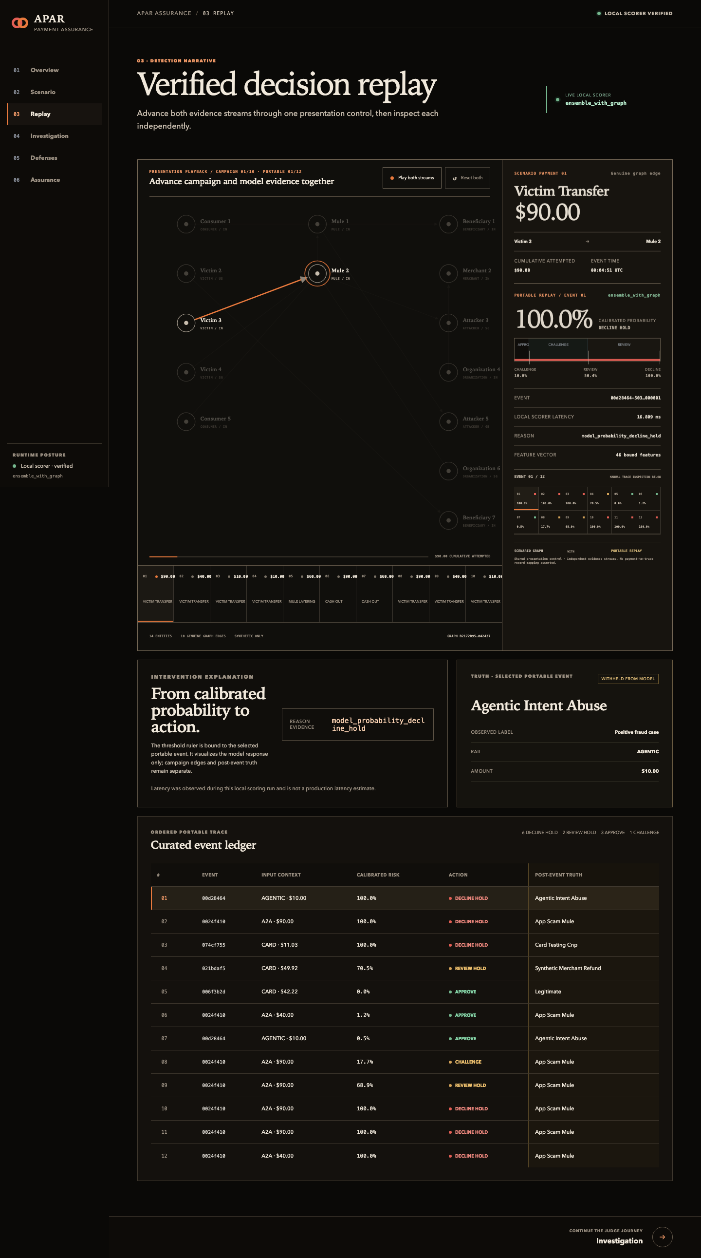
Replay route: synchronized payment lifecycle, campaign evidence, and decision trace.

4. Defend: campaign-aware detection and mitigation
The selected competition model is a portable three-member calibrated CatBoost ensemble over 46 frozen, past-only features. It combines transaction context with actor and counterparty velocity, amount deviation, prior pair behavior, fan-in/fan-out, shared neighbors, two-hop reach, burst motifs, component and density summaries, lifecycle signals, and data-quality flags.
The action policy is selective rather than binary: approve, challenge, review-hold, or decline-hold. Selection therefore considers customer friction, review capacity, latency, calibration, and captured value alongside recall and precision.
Arm | Recall | Precision | F1 | False decline | Challenge | p95 ms
Rules only | 85.949% | 14.878% | 25.366% | 87.436% | 2.639% | 4.062
Ensemble, no graph | 99.745% | 94.756% | 97.186% | 0.000% | 0.802% | 3.382
Ensemble with graph | 99.867% | 95.876% | 97.831% | 0.0037% | 0.572% | 3.544
Full Sentinel hybrid | 99.929% | 16.846% | 28.831% | 87.437% | 2.802% | 19.742

Evidence boundary. These are verified recovered diagnostics on a synthetic development corpus. They support architecture comparison; they are not official Stage 70, production, real-cardholder, Mastercard-data, or external-validation results.

5. What the experiments changed
- Rules were too blunt: fraud coverage came with unacceptable benign friction.
- The calibrated non-graph ensemble established a strong real-time baseline.
- An early perfect result exposed future graph leakage; the path was rejected and causal append/equal-time isolation tests were added.
- Constructed fraud rows were replaced by real campaign, simulator, rail, event, and ledger execution.
- Causal graph summaries produced the best precision/recall/friction balance without placing a heavyweight GNN in the synchronous path.
The graph arm improves the already strong non-graph ensemble by 0.122 percentage points of recall, 1.120 points of precision, 0.645 points of F1, and 0.230 points lower challenge rate for roughly 0.162 ms of additional p95 latency. The full hybrid has the highest recall but fails the friction gates, which is why it is not called the champion.

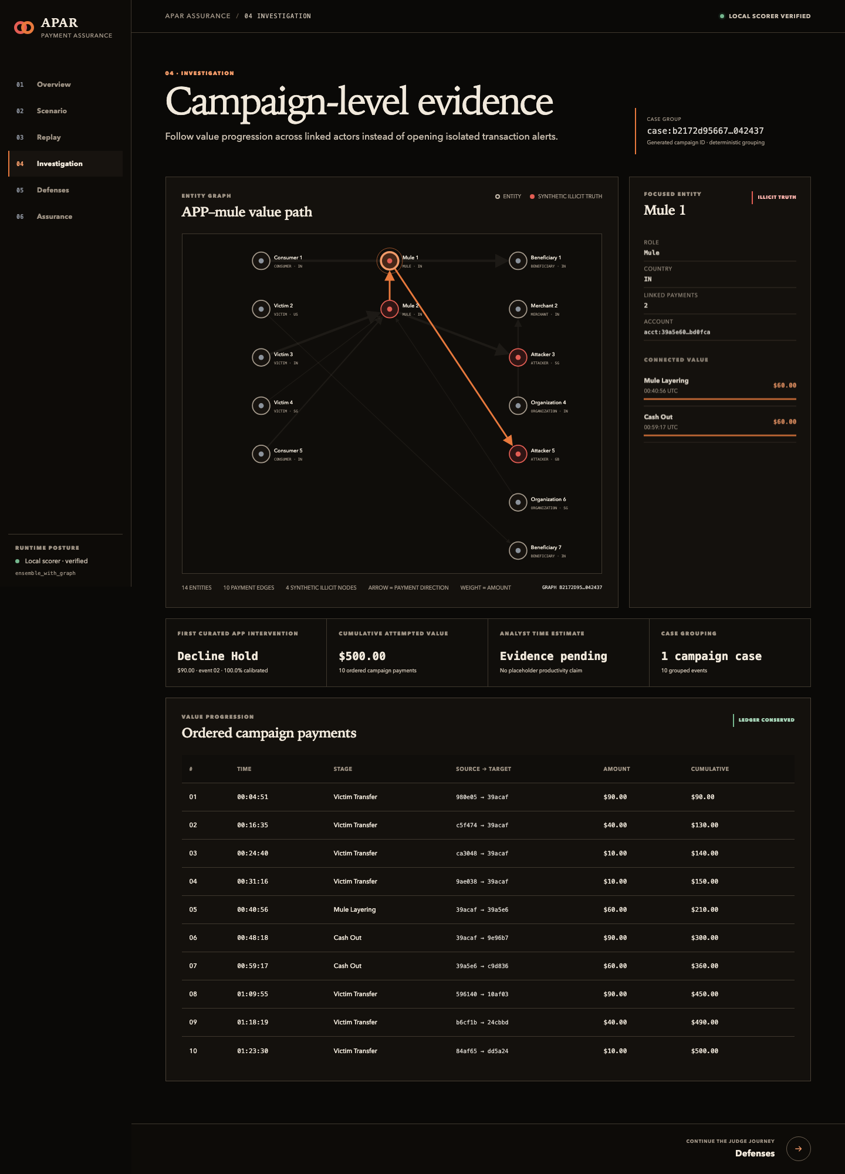
Investigation route: linked campaign context replaces disconnected transaction alerts.

6. Verifiable intent for agentic payments
Agentic commerce introduces an authorization-integrity problem that a fraud score alone cannot solve. Before statistical risk is considered, APAR's deterministic TrustVerifier checks the authority chain for the exact purchase.
- Registered agent identity and signing key.
- User mandate, permitted scope, amount, currency, merchant, and category constraints.
- Merchant and cart binding plus payment-intent hash.
- Token scope, issued-at time, expiry, nonce, and replay state.
- Execution receipt and outcome binding.
Deterministic checks precede ML risk
Invalid signatures, expired mandates, scope mismatches, cart mutations, merchant substitution, and replay fail closed before the model can approve a payment.

7. Evidence governance and assurance
Models, scenarios, controls, results, and replay traces are content-addressed. Independent verifiers recompute hashes and evidence semantics; tampering, label leakage, future information, and broken rail or ledger provenance fail closed. Rejected experiments remain visible, and no model can promote itself.
- Label-shuffle and single-class controls.
- Identity-renaming invariance and feature/label leakage tests.
- Future-append and equal-time isolation tests.
- Rail, lifecycle, ledger, trust, and evidence-tamper tests.
- Hash-bound portable bundle and exact probability/action replay.
- Explicit human promotion decision with rollback and evidence boundaries.

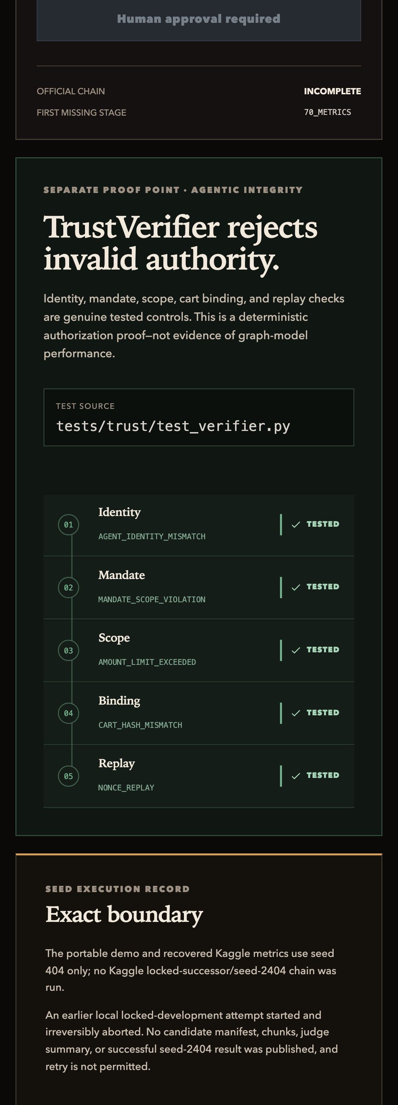
Assurance route: compact evidence inspection, trust checks, and human promotion boundary.

8. Working web prototype
The public six-route console demonstrates the complete loop: threat framing, scenario construction, synchronized replay, connected investigation, defense comparison, and assurance evidence. The hosted build uses a committed, hash-bound trace so the walkthrough remains accessible without a Python service.
The repository also contains the real portable scorer. The local console loads the packaged graph ensemble, scores 12 curated cases, verifies probabilities and actions exactly, and exposes the results through the same interface.
Prototype: https://web-six-tau-bxhm7rwrzu.vercel.app/overview
Repository: https://github.com/Dljdd/LedgerPeLabs
Demo video: https://www.youtube.com/watch?v=A_4Pe_A7iMg

Local run
python3.12 -m venv .venv
.venv/bin/python -m pip install -e '.[dev]'
npm ci --prefix web
.venv/bin/python scripts/run_apar_console.py start

9. Real-world feasibility
APAR is designed as an assurance layer around existing payment-risk and fraud-operations systems, not as a replacement authorization switch. A practical adoption path keeps the model advisory until its evidence and operating impact are independently validated.
Stage | Use | Control boundary
Offline replay | Historical and synthetic evaluation | No customer impact
Shadow mode | Live feature generation and drift measurement | Scores are advisory only
Assisted operations | Human-reviewed cases and selective challenges | Capacity and rollback limits
Limited challenger | Small governed traffic slice | Explicit owner and stop criteria
Governed scale | Continuous adversarial regression | Independent validation and human promotion

The synchronous path contains schema checks, agentic integrity, feature lookup, rules, CPU scoring, and reason codes. Graph expansion, campaign discovery, case formation, drift analysis, and retraining stay asynchronous. This preserves a credible path to low-latency live payment integration.

10. Reproducibility, safety, and limitations
- Synthetic data only; no real cardholder data is included.
- The 12 visible cases are curated replay demonstrations, not a population estimate.
- Recovered four-arm results are verified diagnostics, not official Stage 70 capacity evidence.
- The official chain is incomplete at Stage 70; APAR makes no production-readiness claim.
- The prototype does not export operational attack instructions or autonomously deploy controls.
- Production adoption would require independent data validation, privacy review, monitoring, and model-risk approval.
This boundary is intentional. A payment-assurance system should explain both what its evidence proves and what it does not. APAR's central contribution is a closed, testable, and governable process for adapting defenses as attackers adapt—without granting the model authority over deployment.

Submission links
Working prototype: https://web-six-tau-bxhm7rwrzu.vercel.app/overview
Public source repository: https://github.com/Dljdd/LedgerPeLabs
Competition deck: https://github.com/Dljdd/LedgerPeLabs/blob/codex/apar-final-submission/docs/submission/APAR_COMPETITION_DECK.pdf

