**Amazon Web Services EC2 Instructions**

1. Sign up for AWS Educate at <https://aws.amazon.com/education/awseducate/> and sign up as a student. Make sure you use your school-issued email address when you sign up.

2. Go to EC2 service once you are in your AWS account. Create an VM instance of your choice. The instructions will use Amazon Linux 2 so if you use a different VM, make sure you look up the instructions to install the tools needed.

For the Security Group, we need to add one custom rule. Click Add Rule and make sure the type is Custom TCP. Change the Port Range to 4200 (this is the port where our angular project runs on). If you are using a different port, change it to the appropriate number. This allows traffic from all IP addresses to port 4200.

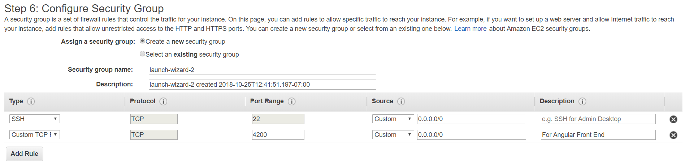

3. Create key value pairs and save the private key onto your system.

For Linux systems, you would save the private key in your .ssh folder and change permissions of the private key: **chmod 400 private_key_name.pem**.

Then you ssh into your instance using **ssh -i */path/my-key-pair*.pem *ec2-user*@*public-dns-hostname***. You can find the DNS in your AWS EC2 Instance.

For Windows, you need to download PuTTY along with PuTTYgen (if you run the msi installer, you should have it already) to ssh into your virtual machine instance. You need to use PuTTYgen to change your private key to a .ppk (PuTTY Private Key) format so PuTTY can use it.

Then, you open PuTTY and put in the Host Name/IP address in the Session category. The hostname **is ec2-user@public-dns-hostname**. You can find the DNS in your AWS EC2 Instance.

Then, go to the Connection category and go down to **SSH**. Expand that by pressing the **+** button and go down and select **Auth**. At the bottom, it says Private key file for authentication. Click on **Browse…** and choose your PuTTY Private Key you created earlier.

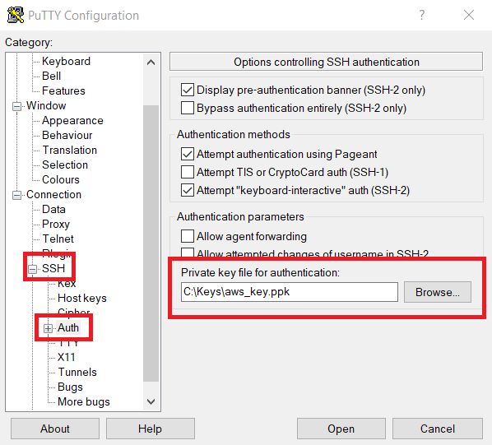

4. Go back to the Session category and click on the Open button below. Then you should be inside your instance.