Dear All,

In accordance with the open position of Forntend Developer in your company and the job description for this position, please consider my application.

Please follow the link with the result:

<https://www.mytestapp.space/>

The following tools were used to carry out the task:

SDK: Visual Studio Code

Framework: Vue 3 CLI

Main libraries: Vue Router, Vuex

Add-on labs: Axios, Normalise.css, .Env

Scripts lang: JS, Styles: SCSS

The following techniques were used to enhance the usability and potential of the application:

Generally:

* Implemented a single page application (SPA) concept using the Vue Router library, allowing the application to be converted to a multi-page application without complex refactoring.
* The Vuex state management library is used to centrally retrieve, store and process data. The data is segmented by topic into namespaced modules.
* The structure of the application follows the idea of compact, reusable components that can be reused without complex re-adjustments.
* The Axios library is used for asynchronous fetching and posting of data (stable and widespread solution).
* The Normilze.css library helps to avoid unwanted styling of DOM elements by browsers.

Details:

* The application has four adaptive mode breakpoints and page block geometry according to the mockup. Scheme of the adaptation - from the min. in to the max. screan.
* The navigation menu (NAV) is fixed at the top and is always visible. The content below the NAV is a SPA.
* The rendering of the phone number format is controlled by a custom directive.
* The email tooltip reflexes to entering position of the cursor.
* Entered data errors processing and form validation fulfilled according to the provided – ‘Test Assignment for frontend developer API documentation version 1’

Issues / nuances:

* The 'nex_url' link provided by the server is not always correct, so the application calculates the pagination itself. Example: total users 48, count=6, while server suggested the 9th page.
* A method of handling the 404 error for user image links has been implemented. Mostly it's used for the url 'https://...api.abz.agency/images/placeholders/placeholder.png'. The problem is solved by handling errors and excluding the error url from loading and replacing it with an alternative.
* Err 401 'The token has expired' is taken into account, but no specific action is taken because 'get token' and 'register new user post request' are processed in the same session.
* On reaching the last page, the 'show more' button is hidden, but no further action has been suggested to the user (…that’s according to task)
* The 2560px breakpoint has been changed to 1280px (…but could be changed back to 2560 in a second)

Summary:

* The application achieved the following test results:

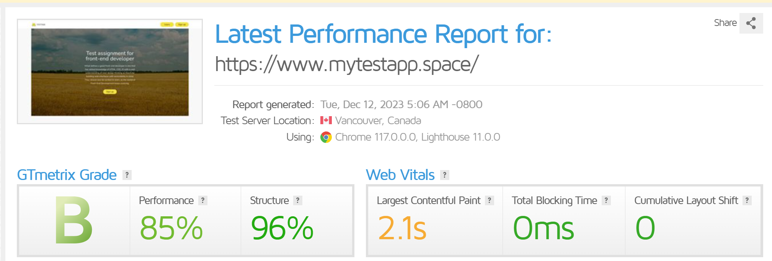

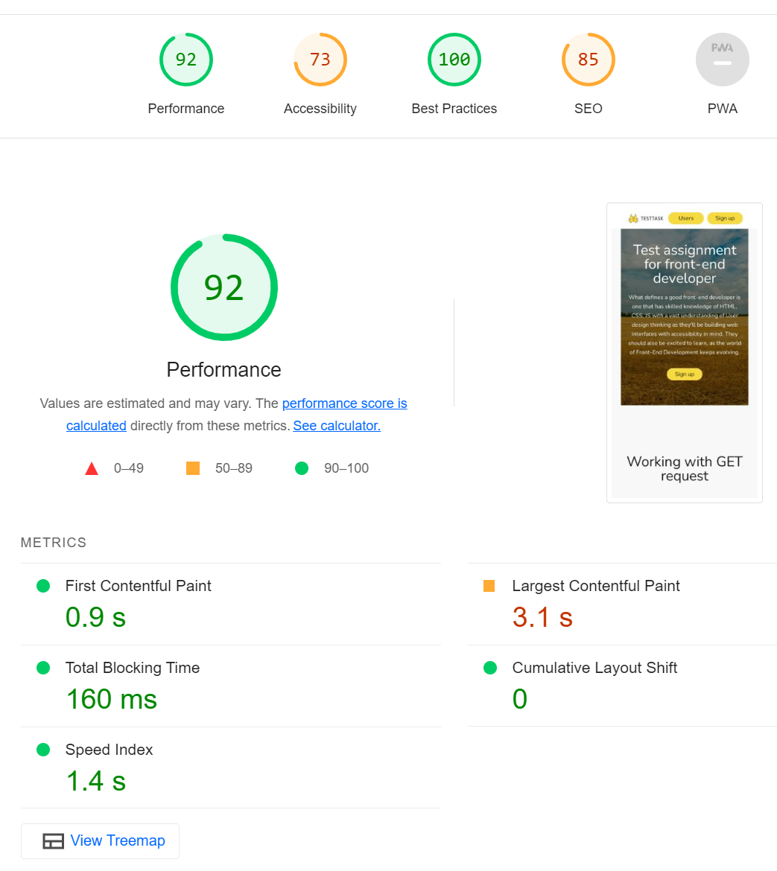

Block and page element placement checked for consistency using PerfectPixel.

* I've been concentrating on the realisation of the task for about 30 to 40 hours.
* my repository: <https://github.com/DmDrozhin>
* All difficulties/problems were reasonably difficult and interesting to solve.
* ! Please note that I haven’t uploaded any finished code to open source, so the code could be made available immediately upon the first request and placed on GitHub account.

Please find attached CV with this email

Thank you for considering me!

Regards,

Dmitry.

[ddrozhin@gmail.com](mailto:ddrozhin@gmail.com)

+38 095 285 64 34

https://t.me/DDrozhin