# **Documentation for the Project**

---

## **Project Objective**
This project demonstrates:
- **CI/CD pipeline** for automating the build, test, and deployment of a Python application.
- **Monitoring system** using Prometheus and Grafana.
- **Alerts** for notifying about critical situations, such as high CPU or memory usage.

---

## **CI/CD Pipeline Deployment and Configuration**

### **1. Tools Used**
- **Jenkins** for CI/CD automation.
- **Docker** for containerizing the application.
- **Docker Compose** for managing multiple services.

### **2. Pipeline Stages**

1. **Clone Repository**:
- Fetches the repository from GitHub.
- The main branch (`main`) is used.

2. **Build Docker Image**:
- Builds a Docker image for the Python application.
- Uses `IMAGE_NAME` and `TAG` variables to tag the image.

3. **Update Services with Docker Compose**:
- Updates services (application, monitoring, and alerting).
- Restarts containers without recreating them using `--no-recreate`.

4. **Test Application**:
- Checks if the application is accessible at `http://localhost:${APP_PORT}`.
- Verifies the response contains "Hello, World!" to confirm successful deployment.

5. **Post Actions**:
- Outputs the status of running containers.
- Helps with diagnostics in case of failure.

---

## **Monitoring Configuration**

### **1. Tools Used**
- **Prometheus** — for collecting metrics.
- **Grafana** — for visualizing data.
- **cAdvisor** — for monitoring Docker container resource usage.

### **2. Configuration Process**
- **Prometheus**:
- Configured to scrape metrics from the application and cAdvisor.
- Configuration file: `prometheus.yml`.

- **Grafana**:
- A dashboard was created to monitor:
- CPU usage.
- Memory usage.

- **cAdvisor**:
- Gathers metrics about container resource usage.

---

## **Alerting Configuration**

### **1. Tools Used**
- **Alertmanager** for handling notifications.
- Integration with **SendGrid** for sending emails.

### **2. Alerts**
- **High CPU Usage**:
- Triggered when CPU usage exceeds 80% for more than 2 minutes.
- **High Memory Usage**:
- Triggered when memory usage exceeds 80% for more than 2 minutes.

### **3. Configuration Details**
- **Prometheus**:
- Stores alert rules in `alert_rules.yml`.

- **Alertmanager**:
- Sends email notifications via SendGrid.
- Configuration file: `alertmanager.yml`.

---

## **Testing the Alerts**

1. **Simulating High Load**:
- Use tools to simulate high CPU and memory load.
- Wait for 2 minutes to trigger alerts.

2. **Validation**:
- Check alerts in Grafana or Prometheus (`/alerts` endpoint).
- Verify email notifications are received via SendGrid.

---

## **Recommended Screenshots**

### **Suggested Areas**
1. **Application Homepage**:
- Screenshot of `http://localhost:5000`.
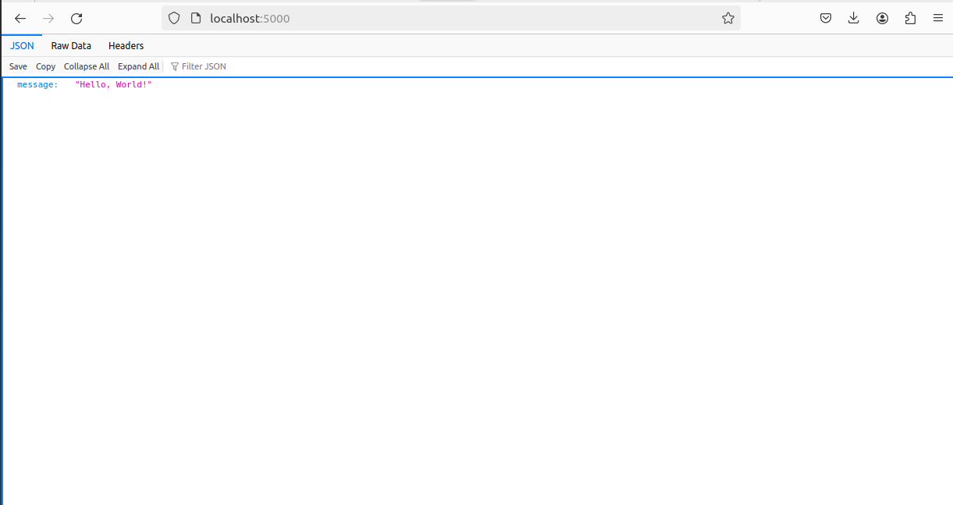

2. **List of Containers**:
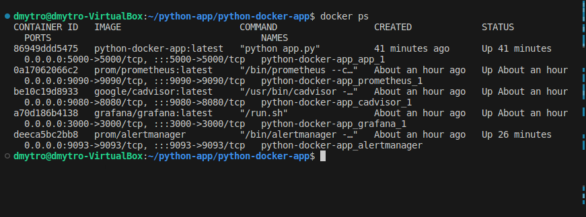

3. **Prometheus Alerts**:
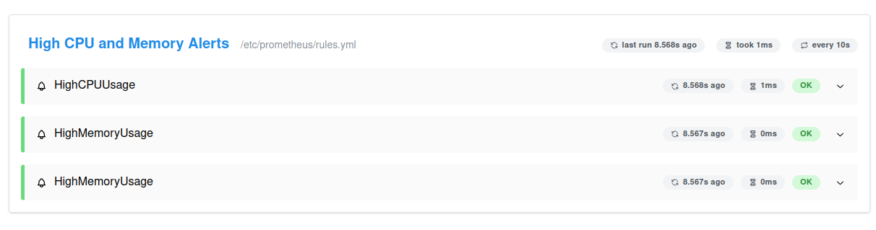

4. **Grafana Dashboard**:
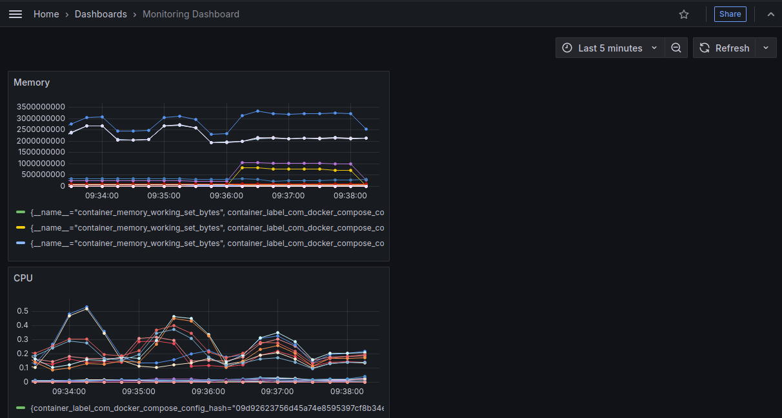

5. **Email Notification**:
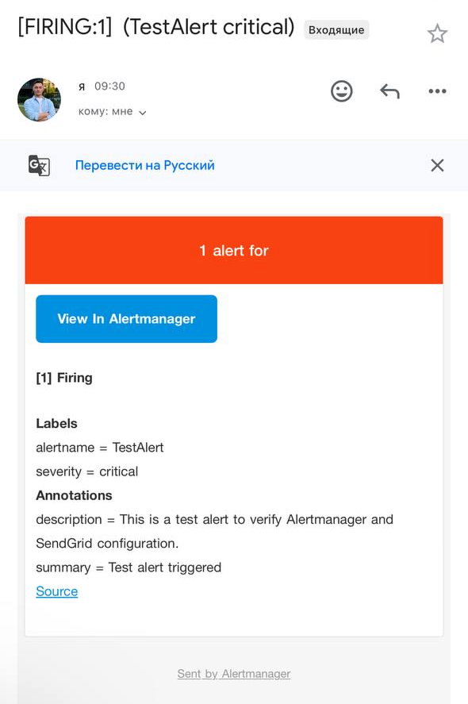

---

## **Conclusion**
This project effectively automates the CI/CD process while ensuring robust system monitoring. With properly configured alerts, the team can quickly respond to critical issues, maintaining system stability and performance.

