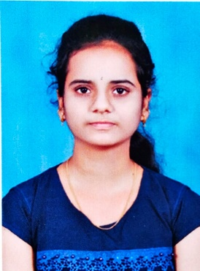DESU MEGHANA

Email:meghanareddy.desu@gmail.com

Mobile No:+91-9182643598

# CAREER OBJECTIVE :

To pursue a job in challenging environment that encourages creativity and provides exposure to new technology to achieve professional and personal growth along with the organization**.**

# ACADEMIC QUALIFICATION:

|  |  |  |  |  |
| --- | --- | --- | --- | --- |
| **Course** | **Institution** | **Board/University** | **Year Of Passing** | **Percentage(%)** |
| B.Tech, Electronics and Communication Engineering | Annamacharya Institute of Technology and Sciences, Rajampet. | Jawaharlal Nehru Technological University, Anantapuram | pursuing | 9.16  (CGPA)  Upto 3-1 |
| Intermediate with Maths,Physics, Chemistry. | Srichaitanya junior  College,  Tirupathi | State Board of Intermediate education, Andhra Pradesh | 2021 | 93% |
| Secondary Education | Dolphin Dale EMHigh School, Rlykodur | Board of Secondary Education | 2019 | 9.2  (GPA) |

**INTERNSHIP:**

* “PLC Programming”

# TECHNICAL SKILLS

* Programming Languages : Basics of C, PYTHON and JAVA

# ACHIEVEMENTS AND CERTIFICATES:

* + A Certified course on “MATLAB programming”

# PERSONAL DETAILS:

* Date of Birth : 29-05-2004
* Father’s Name :Desu Mallikarjunareddy
* Current Address : 5-32A Thurpupalli,Rlykodur,Annamayya dist,516105
* Hobbies : listening music
* Nationality :Indian
* Languages Known :English,Telugu
* Any kind of disability :No
* Willingness to Relocate :Yes

# DECLARATION

I here by declare that all the above-mentioned information is true and correct to the best of my knowledge.

**PLACE** : Rajampet Signature: