

SOFTWARE REQUIREMENT SPECIFICATION
Eyes Clinic Management System (ECMS)

– Hanoi, May 2026 –
Table of Contents
I. Record of Changes 5
II. Software Requirement Specification 7
1. Overall Requirements 7
1.1. Context Diagram 7
1.2. Main Business Processes 8
1.3. User Requirements 14
1.4. System Functionalities 28
1.5. Entity Relationship Diagram 33
2. Use Case Specifications 33
2.1 Business Rules 34
2.2 — Authentication & Account Management 35
2.3 — Reception & Scheduling 46
2.4 — EMR & Clinical 62
2.5 — LIS & Imaging 75
2.6 — Pharmacy 78
2.7 — Service Package & Eyeglass Sales 80
2.8 — Patient Portal 87
2.9 — Administration & Analytics 90
2.10 — System Administration & Security 97
3. Functional Requirements And Feature 100
3.1 Functional Requirement 100
3.2 User Authentication 102
4. Non-Functional Requirements 109
4.1 External Interfaces 109
4.2 Quality Attributes 109
5. Appendix 111
5.1 Assumptions & Dependencies 111
5.2 Limitations & Exclusions 111
5.3 Glossary 111

I. Record of Changes
Version | Date | A/M/D | In Charge | Change Description
V1.1 | 18/05/2026 | M | [Team] | Complete the Use Case Specifications (UC-01 → UC-31), incorporate comprehensive Business Rules, update the database schema (inventory and prescription_items tables), and update the Non-Functional KPIs.
V1.1 | 18/05/2026 | M | [Team] | Complete the Use Case Specifications (UC-01 → UC-31), incorporate comprehensive Business Rules, update the database schema (inventory and prescription_items tables), and update the Non-Functional KPIs.
V2.0 | 26/5/2026 | A | [Team] | Add new Use Cases (UC-40 and UC-41)
V2.1 | 8/5/2026 | M | [Team]
*A – Added M – Modified D – Deleted

II. Software Requirement Specification

1. Overall Requirements
In the context of the digital age, most of the major ophthalmology medical facilities we surveyed have undergone digital transformation, but the old systems are gradually revealing limitations in service and user experience. After surveying the websites of several hospitals and clinics such as Thien Thanh Eye Clinic, Thu Ha Eye Clinic, Tue Anh Eyecare, etc., we can see some limitations as follows:
- Overly simple and passive interface: The current system mainly supports registration through static forms, limiting patient interaction.
- Slow and passive consultation response: Currently, most clinics still provide consultations through separate platforms such as Zalo, Facebook, or Messenger. Patients have to wait for staff to manually respond to messages, leading to information congestion during peak hours and reducing the user experience. Slow connectivity and synchronization: Results from measuring devices (OCT, refractometer) often require synchronization or manual entry into patient records, easily leading to errors.
- The Patient Portal feature is rudimentary: Most systems only offer appointment scheduling and do not provide sufficient medical history information or specialized images for patients to monitor remotely.
- Lack of in-depth management reporting: Older systems only provide static data, making it difficult for Clinic Managers to make business decisions based on forecasts.
- Inflexible security: Access control is often too loose or too rigid, hindering coordination between specialized ophthalmology departments.

1.1. Context Diagram
The ECMS (Eyes Clinic Management System) is a full-stack web application built for the Anh Sao High-Tech Eye Clinic (85 Ba Trieu St., Hai Ba Trung Dist., Hanoi). The system digitalizes the entire patient lifecycle from appointment scheduling, reception, medical examination, laboratory testing, prescription, medicine dispensing, billing, to reporting.
The system interacts with 8 user actors (Patient, Receptionist, Doctor, Lab Technician, Pharmacist, Nurse, Clinic Manager, Admin) and 2 system actor (cron jobs, email service). Architecture: ReactJS (Frontend) <-> Spring Boot REST API (Backend) <-> SQL Server Database.
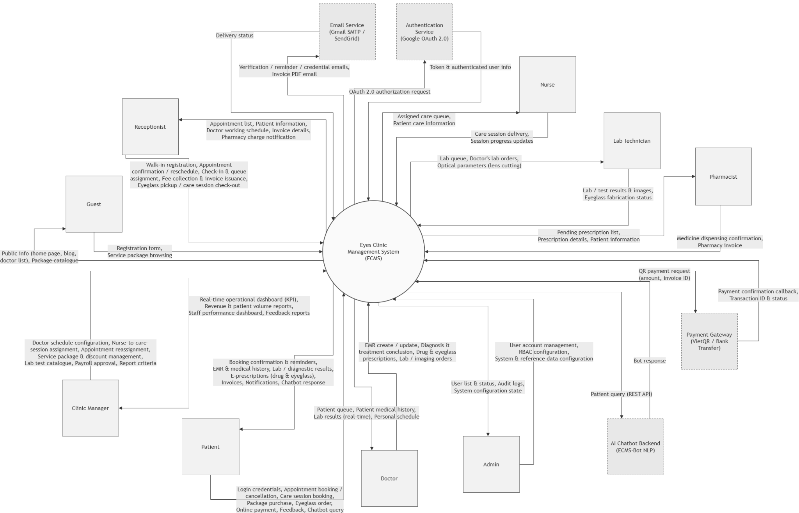

1.2. Main Business Processes

1.2.1. Authentication & Account Management
Step 1: The Guest/Member starts the flow and chooses whether to register a new account or log in to an existing one.
If the user chooses to Register:
Step 2: Guest/Member submits the registration form.
Step 3: System validates the information, sends a verification email, and activates the account.
Else (the user chooses to Log in): the flow proceeds directly to Step 4.
Step 4: Guest/Member enters login credentials.
Step 5: System checks whether the credentials are valid.
If the credentials are valid: the flow proceeds to Step 6.
Else (credentials are invalid): System checks whether this is the 5th failed login attempt in a row.
If fewer than 5 failed attempts: the flow loops back to Step 4 (Guest/Member re-enters credentials).
If 5 failed attempts in a row: System locks the account for 30 minutes, and the flow proceeds to Step 8.
Step 6: System issues an access token and opens the role-based dashboard.
Step 7: Guest/Member manages the account (updates profile, changes or resets password, or logs out).
Step 8: System persists the changes and writes the event to the Audit Log.

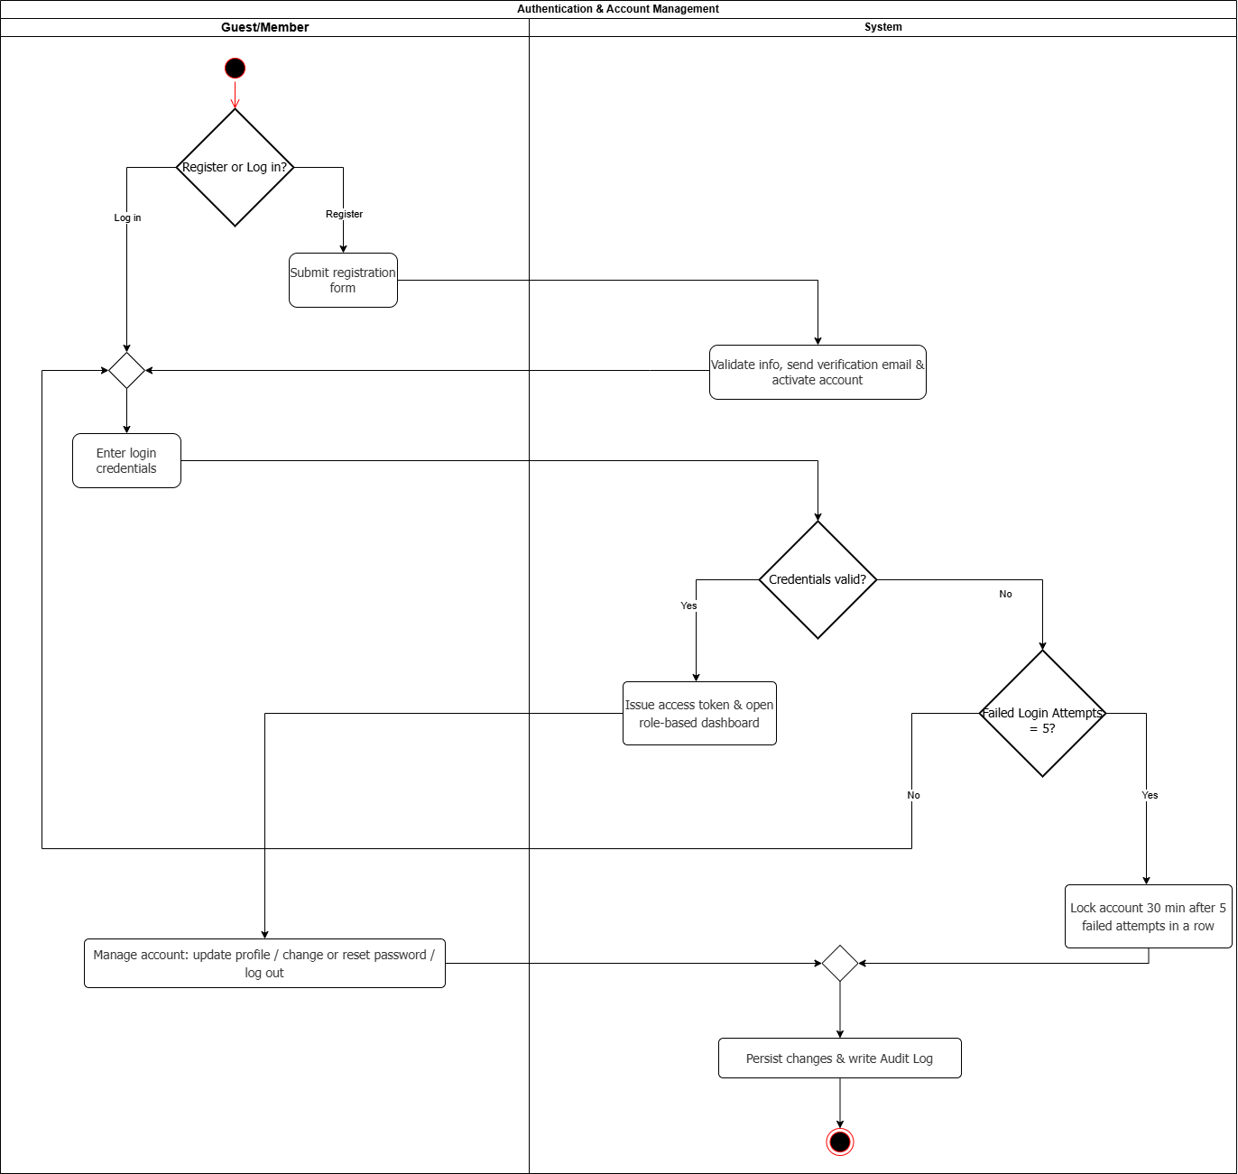

1.2.2. Online Appointment Booking & Patient Check-in:
Step 1: Determine booking channel — online booking or walk-in.
Step 2: (Online) Patient submits a booking request, selecting doctor and date/time.
Step 3: System creates a pending appointment and emails a confirmation.
Step 4: System sends a reminder before the appointment time.
Step 5: Patient arrives at the clinic at the scheduled time.
Step 6: (Walk-in) Receptionist registers the walk-in patient on the spot.
Step 7: System creates the appointment as confirmed immediately.
Step 8: Receptionist confirms the patient's arrival at the counter (branches merge here).
Step 9: Receptionist checks if an urgent reschedule is needed.
Step 10: If yes, receptionist reassigns doctor/time at the counter; if no, proceed directly.
Step 11: Doctor examines the patient.
Step 12: System marks the appointment as completed. End.
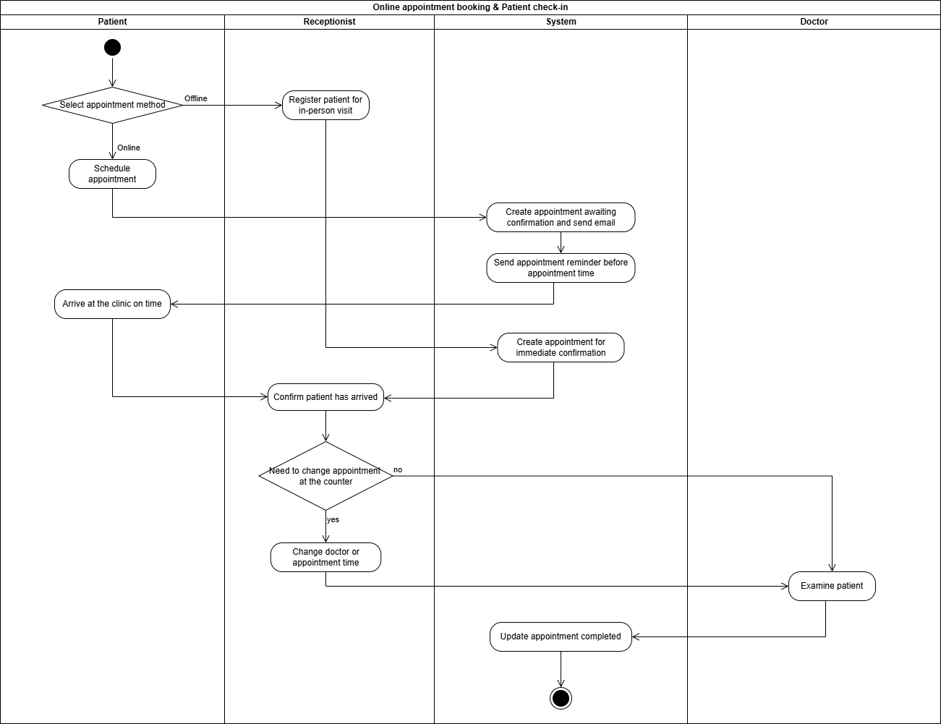

1.2.3. Clinical Examination, Diagnostics & EMR Finalization:
Step 1: Doctor examines patient, reviews medical history, records visit reason and symptoms.
If lab tests are required:
Step 2: Doctor sends a lab order to the Lab Technician.
Step 3: System notifies Lab Technician about the lab order
Step 4: Lab Technician performs the tests and submits the results.
Step 5: Doctor reviews the submitted results.
- If the results are not acceptable: Doctor rejects the results and requests a retest → the flow loops back to Step 3 (Lab Technician performs the tests again).
- Else (results acceptable): the flow proceeds to Step 6.
Step 6: System links the approved results into the EMR's clinical examination section.
Else (no lab tests required): the flow proceeds directly to Step 7.
Step 7: Doctor writes final diagnosis, issues prescriptions (if needed), and finalizes the EMR
Step 8: System validates the required data and locks the EMR.
Step 9: System logs finalization event to the Audit Log.
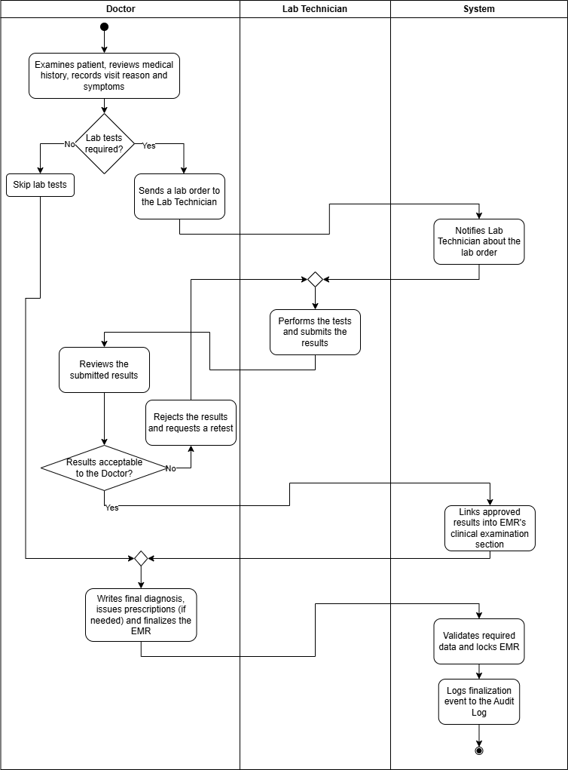

1.2.4. Prescription, Medicine & Eyeglass Dispensing:
Step 1: Doctor performs the general health examination.

If medication is required:

Step 2: Doctor issues a drug prescription.

Step 3: System records the drug prescription.

Else (no medication required): the flow proceeds directly to Step 4.

Step 4: Doctor determines if eyeglasses are required.

If eyeglasses are required:

Step 5: Doctor issues an eyeglass prescription.

Step 6: System records the eyeglass prescription.

Else (no eyeglasses required): the flow proceeds directly to Step 7.

Step 7: Pharmacist checks if the patient purchases the prescribed drug.

If the patient purchases the drug: Pharmacist dispenses the medication.
Else (patient does not purchase the drug): Pharmacist skips the prescription.
Step 8: System updates the prescription status.

Step 9: Patient decides whether to order glasses.

If the patient orders glasses: the flow proceeds to Step 10.
Else (patient does not order glasses): the flow terminates.
Step 10: Patient initiates the eyeglass order.
Step 11: Receptionist processes the deposit and confirms the order.

Step 12: System updates the order status.

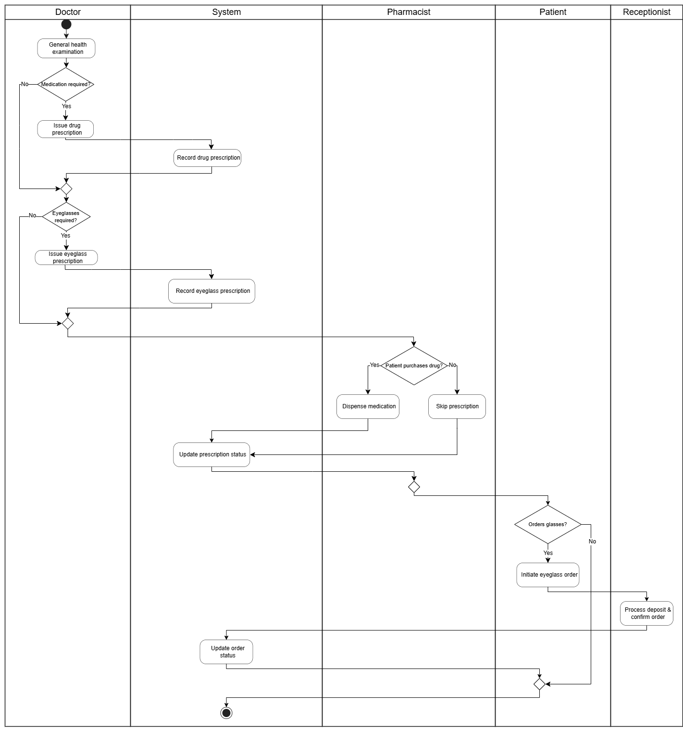

1.2.5. Payment Processing & Invoice Generation:
Step 1. Receptionist opens the invoice screen to see information about visit's services, lab orders, and prescribed medicines
Step 2. Receptionist see and may edit the creating invoice information, confirms creation.
Step 3. System creates the invoice as DRAFT — UNPAID for Cash, or PENDING_PAYMENT for VietQR (the Patient is notified to pay).
If Cash:
Step 4. Receptionist records the cash payment; the invoice becomes ISSUED or PAID.
Step 5. After payment, the Receptionist and Patient may manually email the invoice and download the PDF on their portal.
If VietQR:
Step 4. System shows the VietQR code and polls the payment status every 3 seconds.
Step 5. After patient paid, The System marks the invoice PAID and notifies the Patient; if payment is error, the invoice stays unchanged.
Step 6. After payment, the Receptionist and Patient may manually email the invoice and download the PDF on their portal.

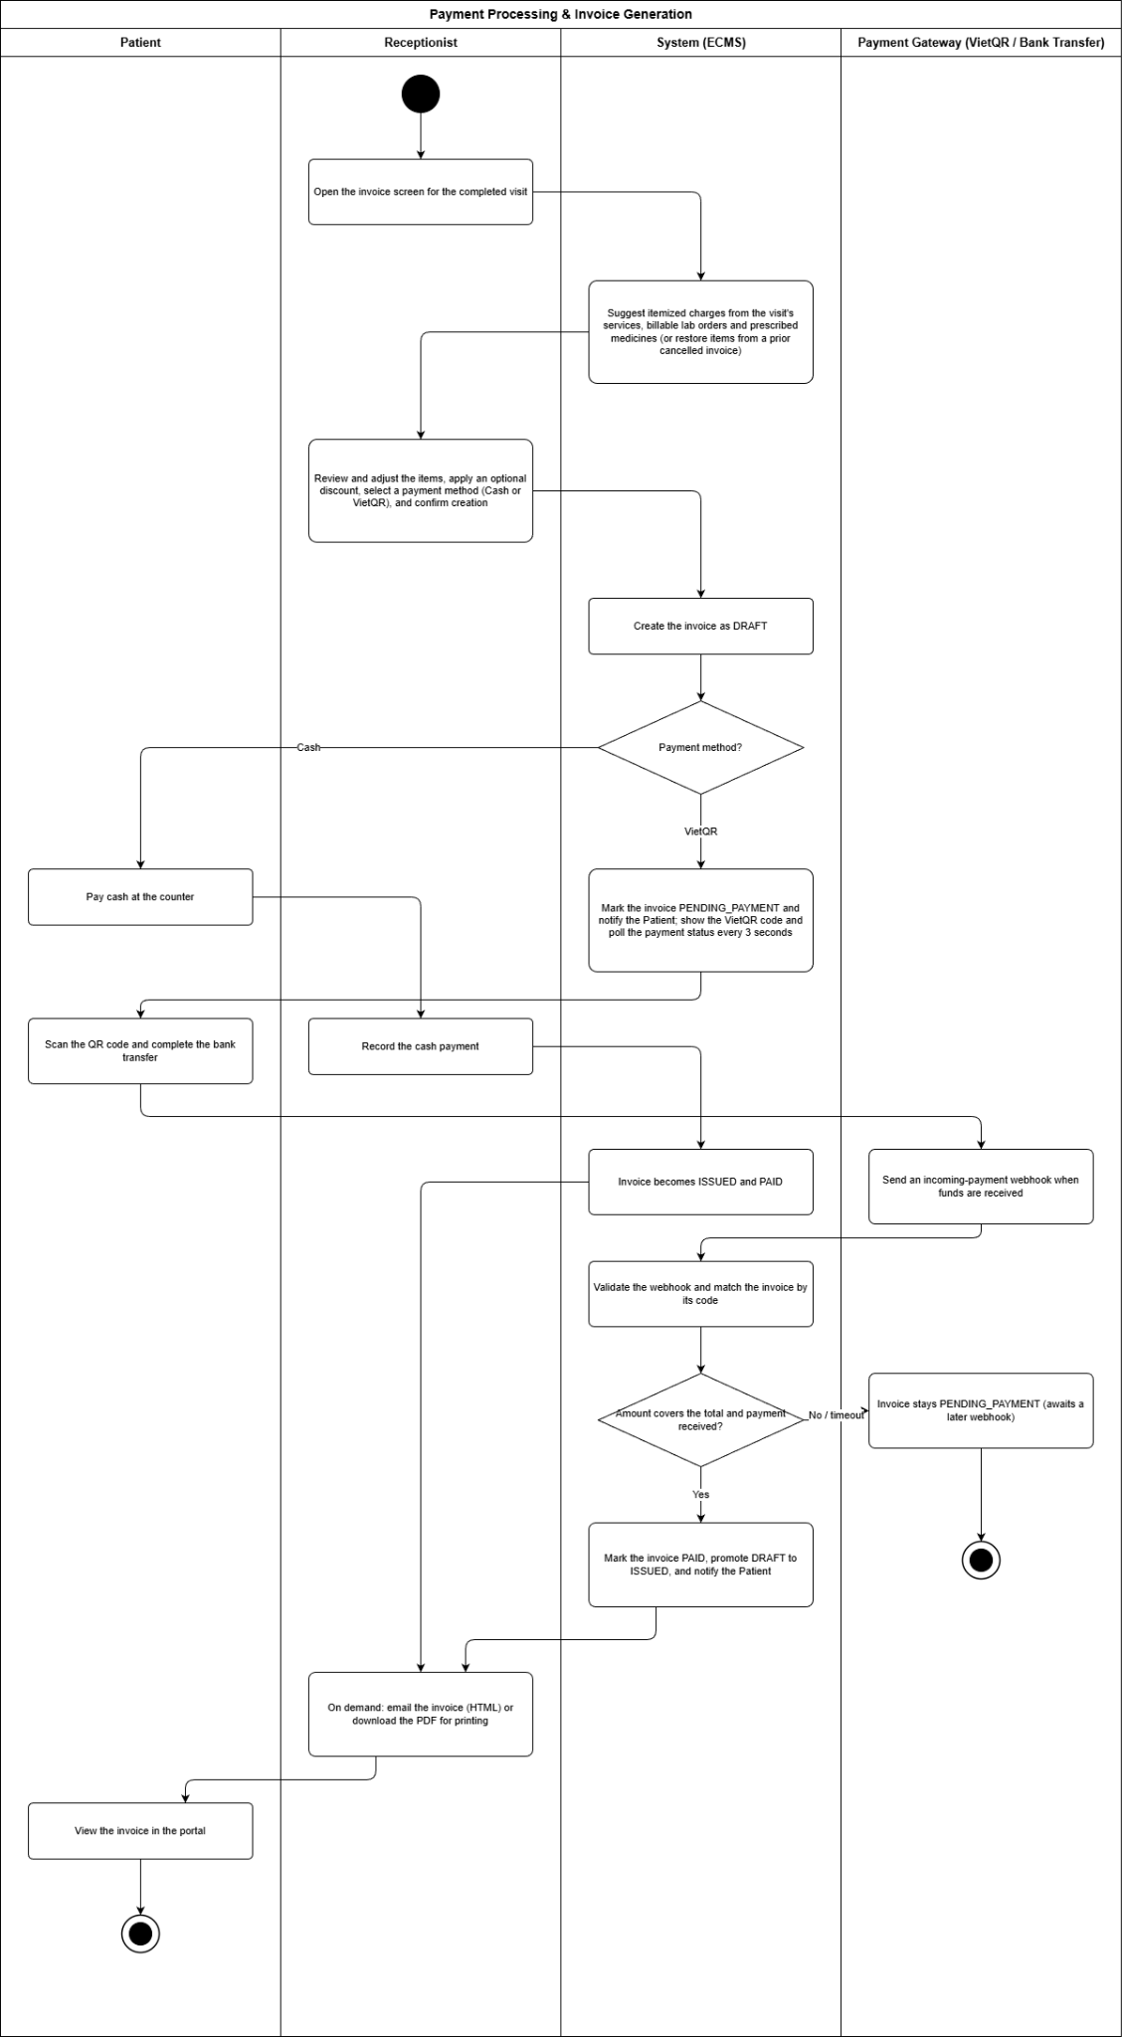

1.2.6. Care Service Package Lifecycle:
Step 1: Patient chooses a service package from the catalogue and submits a registration request.
Step 2: System checks whether this is the patient's first-ever registration for this package.
Step 3: If first time, receptionist follows up with the patient and confirms activation.
Step 4: System activates the package and reserves the first session (no payment collected yet).
Step 5: Patient requests to book an additional session from an active package.
Step 6: System checks whether the package still has sessions remaining.
Step 7: If sessions remain, system deducts one session, confirms the appointment, and notifies the patient; if none remain, the package is marked depleted.
Step 8: Patient arrives and is checked in by the receptionist for the scheduled session.
Step 9: Nurse delivers the care session, records notes, and completes it.
Step 10: Receptionist checks out the session.
Step 11: System checks whether the package has already been invoiced.
Step 12: If not yet invoiced, receptionist issues an invoice and collects payment for the whole package; system records the payment, updates package status, and logs the activity.
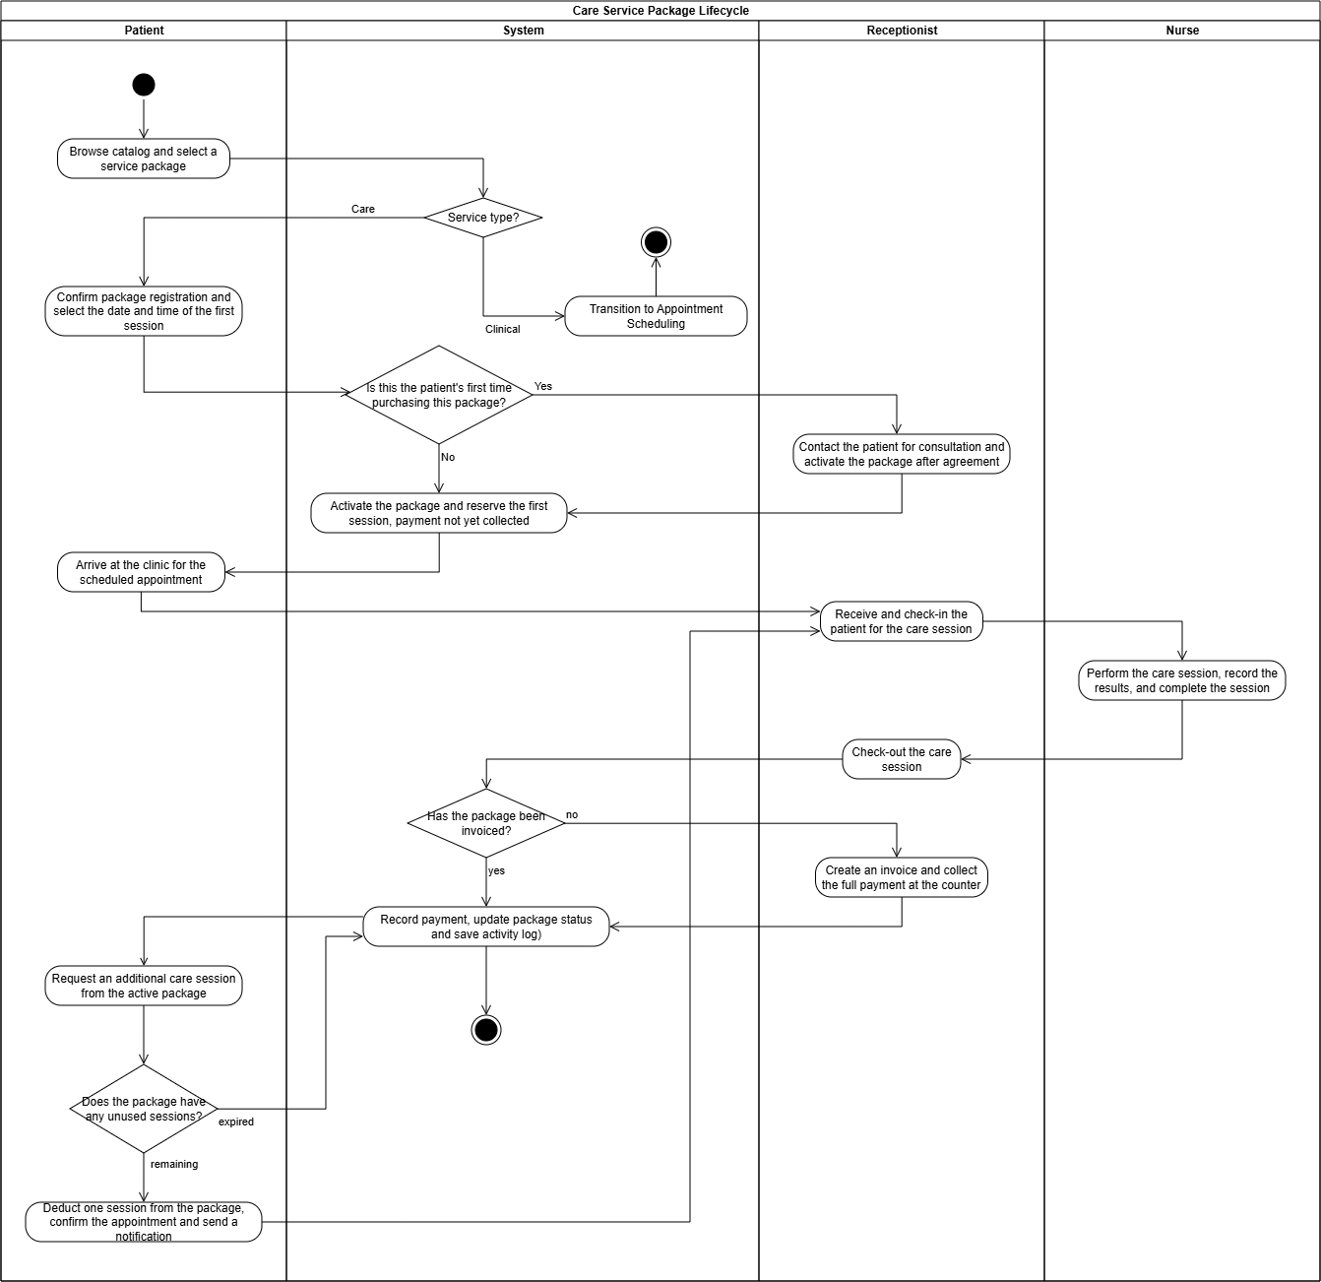

1.2.7. System Administration & RBAC Configuration:
Step 1: Admin creates a new staff account by entering the full name, email, role, and department.
Step 2: System validates that the email is not already registered, creates the account with INACTIVE status, and generates a temporary password.
If custom permissions are required (beyond the role's defaults):
Step 3: Admin adjusts the permission matrix for the new staff member.
Step 4: System saves the customized RBAC configuration and writes the change to the Audit Log.
Else (the default role permissions are sufficient): the flow proceeds directly to Step 5.
Step 5: Admin activates the account.
Step 6: System sets the account status to ACTIVE and sends a welcome email containing the temporary password.
Step 7: New Staff logs in for the first time and is required to change the temporary password.
Step 8: System issues an access token, redirects the New Staff to their role-specific dashboard, and logs the first-login event to the Audit Log.
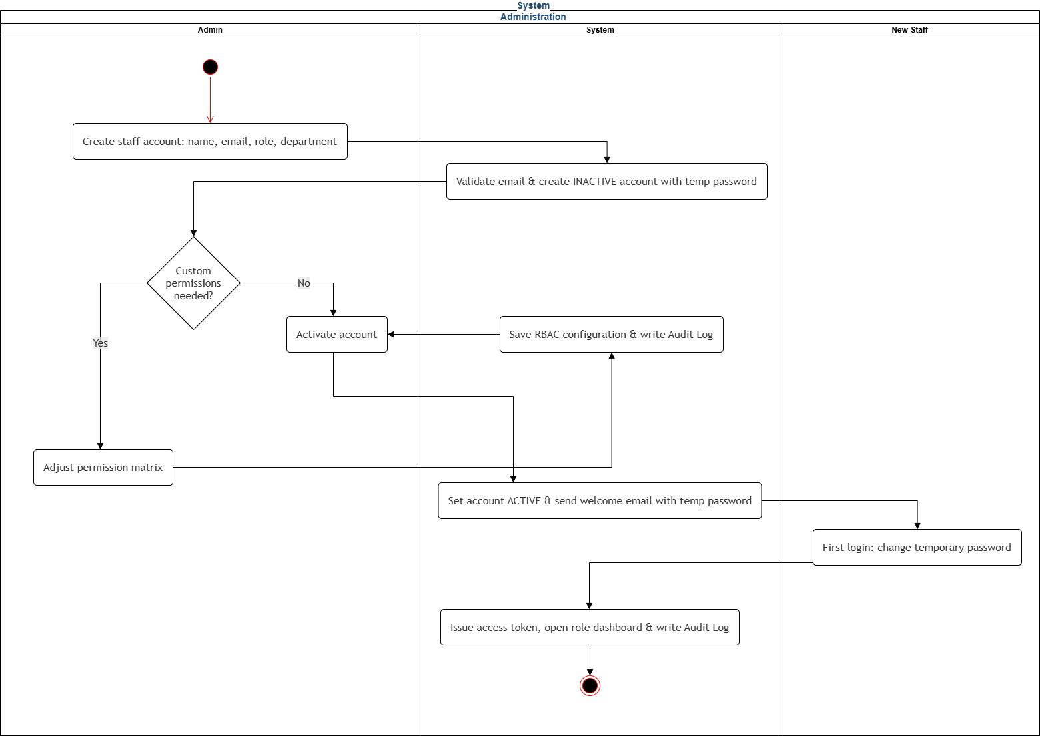

1.3. User Requirements

1.3.1. Actors
STT | Actor | Description
1 | Guest | Guest is an unauthenticated visitor who accesses only the public-facing pages of the ECMS. Guests can view general clinic information and navigate to the registration or login page, but cannot access any protected feature or personal data.
2 | User | User is the abstract base role representing any authenticated account within the system. Upon successful authentication, the user is assigned a specialized role that determines their specific access scope and available functionality.
3 | Patient | Patient is a specialized User who interacts with the system through the Patient Portal. Patients can book appointments online, view their personal EMR and prescription history, and receive automated appointment reminders, with access strictly limited to their own medical data.
4 | Receptionist | Receptionist is a clinic staff member responsible for front-desk operations within the system. Receptionists can register and manage patient profiles, confirm or reschedule appointments, and process service fee collection and invoice generation.
5 | Lab Technician | Lab Technician is a clinical support staff member who handles diagnostic and optical procedures. Lab Technicians can receive lab orders issued by the Doctor, input refraction and OCT examination results into the system, and perform lens cutting based on the prescribed optical parameters.
6 | Doctor | Doctor is a licensed medical practitioner who manages the full clinical examination workflow. Doctors can create and update EMRs, issue lab orders for diagnostic tests, and generate electronic prescriptions for medication and corrective lenses.
7 | Pharmacist | Pharmacist is a clinic staff member responsible for medication dispensing and pharmacy billing. Pharmacists can retrieve electronic prescriptions issued by the Doctor, dispense medicines according to the prescription, and issue electronic pharmacy invoices to be consolidated into the patient's billing record.
8 | Clinic Manager | Clinic Manager is an operational supervisor responsible for monitoring clinic performance and staff administration. Clinic Manager can access revenue and patient statistics reports, manage doctor work schedules, and oversee staff records, but cannot modify system-level configurations.
9 | Admin | Admin is the highest-privilege system administrator with full control over the ECMS. Admin can manage all user accounts and role assignments, configure system-wide reference data and service catalogues, and access audit logs for security and compliance monitoring.
10 | Nurse | Nurse is a clinical support staff member responsible for delivering care sessions to patients. Nurses can view their assigned care queue, execute care service delivery for patients, and manage the progress of these sessions within the system.

1.3.2. Use Cases
UC ID | Use Case | Actors
1. Authentication & Account Management
UC-01 | Register User Account | Guest
UC-02 | View Home Page | Guest
UC-03 | View Blog List | Guest
UC-04 | View Doctor List | Guest
UC-05 | Log In | User, Patient, Receptionist, Lab Technician, Doctor, Pharmacist, Clinic Manager, Admin
UC-06 | Log Out | User, Patient, Receptionist, Lab Technician, Doctor, Pharmacist, Clinic Manager, Admin
UC-07 | Reset Forgotten Password | User
UC-08 | Change Account Password | User, Patient, Receptionist, Lab Technician, Doctor, Pharmacist, Clinic Manager, Admin
UC-09 | Manage Personal Profile | User, Patient, Receptionist, Lab Technician, Doctor, Pharmacist, Clinic Manager, Admin
UC-10 | Receive System Notification | User, Patient, Receptionist, Doctor, Pharmacist, Lab Technician, Clinic Manager
UC-11 | Interact with AI Chatbot (ECMS-Bot) | Patient
2. Reception & Scheduling
UC-12 | Book Appointment Online | Patient
UC-13 | Manage Appointment | Patient, Receptionist
UC-14 | Send Appointment Reminder Notification | Receptionist, Patient
UC-15 | Register Walk-in Patient | Receptionist
UC-16 | Check In Patient | Receptionist
UC-17 | Confirm Appointment | Receptionist
UC-18 | View Daily Appointment Schedule | Receptionist, Doctor, Clinic Manager
UC-19 | Reassign Appointment | Clinic Manager
UC-20 | Assign Nurse | Clinic Manager
UC-21 | Check-out Care Session | Receptionist
UC-22 | Provide Live Support | Receptionist
UC-23 | Process Payment | Receptionist
UC-24 | Deliver Invoice | Receptionist, Patient
3. EMR & Clinical
UC-26 | View Doctor Dashboard | Doctor
UC-27 | Manage Electronic Medical Record (EMR) | Doctor
UC-28 | View Patient Medical History | Doctor, Patient
UC-29 | Issue Drug Prescription | Doctor
UC-30 | Issue Eyeglass Prescription | Doctor
UC-31 | Issue Lab Order | Doctor
UC-32 | View Lab Results | Patient, Doctor
UC-33 | View Care Queue | Nurse
UC-34 | Deliver Care Session | Nurse
4. LIS & Imaging
UC-35 | View Lab Queue | Lab Technician
UC-36 | Process Lab Result | Lab Technician
UC-37 | Review Submitted Lab Result | Doctor
UC-38 | Fabricate Eyeglasses | Lab Technician
5. Pharmacy
UC-39 | Dispense Drug | Pharmacist
6. Service Package & Eyeglass Sales
UC-40 | Purchase Service Package | Guest, Patient
UC-41 | Book Care Session | Patient
UC-42 | Order Eyeglasses | Patient
UC-43 | Manage Service Packages | Clinic Manager
UC-44 | Manage Discount Campaigns | Clinic Manager
7. Patient Portal
UC-45 | View Prescriptions | Patient
UC-46 | View Diagnostic Results | Patient
UC-47 | Register Eye Care Services | Patient
UC-48 | Submit Feedback | Patient
8. Administration & Analytics
UC-49 | View Real-time Operational Analytics Dashboard | Clinic Manager
UC-50 | Generate Revenue Report | Clinic Manager
UC-51 | View Patient Statistics | Clinic Manager
UC-52 | Monitor Staff Performance Dashboard | Clinic Manager
UC-53 | Generate Feedback Report | Clinic Manager
UC-54 | Approve Payroll | Clinic Manager
UC-55 | Manage Room Catalogue & Service Mapping | Clinic Manager
UC-56 | Manage Staff Room Roster | Clinic Manager
9. System Admin & Security
UC-57 | Manage User Account | Admin
UC-58 | Configure System and Data | Admin
UC-59 | Manage System Audit Log | Admin

1.3.3. Use Case Diagrams

1.3.3.1. UCs for Guest
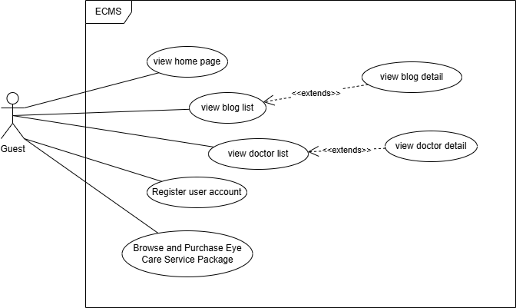
This diagram represents the actions an unregistered visitor can perform on the public portal.
- Actor: Guest.
- Key Capabilities:
  - Information Browsing: Views the home page, reads blogs, and browses the list of clinic doctors (including their details).
  - Account Registration: Registers a new user account to access patient or customer features.
  - Service Discovery: Browses and purchases initial eye care service packages.

1.3.3.2. UCs for User
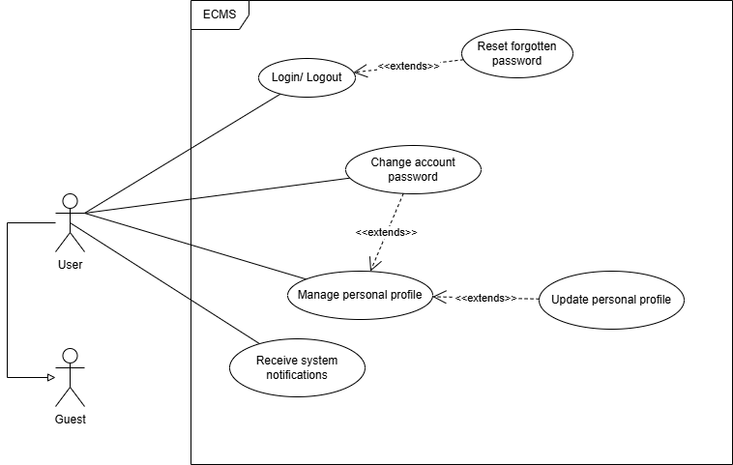
This diagram represents the foundational account security and profile management features shared by all registered users in the system.
- Actor: User (the parent role for Admin, Doctor, Patient, Receptionist, etc., which a Guest becomes after registering).
- Key Capabilities:
  - Authentication: Logs in/out of the system and resets forgotten passwords.
  - Account Maintenance: Changes accounts passwords and manages/updates personal profiles.
  - Communication: Receives automated system notifications and updates.

1.3.3.3. UCs for Patient
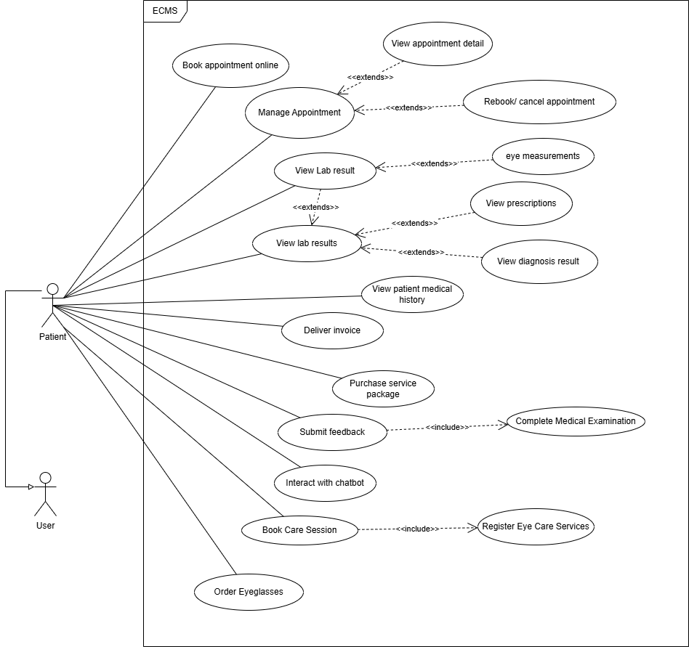
This diagram details the patient-facing portal actions for self-service healthcare management.
- Actor: Patient (inherits from User).
- Key Capabilities:
  - Appointment & Care Booking: Books and schedules appointments online, books eye care sessions, and manages existing appointments.
  - Medical Records: Views personal lab results, diagnosis details, prescription histories, and general medical records.
  - Purchasing & Logistics: Orders prescribed eyeglasses, purchases service packages, and views issued medical invoices.
  - Interactivity: Submits feedback on completed medical examinations and chats with an automated AI chatbot.

1.3.3.3. UCs for Doctor
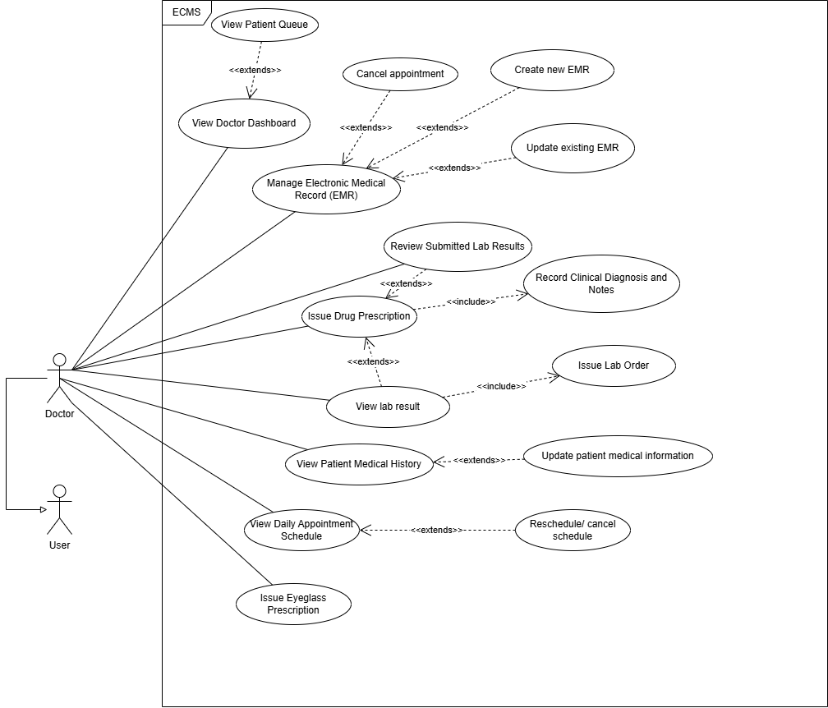
This diagram depicts clinical tasks, patient diagnoses, and medical prescriptions.
- Actor: Doctor (inherits from User).
- Key Capabilities:
  - Dashboard & Scheduling: Monitors the doctor dashboard, views the active patient queue, and manages daily appointment schedules.
  - Electronic Medical Records (EMR): Creates, updates, and manages patient EMRs and medical histories.
  - Diagnostics & Treatment: Reviews lab results, issues laboratory orders, records clinical diagnoses, and writes drug or eyeglass prescriptions.

1.3.3.4. UCs for Receptionist
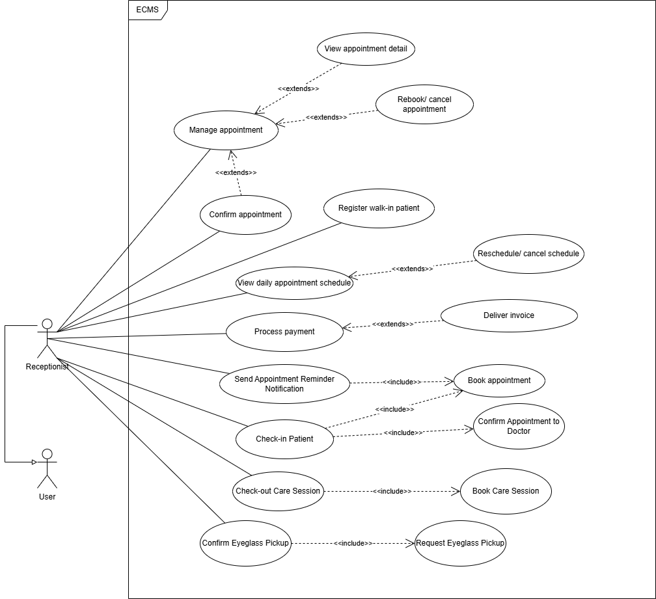
This diagram represents front-desk operations, patient welcoming, and basic clinic logistics.
- Actor: Receptionist (inherits from User).
- Key Capabilities:
  - Patient Intake: Registers walk-in patients, checks in patients upon arrival, and checks them out after their care sessions.
  - Scheduling & Reminders: Schedules/manages appointments and sends automated appointment reminder notifications.
  - Billing & Pickups: Processes patient payments, delivers invoices, and confirms completed eyeglass pickups.

1.3.3.5. UCs for Lab technician
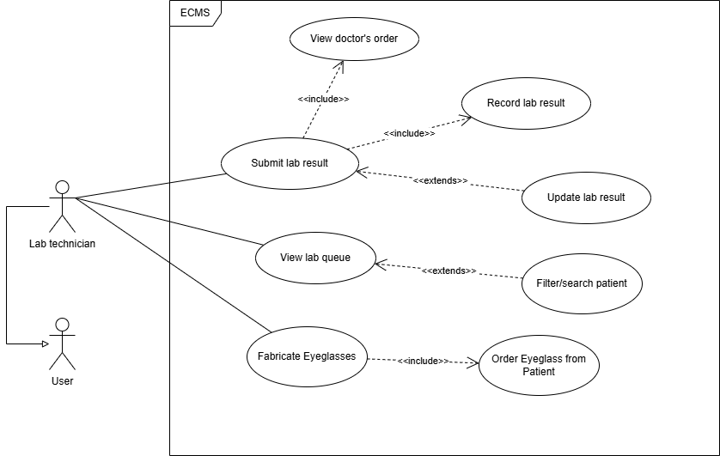
This diagram covers laboratory testing processes and custom optical hardware manufacturing.
- Actor: Lab Technician (inherits from User).
- Key Capabilities:
  - Lab Queue Management: Views and filters patients waiting in the laboratory queue.
  - Lab Results Processing: Views doctors' lab orders, records, submits, and updates laboratory test results.
  - Eyeglass Fabrication: Manufactures eyeglasses based on patients' custom prescription orders.

1.3.3.6. UCs for Pharmacist
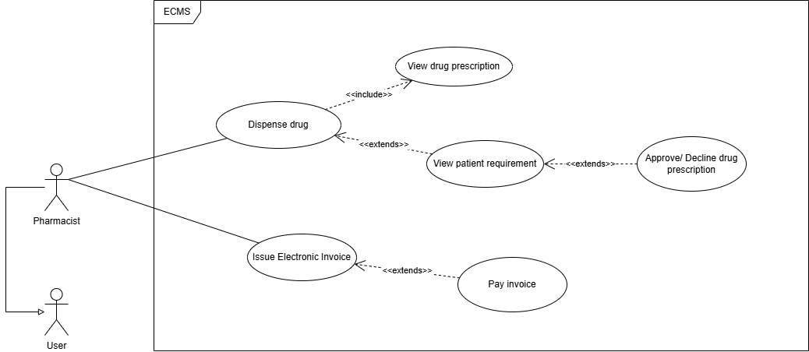
This diagram describes medication dispensing and pharmacy-related checkout workflows.
- Actor: Pharmacist (inherits from User).
- Key Capabilities:
  - Prescription Management: Views, evaluates, and approves or declines doctor-submitted drug prescriptions based on patient requirements.
  - Medicine Dispensing: Dispenses the appropriate medications to patients.
  - Billing: Generates and processes electronic medical invoices for paid medications.

1.3.3.7. UCs for Clinic Manager
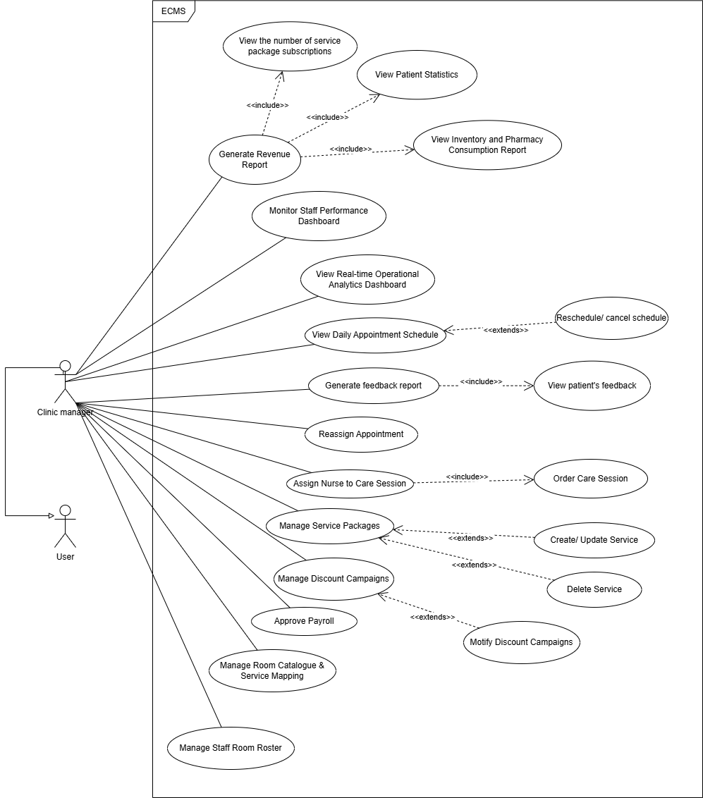
This diagram covers clinic administration, business performance monitoring, and staff coordination.
- Actor: Clinic Manager (inherits from User).
- Key Capabilities:
  - Reporting & Analytics: Generates revenue reports, monitors staff performance, views real-time operational analytics, and tracks patient feedback.
  - Operations & Scheduling: Views daily appointment schedules, reassigns appointments, and manages staff room rosters.
  - Service & Marketing Management: Manages eye care service packages, discount campaigns, and maps services to clinic rooms.
  - Staffing & Financials: Assigns nurses to care sessions and approves staff payroll.

1.3.3.8. UCs for Admin
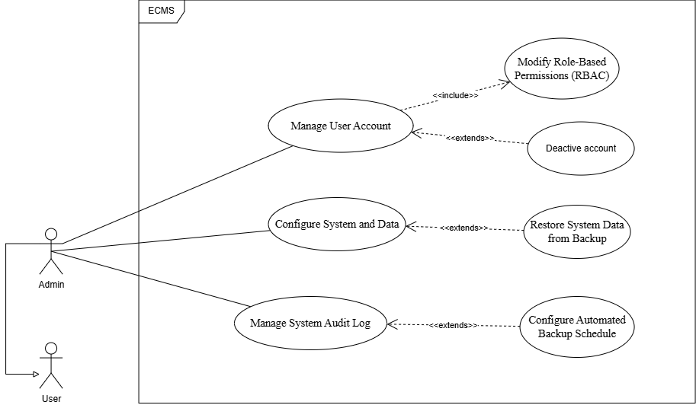
This diagram illustrates the system administration and maintenance functions.
- Actor: Admin (inherits from the general User).
- Key Capabilities:
  - User Management: Manages user accounts, which includes modifying role-based permissions (RBAC) and deactivating accounts.
  - System Configuration: Manages system data backup schedules, restores data, and configures core system settings.
  - Security & Auditing: Reviews and manages the system audit logs to monitor platform activities.

1.3.3.9. UCs for Nurse
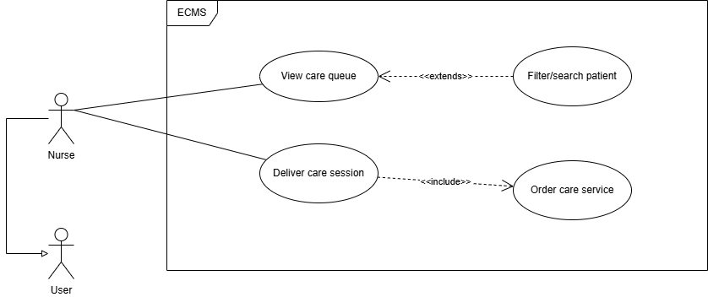
This diagram highlights basic patient care assistance and nursing queue tasks.
- Actor: Nurse (inherits from User).
- Key Capabilities:
  - Care Queue Management: Views, searches, and filters patients currently waiting for standard clinical care.
  - Care Delivery: Delivers specialized care sessions and requests/orders care services as prescribed.

1.4. System Functionalities

1.4.1. Screens Flow
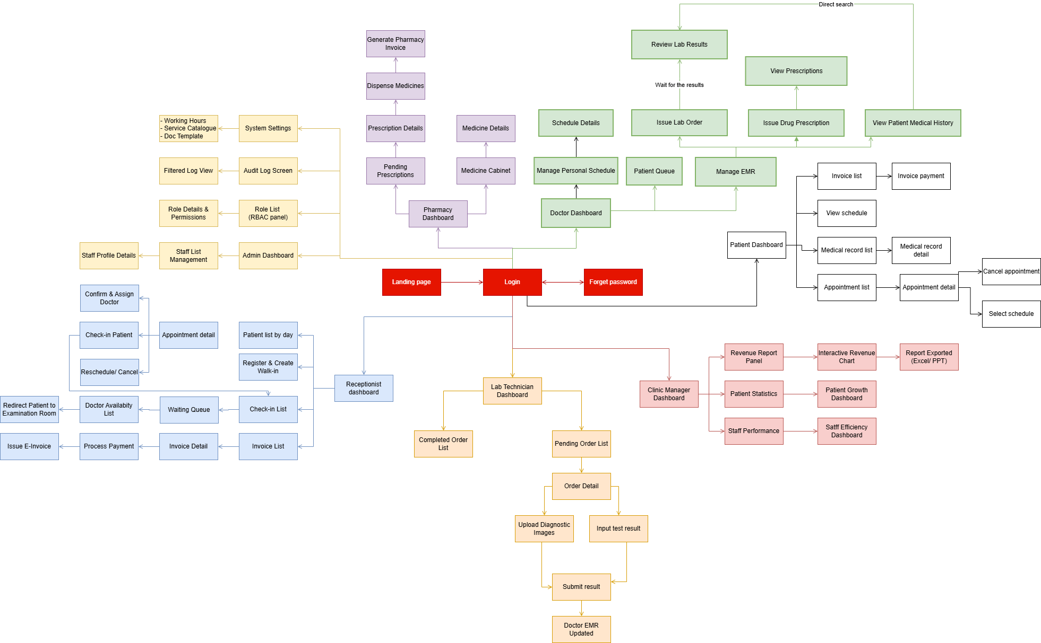

1.4.1.1. Screen flow for Patient:
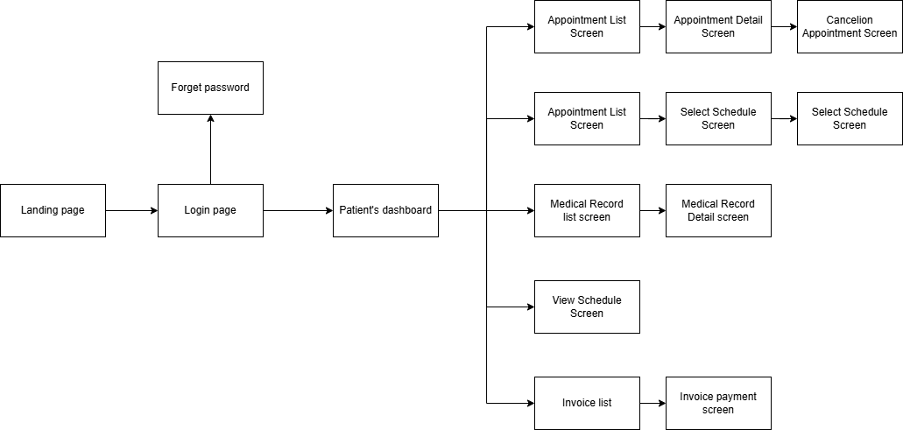

1.4.1.2. Screen flow for Receptionist:
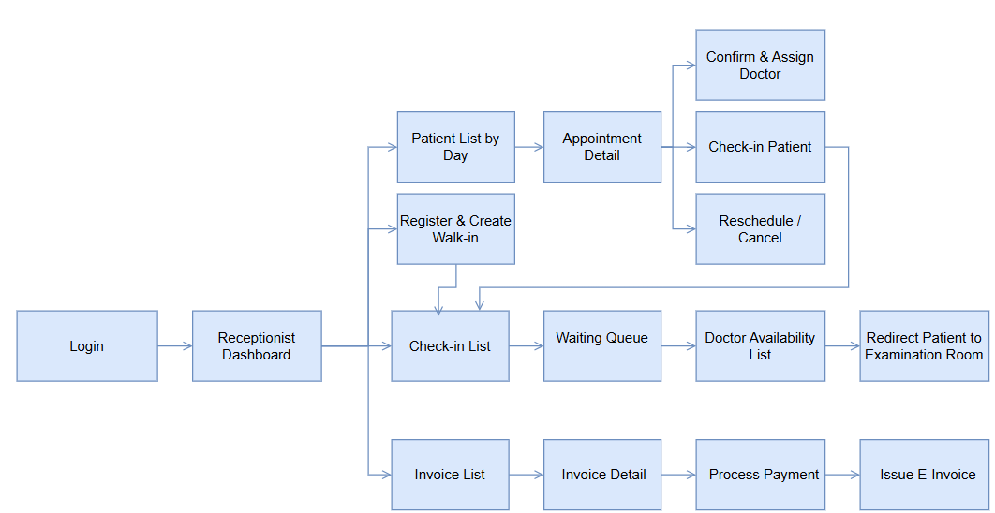

1.4.1.3. Screen flow for Doctor:
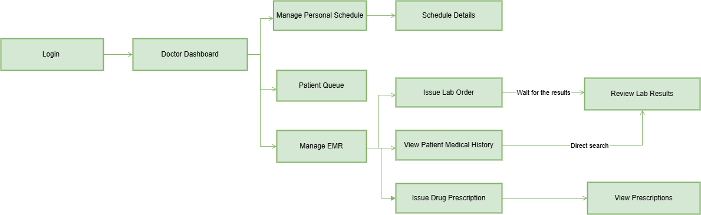

1.4.1.4. Screen flow for Lab Technician:
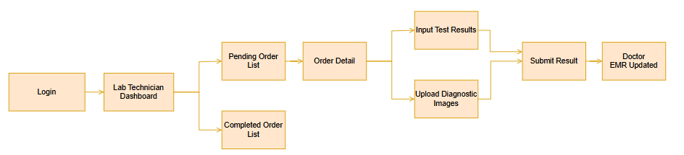

1.4.1.5. Screen flow Clinic Manager: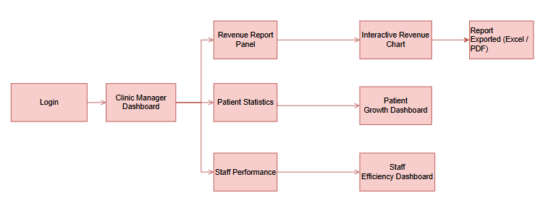

1.4.1.6. Screen flow for Pharmacist:
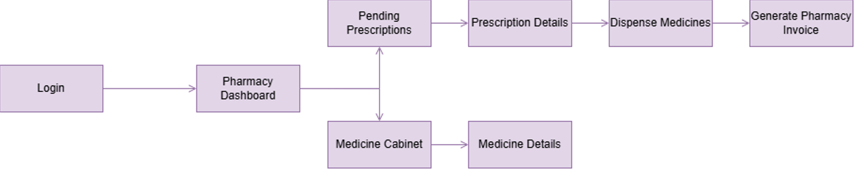

1.4.1.7. Screen flow for Admin: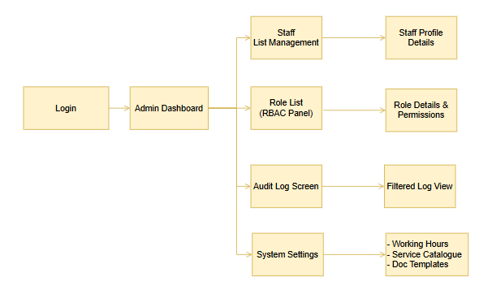

1.4.2. Screen Authorization
X = Full access | ✓(view) = view only | ✓(personal) = personal data| Blank = no access
Screen | Patient | Receptionist | Doctor | Lab Tech | Pharmacist | Nurse | Manager | Admin
Login / Register | X | X | X | X | X | X | X | X
Forgot password | X | X | X | X | X | X | X | X
Home page | X | X | X | X | X | X | X | X
Dashboard | X | X | X | X | X | X | X | X
Personal Profile | X | X | X | X | X | X | X | X
Change Password | X | X | X | X | X | X | X | X
Booking Appointment | X | X
Appointment Detail | X | X | ✓(view) |  |  |  | ✓(view)
View Medical History | X |  | X
Interact with Chatbot | X
Electronic Medical Report (EMR) | ✓(view) |  | X | ✓(view) | ✓(view) |  | ✓(view)
Prescription & Eyeglasses | ✓(view) |  | X | ✓(view) | X
Examination & Diagnosis | ✓(view) |  | X | X
Billing & Invoicing | ✓(view) | X |  |  | X | X | ✓(view)
Reporting & Analysis |  |  |  |  |  |  | X
Staff & Schedule Management |  | X | ✓(personal) | ✓(personal) |  |  | X | X
System Configuration & RBAC |  |  |  |  |  |  |  | X
Audit Logs |  |  |  |  |  |  |  | ✓(view)

1.4.3. Non-UI Functions
STT | Module | Function | Description | Trigger
1 | Appointment | Auto Reminder Job | The cron job runs every hour, automatically sending appointment reminder emails to patients 24 hours in advance. | Per Hour
3 | Billing | Invoice PDF Generator | The service generates a PDF electronic invoice and sends it to the patient via email immediately after payment. | On-demand
4 | Auth | Token Refresh Service | The API endpoint receives a Refresh Token, verifies its validity, and returns a new Access Token (TTL 60 minutes). | On-demand
5 | Reports | Monthly Report Generator | The Cron job at the beginning of the month automatically compiles the previous month's report (revenue, number of visits) and saves it to the database. | Beginning of the month

1.5. Entity Relationship Diagram

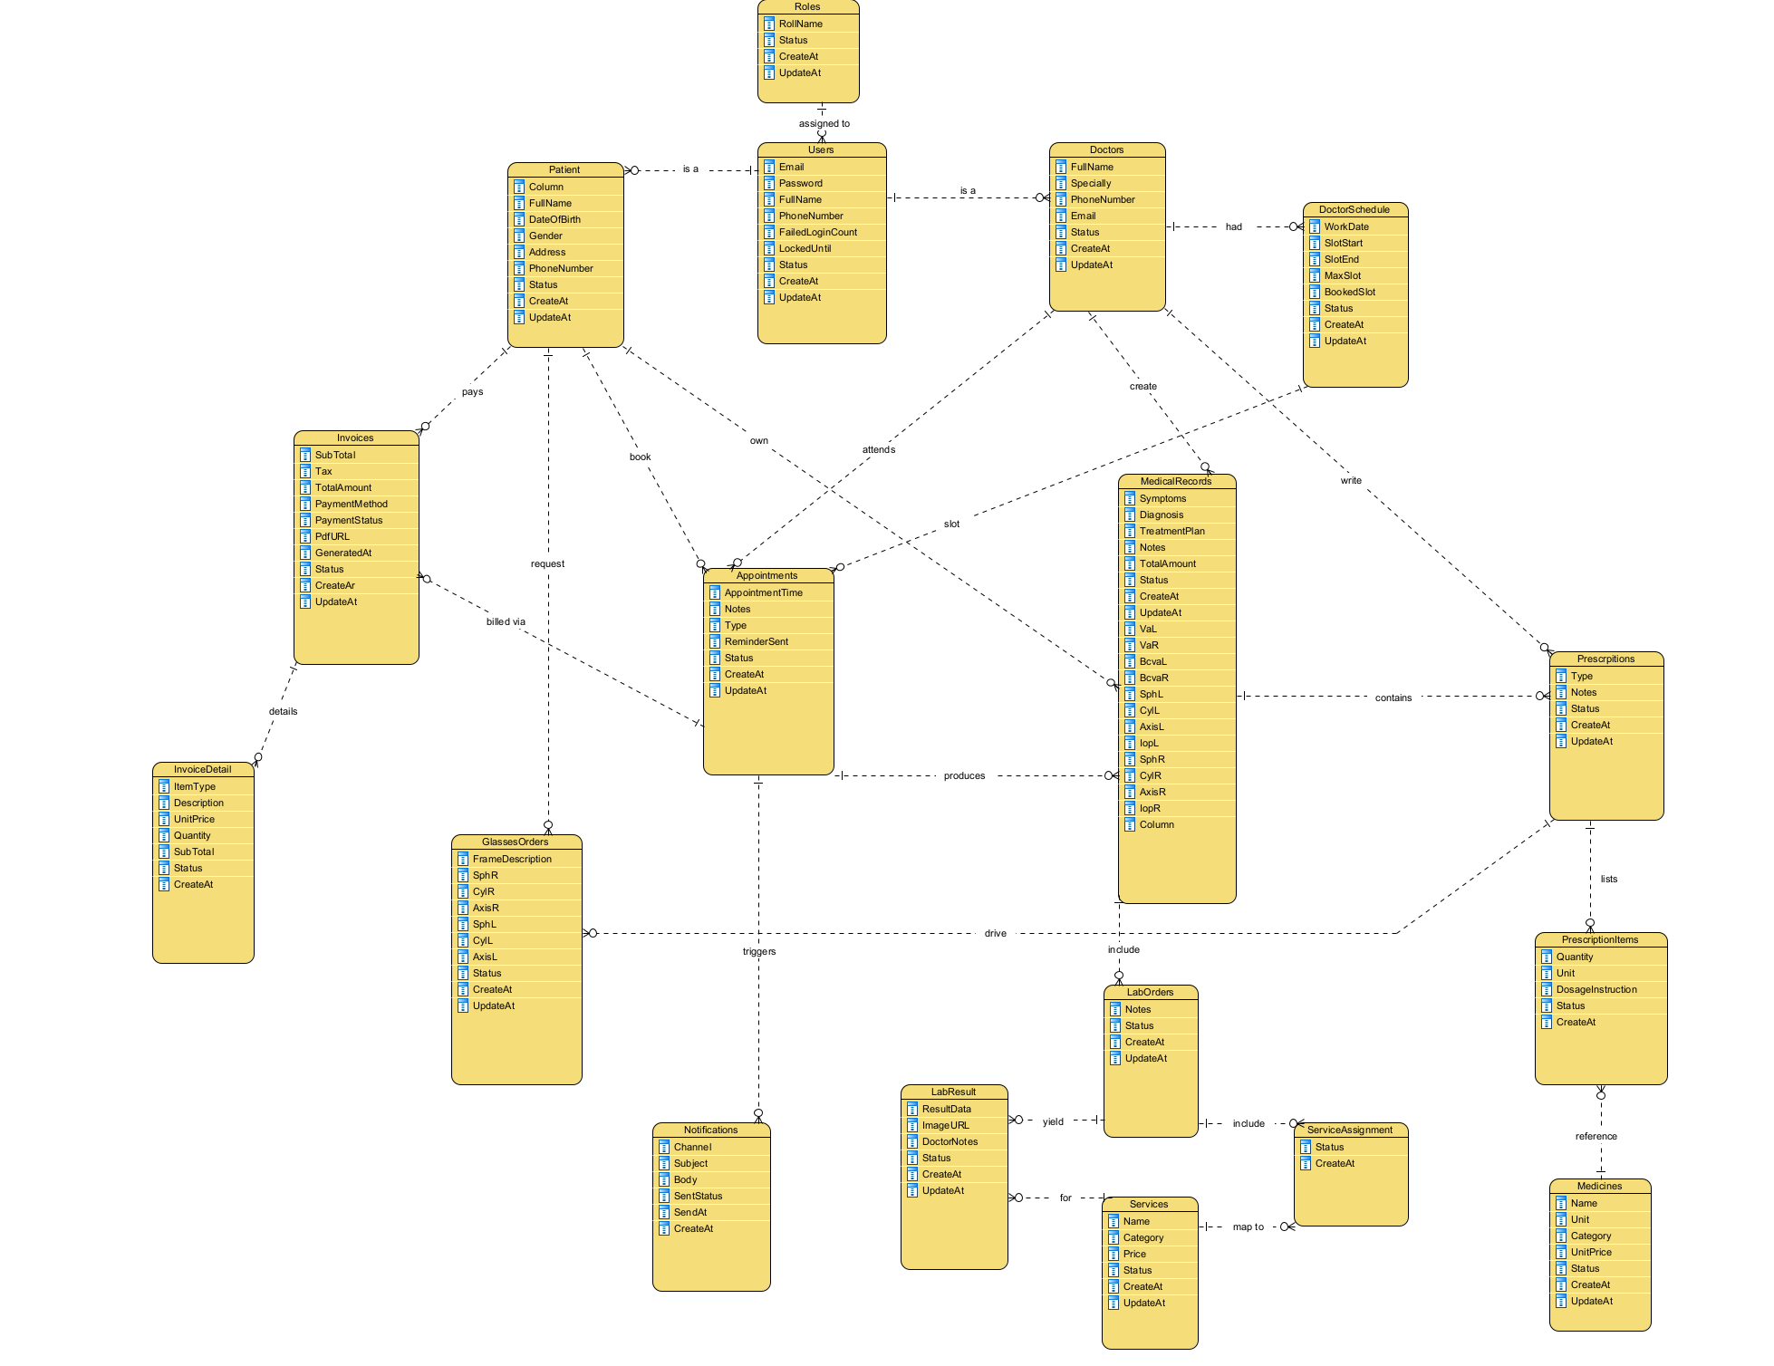

2. Use Case Specifications

2.1 Business Rules
The following Business Rules must be enforced at both layers: Frontend validation (UX) and Backend service layer (correctness). Some BRs also need to be checked at the Database level (constraints/triggers).

BR ID | Class | Rule Name | Rule Description
BR-01 | Security & Authentication | Password Policy | Passwords must be at least 8 characters long, including uppercase letters, lowercase letters, and numbers; they must be hashed using bcrypt (cost ≥ 12) before saving. Related: UC-01, UC-04, UC-06, UC-07.
BR-02 | Security & Authentication | Account Locking | After 5 incorrect login attempts within 30 minutes, the account is locked for 30 minutes. Related: UC-04.
BR-03 | Scheduling | Max Appointments per Day | Each doctor is limited to 30 appointments per workday. Related: UC-11, UC-12, UC-14, UC-15, UC-18, UC-46.
BR-04 | Scheduling | Advance Booking | Appointments must be booked at least 2 hours in advance. Related: UC-11, UC-12, UC-18, UC-46.
BR-05 | Scheduling | Cancellation Deadline | Cancellations are allowed at least 1 hour before the scheduled time. Related: UC-12, UC-16.
BR-06 | Clinical / EMR | Prescription Authority | Only licensed doctors can create prescriptions. Related: UC-28, UC-29.
BR-07 | Pharmacy | Dispensing | Medication dispensing. Related: UC-38.
BR-08 | Data Privacy & Security | EMR Confidentiality | Records accessible only by the assigned doctor and patient. Related: UC-26, UC-27, UC-31, UC-44, UC-45.
BR-09 | Data Integrity | No Hard Delete | Soft-delete/deactivate only for business records. Related: UC-26, UC-28, UC-37, UC-42, UC-53, UC-55, UC-56.
BR-10 | Billing & Payment | Invoice Insurance | Invoice status only changes to PAID upon full payment. Related: UC-16, UC-20, UC-21, UC-39.
BR-11 | Billing & Payment | Invoice Calculation | Total bill = Examination fee + Lab fee + Medicine fee - Discount. Related: UC-16, UC-20, UC-43.
BR-12 | Scheduling / Queue | Queue Uniqueness | Queue number is unique per (doctor, work day) assigned in arrival order. Related: UC-15, UC-17.
BR-13 | Scheduling | Reassignment Lock | Cannot reschedule appointments once IN_PROGRESS or COMPLETED. Related: UC-18.
BR-14 | Service Package | Subscription Consumption | Each CareSession booking deducts 1 session from subscription. Related: UC-40.
BR-15 | Billing / Promotion | Discount Stacking | Only one discount program per invoice, unless explicitly combinable. Related: UC-43.
BR-16 | Scheduling | Care Session Capacity | Max daily sessions per nurse configured by Clinic Manager. Related: UC-19.
BR-17 | Administration / Payroll | Payroll Authority | Only Clinic Manager can approve payroll. Related: UC-53.
BR-18 | Billing / Fulfillment | Eyeglass Pickup | Cannot confirm delivery if invoice is UNPAID. Related: UC-21.
BR-19 | Service Package | Subscription Validity | Package valid from date of payment confirmation. Related: UC-40, UC-40.
BR-20 | Sales / Clinical | Eyeglass Order | Requires ISSUED prescription; warning if >24 months old. Related: UC-41.
BR-21 | Patient Experience | One Feedback | Maximum one feedback per appointment. Related: UC-47.
BR-22 | Scheduling | Reschedule Restriction | Only PENDING or CONFIRMED appointments can be rescheduled. Related: UC-12a.
BR-23 | Scheduling | Reschedule Reset | Rescheduled appointments reset status to PENDING. Related: UC-12a.
BR-24 | Clinical / EMR | Clinical Safety Check | System blocks prescribing allergens without a written medical justification. Related: UC-29.
BR-25 | Customer Service | Transcript Immutability | Chat messages are read-only and cannot be edited or deleted. Related: UC-22.
BR-26 | Order Management | Deposit Requirement | An eyeglass order cannot be transitioned to CONFIRMED status until the required deposit payment is fully collected from the patient. Related: UC-25.
BR-27 | Order Management | Modification Restrictions | An eyeglass order can only be updated (changing frames or coatings) or cancelled while it is in the PENDING state. Modifications are blocked once the order is confirmed. Related: UC-25.
BR-28 | Order Management | Price Recalculation | When an order is updated, the system must automatically recalculate the total amount based on the latest frame and coating prices from the catalog. Related: UC-25.
BR-29 | Order Management | Cancellation Justification | A mandatory cancellation reason must be provided by the Receptionist when cancelling an order to maintain an audit trail. Related: UC-25.

2.2 — Authentication & Account Management

UC-01: Register User Account

UC ID & Name | UC-01: Register User Account
Primary Actor | Guest
Secondary Actors | System (email verification service)
Trigger | Guest clicks the 'Register' button on the Login/Register screen.
Description | A Guest fills in the registration form with personal details (full name, email, password, phone number, date of birth). The system creates a new Patient account with status = PENDING_VERIFICATION and sends an email verification link to activate the account.
Preconditions | PRE-1: The guest accesses the public Login/Register screen.  PRE-2: The email address provided is not already registered in the system.
Postconditions | POST-1: A new record is created in the users table with role = PATIENT and status = PENDING_VERIFICATION.  POST-2: The patient receives an email with a time-limited activation link.  POST-3: After clicking the link, account status transitions to ACTIVE.
Normal Flow | 1. Guest navigates to the Login/Register screen and selects 'Register'.  2. Guest fills in: full name, email, password, confirm password, phone number, date of birth.  3. System validates all required fields and format rules (E1, E2).  4. System hashes the password using bcrypt (cost ≥ 12) and creates the account record.  5. System sends a verification email containing a one-time activation link (valid 24 hours).  6. Guest opens the email and clicks the activation link.  7. System verifies the token, sets account status = ACTIVE.  8. System redirects the guest to the Login screen with a success message.
Alternative Flows | None
Exceptions | E1 — Email already registered:  System displays 'This email is already registered. Please log in.' Guest is redirected to the Login screen.  E2 — Password does not meet policy (BR-01):  System highlights the password field and displays: 'Password must be at least 8 characters, including uppercase, lowercase, and a digit.' Guest corrects and resubmits.  E3 — Activation link expired:  System displays: 'This activation link has expired. Request a new one?' Guest may request a fresh link.
Priority | Must Have
Frequency of Use | Low; primarily during initial patient onboarding
Business Rules | BR-01 (Password Policy)
Assumptions | Guest has a valid email address. SMTP service is available.

UC-02: View Home Page

UC ID & Name | UC-02: View Home Page
Primary Actor | Guest
Secondary Actors | None
Trigger | User navigates to the root URL of ECMS or clicks the clinic logo/Home link.
Description | Any visitor (authenticated or unauthenticated) can access the public home page, which displays clinic information, featured services, announcements, quick-access links (Book Appointment, Login, Register), and the AI chatbot entry point.
Preconditions | PRE-1: The ECMS web application is running and reachable.
Postconditions | POST-1: The home page is rendered successfully with up-to-date clinic content.
Normal Flow | 1. User opens the browser and navigates to the ECMS root URL.  2. System loads and displays the home page, including: clinic name, address, contact details, service highlights, news/announcements, and quick-action buttons.  3. Authenticated users additionally see a personalised greeting and a link to their dashboard.  4. Guest sees 'Book Appointment', 'Login', and 'Register' call-to-action buttons.
Alternative Flows | ALT-1: Authenticated user lands on home page:  System shows role-appropriate greeting and redirects to the dashboard if the user clicks 'Go to Dashboard'.
Exceptions | E1 — Server unavailable:  Browser shows a generic error page. No ECMS content is displayed.
Priority | Must Have
Frequency of Use | High; accessed by every visitor session
Business Rules | —
Assumptions | Home page content (clinic info, announcements) is managed by Admin via System Configuration.

UC-03: View Blog List

UC ID & Name | UC-03: View Blog List
Primary Actor | Guest
Secondary Actors | None
Trigger | User clicks 'Blog' or 'Eye Care Articles' in the navigation menu.
Description | Any visitor can browse a paginated list of published eye care articles and clinic news. Each entry shows a title, summary, publication date, and category tag. Clicking an article opens its full content.
Preconditions | PRE-1: At least one published blog post exists in the system.
Postconditions | POST-1: The blog list is displayed with current published articles.
Normal Flow | 1. User clicks 'Blog' in the navigation menu.  2. System retrieves all published blog posts and displays them as cards, sorted by publication date (newest first).  3. Each card shows: title, category, thumbnail, publication date, and a short excerpt.  4. User may filter by category (e.g., Eye Health, Clinic News, Treatments).  5. User clicks a card to read the full article.
Alternative Flows | ALT-1 — No posts published yet:  System displays: 'No articles available yet. Check back soon.'
Exceptions | None
Priority | Should Have
Frequency of Use | Moderate; informational access by patients and guests.
Business Rules | —
Assumptions | Blog content is created and published by the Clinic manager.

UC-04: View Doctor List

UC ID & Name | UC-04: View Doctor List
Primary Actor | Guest
Secondary Actors | None
Trigger | User navigates to the homepage and scrolls down to the "Bác sĩ - Chuyên gia" (Doctors/Specialists) section.
Description | On the homepage, any visitor can view a curated list of specialist cards. This list is managed independently by the Admin/Clinic Manager through a separate use case (e.g., "Manage Specialist Cards"), and is not automatically synchronized with the clinic's actual roster of employed doctors — i.e., a doctor currently working at the clinic is not guaranteed to appear here, and the reverse may also be true. Each card shows an avatar, full name (with title, e.g. "BS."), years of experience, and specialty. Clicking "Chi tiết" opens that specialist's detail page.
Preconditions | PRE-1: At least one specialist card has status "Active/Published" in the system.
Postconditions | POST-1: The list of specialist cards is displayed correctly on the homepage.
Normal Flow | 1. User accesses the homepage.  2. User scrolls down to the "Bác sĩ - Chuyên gia" section.  3. System retrieves and displays all specialist cards with status = Active, each showing avatar, full name, years of experience, and specialty.  4. User clicks "Chi tiết" on a card.  5. System navigates to the specialist's detail page and displays full information.
Alternative Flows | AF-1: If there are no active specialist cards, the section is hidden or shows a placeholder — cần xác nhận hành vi thực tế
Exceptions | EX-1: If data fails to load (API/network error), the section renders an empty state.
Priority | Must Have
Frequency of Use | High; prominent informational access point for patients and guests on the homepage
Business Rules | —
Assumptions | Specialist cards are content entities managed independently of actual doctor employment records, via a separate back-end use case (Manage Specialist Cards), owned by Admin/Clinic Manager. Doctor profiles are maintained by the Admin or Clinic Manager.

UC-05: Log In

UC ID & Name | UC-05: Log In
Primary Actor | User, Patient, Receptionist, Lab Technician, Doctor, Pharmacist, Clinic Manager, Admin
Secondary Actors | Google Identity Platform (for OAuth login)
Trigger | User navigates to the Login screen, or the system redirects an unauthenticated request to Login.
Description | Any registered user logs in with email/password or Google OAuth 2.0. The system authenticates credentials, enforces account-lock policy, issues a JWT Access Token and Refresh Token, and redirects the user to their role-specific dashboard.
Preconditions | PRE-1: The account exists in the system with status = ACTIVE.  PRE-2: The user's email has been verified.
Postconditions | POST-1: JWT Access Token (TTL = 60 min) and Refresh Token (TTL = 7 days) are issued.  POST-2: Refresh Token is stored in an HttpOnly cookie.  POST-3: User is redirected to their role dashboard.  POST-4: Login event is recorded in the Audit Log.
Normal Flow | 1. User enters email and password on the Login screen.  2. System validates credentials against stored bcrypt hash (E1, E2, E3).  3. System issues JWT Access Token and Refresh Token.  4. System records the login event in the Audit Log.  5. System redirects based on role:  - Patient → Patient Portal  - Doctor → EMR Dashboard  - Receptionist → Appointment Management  - Lab Technician → Lab Queue  - Pharmacist → Dispensing Dashboard  - Clinic Manager → Reports Dashboard  - Admin → Admin Panel
Alternative Flows | ALT-1 — Google OAuth Login (FR-02, Should Have):  1. User clicks 'Sign in with Google'.  2. System redirects to Google Identity Platform.  3. Google authenticates and returns an ID token callback.  4. System validates the token, maps the Google account to a local account (by email).  5. If matched, proceed from normal flow step 3.  6. If no match, system pre-fills registration form and prompts account creation.
Exceptions | E1 — Incorrect password:  System increments login_fail_count. If count = 5 within 30 minutes, account is locked for 30 minutes (BR-02). System displays remaining attempts.  E2 — Account locked (BR-02):  System displays: 'Account locked. Try again in X minutes, or contact support.'  E3 — Email not verified:  System displays: 'Please verify your email first.' with option to resend the verification link.
Priority | Must Have
Frequency of Use | Very high; every user session
Business Rules | BR-01 (Password Policy), BR-02 (Account Locking)
Assumptions | SMTP available for re-send verification emails. Google OAuth credentials configured for Should Have scope.

UC-06: Log Out

UC ID & Name | UC-06: Log Out
Primary Actor | User, Patient, Receptionist, Lab Technician, Doctor, Pharmacist, Clinic Manager, Admin
Secondary Actors | None
Trigger | Authenticated user clicks the 'Log Out' button from any screen.
Description | The user explicitly terminates their session. The system revokes the Refresh Token, clears the client-side JWT, and redirects to the Login screen.
Preconditions | PRE-1: User has an active authenticated session.
Postconditions | POST-1: Refresh Token is invalidated server-side.  POST-2: HttpOnly Refresh Token cookie is cleared on the client.  POST-3: User is redirected to the Login screen.  POST-4: Logout event is recorded in the Audit Log.
Normal Flow | 1. User clicks 'Log Out' from the navigation menu or user-profile dropdown.  2. Client sends the Refresh Token to the logout endpoint.  3. System invalidates the Refresh Token in the database.  4. System clears the HttpOnly cookie on the client.  5. System records the logout event.  6. System redirects the user to the Login screen.
Alternative Flows | ALT-1 — Session expired (Access Token TTL exceeded):  1. Client detects a 401 response on any API call.  2. Client automatically sends the Refresh Token to renew the Access Token.  3. If the Refresh Token is valid, a new Access Token is issued and the action retries.  4. If the Refresh Token is expired or revoked, the system forces logout and redirects to Login.
Exceptions | None
Priority | Must Have
Frequency of Use | Once per session
Business Rules | —
Assumptions | —

UC-07: Reset Forgotten Password

UC ID & Name | UC-07: Reset Forgotten Password
Primary Actor | User
Secondary Actors | System (email service)
Trigger | User clicks 'Forgot Password?' on the Login screen.
Description | A user who has forgotten their password requests a reset. The system sends a one-time reset link to the registered email. The user sets a new compliant password, and all existing sessions are invalidated.
Preconditions | PRE-1: An account with the provided email exists and is ACTIVE.
Postconditions | POST-1: New bcrypt-hashed password replaces the previous one.  POST-2: All existing Refresh Tokens for the account are revoked.  POST-3: Password reset event is logged in the Audit Log.
Normal Flow | 1. User clicks 'Forgot Password?' on the Login screen.  2. System displays an email input field.  3. User enters their registered email address.  4. System generates a one-time reset token (valid 15 minutes).  5. System sends a password reset email with the token link.  6. User clicks the link; system validates the token (E2).  7. System displays the New Password form.  8. User enters and confirms the new password.  9. System validates against BR-01 (E3).  10. System hashes and saves the new password.  11. System revokes all existing Refresh Tokens for this account.  12. System shows success message and redirects to Login.
Alternative Flows | None
Exceptions | E1 — Email not found:  System shows a generic response: 'If this email is registered, a reset link has been sent.' (prevents user enumeration)  E2 — Reset token expired or invalid:  System displays: 'This link has expired or is invalid. Please request a new one.' User is redirected to the Forgot Password screen.  E3 — New password fails policy:  System displays BR-01 requirements inline and prompts the user to retry.
Priority | Must Have
Frequency of Use | Low; occasional per user
Business Rules | BR-01 (Password Policy)
Assumptions | SMTP service is operational. Token TTL = 15 minutes.

UC-08: Change Account Password

UC ID & Name | UC-08: Change Account Password
Primary Actor | User, Patient, Receptionist, Lab Technician, Doctor, Pharmacist, Clinic Manager, Admin
Secondary Actors | None
Trigger | User navigates to Profile Settings → 'Change Password'; or system forces a change on first login with a temporary password.
Description | An authenticated user changes their current password. The user must supply the existing password for verification before setting a new one that meets the security policy.
Preconditions | PRE-1: User is authenticated.  PRE-2: User knows their current password (or is in forced-change mode on first login).
Postconditions | POST-1: New bcrypt-hashed password is stored.  POST-2: All other active Refresh Tokens (other devices) are invalidated.  POST-3: Event recorded in Audit Log.
Normal Flow | 1. User navigates to Profile Settings → Change Password.  2. System displays fields: Current Password, New Password, Confirm New Password.  3. User fills in all fields.  4. System verifies Current Password matches the stored hash (E1).  5. System validates New Password against BR-01 (E2).  6. System hashes and stores the new password.  7. System invalidates for this account.  8. System displays: 'Password changed successfully.'
Alternative Flows | ALT-1 — Forced change on first login:  1. System detects first_login_flag = true immediately after authentication.  2. System redirects to the Change Password screen before the role dashboard is accessible.  3. After successful change, first_login_flag is cleared and user proceeds to their dashboard.
Exceptions | E1 — Current password incorrect:  System displays: 'Current password is incorrect.' Field is cleared; user retries.  E2 — New password fails policy (BR-01):  System displays the requirements inline. Changes are not saved.
Priority | Must Have
Frequency of Use | Low; occasional per user
Business Rules | BR-01 (Password Policy)
Assumptions | —

UC-09: Manage Personal Profile
UC ID & Name | UC-09: Manage Personal Profile
Primary Actor | User, Patient, Receptionist, Lab Technician, Doctor, Pharmacist, Clinic Manager, Admin
Secondary Actors | None
Trigger | User clicks their avatar or 'Profile' in the navigation menu.
Description | Any authenticated user views and updates their personal profile (full name, phone, date of birth, address, profile photo). Email and role fields are read-only and can only be modified by Admin.
Preconditions | PRE-1: User is authenticated.
Postconditions | POST-1: Updated profile data is persisted to the users table (and the relevant role-specific table, e.g., patients or doctors).
Normal Flow | 1. User navigates to the Profile page.  2. System displays current profile information in an editable form.  3. User modifies editable fields (name, phone, DOB, address, photo).  4. User clicks 'Save Changes'.  5. System validates inputs (required fields, phone format, valid date).  6. System saves the updates and displays a success notification.
Alternative Flows | None
Exceptions | E1 — Validation failure:  System highlights the invalid fields with descriptive messages. Changes are not saved until all errors are resolved.
Priority | Must Have
Frequency of Use | Occasional; per user preference
Business Rules | —
Assumptions | Email and role changes require Admin access.

UC-10: Receive System Notification

UC ID & Name | UC–10: Receive System Notification
Primary Actor | User, Patient, Receptionist, Doctor, Pharmacist, Lab Technician, Clinic Manager
Secondary Actors | System (notification engine, email service)
Trigger | A system event occurs that generates a notification (appointment confirmed, prescription ready, lab result uploaded, invoice issued, etc.).
Description | The system automatically delivers in-app notifications and email alerts to relevant actors when key workflow events occur. Users can view their notification history and mark notifications as read.
Preconditions | PRE-1: Recipient is a registered, ACTIVE user.  PRE-2: A triggering event has occurred within ECMS.
Postconditions | POST-1: Notification record created in the database and linked to the recipient.  POST-2: In-app notification badge count increments in real time.  POST-3: Email notification dispatched if the event qualifies (SMTP available).
Normal Flow | 1. A workflow event triggers notification creation (e.g., Receptionist confirms appointment).  2. System creates a notification record for the target user.  3. System pushes the notification to the user's in-app notification bell via WebSocket.  4. System sends an email notification for qualifying events.  5. User clicks the notification bell to open the notification panel.  6. System lists notifications (unread and read) with timestamps and brief descriptions.  7. User clicks a notification to navigate to the relevant screen.  8. System marks the notification as read.
Alternative Flows | ALT-1 — Mark all as read:  1. User clicks 'Mark all as read'.  2. System updates all unread notifications for the user to read status and resets the badge count to 0.
Exceptions | E1 — Email delivery failure:  System logs the failed attempt and retries up to 3 times at 5-minute intervals. In-app notification is always delivered regardless of email status.
Priority | Must Have
Frequency of Use | Multiple times per day per active user
Business Rules | —
Assumptions | Real-time delivery uses WebSocket or server-sent events. Email via Gmail SMTP / SendGrid.

UC-11: Interact with AI Chatbot (ECMS-Bot)
UC ID & Name | UC-11: Interact with AI Chatbot (ECMS-Bot)
Primary Actor | Patient
Secondary Actors | Receptionist (on escalation only)
Trigger | Patient clicks the chatbot icon on the Patient Portal.
Description | The Patient uses the ECMS-Bot to ask about clinic services, review FAQs on eye care, and get basic self-service guidance.  The bot answers common informational queries autonomously from an approved knowledge base and escalates complex or sensitive queries to a human Receptionist.  The bot may guide the patient on HOW to complete tasks (e.g., how to pay an invoice, where to view a prescription), but does not execute transactions on the patient's behalf, access personal medical or appointment records, or perform appointment booking.  The bot does not provide medical diagnosis; symptom-related questions are answered with general information and a recommendation to consult a doctor.
Preconditions | PRE-1: Patient is authenticated on the Patient Portal.
Postconditions | POST-1: Conversation session is logged.  POST-2: If escalated, a support request notification is sent to the Receptionist.
Normal Flow | 1. Patient clicks the chatbot icon to open the chat panel.  2. ECMS-Bot greets the patient and presents quick-reply options: Clinic Info, Services & Pricing, Eye Care FAQs.  3. Patient selects an option or types a free-text query.  4. System classifies the query intent and generates a contextual response from the approved knowledge base.  5. Patient receives the response and may continue the conversation or close the panel.  6. System logs the complete conversation.
Alternative Flows | ALT-1 - Escalate to human Receptionist:  1. Patient asks a query the bot cannot resolve with sufficient confidence (confidence below the configured threshold).  2. Bot responds: 'I'll connect you with our receptionist for further assistance.'  3. System creates a support request notification for the on-duty Receptionist.  ALT-2 - Medical or symptom-related query:  1. Patient describes symptoms or asks for a diagnosis.  2. Bot provides general eye-care information only and recommends booking an appointment or consulting a doctor; it does not diagnose (per BR-13).  3. If the patient needs further assistance, the bot escalates to the Receptionist (per ALT-1).
Exceptions | E1 - AI service unavailable:  System displays: 'Our chat assistant is temporarily unavailable. Please call our hotline or send us an email.'
Priority | Should Have
Frequency of Use | Varies; primarily for self-service patient queries
Business Rules | BR-13 (No Medical Diagnosis): The bot must not provide medical diagnosis, treatment decisions, or personalized clinical advice. Symptom-related queries receive general information only, plus a recommendation to book an appointment or consult a doctor.  BR-14 (Knowledge-Base Grounding): The bot answers only from the approved FAQ / clinic-info knowledge base. If no answer meets the configured confidence threshold, it must escalate (ALT-1) instead of generating an unverified answer.  BR-15 (No Transaction or Record Access): The bot may explain how to complete a task but must not execute transactions (e.g., payment) or display personal medical/appointment records; it directs the patient to the relevant Patient Portal function.
Assumptions | Chatbot NLP/NLU backend integrated via REST API.  Bot response confidence threshold configurable by Admin.  Bot answers are generated from a curated FAQ / clinic-info knowledge base; appointment booking and personal record lookups are out of scope for this use case.

2.3 — Reception & Scheduling

UC-12: Book Appointment Online

UC ID & Name | UC-12: Book Appointment Online
Primary Actor | Patient
Secondary Actors | System (email confirmation service)
Trigger | Patient clicks 'Book Appointment' on the Patient Portal or Home Page.
Description | An authenticated Patient selects a doctor by specialty, chooses an available date and time slot, and confirms an online booking. The system creates an appointment record with status = PENDING and sends an email confirmation.
Preconditions | PRE-1: Patient is logged in.  PRE-2: Patient has a valid email address.
Postconditions | POST-1: Appointment record saved in the appointments table with status = PENDING and the selected doctor assigned.  POST-2: Patient receives a booking confirmation email.  POST-3: Receptionist receives a notification of the new pending appointment.
Normal Flow | 1. Patient navigates to the Appointment Booking screen.  2. Patient selects a doctor with a medical specialty from the filtered list.  3. System displays the doctor's availability calendar for the next 30 days.  4. Patient selects a date; system displays available time slots for that date.  5. Patient selects a time slot (E1, E2).  6. System displays a booking summary (doctor name, date, time).  7. Patient fills a form requiring their information.  8. Patient reviews and confirms.  9. System creates the appointment record (status = PENDING).  10. System sends a confirmation email to the patient.  11. System redirects the patient to 'My Appointments'.
Alternative Flows | Step 7 — Book on behalf of a family member:  1. Patient selects 'Book for someone else' and enters the family member's required information.  2. System continues from step 8 of the normal flow, linking the appointment to the logged-in patient account.
Exceptions | E1 — No available slots on selected date:  System displays: 'No slots available for this doctor on the selected date.' Patient selects a different date or cancels.  E2 — Booking too close to appointment time:  System displays: 'Appointments must be booked at least 2 hours in advance.' Patient selects a later slot.
Priority | Must Have
Frequency of Use | Estimated 50–200 bookings/day; peak 07:00–09:00 and 14:00–16:00
Business Rules | BR-03 (Max Appointments/Day), BR-04 (Advance Booking)
Assumptions | Patient has an active account.

UC-13: Manage Appointment
UC ID & Name | UC-13: Manage Appointment
Primary Actor | Patient, Receptionist
Secondary Actors | System (in-app notification service; no email is sent).
Trigger | Patient accesses 'My Appointments'; or Receptionist opens the Appointment Management screen.
Description | The Patient views, reschedules, and cancels their own upcoming appointments, subject to a minimum notice period. The Receptionist, Manager, or Admin views and cancels any patient's appointment on the patient's behalf; the Reschedule action in this use case is available to the Patient only. Reassigning the doctor or time slot on the patient's behalf is a separate use case, Reassign Appointment.
Sub-Use Cases | UC-13a: View Appointment  UC-13b: Reschedule/ Cancel Appointment

UC-13a: View Appointment
UC ID & Name | UC-13a: View Appointment
Primary Actor | Patient, Receptionist
Secondary Actors | None.
Trigger | Patient accesses 'My Appointments'; or Receptionist opens the Appointment Management screen.
Description | The Patient views all of their own appointments — upcoming, completed, and cancelled — with search and status filters. The Receptionist views all appointments and service care sessions for a selected day, week, or month, with status and doctor filters.
Preconditions | PRE-1: The actor is authenticated with the appropriate role.  PRE-2: The appointment list is scoped to the actor: the Patient's own appointments, or the Receptionist's selected date or date range.
Postconditions | POST-1: The appointment list or appointment detail is displayed to the actor.  POST-2: No appointment data is created, modified, or deleted.
Normal Flow | 1. Actor navigates to the appointment screen My Appointments for the Patient; Dashboard for the Receptionist.  2. System retrieves and displays the appointment list scoped to the actor (PRE-2).  3. Actor applies a search term, a status filter, or a date navigation control.  4. System displays each appointment with its time, doctor/nurse, service, and status; a cancelled appointment additionally shows its cancellation reason.  5. Actor selects an appointment to view its detail.
Alternative Flows | Step 3:  A1: No appointment matches the current filter or date: System displays an empty-state message. Use case ends.  A2: Receptionist selects Week or Month view: System retrieves the date range and displays a read-only grid of appointments; selecting a date returns to Day view for that date.
Exceptions | E1 (at step 2): The appointment list fails to load. Actors may retry.
Priority | Must Have
Frequency of Use | Multiple times/day for Receptionist; occasional for Patients
Business Rules | None. View Appointment is read-only and enforces no booking, cancellation, or reschedule rule.
Assumptions | System clock is synchronised to the clinic's local timezone (UTC+7).

UC-13b: Reschedule/ Cancel Appointment
UC ID & Name | UC-13b: Reschedule/ Cancel Appointment
Primary Actor | Patient
Secondary Actors | Receptionist, Manager, Admin (Cancel only; see Alternative Flows).
Trigger | Patient accesses 'My Appointments'; or Receptionist opens the Appointment Management screen.
Description | The Patient views, reschedules, and cancels their own upcoming appointments, subject to a minimum notice period. The Receptionist, Manager, or Admin views and cancels any patient's appointment on the patient's behalf; the Reschedule action in this use case is available to the Patient only. Reassigning the doctor or time slot on the patient's behalf is a separate use case, Reassign Appointment.
Preconditions | PRE-01: The actor is authenticated.  PRE-02a (Cancel): The appointment exists and its status is not CANCELLED and not COMPLETED.  PRE-02b (Reschedule): The appointment exists and its status is PENDING or CONFIRMED (BR-22).  PRE-03: If the actor is the Patient, the appointment belongs to that actor.
Postconditions | POST-01a (Cancel by Patient): appointment.status = CANCELLED; cancelReason, cancelledAt, and cancelledBy are recorded.  POST-01b (Cancel by Receptionist/Manager/Admin): appointment.status = CANCELLED; cancelReason, cancelledAt, and cancelledBy are not recorded.  POST-02 (Reschedule): appointment.appointmentTime is updated; appointment.status is reset to PENDING; the Receptionist role group receives an in-app notification.
Normal Flow | 1. Actor opens the appointment list and selects an appointment.  2. Actor selects Cancel or Reschedule.  2a. Cancel — Patient: Actor enters a cancellation reason and confirms.  2b. Cancel — Receptionist/Manager/Admin: Actor confirms without entering a reason.  2c. Reschedule — Patient/ Receptionist: Actor specifies a new appointment date and time.  3. If the actor is the Patient, System validates that the current time precedes the appointment's scheduled time by at least 1 hour, BR-05 (→ EX-02, EX-03).  4. For Reschedule, System additionally validates that: the new time is at least 2 hours from the current time, BR-04 (→ EX-05); the new time is within clinic hours 07:30–17:00 (→ EX-06); the doctor has no other appointment at the new time (→ EX-07); and, if the new date differs from the original date, the doctor has not reached the daily appointment limit, BR-03 (→ EX-08).  5. System applies the action: for Cancel, sets status = CANCELLED and releases the time slot (POST-01a/POST-01b); for Reschedule, updates the appointment time, resets status to PENDING, and notifies the Receptionist role group (POST-02).  6. System refreshes the appointment list.
Alternative Flows | 2a-Alt. Receptionist, Manager, or Admin needs to reassign the doctor or time slot on the Patient's behalf: handled by the Reassign Appointment use case (Manager/Admin/Reception only), not by the Reschedule action described here.
Exceptions | EX-01 (at step 1): The appointment status is already CANCELLED or COMPLETED. (BR-22)  EX-02 (at step 3, Cancel): The Patient's request precedes the appointment time by less than 1 hour. System rejects the request.  EX-03 (at step 3, Reschedule): The Patient's request precedes the appointment time by less than 1 hour. System rejects the request.  EX-04 (at step 2c): No new appointment time is specified. System rejects the request.  EX-05 (at step 4): The new time is less than 2 hours from the current time. System rejects the request.  EX-06 (at step 4): The new time is outside clinic hours. System rejects the request.  EX-07 (at step 4): The doctor already has an appointment at the new time. System rejects the request.  EX-08 (at step 4): The new date differs from the original date and the doctor already has 30 appointments on the new date (BR-03). System rejects the request.
Priority | Must Have
Frequency of Use | Multiple times/day for Receptionist; occasional for Patients
Business Rules | BR-03: A doctor may not be assigned more than 30 appointments in one day; enforced on Reschedule when the new date differs from the appointment's original date.  BR-04: A new or rescheduled appointment time must be at least 2 hours in the future and within clinic hours, 07:30–17:00.  BR-05: The Patient may only cancel or reschedule their own appointment when the current time precedes the scheduled time by at least 1 hour; this restriction does not apply to Receptionist, Manager, or Admin.  BR-22: Only an appointment with status PENDING or CONFIRMED may be rescheduled.  BR-23: A successful reschedule resets the appointment's status to PENDING.
Assumptions | The system clock is synchronised to the clinic's local timezone (UTC+7).

UC-14: Send Appointment Reminder Notification

UC ID & Name | UC-14: Send Appointment Reminder Notification
Primary Actor | System (AppointmentReminderScheduler), Receptionist (manual trigger)
Secondary Actors | Patient (recipient)
Trigger | Automated: cron job runs every hour. Manual: Receptionist triggers a reminder for a specific appointment.
Description | The system automatically sends an email reminder to patients 24 hours before their confirmed appointment. Receptionists can also send an ad-hoc manual reminder at any time.
Preconditions | PRE-01: An appointment exists with status CONFIRMED.  PRE-02: The appointment is confirmed and scheduled within the next 24 hours.  PRE-03 (manual path): a Receptionist is authenticated and viewing the appointment in appointments.
Postconditions | POST-01: An in-app notification is created for the patient (only if the patient has a linked User account) describing the upcoming appointment.  POST-02: A role-broadcast notification is created for RECEPTIONIST.  POST-03: The system ensures each appointment receives at most one reminder.
Normal Flow | 1. System checks for confirmed appointments scheduled within the next 24 hours.  2. System sends a reminder notification to the patient (if they have an account) and notifies the Receptionist.  3. The notification bell polls every 30 seconds and updates its unread badge.  4. The recipient opens the bell dropdown and clicks the notification, which marks it read and navigates them.
Alternative Flows | Patient has no linked user account.  A1. The appointment's patient record has no associated User entity.  A2. The per-patient notification is skipped, but the RECEPTIONIST broadcast notification is still created.
Exceptions | EX-01 (Duplicate prevention): if reminderSent is already true for the appointment, the scheduler skips it on subsequent hourly runs.  EX-02 (No eligible appointments): if no CONFIRMED appointment falls in the 24-25h window during a given run, the scheduler performs no action that cycle.
Priority | Should Have
Frequency of Use | Automated hourly; manual as needed
Business Rules | BR-01: Reminders are sent only for CONFIRMED appointments — PENDING or CANCELLED appointments never trigger a reminder.  BR-02: A reminder is sent at most once per appointment, guarded by the reminderSent flag.  BR-03: Role-broadcast notifications (e.g., to RECEPTIONIST) share a single read-state across all members of that role; there is no per-user read tracking for broadcasts.  BR-04: No email channel is currently wired into this flow
Assumptions | The system's automated scheduler runs continuously during clinic operating hours.

UC-15: Register Walk-in Patient

UC ID & Name | UC-15: Register Walk-in Patient
Primary Actor | Receptionist
Secondary Actors | System (sends account credentials via email)
Trigger | A patient arrives at the reception counter without a prior online appointment.
Description | The Receptionist registers a walk-in visit. If the patient has an existing account, the Receptionist retrieves it. If not, the Receptionist creates a new account on the patient's behalf; the system emails temporary login credentials. A CONFIRMED appointment is created immediately — bypassing the PENDING/approval step.
Preconditions | PRE-1: Receptionist is authenticated with role Receptionist.
Postconditions | POST-1: Patient has an ACTIVE account in the system.  POST-2: Appointment created with status = CONFIRMED and a doctor assigned.  POST-3: Patient is added to the assigned doctor's Patient Queue.
Normal Flow | 1. Receptionist opens the Walk-in Registration screen.  2. System creates the account (status = ACTIVE, role = PATIENT).  3.Receptionist searches for the patient by name or phone number or CCCD.  3a. If patient found: Receptionist confirms the existing patient profile.  3b. If not found: Receptionist enters new patient details (full name, DOB, phone, email, gender, address, CCCD) and creates the account.  4. Receptionist selects a doctor and an available time slot.  5. System creates the appointment (status = CONFIRMED, doctor assigned).  6. Patient entry appears in the assigned doctor's Patient Queue.
Alternative Flows | None
Exceptions | E1 — Email already registered:  System warns: 'This email belongs to an existing account.' and loads the existing patient profile. Receptionist confirms before proceeding.
Priority | Must Have
Frequency of Use | Estimated 10–30 walk-ins/day
Business Rules | BR-03 (Max Appointments/Day)
Assumptions | Walk-in appointments are confirmed directly without a Pending/approval step.

UC-16: Check-in Patient
UC ID & Name | UC-16: Check-in Patient
Primary Actor | Receptionist
Secondary Actors | Doctor
Trigger | A scheduled patient arrives at the clinic and the Receptionist requests to register their presence.
Description | The Receptionist performs the check-in procedure. The system records the arrival time, assigns a queue number, and automatically places the patient in the corresponding Doctor's queue.
Preconditions | PRE-1: The Receptionist is authenticated.  PRE-2: The appointment is in the CONFIRMED state.
Postconditions | POST-1: The check-in time and reception staff ID are recorded.  POST-2: The appointment state is changed to WAITING and a queue number is assigned.
Normal Flow | 1. The patient provides their identity.  2. The Receptionist queries the appointment record.  3. The Receptionist confirms the check-in details.  4. The system validates the request and records the actual arrival time.  5. The system generates a queue number automatically.  6. The system changes the appointment status to WAITING.  7. The system adds the patient's medical record to the Doctor's queue.
Alternative Flows | None
Exceptions | E1 — Appointment not found / not for today: System displays "No matching appointment found for today. Would you like to register a walk-in visit?"  E2 — Appointment already checked in: System displays "This patient has already been checked in (Queue #N)" and blocks duplicate check-in.  E3 — Doctor's daily quota reached (BR-03): System warns the Receptionist and offers to reassign to another doctor.
Priority | Must Have
Frequency of Use | Continuously throughout the clinical day; one check-in per visit.
Business Rules | BR-03 (Max Appointments/Day); BR-13 (new) — Queue Number Uniqueness: queue_number is unique per (doctor, work date) and assigned strictly in arrival order.
Assumptions | Walk-in registration and confirmation precede check-in for non-online bookings.
Relations to other UCs | Triggers View Patient Queue; may delegate to Reassign Appointment; depends on (Confirm Appointment).

UC-17: Confirm Appointment

UC ID & Name | UC-17: Confirm Appointment
Primary Actor | Receptionist
Secondary Actors | System (status notification emails)
Trigger | Receptionist opens the Appointment Management screen and processes appointments with status = PENDING.
Description | The Receptionist reviews online booking requests. They may reassign the doctor if necessary. The system allocates a clinic room, updates the status, and notifies the patient.
Preconditions | PRE-1: Receptionist is authenticated.  PRE-2: At least one appointment with status = PENDING exists.
Postconditions | POST-1: The appointment status changes to CONFIRMED or CANCELLED.  POST-2: A room is allocated for the doctor.  POST-3: The system notifies the patient.
Normal Flow | 1. The Receptionist queries the list of PENDING appointments.  2. The Receptionist reviews the appointment details.  3. The Receptionist confirms the appointment.  4. The system automatically allocates an available room for the assigned doctor.  5. The system updates the status to CONFIRMED.  6. The system sends a notification to the patient.
Alternative Flows | ALT-1 — Reject Appointment:  1. Receptionist clicks 'Reject' and enters a rejection reason.  2. System updates status = CANCELLED with the reason stored.  3. System sends a rejection email (with reason) to the patient.  4. System frees the doctor's time slot.  ALT-2 — Reassign doctor (emergency absence):  1. Receptionist selects a different doctor of the same specialty.  2. System updates doctor_id in the appointment record.  3. System notifies the patient of the doctor change.
Exceptions | E1 — Selected doctor fully booked (BR-03):  System alerts: 'This doctor has reached the maximum of 30 appointments today.' Receptionist selects a different doctor or defers to the next day.
Priority | Must Have
Frequency of Use | Processed multiple times throughout the clinic day
Business Rules | BR-03 (Max Appointments/Day), BR-05 (Cancellation Deadline)
Assumptions | None

UC-18: View Daily Appointment Schedule

UC ID & Name | UC-18: View Daily Appointment Schedule
Primary Actor | Receptionist, Clinic Manager
Secondary Actors | None
Trigger | Actor navigates to the Schedule or Dashboard screen.
Description | Actors view the clinic's appointment schedule for the current day or a selected date. Doctors see only their own queue; Receptionists and Managers see all appointments across all doctors, with filter and search capabilities.
Preconditions | PRE-1: Actor is authenticated with an appropriate role.
Postconditions | POST-1: Schedule is displayed with real-time status.
Normal Flow | 1. Actor navigates to the Schedule/Dashboard screen.  2. System defaults to the current day's schedule.  3. System displays appointments grouped by time slot with: patient name, status badge, and doctor name.  4. Actor may filter by doctor, status, or search by patient name.  5. Actor clicks an appointment to view its detail (read-only unless the actor has edit permissions).
Alternative Flows | ALT-1 — View another date:  1. Actor selects a different date from the calendar widget.  2. System reloads the schedule for the selected date.
Exceptions | None
Priority | Must Have
Frequency of Use | Continuously during clinic hours; primary screen for Receptionist and Doctor
Business Rules | —
Assumptions | Doctors only see their own schedule; Manager view is read-only.

UC-19: Reassign Appointment

UC ID & Name | UC-19: Reassign Appointment
Primary Actor | Receptionist, Clinic Manager
Secondary Actors | Doctor, Patient (recipients)
Trigger | Receptionists handle cases directly at the counter when: patients have checked in (WAITING) but have an unexpected reason to change their appointment time/doctor; or appointments need to be changed before the appointment. Clinic Managers can also handle more complex cases themselves (doctor on sick leave, overloaded schedule — BR-03).
Please | The Receptionist or Clinic Manager changes the doctor and/or appointment time for an appointment that is in an ongoing state (PENDING, CONFIRMED, WAITING, IN_PROGRESS), maintaining the current status of the appointment (not resetting to PENDING as when the patient reschedules themselves — different from UC-13b), recording the reason in the history notes, and notifying all parties involved.
Preconditions | PRE-01: Actor (Receptionist or Clinic Manager) has post Import .  PRE-02: Calendar appointment exist in with condition Status: PENDING, CONFIRMED, WAITING, or IN_PROGRESS.  PRE-03: If referring a new physician, that physician must exist, be active, and have vacancies on the target date (BR-03).
Postconditions | POST-01: Calendar appointment Okay update Japan uncle soldier new and / or day hour new ; state Thai presently in Okay hold original (e.g., still WAITING if) sick core (Checked in).  POST-02: Reason for change calendar Okay connect more enter take note uncle calendar appointment , no take note press take note uncle old .  POST-03: Notification (email + in-app) sent to the patient, the old doctor (if changing doctors), and the new doctor (if any).
Normal Flow | 1. Actor opens name book calendar appointment in day and select one calendar appointment need change ( including chief calendar WAITING — illness core ( already checked in).  2. Actor clicks " Change" calendar " and bow grant little best one in : doctor soldier new , day hour new , or Reason .  3. System system check search calendar appointment not yet in state Thai End (Completed/Cancelled) — BR-22.  4. If Have hour new : system system check search hour lie in time slot 07:30–17:00 (BR-04) and Are not parasite calendar presently Have other belong to correct uncle soldier target ( block double-book).  5. If Have uncle soldier new : system system check search uncle soldier exist at , currently active movement , and Not yet 30 calendars / day​ in day Target (BR-03).  6. System system pressure use replace change , connect reason for entering take note Uncle (BR-09), keep original condition Thai calendar appointment .  7. System system send information newspaper give sick person , doctor soldier old , sir soldier new according to BR-06.  8. List calendar appointment Okay do new .
Exceptions | EX-01: Calendar appointment Completed or Cancelled → from Rejected (BR-22).  EX-02: Doctor soldier only predetermined Are not exist in or stop active movement .  EX-03: Doctor soldier destination Satisfied 30 calendars / day (BR-03).  EX -04: Time new outside 07:30–17:00  time slot . EX-05: Time slot destination parasite with one calendar appointment other still effect force belong to together uncle EX - 06  : Sending notification failed — the system still retains the appointment change (no rollback).
Priority | Must Have
Business Rules | BR-03: Gender 30 calendars / doctor​ doctor / day , pressure use chief When reassigning.  BR-04: Time new in Timeframe : 07:30–17:00.  BR-06: Announcement chief uncle soldier old and uncle soldier new When change uncle Officer BR  -09: Reason for change calendar connect enter take note Uncle , no take note Press down .  BR-22: Only calendar appointment not in state Thai last new Reassignment is possible .  BR-24 (new): Reassignment does not return the appointment status to PENDING — unlike UC-13b (patient rescheduling), because this is an internal actor that handles it directly, without requiring a confirmation step.
Relations to other UCs | The word (Check-in, UC-15) can be called when the patient is already in the WAITING state; this supplements UC-13b (Patient Reschedule) and UC-18 (View Daily Schedule).

UC-20: Assign Nurse
UC ID & Name | UC-20: Assign Nurse
Primary Actor | Clinic Manager
Secondary Actors | Nurse (notified), System
Trigger | Clinic Manager opens the 'Unassigned Care Sessions' list to staff each scheduled session with a Nurse.
Description | The Clinic Manager reviews care session bookings (status BOOKED — not 'SCHEDULED', which does not exist as a status in this system) for a given day that still have no Nurse assigned, and assigns each to an available Nurse based on workload and shift schedule, ensuring even distribution and adherence to per-nurse daily capacity. In the current build most sessions already get a Nurse auto-assigned at booking time (see UC-41); this screen mainly handles the remainder where no eligible Nurse was found automatically (e.g., no nurse rostered to a room that day, or all nurses at capacity or double-booked).
Preconditions | PRE-1: Manager is authenticated.  PRE-2: At least one CareSession with status = BOOKED and no assigned nurse exists (in practice, mostly sessions where the automatic nurse assignment made at booking time found no eligible candidate).  PRE-3: At least one Nurse is rostered for that day.
Postconditions | POST-1: CareSession.nurse_id and assigned_at set.  POST-2: Nurse notified and the session appears on their Care Queue.  POST-3: Event logged in the Audit Log. (Note: the automatic nurse assignment performed at booking time — see UC-41 — is not logged to the Audit Log; only assignments made from this screen, manual or auto-assign, are.)
Normal Flow | 1. Manager opens 'Unassigned Care Sessions' for the selected date.  2. System lists sessions sorted by time, with current nurse workload counts.  3. Manager selects a session and assigns it to a Nurse from the rostered, available list.  4. System validates the nurse's daily session count is below the configured capacity.  5. Manager confirms; system sets nurse_id and assigned_at.  6. System notifies the assigned Nurse; the session appears on their Care Queue.
Alternative Flows | ALT-1 — Auto-assign: Manager clicks 'Auto-Assign Remaining'; system distributes all unassigned sessions evenly across available nurses by current load, subject to Manager review before final confirmation.  ALT-2 — Reassign a session to a different nurse (e.g., nurse called in sick); prior nurse is notified of the removal.
Exceptions | E-1 — No nurse rostered for the day: the system does not show this specific message. Auto-assign silently reports a count of sessions it could not assign (e.g., "N sessions could not be auto-assigned"), and manual assignment simply shows an empty nurse list for that day.  E-2 — Selected nurse already at daily capacity: System warns but allows the Manager to override with confirmation.
Priority | Should Have
Frequency of Use | Daily, once or twice per shift.
Business Rules | BR-17 (new) — Care Session Capacity: maximum care sessions per nurse per day is currently a hardcoded constant (12) in both backend and frontend code, not yet exposed as a Clinic-Manager-configurable setting (mirrors BR-03 for doctors).
Assumptions | Requires the 'Nurse' role to be added to the roles/RBAC table (extends the original 7-role model).
Relations to other UCs | Consumes sessions created by; populates (View Care Queue); delivery proceeds.

UC-21: Check-out Care Session

UC ID & Name | UC-21: Check-out Care Session
Primary Actor | Receptionist
Secondary Actors | System (invoice generation)
Trigger | Receptionist is notified that a CareSession is COMPLETED and the patient approaches the desk to leave.
Description | The Receptionist finalises the visit for a care session: confirms the session was satisfactory and marks it CHECKED_OUT. In the current build every Care Session still belongs to a Service Subscription — there is no 'standalone' (non-subscription) session type — but payment is no longer collected when the subscription is purchased (see UC-40). It is owed once per Service Subscription, regardless of total Sessions, and collected in person at the clinic at the first check-out of any Care Session under that subscription. The check-out action itself only changes status; if this session's subscription has no invoice yet, the Receptionist is redirected to a separate step to create the invoice — every later session of the same subscription then checks out with no further payment prompt.
Preconditions | PRE-1: CareSession status = COMPLETED.  PRE-2: Receptionist is authenticated.
Postconditions | POST-1: CareSession status = CHECKED_OUT.  POST-2: The system checks whether a non-cancelled Invoice already exists for this session's Service Subscription. If not (i.e. this is the subscription's first check-out), the Receptionist is redirected to create an Invoice linked to the subscription — this is a separate manual action. If an invoice already exists, no further payment step occurs.  POST-3 — Not implemented: the checkout/invoice actions only update status and billing records; no receipt or confirmation is printed or emailed to the patient.
Normal Flow | 1. Receptionist opens the completed session from the day's care-session list.  2. System displays the session details together with the payment status of its service package.  3. Receptionist confirms checkout; system sets the session status to CHECKED_OUT.  4. If the package has not yet been invoiced, the system directs the Receptionist to the invoice screen to collect payment for the whole package.  5. Receptionist issues the invoice and collects payment from the patient at the counter.  6. If the package has already been invoiced from an earlier session, checkout completes with no further payment step.
Alternative Flows | ALT-1 — Not implemented: there is no dispute/escalation action in the current UI; a Receptionist can only check out a session or leave it sitting at COMPLETED indefinitely.
Exceptions | E-1 — Standalone payment fails/declined: Invoice remains UNPAID; Receptionist retries payment or arranges alternate settlement before final checkout.
Priority | Should Have
Frequency of Use | One per completed care session.
Business Rules | BR-10 (Invoice Issuance), BR-12 (Invoice Calculation) — not applicable in the current build; see Description above.
Assumptions | Subscription-covered sessions do not generate a new invoice line per visit. (It is not confirmed whether the current build generates any Invoice record at all when a CARE package/subscription is purchased — payment is currently collected in person, with no online payment or formal invoicing flow; see UC-40.)
Relations to other UCs | Triggered by standalone payment; complements subscription model.

UC-22: Provide Live Support

UC ID & Name | UC-22: Provide Live Support
Primary Actor | Receptionist
Secondary Actors | Patient
Trigger | The Patient submits a support request via the messaging system.
Description | The Patient interacts with the system via messages. The system manages support sessions, allowing the Receptionist to monitor, accept, and reply in real time.
Preconditions | PRE-1: Both the Patient and Receptionist are authenticated.
Postconditions | POST-1: The support session is assigned to a specific Receptionist.  POST-2: The exchange is stored immutably.
Normal Flow | 1. The Patient provides the message content.  2. The system initializes an ACTIVE chat session if one does not exist.  3. The message is stored .  4. The Receptionist queries ongoing support sessions.  5. The Receptionist requests to take over a session.  6. The system assigns the session to the Receptionist.  7. The Receptionist provides a response, and the system forwards it to the Patient.
Alternative Flows | ALT-1 — Take over chat:  1. At step 4, if the chat is already assigned to another Receptionist, the current Receptionist takes over.  2. System reassigns the session to the new Receptionist.
Exceptions | None
Priority | Should Have
Frequency of Use | Multiple times a day, depending on AI Chatbot's deflection rate.
Business Rules | BR-25: Chat transcripts cannot be deleted (No Hard Delete) to ensure quality control and auditability.

UC-23: Process Payment
UC ID & Name | UC-23: Process Payment
Primary Actor | Receptionist
Secondary Actors | Patient, System (invoice PDF generator, payment gateway)
Trigger | The visit's EMR status = COMPLETED. Receptionist opens Invoice & Payment for that visit.
Description | Receptionist reviews the auto-generated itemised fee breakdown, confirms the total with the patient, records payment (cash or QR), and the system issues a digital invoice.
Preconditions | PRE-1: Visit EMR status = COMPLETED.  PRE-2: Receptionist is authenticated.
Postconditions | POST-1: Invoice record saved with status = PAID.  POST-2: Patient receives e-invoice PDF via email.  POST-3: Appointment status updated to COMPLETED/PAID.  POST-4: Revenue transaction recorded for reporting.
Normal Flow | 1. Receptionist opens Invoice & Payment for the completed visit.  2. System aggregates charges: base examination fee + lab fees (if any) + pharmacy fees (if dispensed) per BR-12.  3. System displays an itemised invoice breakdown.  4. Receptionist confirms the total with the patient.  5. Patient selects payment method (cash or QR — see ALT-1 and ALT-2).  6. System creates the invoice with status = PAID.  7. System generates and emails the e-invoice PDF to the patient.  8. System logs the revenue transaction.
Alternative Flows | ALT-1 — Cash payment:  1. Patient pays in cash at the counter.  2. Receptionist clicks 'Confirm Cash Received'.  3. Continue from step 6.  ALT-2 — QR Code / Bank Transfer payment:  1. System displays a VietQR code with the invoice amount.  2. Patient completes the transfer on their mobile device.  3. System awaits payment gateway callback (timeout: 5 min).  4a. On success: invoice status = PAID; continue from step 7.  4b. On failure/timeout: status = PAYMENT_FAILED; patient is prompted to retry.
Exceptions | E1 — Duplicate invoice (already exists):  System loads the existing invoice instead of creating a duplicate.  E2 — Partial payment (BR-10):  System keeps invoice status = PENDING_PAYMENT. Invoice is only marked PAID when full payment is received.
Priority | Must Have
Frequency of Use | Once per completed visit; estimated 30–100 times/day
Business Rules | BR-10 (Invoice Issuance), BR-12 (Invoice Calculation)
Assumptions | Service pricing fully configured by Admin in the services table.

UC-24: Deliver Invoice

UC ID & Name | UC-24: Deliver Invoice
Primary Actor | Receptionist
Secondary Actors | System (PDF generator, email service)
Trigger | Invoice status = PAID. Receptionist clicks 'Print' or 'Send Email'; or Patient downloads from the Patient Portal.
Description | The Receptionist prints a physical copy of a paid invoice on patient request, or the system automatically sends the e-invoice PDF by email. Patients can independently download their invoices from the Patient Portal.
Preconditions | PRE-1: Invoice exists with status = PAID.
Postconditions | POST-1: PDF invoice generated and either printed or emailed.  POST-2: Print/download action is logged.
Normal Flow | 1. System automatically sends the e-invoice PDF to the patient's email upon payment confirmation.
Alternative Flows | ALT-1 — Print Invoice (Receptionist on patient request):  1. Receptionist opens the paid invoice record.  2. Receptionist clicks 'Print Invoice'.  3. System opens a print-ready PDF preview.  4. Receptionist prints using the connected printer.  ALT-2 — Patient downloads from Portal:  1. Patient navigates to 'Payment History' in the Patient Portal.  2. Patient selects a paid invoice and clicks 'Download PDF'.  3. System generates and downloads the invoice PDF.
Exceptions | E1 — Email delivery failure:  System logs the failure and retries up to 3 times. Receptionist is notified to manually send or print the invoice.
Priority | Must Have
Frequency of Use | Once per paid visit
Business Rules | BR-10 (Invoice Issuance)
Assumptions | PDF generation service (iText / JasperReports) is running.

UC-25: Manage Eyeglasses Order

UC ID & Name | UC-25 : Manage Eyeglasses Order
Primary Actor | Receptionist
Secondary Actors | Lab Technician
Trigger | Receptionist opens Eyeglass Orders Management
Description | The receptionist manages pending eyeglass orders placed by patients or receptionists. They can confirm deposits to send the order to the Lab, or update/cancel orders
Preconditions | PRE-1: Receptionist is authenticated.  PRE-2: A pending eyeglasses prescription exists.
Postconditions | POST-1: The order status is updated.  POST-2: The billing invoice accurately reflects the final order cost.
Normal Flow | 1. The Receptionist queries the details of a PENDING_CONFIRMATION order.  2. The Receptionist records full payment collection and confirms the procedure.  3. The system changes the order status to PENDING_LAB.  4. The system updates the corresponding prescription status to PENDING.  5. The system notifies the Lab Technician to begin production.
Alternative Flows | ALT-1 — Modify Order: The Receptionist alters the frame/coating selections. The system recalculates the total, saves the order, and updates the corresponding Invoice Item cost.  ALT-2 — Cancel Order: The Receptionist provides a cancellation reason. The system updates the status to CANCELLED and completely removes the eyeglass charges from the Invoice.
Exceptions | None
Priority | Must Have
Frequency of Use | Per dispensed prescription
Business Rules | BR-26 (Deposit Requirement ), BR-27(Modification Restrictions ), BR-28 (Price Recalculation), BR-29 (Cancellation Justification)
Assumptions | Pricing for eyeglass frames and coatings is current in the catalog

2.4 — EMR & Clinical

UC-26: View Doctor Dashboard

UC ID & Name | UC-26: View Doctor Dashboard
Primary Actor | Doctor
Secondary Actors | None
Trigger | Doctor decides to manage the day's appointment queue.
Description | Doctor monitors the real-time list of patients awaiting examination to manage the workflow and initiate consultations.
Preconditions | PRE-1: User authenticated as Doctor.  PRE-2: Patients have completed the check-in process at the reception.
Postconditions | POST-1: Doctor identifies the next patient for consultation.  POST-2: The selected patient's visit status is updated to "In Progress".
Normal Flow | 1. Doctor views the list of checked-in patients for the current day.  2. System displays the queue in chronological order based on appointment time.  3. Doctor selects the next patient from the waiting list.  4. System updates the visit status to indicate the consultation is in progress.  5. System provides access to the patient's active medical record.
Alternative Flows | None
Exceptions | E-2 — No patients waiting: System indicates that no patients are currently waiting.
Priority | Must Have
Frequency of Use | Continuously throughout the clinical day.
Business Rules | None
Assumptions | The queue data is refreshed in real-time to reflect new check-ins.

UC-27: Manage Electronic Medical Record (EMR)

UC ID & Name | UC-27: Manage Electronic Medical Record (EMR)
Primary Actor | Doctor
Secondary Actors | None
Description | This use case allows the Doctor to manage the entire lifecycle of a patient's clinical documentation during a visit, ensuring clinical findings are recorded, updated, and secured.
Sub-Use Cases | UC-27a: Initiate Electronic Medical Record  UC-27b: Update Electronic Medical Record  UC-27c: Finalize and Lock Electronic Medical Record  UC-27d: Cancel Clinical Session

UC-27a: Initiate Electronic Medical Record (EMR):

UC ID & Name | UC-27a: Initiate Electronic Medical Record (EMR)
Primary Actor | Doctor
Secondary Actors | None
Trigger | Doctor identifies the next patient in the queue and decides to begin the consultation
Description | Doctor starts a new clinical visit for a patient. The system updates the visit status and provides a clinical record template for documentation
Preconditions | PRE-1: Doctor is logged in.  PRE-2: Patient is present in today's queue with "Waiting" status.
Postconditions | POST-1: Patient queue status is updated to "In Progress".  POST-2: A new active EMR form is initialized for the session.
Normal Flow | 1. Doctor views the daily patient queue.  2. Doctor selects a patient with "Waiting" status.  3. Doctor requests to start the clinical assessment for the patient .  4. System updates the patient's queue status from "Waiting" to "In Progress" in real-time.  5. System generates a new active EMR record form and loads layout onto the screen.
Alternative Flows | None
Exceptions | None
Priority | Must Have
Frequency of Use | High; once for every patient visit
Business Rules | BR-08: Record is only accessible by the assigned doctor
Assumptions | The patient is physically present at the clinic

UC-27b: Update Electronic Medical Record (EMR):

UC ID & Name | UC-27b: Update Electronic Medical Record (EMR)
Primary Actor | Doctor
Secondary Actors | None
Trigger | Doctor wants to record findings or update clinical data during an active session
Description | Doctor records examination findings and saves them as a draft to ensure data is preserved before the final conclusion is reached
Preconditions | PRE-1: A clinical session is active (Appointment status is "In Progress") .
Postconditions | POST-1: Current data is saved as a draft.  POST-2: Appointment status remains "In Progress", allowing future modifications.
Normal Flow | 1. Doctor records data (e.g., Symptoms, Notes) on the active EMR form.  2. Doctor requests to store the current clinical data temporarily.  3. System preserves the clinical data in a draft (editable) state .  4. System confirms the successful preservation of the clinical findings
Alternative Flows | None
Exceptions | E1 — Connection lost mid-entry:  System restores the most recent draft automatically upon reconnection.
Priority | Must Have
Frequency of Use | Very High; multiple times during a single consultation
Business Rules | BR-08: Confidentiality of the EMR must be maintained
Assumptions | The system performs background saves periodically

UC-27c: Finalize and Lock Electronic Medical Record (EMR):

UC ID & Name | UC-27c: Finalize and Lock Electronic Medical Record (EMR)
Primary Actor | Doctor
Secondary Actors | None
Trigger | Doctor reaches a clinical conclusion and chooses to end the examination session.
Description | Doctor completes the visit record. The system validates all required information, locks the record for security, and updates the appointment status and EMR status to "Completed".
Preconditions | PRE-1: A clinical session is active (Appointment status is "In Progress").
Postconditions | POST-1: EMR status and Appointment status are updated to "Completed"  POST-2: The medical record is locked and becomes Read-Only.
Normal Flow | 1. Doctor finishes entering all the necessary clinical information including the final diagnosis and notes.  2. Doctor requests to finalize the clinical session.  3. System validates that all mandatory clinical data is provided.  4. System locks the medical record to prevent future modifications.  5. System updates the appointment status and EMR status to "Completed".  6. System confirms the successful finalization of the EMR
Alternative Flows | ALT-1 — Direct Finalization (Bypassing Save Draft):  1. Doctor completes all inputs and requests finalization without ever requesting a draft save.  2. System executes all validation and finalization steps as in the Normal Flow.
Exceptions | E1 — Mandatory data is missing:  System identifies the missing fields and prompts the Doctor to provide them before finalizing.
Priority | Must Have
Frequency of Use | High; once per completed visit
Business Rules | BR-08: Record becomes Read-Only after finalization  BR-13: Appointment status cannot be changed once "Completed"
Assumptions | Once finalized, any further changes require an audit-protected administrative process

UC-27d: Cancel Clinical Session:

UC ID & Name | UC-27d: Delete Electronic Medical Record (EMR)
Primary Actor | Doctor
Secondary Actors | None
Trigger | Patient decides to terminate the examination before completion, or the Doctor identifies the session cannot proceed.
Description | Doctor cancels the current session. The system discards the unsaved data, updates the visit status to "Cancelled", and releases the patient from the active consultation list.
Preconditions | PRE-1: Doctor is logged in.  PRE-2: A clinical session is active (Appointment status is "In Progress").  PRE-3: The current EMR form has not been finalized.
Postconditions | POST-1: Unsaved clinical data is discarded  POST-2: The patient's appointment status is updated to "CANCELLED" (Đã hủy).
Normal Flow | 1. Doctor identifies the need to stop the examination halfway.  2. Doctor requests to cancel the current session.  3. System requests confirmation for the cancellation to prevent data loss.  4. Doctor confirms the cancellation request.  5. Doctor selects "Confirm".  6. System updates the appointment status and EMR status to "Cancelled".  7. System redirects the Doctor back to the daily patient queue .
Alternative Flows | ALT-1: Cancellation Aborted  1. Doctor requests to cancel but then chooses "No" at the confirmation prompt.  2. System maintains the active session state and returns to the EMR form.
Exceptions | None
Priority | Must Have
Frequency of Use | Low; only for incomplete visits
Business Rules | BR-09: No Hard Delete. The record is marked as "Cancelled" but not physically removed from the audit trail
Assumption | Cancelling the session frees the Doctor's time to call the next patient in the queue

UC-28: View Patient Medical History

UC ID & Name | UC-28: View Patient Medical History
Primary Actor | Doctor, Patient
Secondary Actors | None
Trigger | Actor wants to review past medical data for clinical context or personal tracking.
Description | Authorised actors access a chronological history of all past clinical visits, including diagnoses, prescriptions, and test results.
Preconditions | PRE-1: Actor is authenticated.  PRE-2: For Doctor: Is the assigned doctor for the patient.  PRE-3: For Patient: access is limited strictly to their own appointments and records.
Postconditions | POST-1:The actor reviews past clinical events.  POST-2: The access event is recorded in the system logs.
Normal Flow | 1. Actor requests the comprehensive medical history for a patient.  2. For Doctor: System retrieves all EMRs sorted by visit date (newest first); For Patient: System retrieves all appointments sorted by visit date (newest first).  3. System provides clinical summaries including past diagnoses and treatments.  4. Actor reviews the detailed findings of a specific visit.  5. System logs the access event to maintain confidentiality.
Alternative Flows | None
Exceptions | E1 — Unauthorised access attempt:  System rejects the request and logs a security violation.
Priority | Must Have
Frequency of Use | Multiple times/day for Doctor; occasional for Patient
Business Rules | BR-08: EMR records are accessible only by the assigned doctor and patient
Assumptions | All past records are stored in a standardized format for easy retrieval.

UC-29: Issue Drug Prescription

UC ID & Name | UC-29: Issue Drug Prescription
Primary Actor | Doctor
Secondary Actors | Pharmacist
Trigger | The Doctor requests to create a new prescription for an active medical record.
Description | The attending Doctor prescribes medications, dosages, and instructions. The system sanitizes duplicate pending records, saves the prescription, and alerts the pharmacy.
Preconditions | PRE-1: The Doctor is authenticated.  PRE-2: The Doctor has authorization over the current medical record.
Postconditions | POST-1: A prescription is generated with a PENDING status.  POST-2: A preparation request is sent to the Pharmacist.
Normal Flow | 1. The Doctor requests prescription creation.  2. The Doctor provides a list of medications, dosages, and usage instructions.  3. The system clears any existing PENDING prescriptions for this medical record to prevent duplicates.  4. The system validates the medication catalog.  5. The system saves the prescription as PENDING.  6. The system notifies the Pharmacy department.
Alternative Flows | ALT-1 — Update Prescription:  The Doctor requests to modify their own PENDING prescription by providing a new medication list. The system replaces the old data and updates the timestamp.
Exceptions | E1 — Unauthorized Access: The system rejects the action if the Doctor is not assigned to this medical record.  E2 — Invalid Status: The system prevents updates if the prescription is no longer PENDING.
Priority | Must Have
Frequency of Use | Multiple per day; one prescription set per EMR requiring medication
Business Rules | BR-06 (Prescription Authority), BR-09 (No Hard Delete), BR-24 (Clinical safety check before prescribing) BR- 25 (Template Ownership)
Assumptions | Medicine catalogue is maintained and up-to-date by Admin.

UC-30: Issue Eyeglass Prescription

UC ID & Name | UC-30: Issue Eyeglass Prescription
Primary Actor | Doctor
Secondary Actors | Patient (notified)
Trigger | Doctor identifies a need for corrective lenses during an examination.
Description | Doctor records specific refractive parameters and issues a formal prescription for eyeglasses .
Preconditions | PRE-1: Clinical examination is in progress.  PRE-2: Refraction and visual acuity findings have been recorded.
Postconditions | POST-1: Eyeglass prescription is stored and linked to the medical record.  POST-2: Prescription is available for the eyeglass ordering process.
Normal Flow | 1. Doctor has received refractive parameters (SPH, CYL, AXIS, etc.) for both eyes.  2. Doctor issue the formal eyeglass prescription.  3. System stores the prescription and sets the status to "ISSUED".
Alternative Flows | ALT-1 — Doctor revises a prescription:  1. Doctor corrects values before the EMR is finalized.  2. System overwrites previous values and records the change.
Exceptions | E-1 — Input values exceed clinical limits: System identifies the out-of-range field and requests correction.
Priority | Must Have
Frequency of Use | Issued for a meaningful share of visits; one prescription per qualifying visit.
Business Rules | BR-06: Only licensed doctors can create prescriptions.
Assumptions | The patient's PD (Pupillary Distance) is accurately measured.

UC-31: Issue Lab Order

UC ID & Name | UC-31: Issue Lab Issue
Primary Actor | Doctor
Secondary Actors | Lab Technician (notified)
Trigger | Doctor determines further diagnostic data is required to finalize a diagnosis.
Description | Doctor selects a lab technician and a service then sends the request to the laboratory.
Preconditions | PRE-1: Clinical examination is in progress.  PRE-2: At least one active test exists in the catalogue.
Postconditions | POST-1: Lab order is created with "PENDING" status.  POST-2: Order appears on the Lab Order Queue.
Normal Flow | 1. Doctor determines additional diagnostic tests are necessary.  2. System displays the list of lab technician and the lab test catalogue.  3. Doctor selects specific test types and assigns processing priority.  4. Doctor adds optional clinical notes for the technician.  5. Doctor requests to submit the diagnostic order.  6. System records the order and notifies the Lab Technician.
Alternative Flows | ALT-1 — Cancel a pending order:  1. Doctor identifies the test is no longer needed before execution.  2. System updates order status to "CANCELLED".
Exceptions | E-1 — No service selected: System blocks submission and prompts the Doctor to select a service.  E-2 — No lab technician selected: System blocks submission and prompts the Doctor to select a lab technician.
Priority | Must Have
Frequency of Use | Multiple per day; one or more orders per EMR requiring diagnostics.
Business Rules | BR-08: Order confidentiality is maintained
Assumptions | Test catalogue (name, price, turnaround time) is maintained by the Clinic Manager rather than the Admin.

UC-32: View Lab Result

UC ID & Name | UC-32: View Lab Result
Primary Actor | Patient, Doctor
Secondary Actors | None
Trigger | Actor wants to review the outcomes of diagnostic tests.
Description | Authorized actors view completed test measurements, diagnostic images, and clinical interpretations.
Preconditions | PRE-1: The Lab order (contains the Lab result wanted) status is "COMPLETED" .  PRE-2: Access control validated per BR-08.
Postconditions | POST-1: The access event is recorded in the system audit logs.
Normal Flow | 1. Actor requests to view lab results for a specific visit.  2. System retrieves authorized results (measurements, reference ranges, images, notes,...).  3. System displays the consolidated diagnostic report.  4. Patient may download results as PDF.  5. System logs the access event for security compliance.
Alternative Flows | None
Exceptions | None
Priority | Must Have
Frequency of Use | Multiple times/day for Doctors; occasional for Patients
Business Rules | BR-08: EMR/Lab Order confidentiality
Assumptions | —

UC-33: View Care Queue
UC ID & Name | UC-33: View Care Queue
Primary Actor | Nurse
Secondary Actors | None
Trigger | Nurse logs in or opens the 'Care Queue' screen.
Description | The Nurse views all CareSessions assigned to them for the day, ordered by scheduled time, and selects the next patient to begin a session. Parallels (Lab Technician's queue) and (Doctor's patient queue) for the wellness-care workflow.
Preconditions | PRE-1: Nurse is authenticated.  PRE-2: At least one CareSession is assigned to this nurse with status = BOOKED for today. (Note: the system's actual status name is BOOKED throughout this document, not SCHEDULED — SCHEDULED does not exist as a CareSession status.)
Postconditions | POST-1: Queue displayed, refreshed in real time.
Normal Flow | 1. Nurse opens 'Care Queue'.  2. System displays all CareSessions assigned to this nurse for today, status = BOOKED, ordered by scheduled time.  3. Each row shows patient name, service/session type, scheduled time, and package/subscription reference.  4. Nurse selects a session and clicks 'Start Session'.
Alternative Flows | None.
Exceptions | E-1 — No sessions assigned: System displays "No care sessions assigned to you today."
Priority | Should Have
Frequency of Use | Continuously throughout the nurse's shift.
Business Rules | —
Assumptions | Queue refreshes in real time via WebSocket or polling, consistent with UC-20 and UC-34.
Relations to other UCs | Populated by (Assign Nurse); leads into (Deliver Care Session).

UC-34: Deliver Care Session
UC ID & Name | UC-34: Deliver Care Session
Primary Actor | Nurse
Secondary Actors | System (notification to Receptionist for checkout)
Trigger | Nurse clicks 'Start Session' on a queued CareSession.
Description | The Nurse conducts the wellness/care session (e.g., eye massage, eye meditation), records brief session notes and any observed issues, and marks the session complete, triggering checkout.
Preconditions | PRE-1: CareSession status = BOOKED and assigned to this nurse, and the patient has been checked in at the front desk (checkedIn = true). This check-in step is not otherwise described in this document, but the current backend/UI enforces it as a prerequisite to Start Session.  PRE-2: Nurse is authenticated.
Postconditions | POST-1: CareSession status = IN_PROGRESS then COMPLETED, with start/completion timestamps.  POST-2: Session notes saved.  POST-3: Receptionist notified to perform checkout.
Normal Flow | 1. Nurse clicks 'Start Session'; system sets status = IN_PROGRESS.  2. Nurse performs the care session with the patient.  3. Nurse records session notes and duration.  4. Nurse clicks 'Complete Session'.  5. System validates notes are saved, sets status = COMPLETED.  6. System notifies the Receptionist that the session is ready for checkout.
Alternative Flows | ALT-1 — Patient reports discomfort or an adverse reaction during the session: Nurse flags the session as 'Incident' with a mandatory note; system notifies the Clinic Manager. (There is currently no automated escalation path to a Doctor — only the Manager is notified.)
Exceptions | E-1 — Attempt to complete without notes: System requires at least a brief note before allowing completion.
Priority | Should Have
Frequency of Use | One per scheduled care session; several per nurse per day.
Business Rules | —
Assumptions | Care session notes are non-clinical and distinct from the EMR; incidents may be escalated but do not themselves constitute a medical record.
Relations to other UCs | Completion triggers (Check-out Care Session).

2.5 — LIS & Imaging

UC-35: View Lab Queue

UC ID & Name | UC-35: View Lab Queue
Primary Actor | Lab Technician, Doctor
Secondary Actors | None
Trigger | Actor needs to see the status of pending lab orders.
Description | Provides a real-time list of diagnostic orders to manage laboratory workload.
Preconditions | PRE-1: Actor is authenticated with appropriate role permissions.
Postconditions | POST-1: Lab Technician can see and act on all current PENDING lab orders. Doctor can see all of their lab orders and act on SUBMITTED lab orders
Normal Flow | 1. Actor requests to view the laboratory work queue.  2. System retrieves all lab orders sorted chronologically (oldest first).  3. System displays patient names, requested tests, and ordering doctors, time ordered.
Alternative Flows | None
Exceptions | None
Priority | Must Have
Frequency of Use | Continuously throughout the clinical day
Business Rules | —
Assumptions | The queue refreshes in real-time via WebSocket or polling.

UC-36: Process Lab Result

UC ID & Name | UC-36: Process Lab Result
Primary Actor | Lab Technician
Secondary Actors | Doctor (notified)
Trigger | Lab Technician completes the physical testing for an order.
Description | Lab Technician records test measurements and images into the system, linking them to the patient's EMR.
Preconditions | PRE-1: A lab order exists with "PENDING" status.  PRE-2: Lab Technician is authenticated.
Postconditions | POST-1: Lab result record created and linked to the corresponding lab order.  POST-2: Lab order status is updated to "SUBMITTED".
Normal Flow | 1. Lab Technician selects a pending order from the queue.  2. Lab Technician performs the tests and records measurements.  3. Lab Technician attaches diagnostic images (e.g., OCT, Fundus) to the record.  4. Lab Technician requests to submit the Lab order.  5. System validates and stores the results.  6. System notifies the ordering Doctor that results are ready.
Alternative Flows | None
Exceptions | E1 — Image upload failure:  System prompts for a retry but allows saving numerical data first.
Priority | Must Have
Frequency of Use | Multiple times/day; one result set per lab order
Business Rules | BR-08: Confidentiality
Assumptions | File storage for images is configured (Cloudinary).

UC-37: Review Submitted Lab Result

UC ID & Name | UC-37: Review Submitted Lab Result
Primary Actor | Doctor
Secondary Actors | Lab Technician (notified if rejected)
Trigger | Doctor receives a notification that lab results are ready.
Description | Doctor evaluates the findings and either accepts them for diagnosis or requests a re-test.
Preconditions | PRE-1: Lab result exists with "SUBMITTED" status.  PRE-2: Doctor is the actor who creates the Lab order.
Postconditions | POST-1: Lab order status is updated to "COMPLETED" (if approved).  POST-2: EMR is assigned with visual acuity parameters and images if Lab order is approved.  POST-3: Access event logged.
Normal Flow | 1. Doctor reviews the measurements and images provided by the Lab Technician.  2. Doctor confirms the findings are clinically acceptable.  3. System integrates the results permanently into the patient's EMR.  4. System updates the lab order status to "COMPLETED".
Alternative Flows | ALT-1 – Doctor rejects findings:  1. Doctor identifies inconclusive or incorrect data and requests a retest.  2. System prompts for a mandatory rejection reason.  3. Doctor provides the reason.  4. System generates a new pending order and notifies the Lab Technician.
Exceptions | None
Priority | Must Have
Frequency of Use | Per lab order
Business Rules | BR-08: Confidentiality
Assumptions | Real-time push notification via WebSocket.

UC-38: Fabricate Eyeglasses

UC ID & Name | UC-38: Fabricate Eyeglasses
Primary Actor | Lab Technician
Secondary Actors | Receptionist, Patient (notified on completion)
Trigger | Lab Technician identifies an eyeglass order in the production queue.
Description | Lab Technician (optical workshop) processes an eyeglass order: fits the lenses into the selected frame according to the locked prescription parameters, updates production status, and marks the pair ready for pickup.
Preconditions | PRE-1: Eyeglass order exists with "PENDING" status.  PRE-2: Lab Technician is authenticated.
Postconditions | POST-1: Order status progresses to "READY".  POST-2: Receptionist/Patient notified when status is “READY”.
Normal Flow | 1. Lab Technician selects a pending order from the production queue.  2. Lab Technician requests to start fabrication.  3. System sets the order status to "IN_PRODUCTION".  4. Lab Technician performs lens cutting and frame fitting.  5. Lab Technician requests to mark the order as ready.  6. System validates the order status and updates it to "READY".  7. System notifies the Receptionist and Patient that glasses are ready for pickup.
Alternative Flows | ALT-1 — Quality issue discovered mid-production (e.g., lens defect): Lab Technician flags the order as 'Rework Needed', logs a note, and restarts from step 3 with a new lens batch; the original order record is retained (no hard delete, BR-09).
Exceptions | E-1 — Order was cancelled by the Patient/Receptionist before production completed: System blocks further production steps.
Priority | Should Have
Frequency of Use | Several orders per week.
Business Rules | BR-09 (No Hard Delete).
Assumptions | Frame inventory availability was confirmed at order time.

2.6 — Pharmacy

UC-39: Dispense Drug

UC ID & Name | UC-39: Dispense Drug (Receive & Dispense Drug Prescription)
Primary Actor | Pharmacist
Secondary Actors | System (inventory update, notification to Receptionist)
Trigger | The Pharmacist requests the dispensing function for a specific prescription.
Description | The Pharmacist reviews the prescription, adjusts the actual dispensed quantities, and confirms completion. The system updates the status and generates a billing invoice.
Preconditions | PRE-1: Pharmacist is authenticated and on the Dispensing Dashboard.  PRE-2: A pending drug prescription exists.
Postconditions | POST-1: Prescription status is updated to DISPENSED.  POST-2: The system generates a billing Invoice if drugs were dispensed.
Normal Flow | 1. The Pharmacist queries the list of PENDING prescriptions.  2. The Pharmacist reviews the details and inputs the actual dispensing quantities for each medication.  3. The Pharmacist confirms the dispensing action.  4. The system changes the status to DISPENSED and logs the Pharmacist's ID.  5. The system generates an unpaid DRAFT Invoice for the medical record.  6. The system creates Invoice Items based on the dispensed quantities and calculates the total amount.  7. The system returns the prescription details along with the new invoice reference.
Alternative Flows | ALT-1 — Skip Prescription:  1. At step 3, Pharmacist skip dispensing.  2. Pharmacist confirms skipping the prescription.  3. System updates status to SKIPPED.
Exceptions | E1 — Medicine not available:  If the medicine in the clinic is out of stock, the pharmacist also presses the "Skip" button to change the order status to SKIPPED and the patient will go out to purchase drugs.
Priority | Must Have
Frequency of Use | Multiple per day; one dispense event per patient prescription
Assumptions | None

2.7 — Service Package & Eyeglass Sales

UC-40: Purchase Service Package

UC ID & Name | UC-40: Purchase Service Package
Primary Actor | Guest (browse only), Patient (purchase & register)
Secondary Actors | Receptionist (registers a package on behalf of a patient)
Trigger | User navigates to the 'Service Packages' section on the Home Page or Patient Portal.
Description | Any visitor (Guest) can view the clinic's published wellness/service package catalogue (e.g., eye massage, eye meditation, care bundles) with names, descriptions, general benefit overviews, and prices — without login. Only the registration/purchase action itself is gated behind an authenticated Patient session (in the current build, price is shown to every visitor, not only to logged-in Patients). An authenticated Patient registers for a CARE package directly — there is no VietQR or bank-transfer step; upon confirmation the package is activated immediately as an ACTIVE Subscription linked to their account, and payment is collected in person at the clinic. Patients may then book individual sessions from the package.
Preconditions | PRE-01: At least one active service package exists in the catalog, each categorized as either a clinical or a care service.  PRE-02: The catalog page is publicly accessible without authentication.
Postconditions | POST-01 (CARE service, Patient — repeat purchase of this service):If the Patient has purchased this same service before, a service registration is created with status COMPLETED and a Subscription is activated immediately (status ACTIVE), linked to the patient's account and visible under the patient's registered services; the first care session is booked for the chosen date/time as part of the same confirmation step. No payment is collected at this step. Payment for the whole package is owed once and is collected in person at the clinic, at the first check-out of any Care Session under this subscription (see UC-21) — there is no online payment step anywhere in this flow.  POST-02 (CARE service, Receptionist on behalf): Same as POST-01, with the patient identified via search, and the date/time and optional notes supplied by the Receptionist.  POST-03 (CLINICAL service, Patient): No registration is created; the Patient is redirected into the appointment booking flow with the service pre-selected.
Normal Flow | 1. The actor opens the service catalog page.  2. The system displays all active service packages as cards showing name, category, description, duration, number of sessions, price, and thumbnail.  3. The actor can search by keyword or category, or switch between grid and list views.  4. The actor selects a package card to view its full details.  5. If the actor is unauthenticated, the system prompts them to log in before proceeding.  6. If the actor is an authenticated Patient and the package is a CARE service, the system requests confirmation to register along with a chosen session date/time; upon confirmation the registration (COMPLETED), an ACTIVE subscription, and the first care session are created together in a single step, and a success message is shown. There is no online payment gateway — payment is collected in person at the clinic.  7. If the actor is an authenticated Patient and the package is a CLINICAL service, the system redirects to the appointment booking flow with the service pre-selected.  8. If the actor is a Receptionist and the package is a CARE service, the system prompts the Receptionist to search for and identify the target patient, choose a session date/time and optionally add notes, then confirm — creating the registration, the subscription, and the first care session on the patient's behalf in the same step.
Alternative Flows | First-time consultation gate (per service).  A1. The first time a Patient self-registers for a given service, the system only records a Registration with status PENDING — no Subscription or Care Session is created yet. The Patient sees a confirmation that the clinic will contact them to complete a consultation. This gate is evaluated per service, not per patient overall: a later purchase of a different service by the same patient is still gated on its own first purchase, while any repeat purchase of the same service is no longer gated and follows the Normal Flow (POST-01).  A2. The Receptionist reviews these PENDING list on the Service Registrations screen, contacts the patient to complete the consultation, then confirms a session date/time — which activates the Subscription and books the first Care Session. This gate does not apply to Receptionist-assisted counter registration (POST-02): a walk-in patient registered directly by the Receptionist always completes registration, subscription activation, and first-session booking together in one step, first-time or not, since the consultation has already happened face-to-face at the counter.
Exceptions | EX-01 (Registration fails): The system displays an error message and keeps the registration form open for retry.  EX-02 (No patient selected, Receptionist flow): The system prevents the Receptionist from confirming registration until a patient has been identified via search.  EX-03 (Catalogue empty or no search matches): The system displays an appropriate empty-state message indicating no services are available or no results were found.
Priority | Should Have
Frequency of Use | Occasional; expected spike during promotional campaigns.
Business Rules | BR-01: Browsing the catalog requires no authentication; registering for a CARE package or booking a CLINICAL service requires the Patient role, or a Receptionist acting on a patient's behalf.  BR-02: The service category determines the action — CLINICAL services always route into the appointment booking flow; CARE services go through the registration funnel.  BR-03: A Receptionist registering on behalf of a patient must first locate that patient via search; no new patient may be created from this screen.
Assumptions | The service package catalog is maintained by the Clinic Manager.  Payment configuration is managed separately by the system administrator.
Non-functional requirements | NFR-01 (Performance): catalogue list must load within < 2 seconds at P95 for a public, unauthenticated visitor.  NFR-02 (Availability): the catalogue is publicly cacheable since it requires no auth, but registration/booking actions enforce role checks server-side regardless of UI button state.

UC-41: Book Care Session

UC ID & Name | UC-41: Book Care Session
Primary Actor | Patient
Secondary Actors | Receptionist (books on behalf of a patient).
Trigger | Patient selects 'Book a Session' from an active service-package subscription on 'My Packages' (UC-40), or selects a single non-medical care service directly from the catalogue.
Description | Patient selects 'Book a Session' from an active service-package subscription on 'My Packages' (UC-40), or selects a single non-medical care service directly from the catalogue.
Preconditions | PRE-01: The Patient holds an active service-package subscription with at least one remaining session.  PRE-02: The subscription's expired date, if set, has not passed.
Postconditions | POST-01: A care session record is created with status BOOKED, assigned the next sequential session number for that subscription, the chosen date/time, and any optional notes.  POST-02: The subscription's used session count is incremented and the remaining session count is decremented immediately at booking time.  POST-03: If the remaining session count reaches zero, the subscription status is automatically updated to DEPLETED.  POST-04: An in-app notification is sent to the patient confirming the booking.
Normal Flow | 1. The Patient opens their care session booking page, optionally pre-filled from a specific subscription.  2. The system lists the Patient's active subscriptions that still have remaining sessions.  3. The Patient selects a subscription, picks a future date and time, and optionally enters notes.  4. The Patient submits the booking request.  5. The system validates that the selected subscription is active, not expired, and has remaining sessions, and that the chosen date and time is in the future.  6. The system creates the care session, deducts one session from the subscription balance, and marks the subscription as DEPLETED if no sessions remain.  7. The system sends a confirmation notification to the patient and confirms the booking.
Alternative Flows | Receptionist books on behalf of a patient.  A1. Not yet available in the current UI — the backend authorizes RECEPTIONIST to call the booking endpoint, but no receptionist-facing screen exists to open this booking form on a patient's behalf.  A2. When implemented, the same validation and session-deduction rules will apply. Note: the CareSession response currently has no 'booked by' attribution field, unlike the equivalent Appointment flow, which already tags bookings made by a Receptionist on a patient's behalf.
Exceptions | EX-01 (Missing subscription): The system prompts the actor to select a valid subscription before proceeding.  EX-02 (Missing date/time): The system prompts the actor to provide a valid date and time.  EX-03 (Past date/time): The system rejects the booking and informs the actor that the scheduled time must be in the future.  EX-04 (Subscription not active): The system informs the actor that the selected subscription is no longer active.  EX-05 (Subscription expired): The system informs the actor that the subscription has passed its expiry date and marks it as EXPIRED.  EX-06 (No remaining sessions): The system informs the actor that all sessions in the subscription have been used.  EX-07 (Ownership mismatch): The system rejects the request if a Patient attempts to book against a subscription that does not belong to them.
Priority | Should Have
Frequency of Use | Occasional; tied to active subscription volume.
Business Rules | BR-01: Sessions are deducted from the subscription balance at booking time, not at session-delivery time, to prevent overbooking beyond the purchased balance.  BR-02: The session number is assigned sequentially based on the patient's existing booked sessions for that subscription.  BR-03: A subscription automatically transitions from ACTIVE to DEPLETED once all sessions are consumed, and from ACTIVE to EXPIRED the first time a booking is attempted past its expiry date.
Assumptions | Care-session capacity per time slot is configured by the Clinic Manager; nurse staffing is resolved afterward, not at booking time.
Non-functional requirements | NFR-01 (Performance): subscription validation and CareSession creation must complete within < 2 seconds at P95.  NFR-02 (Concurrency): the session-deduction check and CareSession insert should be treated as one atomic unit to avoid a double-booking race against the same balance.

UC-42: Order Eyeglasses

UC ID & Name | UC-42: Order Eyeglasses
Primary Actor | Patient
Secondary Actors | Receptionist
Trigger | Patient order glasses from their Eyeglass Prescription detail screen, or Receptionist initiates an order for the Patient at the counter.
Description | Patient places an order for glasses by selecting a frame and coatings from the catalogue. The system calculates the total price and creates an order linked to the prescription.
Preconditions | PRE-1: Patient is authenticated.  PRE-2: Patient has an issued eyeglass prescription.
Postconditions | Order is created with status PENDING.
Normal Flow | 1. Patient navigates to the medical record, views an eyeglass prescription, and select order eyeglasses.  2. Choose the OrderGlassesPage with locked prescription details (SPH, CYL, AXIS, ADD, Lens Type).  3. Choose available Frames and Coatings from the catalog.  4. Patient selects a Frame and optionally selects Coatings.  5. System dynamically updates the total estimated price.  6. Patient clicks confirm eyeglasses order.  7. System saves the order as PENDING and redirects the Patient back to medical record
Alternative Flows | ALT-1 — Receptionist orders on behalf of patient:  1. Receptionist goes to manage eyeglasses order and create new order.  2. Receptionist selects a pending eyeglass prescription from a list.  3. System navigates Receptionist to OrderGlassesPage.  4. Receptionist selects Frame/Coatings and confirms the order.  5. System saves the order and redirects Receptionist back to "Quản lý đơn kính".
Exceptions | None
Priority | Should Have
Frequency of Use | Several orders per week; peaks after high-volume examination days.
Business Rules | Eyeglass prescription parameters (SPH/CYL/AXIS/ADD) are read-only from the issued prescription — Patient cannot modify clinical values (BR-08 variant).  An order cannot be placed without a valid ISSUED prescription.  Prescription expiry warning triggered at > 24 months from issue date (non-blocking).
Assumptions | None
Relations to other UCs | Triggered from (View Prescriptions).  Prescription source: (Issue Eyeglass Prescription).  Frame catalogue maintenance: (Configure System and Data).

UC-43: Manage Service Packages

UC ID & Name | UC-43: Manage Service Packages
Primary Actor | Clinic Manager
Secondary Actors | __
Trigger | Clinic Manager navigates to 'Service Package Management'.
Description | The Clinic Manager creates and maintains the catalogue of sellable wellness/care service packages (name, description, included services, session count, validity period, price), distinct from clinical services and lab tests, which require business/pricing judgement rather than purely technical configuration.
Preconditions | PRE-01: The Clinic Manager is authenticated and has access to the Service Package Management section.  PRE-02: The system is configured to correctly store and display Vietnamese text in package descriptions, labels, and pricing fields.
Postconditions | POST-01 (Create): A new service package is added to the system with the supplied details and status ACTIVE, immediately visible on the public service catalog.  POST-02 (Edit): The targeted package is updated with the new details.  POST-03 (Stop selling / Resell): The package's visibility is toggled; hidden packages are excluded from the patient-facing catalog until reactivated.
Normal Flow | 1. The Clinic Manager opens the Service Package Management page and views the list of packages, including any hidden ones if the filter is enabled.  2. The Clinic Manager selects to create a new package or edit an existing one.  3. The Clinic Manager fills in the package name, description, price (must be greater than zero), duration in minutes (must be greater than zero), number of sessions included (must be at least one), and uploads a thumbnail image.  4. The system validates all required fields and rejects the form with field-specific errors if any constraint is not met.  5. On successful validation, the system saves the package and reflects the change immediately on the public service catalog for ACTIVE packages.
Alternative Flows | Stop selling / resell a package.  A1. The Clinic Manager selects an ACTIVE package and chooses to stop selling it; the system hides the package from the patient-facing catalog.  A2. The Clinic Manager enables the hidden-packages filter, selects a hidden package, and chooses to resell it; the system restores it to the public catalog via the same toggle action.
Exceptions | EX-01 (Validation failure): If any required field is empty or violates a constraint (price ≤ 0, duration ≤ 0, sessions < 1), the system blocks submission and highlights the specific fields with error messages.  EX-02 (Encoding issue): If Vietnamese characters appear corrupted after saving, this indicates a database configuration issue that must be resolved by the system administrator before further catalog edits are made.
Priority | Should Have
Frequency of Use | Occasional; during catalogue planning or seasonal promotions.
Business Rules | BR-01: Required fields for any package are name, description, price greater than zero, duration greater than zero, sessions included at least one, and a thumbnail image.  BR-02: Only the Clinic Manager and Admin roles can create, edit, or manage the visibility of service packages.  BR-03: Hidden packages remain editable and visible to the Clinic Manager but are excluded from the patient-facing catalog until reactivated.
Assumptions | Distinguished from (general system/medicine/service config, Admin-owned) by being a Manager-owned, business/pricing-focused catalogue specific to wellness packages.
Non-Functional Requirements | NFR-01 (Performance): package list and catalogue refresh must complete within < 2 seconds at P95.  NFR-02 (Data integrity): image uploads must be restricted to MANAGER/ADMIN and the backend must be restarted after upload-handling code changes for the new route to take effect (operational note from implementation).

UC-44: Manage Discount Campaigns

UC ID & Name | UC-44: Manage Discount Campaigns
Primary Actor | Clinic Manager
Secondary Actors | System (applies discount at checkout)
Trigger | Clinic Manager navigates to 'Discount Campaigns' to create a promotional offer.
Description | The Clinic Manager defines discount campaigns (percentage, fixed amount, or voucher) with optional usage limits and a promo code, toggled active/inactive via a simple boolean flag — there is currently no separate 'applicable scope' restricting a campaign to service packages, eyeglasses, or a specific service. At checkout, the system validates and applies a promo code that the user enters; there is no automatic 'best eligible discount' selection when no code is entered.
Preconditions | PRE-1: Manager is authenticated.
Postconditions | POST-1: Discount campaign record created with a simple `isActive` boolean flag — there is no SCHEDULED/ACTIVE/EXPIRED status enum, and no scheduled job transitions it automatically (see Normal Flow steps 4-5 below).  POST-2: Discount applied when a Patient/Receptionist enters and validates a promo code at checkout, within the campaign's date range and usage limit. There is no scope restriction and no automatic best-campaign selection without a code.  POST-3: Event logged in the Audit Log.
Normal Flow | 1. Manager navigates to 'Discount Campaigns' and clicks 'Create Campaign'.  2. Manager enters campaign name, discount type (percentage/fixed amount/voucher), value, start/end date, usage limit, and optional promo code. (There is currently no separate 'applicable scope' field — a campaign is not restricted to a specific service, package, or eyeglasses category.)  3. System validates the date range and discount value.  4. Manager saves; system creates the campaign with `isActive = true` by default — a simple boolean, not a SCHEDULED/ACTIVE/EXPIRED status.  5. There is no scheduled job that transitions status by date. The frontend computes an "active" label at runtime by comparing today's date against the campaign's start/end dates, but the underlying `isActive` flag does not change automatically.  6. During checkout, the system validates a promo code entered by the user (required) against the date range and usage limit; it does not scan for or auto-apply the best eligible campaign when no code is entered.
Alternative Flows | ALT-1 — Manually deactivate a running campaign (e.g., budget exhausted): Manager sets status = INACTIVE; campaign stops applying immediately.  ALT-2 — View campaign performance: Manager opens a campaign's detail page to see usage count and total discount value granted, feeding into (Generate Revenue Report).
Exceptions | E-1 — Invalid date range or value: System blocks save and highlights the field.  E-2 — Promo code not found or expired: System displays "Invalid or expired promo code."  E-3 — Usage limit reached: System displays "This promotion has reached its usage limit."
Priority | Could Have
Frequency of Use | Occasional; aligned with the marketing/promotional calendar.
Business Rules | BR-16 (new) — Discount Stacking: at most one discount campaign can be applied per invoice/order, since only a single promo-code field exists in the current UI. This is enforced by the form shape, not by a 'combinable' flag or an automatic best-value selection — the 'always apply the single best-value eligible discount automatically' behavior described above is not yet implemented.
Assumptions | Discount value is reflected in the invoice's discount fields per BR-12 (Invoice Calculation).
Relations to other UCs | Consumed by (Process Payment); performance feeds (Generate Revenue Report).

2.8 — Patient Portal

UC-45: View Prescriptions

UC ID & Name | UC-45: View Prescriptions
Primary Actor | Patient
Secondary Actors | None
Trigger | Patient navigates to 'My Prescriptions' in the Patient Portal.
Description | The Patient views all drug prescriptions and eyeglass prescriptions (toa kính) issued by Doctors across past visits. Patients can download the eyeglass prescription PDF to share with optical shops.
Preconditions | PRE-1: Patient is authenticated.  PRE-2: At least one prescription is linked to the patient's visits.
Postconditions | POST-1: Access event logged.
Normal Flow | 1. Patient navigates to 'My Prescriptions'.  2. System retrieves all prescriptions linked to the patient's visits.  3. System displays a list grouped by visit date, showing drug prescriptions and eyeglass prescriptions separately.  4. Patient expands a record to see details: medicine names, dosage, lens parameters.  5. For eyeglass prescriptions, Patient clicks 'Download PDF'.  6. System generates and downloads the PDF.
Alternative Flows | None
Exceptions | None
Priority | Must Have
Frequency of Use | Occasional per patient
Business Rules | BR-08 (EMR Confidentiality)
Assumptions | PDF generation is available for eyeglass prescriptions.

UC-46: View Diagnostic Results

UC ID & Name | UC-46: View Diagnostic Results
Primary Actor | Patient
Secondary Actors | None
Trigger | Patient wants to review the clinical outcomes of their diagnostic tests.
Description | Patient accesses a consolidated history of all finalized laboratory and imaging results. Unlike the visit-centric medical history, this use case provides a simplified, data-centric view optimized for tracking specific diagnostic findings (e.g., OCT scans, refraction trends) over time.
Preconditions | PRE-1: Patient is authenticated.  PRE-2: At least one completed lab_result (status = COMPLETED) linked to the patient exists.
Postconditions | POST-1: The system logs the access event for security auditing (BR-08).
Normal Flow | 1. Patient requests to view their consolidated diagnostic history.  2. System retrieves all lab results for the patient's visits.  3. System displays results grouped by visit date, test type, key values, doctor annotations,...  4. Patient reviews specific findings or opens diagnostic images.  4. Patient may download results as PDF.  6. System generates and downloads the requested document.
Alternative Flows | ALT-1: No results found:  1. System identifies that the Patient has no finalized lab results.  2. System informs the Patient that no results are currently available.
Exceptions | None
Priority | Must Have
Frequency of Use | Occasional per patient
Business Rules | BR-08 (EMR Confidentiality): Diagnostic data is strictly restricted to the owning Patient and the assigned clinical staff.  BR-09 (No Hard Delete): Past results are maintained for clinical and audit purposes.
Assumptions | 1. The system provides a simplified, user-friendly presentation of clinical data.  2. All meta-data (test names, ordering doctors) is correctly aggregated from linked lab orders.

UC-47: Register Eye Care Services

UC ID & Name | UC-47: Register Eye Care Services
Primary Actor | Patient
Secondary Actors | Receptionist
Trigger | Patient browses 'Eye Care Services' on the Patient Portal and selects a service to register for.
Description | The Patient browses the clinic's published service catalogue, selects a service or care package, and initiates a booking request pre-linked to that service. This delegates to the appointment booking flow (UC-11) with the service pre-selected.
Preconditions | PRE-01: The Patient is authenticated with an active account.  PRE-02: At least one active CARE-type service package exists and is visible on the catalog.  PRE-03: The Patient has navigated to this screen either directly from their subscriptions page or after expressing interest in a package from the catalog.
Postconditions | POST-01: For a new registration, a service registration record is created with status PENDING; no session balance is allocated at this stage.  POST-02: Once the clinic confirms the registration and the patient's subscription becomes ACTIVE — handled through Receptionist follow-up — the Patient gains access to a subscription card with session balance and an entry point to book care sessions.  POST-03: Canceling a not-yet-used subscription sets its status to CANCELLED.
Normal Flow | 1. Patient navigates to the services page and subscriptions page.  2. The system displays two sections: pending and confirmed registrations, and active, expired, or depleted subscriptions.  3. For each ACTIVE subscription with remaining sessions, the system shows a 'Book a Session' option leading into UC-41.  4. For each ACTIVE subscription that has not yet been used, the system shows a cancellation option.  5. If the Patient wishes to register for a new package, they follow the link to the service catalog (UC-41).
Alternative Flows | Cancel an unused subscription.  A1. The Patient selects the cancellation option on a subscription with no sessions used.  A2. The system requests confirmation before proceeding.  A3. Upon confirmation, the subscription status is set to CANCELLED and the list is refreshed.
Exceptions | EX-01 (No registrations or subscriptions): The Patient has never registered for any package; the system displays an empty state with a call-to-action directing the Patient to the service catalog.  EX-02 (Cancel rejected): The subscription can no longer be canceled because sessions have already been used or it has already been canceled; the system informs the Patient and leaves the list unchanged.
Priority | Should Have
Frequency of Use | Occasional
Business Rules | BR-01: A subscription can only be canceled by the owning Patient and only while no sessions have been used; the cancellation option is hidden once any session has been consumed.  BR-02: A PENDING registration carries no session balance; the Patient cannot book a care session until the subscription becomes ACTIVE.  BR-03 (Known limitation): There is currently no in-system action that automatically converts a confirmed registration into an active subscription; this step is performed manually by the Receptionist. This limitation is acknowledged and planned for a future iteration.
Non-Functional Requirements | NFR-01 (Performance): /patient/subscriptions must load both registrations and subscriptions within < 2 seconds at P95.  NFR-02 (Data integrity): cancellation is a single PATCH call; no partial state should remain if the call fails (UI keeps the previous list unchanged on error).

UC-48: Generate Feedback

UC ID & Name | UC-48: Generate Feedback
Primary Actor | Patient
Secondary Actors | None
Trigger | Patient clicks ‘Leave Feedback’ on the Patient Portal after an appointment is marked COMPLETED.
Description | After the appointment is completed, the system sends a feedback request to the patient via the Portal and email. The patient may optionally rate the service quality (1–5 stars) and leave a written comment about the doctor and clinic experience. The feedback is submitted, saved with status PENDING, and the Clinic Manager is notified for review.
Preconditions | PRE-1: Patient is authenticated.  PRE-2: The appointment linked to this visit is in COMPLETED status.  PRE-3: Patient has not already submitted feedback for this appointment.
Postconditions | POST-1: A new record is created in the feedbacks table with status = PENDING.  POST-2: Clinic Manager receives an in-app notification of the new feedback.
Normal Flow | 1. System automatically sends a feedback request to the patient via Portal and email after appointment is COMPLETED.  2. Patient opens the feedback form and selects a star rating (1–5).  3. Patient optionally types a written comment.  4. Patient clicks ‘Submit’. System validates the rating is provided.  5. System saves feedback record (status = PENDING) and notifies Clinic Manager.  6. System confirms submission to the patient with a success message.
Alternative Flows | ALT-1: Patient chooses to skip feedback — closes the form without submitting. No record is created.
Exceptions | E1 — No rating selected: System displays ‘Please select a star rating before submitting.’
Priority | Should Have
Business Rules | One feedback per appointment per patient (system prevents duplicate submissions).

2.9 — Administration & Analytics

UC-49: View Real-time Operational Analytics Dashboard

UC ID & Name | UC-49: View Real-time Operational Analytics Dashboard
Primary Actor | Clinic Manager
Secondary Actors | None
Trigger | Clinic Manager opens the Dashboard from the main navigation.
Description | The Clinic Manager views a live operational dashboard showing today's appointment progress, current queue lengths per doctor, pending prescriptions, outstanding invoices, and active lab orders. The dashboard auto-refreshes every 60 seconds.
Preconditions | PRE-1: Clinic Manager is authenticated.
Postconditions | POST-1: Live operational widgets displayed with auto-refresh.
Normal Flow | 1. Manager opens the main Dashboard.  2. System displays real-time widgets:  Today's total appointments vs. completed  Queue lengths per doctor  PENDING prescriptions awaiting dispensing  Outstanding (unpaid) invoices  Lab orders currently IN_PROGRESS  3. Dashboard auto-refreshes every 60 seconds.
Alternative Flows | None
Exceptions | None
Priority | Must Have
Frequency of Use | Continuously during clinic hours
Business Rules | —
Assumptions | Backend APIs respond with sub-second latency for dashboard widgets.

UC-50: Generate Revenue Report

UC ID & Name | UC-50: Generate Revenue Report
Primary Actor | Clinic Manager
Secondary Actors | None
Trigger | Clinic Manager navigates to Reports → Revenue Report and selects a time range.
Description | The Clinic Manager generates a revenue report for a selected period (day, week, month, or year), broken down by service type, doctor, and payment method. The report is exportable to Excel.
Preconditions | PRE-1: Clinic Manager is authenticated.  PRE-2: Paid invoice records exist within the selected period.
Postconditions | POST-1: Revenue data rendered on-screen.  POST-2: Excel file generated and downloaded if export is requested.
Normal Flow | 1. Clinic Manager navigates to Reports → Revenue Report.  2. Manager selects a time range (day, week, month, custom).  3. System queries all PAID invoices within the range.  4. System displays: total revenue, breakdown by service category, breakdown by doctor, payment method split (cash vs. QR).  5. Manager clicks 'Export to Excel'.  6. System generates and downloads the .xlsx file.
Alternative Flows | None
Exceptions | E1 — No data for selected period:  System displays: 'No revenue data found for the selected period.'
Priority | Must Have
Frequency of Use | Daily and monthly by Clinic Manager
Business Rules | —
Assumptions | All invoice records are correctly linked to service types and doctors.

UC-51: View Patient Statistics

UC ID & Name | UC-51: View Patient Statistics
Primary Actor | Clinic Manager
Secondary Actors | None
Trigger | Clinic Manager navigates to Reports → Patient Statistics.
Description | The Clinic Manager views patient volume analytics: total visits per period, new vs. returning patients, top diagnoses, and appointment status distribution, presented as charts and tables.
Preconditions | PRE-1: Clinic Manager is authenticated.
Postconditions | POST-1: Statistics displayed on screen.
Normal Flow | 1. Manager navigates to Patient Statistics.  2. Manager selects a time range.  3. System calculates and displays:  Total appointments by status  New vs. returning patients  Top 5 diagnoses (ICD codes)  Appointments per doctor  4. Data is visualised as bar/line charts and can be exported to Excel.
Alternative Flows | None
Exceptions | None
Priority | Should Have
Frequency of Use | Weekly / monthly
Business Rules | —
Assumptions | —

UC-52: Monitor Staff Performance Dashboard

UC ID & Name | UC-52: Monitor Staff Performance Dashboard
Primary Actor | Clinic Manager
Secondary Actors | None
Trigger | Clinic Manager navigates to the Staff Performance section.
Description | The Clinic Manager views performance KPIs for Doctors and clinical staff: patients seen, average consultation time, prescription volume, and on-time rate.
Preconditions | PRE-1: Clinic Manager is authenticated.
Postconditions | POST-1: Staff KPIs displayed.
Normal Flow | 1. Manager navigates to Staff Performance.  2. Manager selects a time range and optionally a specific staff member.  3. System aggregates metrics from appointments and EMR timestamps.  4. System displays: patients seen per doctor, average appointment duration, prescription volume, on-time start rate.
Alternative Flows | None
Exceptions | None
Priority | Should Have
Frequency of Use | Weekly / monthly
Business Rules | —
Assumptions | Appointment start and end timestamps are recorded.

UC-53: Generate Feedback Report

UC ID & Name | UC-53: Generate Feedback Report
Primary Actor | Clinic Manager
Secondary Actors | None
Trigger | Clinic Manager navigates to Reports → Feedback Report and selects a time range.
Description | The Clinic Manager views aggregated patient feedback collected after visits. The report shows average ratings per doctor, common feedback themes, and response rates.
Preconditions | PRE-1: Clinic Manager is authenticated.  PRE-2: At least one patient feedback record exists for the selected period.
Postconditions | POST-1: Feedback analytics displayed.  POST-2: Exportable to Excel if requested.
Normal Flow | 1. Manager navigates to Reports → Feedback Report.  2. Manager selects a time range.  3. System retrieves all submitted feedback records within the range.  4. System displays: average star ratings per doctor, total responses, response rate percentage, and most common comment themes (word cloud or tag summary).  5. Manager may export the detailed feedback list to Excel.
Alternative Flows | None
Exceptions | E1 — No feedback for selected period:  System displays: 'No feedback collected for this period.'
Priority | Should Have
Frequency of Use | Monthly by Clinic Manager
Business Rules | —
Assumptions | Patient feedback is collected automatically after each finalised EMR.

UC-54: Approve Payroll

UC ID & Name | UC-54: Approve Payroll
Primary Actor | Clinic Manager
Secondary Actors | Admin/Accounting (export), System
Trigger | Clinic Manager opens 'Payroll' at the end of a pay period (e.g., monthly).
Description | The Clinic Manager reviews the system-generated payroll summary for all staff — based on attendance, shifts, and performance-linked items (e.g., consultations completed, care sessions delivered) — adjusts line items if necessary, and approves the payroll run for processing/export to accounting.
Preconditions | PRE-1: Manager is authenticated.  PRE-2: The pay period has ended and attendance/activity data for all staff is finalised.
Postconditions | POST-1: PayrollPeriod record created/updated with status = APPROVED.  POST-2: Individual PayrollItem records locked against further edits once approved.  POST-3: Approved payroll exported/available for Accounting/Admin.  POST-4: Event logged in the Audit Log.
Normal Flow | 1. Manager navigates to 'Payroll' and selects the pay period.  2. System generates a draft payroll summary per staff member: base rate, hours/shifts attended, performance-linked components, deductions, and net pay.  3. Manager reviews each line item; may adjust amounts with a justification note.  4. Manager clicks 'Approve Payroll' for the period.  5. System validates no line item is missing required data, sets status = APPROVED, and locks all PayrollItem records.  6. System makes the approved payroll available for export to Accounting/Admin.  7. Event logged in the Audit Log with the approving manager and timestamp.
Alternative Flows | ALT-1 — Reject and recalculate: Manager sends the draft back for recalculation (e.g., missing attendance data); status remains DRAFT.  ALT-2 — Export only (no system disbursement): System generates an export file; the actual fund transfer is performed outside ECMS via the clinic's banking process.
Exceptions | E-1 — Manual adjustment exceeds a configured variance threshold: System requires a mandatory justification note before saving.  E-2 — Missing attendance/activity data for a staff member: System blocks approval for that line and flags it for review.
Priority | Should Have
Frequency of Use | Periodic (e.g., monthly), once per pay cycle.
Business Rules | BR-18 (new) — Payroll Approval Authority: only the Clinic Manager (or higher) may approve a payroll period; once APPROVED, line items cannot be edited or hard-deleted (BR-09).
Assumptions | ECMS computes payroll figures from attendance/activity data already captured by the system; it does not execute the actual bank transfer, consistent with the platform's exclusion of payment-gateway-side disbursement automation.

UC-55: Manage Room Catalogue & Service Mapping

UC ID & Name | UC-55: Manage Room Catalogue & Service Mapping
Primary Actor | Clinic Manager
Secondary Actors | System
Trigger | Clinic Manager navigates to 'Room Management'.
Description | The Clinic Manager maintains the catalogue of physical rooms (Clinical Exam, Surgery, Care & Recovery, Lab/Imaging) and maps each room to the service(s) or lab/imaging test type(s) it is equipped to deliver. A service or test type may have several rooms (e.g., Room A/B/C all serving 'General Eye Exam'); each room serves exactly one service category at a time. This catalogue is the static reference other flows use to resolve which room an appointment, care session, or lab order belongs to.
Preconditions | PRE-1: Manager authenticated.  PRE-2: The service/test type being mapped already exists (UC-42 or UC-54).
Postconditions | POST-1: Room created/updated/deactivated.  POST-2: Room-to-service (or room-to-test-type) mapping persisted.  POST-3: Change immediately available to UC-59 and to room resolution in UC-11/UC-19/UC-30.  POST-4: Event logged.
Normal Flow | 1. Manager navigates to 'Room Management Page'.  2. System lists existing rooms grouped by category, with mapped service(s)/test type(s) and capacity.  3. Manager clicks 'Add New Room' (or selects an existing room to edit).  4. Manager enters room name/code, category, capacity (default 1 for Care & Recovery rooms), and selects the service(s)/test type(s) the room serves.  5. System validates required fields and that at least one service/test type is mapped.  6. Manager saves; system creates/updates the room and its mapping.  7. The updated room is immediately selectable in UC-59 and usable for room resolution in booking flows.
Alternative Flows | ALT-1 — Deactivate a room: status = INACTIVE; that day's existing roster/assignments for the room are flagged for Manager reassignment, and it is hidden from new selection.  ALT-2 — One service/test type mapped to multiple rooms (e.g., A/B/C): Manager adds each room individually with the same service mapping.
Exceptions | E-1 — No service/test type selected: blocks save.  E-2 — Duplicate room name within the same category: blocks save, highlights field.
Priority | Should Have
Frequency of Use | Occasional; during facility setup or service-line changes
Business Rules | BR-09 (No Hard Delete), BR-24 (Staff Room Assignment)
Assumptions | Net-new `rooms` table and room-service mapping table; no existing entity reused. Capacity for Care & Recovery rooms fixed at 1 staff/patient per the clinic's operating model.

UC-56: Manage Staff Room Roster

UC ID & Name | UC-56: Manage Staff Room Roster
Primary Actor | Clinic Manager
Secondary Actors | Doctor / Nurse / Lab Technician (notified), System
Trigger | Clinic Manager opens 'Room Roster' to assign on-duty staff to rooms for a given work day.
Description | The Clinic Manager assigns each on-duty Doctor, Nurse, or Lab Technician to one room from the catalogue (UC-) for a given day. An assignment persists unchanged on subsequent days until the Manager explicitly changes it, so staff normally keep the same room day to day unless reassigned. Once assigned, the staff member's room is used to resolve the room for their appointments/care sessions/lab orders that day.
Preconditions | PRE-1: Manager authenticated.  PRE-2: Room catalogue (UC-58) has at least one active room matching the staff member's service category. PRE-3: Staff member is rostered/on duty for the selected day.
Postconditions | POST-1: Staff-room assignment (staff_id, room_id, work_date) created/updated.  POST-2: Assignment carries forward to future days until changed. POST-3: Affected staff notified of a new or changed room.  POST-4: Event logged.
Normal Flow | 1. Manager opens 'Room Roster' for the selected date (defaults to today).  2. System lists on-duty staff with their current room assignment (carried over from the prior assignment, if any) and any unassigned staff.  3. Manager selects a staff member and assigns/changes their room from the list of rooms matching that staff member's category.  4. Manager confirms; system persists the assignment for that date forward, until changed again.  5. System notifies the affected staff member of their room for the day.
Alternative Flows | ALT-1 — Change takes effect for today only: Manager marks the change as a one-day override; the prior standing assignment resumes the next day.  ALT-2 — Two staff need the same room on the same day (e.g., shift overlap): system warns but allows the Manager to confirm.
Exceptions | E-1 — No matching room for the staff member's category: 'No room available for this role/category. Configure a room first (UC-58).'  E-2 — Room already at its fixed capacity (e.g., a Care & Recovery room already has 1 assigned staff member for that day): blocks unless Manager overrides.
Priority | Should Have
Frequency of Use | Occasional (set once, changed only on reassignment); reviewed daily
Business Rules | BR-24 (Staff Room Assignment)
Assumptions | Net-new `staff_room_assignments` table; reuses the assign-with-override UX pattern already established by UC-19 (Assign Nurse to Care Session).
Relations to other UCs | Depends on UC-58; feeds room resolution used by UC-11 (appointment room), UC-19 (care session room), and UC-30/UC-34 (lab order room).

UC-57: Manage Blog Post (Overview)
UC ID & Name | UC-57: Manage Blog Post
Primary Actor | Clinic Manager
Secondary Actors | None
Description | This use case group covers all CRUD operations the Clinic Manager can perform on ophthalmology blog posts within the CMS module: viewing/filtering the post list, creating new posts, viewing post details, editing posts, and deleting posts. Each operation is specified as a separate sub-use case below.
Preconditions | PRE-1: Manager is authenticated and has permission to access the "Quản lý bài viết" module.
Sub-Use Cases | UC-XXa: View/Filter Blog Post List<br>UC-XXb: Add New Blog Post<br>UC-XXc: View Blog Post Detail<br>UC-XXd: Edit Blog Post<br>UC-XXe: Delete Blog Post
Priority | Must Have

UC-57a: View/Filter Blog Post List
UC ID & Name | UC-57a: View/Filter Blog Post
Primary Actor | Clinic Manager
Secondary Actor | None
Trigger | Manager clicks "Quản lý bài viết" in the CMS side navigation.
Description | Manager views the full list of blog posts with summary statistics (total, published, draft), and can filter/sort the list.
Preconditions | Inherits PRE-1 from UC-57.
Postconditions | POST-1: The post list, statistics, and applied filters/sort are displayed correctly.
Normal Flow | 1. Manager selects "Quản lý bài viết" from the sidebar.  2. System displays summary cards: Total Posts, Published, Draft.  3. System displays the post table: Thumbnail, Title (+ Post ID), Category, Author, Status, Publish Date, Actions.  4. Manager may filter by Category ("Tất cả danh mục") and/or Status ("Tất cả trạng thái").  5. Manager may change sort order ("Sắp xếp theo").  6. System updates the table according to the selected filters/sort.
Alternative Flows | AF-1: No posts match filter → system displays empty-state message.
Exceptions | EX-1: Data fails to load → system displays error state with retry option.
Priority | Must Have
Frequency of Use | High
Business Rules | BR-1: Summary statistics reflect system-wide counts, independent of active filters.<br>BR-2: Default sort order is "Ngày mới nhất".

UC-57b: Add New Blog Post
UC ID & Name | UC-57b: Add Blog Post
Primary Actor | Clinic Manager
Trigger | Manager clicks "+ Thêm bài viết mới" (from UC-XXa).
Description | Manager creates a new blog post and saves it as Draft or Published.
Preconditions | Inherits PRE-1 from UC-XX.
Postconditions | POST-1: A new post is created and appears in the list (UC-XXa).
Normal Flow | 1. Manager clicks "+ Thêm bài viết mới".  2. System displays the post creation form (fields TBD — likely title, thumbnail, category, author, content body).  3. Manager fills in required fields.  4. Manager chooses Save as Draft or Publish.  5. System validates input, generates Post ID, and saves the post.
Alternative Flows | AF-1: Manager saves as Draft to continue editing later.
Exceptions | EX-1: Missing/invalid required fields → system shows validation errors and does not save.
Priority | Must Have
Frequency of Use | Medium
Business Rules | BR-1: Post ID is system-generated and unique.<br>BR-2: Post must have at least title and category to be published.

UC-57c: View Blog Post Detail
UC ID & Name | UC-57c: View Blog Post Details
Primary Actor | Clinic Manager
Trigger | Manager clicks the "eye" icon on a post row (from UC-57a).
Description | Manager views full content of a selected post in read-only mode.
Preconditions | PRE-1: The selected post exists in the system.
Postconditions | POST-1: Full post content is displayed.
Normal Flow | 1. Manager clicks the eye icon on a post row.  2. System retrieves and displays the full post content.
Alternative Flows | None
Exceptions | EX-1: Post no longer exists → system shows "Post not found" message.
Priority | Should Have
Frequency of Use | Medium

UC-57d: Edit Blog Post
UC ID & Name | UC-57d: Edit Blog Post
Primary Actor | Clinic Manager
Trigger | Manager clicks the "pencil" icon on a post row (from UC-57a).
Description | Manager modifies content, category, status, or thumbnail of an existing post and saves changes.
Preconditions | PRE-1: The selected post exists.  PRE-2: Manager has edit permission.
Postconditions | POST-1: Post is updated and reflected in the list (UC-57a).
Normal Flow | 1. Manager clicks the pencil icon on a post row.  2. System loads the edit form pre-filled with current data.  3. Manager modifies one or more fields.  4. Manager saves changes.  5. System validates and updates the post record.
Alternative Flows | AF-1: Manager changes status from Draft to Published during editing.
Exceptions | EX-1: Validation error on save → system shows error, retains unsaved input.
Priority | Must Have
Frequency of Use | Medium

UC-57e: Delete Blog Post
UC ID & Name | UC-57d: Delete Blog Post
Primary Actor | Clinic Manager
Trigger | Manager clicks the "trash" icon on a post row (from UC-57a).
Description | Manager permanently removes a blog post after confirmation.
Preconditions | PRE-1: The selected post exists.  PRE-2: Manager has delete permission.
Postconditions | POST-1: Post is removed; statistics in UC-57a are updated.
Normal Flow | 1. Manager clicks the trash icon on a post row.  2. System displays confirmation dialog.  3. Manager confirms deletion.  4. System deletes the post and refreshes the list.
Alternative Flows | AF-1: Manager cancels dialog → no change made.
Exceptions | EX-1: Post already deleted by another session → system shows error, refreshes list.
Priority | Must Have
Frequency of Use | Low
Business Rules | BR-1: Deletion requires explicit confirmation.

UC-58: Manage Doctor Profile & Homepage Showcase
UC ID & Name | UC-58: Manage Doctor Profile & Homepage Showcase
Primary Actor | Clinic Manager
Secondary Actors | Admin
Trigger | User selects "Doctor Management" in the admin sidebar.
Description | Allows the Clinic Manager to view and update doctor profiles (photo, specialty, department, years of experience) and select which doctors are featured in the "Doctors - Experts" block on the public home page.
Preconditions | PRE-1: Actor is authenticated with Clinic Manager (or Admin) role.  PRE-2: Doctor records already exist in the system (created via UC-59 Manage User Account).
Postconditions | POST-1: Doctor profile data is updated in the database.  POST-2: The "Doctors - Experts" block on the home page reflects the current set of featured doctors.  POST-3: The change is recorded in the audit log.
Normal Flow | 1. Actor selects "Doctor Management" from the sidebar.  2. System displays a table of doctors: photo, name (with academic title), specialty, department, years of experience, featured status, and an actions column.  3. Actor performs one action on a row: (a) upload a new photo, (b) edit the profile, or (c) toggle "Featured" status.  4. Actor confirms the change.  5. System validates the input, saves the change, and updates both the table and the home page showcase block.  6. System displays a success message.
Alternative Flows | ALT-1 — Edit doctor profile (pencil icon): System opens a form with fields for specialty, department, years of experience, academic title, and short bio. Actor edits and clicks Save; system validates and updates the record.  ALT-2 — Toggle "Featured" status (star icon): Actor clicks the star icon; system checks the maximum allowed number of featured doctors; if valid, toggles status between "Displayed"/"Hidden" and syncs the home page block.  ALT-3 — Upload new photo (upload icon): Actor selects an image file; system validates format/size, saves the image, and updates the avatar in the table and home page.
Exceptions | E1 — Featured doctor limit reached: System shows a warning and requires the actor to unfeature another doctor first.  E2 — Invalid image file: System rejects unsupported format or oversized files; previous photo is kept.  E3 — Invalid profile data: System shows field-level validation errors (e.g., missing required field, negative years of experience) and does not save.  E4 — Connection/server error on save: System rolls back the change, shows an error message, and retains previous data.
Priority | Should Have
Frequency of Use | Low–Medium; used when a new doctor joins or home page content needs updating.
Business Rules | BR-1: Max N doctors (e.g., 6–8) may be marked "Featured" at once on the home page.  BR-2: Only doctors with an active account appear in the list (consistent with BR-09 No Hard Delete).  BR-3: Uploaded photos must be jpg/png, ≤ 2MB.  BR-4: Only Clinic Manager and Admin may edit publicly displayed doctor profiles.
Business rules are proposed based on your project's existing BR patterns — verify against your actual SRS before finalizing.

2.10 — System Administration & Security

UC-59: Manage User Account

UC ID & Name | UC-59: Manage User Account
Primary Actor | Admin
Secondary Actors | System (sends account emails to new staff)
Trigger | Admin navigates to the User Management screen.
Description | The Admin creates, views, edits, activates, and deactivates staff accounts (Doctor, Receptionist, Lab Technician, Pharmacist, Manager). For Patient accounts — created via self-registration or walk-in registration — the Admin has read access plus the ability to activate/deactivate (e.g., on patient request, suspected fraud, or duplicate-account cleanup). Admin cannot create a Patient account directly through this use case. Hard deletion is prohibited for all account types (BR-09).
Preconditions | PRE-1: Admin is authenticated.
Postconditions | POST-1: Account changes persisted.  POST-2: New staff account email sent if a new staff account was created.  POST-3: Event recorded in Audit Log.  POST-4: If a Patient account is deactivated, all active sessions/tokens for that account are invalidated and any pending appointments remain unaffected unless separately cancelled.
Normal Flow | 1. Admin navigates to User Management.  2. Admin selects account type filter: Staff or Patient.  3. (Staff path) Admin clicks 'Add New User', enters full name, email, role, department.  4. System validates the email is not already registered (E1).  5. System creates the account (status = INACTIVE) with a temporary password.  6. Admin reviews the default RBAC permissions for the assigned role.  7. Admin clicks 'Activate Account'.  8. System sets status = ACTIVE and sends a welcome email with temporary credentials.  9. Event is recorded in the Audit Log.
Alternative Flows | ALT-1 — Deactivate Account (Staff or Patient):  1. Admin selects an active account and clicks 'Deactivate'.  2. System sets status = INACTIVE and invalidates all active tokens.  3. Event logged.  ALT-2 — Edit Account Details (Staff only):  1. Admin selects a staff account and modifies: name, role, department.  2. System saves changes and logs the event.  ALT-3 — Search and View Patient Account:  1. Admin switches filter to "Patient" and searches by name, phone number, or patient code.  2. System displays read-only patient account details (profile info, account status, registration date). Admin cannot edit clinical/EMR data from this screen — that remains governed by BR-08.  ALT-4 — Reactivate Patient Account:  1. Admin selects an inactive Patient account and clicks 'Reactivate'.  2. System sets status = ACTIVE.  3. Event logged; optional notification email sent to the patient.
Exceptions | E1 — Email already registered: System displays "This email is already registered." Account creation is blocked.  E2 — Attempt to create a Patient account via Admin UI: System displays "Patient accounts must be created via self-registration or walk-in check-in" and blocks the action.
Priority | Must Have
Frequency of Use | Occasional; during staff onboarding / offboarding
Business Rules | BR-09 (No Hard Delete)
Assumptions | Patient accounts are created only via UC-01 (self-registration) or UC-15 (walk-in registration); this use case governs only their status (active/inactive) and read access, not creation or clinical data editing.

UC-60: Configure System and Data

UC ID & Name | UC-60: Configure System and Data
Primary Actor | Admin
Secondary Actors | None
Trigger | Admin navigates to System Configuration.
Description | The Admin configures system-wide reference data: service catalogue and pricing, medicine catalogue, clinic information, and notification message templates. All changes take effect immediately and are logged.
Preconditions | PRE-1: Admin is authenticated.
Postconditions | POST-1: Configuration changes saved and immediately reflected across the system.  POST-2: Changes logged in the Audit Log.
Normal Flow | 1. Admin navigates to System Configuration.  2. Admin selects the data category: Services & Pricing / Medicines / Clinic Info / Notification Templates.  3. Admin adds, edits, or deactivates records.  4. System validates inputs (required fields, no duplicate names, valid price format).  5. Admin clicks 'Save'.  6. System applies changes and logs them.
Alternative Flows | None
Exceptions | E1 — Delete a record with active references:  System prevents hard deletion and displays: 'This item is in use. Deactivate instead of deleting.' (BR-09)
Priority | Must Have
Frequency of Use | Occasional; during initial setup and catalogue maintenance
Business Rules | BR-09 (No Hard Delete)
Assumptions | Price changes do not retroactively affect existing PAID invoices.

UC-61: Manage System Audit Log

UC ID & Name | UC-61: Manage System Audit Log
Primary Actor | Admin
Secondary Actors | None
Trigger | Admin navigates to Audit Log.
Description | The Admin views the append-only audit log recording all significant system events: login/logout, EMR access, RBAC changes, prescription creation, payment transactions, and configuration changes. The log is read-only and cannot be modified or deleted.
Preconditions | PRE-1: Admin is authenticated.
Postconditions | POST-1: Audit log entries displayed (no mutations allowed).
Normal Flow | 1. Admin navigates to Audit Log.  2. System displays log entries in reverse-chronological order.  3. Admin may filter by: actor (user), event type, date range, affected entity ID.  4. Admin clicks an entry to view full event details: actor ID, timestamp, IP address, before/after values for data changes.  5. Admin may export the filtered log to CSV for external audit purposes.
Alternative Flows | None
Exceptions | None
Priority | Must Have
Frequency of Use | On-demand; primarily for security review and compliance
Business Rules | —
Assumptions | Audit log is implemented as an append-only table with no UPDATE/DELETE permissions granted to the application user.

3. Functional Requirements And Feature

3.1 Functional Requirement

FR ID | Modules | Description | Priority | Related BR
FR-01 | Authentication & Authorization | Register and log in using your email and password. The password is encrypted with bcrypt (cost ≥ 12). | Must | BR-01
FR-02 | Authentication & Authorization | Log in to Google OAuth 2.0 for patients. | Should | —
FR-03 | Authentication & Authorization | RBAC has 7 roles: Admin, Manager, Doctor, Receptionist, Pharmacist, Patient, and Lab Technician. | Must | —
FR-04 | Authentication & Authorization | The account will be locked after 5 consecutive failed login attempts within 30 minutes. | Must | BR-02
FR-05 | Patient Management | CRUD patient record: full name, date of birth, gender, address, phone number, citizen identification number. | Must | BR-09
FR-06 | Patient Management | Search for patients by name, phone number, or patient code. | Must | —
FR-07 | Appointment Management | Patients can book appointments online: choose a doctor, date, and available time slot. | Must | BR-03, BR-04
FR-08 | Appointment Management | Reception staff confirm, modify, or cancel appointments. The system automatically sends emails/SMS notifications. | Must | BR-05
FR-09 | Appointment Management | The system automatically sends appointment reminders via email 24 hours in advance. | Should | —
FR-10 | EMR | Doctors create and update EMRs: symptoms, diagnosis, and treatment plans. | Must | BR-08
FR-11 | EMR | EMR ophthalmology: VA, BCVA, current lens power, intraocular pressure, fundus condition. | Must | BR-08
FR-12 | EMR | Electronic prescription and glasses systems, interconnected pharmacy warehouse. | Must | BR-06, BR-08
FR-13 | Laboratory Examination | The doctor orders the tests; the technician enters the results (refraction, OCT, fundus images). | Must | —
FR-14 | Laboratory Examination | The test results are displayed directly in the EMR; the doctor adds annotations to help interpret the results. | Must | —
FR-15 | Prescription Dispensing | Dispense medications according to prescriptions. | Must | BR-09
FR-16 | Payment Processing | Calculate the total bill: examination fee + test fee + medication/glasses fee. | Must | —
FR-17 | Payment Processing | We support cash payments and QR code transfers. | Must | —
FR-19 | Reporting | Generate daily/weekly/monthly/yearly sales reports and export them to Excel. | Must | —
FR-20 | Reporting | Report on the number of visits, new patients, and disease rates by type. | Should | —
FR-21 | Administration | Admin manages accounts, assigns roles, and locks/unlocks accounts. | Must | —
FR-22 | Administration | Admin configures categories: service type, price list, medication type, clinic. | Must | —

3.2 User Authentication

3.2.1 Landing Page
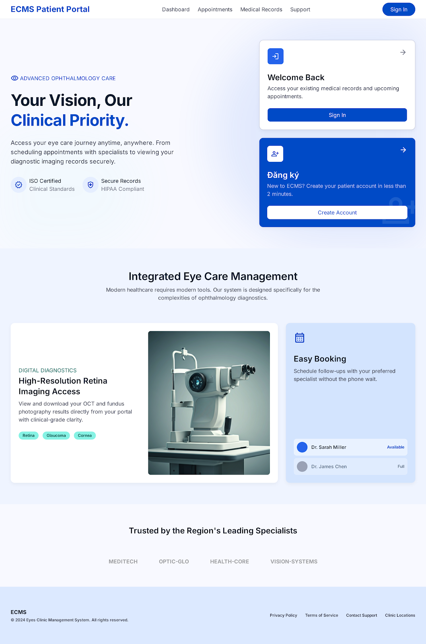

3.2.2 Register Account
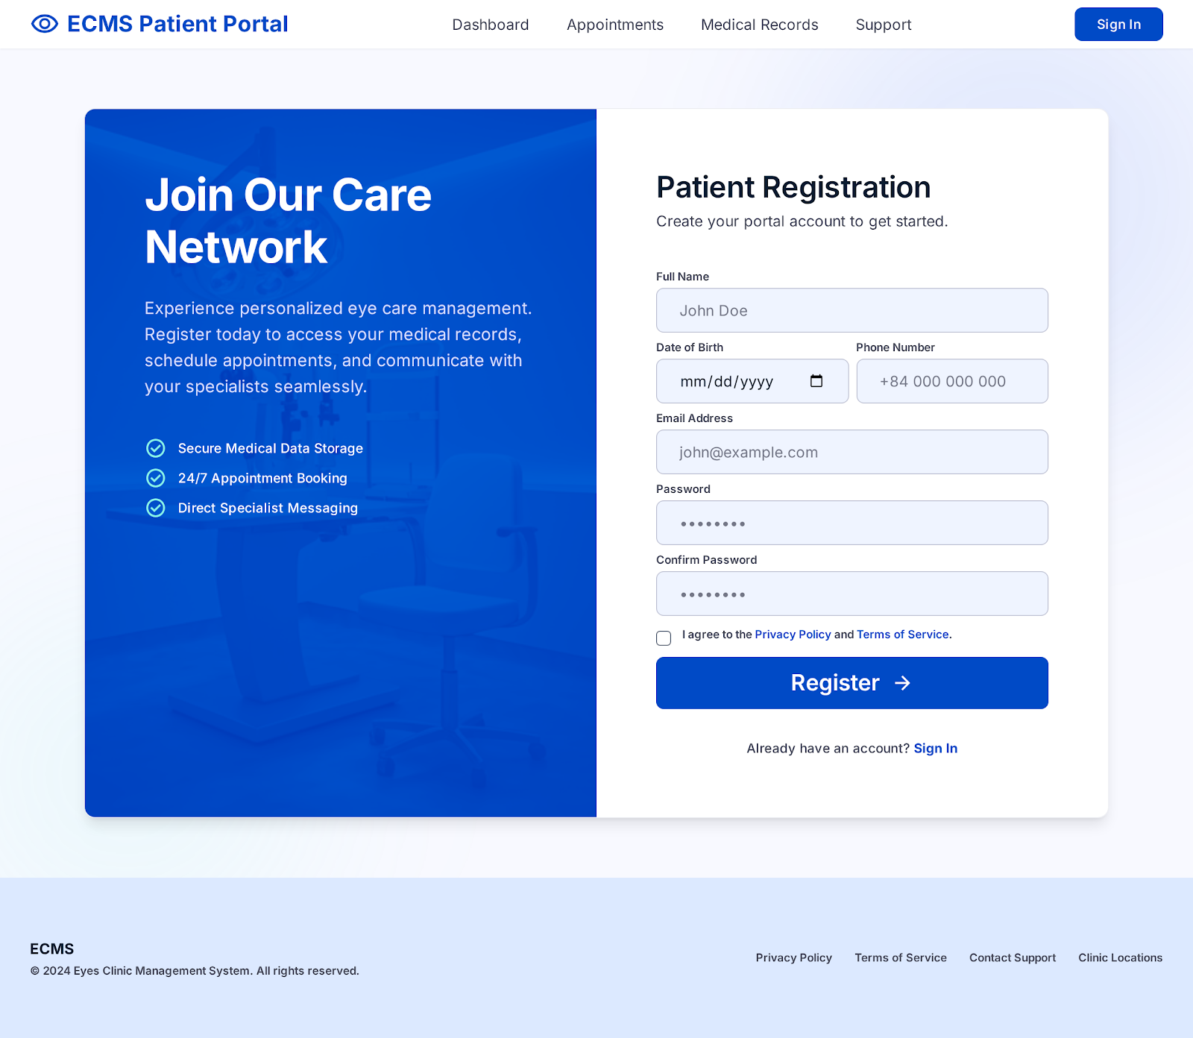

3.2.3 Log In

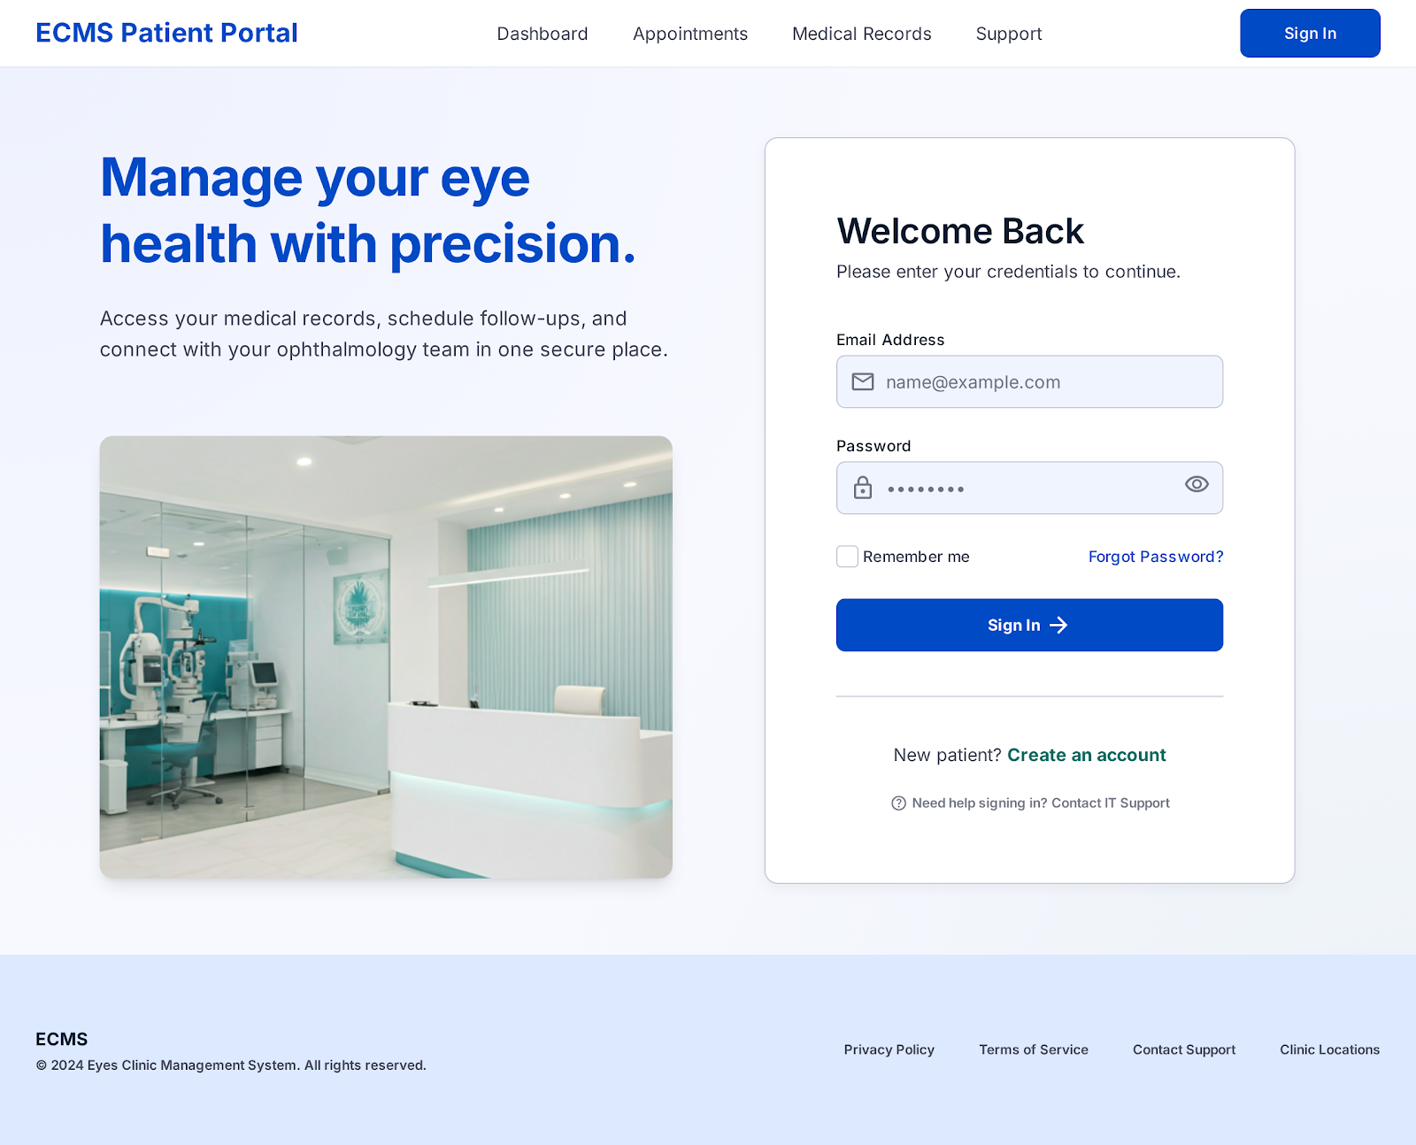

3.2.4 Reset Password

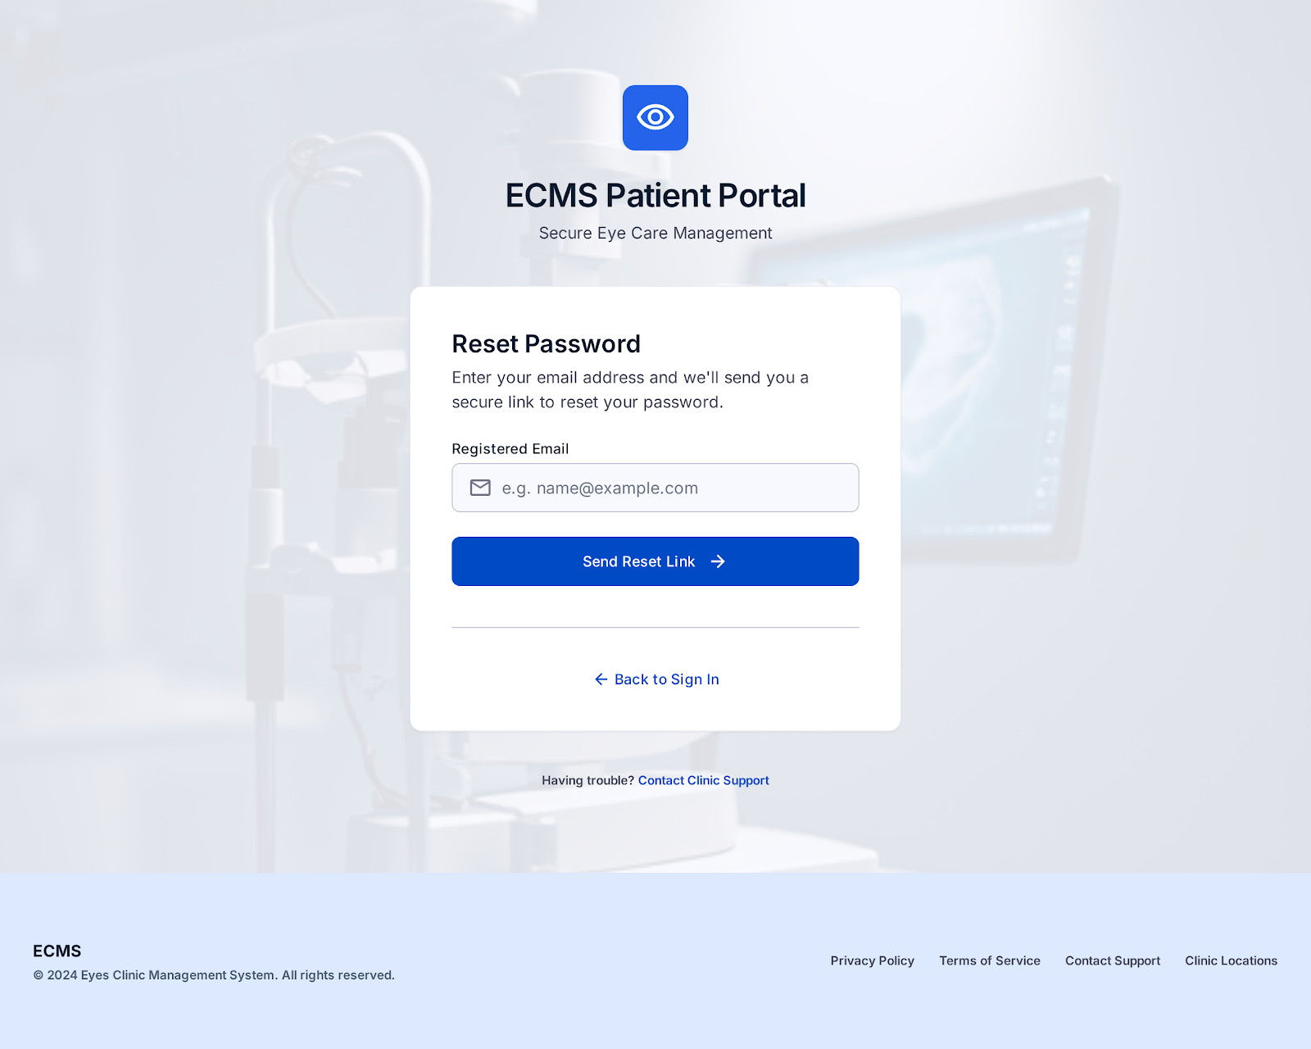

3.2.5 Change Password
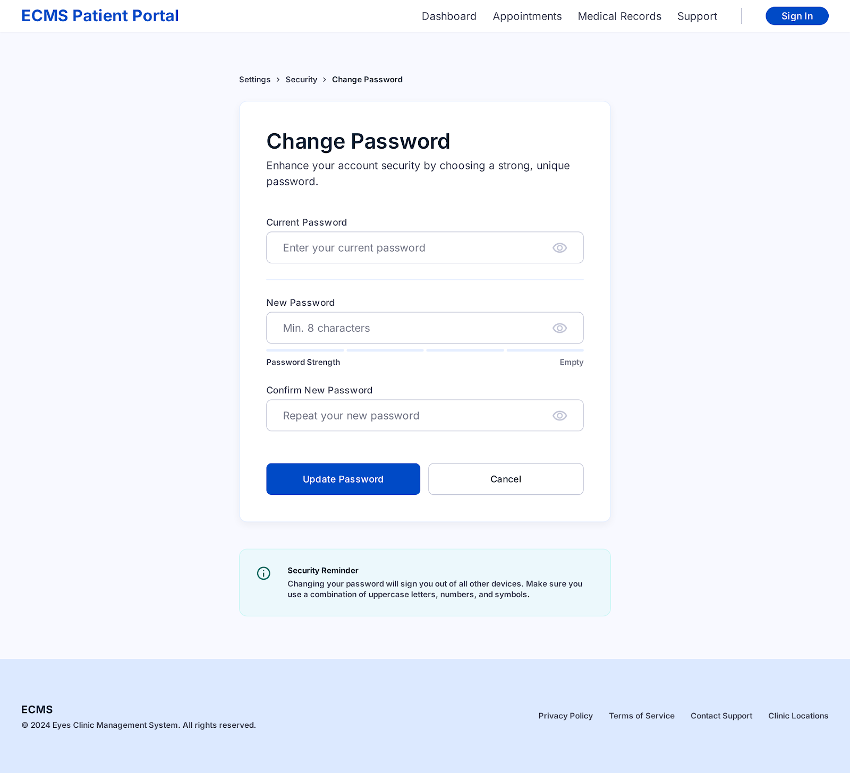

3.2.6 User Profile
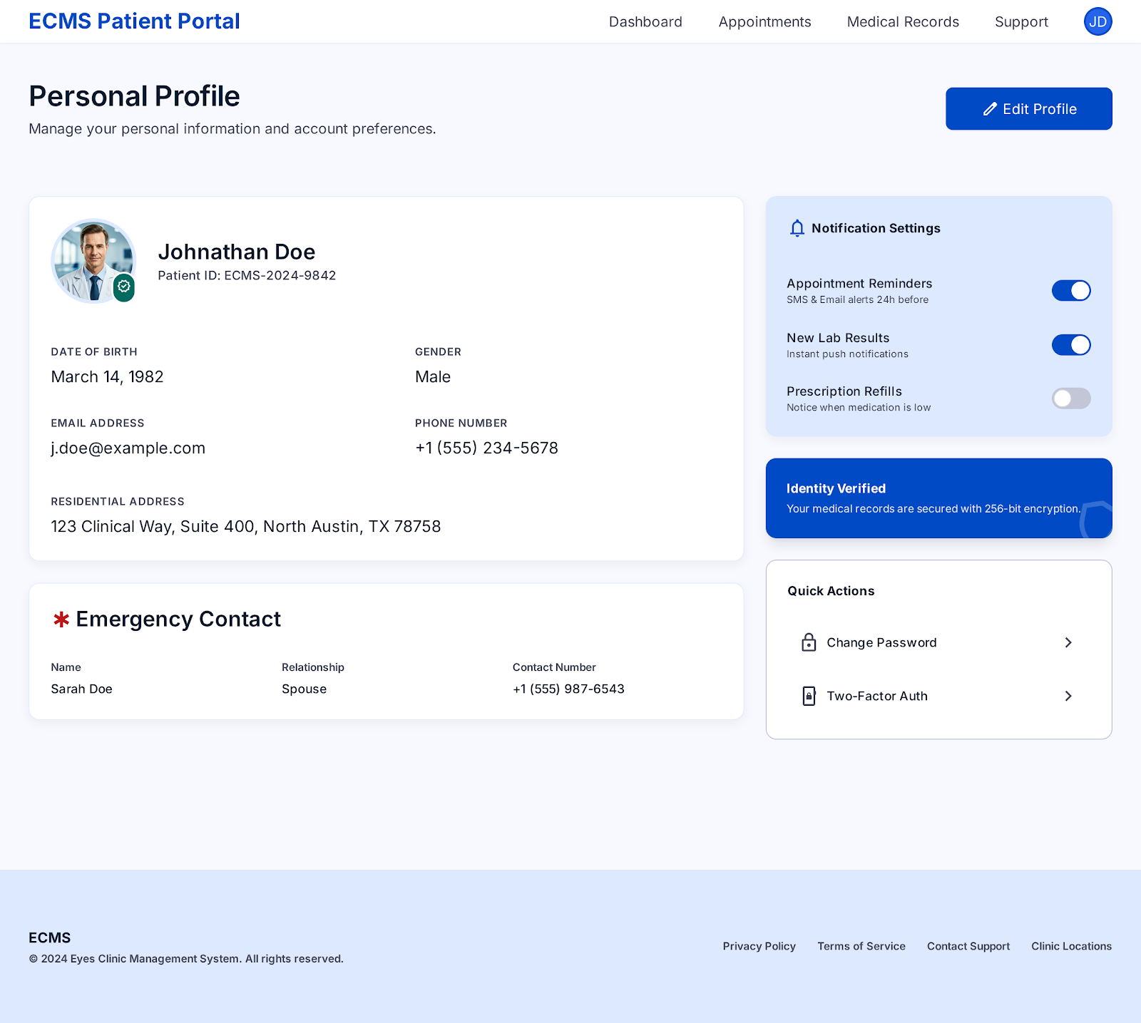

4. Non-Functional Requirements

4.1 External Interfaces
DE-1: SMTP Service — Gmail SMTP or SendGrid to send verification emails, reminders, and invoices.
DE-2: Google Identity Platform — Supports Google OAuth 2.0 login for patients (FR-02, Should Have).
DE-3: Cloud Infrastructure — AWS EC2 / Railway / VPS; HTTPS certificate via Let's Encrypt or ACM.
DE-4: QR Code Payment — Payment gateway supporting VietQR / domestic bank transfer.

4.2 Quality Attributes
Quality Attributes | Requirements | Criteria (KPI)
Performance | API response time at P95 is less than 2 seconds with 100 concurrent users. | P95 latency < 2s measured using JMeter or k6
Performance | Download React (First Contentful Paint) screenplay on 4G | FCP < 3s; LCP < 4s; Lighthouse Score ≥ 80
Performance | Minimum throughput backend | ≥ 100 RPS with the stated SLA
Performance | The test results are synchronized to the EMR. | Less than 5 seconds after the technician saves the results.
Security | Client-server transmission encryption | 100% HTTPS/TLS 1.2/1.3 endpoints; no HTTP plain-text
Security | JWT Access Token & Refresh Token | Access Token TTL = 60 minutes; Refresh Token TTL = 7 days
Security | Encrypt passwords | bcrypt with salt, cost factor ≥ 12; never store plaintext.
Security | Patient data & medical records | AES-256 encryption at rest; audit log for accessing sensitive data.
Security | OWASP Top 10 | Passed OWASP ZAP scan; 0 vulnerabilities (High/Critical level).
Availability | System uptime: Working hours 7:00–20:00 | ≥ 99.5% / month
Availability | Backup & Recovery | Daily backup; RPO ≤ 24h; RTO ≤ 4h
Scalability | Concurrent users | ≥ 300 users with the stated performance SLA
Scalability | DB capacity | Query over 500,000 records in under 3 seconds with a suitable index.
Usability | Responsive UI | The UI doesn't break in the 375px – 1920px viewport.
Usability | Appointment booking workflow | New users can complete the process within < 3 minutes without guidance.
Maintainability | Unit test coverage | ≥ 70% test coverage on the service layer (Backend)
Maintainability | API documentation | 100% of endpoints must be documented using Swagger/OpenAPI 3.0, including request and response schemas.
Compliance | Personal data protection | Comply with Decree No. 13/2023/ND-CP; maintain a Privacy Policy; and log access to sensitive data.

5. Appendix

5.1 Assumptions & Dependencies
AS-1: The clinic has a stable internet connection to use the web-based system.
AS-2: Patients have valid email addresses to receive notifications and electronic invoices.
AS-3: Existing patient data will be manually entered or imported from Excel during the deployment phase; there will be no automatic migration in v0.
DE-1: The system relies on the SMTP service (Gmail SMTP / SendGrid) for email sending. If SMTP is unavailable, appointment reminders and invoice sending will be suspended.
DE-2: Google OAuth 2.0 login functionality relies on the Google Identity Platform (Should Have).
DE-3: Cloud deployment (AWS EC2 / Railway) or VPS with HTTPS support.

5.2 Limitations & Exclusions
The following features are outside the scope of version 0:
• Does not integrate with the national health insurance system.
• Does not support telemedicine/remote consultations.
• Does not integrate automatic vision testing devices (electronic refractometers, automatic tonometers).
• Only supports single-clinic; does not yet support multi-branch clinic chains.
• Does not yet support private insurance payments.

5.3 Glossary
Terminology | Acronym | Description
Electronic Medical Record | EMR | Electronic Medical Record (EMR) is a digital version of a patient's paper chart that contains their medical history, diagnoses, and treatment plans within a single healthcare practice.
Visual Acuity (without correction) | VA | Visual Acuity without correction (VA) is the natural sharpness of a person's vision measured without the use of any corrective glasses or contact lenses.
Best Corrected Visual Acuity | BCVA | Best Corrected Visual Acuity (BCVA) is the sharpest possible vision a person can achieve while wearing the optimal prescription glasses or contact lenses.
Intraocular Pressure | IOP | The pressure inside the eye, known as intraocular pressure (IOP), is measured in millimeters of mercury (mmHg).
Optical Coherence Tomography | OCT | Optical Coherence Tomography (OCT) is a non-invasive imaging technique that visualizes the eye's microvasculature in 3D without the need for dye injections.
Role-Based Access Control | RBAC | User role-based access control
JSON Web Token | JWT | Stateless authentication token; Access Token expires in 60 minutes, Refresh Token in 7 days.
Spherical / Cylindrical / Axis | SPH / CYL / AXIS | Diameter measurement parameters: spherical / cylindrical / axial

— End of Document —

