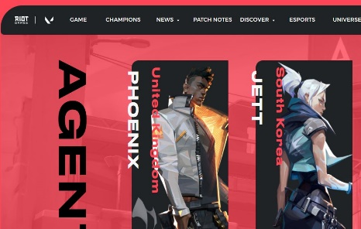

**Страница выбора агента**

Страница: http://xn----8sbaaankiwtdeytygl.xn--p1ai/Kristina/

Технологии:

Used: HTML, CSS, Flex, JQuery (menu, accordion), JS (delivery timer), @media запросы

Did not use: Bootstrap, Grid, React, SASS

**Agent Selection Page**

Page: <http://xn----8sbaaankiwtdeytygl.xn--p1ai/Kristina/>

GitHub:

Technologies:

**Used:** HTML, CSS, jQuery (menu, slider)

**Not used:** Bootstrap, Grid, React, SASS, JS