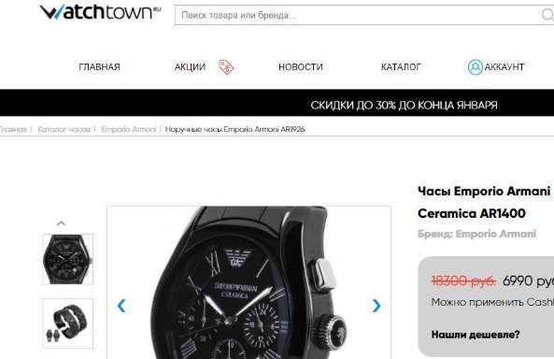

**Страница товара интернет-магазина часов WatchTown.ru**

Страница: http://pletnevd.com/watch/

Технологии:

Used: HTML, CSS, Flex, JQuery (menu, accordion), JS (delivery timer), @media запросы

Did not use: Bootstrap, Grid, React, SASS

**Product page of the online watch store WatchTown.ru**

Page: <http://pletnevd.com/watch/>

GitHub: https://github.com/Dmitr45/Watchtown

Technologies:

**Used:** HTML, CSS, Flex, jQuery (menu, accordion), JS (delivery timer), @media queries

**Not used:** Bootstrap, Grid, React, SASS