The Story of Elon Musk in 3 Minutes!

https://www.youtube.com/watch?reload=9&v=-BDSnB_94Jw

1) - [Narrator] This is the story of Elon Musk in three minutes. Elon Musk was born in Pretoria, South Africa in 1971 to Maye Musk, a Canadian model and dietician, and Errol Musk, an engineer and pilot. He developed a love for reading at a young age and by 12 years old he used self-taught programming skills to develop code for a video game he called Blastar, which he then sold for $500.

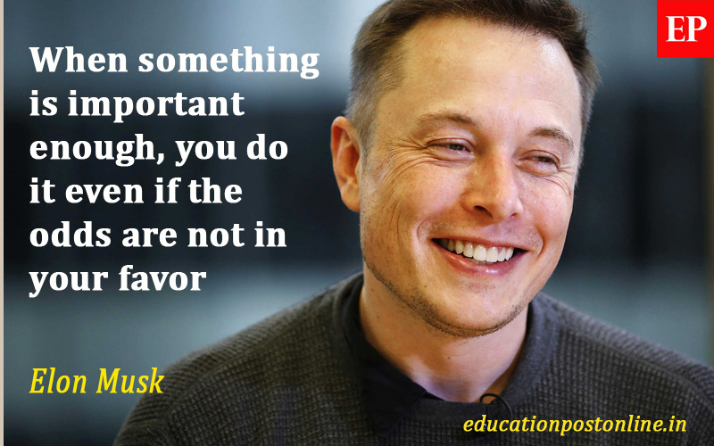

2) Musk was a victim of severe bullying, including an incident that landed him in the hospital after being thrown down a flight of stairs. Despite this, Elon has said, “he believes his purpose in life to try to take a set of actions that are likely to prolong civilization, minimize the probability of a Dark Age, and reduce the length of the Dark Age, if there is one”.

3) Musk attended Queens University in Canada for two years before moving on to Penn. While at Penn, Musk ran an unofficial night club out of a rented 10 bedroom frat house. In 1995 Musk entered the PhD program at Stanford. And then dropped out after two days to focus on entrepreneurial ventures based on this internet thing everyone is suddenly talking about.

4) He created Zip 2 along with his brother. Four years later he received $22 million for his share when they sold Zip 2 to Compac. Musk used some of this money to cofound X.com, a user-friendly online financial service. You might know it better today as PayPal, and when eBay purchased PayPal in 2002, Musk's shares netted him a cool $165 million.

5) Committed to fighting global climate change, Musk founded Solar City and Tesla. The Solar City plant, to be constructed in Buffalo, will be the biggest solar plant in the United States three times over, and he plans to build even bigger plants in the future. Tesla has grown into the leading electric car manufacturer and the fourth most valuable automotive company in the world.

6) Musk conceptualized the Mars Oasis, a plan to commercialize space travel and colonize Mars in order to avoid the inevitable extinction of human kind on earth. And let's be honest, even if you survive, nobody wants to be the only human left on a planet with crocodiles, cockroaches, and Twinkies.

7) Musk founded SpaceX with $100 million of his own cash. In February 2018, SpaceX successfully test launched the most powerful operational rocket in the world, the Falcon Heavy. And yes, the Falcon does take its name from a certain stuck up, half witted, scruffy looking Nerf herder. Oh, and as part of the launch, they sent a Tesla Roadster into space. It's orbiting the earth right now. You can see the reflection of the earth on the hood. Check mate, flat earthers.

8) When he's not launching sports cars into space, Musk is working on the Hyperloop, a high speed transit system that shoots pods holding riders through a reduced pressure tube. It is expected to get people from Los Angeles to San Francisco in less than an hour, which is less time than it takes to drive from one side of L.A. to the other.

9) While tweeting in traffic in 2016, Musk mused, I'm going to build a tele-boring machine and just start digging. And thus, the Boring Company was born.

The Boring Company recently released plans for a flamethrower, which has

received 20,000 preorders. U.S. Customs have warned a flamethrower will not clear international security. Musk responded by renaming the product a temperature enhancement device. As of 2018, Elon Musk is worth an estimated $20.4 billion. He states that he hopes to die on Mars, just not on impact. And that's the story of Elon Musk in three minutes.

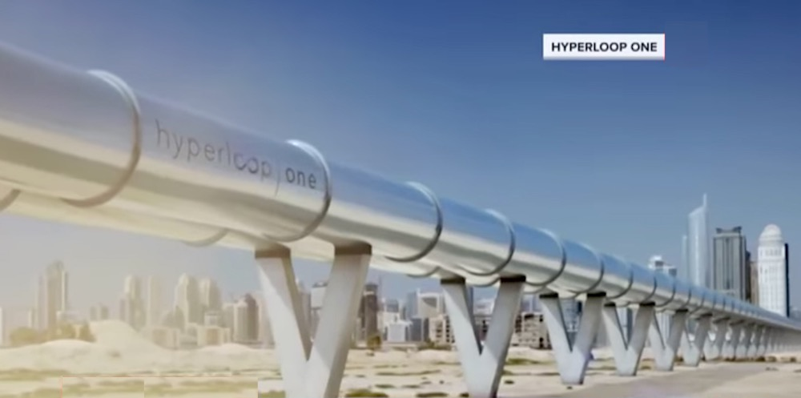

|  |  |
| --- | --- |
| dietician | an expert in dietetics; specialist in planning meals or diets |
| self-taught | having taught oneself through one's own efforts; self-educated |
| landed | cause someone to have serious problems or be in a difficult situation |
| thrown down | to cast or fling someone or something down through or into something |
| despite | in spite of; notwithstanding |
| minimize | to reduce to a minimum; decrease to the least possible degree |
| frat house | (fraternity house) a dwelling that serves as living quarters for one or more people, usually students |
| drop out | If someone drops out of college or a race, for example, they leave it without finishing what they started. |
| entrepreneurial | a person who sets up businesses and business deals. |
| ventures | is a project or activity which is new, exciting, and difficult because it involves the risk of failure. |
| cofound | to establish (an organization) with another or others |
| user-friendly | easy to use or understand |
| netted | to acquire or obtain |
| conceptualize | to form a concept or idea of; conceive |
| stuck up | staying aloof from others because one thinks one is superior |
| half wit | a foolish or stupid person |
| scruffy | shabby and untidy or dirty |
| Nerf herder | A shepherd of limited intelligence caring for creatures of a limited intelligence. 2) An insult in the Star Wars trilogy. |
| check mate | defeat or frustrate totally |
| flat earthers | a person who believes that the earth is flat |
| shoot | to make move with great speed or sudden force |
| pods | a detachable or self-contained unit on an aircraft, spacecraft, vehicle, or vessel |
| muse | think about it |
| flamethrower | a weapon for shooting a stream of flaming gasoline, oil, napalm, etc. |

**Use the words in red in the following sentences.**

Becky studied the piano at school but was largely **self-taught**.

Computer programs have become more **user-friendly**.

During the New Year’s Eve celebrations people **shot** many fireworks into the night sky.

Good hygiene helps to **minimize** the risk of infection.

I still enjoyed my weeks’ vacation **despite** the weather.

Many students **drop out** or fail because they're not enjoying the course.

She **landed** up in a strange city without any money or friends.

The murderer had **thrown** the body **down** a disused mineshaft.

The sale **netted** a large profit for the company.

Question answers are found in the same paragraph number as the question.

1. When and how did Elon Musk learn computer programing?

Elon Musk learned programming on his own and by the age of 12 he created his own game.

1. What does Elon Musk say his purpose in life is?

Elon Musk believes that his purpose in life is to prolong civilization and to avoid the Dark Age.

1. Why did Elon drop out of Stanford?

He dropped out of Stanford, because he wanted to focus on entrepreneurial ventures.

1. Can you name any internet programs that Musk created?

He created Zip2 (with his brother) and Paypal.

1. What has Elon Musk done to combat global warming?

In order to combat global warming, he founded Tesla and Solar City. These 2 companies are environmentally- friendly.

1. Why does Musk feel that going to Mars is Important?

According to Elon Musk, going to Mars is important because the extinction of the humanity on Earth is inevitable.

1. Has SpaceX been successful? What have they accomplished?

SpaceX is successful. They launched the most powerful operational rocket in the world.

1. What is Hyperloop?

Hyperloop is high speed transit system that shoots pods through a reduced pressure tube.

1. Why do you think Musk wanted to start the Boring Company?

I think he did it for the possible memes.

Extra Question: Tell me what you know about Elon Musk

