

**PAST SIMPLE – regular/ irregular verbs**

**Nikola Tesla** (1856-1943) Croatian Inventor

Nikola Tesla **was** (be) born on **10th July 1856** in **Smiljan**, small village in **Croatia** (then part of the Austro-Hungarian Empire). His father **was** (be) a Serbian Orthodox priest and his mother **took** (take) care of the family’s farm. Nikola **said** (say) that he **must** (must) to thank her for his creative abilities and near photographic memory - he **could** (can) memorize entire books and recite them at will. Tesla **spoke** (speak) **eight languages**: Serbian, Latin, German, Hungarian, Italian, Czech, French and English.

He **used** (use) to say ''I'm proud of my Serbian origin and my Croatian homeland''.

When Tesla’s brother Daniel **died** (die) in an accident, it **was** (be) a shock to the 7-year-old Nikola. He then **started** (start) to have **visions**, important also in his later life.

Tesla **went** (go) to the gymnasium in Carlstadt (Karlovac, Croatia). When performing calculus equations in his head his teachers **thought** (think) he **was** (be) cheating. He **loved** (love) mathematics and science. Tesla’s father, however insisted that he enter the priesthood. After his recovery from cholera father **sent** (send) him to the Polytechnic school in Graz, Austria in 1875. He **was** (be) excellent there. He **began** (begin) each day at 3:00 a.m. and **worked** (work) until 11:00 p.m..

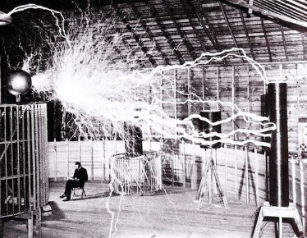In school Tesla **was** (be) obsessed with a new **direct current** (**DC**) dynamo as he **knew** (know) better solution: electric power created by **alternating current** (**AC**).

At the age of 28, working for Edison, he **moved** (move) from France to New York City with only four cents in his pocket. One day Tesla **told** (tell) Edison that he **could** (can) improve his motors and generators. Edison **promised** (promise) him 50.000 dollars. After several months Tesla **improved** (improve) the motor but when he **asked** (ask) about payment, Edison **told** (tell) him that he **was** (be) only joking. Tesla immediately **resigned** (resign).

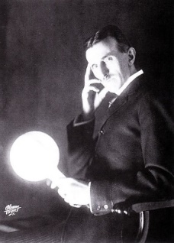Later he **founded** (found) the *Tesla Electric Company* and **patented** (patent) his AC motors.

After many years of debate in so called **'War of the Currents'** Tesla **demonstrated** (demonstrate) at ***1893*** ***World Fair in Chicago,*** the safety of AC power with his new **phosphorescent lighting** and his gigantic **'Tesla coils'**. It **was** (be) a key event in the history of electricity.

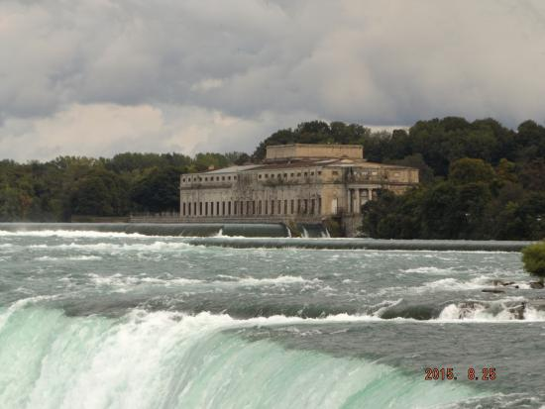Tesla and Westinghouse with the *General Electric* company **created** (create) **the first modern power station** at **Niagara** **Falls**.

Tesla also **made** (make) important research in radiant energy (later called **X-ray**), and on the fundamentals of **radio**.

Tesla **had** (have) an eccentric private life. He never **slept** (sleep) for more than two hours at a time. He **lived** (live) alone in a hotel suite. He also **had** (have) several obsessions: a phobia of germs (when meeting people, he **didn’t want** (not want) to shake hands), round objects (especially jewelry), the number three and also feeding pigeons... Tesla **said** (say) this behavior **made** (make) his concentration on the experiments better.

On 7th January 1943, at the age of 86, Nikola Tesla **died** (die) in New York a poor and reclusive man. He **had** (had) 700 patents. His legacy, however, continues to move on.