For all IPv6 test cases we are sending WSA over the air with repeat rate of 1 packet every 5 seconds and with the following parameters:

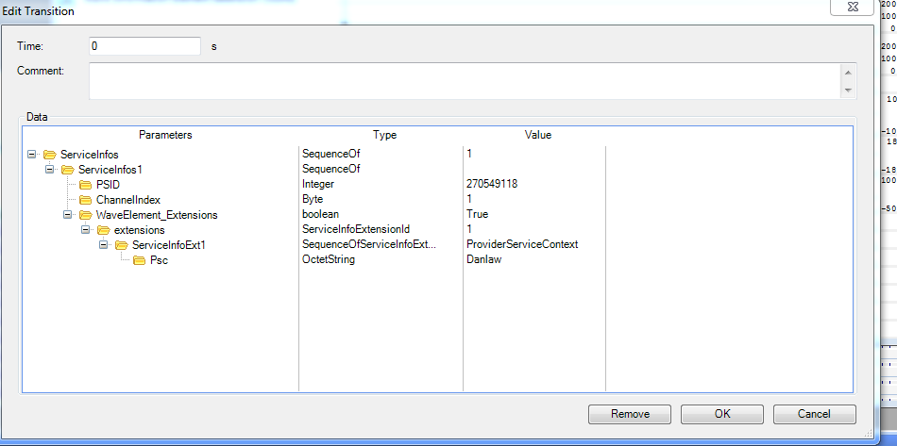

**Figure 1. WSA ServiceInfos**

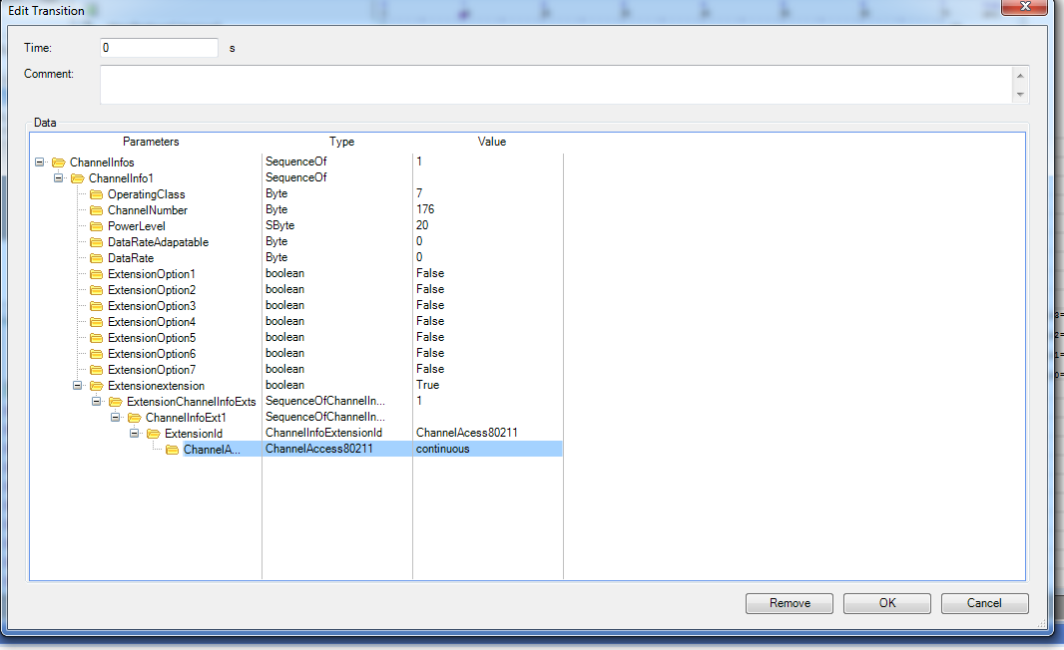

**Figure 2. WSA ChannelInfos**

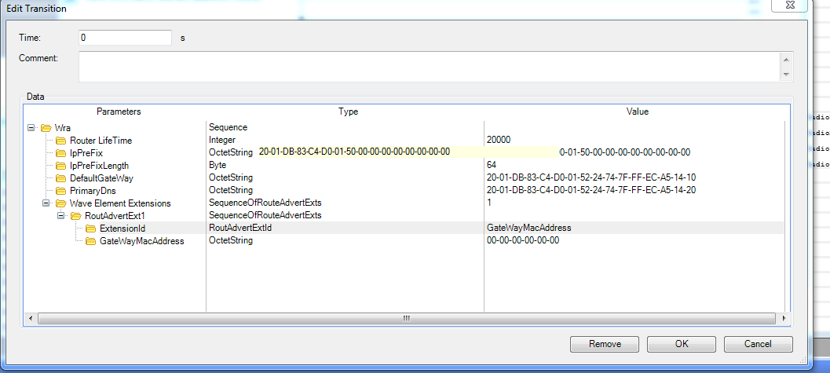

**Figure 3. WSA WRA**

**/**** Starting Test Case: TP_16093_IP_CFG_BV_01 ***/**

-----------------Message Processing Started-----------------  
Time: 1493841594636 ms, 19:59:54:636, Packet Received from test system.  
Frame Id: SutCtrlChosen  
RequestSutAvailability Message Received  
------------------------------------------------------  
  
-----------------Message Processing Started-----------------  
Time: 1493841595387 ms, 19:59:55:387, Packet Received from test system.  
Frame Id: D16093Chosen  
Set Initial State Message Received, parameter = true  
------------------------------------------------------  
  
-----------------Message Processing Started-----------------  
Time: 1493841596294 ms, 19:59:56:294, Packet Received from test system.  
Frame Id: SutCtrlChosen  
Starting Test Case: TP_16093_IP_CFG_BV_01  
------------------------------------------------------  
  
-----------------Message Processing Started-----------------  
Time: 1493841597703 ms, 19:59:57:703, Packet Received from test system.  
Frame Id: D16093Chosen  
StartWsmRx Message Received  
    Channel = 176  
    Radio = Radio0  
    Timeslot = Continuous  
    PSID = 135  
    Event Handling  
        RxFlag = Don't Match Psid = false, Include PDU = true, Include PDU Params = true  
        Event Flag: e16093PktRx  
        PDU Frame Type = D16093frame  
        Security Flag = BypassSecurityVerification   
------------------------------------------------------  
  
-----------------Message Processing Started-----------------  
Time: 1493841606386 ms, 20:0:6:386, Packet Received from test system.  
Frame Id: D16093Chosen  
GetIPv6InterfaceInfo Message Received  
    Radio = Radio0  
------------------------------------------------------

**/**** Starting Test Case: TP_16093_IP_CFG_BV_02 ***/**

-----------------Message Processing Started-----------------  
Time: 1493841801278 ms, 20:3:21:278, Packet Received from test system.  
Frame Id: SutCtrlChosen  
RequestSutAvailability Message Received  
------------------------------------------------------  
  
-----------------Message Processing Started-----------------  
Time: 1493841801666 ms, 20:3:21:666, Packet Received from test system.  
Frame Id: D16093Chosen  
Set Initial State Message Received, parameter = true  
------------------------------------------------------  
  
-----------------Message Processing Started-----------------  
Time: 1493841802085 ms, 20:3:22:85, Packet Received from test system.  
Frame Id: SutCtrlChosen  
Starting Test Case: TP_16093_IP_CFG_BV_02  
------------------------------------------------------  
  
-----------------Message Processing Started-----------------  
Time: 1493841804374 ms, 20:3:24:374, Packet Received from test system.  
Frame Id: D16093Chosen  
StartWsmRx Message Received  
    Channel = 176  
    Radio = Radio0  
    Timeslot = Continuous  
    PSID = 135  
    Event Handling  
        RxFlag = Don't Match Psid = false, Include PDU = true, Include PDU Params = true  
        Event Flag: eIpv6ConfigChanged  
        PDU Frame Type = D16093frame  
        Security Flag = BypassSecurityVerification   
------------------------------------------------------  
  
-----------------Message Processing Started-----------------  
Time: 1493841812073 ms, 20:3:32:73, Packet Received from test system.  
Frame Id: D16093Chosen  
GetIPv6InterfaceInfo Message Received  
    Radio = Radio0  
------------------------------------------------------  
  
-----------------Message Processing Started-----------------  
Time: 1493841813573 ms, 20:3:33:573, Packet Received from test system.  
Frame Id: D16093Chosen  
SetIPv6IAddress Message Received  
    Radio = Radio0  
    InterfaceName = wlan0  
    IPv6Address = fe80::c001:37ff:fe6c:1  
------------------------------------------------------  
  
-----------------Message Processing Started-----------------  
Time: 1493841815577 ms, 20:3:35:577, Packet Received from test system.  
Frame Id: D16093Chosen  
GetIPv6InterfaceInfo Message Received  
    Radio = Radio0  
------------------------------------------------------

**/**** Starting Test Case: TP_16093_IP_CHG_BV_01 ***/**

-----------------Message Processing Started-----------------  
Time: 1493841854861 ms, 20:4:14:861, Packet Received from test system.  
Frame Id: SutCtrlChosen  
RequestSutAvailability Message Received  
------------------------------------------------------  
  
-----------------Message Processing Started-----------------  
Time: 1493841855254 ms, 20:4:15:254, Packet Received from test system.  
Frame Id: D16093Chosen  
Set Initial State Message Received, parameter = true  
------------------------------------------------------  
  
-----------------Message Processing Started-----------------  
Time: 1493841855661 ms, 20:4:15:661, Packet Received from test system.  
Frame Id: SutCtrlChosen  
Starting Test Case: TP_16093_IP_CHG_BV_01  
------------------------------------------------------  
  
-----------------Message Processing Started-----------------  
Time: 1493841860060 ms, 20:4:20:60, Packet Received from test system.  
Frame Id: D16093Chosen  
SetIPv6IAddress Message Received  
    Radio = Radio0  
    InterfaceName = wlan0  
    IPv6Address = fe80:884a:3749:20b6:1234:6789:abcd:ef01  
------------------------------------------------------  
  
-----------------Message Processing Started-----------------  
Time: 1493841861564 ms, 20:4:21:564, Packet Received from test system.  
Frame Id: D16093Chosen  
GetIPv6InterfaceInfo Message Received  
    Radio = Radio0  
------------------------------------------------------

**/**** Starting Test Case: TP_16093_IP_CHG_BV_02 ***/**

-----------------Message Processing Started-----------------  
Time: 1493842049422 ms, 20:7:29:422, Packet Received from test system.  
Frame Id: SutCtrlChosen  
RequestSutAvailability Message Received  
------------------------------------------------------  
  
-----------------Message Processing Started-----------------  
Time: 1493842050214 ms, 20:7:30:214, Packet Received from test system.  
Frame Id: D16093Chosen  
Set Initial State Message Received, parameter = true  
------------------------------------------------------  
  
-----------------Message Processing Started-----------------  
Time: 1493842051121 ms, 20:7:31:121, Packet Received from test system.  
Frame Id: SutCtrlChosen  
Starting Test Case: TP_16093_IP_CHG_BV_02  
------------------------------------------------------  
  
-----------------Message Processing Started-----------------  
Time: 1493842052518 ms, 20:7:32:518, Packet Received from test system.  
Frame Id: D16093Chosen  
StartWsmRx Message Received  
    Channel = 176  
    Radio = Radio0  
    Timeslot = Continuous  
    PSID = 135  
    Event Handling  
        RxFlag = Don't Match Psid = false, Include PDU = true, Include PDU Params = true  
        Event Flag: eIpv6ConfigChanged  
        PDU Frame Type = D16093frame  
        Security Flag = BypassSecurityVerification   
------------------------------------------------------  
  
-----------------Message Processing Started-----------------  
Time: 1493842060223 ms, 20:7:40:223, Packet Received from test system.  
Frame Id: D16093Chosen  
GetIPv6InterfaceInfo Message Received  
    Radio = Radio0  
------------------------------------------------------  
  
-----------------Message Processing Started-----------------  
Time: 1493842061722 ms, 20:7:41:722, Packet Received from test system.  
Frame Id: D16093Chosen  
SetIPv6IAddress Message Received  
    Radio = Radio0  
    InterfaceName = wlan0  
    IPv6Address = fe80::c001:37ff:fe6c:1  
------------------------------------------------------  
  
-----------------Message Processing Started-----------------  
Time: 1493842063720 ms, 20:7:43:720, Packet Received from test system.  
Frame Id: D16093Chosen  
GetIPv6InterfaceInfo Message Received  
    Radio = Radio0  
------------------------------------------------------

**/**** Starting Test Case: TP_16093_IP_COM_BV_01 ***/**

-----------------Message Processing Started-----------------  
Time: 1493842148724 ms, 20:9:8:724, Packet Received from test system.  
Frame Id: SutCtrlChosen  
RequestSutAvailability Message Received  
------------------------------------------------------  
  
-----------------Message Processing Started-----------------  
Time: 1493842149436 ms, 20:9:9:436, Packet Received from test system.  
Frame Id: D16093Chosen  
Set Initial State Message Received, parameter = true  
------------------------------------------------------  
  
-----------------Message Processing Started-----------------  
Time: 1493842150341 ms, 20:9:10:341, Packet Received from test system.  
Frame Id: SutCtrlChosen  
Starting Test Case: TP_16093_IP_COM_BV_01  
------------------------------------------------------  
  
-----------------Message Processing Started-----------------  
Time: 1493842151759 ms, 20:9:11:759, Packet Received from test system.  
Frame Id: D16093Chosen  
StartWsmRx Message Received  
    Channel = 176  
    Radio = Radio0  
    Timeslot = Continuous  
    PSID = 135  
    Event Handling  
        RxFlag = Don't Match Psid = false, Include PDU = true, Include PDU Params = true  
        Event Flag: e16093PktRx  
        PDU Frame Type = D16093frame  
        Security Flag = BypassSecurityVerification   
------------------------------------------------------  
  
-----------------Message Processing Started-----------------  
Time: 1493842161535 ms, 20:9:21:535, Packet Received from test system.  
Frame Id: D16093Chosen  
SendIPv6Ping Message Received  
    Radio = Radio0  
    InterfaceName = wlan0  
    DestinationIPv6Addrerss = 2001:db8:3c4d:15:2247:47ff:feca:5141  
------------------------------------------------------

**/**** Starting Test Case: TP_16093_IP_COM_BV_02 ***/**

Same as the previous message except with a Link Local IPv6 address