Network is - a system that allows multiple devices to communicate with one other

In order to communicate with each other (devices) they need to have agreement on how the data should be sent, how it is received, how it is organized, how it is handled. This agreement is called a **protocol**. And there are a lot of protocols (or agreements) outhere:

-Ethernet, TCP - both are used to send information from one device to another.

-HTTP used for accessing web sites.

-SMTP used for sending and receiving emails.

Usually there are multiple protocols involved in one time, in order to do multiple task.

**SWITCH**

SWITCH includes:

1) - router is used to connect to the internet

2) - switch

3) - access point (wi-fi)

Т.е. это один девайс (речь сейчас идёт об интернете например в квартире) у нас он называется модем, У них switch, он выполняет роль роутера, switch-a (т.е. тупа соединяет девайсы по шнурам), вай фай.

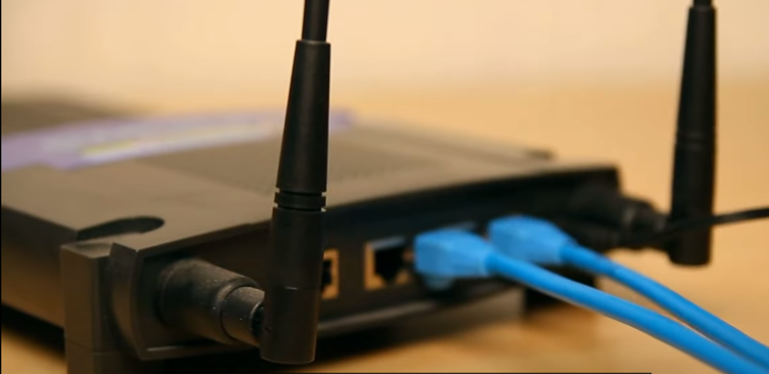

Each device has 2 adresses:

- MAC

- ip

They are used in a different way.

Each host has at least 1 mac address, we can't change it, it is assigned for fiscal device. Each MAC is guaranteed to be uniq. A mac address is needed when one device needs to communicate with another device within the LAN segment.

Each device also has an ip address, this address is chosen by us. It can be used within LAN segment and to pass traffic to different LAN segment.

**ip address**

