The @Test is the most important and commonly used annotation of TestNG. It is used to mark a method as Test. So, any method over which we see @Test annotation is considered as a TestNG test.

@Test

public void sampleTest() {

//Any test logic

System.out.println("Hi! ArtOfTesting here!");

}

Now, let’s see some important attributes of @Test annotations-

1. **description** – The ‘description’ attribute is used to provide a description to the test method. It generally contains a one-liner test summary.

@Test(description = "Test summary")

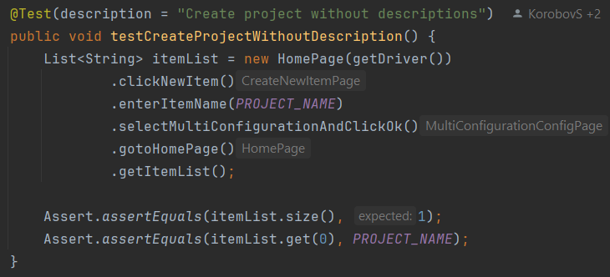

2. **dataProvider** – This attribute helps in creating a data driven tests. It is used to specify the name of the data provider for the test.

@Test(dataProvider = "name of dataProvider"). Смотри [Parameterization (DataProviders)](https://docs.google.com/document/u/0/d/1lOFF71EmnXXlJ_ktknw_supPCAY_WEOHwyXCu90c8Qk/edit)

3. **priority** – This attribute helps in prioritizing the test methods. The default priority starts with 0 and tests execute in ascending order.

@Test(priority = 2) цифрой задаётся поочерёдность выполнения для данного теста.

[Что такое priority и как его использовать](https://docs.google.com/document/u/0/d/1SUI1suABTd-Mm-GEFFl_LPktA_0TSUa7YmmtdFedcH0/edit)

4. **enabled** – This attribute is used to specify whether the given test method will run with the suite or class or not.

@Test(enabled = false)

5. **groups** – Used to specify the groups, the test method belongs to.

@Test(groups = { "sanity", "regression" })

7. **dependsOnMethods** – Used to specify the methods on which the test method depends. The test method only runs after successful execution of the dependent tests.

@Test(dependsOnMethods = { "dependentTestMethodName" })

8. **dependsOnGroups** – Used to specify the groups on which the test method depends.

@Test(dependsOnGroups = { "dependentGroup" })

9. **alwaysRun** – When set as True, the test method runs even if the dependent methods fail.

@Test(alwaysRun=True)

10. **timeOut** – This is used to specify a timeout value for the test(in milli seconds). If the test takes more than the timeout value specified, the test terminates (заканчивается) and is marked as failure.

@Test (timeOut = 500)

11. **@Test(invocationCount = ?)** - атрибут воспроизводит тест заданное количество раз. Вместо ? подставь цифру, сколько раз надо выполнить тест. Это может быть подходящим при Exastive (исчерпывающее) тестирование