Final Project Report: TCP Modeling in Glioblastoma (CFB-GBM)
TCP Modeling GBM Project Group

Final Project Report: Tumor Control Probability Modeling in Glioblastoma
Course: TCP Modeling in GBM — Final Project
Dataset: CFB-GBM (TCIA v3, DOI 10.7937/v9pn-2f72)
Modeling cohort: n=190 (after DVH QC) · RANO subset: n=137
Report date: 2026-06-28 · Numbers from RESULTS.md (make report)

Abstract
We implemented a reproducible Python pipeline for Tumor Control Probability (TCP) modeling on the open CFB-GBM glioblastoma cohort. Four TCP models (Poisson, logistic, probit, gEUD) were fitted with bootstrap confidence intervals. Version 3 supplementary data provided RANO imaging response labels and author PyRadiomics features. Pooled EQD2 discriminated an OS median-split proxy (AUC≈0.68) but not RANO non-progressive disease (AUC≈0.43) when used as a dose-only predictor. After adjusting for fractionation scheme, GTV volume and radiomics features predicted early RANO with moderate cross-validated discrimination (LOOCV AUC≈0.64–0.74). Classical pooled TCP dose–response validation is not supported on this routine-care dataset; we provide a feasibility checklist for future open-cohort TCP studies.
Keywords: glioblastoma; TCP; DVH; RANO; CFB-GBM; open data

1. Introduction and Clinical Background
Glioblastoma (GBM) is the most common malignant primary brain tumour in adults. Standard treatment includes maximal safe resection, radiotherapy, and concurrent temozolomide (Stupp protocol: 60 Gy in 30 fractions) [1]. In elderly or poor-performance patients, hypofractionated schedules (e.g. 40 Gy in 15 fractions) are commonly used [2,3,15].
Tumor Control Probability (TCP) models estimate the probability of sterilising clonogenic tumour cells as a function of dose and radiobiological parameters [4,5]. Valid TCP studies require (i) a well-defined tumour control endpoint, (ii) inter-patient dose variation, and (iii) adequate sample size [7].
The CFB-GBM dataset (Centre François Baclesse, n=264) provides MRI, RTDOSE, GTV contours, clinical covariates, and RANO response labels [8–10]. Project aim: build a standard TCP pipeline on this open cohort and assess whether classical dose–response validation is feasible; if not, identify where prognostic signal remains.

2. Dataset Description
Item | Value
Source | TCIA CFB-GBM Version 3
Total patients (TSV) | 264
Included for modeling | 190
Excluded | 74 (unknown dose, missing imaging, etc.)
DVH QC exclusion | 1 (patient 32, Dmean=0 Gy)
Fractionation | 120 × 60 Gy/30 fr; 61 × 40.05 Gy/15 fr
Median age | 70 years
Median OS | 51 weeks
RANO t0→t1 labels | 137 / 190
Imaging format: Pre-processed NIfTI (skull-stripped, co-registered), not raw DICOM-RT. RTPLAN/RTSTRUCT DICOM are not in the public package. GTV-only contours at t0; CTV/PTV not provided.

3. Data Acquisition and Curation
- Downloaded clinical/treatment/RANO/PyRadiomics TSVs (python -m src.data.download_clinical_data).
- Built cohort.csv with inclusion rules (cohort_builder.py).
- Downloaded RTDOSE + GTV t0 NIfTI for 191 patients (IBM Aspera).
- Verified completeness (verify_raw_data.py); extracted DVH metrics (feature_builder.py).
- Merged into modeling_table.csv (190 × 58 columns).
EQD2 computed with α/β = 10 Gy for GTV [6,11].

4. Dosimetric Feature Extraction
From registered RTDOSE and t0 GTV masks we computed:
- Cumulative DVH and scalars: D95, D98, D50, D2, Dmean, Dmax, GTV volume_cc, Vx, gEUD (a = −10, 1, 10), homogeneity index (HI).
- EQD2 for cross-scheme comparison.
Within the 60 Gy arm, GTV Dmean SD = 0.28 Gy — essentially no dose escalation within protocol.

5. Mathematical Description of TCP Models
Four binary-outcome TCP formulations [4–7]:
- Poisson TCP: clonogenic cell survival; parameters D50, γ50.
- Logistic TCP: sigmoid dose–response; D50, k.
- Probit TCP: normal CDF link; D50, σ.
- gEUD TCP: dose metric from full DVH, then Poisson-style TCP; extra parameter a.
Full equations: reports/manuscript_equations_fragment.tex.
Estimation: maximum likelihood; 95% CI: bootstrap (1000 resamples, seed 42).

6. Parameter Estimation and Model Comparison
Model | AIC | ROC AUC | Brier | Notes
Probit TCP | 241.73 | 0.684 | 0.218 | Best AIC (marginal)
Logistic TCP | 241.75 | 0.684 | 0.218 | ≈ Poisson
Poisson TCP | 241.82 | 0.684 | 0.218 | D50≈53 Gy, γ50≈3.3
gEUD TCP | 243.69 | 0.685 | 0.218 | 3 parameters
Bootstrap Poisson (EQD2, OS proxy): D50 = 53.2 Gy [49.5–56.7]; γ50 = 3.32 [2.06–4.69].

7. Results

7.1 Clinical prognosis
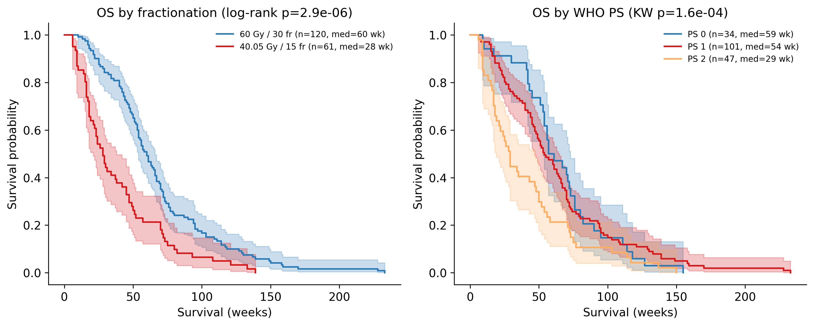
Figure 1
Figure 1. Kaplan–Meier OS by fractionation scheme and WHO performance status. Sixty Gy patients had median OS 60 weeks vs 28 weeks for 40 Gy (log-rank p≈3×10⁻⁶). Cox model: scheme HR≈0.54 (p≈0.0007), WHO PS HR≈1.42 (p≈0.001).

7.2 Pooled TCP — OS proxy
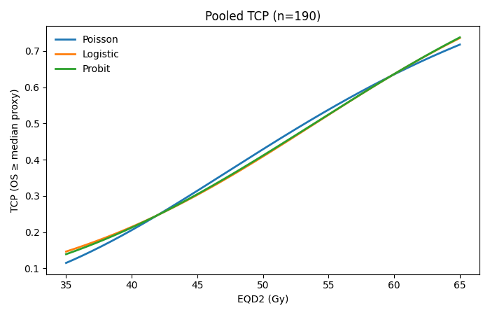
Figure 2
Figure 2. TCP dose–response curves for EQD2 vs OS ≥ median (51 weeks, n=190). AUC≈0.68; LR p≈3×10⁻⁶. Interpretation confounded by fractionation (r(age, EQD2)=−0.57).

7.3 Pooled TCP — RANO endpoint
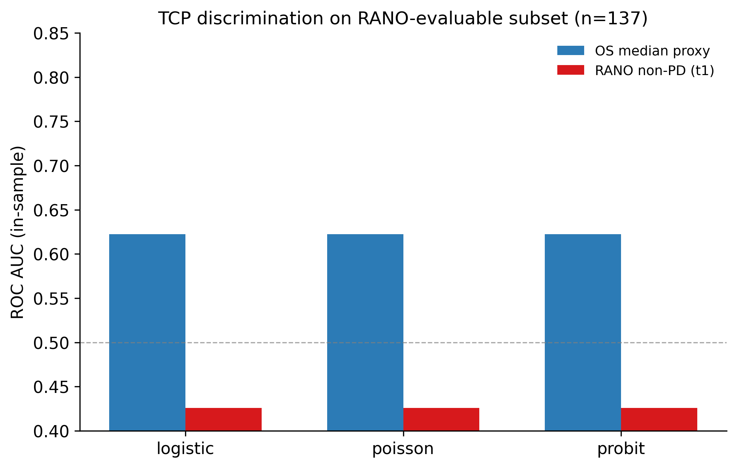
Figure 3
Figure 3. Same Poisson TCP on 137 RANO-labelled patients: OS proxy AUC≈0.62; RANO non-PD AUC≈0.43 (no signal). Higher EQD2 associated with more early PD at t1 (27% vs 15% by scheme).

7.4 Within-arm analysis
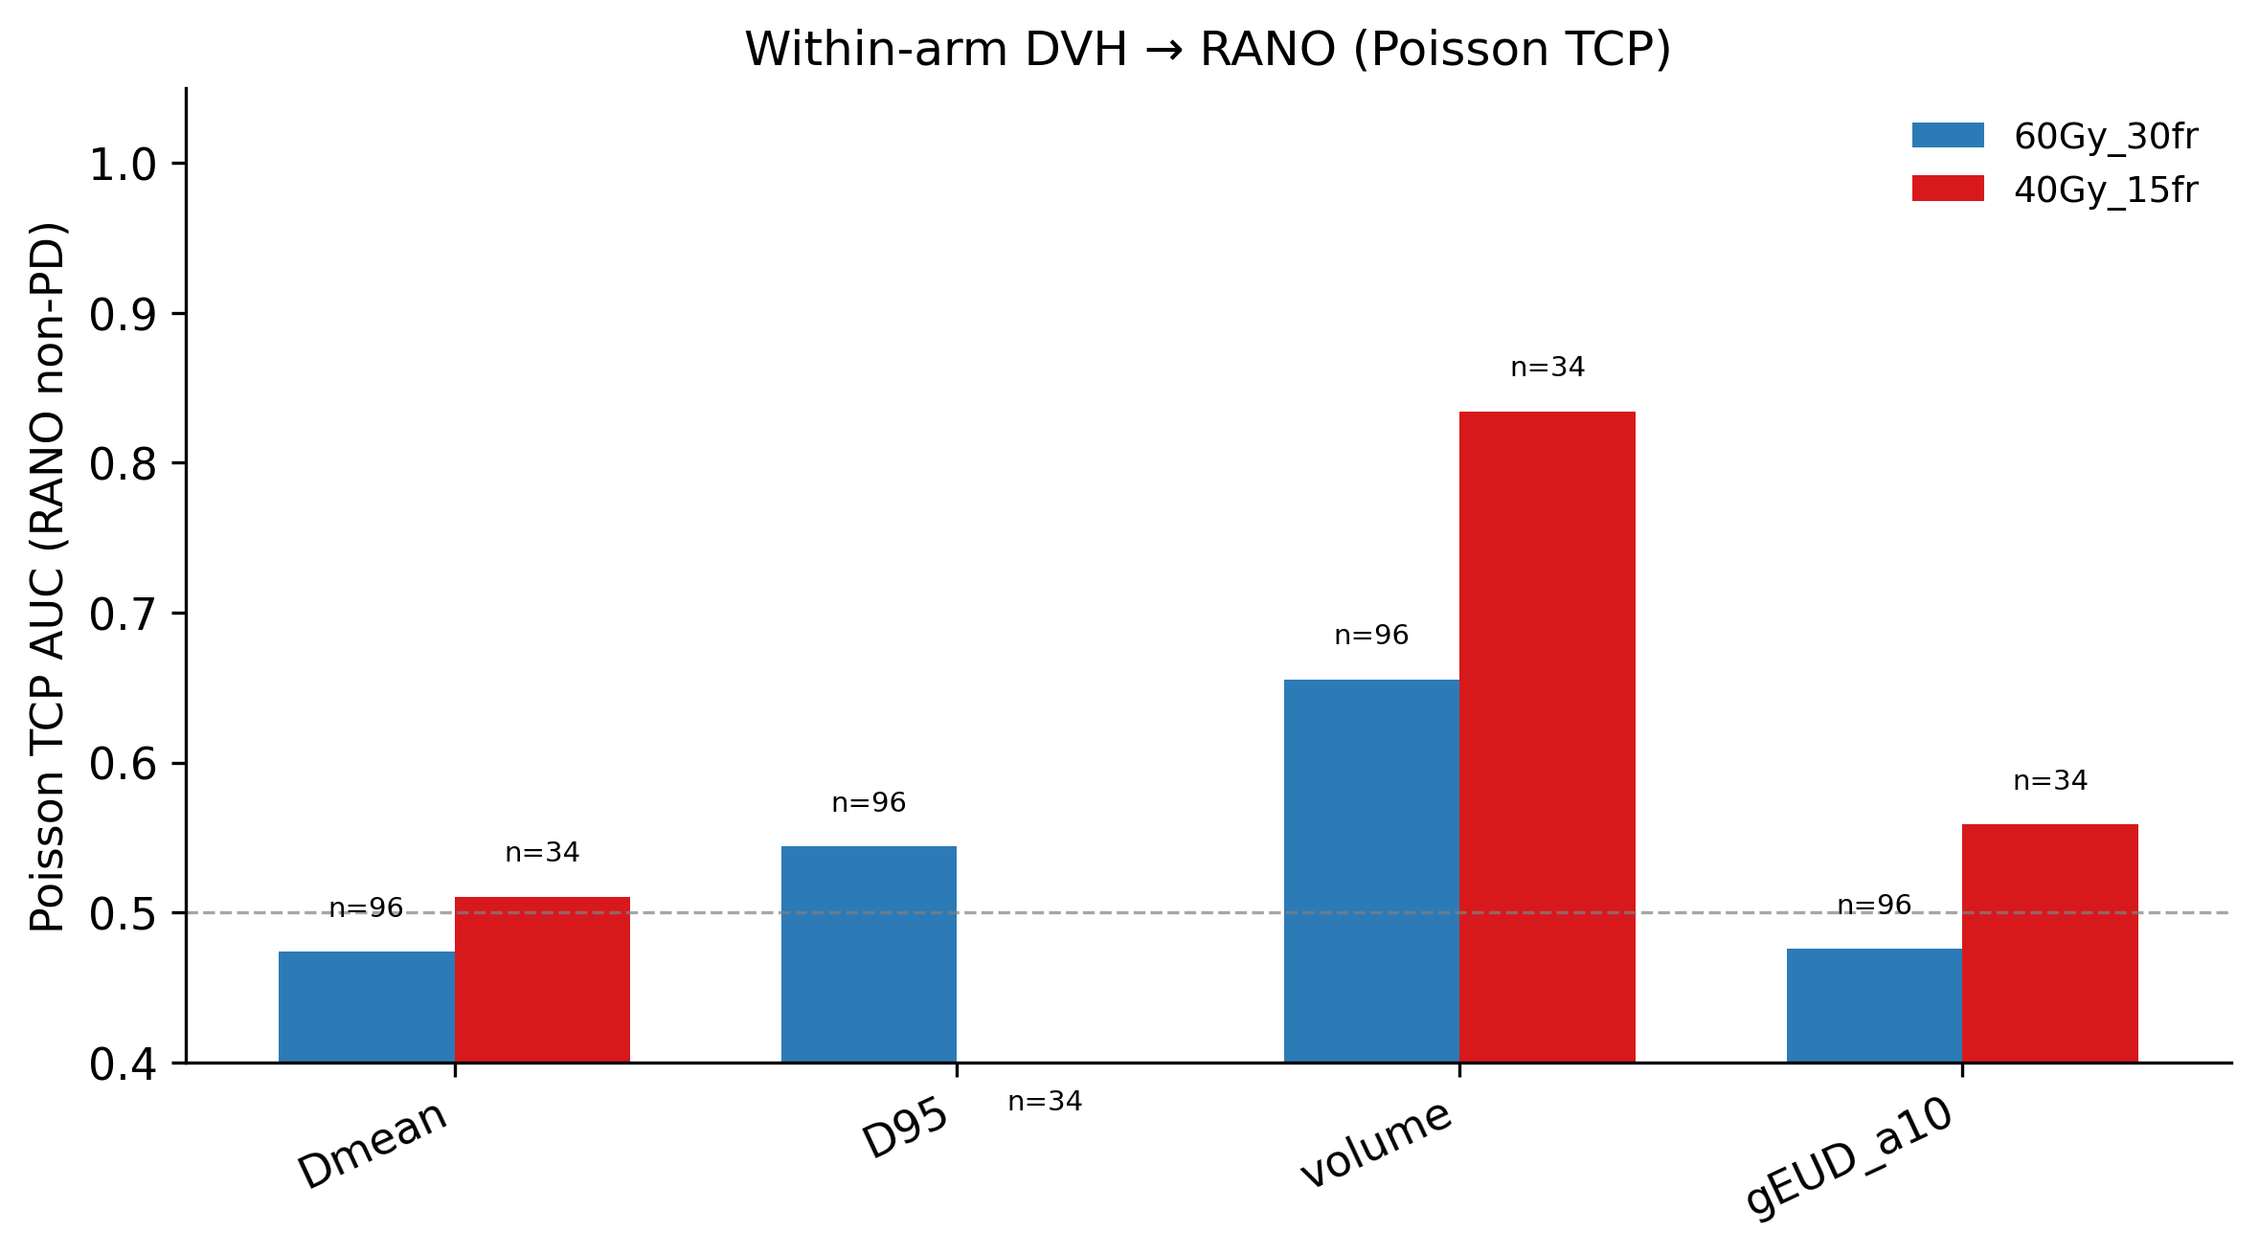
Figure 4
Figure 4. Stratified by fractionation: dose metrics flat within arm; GTV volume predicts RANO in 40 Gy arm (n=34; Poisson AUC=0.83, p≈0.037).

7.5 Multivariable and pooled RANO models
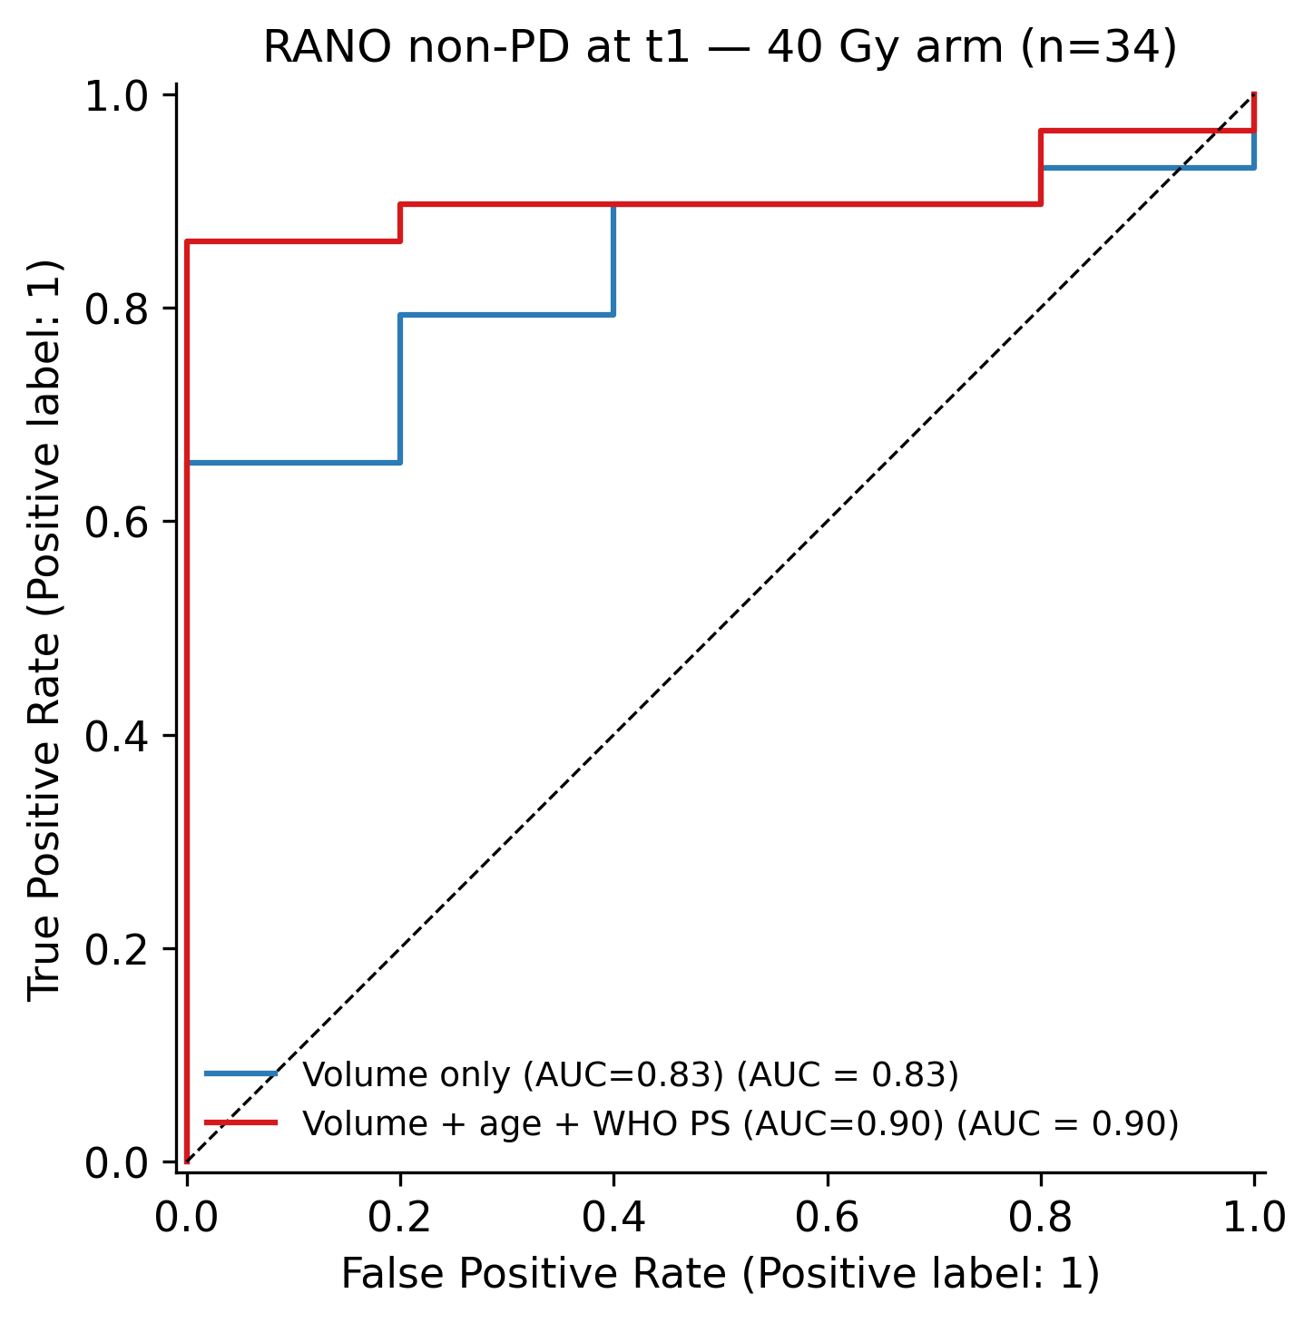
Figure 5
Figure 5. 40 Gy arm multivariable logistic ROC (volume + age + PS; in-sample AUC=0.90).
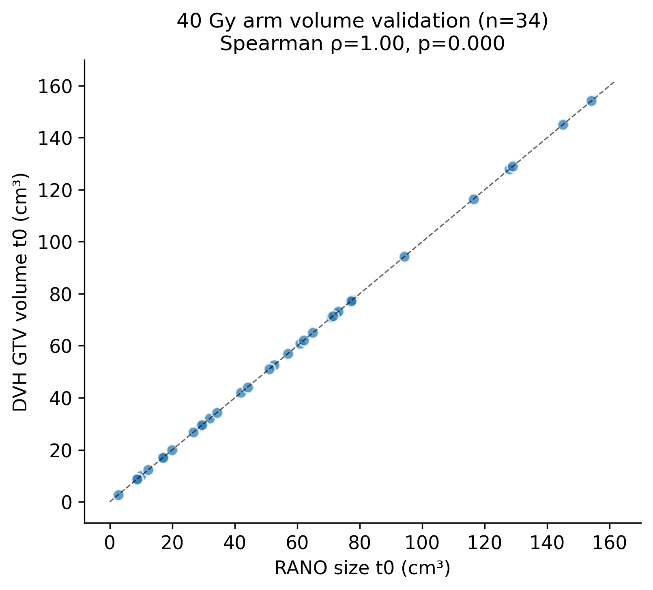
Figure 6
Figure 6. DVH volume validation vs author RANO volumes (ρ=1.00, n=141).
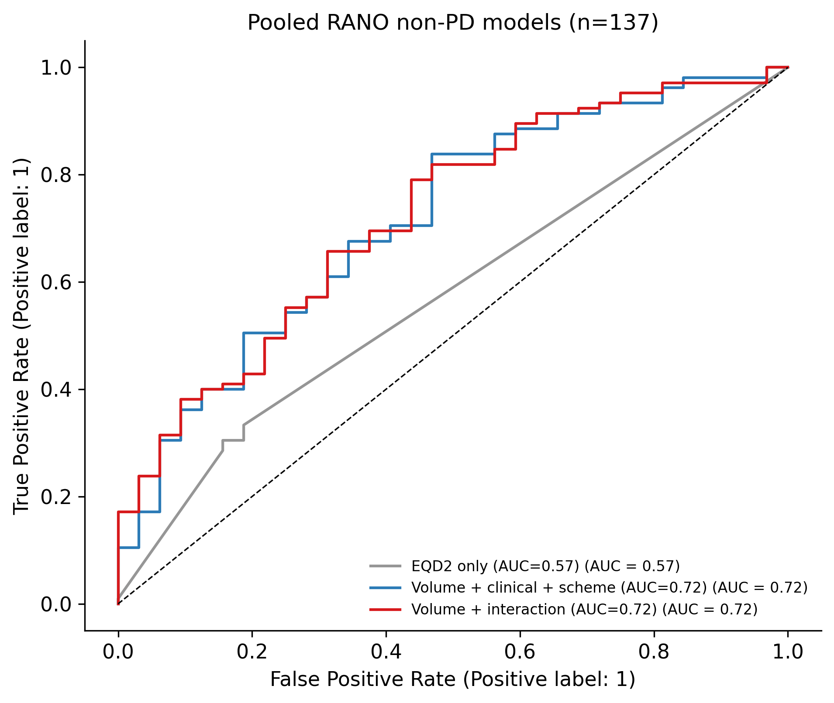
Figure 7
Figure 7. Pooled models (n=137): volume + clinical + scheme AUC≈0.72; LOOCV≈0.64.

7.6 PyRadiomics comparison
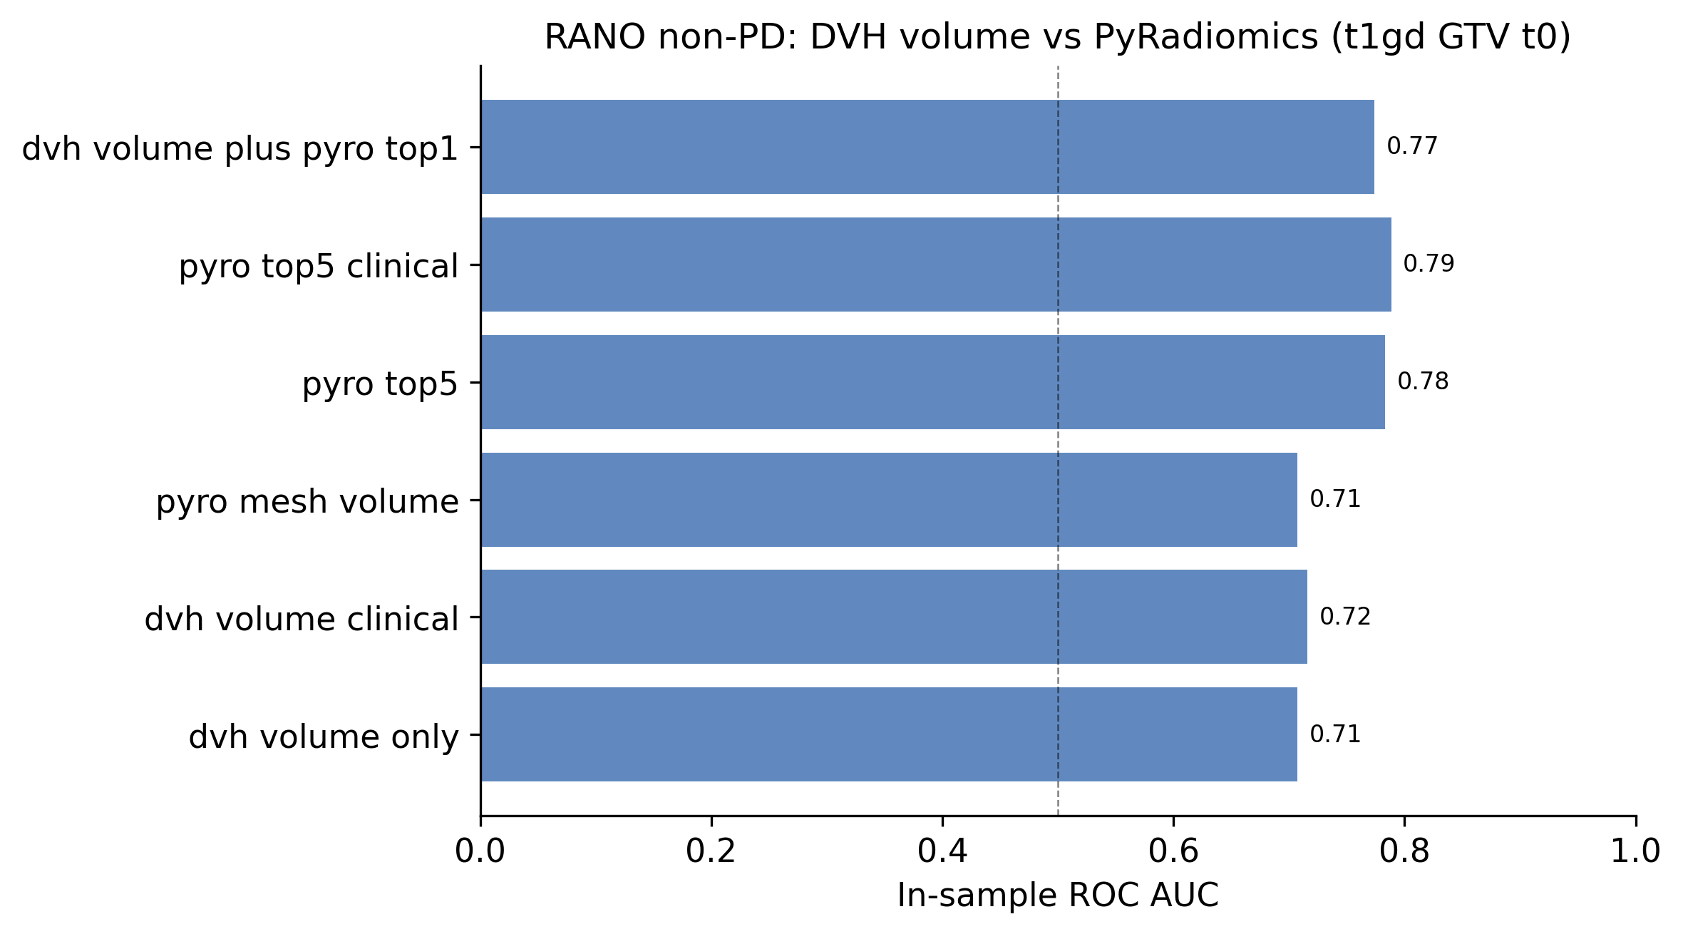
Figure 8
Figure 8. Author PyRadiomics (t1gd GTV t0) top-5 features vs DVH volume (in-sample AUC 0.78 vs 0.71).
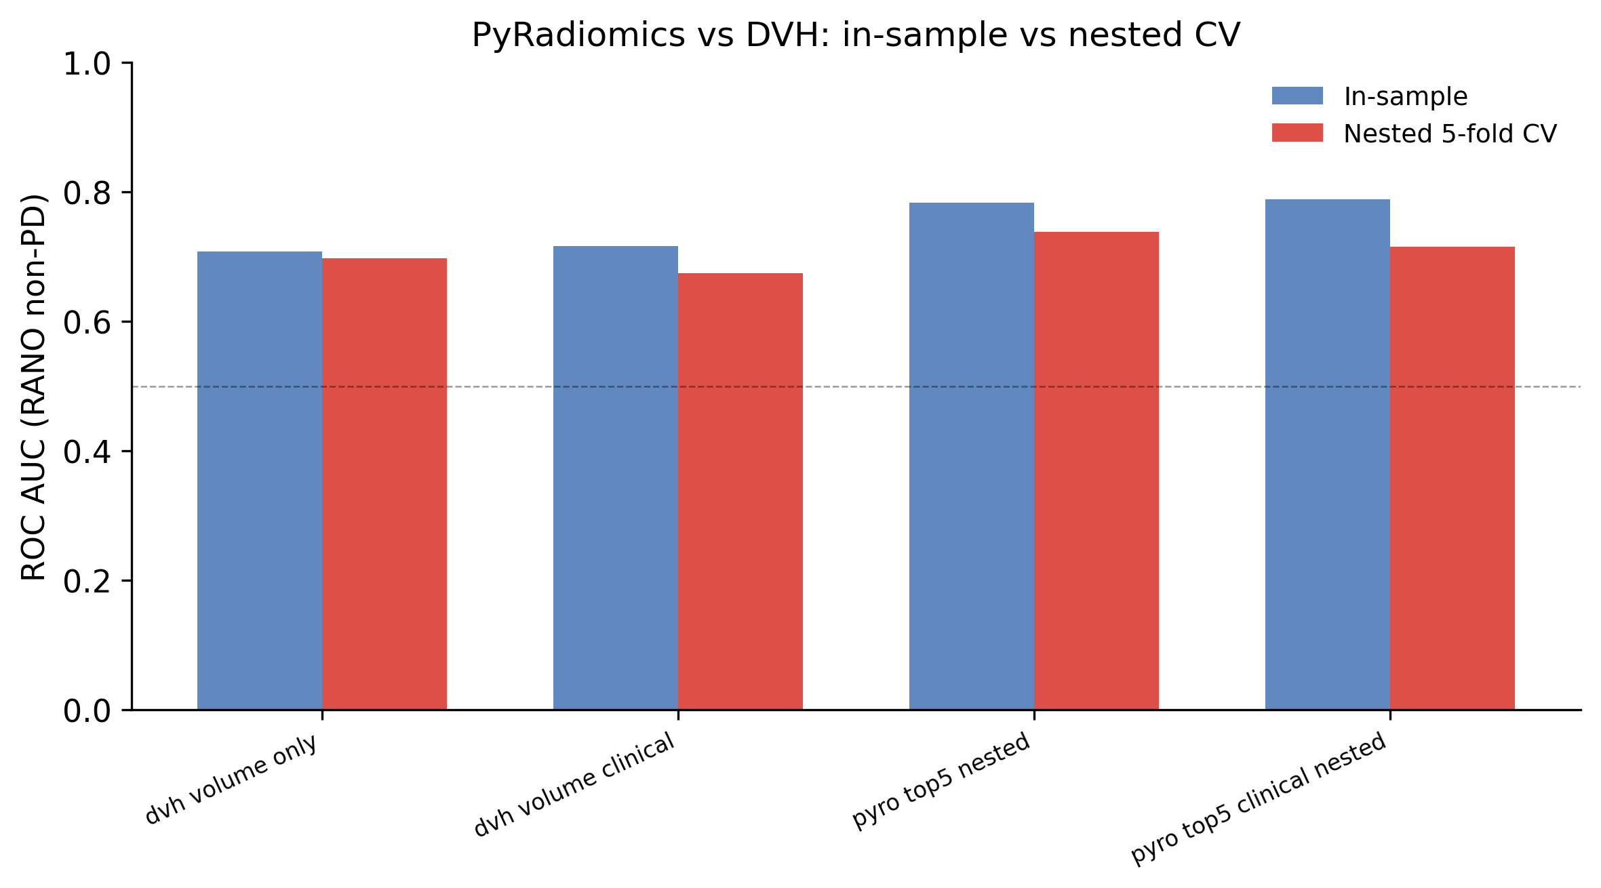
Figure 9
Figure 9. Nested 5-fold CV reduces optimism: radiomics nested AUC≈0.74 vs volume 0.70.

8. Survival Analysis
Kaplan–Meier and Cox proportional hazards models (lifelines) included EQD2, Dmean, age, sex, WHO PS, fractionation scheme, and RANO non-PD.
Covariate (Cox, n=137) | HR | p
RANO non-PD | 0.48 | 0.0009
WHO PS | 1.57 | 0.0005
EQD2 | 0.97 | 0.009
RANO non-PD predicts OS independently of dose and performance status.

9. Literature Review and TCP Parameter Comparison (Part VI)
Literature table: reports/literature_table.csv (18 references). DOI verification: reports/literature_doi_check.md.
Source | D50 (Gy) | γ50 | Endpoint | Comparable?
This study (CFB-GBM) | 53.2 | 3.32 | OS ≥ median (proxy) | reference
Maitre et al. 2020 (review) | 40–80 | 1–5 | LC / NTCP | partial
Okunieff et al. 1995 (meta) | ~50–70 | ~1–4 | Tumour control | partial
Ohri et al. 2017 | — | — | LC preferred | design note
Our D50 falls in published ranges but is not interpretable as GBM tumour-control D50 without local control endpoint and single-protocol dose spread.

10. Discussion
Why pooled dose–TCP fails: CFB-GBM reflects routine practice, not dose escalation. Within-arm GTV Dmean variation <1 Gy. OS and early RANO capture different biology; fractionation is confounded with age and treatment intent [7,15].
Where signal remains: GTV volume and PyRadiomics predict RANO when scheme is adjusted (pooled LOOCV AUC≈0.64; 40 Gy LOOCV≈0.74; PyRadiomics nested CV≈0.74). This reframes the project from classical TCP to tumour burden → imaging response — clinically interpretable and aligned with Moreau et al. radiomics work on the same dataset [9,10].
Limitations: No formal local control; single institution; small 40 Gy RANO subset (n=34); t1 GTV NIfTI not validated locally.
Feasibility checklist for future open TCP studies [7]: report within-arm Dmean IQR; prefer LC or RANO over OS; adjust for fractionation; report LOOCV/nested CV; compare against author radiomics baselines.

11. Conclusion
We delivered an open, reproducible TCP modeling pipeline on CFB-GBM and demonstrated that classical pooled TCP validation is not feasible on this cohort. With confounding addressed, GTV volume and PyRadiomics features predict early RANO with moderate cross-validated discrimination. All code, figures, and auto-generated metrics regenerate via make report.

References
- Stupp R et al. Lancet Oncol. 2009. doi:10.1016/S1470-2045(09)70025-7
- Minniti G et al. Expert Rev Anticancer Ther. 2021. doi:10.1080/14737140.2021.1919470
- Malmström A et al. Lancet Oncol. 2012. doi:10.1016/S1470-2045(12)70265-6
- Maitre A et al. Cancer Radiother. 2020. doi:10.1016/j.canrad.2019.08.002
- Gardner LL et al. Phys Med Biol. 2024. doi:10.1088/1361-6560/ad70f0
- Niemierko A. Med Phys. 1997. doi:10.1118/1.598061
- Ohri N et al. Transl Cancer Res. 2017. doi:10.21037/tcr.2017.02.01
- Moreau NN et al. TCIA. 2025. doi:10.7937/v9pn-2f72
- Moreau NN et al. Front Oncol. 2025. doi:10.3389/fonc.2025.1497195
- Moreau NN et al. PRIME 2025 LNCS. doi:10.1007/978-3-032-07904-6_3
- Fowler JF. Br J Radiol. 2010. doi:10.1259/bjr/86359321
- Wen PY et al. J Clin Oncol. 2010. doi:10.1200/JCO.2009.25.5874
- van Dijk WT et al. Lancet Oncol. 2021. doi:10.1016/S1470-2045(21)00489-7
- Cox DR. J R Stat Soc B. 1972. doi:10.1111/j.2517-6161.1972.tb00999.x
- Perry JR et al. N Engl J Med. 2017. doi:10.1056/NEJMoa1611977
- Embring A et al. Radiother Oncol. 2020. doi:10.1016/j.radonc.2019.11.014
- Zwanenburg A et al. Radiother Oncol. 2020. doi:10.1016/j.radonc.2019.11.009
- Efron B, Tibshirani RJ. An Introduction to the Bootstrap. Chapman & Hall; 1994.

Appendix — Reproducibility
pip install -r requirements.txt
make report # regenerate RESULTS.md
python scripts/verify_literature_dois.py # check reference links
bash scripts/run_notebooks_check.sh # execute notebooks 01, 03–06
bash scripts/export_assignment_report.sh # this document → DOCX/PDF
bash scripts/export_manuscript.sh # scientific manuscript export
Group glossary (plain language): group_glossary_guide.md

