1. **DATA EVALUATION**

1.1. Sales per month

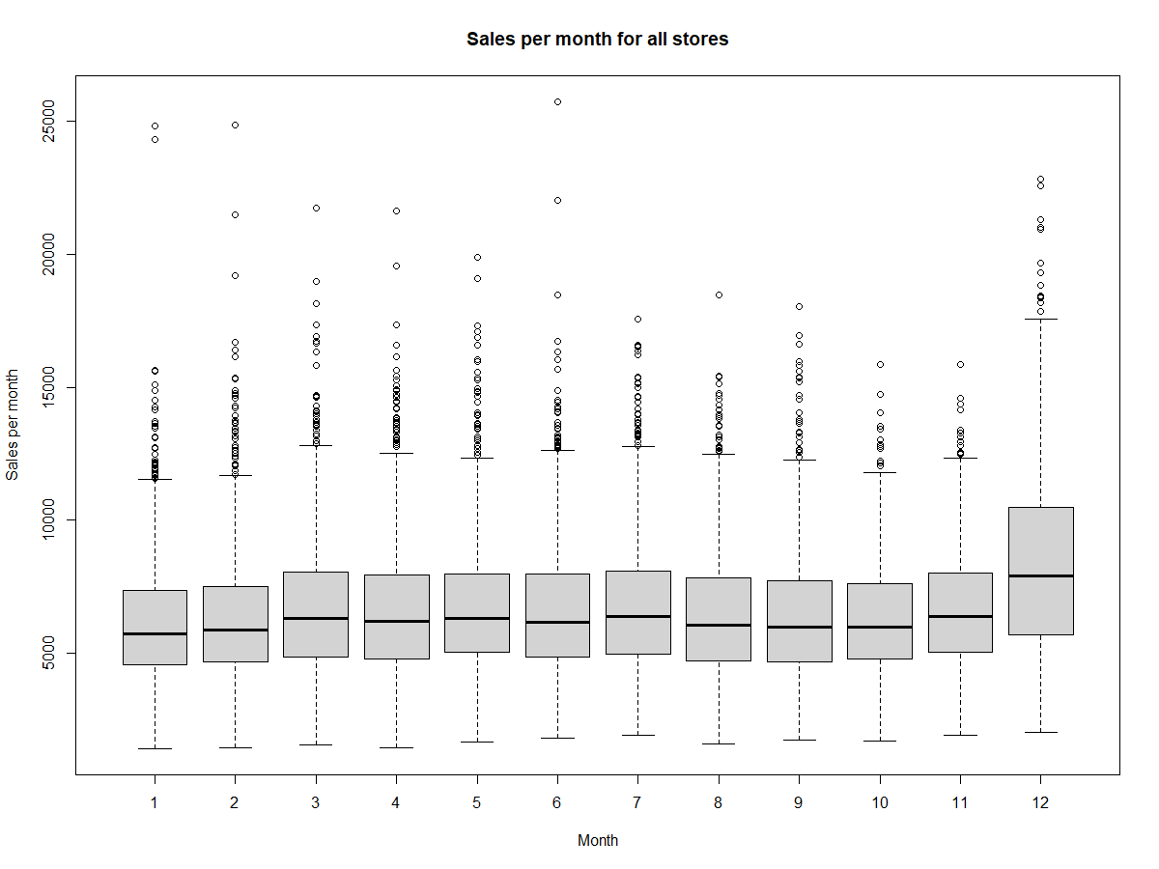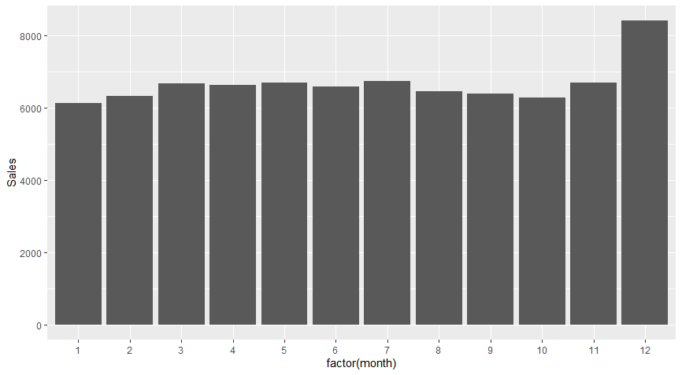

The steady growth of sales is observed in December for all stores, and reduction of sales in January. Standard tendency for Christmas vacation times, and decrease after it. Most likely, offered goods are of "to-be-a-good-gift" origin.

1.2. More detailed overview (sales by week)

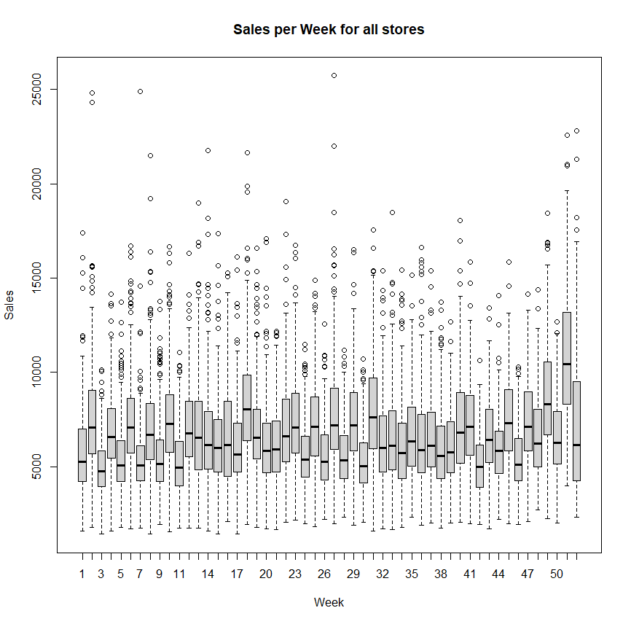If to assess data per each week, there are 2 clear out-of-trend weeks:

1. Week 51 with extremely high sales due to Christmas holidays
2. Week 18 with high sales due to May holidays.

High variation of data is observed between sales and stores as well with its peak in December due to holidays.

1.3. Sales by day of week

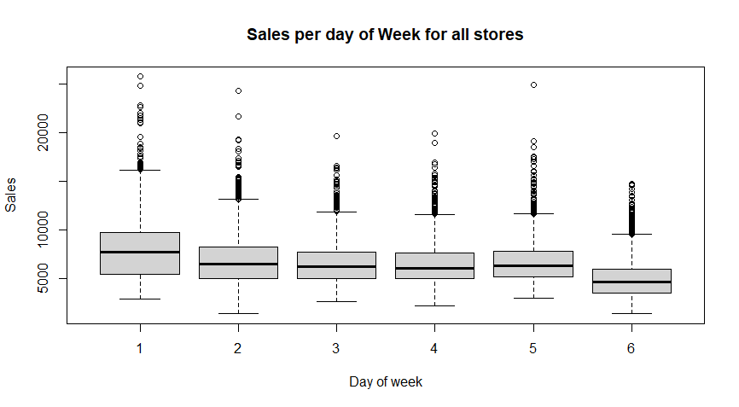

Peak of all sales is observed on Mondays, with minimum on Saturdays. The same tendency s observed for all individual stores if correction on holidays is made.

1.4. Sales per store

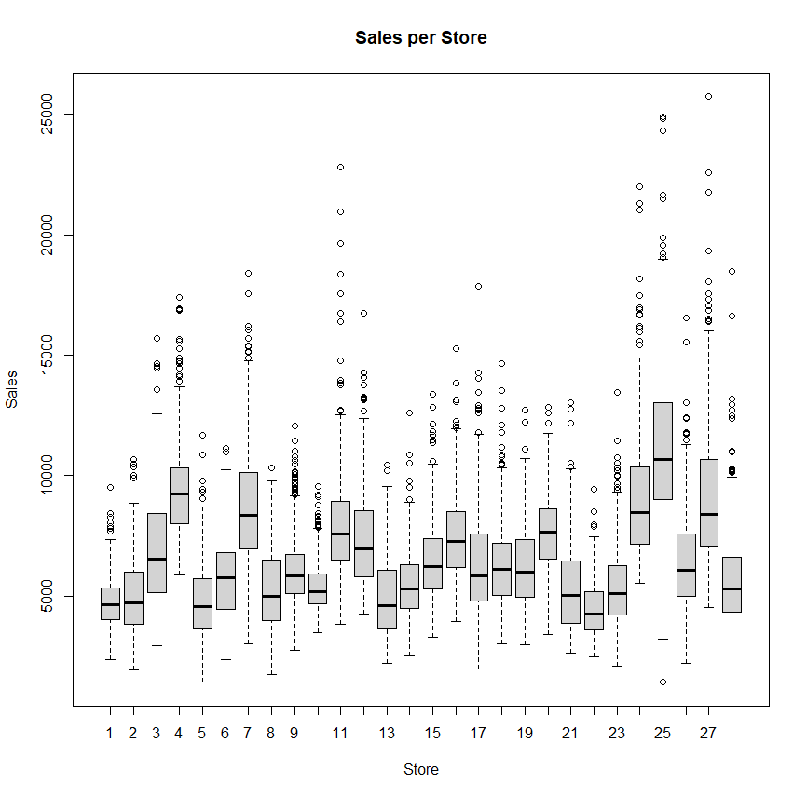There is a clear leader of sales: store 25.

Top 5 stores by sales are:

1. Store 25
2. Store 4
3. Store 24
4. Store 7
5. Store 27

2. DIFFICULTIES DURING DATA ANALYSIS

2.1. There are 3 stores, for which only 539 data units are available (ending in 30.06.2014.), however all other stores contain all data units upto 01.10.2014. Since, we do not know the precise reason for lack of statistics, and trend data of missed stores show steady Sales, there is no reason to think, that these stores were closed. Statistics is decreased to 30.06.2014. For all stores due to these 3 stores.

2.2. Stores are closed during Sundays and most of State-holidays, therefore some fluctuation may be observed, when Day-of-Week data is assessed.

3. DATA AGGREGATION AND SEASONALITY CHECK

3.1. Total Sales per month combined

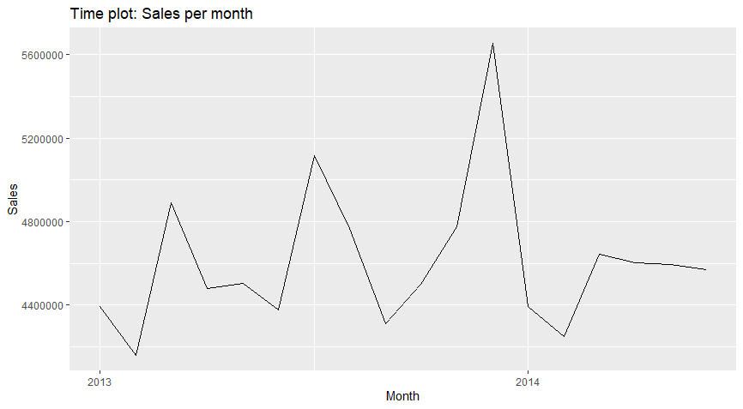No Clear trend is observed.

3.2. Seasonality

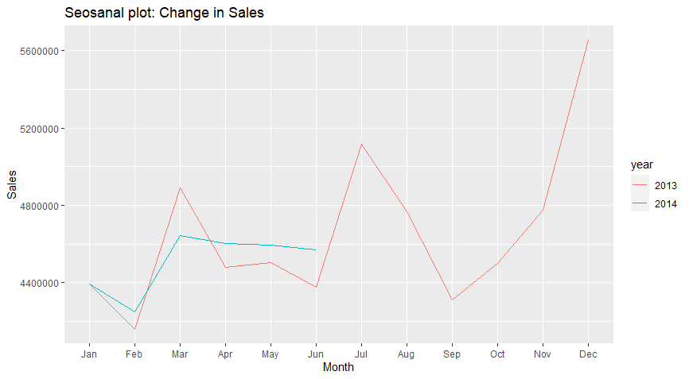Clear seasanality is seen, however more year statistics is required to approve seasonability with increase in December and drop in January.

**4.FORECASTING**

4.1. ETS model.

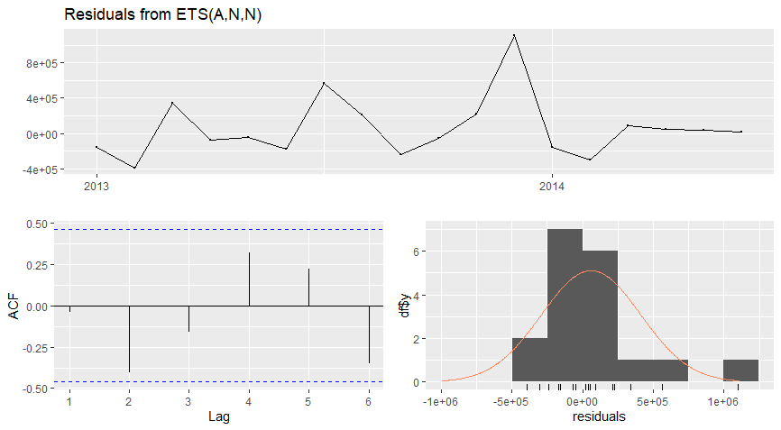RSD (sigma) = 366438.1. Model fits, but is not ideal.

4.2. SNaive model.

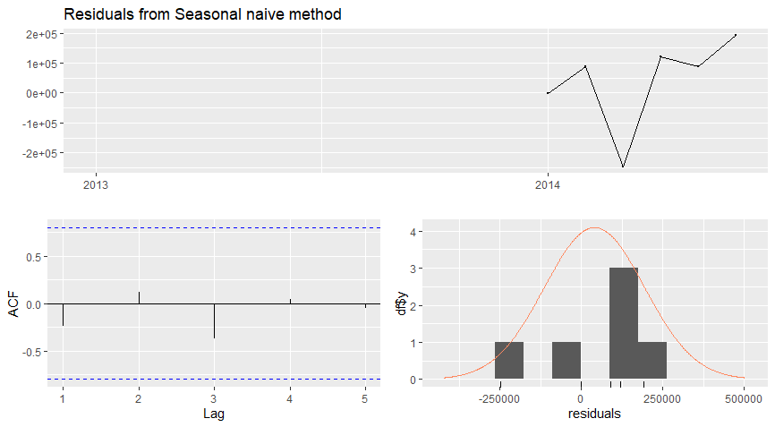

RSD = 146095.3. Fits well. It will be chosen for forecasting.

4.3. ARIMA model.

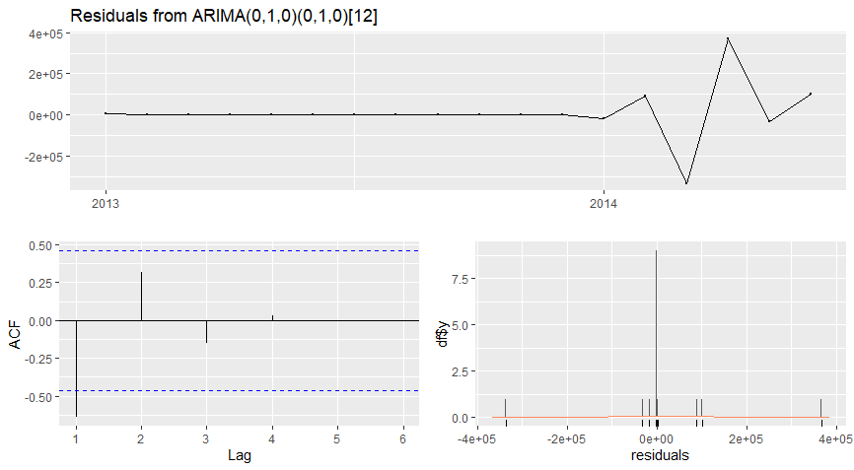

RSD = 231495. Does not fit, has some data out of range.

**5.FORECAST ON TOTAL SALES**  
