**CV**

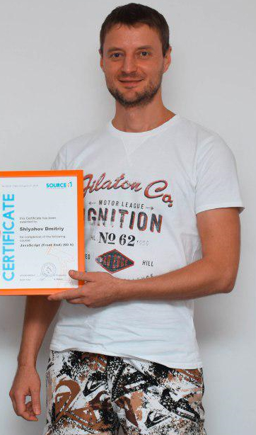 **Shlyahov Dmitriy**

**Desired position:** Junior Front-end Developer (Trainee)

**Desired income:** 100 $

Date of birth: 10.06.1984

Address: Kharkiv, Zhasminovij blvd.

**Contact information:**

+38 096 1834859 https://lardi-trans.com/tpl/jsp/images/viber_16x16.png Viber

[rusak.kh@gmail.com](mailto:rusak.kh@gmail.com)

**Purpose:** Turn your hobby into a job and start a career as a junior developer in

an IT company and develop in this area.

**Main skills and knowledge:**

- practical knowledge of HTML5, CSS3, LESS, JavaScript (ES5 & ES6), jQuery;

- basic understanding of Object-oriented programming;

- basic skills of using PHP, MySQL, Photoshop;

- understanding and using of the principles of the BEM-naming methodology;

- English knowledge - Intermediate;

- I'm learning React.js on my own now.

**Projects:**

<https://dmitriy-rusak.github.io/> **-** my site - portfolio.

**Working experience:**

I don’t have commercial experience in IT. Only experience in academic practice.

10.2018 – nowadays –logistician-dispatcher of freight vehicles;

07.2007 – 10.2018 – universal cook, chef (3 years);

**Education:**

**2019 year** – «Source iT», Kharkiv

JavaScript (Front-end) course, certificate.

**2011 year** –Training center "Career", Kharkiv

Web design and web development course.

**2008 year** –NTU «KhPI»

Speciality «Electric vehicle engineer», specialist diploma

**2003 year** – Kharkiv motor transport college,

Speciality «Organization of transportation by vehicles», diploma.