MODULAR UNIVERSITY MANAGEMENT PLATFORM
Phase I Report: Requirements, User Guide & Project Schedule
Team 5: Student Registration & Records (SIS / Enrollment)
Team Members:
• Dmytro Ilnytskiy
• Denys Konovalov
• Oleksandr Slavskyi(Team Leader)
Course: Software Engineering & AI
Institution: American University Kyiv
Due Date: September 29, 2026

1. Project Overview

1.1 Introduction and Scope
The Student Registration & Academic Records (SIS / Enrollment) module serves as the authoritative core of the Modular University Management Platform. It manages the complete student lifecycle from initial enrollment and course registration to graduation and academic history tracking. Designed with a robust backend (Java / Spring Boot) and integrated via REST APIs with a React frontend and MySQL database, the SIS module ensures data integrity, rigorous prerequisite validation, and seamless interoperability with LMS Core, Academic Scheduling, Admissions, and Core Platform services.

1.2 Functional Requirements
The SIS module fulfills the following core functional requirements:
- Student Profiles & Academic History: The system maintains comprehensive student profiles, including personal data, contact information, major/program declarations, advisor assignments, and complete chronological academic records (semesters, GPA, earned credits).
- Course Catalog Management: Administrators and authorized staff can create, update, and archive course offerings, course descriptions, credit values, department affiliations, and term availability.
- Registration & Add/Drop Engine: Students can search for open courses, add them to their schedule, or drop courses within designated add/drop periods. The engine automatically checks course capacity limits, seat availability, and prerequisite completions in real-time.
- Prerequisite & Corequisite Enforcement: The system automatically blocks registration if prerequisite courses have not been passed with a satisfactory grade or if corequisites are missing, unless an administrative waiver is applied.
- Waitlists & Automated Enrollment: When a course reaches maximum capacity, students can join an automated waitlist. If a seat opens up (via a drop or capacity increase), the system automatically promotes the next student in the queue and sends a notification.
- Transcripts & Degree Progress Tracking: Generates official and unofficial academic transcripts in digital format (PDF/HTML). Tracks student progress against degree audit requirements, showing completed, in-progress, and remaining requirements for graduation.
- Holds & Restrictions Management: Administrators can place financial, academic, or disciplinary holds on student accounts. Active holds automatically restrict course registration, transcript generation, and diploma issuance until resolved.

1.3 Non-Functional Requirements
- Performance & Scalability: The registration engine must handle high concurrency during peak enrollment periods (e.g., supporting up to 1,000 simultaneous registration requests with API response times under 500ms).
- Security & Data Privacy: Strict role-based access control (RBAC) powered by Spring Security and JWT ensures that students only access their own records, while faculty and admins have appropriate tiered access. All personal and academic data is encrypted in transit (TLS 1.3) and at rest.
- Reliability & Auditability: Maintains immutable audit logs for all registration actions, grade updates, and administrative overrides to ensure academic accountability.
- API Integration: Provides well-documented RESTful endpoints consumed by the Academic Scheduling module (for room/time validation) and LMS Core (for automated roster synchronization).

2. User's Guide / Walkthrough

2.1 System Features Overview
The SIS module provides a responsive web interface tailored to two primary user roles: Students and Administrators. Below is the operational walkthrough for key workflows within the platform.

2.2 Walkthrough: Student View
Workflow 1: Course Search and Registration
- Login & Dashboard: The student logs into the portal using university credentials. The dashboard displays current GPA, earned credits, and registration status flags.
- Course Catalog Browsing: Navigate to 'Course Catalog' to search for courses by code, title, department, or instructor. Filters allow viewing only open courses.
- Adding a Course & Prerequisite Check: Click 'Register' on a desired course. The system instantly evaluates prerequisites, capacity, and schedule conflicts. If all checks pass, the course is added to the student's active schedule.
- Waitlisting: If a class is full, the student clicks 'Join Waitlist' and is assigned a queue position.
Student Screens
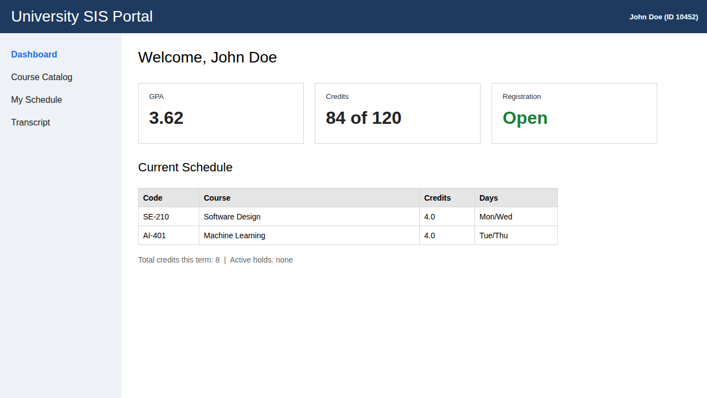
Figure 1. Student dashboard
After logging in, the student lands on the dashboard. Three cards at the top show the GPA (3.62), the earned credits (84 of 120) and the registration status (Open). The current schedule sits below them, followed by the term's credit total and a note on whether any holds are active. The menu on the left links to the catalog, the schedule and the transcript.
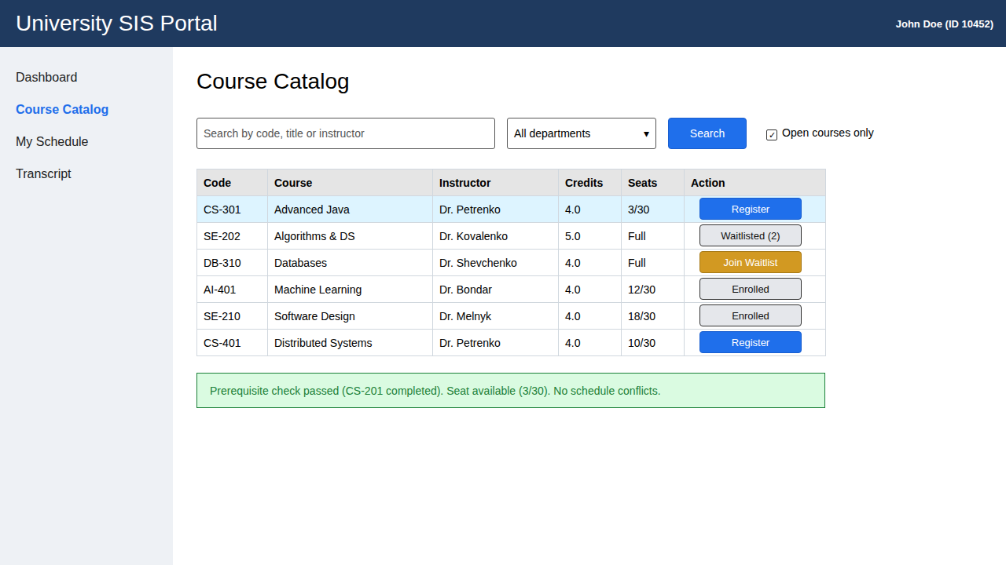
Figure 2. Course catalog and registration
The catalog lists each course with its instructor, credits and open seats. The student can search by code, title or instructor, filter by department, and show only open courses. The button in the Action column changes with the course status: Register when seats are open, Join Waitlist when the course is full, Waitlisted with a queue position once the student has joined, and Enrolled for courses the student already has. When the student clicks Register on CS-301, the system checks the prerequisite (CS-201, already passed), the seat count (3 of 30) and the schedule. A green message confirms the result.
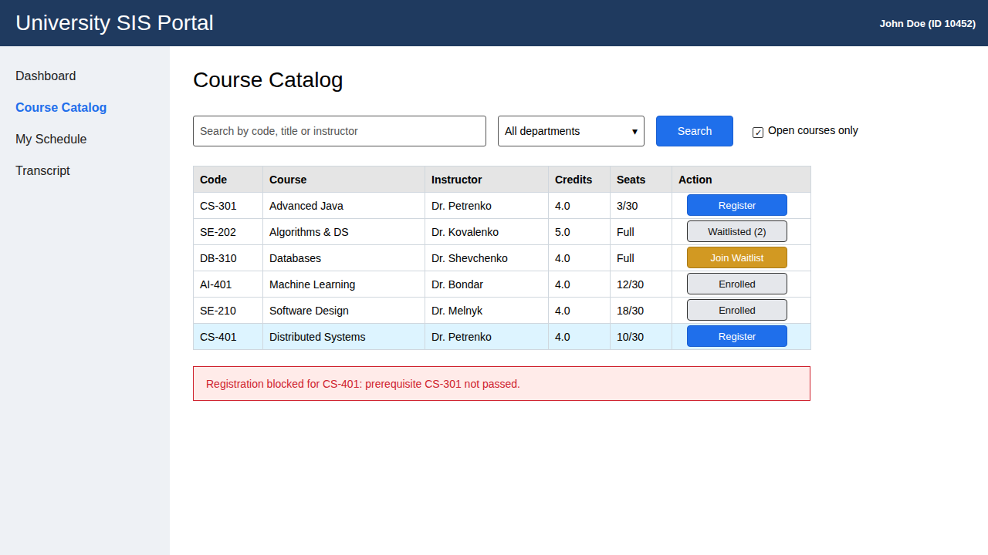
Figure 3. Registration blocked by a prerequisite
When a check fails, the system blocks the registration and explains why in a red message. Here the student cannot register for CS-401 because CS-301 has not been passed. An administrator can override the block with a waiver.
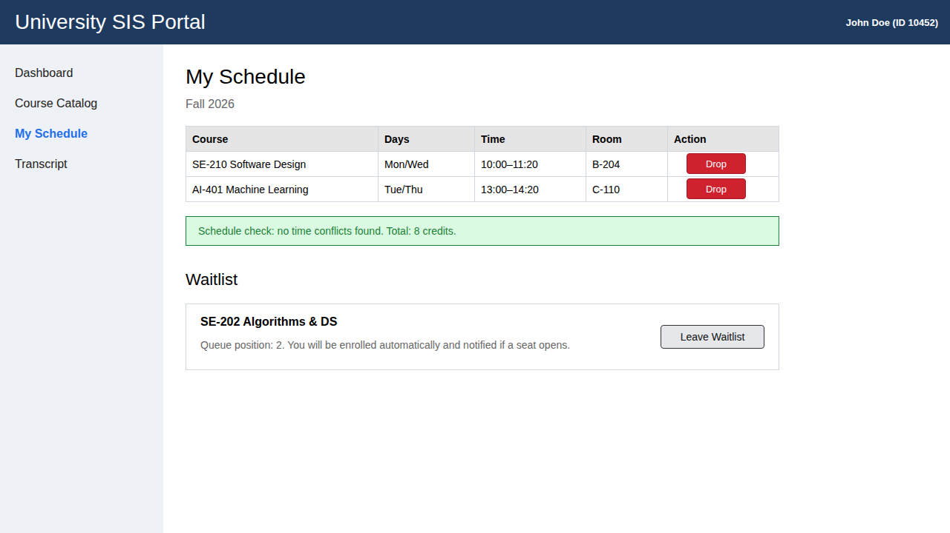
Figure 4. My Schedule and waitlist
My Schedule lists the courses the student is taking this term with their days, times and rooms. The Drop button removes a course during the add/drop period. A green message confirms that no courses overlap and shows the total of 8 credits. The waitlist section below shows SE-202 and the student's queue position (2). If a seat opens, the system enrolls the student automatically and sends a notification. The student can also click Leave Waitlist.
Workflow 3: Viewing the Transcript and Degree Progress
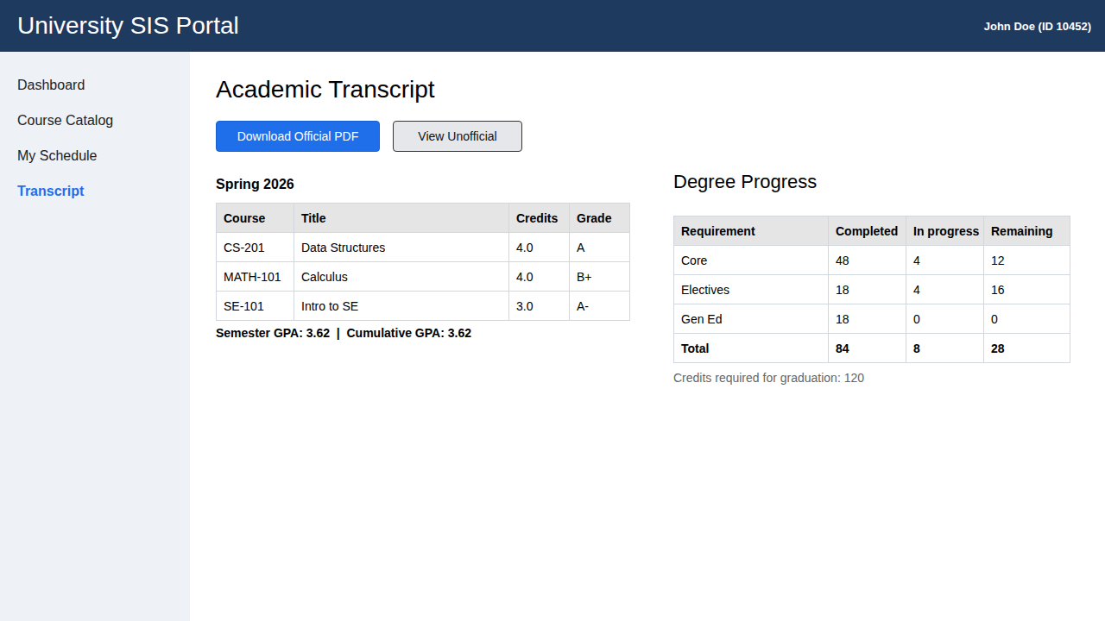
Figure 5. Transcript and degree progress
The Transcript page lists completed courses by term with their credits and grades, and shows the semester and cumulative GPA. Download Official PDF produces the official transcript, and View Unofficial opens an unofficial copy. An active hold blocks the official transcript until an administrator lifts it. The Degree Progress table shows completed, in-progress and remaining credits for Core, Electives and Gen Ed, against the 120 credits required to graduate.

2.3 Walkthrough: Administrator View
Workflow 2: Managing Course Catalog and Student Holds
- Admin Console Access: Administrators log in with elevated privileges to access the SIS management dashboard.
- Modifying Course Capacity & Prerequisites: Select a course from the directory, update maximum seat limits, or add/remove prerequisite course rules.
- Managing Account Holds: Search for a student profile, view active financial or advising holds, and lift holds once requirements are fulfilled.
Administrator Screens
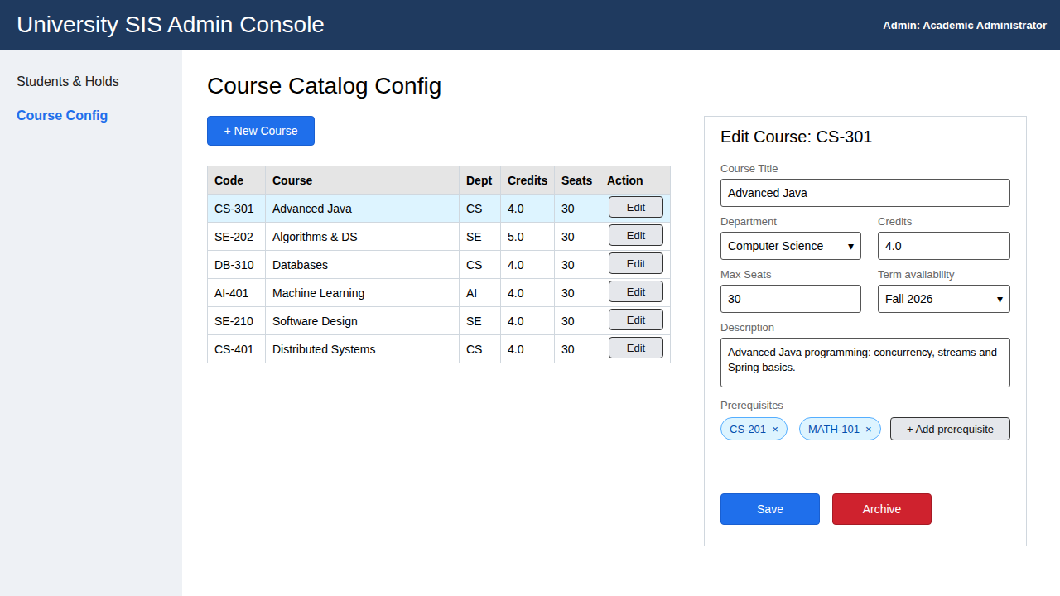
Figure 6. Course catalog configuration
The Course Config page is where staff manage the catalog. The table lists every course with its department, credits and seats, and New Course adds an offering. Edit opens the panel on the right, where the administrator can change the title, department, credits, maximum seats, term availability, description and prerequisites. Prerequisites are added with Add prerequisite and removed with the x on each one. Save applies the changes, and Archive retires the course.
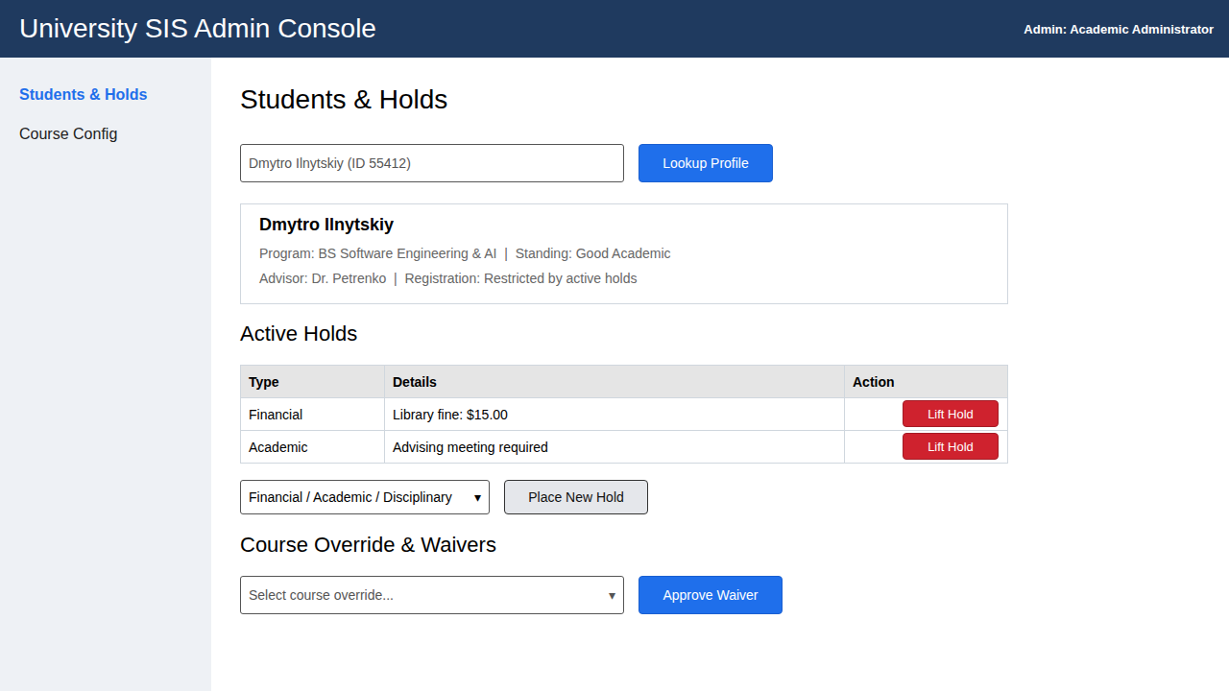
Figure 7. Student holds and waivers
On the Students & Holds page, the administrator looks up a student by name or ID. The profile card shows the program, standing and advisor. Each active hold has a Lift Hold button, used once the requirement is met: here, a $15.00 library fine and a required advising meeting. To add a hold, the administrator chooses a type (financial, academic or disciplinary) and clicks Place New Hold. Active holds block registration, official transcripts and diploma issuance. The Course Override & Waivers section lets the administrator approve a waiver for a student who is blocked by a prerequisite.

2.4 Inter-Module Integration Points
• LMS Core: Automatically pushes finalized student rosters for enrolled courses.
• Academic Scheduling: Consumes room and timetable data to prevent scheduling overlaps.
• Admissions: Receives newly admitted applicant records to initialize student profiles.

3. Project Schedule & Infrastructure

3.1 Project Management (Jira Schedule)
Development tasks are tracked using Jira across structured sprints aligned with course phases. Phase I focuses on requirements elicitation, architectural mapping, and UI wireframing.

3.2 Public GitHub Repository Structure
The project repository is publicly hosted and maintained with up-to-date documentation, source code, and weekly team logs:
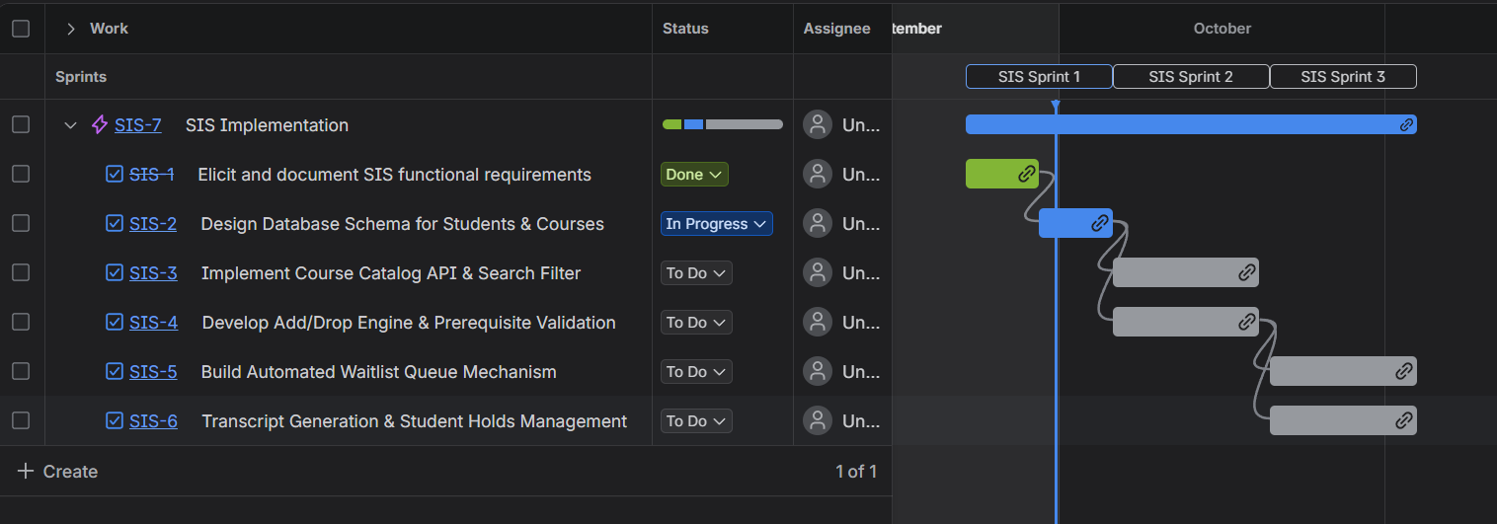
Repository URL: https://github.com/DmitriyIlnytskiy/sdt213_group_project
Repository Directory Structure:
• /docs — Phase reports, SRS, requirements documentation, and user guides.
• /src — Backend Spring Boot source code and frontend React components.
• /team-journal — Weekly team meeting logs and journals.
• /individual-logs — Individual member contribution logs.
• /recordings — Links/archives of weekly team meeting video recordings.

