Week 4 Homework: DevOps Foundations & Git
Student: Dmytro Ilnytskiy
GitHub URL: https://github.com/DmitriyIlnytskiy/sdt316-week4

Task 1 — Merge a Conflicting Branch

Graph Output:
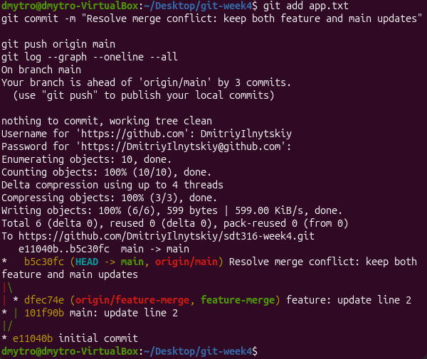

Written Answer:
The merge commit in the graph is b5c30fc. It has two parents (dfec74e and 101f90b). We can tell the history forked and rejoined because the visual graph splits into two parallel vertical tracks (the red and yellow lines) representing simultaneous work, which then converge diagonally (\ and /) back into a single, unified merge commit.

Task 2 — Rebase Instead

Graph Output:
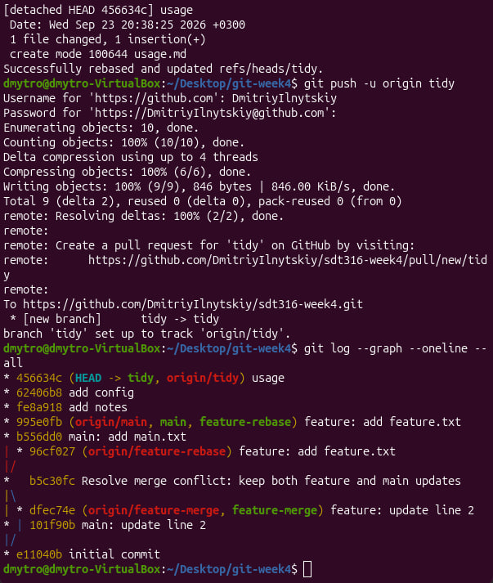

Written Answers:
- 1. Why the SHA changed: A Git commit's SHA hash is mathematically generated from its contents AND its parent commit. Because rebasing changes the commit's parent (moving it to the tip of main), Git generates a completely new SHA (995e0fb) for the commit, even though the file contents are identical to the original (96cf027).
- 2. Why GitHub rejected the normal push: GitHub rejected the normal push because rebasing rewrote the local history, meaning the local feature-rebase branch diverged entirely from the version currently stored on GitHub. Git prevents standard pushes in this scenario to prevent accidental history loss.
- 3. How this graph differs from Task 1: This graph is completely linear. Unlike Task 1, there are no branching paths or merge commits created for the feature-rebase branch; the commits are stacked in a straight, fast-forwarded line.
- 4. Why rebasing a teammate's pulled branch is risky: Rebasing a shared branch rewrites the repository history, meaning if a teammate tries to pull or push after you force-push a rebase, their local commits will be completely detached from the new upstream history, causing severe synchronization conflicts.

Task 3 — Curate Commits & Pull Request

Pull Request Description:
Title: Add project notes, config parameters, and usage documentation
Description:
- - What changed: Added notes.txt for project tracking, config.ini with initial application settings, and usage.md containing basic usage documentation.
- - Why it changed: To establish the foundational documentation and configuration architecture required for the upcoming deployment environments.
- - How to verify: Check the file tree to ensure notes.txt, config.ini, and usage.md are present and populated with their respective initial values.

Pull Request Commits Screenshot:

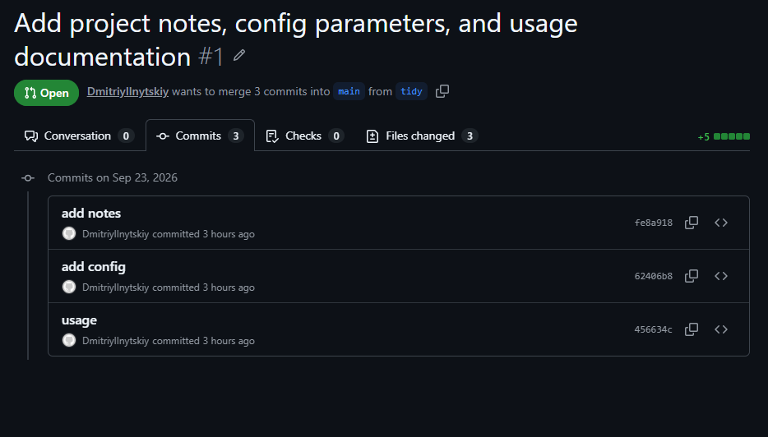Merge Options Answers:
- 1. Create a merge commit: Preserves all individual branch commits identically to how they were authored and adds a new dedicated merge commit linking the branch to main (Task 1 produced this shape).
- 2. Squash and merge: Condenses all commits from the branch into a single, brand new commit placed on the tip of main.
- 3. Rebase and merge: Re-applies the branch's individual commits directly onto the tip of main in a straight, linear sequence without creating a merge commit (Task 2 produced this shape).
- 4. Which option destroys the curated commits: Squash and merge. This option would take the three carefully curated commits and forcefully smash them together into one single commit, destroying the deliberate history separation.

Final Question Answer:
The two removed commits (the typo fix and the forgotten setting) were disposable because they were merely corrections of immediate mistakes that held no standalone logical value. The remaining three commits (fe8a918, 62406b8, and 456634c) were preserved because they represented distinct, complete, and coherent feature additions that provide clear, individual context for future developers reviewing the history.

Appendix: Terminal Execution Evidence
The following screenshots document the step-by-step terminal execution:
