**מעבדה 7 - תזמון תהליכים - תרגיל**

**מגישים:** 1. חוטמליאנסקי דמיטרי 334017415

2. שיח אחמד מוחמד 209158120

תרגיל 1

#include <stdio.h>

#include <pthread.h>

#include <time.h>

#include <errno.h>

#include <string.h>

#include <unistd.h>

#include <stdlib.h>

//*****function declarations*******

void *f(void* thread_num);

//*****global values**********

int this_thread;

int N;

int main(int argc, char **argv){

int i,j;

int *ans, *t_num; //pointers to arrays

pthread_t* t_array;

if(argc != 2){ //check if has only 1 argument

printf("\nError parameters");

exit(0);

}

if((N = atoi(argv[1])) == 0){ //check correct input

printf("\nIllegal number of threads");

exit(0);

}

//**********memory allocation for arrays**********

if((ans = (int*)malloc(N*sizeof(int))) == NULL){

printf("\nError memory allocation of 'ANS'");

exit(0);

}

if((t_num = (int*)malloc(N*sizeof(int))) == NULL){

printf("\nError memory allocation of 'T_NUM'");

exit(0);

}

if((t_array = (pthread_t*)malloc(N*sizeof(pthread_t))) == NULL){

printf("\nError memory allocation of 'T_ARRAY'");

exit(0);

}

//**********creating N threads************

for(i = 0; i < N; i++){

t_num[i] = i+1;

ans[i] = pthread_create(&t_array[i], NULL, f, (void*)&t_num[i]);

if(ans[i]){ //check if creating was successful

printf("\nCan't create thread #%d", i);

exit(0);

}

}

for(i = 0; i < N; i++){

pthread_join(t_array[i], NULL); //wait for threads ending

}

//**********freeing allocated memory******

free(ans);

free(t_num);

free(t_array);

return 0;

}

void *f(void* thread_num){

double time;

struct timeval t1, t2;

while(1){

this_thread = *(int*)thread_num;

gettimeofday(&t1, NULL);

//*******run in the while loop untill it's the same thread

while(this_thread == *(int*)thread_num){

gettimeofday(&t2, NULL);

}

//convert to milliseconds

time = (t2.tv_sec - t1.tv_sec) * 1000.0;

time += (t2.tv_usec - t1.tv_usec) / 1000.0;

printf("Time slice for thread %d = %0.6f ms\n", this_thread, time);

this_thread = *(int*)thread_num;

}

}

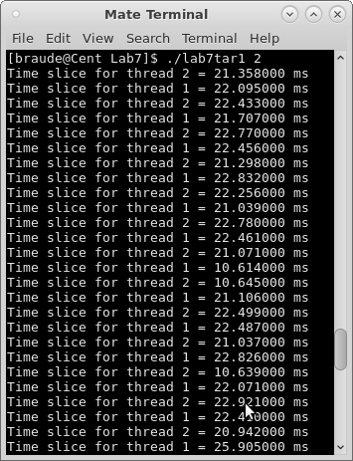

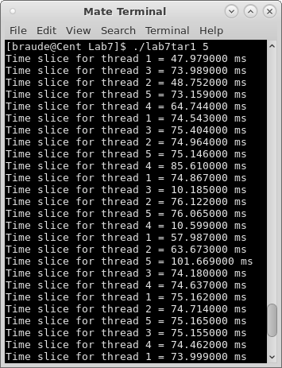

תרגיל 2

#include <stdio.h>

#include <pthread.h>

#include <time.h>

#include <errno.h>

#include <string.h>

#include <unistd.h>

#include <stdlib.h>

//*****function declarations*******

void *f(void* thread_num);

void *print_count(void *arg);

//*****global values**********

int this_thread;

int N;

int sec;

int* count_array;

int main(int argc, char **argv){

int i,j;

int *ans, *t_num; //pointers to arrays

pthread_t* t_array;

if(argc != 2){ //check if has only 1 argument

printf("\nError parameters");

exit(0);

}

if((N = atoi(argv[1])) == 0){ //check correct input

printf("\nIllegal number of threads");

exit(0);

}

//**********memory allocation for arrays**********

if((ans = (int*)malloc((N + 1) * sizeof(int))) == NULL){

printf("\nError memory allocation of 'ANS'");

exit(0);

}

if((t_num = (int*)malloc(N * sizeof(int))) == NULL){

printf("\nError memory allocation of 'T_NUM'");

exit(0);

}

if((t_array = (pthread_t*)malloc((N + 1) * sizeof(pthread_t))) == NULL){

printf("\nError memory allocation of 'T_ARRAY'");

exit(0);

}

if((count_array=(int*)malloc(N * sizeof(int))) == NULL){

printf("\nError memory allocation of 'COUNT_ARRAY'");

exit(0);

}

//**********set all count_array's cells to (0)************

for (i = 0; i < N + 1; i++){

count_array[i]=0;

}

//**********creating N threads************

for(i = 0; i < N; i++){

t_num[i] = i;

ans[i] = pthread_create(&t_array[i], NULL, f, (void*)&t_num[i]);

if(ans[i]){ //check if creating was successful

printf("\nCan't create thread #%d", i);

exit(0);

}

}

//**********one more thread for printing******

ans[N] = pthread_create(&t_array[N], NULL, print_count, NULL);

for(i = 0; i < N + 1; i++){

pthread_join(t_array[i], NULL); //wait for threads ending

}

//**********freeing allocated memory******

free(ans);

free(t_num);

free(t_array);

free(count_array);

return 0;

}

//*********printing counters of threads function********

void *print_count(void *arg){

int i;

sec = 0;

while(sec <= 20){

printf("Past %d seconds\n", sec);

sec += 2;

for(i = 0; i < N; i++){

printf("Thread #%d -> %d\n", i + 1, count_array[i]);

}

printf("\n");

sleep(2);

}

}

//*********running threads function**********

void *f(void* thread_num){

while(sec <= 20){

this_thread = *(int *)thread_num;

count_array[this_thread]++;

while(this_thread == *(int*)thread_num){

}

this_thread = *(int*)thread_num;

}

}

