**מעבדה 8 - סמפורים**

**מגישים:** 1. חוטמליאנסקי דמיטרי 334017415

2. שיח אחמד מוחמד 209158120

תרגיל 1

#include <pthread.h>

#include <stdio.h>

#include <string.h>

#include <semaphore.h>

sem_t sem1; //semaphore declaration

sem_t sem2;

void* create_message(void* str){

int i = 0;

for(i = 0; i < 10; i++){

sem_wait(&sem1); //block thread and wait

printf("I've wrote a message #%d. %s\n", i+1, (char*)str);

sem_post(&sem2); //wake up thread

}

}

int main(){

pthread_t thread;

sem_init(&sem1, 0, 1); //semaphore initialization

sem_init(&sem2, 0, 0);

int i = 0;

pthread_create(&thread, NULL, create_message, (void*)"Thread A");

for(i = 0; i < 10; i++){

sem_wait(&sem2); //block thread and wait

printf("The message #%d was printed. Thread B \n", i+1);

sem_post(&sem1); //wake up thread

}

pthread_join(thread, NULL);

sem_destroy(&sem1); //destroy the semaphore

sem_destroy(&sem2);

}

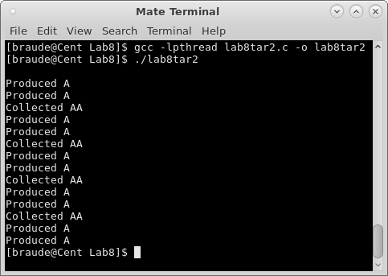

תרגיל 2

#include <stdlib.h>

#include <stdio.h>

#include <unistd.h>

#include <pthread.h>

#include <semaphore.h>

sem_t sem; //semaphore declaration

void* producer(); //function producing A product

void* collector(); //function collect AA and produce new product

int main(){

int ans[2];

pthread_t th1, th2; //two threads for each function

sem_init(&sem, 0, 0); //initializing the semaphore

ans[0] = pthread_create(&th1, NULL, producer, NULL); //first thread

if(ans[0] != 0){ //check if thread creating was successful

printf("Creating thread 1 ERROR");

exit(1);

}

ans[1] = pthread_create(&th1, NULL, collector, NULL); //second thread

if(ans[1] != 0){ //check if thread creating was successful

printf("Creating thread 2 ERROR");

exit(1);

}

sleep(20); //the program will close after 20 seconds

sem_destroy(&sem); //destroy the semaphore

return 0;

}

//*******Produce A product********

void* producer(){

while(1){

sem_post(&sem); //wake up the thread for producing

printf("\nProduced A");

sleep(2); //wait 2 seconds

}

}

//*******wait for producing 2 A products and create new AA product********

void* collector(){

while(1){

sem_wait(&sem); //wait for product A

sem_wait(&sem); //wait for product A

printf("\nCollected AA");

}

}

