**מעבדה 9 - סמפורים – בעיות נוספות**

**מגישים:** 1. חוטמליאנסקי דמיטרי 334017415

2. שיח אחמד מוחמד 209158120

תרגיל 1

#include <pthread.h>

#include <stdio.h>

#include <stdlib.h>

#include <semaphore.h>

#include <unistd.h>

#define K 5

#define N 10

void* tFunc(void* p);

void stkPush(int num);

int stkPop();

//****global variables definition****//

int stk[N];

int idx = 0;

//****semaphores definition****//

sem_t mutex;

sem_t empty;

sem_t full;

int main(int argc, char * argv[]){

pthread_t tArr[K];

int i = 0 , ans[K];

//*******semaphores initiatization****//

sem_init( &mutex, 0, 1 );

sem_init( &empty, 0, 0 );

sem_init( &full, 0, N );

for(i = 0; i < K; i++)

ans[i] = pthread_create(&tArr[i], NULL, tFunc, NULL);

sleep(10);

return 0;

}

void* tFunc(void* p) {

int num;

while(1){

num = rand() % 100;

if(rand() % 2) {

printf("Push %d\n", num);

stkPush(num);

} else {

printf("Pop %d\n", stkPop());

}

sleep(1);

}

}

int stkPop() {

int ret = 0;

sem_wait(&empty); //wait if the stack is empty

sem_wait(&mutex); //wait if another thread works on the stack

// and then catch the CPU's time for this code

ret = stk[idx - 1]; //popping

idx--;

sem_post(&full); //wake-up push thread

sem_post(&mutex); //end of critical code

return ret;

}

void stkPush(int num) {

sem_wait(&full); //wait if the stack is full

sem_wait(&mutex); //wait if another thread works on the stack // and then catch the CPU's time for this code

stk[idx] = num; //pushing

idx++;

sem_post(&empty); //wake-up pop thread

sem_post(&mutex); //end of critical code

}

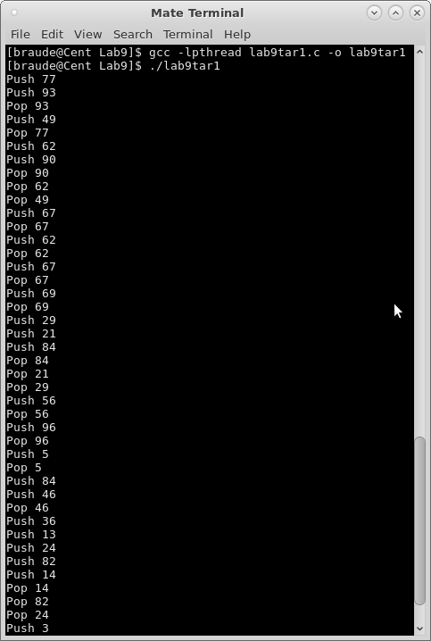

תרגיל 2

#include <stdio.h>

#include <semaphore.h>

#include <pthread.h>

#include <unistd.h>

#include <stdlib.h>

#define N 2

#define M 3

//****semaphores definition***//

sem_t old_in_store;

sem_t young_in_store;

sem_t mutex;

//****global variable***//

int n = 0;

void* oldManWantsToBuy(void* ind);

void* youngManWantsToBuy(void* ind);

void main(){

pthread_t t_Old[N], t_Young[M]; //threads arrays

int ansOld[N], ansYoung[M], i;

int idOld[N], idYoung[M]; //arrays for saving man id

//******semaphores initialization****//

sem_init(&old_in_store, 0 , 0);

sem_init(&young_in_store, 0, M);

sem_init(&mutex, 0 ,1);

for(i = 0; i < N; i++){

idOld[i] = i; //save old man id into array

ansOld[i] = pthread_create(&t_Old[i], NULL, oldManWantsToBuy, (void*)&idOld[i]);

//*****check if thread creating was success

if(ansOld[i] != 0){

printf("Thread creating error!!!\n");

exit(1);

}

}

for(i = 0; i < M; i++){

idYoung[i] = i; //save young man id into array

ansYoung[i] = pthread_create(&t_Young[i], NULL, youngManWantsToBuy, (void*)&idYoung[i]);

//*****check if thread creating was success

if(ansYoung[i] != 0){

printf("Thread creating error!!!\n");

exit(1);

}

}

sleep(10);

sem_destroy(&mutex);

sem_destroy(&old_in_store);

sem_destroy(&young_in_store);

}

void* oldManWantsToBuy(void* ind){

int i = *(int*)ind;

printf("Old man #%d wants to buy\n", i);

sem_wait(&mutex); //catch the CPU's time for this code

n = 1; //flag = 1

printf("Old man #%d is buying\n", i);

sleep(1);

printf("Old man #%d is done\n", i);

sem_post(&mutex); //end of critical code

n = 0; //flag = 0

sem_post(&old_in_store); //signal that the old man left the store

}

void* youngManWantsToBuy(void* ind){

int i = *(int*)ind;

printf("Young man #%d wants to buy\n", i);

if(n != 0) //if n != 0 signal that old man in the store

sem_wait(&old_in_store); //wait for old man left the store

sem_post(&young_in_store); //one of young man enter into the store

printf("Young man #%d is buying\n", i);

sleep(1);

printf("Young man #%d is done\n", i);

sem_wait(&young_in_store); //signal that the young man left the store

}

