Activity: Creating Sample Test Case

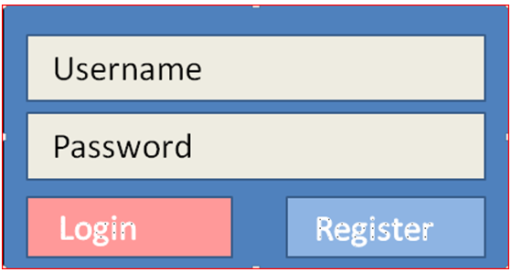

So we have a username and a password fields. The username is a valid email address and no longer than max valid email address and the **password has to be at least 8 characters** and **no more than 12 characters** with **only letters and numbers** allowed.  Once both registered username and password are **entered** and Login button **clicked**, the **welcome page will be displayed**.

The design indicates that if either username or password is incorrect, we should get the following message above the login area above and the username and password fields should be cleared:

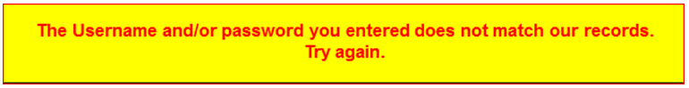

**Test Scenario**: Verify the login functionality

* **Test Case 1:** Click on Login without typing in username or password
* **Test Case 2:** Type in correct username and nothing for password
* **Test Case 3:** Type in correct password and nothing for username
* **Test Case 4:**Type in incorrect username and incorrect password

|  |  |
| --- | --- |
| **Test Case Name/ID** | T1-ClickLogin |
| **Test Scenario**  **Test Case description** | Login:  Missing both username and password |
| **Pre-requisites** | None |
| **Test input** | None |
| **Execution Steps** | 1.      Click Login button  2.      Check the error message  3.      Check that there is no text in the username and password fields |
| **Expected behavior** | Message will be displayed above login box  “The Username and/or password you entered does not match our records.  Try again.”  Both the username and password fields will be cleared |
| **Assumptions** | The GUI design will be tested in a separate test scenario |
| **Actual results** |  |
| **Status** | Not tested |

**Activity Task:**

Fill in the table below.

|  |  |
| --- | --- |
| **Test Case Name/ID** | T2-CorrectUsernameClickLogin |
| **Test Scenario**  **Test Case description** | Login:  Incorrect Username missing password |
| **Pre-requisites** | None |
| **Test input** | LoginiInfo.xls |
| **Execution Steps** | 1.      Click Login button  2.      Check the error message  3.      Check that there is no text in the username and password fields |
| **Expected behavior** | Message will be displayed above login box  “The Username and/or password you entered does not match our records.  Try again.”  Both the username and password fields will be cleared |
| **Assumptions** | The GUI design will be tested in a separate test scenario |
| **Actual results** | The login page showed Failure message “Not done”. |
| **Status** | Closed |