NATIONAL RESEARCH UNIVERSITY
HIGHER SCHOOL OF ECONOMICS
Faculty of Computer Science

Piankov Dmitrii

DIPLOMA THESIS

Interpreting Embeddings in Market Basket Analysis

Field of study 01.04.02 Applied Mathematics and Computer Science
Degree programme: Master of Data Science

Moscow 2026 | Academic Supervisor  Senior Lecturer  Kayumov R.A.  Research Supervisor  Visiting instructor  Bykov K.V.

ФЕДЕРАЛЬНОЕ ГОСУДАРСТВЕННОЕ АВТОНОМНОЕ ОБРАЗОВАТЕЛЬНОЕ УЧРЕЖДЕНИЕ
ВЫСШЕГО ОБРАЗОВАНИЯ
«НАЦИОНАЛЬНЫЙ ИССЛЕДОВАТЕЛЬСКИЙ УНИВЕРСИТЕТ
«ВЫСШАЯ ШКОЛА ЭКОНОМИКИ»

Факультет компьютерных наук

Пьянков Дмитрий Олегович

Интерпретация эмбеддингов в анализе потребительских корзин

Выпускная квалификационная работа (Магистерская диссертация)
студента 2-го курса
по направлению подготовки 01.04.02 Прикладная математика и информатика
образовательная программа «Магистр по наукам о данных»

Москва 2026 | Академический руководитель  Старший преподаватель  Р.А. Каюмов  Научный руководитель  Приглашённый преподаватель  К.В. Быков
Table of contents
INTRODUCTION 10
LITERATURE REVIEW 12
1 Market basket analysis as a task of extracting product relationships 12
2 Recommendation systems and implicit feedback 12
3 Word2Vec and the transfer of NLP approaches to products 13
4 Linear models of product relationships and EASE 13
5 Variational autoencoders and latent representations of items 14
6 Interpretability of embeddings and explicable representations 14
7 Hybrid models and reranking 15
8 Adding new SKUs without complete retraining 15
1 DATA DESCRIPTION AND PRELIMINARY ANALYSIS 17
1.1 Data source and structure 17
1.2 Formalization of data 17
1.3 Basket size analysis 18
1.4 Popular Product Analysis 19
1.5 Product category analysis 20
1.6 Data preprocessing 21
1.7 Conclusions on the chapter 21
2 PROBLEM STATEMENT 22
2.1 General statement of the problem 22
2.2 Setting the task of restoring the product 22
2.3 Formalization of the task 22
2.4 Quality metric 23
2.5 Justification of the choice of metric 23
2.6 Limitations of the statement 23
1 Independence of checks 24
2 Scalability of the EASE model 24
3 The shift towards popular products 24
4 Restrictions on adding new SKUs 24
5 Limited information used 24
Conclusion 25
2.7 Conclusions on the chapter 25
3 PROPOSED APPROACH 25
3.1 General architecture of the solution 25
3.2 Model EASE 25
3.3 Variational Autoencoder (VAE) 26
3.4 Building features 27
1 EASE score: 27
2 VAE score: 27
3 Cosine proximity: 27
4 Interactions of features: 27
5 Additional features: 28
3.5 The ranking model (reranker) 28
3.6 Final score 28
3.7 Justification of the approach 28
3.8 Conclusions on the chapter 29
4 EXPERIMENTAL STUDY 29
4.1 The purpose of the experiments 29
4.2 Data preparation 29
4.3 Assessment methodology 30
4.4 Results of the baseline model 30
4.5 VAE Model Results 31
4.6 EASE model results 33
4.7 Results of the hybrid model 33
1 Simple embedding: 34
2 Linear integration of scores: 34
3 Final approach: 34
4.8 Summary Table 35
4.9 Model comparison 35
4.10 Interpretation of results 35
4.11 Chapter conclusions 36
5 ADDING NEW SKUS WITHOUT RETRAINING THE MODEL 37
5.1 Setting the task 37
5.2 The basic idea of the approach 37
5.3 Adding a new SKU to EASE 37
5.4 Adding a new SKU to the VAE 38
5.5 Limitations of the approach 38
5.6 Example of interpretation of a new SKU 39
5.7 Practical application 39
5.8 Conclusions on the chapter 40
CONCLUSION 41
BIBLIOGRAPHY 42
APPLICATIONS 43
Application A. The main stages of data preprocessing 43
Application B. Construction of the EASE matrix 43
Application C. VAE Architecture 43
Application D. Signs for reranker 43
Application E. Adding a new SKU 44

АННОТАЦИЯ
В работе рассматривается задача построения интерпретируемых представлений товаров на основе данных рыночных корзин. В отличие от классических рекомендательных систем, основной акцент делается не на генерации рекомендаций, а на получении числовых признаков товаров, пригодных для использования в различных downstream задачах.
В рамках работы исследуются несколько подходов к построению эмбеддингов товаров, включая модель Word2Vec (бейзлайн), линейную модель EASE и вариационный автоэнкодер с мультиуровневым представлением данных. Предложен гибридный подход, объединяющий поведенческие связи между товарами и латентные представления, полученные нейросетевой моделью.
Особое внимание уделяется интерпретации полученных представлений и их устойчивости при добавлении новых товаров. Разработан метод получения признаков для новых SKU без переобучения моделей, основанный на анализе совместного потребления и агрегации латентных представлений.
Экспериментальное исследование проводится на реальных данных компании «Магнит». Качество моделей оценивается с использованием метрики Recall@10 в постановке leave-one-out. Полученные результаты показывают, что гибридный подход позволяет улучшить качество предсказаний по сравнению с отдельными моделями.
Практическая значимость работы заключается в возможности использования полученных признаков товаров в задачах рекомендаций, аплифт-моделирования и анализа покупательского поведения.

ABSTRACT
This work focuses on the problem of learning interpretable representations of products based on market basket data. Unlike traditional recommender systems, the main goal is not to generate recommendations, but to obtain numerical features of items that can be used in various downstream tasks.
Several approaches to item representation learning are studied, including Word2Vec, the linear EASE model, and a variational autoencoder with a multi-view input structure. A hybrid approach is proposed, combining behavioral relationships between items with latent representations learned by the neural network.
Special attention is given to the interpretability of learned representations and their stability when new items are introduced. A method for generating features for new SKUs without retraining the models is proposed, based on co-occurrence statistics and aggregation of latent embeddings.
Experiments are conducted on real-world retail data from Magnit. Model performance is evaluated using Recall@10 in a leave-one-out setting. The results demonstrate that the hybrid approach improves performance compared to individual models.
The practical value of the work lies in the ability to use the learned item features in recommendation systems, uplift modeling, and customer behavior analysis.

List of keywords:
NLP, product embeddings, market baskets, SKU, EASE, VAE, variational autoencoder, model interpretation, hybrid models, machine learning, recommendations.

INTRODUCTION
In the analysis of consumer behavior, the representation of items in the form of numerical features plays an important role. Such representations make it possible to apply machine learning methods to solve a wide range of tasks, including recommendations, product segmentation, and demand analysis.
One of the most common sources of data for such tasks is market baskets, which are sets of items purchased together as part of a single receipt. Analyzing such data allows you to identify hidden dependencies between products and use them to build models.
There are several approaches to building product representations. Classical methods include models based on ideas of distributive representations, such as Word2Vec, which treat products similarly to words in a text. Additionally, models based on item co-occurrence analysis were considered, such as the EASE model, which directly captures relationships between items.
In recent years, neural network-based methods have been actively developing, in particular variational autoencoders, which allow latent representations to be constructed that take into account complex nonlinear dependencies in data. Such models can take into account additional features, for example, the hierarchical structure of product categories. Since the dataset contains a hierarchical product structure, this information was incorporated into the proposed approach to exploit the available data more effectively and improve model performance.
Despite the variety of existing methods, several important tasks remain unresolved. First, most models are focused on building recommendation systems, rather than on obtaining interpretable product features. Secondly, adding new products usually requires retraining the model, which makes it difficult to use such solutions in real systems.
The purpose of this work is to study methods for constructing interpretable representations of items based on market basket data and to develop an approach that allows combining the advantages of various models, as well as using the results obtained for subsequent transfer to other teams: uplift, churn, etc. (solving problems of uplift, recommendations, classifications, clusterizations, etc.)
To achieve this goal, the following tasks are being solved:
- study of existing methods of building product embeddings;
- implementation of the Word2Vec (baseline), EASE and variational autoencoder (VAE) models;
- development of a hybrid approach combining behavioral and latent features;
- model quality research using the Recall@10 metric;
- development of a method for adding new products without retraining the model.
The practical part of the work is based on Magnit's data, which contains information about purchases. The experiments carried out make it possible to compare different approaches and evaluate their applicability to solve the problem.
The novelty of the work lies in the research and practical implementation of a hybrid approach to building product representations based on market basket data, combining the linear EASE model and a variational autoencoder.
The paper proposes a two-stage scheme for constructing recommendation scoring: at the first stage, the EASE model is used to generate candidates (the most likely products based on co-occurrence), after which their additional ranking is performed using features obtained from the VAE latent space. To combine the signals, a logistic regression model is used, trained on a specially generated ranking dataset.
This approach allows you to simultaneously take into account both explicit behavioral relationships between products and hidden dependencies extracted by the neural network model, which leads to an improvement in quality according to the Recall@10 metric compared to using separate models.
Additionally, the paper considers the task of steadily adding new products to the model. A method for obtaining a representation of a new SKU without retraining is proposed, based on the analysis of co-occurrence (for EASE) and aggregation of latent basket representations (for VAE). This allows us to maintain the stability of the feature space and ensures the applicability of the approach in a dynamically changing assortment.
The structure of the work includes an overview of existing methods, a formalization of the task, a description of the proposed approach, an experimental study and an analysis of the results obtained.

LITERATURE REVIEW

1 Market basket analysis as a task of extracting product relationships
Market basket analysis is one of the classic areas of application of data analysis methods in retail trade. Its main idea is to study the structure of receipts and identify patterns of joint consumption of items. In practice, such patterns can be used to manage the assortment, display products, build promotional mechanics, recommendations, as well as to form additional features in machine learning models.
Traditionally, methods of searching for associative rules are used in such tasks. They allow you to find products that are often found together in the same basket, and describe these relationships through support, confidence, and lift metrics. This approach is well interpreted, since the result can be represented as a rule of the form "if there is product A in the basket, then there is some probability that product B is found in it." However, this approach has several limitations. First, with a large number of products, the number of possible rules grows rapidly. Secondly, high-frequency products can dominate the results and distort the real structure of commodity relations. Thirdly, associative rules are poorly suited for obtaining a compact numerical representation of each SKU.
In the work of G. De Swardt specifically emphasizes that classical methods of analyzing commodity relations, including Association Rules Mining and recommendation systems, can produce useful results, but at the same time have limitations on large and sparse transactional data. The author shows that the ability of the model to work with a large number of products and receipts is especially important for grocery retail data, as well as to extract not only obvious joint purchases, but also more hidden connections between items [5].

2 Recommendation systems and implicit feedback
The task of analyzing receipts is close to the tasks of recommendation systems, since in both cases it is required to work with a sparse matrix of interactions. However, in this paper, the goal differs from the classical recommendation statement. The main objective is not personalized recommendation, but learning interpretable SKU features.
Referral systems often use implicit feedback, where the fact of a purchase or interaction is considered a positive signal, and lack of interaction does not always mean negative interest. Collaborative filtering, matrix factorization, and ranking-based approaches are used in such tasks. The classic work of Koren, Bell, and Volinsky on matrix factorization shows that latent representations of users and products make it possible to work effectively with sparse user-product matrices [8]. However, in the context of retail checks, user information may not be available or used, so item-item methods that directly model relationships between products are particularly important.
That is why in this work the main focus is on models that allow you to get an idea of the product through its environment in the baskets. This approach is closer to item-based collaborative filtering: a product is described not only by its attributes, but also by what other products it meets in real purchases.

3 Word2Vec and the transfer of NLP approaches to products
One of the important directions for building product representations is the transfer of ideas from natural language processing. In the Word2Vec model, words are represented as dense vectors, and the proximity of the vectors reflects the similarity of the contexts in which these words occur. Mikolov et al. proposed CBOW and Skip-Gram architectures that allow learning vector representations of words on large corpora with lower computational costs compared to earlier neural network language models [1].
This idea naturally translates to market baskets. In this formulation, a receipt can be considered as an analog of a sentence, and a product as an analog of a word. If two products are often found in similar contexts, then their vector representations should be close. This approach has been developed in the Item2Vec model. Barkan and Koenigstein showed that item-based collaborative filtering can be reduced to the task of learning item embeddings by analogy with Skip-Gram with Negative Sampling, and the resulting representations allow extracting item-item connections even without user information [2].
The work of De Swardt is particularly relevant to this thesis because it explores the use of Word2Vec for modeling grocery basket transaction data. The author considers transactions as analogues of sentences, and product codes as analogues of words. As a result, Word2Vec generates product embeddings that group similar products and allow you to identify hidden features such as package size or price segment. In addition, the paper shows that Word2Vec scales better than traditional market basket analysis methods and is able to process a significantly larger volume of transactional data [5].
In this work, Word2Vec is considered as a baseline. It is useful for testing the hypothesis that baskets can indeed be used as a source of context for learning product representations. However, Word2Vec has a limitation: it returns a dense embedding of the product, but its individual coordinates are difficult to interpret directly. Therefore, the following models are considered, which allow us to obtain more useful features for explanation and further use.

4 Linear models of product relationships and EASE
One of the most important methods for this work is EASE - Embarrassingly Shallow Autoencoder. Steck proposed a linear model for sparse implicit feedback data. Despite its simple architecture with no hidden layers, EASE shows strong quality in ranking tasks and has a closed form of solution [3].
From the point of view of this work, EASE is important not only as a ranking model, but also as a source of interpretable features. The EASE weight matrix shows the links between products. For each SKU, you can take a row of the matrix and get a vector of its relationships with all other products. Unlike a regular embedding, such a vector has a clear structure: each coordinate corresponds to a link with a specific product. Therefore, EASE is suitable for explaining a product through its consumer environment.
For example, if bananas, cucumbers, onions, tangerines, and carrots have the highest weights for kefir, this does not mean that kefir is similar to these products in terms of text description or category. This means that these products frequently appear in similar purchasing contexts. This result is important for retail analytics, because it reflects not the formal similarity of items, but the real patterns of co-occurrence.
The limitation of EASE is that the model is linear. It captures direct links between products well, but reflects complex nonlinear dependencies worse. Therefore, in this paper, EASE is used not as a single model, but as part of a hybrid approach.

5 Variational autoencoders and latent representations of items
Another area important for this work is autoencoders and variational autoencoders. VAE allows you to build a latent object space in which the source data is encoded into a more compact representation. The basic idea of VAE was proposed by Kingma and Welling: the model trains a probabilistic latent representation and uses a reparameterization trick to optimize the variational lower bound [7].
In recommendation systems, VAE was adapted for collaborative filtering in the work of Liang et al. The authors have shown that a nonlinear probabilistic model can be used for implicit feedback and allows to go beyond the limitations of linear factorization models [4].
In this paper, VAE is used not only as a model for restoring items in the basket, but also as a way to obtain a latent representation of the SKU. Unlike EASE, VAE embedding is a dense vector that is not interpreted co-ordinately through specific products. Its usefulness lies in another way: it can capture more complex dependencies that are not always expressed through direct co-occurrence.
At the same time, the multi-view approach is used in the work: the basket is described not only through products, but also through the levels of the product hierarchy. This is important because categories help the model take into account not only a specific SKU, but also the more general structure of the product range. This approach makes VAE more stable and allows embedding to be used as a universal numeric attribute of a product.

6 Interpretability of embeddings and explicable representations
The problem of interpreting embedding models is one of the key issues for this thesis. In many models, embedding is a useful numerical representation, but it can be difficult to explain why two products are close. This is especially important in business tasks, where the result of the model must be clear to analysts and related teams.
Laenen and Moens consider the task of constructing explicable disentangled representations for e-commerce data. The authors emphasize that interpretability and explainability of item representations are becoming important for e-commerce search and recommendation applications. They offer E-VAE, an explicable variational autoencoder that uses visual and textual attributes of products to build explicable disentangled representations [6].
This work is methodologically important for this thesis. It shows that VAE can be considered not only as a model for data recovery, but also as a tool for building an interpretable product space. However, unlike Laenen and Moens, which use visual and textual e-commerce data, in this work the main source of information is checks and the structure of joint purchases. Therefore, the interpretation is built not through the visual or textual attributes of the product, but through its behavioral context in the baskets.
Laenen and Moens also emphasize that disentangled representations are useful due to their greater generalizing ability, stability, and interpretability [6]. This is important for this work, since the resulting SKU features should be applicable not only within one model, but also as a feature engine for other tasks: classification, uplift modeling, recommendations, and assortment analytics.

7 Hybrid models and reranking
A separate area is related to hybrid models that combine multiple signal sources. In practical systems, a two-stage scheme is often used: first, a simple and fast model generates a limited set of candidates , then a more complex model performs reranking. This approach allows us to maintain computational efficiency and at the same time improve the quality of the final ranking.
This paper uses a similar logic. First, EASE generates the top-100 candidates using a strong item-item signal based on the relationship matrix. Next, features based on EASE and VAE are constructed for these candidates: EASE score, VAE score, cosine proximity in the VAE space, candidate rank in EASE output and feature interactions. After that, a logistic regression is trained, which performs reranking.
This approach differs from simple score averaging. If you simply add up the EASE and VAE results, a weaker or noisier signal may worsen the result. Using logistic regression allows the model to determine for itself which features are more important for recovering masked items in the basket. Therefore, the hybrid model in this paper combines the interpretability of EASE and the ability of VAE to capture more complex latent dependencies.

8 Adding new SKUs without complete retraining
For retail tasks, it is important to take into account that the assortment is constantly changing. New products are being introduced, old products are being withdrawn from sale, packaging and names are being changed. If the embedding model is completely retrained with each new SKU, the feature space will shift. This creates a problem for downstream teams that already use the old features.
This paper considers a practical approach to adding a new SKU without completely retraining the models. For a new product, checks are collected in which it occurs. Further, these checks are used to build a vector of joint consumption relative to already known items. Such a vector can be used as an approximation of the EASE representation of the new SKU. However, the old EASE matrix does not change.
For VAE, the logic is different: using a pretrained encoder, you can get latent representations of baskets where a new product is found, and then aggregate them into the embedding of a new SKU. This allows you to get the attributes for the new product in the space of the old model. This approach does not completely solve the cold start problem, since a minimum number of checks is still required for a new product, but it shows how the system can work in an production environment without constant full retrain.

1 DATA DESCRIPTION AND PRELIMINARY ANALYSIS

1.1 Data source and structure
The work uses data from the Magnit retail chain, which contains information about transactions (receipts) and the composition of purchases. The data is presented in two tables:
the check table df_cheques:
cheque_id - receipt ID;
contact_id - buyer's ID;
summ_discounted - the total amount of the receipt;
table of df_products:
cheque_id - receipt ID;
item_number - item number;
quantity - Product quantity;
name - Product name;
art_pricing_model - Macro: pricing model
art_grp_lvl_0_name - Macro category
art_grp_lvl_1_name - Subcategory
art_grp_lvl_2_name - Detailed (optional) doesn't add much quality anywhere, but we'll leave it anyway
After combining the tables by cheque_id, a single dataset of 804,737 rows is formed.
Main data characteristics:
number of receipts: 50,000;
Number of customers: 49,719;
number of unique products: 27,224.
Thus, the data under consideration is a typical example of a sparse "receipt–product" structure typical for the tasks of analyzing market baskets.

1.2 Formalization of data
Each receipt can be represented as a set of products:
IB⊆I
where I is the set of all products.
The receipt can also be represented as a binary vector.:
x∈{0,1}^{N}
where:
N - number of products,
x_{i}=1, if product i is present in the shopping cart.
The entire dataset can be written as a matrix:
X∈R^{M*N}
where:
M - number of transactions,
N - Number of products.
This formalization is used further in the construction of models..

1.3 Basket size analysis
The basket size is defined as the number of items in one receipt.
Basic statistics:
average: 16.09;
Median: 16;
Mode: 15;
standard deviation: 7.39;
minimum: 1;
maximum: 150.
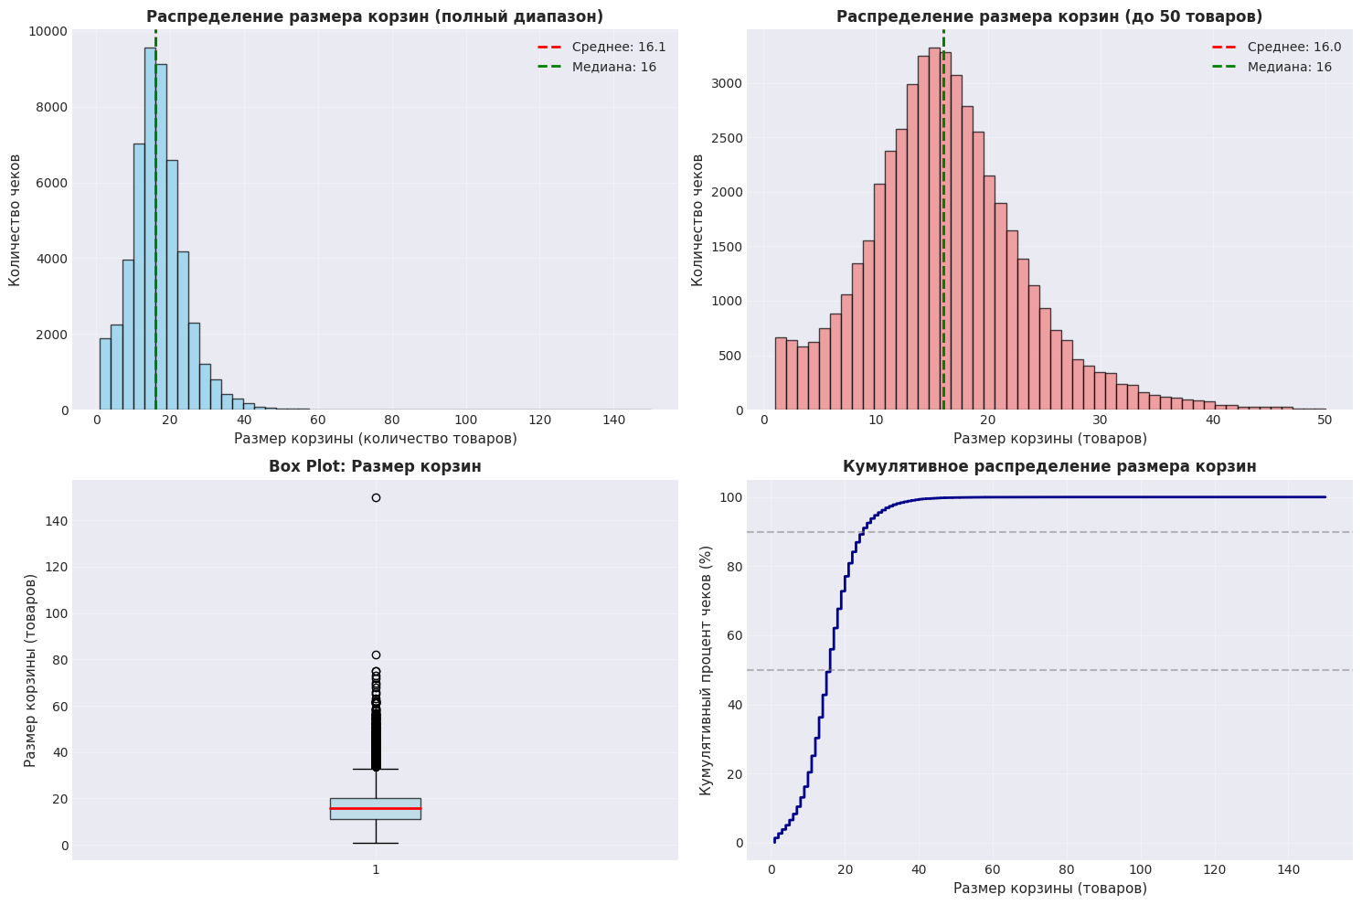
Figure 1 - Basket size distribution
Analysis
The distribution of the basket size has the following features:
The bulk of checks is in the range of 10-20 items (median and average 16).
There is a long right tail of the distribution.
There are outliers (a receipt with >100 items).
The cumulative distribution shows that:
About 50% of the checks contain up to 16 items;
About 90% of checks contain up to 30 items.
Conclusion
This data structure suggests that:
the data is well suited for training models of co-occurrence;
Outliers can negatively affect learning;
filtering of abnormal checks is required.
In the future, the following are excluded from the analysis:
checks with 1 product;
checks with more than 100 items.

1.4 Popular Product Analysis
Consider the distribution of the frequency of purchases of items.

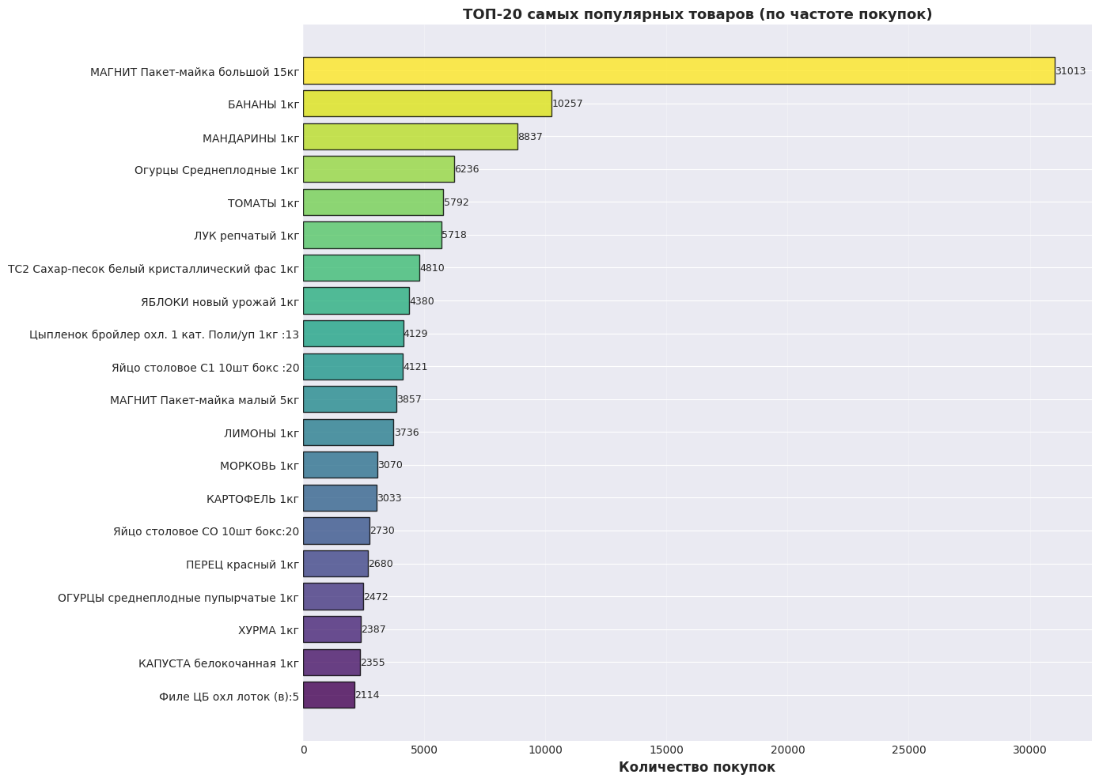
Figure 2 - Top 20 products by purchase frequency
Analysis
Most frequently purchased items:
bananas;
Mandarins;
cucumbers;
tomatoes;
onion;
sugar.
There are also service items in the top, for example:
"T-shirt package".
Conclusion
Popular products form the basic demand.
Technical products do not carry useful information.
Such products must be deleted.

1.5 Product category analysis
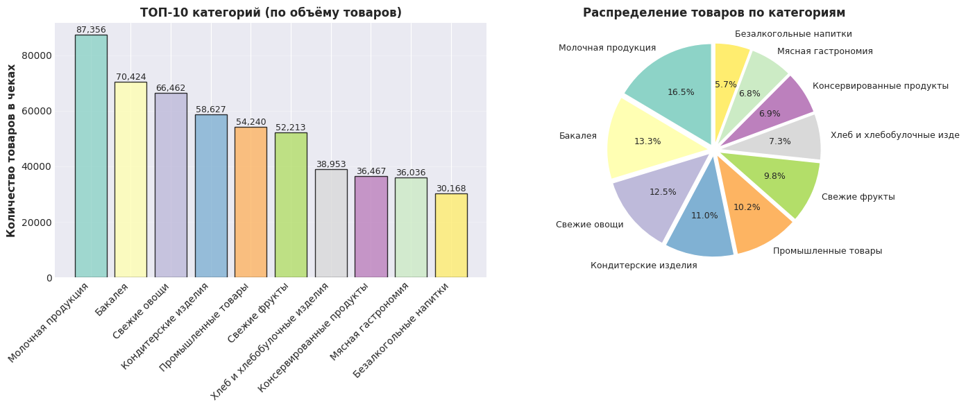 Figure 3 - Distribution of items by category
Analysis
The largest categories
are dairy products (~16.5%);
groceries (~13.3%);
fresh vegetables (~12.5%);
confectionery (~11%).
Conclusion
The categories are unevenly distributed;
The models will be shifted towards popular categories.;
It is important to consider the categorical structure.

1.6 Data preprocessing
At the stage of data preparation, the following operations are performed:
Deleting receipts:
with one product;
with more than 100 products;
Removal of technical items:
packages;
Cleaning up texts:
reduction to lowercase;
removing special characters.
After clearing:
the number of rows is reduced to 769,688;
The number of items remains almost unchanged.

1.7 Conclusions on the chapter
The analysis showed that the data has a sparse structure, the baskets have a stable distribution, and there are also outliers and noise. The categories are unevenly distributed, and popular products can distort the learning process. The results obtained are used in the construction of models:
- filtering check;
- removing noisy products;
- using categories in VAE

2 PROBLEM STATEMENT

2.1 General statement of the problem
In this paper, the problem of constructing a numerical representation of items (SKU) based on market basket data is considered.
Unlike classical recommendation systems, the goal is not to build personalized recommendations for the user, but to obtain universal product features reflecting their position in the space of consumer behavior.
Thus, it is required to build a mapping:
f: I -> R^{d}
where:
• I - set of products;
• d - dimension of the feature space.

The received representations should:
• take into account the structure of joint consumption;
• be suitable for use in downstream tasks;
• maintain interpretability.

2.2 Setting the task of restoring the product
To evaluate the quality of the models, the task of predicting hidden items from the basket is used.
Let B be a basket of items:
B ⊆ I
A random product i ∈ B is selected, after which the context is formed:
C = B \ {i}
The task of the model is to predict the product i based on the context C.
Thus, the model should specify a scoring function:
s(j | C)
which evaluates the probability that product j should be present in the cart.

2.3 Formalization of the task
In terms of matrix representation:
X ∈ R^{{M×N}}
where:
• M - number of transactions;
• N - Number of products.
Random masking is performed for the string x ∈:
x_i = 0, where before x_i = 1
After that, the model should restore the value x_i.
Thus, the task is reduced to the task of reconstruction:
x -> x̂
where x̂ - predicted shopping cart.

2.4 Quality metric
Recall@K is used as the main metric.
For each receipt:
1 Product i is randomly selected;
2 The C context is being formed;
3 The model generates a list of candidates;
4 It is checked whether i is in the top K.
Formally:
Recall@K = (1 / T) * Σ 1(i ∈ TopK(C))
where:
• T - number of test cases;
• TopK(C) - the set of K best predictions.
The work uses: Recall@10

2.5 Justification of the choice of metric
The choice of the Recall@10 metric is due to the following reasons:
1 The task is not a classic recommendation system, where it is required to take into account the ranking of all products.
2 The main interest is the ability of the model to recover hidden items in a limited set of candidates.
3 Recall@10 directly reflects the likelihood that the model will offer a relevant product among a small number of options.
Thus, the metric corresponds to the task statement and allows you to correctly compare different approaches.

2.6 Limitations of the statement
Despite the correctness of the problem statement, the approach used has a number of limitations related to both data and model architecture.

1 Independence of checks
The paper assumes that the checks are independent observations.
This does not take into account the sequence of purchases of one user over time,
which limits the possibility of modeling long-term behavior.

2 Scalability of the EASE model
The EASE model requires the calculation of a matrix:
G = X^{T} X
and the subsequent matrix inversion:
P = G^{{-1}}
This operation has a complexity of O(N³), where N is the number of items.
As the range increases (for example, when using all SKUs of the network), calculating the inverse matrix becomes computationally expensive and may require optimizations or approximations.

3 The shift towards popular products
The data has a pronounced distribution of popularity: some products are much more common than others.
This leads to the fact that models (especially EASE) may overestimate popular products and underestimate rare ones.

4 Restrictions on adding new SKUs
Although the paper suggests a method for adding new products without retraining,
its application requires a sufficient number of checks with a new SKU.
Thus, a completely cold start (without data) is not solved.

5 Limited information used
The models are trained solely on the structure of receipts and categorical information.
Additional features are not used, such as:
• price,
• promotions,
• temporal factors
• user behavior.
This simplifies the model, but limits its expressiveness.
Conclusion
These limitations do not prevent the application of the approach,
but they should be taken into account when interpreting the results and further developing the model.

2.7 Conclusions on the chapter
In this chapter, the task of constructing representations of items based on market baskets was formulated.
Key points:
• the task is reduced to restoring the product from the basket;
• matrix formalization of data is used;
• The Recall@10 metric has been introduced;
• the choice of the metric is justified.
This statement is further used in the development of models and experiments.

3 PROPOSED APPROACH

3.1 General architecture of the solution
Within the framework of the work, a hybrid approach to building product representations is proposed, combining several models.
The architecture consists of three main components:
• EASE model;
• Variational Autoencoder (VAE);
• The ranking model (reranker).
The general scheme of work is as follows:
1 At the first stage, the EASE model is used to generate candidates.
2 At the second stage, features are computed for candidates based on EASE and VAE.
3 At the third stage, a logistic regression model is applied, which performs the final ranking.
Thus, the resulting model combines:
• interpretability of the linear model;
• the ability of the neural network model to account for complex dependencies;
• Flexibility in combining signals through training.

3.2 Model EASE
The EASE model is used to build links between items based on co-occurrence.
Let X ∈ R^{{M*N}} be the check matrix.
Then the matrix of joint occurrence is defined as:
G = X^{T} X
Regularization is introduced to stabilize the solution.:
G = G + λI
where λ is the regularization coefficient.
Next, it is calculated:
P = G^{{-1}}
And the weight matrix:
B = -P / diag(P)
In this case, the diagonal elements are reset to zero.:
B_ii = 0
Each row of matrix B corresponds to one product and shows its relationship to all other products.
For a given context, the C score of the product is calculated as:
s_EASE(j) = Σ B_{c,j},
where c ∈ C
Thus, EASE allows you to quickly receive the products that are most likely to be found with the current set.
In this paper, EASE is used as:
• Candidate generator;
• the source of interpreted features.

3.3 Variational Autoencoder (VAE)
The second component of the model is a variational autoencoder.
The main task of VAE is to build a latent basket representation:
x => z => x̂

where:
• x - the input vector of the basket;
• z - latent representation;
• x̂ - the restored shopping cart.
The loss function has the form:
L = BCE(x, x̂) + β · KL(q(z|x) || p(z))
where:
• BCE - reconstruction error;
• KL - the Kullback–Leibler divergence;
• β - the regularization coefficient.
One implementation feature is the use of a multi-view representation.
The model's input includes:
• products;
• LVL2 level categories;
• LVL1 level categories;
• lvl0 level categories.
Each representation is encoded separately, after which it is combined into a common latent vector.
This approach allows you to take into account not only the products themselves, but also the structure of the assortment.
Embedding is generated for each product:
e_i ∈ R^{d}
Embedding is further used as a feature in the hybrid model.

3.4 Building features
After receiving candidates from EASE, a set of features is formed for each of them.
For candidate j, the following are calculated:

1 EASE score:
s_EASE(j)

2 VAE score:
s_VAE(j)

3 Cosine proximity:
cos(z_C, e_j)
where:
• z_C - embedding the shopping cart;
• e_j - product embedding.

4 Interactions of features:
• s_EASE · s_VAE
• s_EASE · cos
• s_VAE · cos

5 Additional features:
• Basket size;
• the candidate rank in EASE output.
Before learning, the features are normalized (z-score).
Thus, a matrix of features is formed:
X_feat ∈ R^{{K*d}}
where K is the number of candidates.

3.5 The ranking model (reranker)
Logistic regression is used to combine features.
Each candidate is assigned a label:
y = 1 if the product is hidden,
y = 0 otherwise.
The model is trained to predict the probability:
p(j | C)
After training, the model returns probabilities for all candidates.

3.6 Final score
The final score of a product is defined as a combination:
s(j) = s_EASE(j) + α · p(j)
where:
• p(j) - probability from reranker;
• α - ratio.
Thus:
• EASE is responsible for the candidates;
• VAE contributes through additional features;
• reranker combines signals.

3.7 Justification of the approach
The proposed method allows you to combine the advantages of different models:
• EASE extracts explicit links between products well;
• VAE captures hidden dependencies;
• reranker allows you to adaptively combine features.
In contrast to the simple addition of models, this approach:
• reduces the impact of noise;
• allows you to take into account non-linear dependencies;
• Improves the quality according to the Recall@10 metric.

3.8 Conclusions on the chapter
In this chapter, a hybrid approach to building product representations was proposed.
Main results:
• the EASE model has been formalized;
• The VAE architecture is described;
• a scheme for combining models has been built;
• A ranking mechanism is proposed.
This approach is used further for conducting experiments.

4 EXPERIMENTAL STUDY

4.1 The purpose of the experiments
The aim of the experimental study is to evaluate the quality of various approaches to constructing representations of items based on market baskets.
The experiments compare:
• baseline model (Word2Vec);
• popular product model (also baseline);
• EASE model;
• VAE model;
• Hybrid model.
The main task is to test the hypothesis that combining models can improve the quality of product recovery compared to individual approaches.

4.2 Data preparation
The dataset described in Chapter 1 is used for conducting experiments.
Preprocessing is performed before training the models.:
• removing receipts with 1 product;
• removing receipts with more than 100 items;
• removal of technical items (e.g. packages);
• text preprocessing.
After cleaning, a matrix is formed:
X ∈ R^{{ M×N}}
where:
• M - number of checks;
• N - Number of products.
Fixed train/test splits are used for the models. In all experiments, the same partitioning is applied with the same value of random seed = 42. This allows you to correctly compare the results of different models on the same sample.
The validation split is additionally used for the VAE model:
• train - 80%;
• validation - 10%;
• test - 10%.

4.3 Assessment methodology
The quality of the models is assessed using the Recall@10 metric.
For each receipt:
1 The product is randomly selected;
2 The selected product is hidden;
3 The rest of the basket is used as a context;
4 The model is trying to recover the hidden item.
Thus, the ability of the model to recover the missing product from the rest of the basket is evaluated.
Formally:
Recall@10 = (1 / T) * Σ 1(i ∈ Top10(C))
where:
• T - number of test cases;
• i - hidden items;
• Top10(C) - top 10 predictions of the model.
It is important to note that the metric used is stochastic, since the hidden product is selected randomly. This leads to a slight variation in the results between runs.

4.4 Results of the baseline model
The Word2Vec model is used as the baseline. The model is trained on baskets represented as a sequence of products. Each product is treated as an analog of a word, and a shopping cart is treated as an analog of a sentence.
A limited selection of hyperparameters was performed for the baseline model:
• embedding size;
• the size of the context window;
• number of epochs;
• negative sampling.
A deep search of the parameters was not carried out, since the model is used solely as a baseline for comparison with more complex approaches.
Additionally, a model of popular products was implemented. In this setting, the most frequently encountered products from the training sample are always recommended.
It is important to note the difference in computational complexity:
• metrics for popular products are calculated almost instantly;
• The Word2Vec assessment took more than two hours.
For this reason, Word2Vec was evaluated not on the entire test sample, but on a random sample of 3,000 baskets.
Results:
• Popularity Recall@10 ≈ 0.058;
• Word2Vec Recall@10 ≈ 0.0417
Despite the low quality, Word2Vec confirms that baskets can indeed be used to teach embedding products.
However, the model has a number of limitations:
• the model is worse than the usual Popularity;
• embedding is difficult to interpret;
• the model does not explain the structure of co-occurrence well.

4.5 VAE Model Results
The next stage was the implementation of a variational autoencoder.
Unlike baseline, VAE uses a multi-view representation of the data:
• Products;
• lvl2 categories;
• lvl1 categories;
• lvl0 categories.
Thus, the model takes into account not only the SKUs themselves, but also the hierarchical structure of the assortment.
One of the main difficulties in VAE training was the selection of hyperparameters. A large series of experiments was conducted with:
• the dimension of the latent space;
• coefficient β;
• masking probability;
• learning rate;
• number of epochs
The stochasticity of the Recall@10 metric created additional complexity. Since the hidden product is randomly selected, the quality of the model could change between launches.
Initially, the bootstrap assessment approach was considered:
• multiple independent runs;
• averaging the result.
However, the computational cost of this approach turned out to be too high.
As a result, it was decided to:
• use the entire validation sample instead of a sample of 3,000 baskets;
• Perform early stopping on Recall@10 on validation.
This approach has made it possible to reduce the spread of metrics and stabilize training.
The early stop usually occurred around epoch 13, although the specific value could vary between launches.
Bootstrap was used for the final test evaluation.:
• 5 independent Recall@10 calculations were performed;
• the final metric was averaged.
The coefficient β in the VAE loss function was studied separately.
Two approaches were considered:
• dynamic β;
• Static β.
In the literature, a dynamic increase of β over epochs is often used, but in the course of experiments it was found that a fixed value of β shows a more stable and high result. For this reason, β is used as a static hyperparameter in the final model.
The final result of the model:
Recall@10 ≈ 0.086
The model shows the ability to take into account:
• hidden dependencies between products;
• categorical structure;
• Nonlinear interactions.
However, there are limitations:
• the quality is lower than EASE's;
• embedding is difficult to interpret directly;

4.6 EASE model results
The EASE model is trained on a matrix of product interactions.
The regularization coefficient λ was selected for the model. An extended grid of parameters was used:
• λ = 0.1;
• λ = 0.3;
• λ =0.5;
• λ = 0.7;
• λ = 1;
• λ = 10;
• λ = 30;
• λ = 50;
• λ = 70;
• λ = 100;
• λ = 130;
• λ = 150;
• λ = 250.
Experiments have shown that optimal results are achieved when:
λ ≈ 100–150.
The final model uses: λ = 150.
The final result:
Recall@10 ≈ 0.1248
The model demonstrates:
• High quality product recovery;
• stable operation on sparse data;
• interpreted item-item relationships.
Unlike Word2Vec and VAE, EASE allows you to directly analyze the relationships between products through a matrix of weights.

4.7 Results of the hybrid model
After receiving the individual models, a hybrid architecture was implemented.
Initially, several options for combining models were considered.

1 Simple embedding:
The EASE and VAE vectors were linearly combined. This approach showed extremely poor quality, as the model spaces turned out to be poorly coordinated.

2 Linear integration of scores:
s = s_EASE + λ · s_VAE
This approach showed more stable results, but the effect of VAE remained weak (we went over the parameter λ and the best one was 0).

3 Final approach:
• EASE is used to generate candidates;
• VAE is used as a feature source;
• Logistic regression performs reranking.
It was this option that showed the best quality.
The working process of the model:
1 EASE generates the top-K candidates;
2 The following criteria are calculated for candidates:
• EASE score;
• VAE score;
• cosine similarity;
• interactions of features;
3 Logistic regression forms the final score.
Additionally, the coefficient α was selected:
s = s_EASE + α · p
where:
• p - probability from reranker.
Experiments have shown that the optimal value is:
α ≈ 0.3
The final result:
Recall@10 ≈ 0.140
Thus, the hybrid model showed the best result among all the studied approaches.

4.8 Summary Table
Table 1 – Comparison of model performance relative to the Word2Vec baseline
Model | Recall@10 | Absolute gain | Relative gain (%) | Comment
Word2Vec | 0.0417 | +0.0000 | 0.0 | baseline embedding model
Popularity baseline | 0.0580 | +0.0163 | +39.1 | Simple popularity-based baseline
VAE | 0.0860 | +0.0443 | +106.2 | uses multi-view item/category representation
EASE | 0.1248 | +0.0831 | +199.3 | strong item-item co-occurrence model
Hybrid model | 0.1400 | +0.0983 | +235.7 | EASE + VAE features + reranker

As shown in Table 1, all proposed approaches outperform the Word2Vec baseline. The hybrid model achieved the highest Recall@10 score and improved performance by 0.0983 points (+235.7%) relative to the baseline.

4.9 Model comparison
Final comparison of results:
• Popularity - low quality, but slightly better than baseline Word2Vec;
• Word2Vec - baseline model;
• VAE - takes into account hidden dependencies;
• EASE - a strong linear model;
• Hybrid - the best result.
The final quality ratio:
Recall_hybrid > Recall_EASE > Recall_VAE > Recall_popularity > Recall_Word2Vec

4.10 Interpretation of results
The results show the following.
1. EASE is a very strong model for analyzing co-occurrence.
2. VAE allows you to account for information that EASE cannot extract directly.
3. Simply combining embeddings does not work effectively.
4. The best result is achieved when using VAE as an additional source of features for reranking.

Thus, quality improvement is achieved not by replacing one model with another, but by using them together.

4.11 Chapter conclusions
In the course of an experimental study, it was shown that:
• the task of restoring the product correctly reflects the quality of the models;
• Word2Vec is suitable as a baseline;
• EASE is a strong model for sparse data;
• VAE allows you to take into account hidden dependencies and categorical structure;
• Hybrid approach ensures the best quality.
It has also been shown that:
• Recall@10 stochasticity must be taken into account when training;
• bootstrap allows you to stabilize the final score;
• reranking is a more efficient way to combine models than simple embedding.
Thus, the proposed hybrid approach proves its effectiveness in the task of constructing representations of items based on market baskets.

5 ADDING NEW SKUS WITHOUT RETRAINING THE MODEL

5.1 Setting the task
One of the main practical problems of embedding models in retail is to change the assortment.
In real systems:
• new products appear regularly;
• packages are changing;
• updated product lines;
When using classic embedding approaches, adding a new SKU usually requires a complete retraining of the model.
However, this approach has a number of disadvantages.:
• High computational cost;
• changing the embedding space;
• incompatibility with previously learned features;
• the need for repeated training of downstream models.
Therefore, the work considers the task of adding a new SKU without completely retraining the models.

5.2 The basic idea of the approach
The proposed approach is based on the assumption that a new product can be described through its behavior in an already existing product space.
For this:
1 Checks with a new SKU are collected;
2 Joint consumption is analyzed;
3 A representation of a new product is being built relative to already known products.
Thus:
• the existing space does not change;
• old embeddings remain fixed;
• a new product is integrated into an already trained system.

5.3 Adding a new SKU to EASE
The EASE model uses an approximate method of constructing a vector of new product relationships through co-occurrence.
Let:
• S_new - new item;
• C(S_new) - there are many receipts in which it is found;
• I_old - a variety of products already present in the trained space.
For each known product i ∈ I_old, the number of joint meetings with the new SKU is calculated:
co(i, S_new) = |{c ∈ C(S_new): i ∈ c}|
After that, a vector of co-occurrence is formed:
v_new = (co(1, S_new), co(2, S_new), ..., co(N, S_new))
where N - number of known products.
Next, normalization by amount is performed:
v_new = v_new / Σ v_new
After that, the vector is additionally normalized according to the L2 norm:
b_new = v_new / ||v_new||_2
The resulting b_new vector is used as an approximate EASE representation of the new SKU. It is important to note that this is not a complete retraining of EASE. The old matrix B remains unchanged, and the new product receives only a separate vector of links with already known products.

5.4 Adding a new SKU to the VAE
A different approach is used for VAE.
Let:
• B_1, ..., B_k - baskets containing a new product.
Each basket is fed into the encoder of the model:
x -> z
The result is a set of latent representations:
z_1, ..., z_k
The embedding of a new product is calculated as:
z_new = (1/k) Σ z_i
This way, the new SKU gets embedded in the already existing latency space.
It is important that:
• The encoder is not being retrained;
• Latency space remains stable;
• downstream models may continue to use the old features.

5.5 Limitations of the approach
The proposed method has a number of limitations.
1 A new SKU requires receipts.
A completely cold start without data is not solved.
2 The quality of the presentation depends on the number of baskets.
If a new product is too rare, the signs obtained may be unstable.
3 EASE-the presentation of the new SKU is an approximation.
Since the weight matrix is not fully recalculated, the new product is not involved in optimizing the global space.
Nevertheless, the proposed approach avoids a complete retrain and preserves the compatibility of the embedding space.

5.6 Example of interpretation of a new SKU
As part of the experiment, a new product was reviewed:
«ВАША КОРОВА Кефир 1,0% 900г».
Receipts containing the product were collected, after which the following features were constructed:
• EASE vector;
• VAE embedding.
EASE's strongest connections are:
• Bananas;
• cucumbers;
• onion;
• tangerines;
• carrots.
The result shows that the model forms not a categorical, but a behavioral representation of the product. Thus, the product is described through real patterns of co-occurrence.

5.7 Practical application
The resulting features can be used as a feature source for downstream tasks.
In particular:
• recommendation systems;
• uplift models;
• classification of items;
• assortment analysis;
• Search for similar SKUs.
It is especially important that:
• features of new products are compatible with existing ones;
• embedding space remains stable;
• No complete retraining of the model is required.
This makes the proposed approach applicable in production systems..

5.8 Conclusions on the chapter
In this chapter, we discussed an approach to adding new SKUs without completely retraining the models.
Main results:
• a method for constructing an EASE representation of a new product is proposed;
• a method for obtaining VAE embedding is proposed;
• the stability of the embedding space is shown;
• The limitations of the method are considered.
Thus, the proposed approach makes it possible to adapt the system to a dynamically changing assortment without a complete retrain of models.

CONCLUSION
As part of the work, the task of constructing interpretable representations of items based on market basket data was investigated. The main focus was not on building a classical recommendation system, but on obtaining SKU features that can be used in various downstream tasks.
In the course of the work, several approaches were implemented and investigated:
• Word2Vec as a baseline model;
• EASE as a model of explicit links between products;
• multi-view VAE as a latent view model;
• A hybrid model combining EASE and VAE through reranking.
The experiments have shown that EASE is a strong model for analyzing co-occurrence and provides interpretable item-item relationships. VAE showed lower quality by Recall@10, however, it allowed us to obtain latent representations of items taking into account the categorical hierarchy. The best result was achieved using a hybrid approach, where EASE generates candidates, and VAE is used as a source of additional features for reranker.
The final hybrid model showed a Recall@10 of about 0.140, which is higher than the result of individual models. This confirms the hypothesis that explicit links between items and latent features can complement each other.
The issue of adding new SKUs without completely retraining the model was considered separately. An approach was proposed in which an approximate EASE vector is constructed for a new product based on joint occurrence, and the VAE representation is obtained through aggregation of latent representations of baskets. This approach allows you to maintain the stability of the old feature space and use the model in conditions of a changing assortment.
The practical significance of the work lies in the fact that the obtained EASE vectors and VAE embeddings can be used as features for other models: recommendations, uplift models, classification and assortment analysis.
Possible directions for further development:
• using more data;
• transition to temporal split;
• optimize EASE for the full range;
• Adding price and promotional features;
• More rigorous assessment of the stability of new SKU features.

BIBLIOGRAPHY
[1] Mikolov T., Chen K., Corrado G., Dean J. Efficient Estimation of Word Representations in Vector Space. arXiv:1301.3781, 2013. [https://arxiv.org/abs/1301.3781]
[2] Barkan O., Koenigstein N. Item2Vec: Neural Item Embedding for Collaborative Filtering. IEEE International Workshop on Machine Learning for Signal Processing, 2016. [https://arxiv.org/abs/1603.04259]
[3] Steck H. Embarrassingly Shallow Autoencoders for Sparse Data. The Web Conference, 2019. [https://arxiv.org/pdf/1905.03375]
[4] Liang D., Krishnan R. G., Hoffman M. D., Jebara T. Variational Autoencoders for Collaborative Filtering. The Web Conference, 2018. [https://arxiv.org/abs/1802.05814]
[5] De Swardt G. J. Exploring the Application of Word2Vec to Basket Transaction Data in the Grocery Retail Industry. Master’s thesis. University of Cape Town, 2021. [https://open.uct.ac.za/handle/11427/36434]
[6] Laenen K., Moens M.-F. Learning Explainable Disentangled Representations of E-Commerce Data by Aligning Their Visual and Textual Attributes. Computers. 2022. Vol. 11. No. 12. Article 182. [https://www.mdpi.com/2073-431X/11/12/182]
[7] Kingma D. P., Welling M. Auto-Encoding Variational Bayes. arXiv:1312.6114, 2013. [https://arxiv.org/abs/1312.6114]
[8] Koren Y., Bell R., Volinsky C. Matrix Factorization Techniques for Recommender Systems. Computer. 2009. Vol. 42. No. 8. P. 30–37. [https://homepages.math.uic.edu/~lreyzin/s15_mcs590/koren09.pdf]

APPLICATIONS

Application A. The main stages of data preprocessing
As part of the preprocessing, the following actions were performed:
• combining tables of checks and items by cheque_id;
• removing receipts with one product;
• removing receipts with more than 100 items;
• removal of technical items, such as packages;
• clearing text names of items;
• building product_id identifiers;
• formation of the "receipt–product" matrix.

Application B. Construction of the EASE matrix
Basic steps:
1 Formation of the sparse matrix X.
2 Calculation G = X^{T X}.
3 Adding regularization λI.
4 Matrix conversion.
5 Construction of the matrix of weights B.
6 Resetting the diagonal.

Application C. VAE Architecture
The VAE model uses multiple input representations:
• item-level;
• lvl2 category;
• lvl1 category;
• lvl0 category.
Each input is encoded by a separate encoder block. After that, the representations are combined and translated into latent distribution parameters.: μ and logσ².

Application D. Signs for reranker
For each candidate, the following are calculated:
• EASE score;
• VAE score;
• cosine similarity between the shopping cart and the product;
• the product of EASE and VAE score;
• the product of EASE score and cosine similarity;
• the product of VAE score and cosine similarity;
• Basket size;
• candidate's position in EASE ranking.

Application E. Adding a new SKU
For a new product:
1 receipts containing the product are collected;
2 A co-occurrence vector with known products is being built;
3 An approximate EASE vector is formed.;
4 Latent basket representation are obtained through the VAE encoder;
5 Averaging these representations gives the VAE embedding of the new SKU.
The result is a dictionary of features:
{
"sku_name": the original product name,
"sku_clean": cleared product name,
"n_cheques": number of checks,
"ease": {
"vector": EASE-vector,
"idx_to_name": a dictionary for interpretation
},
"vae": {
"embedding": VAE embedding
}
}

