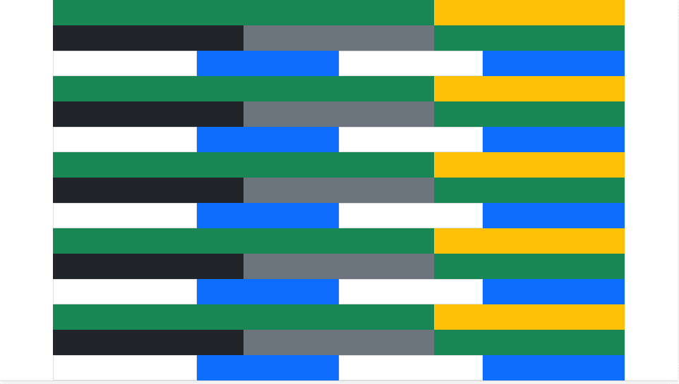

Picture 1. View beginning from Mobile landscape layout

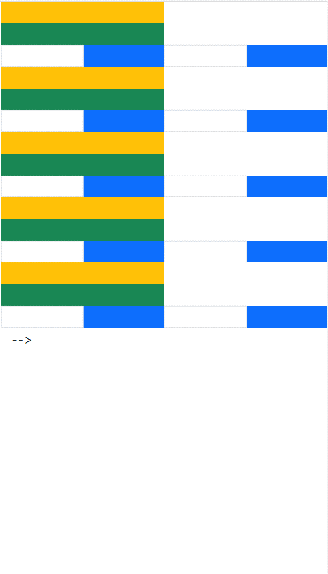

Picture 2. View only for Mobile portrait layout

Your task to create index.html file providing the above views. Limitation: no custom styles, no custom CSS, no Sizing utilities.