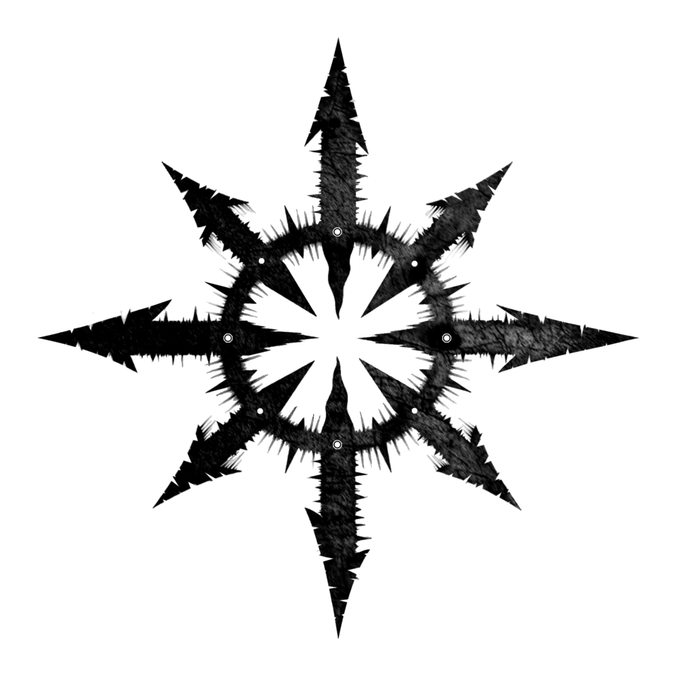
Ludocodam

Design by Stalwitfen
For Personal Computer
Rating: RP

Storyline

Brief description
3D Action RPG with open world with a third-person view.
Countless worlds are involved in the bloodthirsty gods of Chaos in a cruel Game that has no end. Both mortals and gods have come together in it to fight and die in the arenas and battlefields. Every player is given a chance to win, but not everyone is destined to survive. There is no place for the weak in the Game: kill or die yourself. Each player goes to victory in his own way, shedding blood, his own and someone else's. There are no rules other than game rules. But the rules can change...
Ranion is one of the participants in the Game, who has been plowing through the Shards for 80 years with one goal-to survive. Well, or reach the 66th Stages and make a wish from the Laughing Majesty.
But to do this is on the verge of impossible.

Locations
- Double Helix City
Twilight
Time is not immutable
3 squares, with spiral staircases 100 paces wide at the edges. The ascent takes different times, because they move non-stop.
First, lower tier – Arrival Area (Manual Chapter 3)
The middle tier is called the Market Area
The changing location of the buildings (except for three: the House of Chalice, the Arena and the Card Shop.)
Immediately behind the Arena, a small block is reserved for the entrances of guilds and private houses.
Entertainment district.
? Alley of the Gods, bright night, unsafe, Backstreet of the Forgotten Gods. Entrance(Book 3, p. 40)
? Triumphant Square, solitude, the Pillar of Ascension (Book 3, p. 48.)
On the upper tier of the City, it is also called the Upper Platform, there is only one single building-the Temple of Chaos.

- Clockwork Gear
Book 1 p.113 (chapter 5)

- Dump
Book 1 chapter 1

Main character

Find 3D models

Find in:
- characteristic blank dnd.pdf
- characteristic blank shadowrun.pdf

Gameplay

Controls: keyboard + mouse

Game worlds
- Double Helix City
Loot: players,
Mood: “I returned to home”, “fuss”
Music: main theme, conversation, arena, the House of Chalice, Alley of the Gods, Card Shop

- Clockwork Gear
Loot: steampunk gun, Lower Horizons Guardian, iron, oil, infirit crystal, mechanisms, mechanoids
Mood: “don't screw it up”
Music: main theme, battle theme, Lower Horizons,

- Dump
Loot: mechanisms, electronics, iron, plastic, Yu-mari
Mood: “depressingly”
Music: main theme, settlement, shop, conversation, battle theme

What does the player see first at the start?
Introductory video, Arrival Square.

What emotions and mood should the game create?
Feelings of alertness, danger, and joy when returning home.

Game mechanics
battle
Chaos attributes: Book, Compass, Activator
triple tree of development
hacking the activator

…and more in the manual

Enemies
mechanoid
the shooter mechanoid
rat
mb Yu-mari

Videos
intro

Additional content

Other
Music by Kevin MacLeod

