from tkinter import *  
root = Tk()  
root.title('window')  
root.geometry('500x300')  
def function1():  
 w1.config(text=str(w2.get()*2))  
w1=Label(root, text='Это подпись', width = 15, bg = 'cyan', font = 'consolas')  
w2=Entry(root, bg = 'green', fg = 'red')  
w3=Button(root, text='кнопка', width = 30, height = 20, command=function1, activebackground = 'yellow', bg = 'orange', fg = 'cyan')  
w1.pack()  
w2.pack()  
w3.pack()  
root.mainloop()

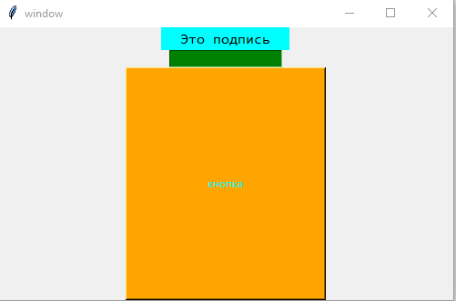

Калькулятор (можно сделать)

Фигуры

from tkinter import *  
root = Tk()  
root.title('window')  
root.geometry('500x300')  
  
canvas = Canvas(root, width=200, height=200, bg = 'red')  
canvas.pack()  
canvas.create_line(15,15,150,150, width = 5)  
canvas.create_rectangle(110,110,180,180, width = 5, fill = 'yellow')  
root.mainloop()

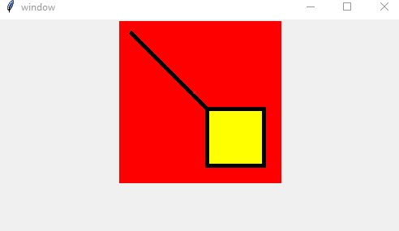

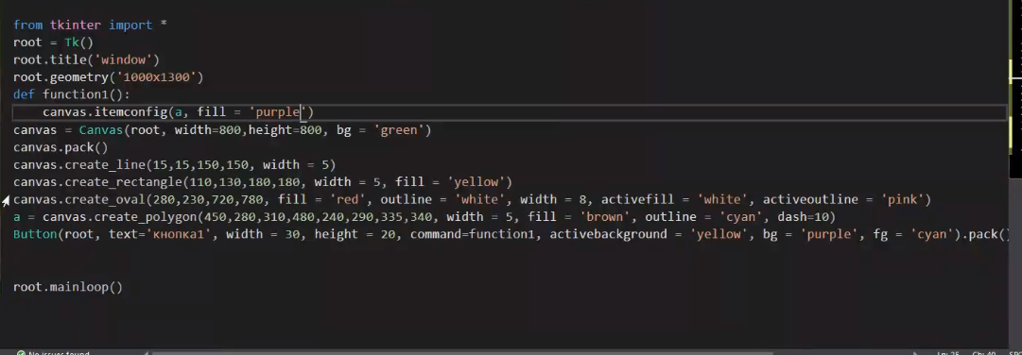

from tkinter import *  
root = Tk()  
root.title('window')  
root.geometry('1000x1300')  
  
canvas = Canvas(root, width=800, height=800, bg = 'green')  
canvas.pack()  
canvas.create_line(15,15,150,150, width = 5)  
canvas.create_rectangle(110,110,180,180, width = 5, fill = 'yellow')  
canvas.create_oval(280,230,720,780, fill = 'red', outline = 'white', width = 3, activefill = 'white', activeoutline = 'pink')  
canvas.create_polygon(450,280,310,480,240,290,335,340, width = 5, fill = 'orange', outline = 'cyan', dash=10)  
root.mainloop()

Моё

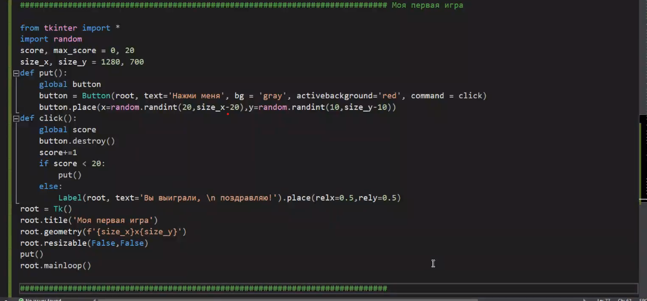

from tkinter *  
import random  
score, max_score = 0,20  
size_x, size_y = 1280, 700  
def put():  
 global button  
 button = Button(root, text='Нажми меня', bg='grey', active background='red', command = click)  
 btton.place(x=random.randit(20,size_x-20,y=random.randint(10,size_y-10)))  
def click():  
 global score  
 button.destroy()  
 score+=1  
 if score < 20:  
 put()  
 else:  
 Label(root, text='Вы выиграли, \n поздравляю!')

Калькулятор сложный

from tkinter import *  
def set_value(formula):  
 if formula == '':  
 label['text'] = '0'  
 else:  
 label['text'] = str(eval(formula))  
def logic(operator):  
 if operator == 'C':  
 set_value('')  
 elif operator == 'DEL':  
 label['text']= label['text'][0:-1]  
 if label['text'] == '':  
 label['text'] = '0'  
 elif operator == 'X^2':  
 set_value(str((eval(label['text']))**2))  
 elif operator == '=':  
 set_value(label['text'])  
 else:  
 if label['text'] == '0':  
 label['text'] = ''  
 label['text'] = label['text']+operator  
  
list = ['C','DEL','*','=','1','2','3','/','4','5','6','+','7','8','9','-','(','0',')','X^2']  
root = Tk()  
root['bg']= 'black'  
root.title('Сложный калькулятор')  
root.geometry('485x550')  
root.resizable(False,False)  
label = Label(text='0', font=('Consolas',21,'bold'), bg='black', foreground = 'white')  
label.place(x=10,y=50)  
x=10  
y=140  
for lis in list:  
 com = lambda x=lis: logic(x)  
 Button(text=lis, bg = 'white', font=('Consolas',15), command = com).place(x=x,y=y,width=115,height=79)  
 x+=117  
 if x>400:  
 x=10  
 y+=81  
root.mainloop()

Римские цифры

