# **Human Authentication by Voice Passphrase**

**1. General principles of the voice authentication system**

Voice biometric authentication systems (hereinafter VBAU) recently gaining more and more popularity. This is primarily due to the development of new methods of machine learning, new methods of signal processing and noise reduction. However, of all existing biometric technologies, voice biometric parameters are the most unstable. This technology belongs to the category of "dynamic biometrics". Below is a short list of factors affecting the change in biometric parameters:

1) human speech is able to change after a certain time in the course of growing up;

2) the influence of atmospheric pressure;

3) the impact of the disease;

4) the impact of lack of sleep;

5) the influence of the external environment (stationary noises, sudden sounds, other people's voices, etc.);

6) the impact of changing the recording device.

Nevertheless, to solve the described problems of biometric voice authentication, every year new methods are being developed in the world that stabilize the system. The new methods, in turn, determine whether certain conditions are met. So, for example, for the stable operation of the system in the cockpit of a fighter, Samson Technologies has developed its own microphones with software noise cancellation for each specific model of the fighter. To suppress stationary noise of a sound card, there are also a large number of ready-made programs and algorithms based on neural network methods. Of the neural network methods for recognizing speakers by voice, two classification methods are distinguished:

1) Classification of a certain number of users - deep learning networks are used (for example, based on the sklearn and tensorflow libraries of the python programming language);

2) Classification of OWN/ALLIEN - linear neural networks are used. World famous companies that provide services in access control systems usually negotiate the conditions for using voice technologies and offer the customer solutions. Many companies, such as MDG, offer the use of a combined application of voice recognition and 2D / 3D face recognition. The main and qualitative characteristics showing the resistance of the system to brute force attacks and stability in recognizing the corresponding speaker are:

1) The probability of an error of the first kind (hereinafter abbreviated as P1) - denial of access for "Own";

2) The likelihood of an error of the second kind (hereinafter abbreviated as P2) is a false acceptance of an outsider for “own”. There is no universal and fixed estimate of these probabilities in modern off-the-shelf VBAUs. Each system has its own assessments based on additional conditions and external factors. Let's consider examples of possible conditions with the presentation of ways to solve the assigned tasks:

Task 1. It is necessary to use VBAU to increase the resistance of any access control system as part of multi-biometrics at an enterprise / institute / military base and similar limited places. Solution. Using microphones of the same type and classifying people using deep learning algorithms.

Task 2. It is necessary to use VBAU to increase the security of any access control system as part of multi-biometrics from various capturing devices. Solution. Using deep learning algorithms or linear network algorithms with a recognition threshold shifted towards P1. It is necessary to test both systems on the provided experimental voice data and select the one on which the probability of error is minimal.

Task 3. It is necessary to use VBAU with speech recording from various recording devices on any terrain (for example: from a tablet / walkie-talkie / smartphone). Solution 1. Using linear neural to exclude the case of theft by an attacker of a tablet / walkie-talkie / smartphone. Consequences: Higher P1 and P2 as opposed to solution case 2. Advantage: ease of use and independence from the base of all users. Solution 2. Using deep networks. Disadvantages: the need to refer to the neural network model. Advantage: ease of use and good P1 and P2 values. To minimize P1 and P2 in both cases, it is recommended to use the same type of microphones / throatphones with a working noise reduction program that is equally configured for all devices.

Task 4. It is necessary to use VBAU with voice recording from a device located in military equipment (armored personnel carrier, tank, plane, helicopter, etc.). Solution. Using microphones of the same type and setting up a noise reduction program for each individual technique. The choice of a neural network is based on the test results and p of example task 3.

# **Structure VBAU**

# **2.1 General scheme**

Figure 1 shows a brief block diagram of the operation VBAU.

Biometric Authentication

Speech-to-text translation

Voice parameters 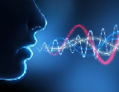

Processing (normalization, noise reduction)

Allien

no

yes

Extraction of biometric parameters

Authentication

password

Allien

no

yes

OWN

Figure 1 - Brief block diagram of the operation of the voice biometric authentication system

The described structure is the basis of any VBAU system, the purpose of which is to confirm the identity of a person using only the passphrase he uttered. The only exceptions are VBAU systems that do not use passphrase authentication. The advantage of such systems is that a person does not need to remember the password, but it is enough to read a random text into the microphone. A random text can be, for example, generated on a monitor screen, or "taken out of my head" (for example, a quatrain learned at school from a poem / a passage from a soldier's charter).

There is a huge amount of variation in the algorithms for each particular block. Further in the report, each block (VBAU stage) is considered in detail, with a description of existing algorithms and programs.

# **2.2 Choosing a passphrase for VBAU**

The choice of passphrase in VBAU can be determined by the user himself or by the person responsible for the access control system. There are no strict restrictions on the choice, but it must be understood that the longer the passphrase, the higher the degree of protection. However, you can neglect this degree and choose a passphrase consisting of 1-2 words in case there is an urgent need: for example, it is difficult for a person to talk a lot due to health problems, or it is necessary to quickly pass authentication due to a rush. A one-word passphrase will obviously have a higher chance of a Type II error compared to a 5-word passphrase. But, if VBAU is an addition to the ACS, in which the user is already authenticated, for example by face, the resistance to brute-force attacks will be more than sufficient. In the testing section, estimates of the probabilities of errors of the first and second kind are given in the ratio of the dependence of the length of the passphrase. In the case of autonomous use of VBAU, according to the test results, the following recommendations for composing a passphrase were identified:

1) the number of words, excluding prepositions, should be from 6 to 10 units;

2) there must be a variability of words in the phrase (exclude repetitions of words and tautologies);

3) the phrase should be easy for the user to remember (an excerpt from a favorite song / poem; words of a military oath; words containing the user's identification number; words containing the user's first name, surname, date of birth, etc.);

4) the clarity of the pronunciation of the phrase (the phrase should be repeated confidently with the same intonation from day to day);

5) a small number of hissing and explosive sounds do not have biometric features, so the choice as a passphrase - "Sasha walked along the highway" - will be unsatisfactory.

# **2.3 Selecting a microphone for picking up voice data**

For training and authentication, it is possible to use any microphones, if, similarly to the example from the previous paragraph, VBAU is part of multi biometrics and the system does not require low P1 and P2. There are a wide variety of microphones of different types and price ranges. The main differences between all of them are:

1) lack of opportunity / ability to work in a noisy facility;

2) the quality of speech - which greatly affects the biometric parameters. So, if a person calls a landline phone in a room in which there are several people he knows, the person does not always manage to correctly recognize the identity of the person who picked up the phone. This is due to the compression and restoration of speech in telephony and due to the quality of the phone itself;

3) the range of speech capture;

4) the level of the microphone's own noise. This characteristic can be corrected by software (see clause 2.4);

5) directivity characteristic;

6) frequency response of sensitivity.

The sensitivity of a microphone is determined by the ratio of the voltage at the output of the microphone to the sound pressure P0, as a rule, in a free sound field, that is, in the absence of the influence of reflective surfaces. When a sinusoidal sound wave propagates in the direction of the working axis of the microphone, this direction is called axial sensitivity:  (1)

The working axis of the microphone is the direction of its preferential use and usually coincides with the axis of symmetry of the microphone. If the microphone design does not have an axis of symmetry, then the direction of the working axis is indicated in the specification. The sensitivity of modern microphones ranges from 1–2 (dynamic microphones) to 10–15 (condenser microphones) mV / Pa. The higher the value, the higher the sensitivity of the microphone.

Thus, a microphone with a sensitivity of -75 dB is less sensitive than a -54 dB, and a microphone with a 2 mV / Pa designation is less sensitive than 20 mV / Pa. For orientation: -54 dB is the same as 2.0 mV / Pa. It should also be taken into account that if the microphone has less sensitivity, this does not mean that it is worse.

The influence of the sound field of the microphone is estimated by the acoustic characteristic, which is determined by the ratio of the force acting on the microphone diaphragm, and the sound pressure in the free sound field: A = F / P, therefore the microphone sensitivity M = U / P can be represented as U / P = U / F • F / P and express through A. Then we get: M = A • U / F. The ratio of the voltage at the output of the microphone to the force acting on the diaphragm U / F characterizes the microphone as an electromechanical converter.

Acoustic response determines the directional response of the microphone. By the type of acoustic characteristics, and, consequently, the directivity characteristics, three types of microphones are distinguished as sound receivers: pressure receivers; pressure gradient; combined.

The directivity characteristic is the dependence of the sensitivity of the microphone on the direction of incidence of the sound wave with respect to the axis of the microphone. It is determined by the ratio of the sensitivity Мα when a sound wave is incident at an angle α relative to the acoustic axis of the microphone to its axial sensitivity:

 (2)

Directionality of a microphone refers to its possible location in relation to sound sources. If the sensitivity does not depend on the angle of incidence of the sound wave, that is, φ = 1, then the microphone is called non-directional, and sound sources can be located around it. And if the sensitivity depends on the angle, then the sound sources should be located in a spatial angle, within which the sensitivity of the microphone differs little from the axial sensitivity. In omnidirectional microphones - pressure receivers - the force acting on the diaphragm is determined by the sound pressure at the surface of the diaphragm. The sound field can only act on one side of the diaphragm. The second side is structurally protected. If the microphone is small compared to the sound wavelength, the microphone does not change the sound field. If the dimensions are commensurate with the wavelength, then due to the diffraction of sound waves, the microphone acquires directivity. At frequencies from 5000 Hz and below, these microphones are omnidirectional. The advantage of omnidirectional microphones is simplicity of design, capsule design and stability over time. Omnidirectional capsules are often used as part of measuring microphones; in everyday life they can be used to record the conversation of people sitting at a round table. Figure 2 shows the audio coverage of the microphones.

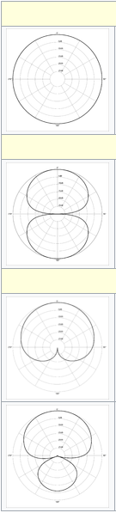

Figure 2 - Directionality of microphones. Polar representation

In bi-directional microphones - pressure gradient receivers - the force acting on the moving microphone system is determined by the difference in sound pressure on the two sides of the diaphragm. That is, the sound field acts on both sides of the diaphragm. The directivity characteristic has the form of an eight. Two-way microphones are convenient, for example, for recording a conversation between two interlocutors sitting opposite each other. One-way directivity is achieved in combination microphones. Their directional patterns are close in shape to the cardioid, therefore they are often called cardioid. Microphone modifications that are even less directivity than cardioid are called supercardioid and hypercardioid, but these versions, unlike cardioid microphones, are also sensitive to signals from the opposite side. These microphones have certain advantages in operation: the sound source is located on one side of the microphone within a fairly wide spatial angle, and the microphone does not perceive sounds propagating beyond it. In accordance with international standards, the intrinsic noise level of a microphone is defined as the sound pressure level that creates a voltage at the output of a microphone equal to the voltage that occurs in it due to its own noise in the absence of an audio signal. It can be calculated by the formula

 (3)

To summarize, the recommended microphone choice for achieving high-quality speech recording is a microphone that has the following characteristics:

1) Principle of operation - capacitor;

2) Directivity - cardioid;

3) Sensitivity - 38 dB;

4) The minimum frequency is 30 Hz;

5) Maximum frequency - 18000 Hz;

6) Maximum sound pressure level - 96 dB;

7) Sampling rate - 24 bit / 192 kHz;

8) Availability of pop filters.

# **2.4 Software noise reduction**

To eliminate microphone noise or environmental noise, there are a number of ready-made programs. The principle of their operation is based on the fact that the microphone removes a sample of stationary noise (the noise of a city street and the noise of large crowds of people) and noise emanating from the microphone itself. The difference between these programs is the following characteristics:

1) High-speed performance;

2) Demanding technical resources;

3) Quality of noise reduction;

Two types of processing should be distinguished:

1) Processing before recording voice images;

2) Post-processing.

Background noise during authentication has a strong impact on the result. Particularly unpleasant for VBAU in our experiments were the hard-to-neutralize city street noise and the noise of crowded crowds. The original plan is to find an analytical solution for these two specific types of noise and to neutralize them. But in the process of experiments with several algorithms, it turned out that, firstly, the voice was quite distorted, and secondly, there were much more types of noise in our training sample. Plus, we didn't want (relatively) clear speech to be modified in any way, as this would negatively affect recognition. Deep neural networks are an excellent solution in cases where an analytical solution for a function is difficult or impossible to find. A function has been selected to transform a noisy speech signal into a noisy one. As a similar algorithm, it is proposed to use the "RNNoise" algorithm, the sources of which are written in the C ++ language. In this algorithm, ready-made models are provided, and it is also possible to train the models on the required conditions (constant engine sound, street noise, etc.). When creating RNNoise, the developers aimed to get a small and fast algorithm that will work efficiently in real time, even on the Raspberry Pi. And they succeeded, and RNNoise shows a higher quality result than the coolest and most sophisticated modern filters. Neural networks have been used for noise suppression in the past, and in recent years it has become a popular area of ​​research. But most of them are intended for use in automatic speech recognition applications, where latency and processing power are not the determining factors. In contrast, the Mozilla project focuses on real-time applications such as video conferencing and audio processing at a full 48 kHz sampling rate. Figure 3 shows examples of noise reduction spectrograms.

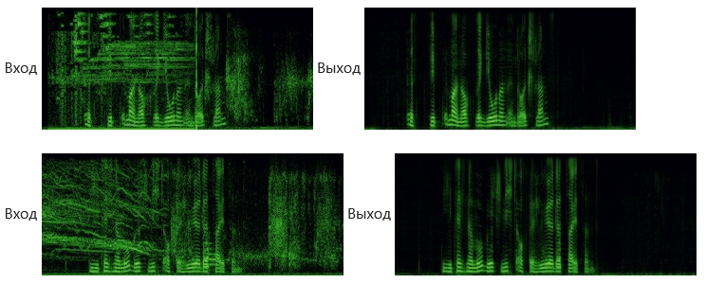

Figure 3 - An example of the operation of the noise reduction program

# **2.5 Sound normalization**

Before extracting biometric parameters, voice .wav files must be brought to a stationary volume level. A person pronounces passphrases at different distances from the microphone and possibly with different settings for microphone gain. Also, the result of signal noise reduction affects the instability of biometric parameters. Therefore, the normalization must be carried out after the noise reduction operation. Figure 4 shows examples of differences in biometric parameters (chalk-frequency coefficients) from different microphone distances.

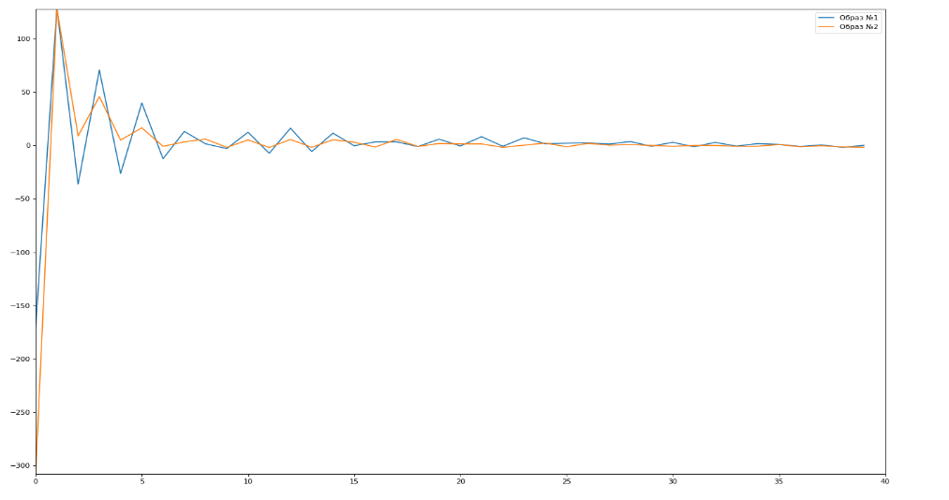

Figure 4 - The difference between the chalk-frequency coefficients of two identical voice images from the position of the microphone

Figure 5 shows examples of 20 identical phrases after the normalization procedure.

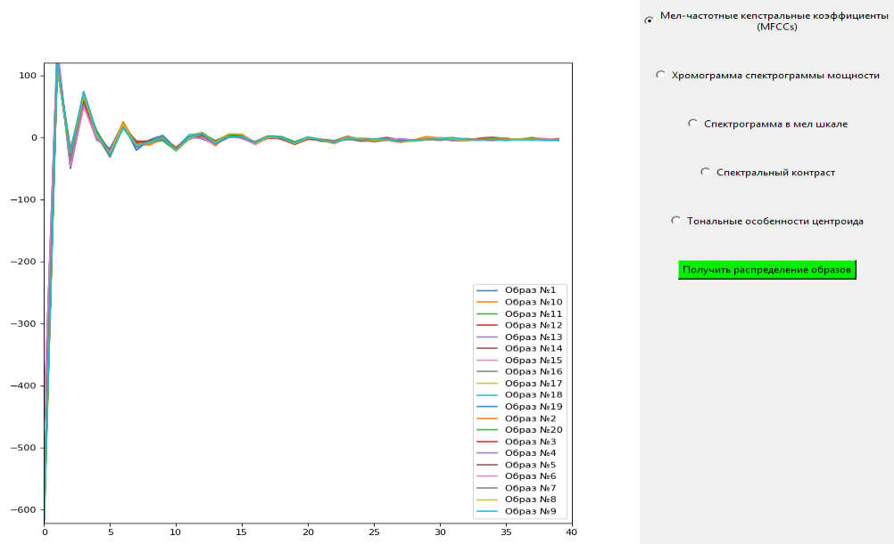

Figure 5 - Chalk-frequency coefficients of 20 identical voice images after normalization

Recommended normalization ratio = 20 dB.

# **2.6 Speech-to-text translation**

The "vosk" library based on the largest tool "Kaldi" was used as a speech-to-text translation system. Library advantages:

1) Supports 18 languages ​​and dialects - Russian, English, Indian English, German, French, Portuguese, Spanish, Chinese, Turkish, Vietnamese, Italian, Dutch, Valencian, Arabic, Greek, Persian, Filipino, Ukrainian. More are expected to be added soon;

2) Works without network access even on mobile devices - Raspberry Pi, Android, iOS;

3) Models for each language take only 50MB, but there are also much more accurate large models for more accurate recognition;

4) Made for streaming audio processing, which allows you to implement instant response to commands;

5) Supports several popular programming languages ​​- Python, Java, NodeJS, C #, C ++;

6) Allows you to quickly customize the recognition dictionary to improve the recognition accuracy;

7) Can be run on Windows, Linux, Android.

At the moment, "kaldi" is an advanced tool for offline speech-to-text conversion, and for more accurate recognition, it is possible to customize the model for specific conditions and needs. However, there are several companies that are improving this tool, specifically in terms of methods of neural network transformation and noise reduction for specific tasks. This indicates the possibility of solving "particular problems" if necessary, since the tool is provided with open source code. According to the test results, which will be presented below (2.6.3), the system showed good performance even in noise and interference conditions.

The final scheme of the password phrase identification algorithm is shown in Figure 6.

Multiple repetition of the phrase by the announcer

Vosk phrase recognition

Linguistic model

List of variations of recognized phrases

List of variations of morphological phrases

General list of possible passphrases

Authentication

Figure 6 - The procedure for extracting a list of possible variations of a passphrase

The final authentication for the passphrase is shown in Figure 7. A list of variations of the spoken phrase is compiled, according to the scheme in Figure 6. If one of the variations of the spoken phrase is found in the list of possible passphrases, the search is terminated - it is concluded that the phrase belongs to the "OWN" image. in case of mismatch none - "ALLIEN".

General list of possible passphrases

Authentication. Spoken phrase

Procedure for retrieving a list of possible variations of a spoken phrase

General list of variations of the spoken phrase

Test phrase = possible from

ALLIEN

-

+

OWN

Figure 7 - Authentication procedure for a password voice phrase without taking into account biometrics

# **2.7 Testing the speech-to-text system**

It is impossible to name specific numbers that would characterize the quality and accuracy of the transducer recognition. However, among all available speech-to-text conversion systems based on the Russian language corpus, the "vosk" system is the leader in terms of testing on the same bases of voice images. The quality of recognition is practically not inferior to the world's online systems, as evidenced by further testing.

In automatic speech recognition systems, the main indicator of quality is recognition accuracy, which is defined as the percentage of correctly recognized words (WRR - Word Recognition Rate) or incorrectly recognized words (WER - Word Error Rate).

Records and corresponding text transcripts from the VoxForge website were taken as a dataset. As a result, after recognition of 3677 sound files by each system, the following WER values ​​were obtained (Figure 8).

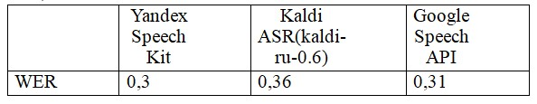

Figure 8 - WER database 3677 words

VoxForge recordings are roughly similar in terms of the absence of background noise, intonation, speech rate, etc.

The following base was also taken, consisting of the "open_stt" validation corpus, which includes telephone conversations, audio tracks of YouTube videos and audiobooks. The work was evaluated using WER and CER (Character Error Rate). After receiving the text transcripts, it was noticed that Google and Yandex (unlike Kaldi) recognized words like "one" as "1". (result - figure 9)

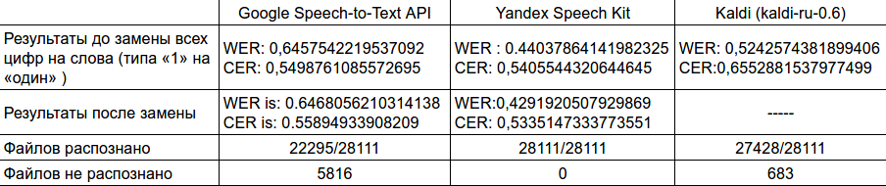

Figure 9 - WER and CER database 28111 words

Accordingly, it became necessary to correct such cases (since in the reference decryptions provided by the authors of open_stt, everything is presented in literal terms), which influenced the final result.

On the basis of the data collected at JSC PNIEI for testing VBAU, the following results were obtained:

After listening to audio recordings in which the system made a mistake, the following factors were identified:

1) the microphone (headset) flew off the neck due to which the sound turned out to be indistinct;

2) the person made a mistake himself;

3) loud bangs of the door occurred at the time of recording;

4) poor quality of the microphone itself, especially the microphone 6.

Probability of error for a passphrase consisting of words longer than 3 letters:

1) for the first microphone was 2.5%;

2) for the second microphone was 7.3%;

3) for the third microphone was 6.3%;

4) for the fourth microphone was 5.8%;

5) for the fifth microphone was 3.3%;

6) for the sixth microphone was 11.3%.

Obviously, it is impossible to name an exact figure for the probability of error, since the words in the phrases are random and have no relationship, which makes the linguistic model useless.

# **2.8 Recommendations for using the speech recognition system in the task of voice control**

As can be seen from the test results, most errors occur in password words that do not have a linguistic and logical combination, for example, there is not a single corpus in the world in which the words "eagle, turtle" are frequently encountered, unlike, for example, the words "open a door". In the authentication system, these errors do not carry any significance due to the presence of a training sample. From the positive ratings, it can be seen that the system shows stable performance in noisy environments, even with the cheapest microphone.

If you use a speech recognition system in a voice control task, you must fulfill one of the following recommended conditions to improve the quality of recognition:

1) carry out the adaptation on the model;

2) limit the command dictionary. For example, create an OWN "lm" dictionary ("open the gate", "start the car", "turn on the alarm, etc.);

3) use microphones with a cardioid directivity, with a small radius of sound perception (buttonhole, headset).

4) use those speech turns and phrases that are most stable for recognition systems (phrases in which there is a logical chain and the relationship of words)

**2.6 Biometric voice tags**

Each audio signal consists of many features. Spectral (frequency) features are obtained by transforming the time signal into the frequency domain using the Fourier transform. These include pitch frequency, frequency components, spectral centroid, spectral flux, spectral density, spectral decay, etc. Figure 10 shows 12 examples of the passphrase of the original, normalized .wav files.

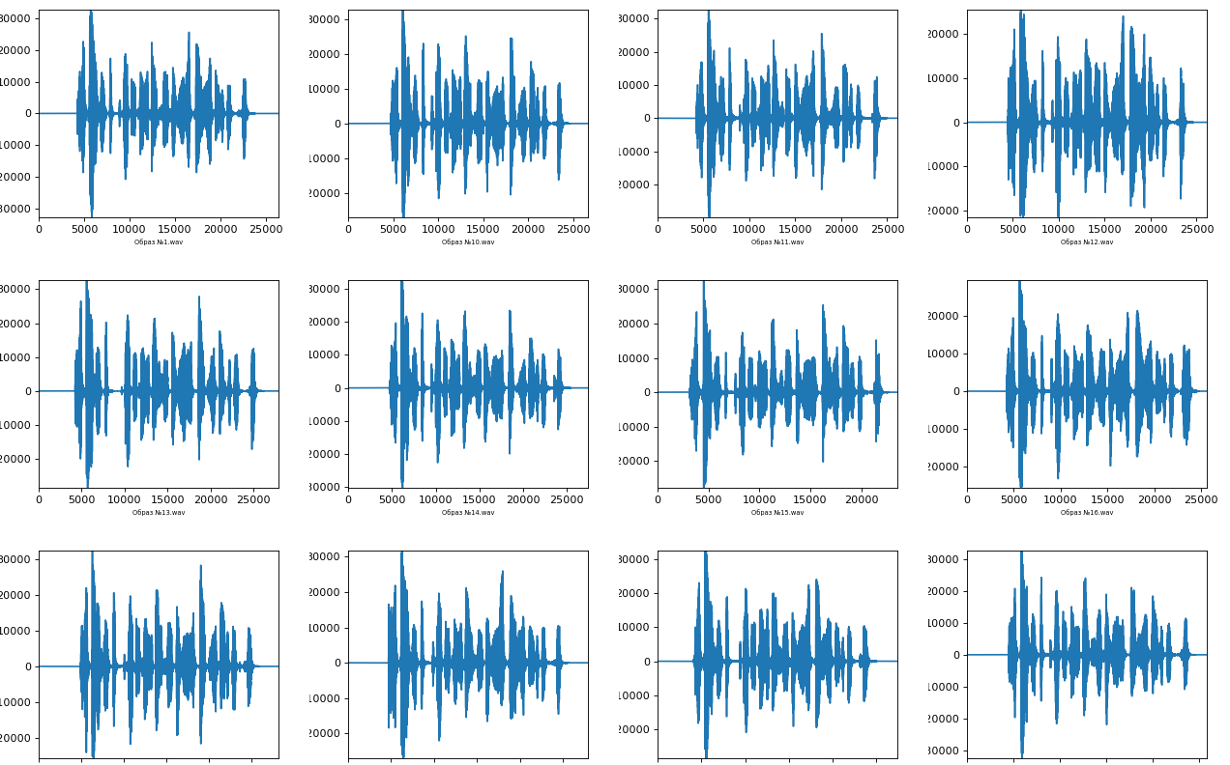

Figure 10 - Examples of passphrase

Further, when considering biometric parameters, the transformations of these examples will be presented.

1. Chalk Frequency Cepstral Coefficients (MFCC) - These are a small set of features (40 parameters) that briefly describe the overall shape of the spectral envelope. They simulate the characteristics of the human voice. An example is Figure 11.

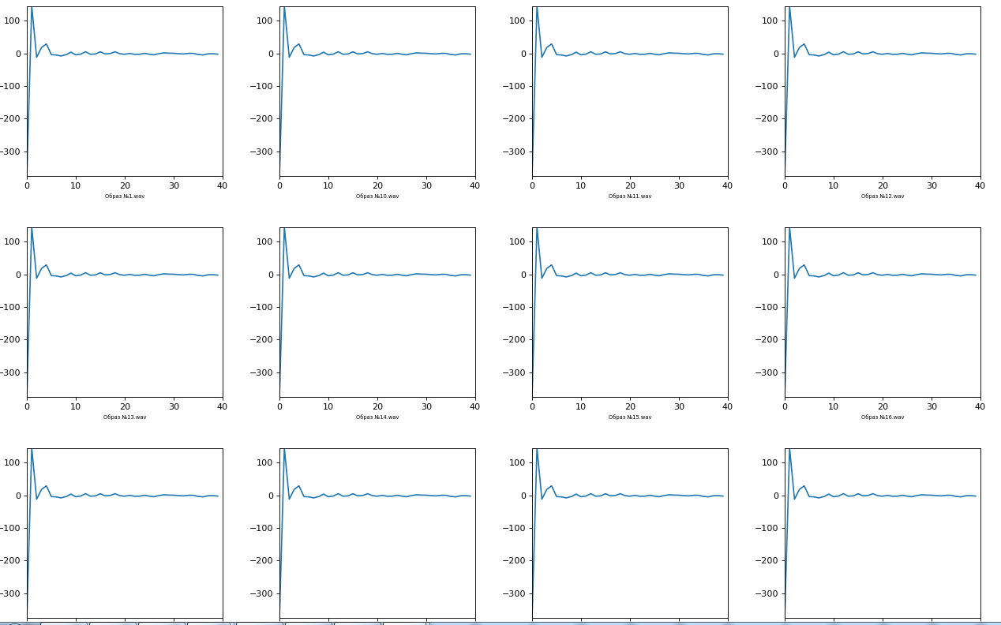

Figure 11 - Examples of MFCC coefficients

2. Chromaticity - A feature or a vector of chromaticity is represented by a feature vector of 12 elements, which indicates the amount of energy of each height class {C, C #, D, D #, E,…, B} in the signal (12 parameters in total) - Figure 12;

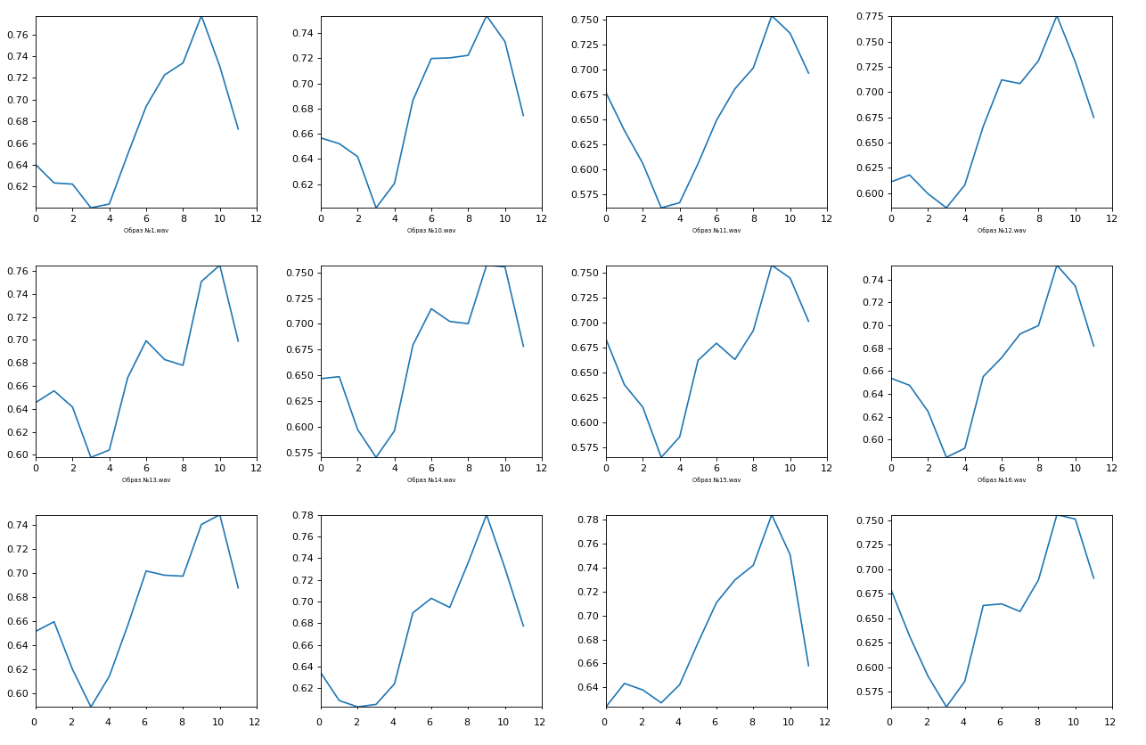

Figure 12 - Examples of chromaticity parameters

3. A spectrogram is a visual way of representing the level or “loudness” of a signal over time at the various frequencies present in the waveform. Usually depicted as a heat map. Converts data into short-term Fourier transform (129 parameters) - (example Figure 13).

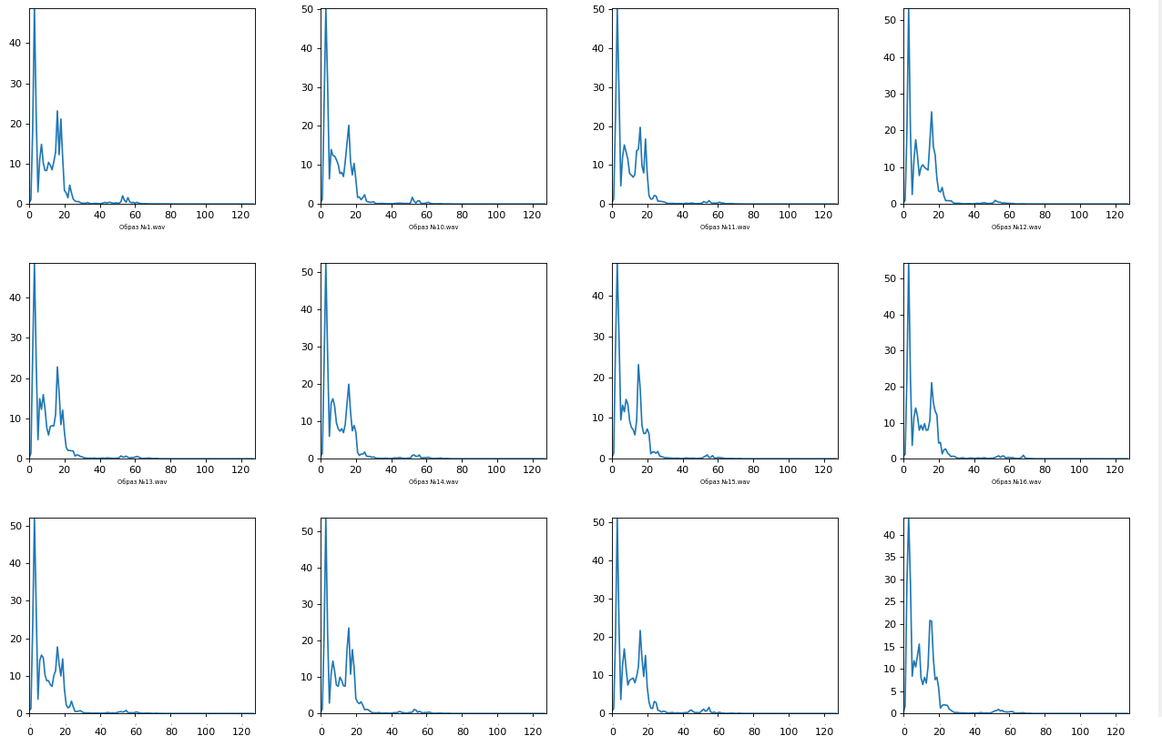

Figure 13 - Spectrogram examples

4. Spectral contrast - is defined as the difference in decibels between the peaks and troughs in the spectrum (6 parameters), example - Figure 14.

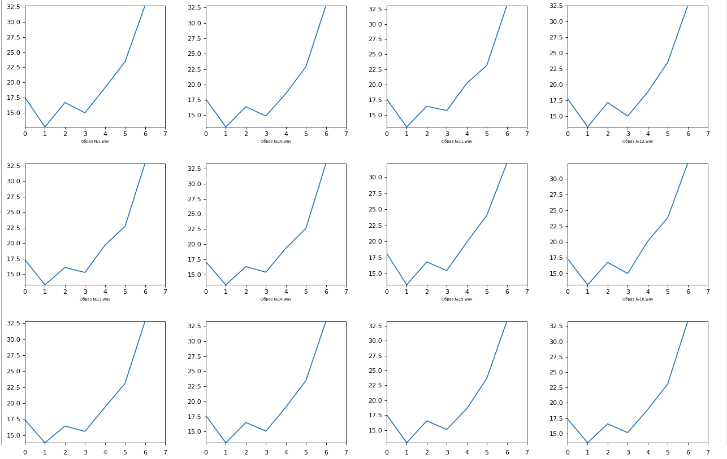

Figure 14 - Examples of spectral contrast parameters

5. Spectral centroid - indicates at what frequency the energy of the spectrum is concentrated or, in other words, indicates where the “center of mass” for sound is located. Similar to the weighted average:

 (13)

where S (k) is the spectral value of the resolution element k, and f (k) is the frequency of the element k. There are 6 parameters in total, an example is Figure 15.

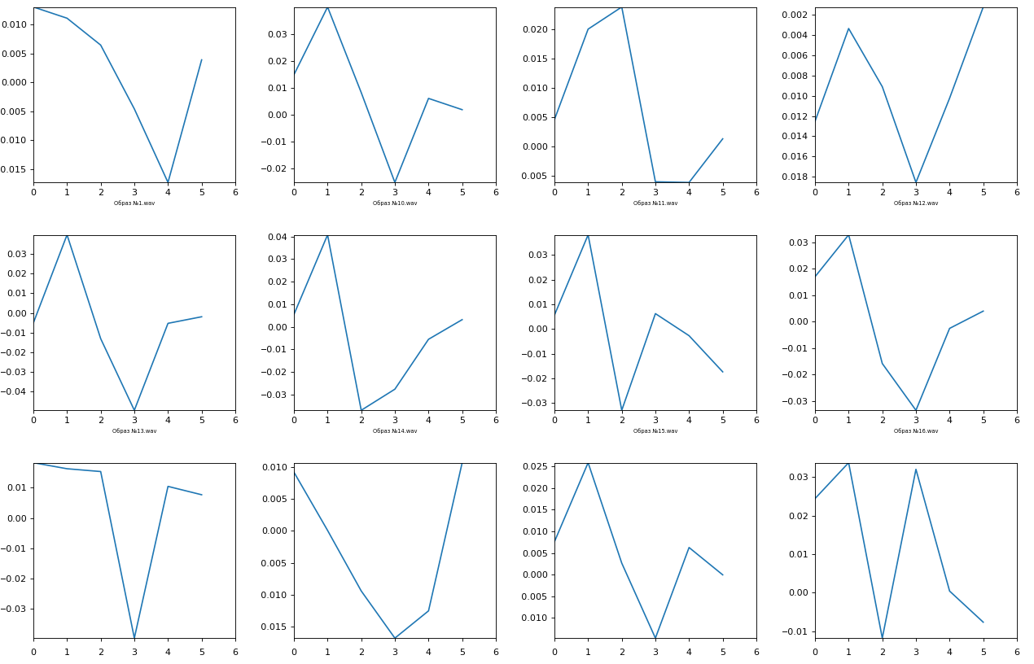

Figure 15 - Examples of spectral centroid parameters

The total number of parameters ultimately amounted to 193 units.

# **2.9 Normalization of biometric parameters relative to the database of images "ALL ALLIANCES"**

For further classification of users into "OWN / ALLIEN", it is necessary to normalize biometric parameters relative to the base of images "ALL ALLIENCES". The base of images was collected on various microphones, thanks to the help of the staff of JSC PNIEI. From this base, vectors of mathematical expectation and standard deviation were obtained, for applying the normalization formula:

 (14)

where is the new value of the biometric parameter, is the initial value of the biometric parameter, is the mathematical expectation of the ALL ALLIENCES images, and is the mean standard deviation of the ALL ALLIENCES images.

The normalization procedure significantly shifts the distribution of the Euclidean distance between the “OWN” and “ALLIEN” images. This effect is clearly seen in Figure 16, which shows the Euclidean distance distributions for the OWN image relative to the four ALLIEN images.

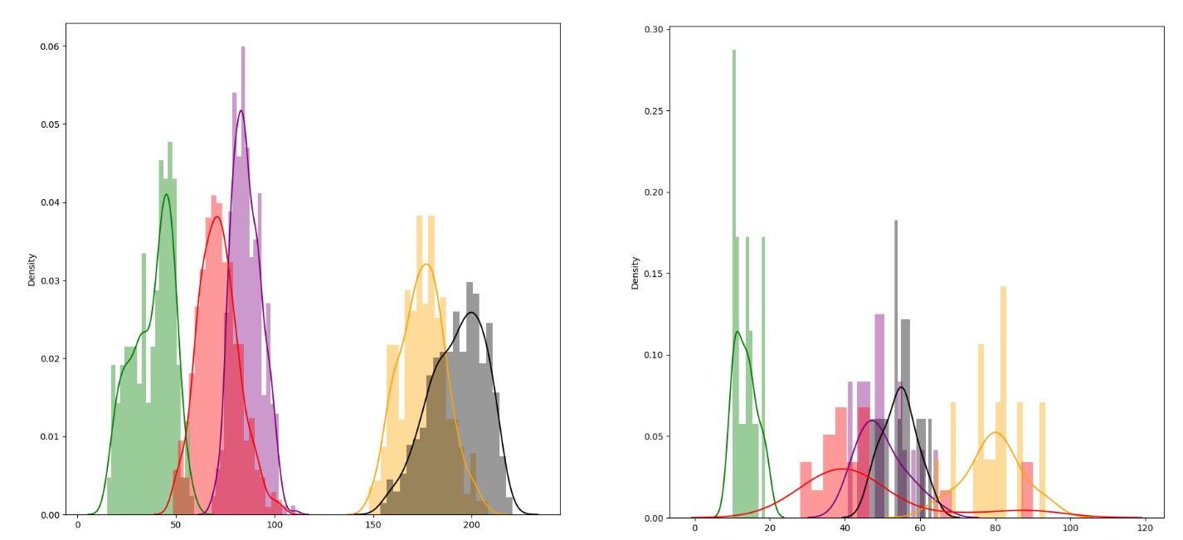

Figure 16 - Examples of the distribution of distances at "normal" Euclidean distance and weighted Euclidean distance.

As can be seen from the figure, the weighted distances significantly increase the distance between the OWN and ALLIEN images, which in turn has a positive effect on the probability of a Type II error. Also, the distance between OWN images is reduced, which indicates the stability of the P1. The values of the "Own" distances at the "usual" Euclidean distance range from 0 to 60, at the weighted one - [0..18].

# **2.10 Assessment of the quality of biometric parameters**

The quality of biometric parameters is calculated by the ratio of the mathematical expectation to the mean standard deviation of the calculated parameter:

 (15)

where the vector of mathematical expectation and standard deviation is calculated for a separate sample of OWN patterns. According to GOST 52633, a value> 3 is considered normal quality for stable operation of biometric authentication.

Based on the collected database, the parameters for each individual user of the corresponding phrase were considered. Figure 17 shows an example of calculating the quality of biometric parameters for the "OWN" image.

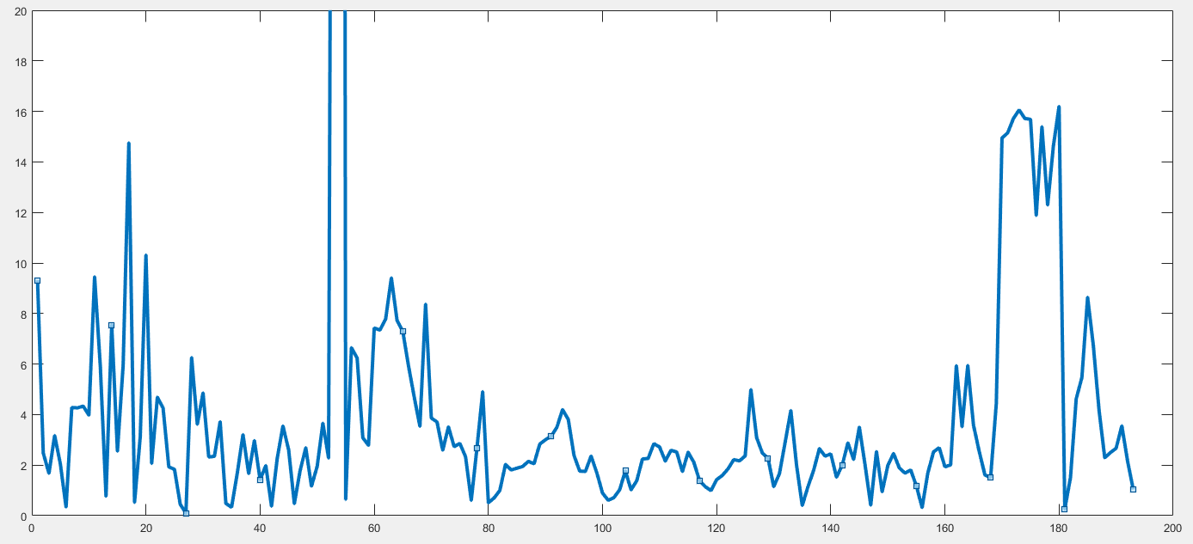

Figure 17 - Examples of values of the quality of the biometric parameter for images "OWN"

Table 2 shows the number of parameters whose quality is greater than this or that value.

Table 2 - Number of parameters relative to the quality range of Figure 18

|  |  |
| --- | --- |
| Quality range | Number of parameters |
| Q>15 | 9 |
| Q = [10..15] | 6 |
| Q = [8..10] | 5 |
| Q = [5..8] | 16 |
| Q = [3..5] | 36 |
| Q = [2.5..3] | 23 |
| Q = [1.5..2.5] | 63 |
| Q = [0.5..1.5] | 24 |
| Q = [0..0.5] | 11 |

It can be seen from the table and figure that some biometric parameters are of low quality. However, one should not make hasty conclusions and discount them, since other users, other microphones, in other noise conditions, they will give completely different values, as evidenced by the histogram of the probability quality distribution for each biometric parameter in Figure 18. Distributions built on 17 different users, 5 different microphones and 10 different passphrases.

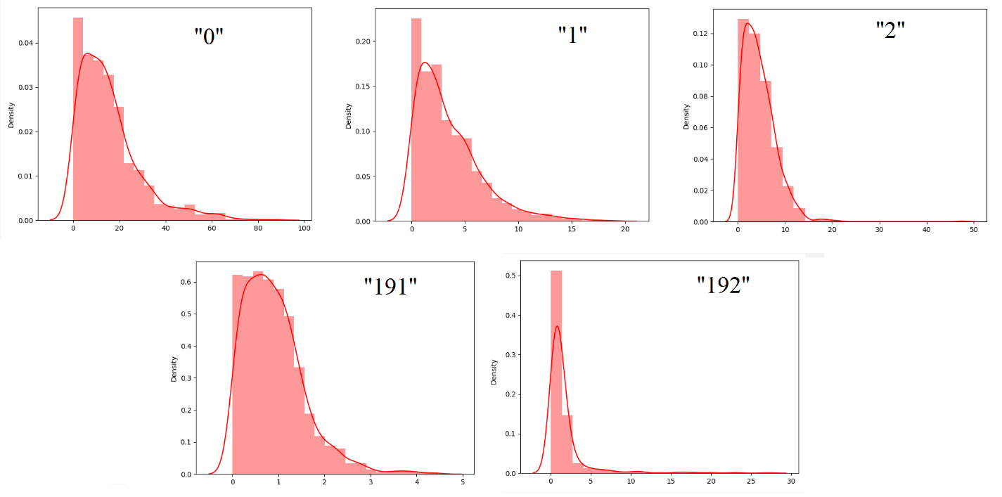

Figure 18 - Distribution of the quality of biometric parameters collected on a large base

To show the distribution of quality parameters for each biometric parameter, it will take about a hundred pages, since the total number of parameters used is 193. Therefore, table D.1 of Appendix D presents the distribution ranges for each biometric parameter. The table also shows the total number of parameters, whose quality is distributed in a certain range, for tracking the density. A total of 1106 example parameters are shown.

This testing is necessary to track the best method, either the noise reduction model or the recording microphone, in a particular environment.

Table 3 shows statistics of biometric characteristics for microphones similar to Table D.1.

Table 3 - Quality of biometric parameters relative to the microphone

|  |  |  |  |  |
| --- | --- | --- | --- | --- |
| Microphone | Number of parameters[0..2] | Number of parameters[2..4] | Number of parameters[4..10] | Number of parameters>10 |
|
|
| 1 | 98 | 93 | 247 | 668 |
| 2 | 432 | 289 | 339 | 46 |
| 3 | 279 | 288 | 462 | 77 |
| 4 | 554 | 349 | 187 | 16 |
| 5 | 409 | 301 | 340 | 56 |
| 6 | 350 | 286 | 409 | 61 |

As you can see from the table, the highest quality of biometric parameters is concentrated in microphone # 1. This is the most expensive microphone with noise cancellation applied to it. However, the same microphone without noise cancellation shows the worst results. It can be concluded that noise greatly affects the quality of biometrics. The lavalier microphone has good performance, with a minimum noise level, but in terms of the number of the highest quality parameters it is inferior to a condenser microphone.

# **2.7.3 Подсчет расстояния между образами и задание порога определения образов «OWN»/«ALLIEN»**

Quality Range This clause deals with the final classification between the OWN and ALLIEN images. To carry out this classification, it is necessary first of all to determine the classification threshold. To calculate, you must first calculate the weighted Euclidean distances for the training set "OWN" by the formula 16:

 (16)

where – normalized parameter with respect to images «ALL ALLIENCES», – mathematical expectation of images «OWN»,  – standard deviation of images «OWN». The number of distances obtained is equal to the number of images in the training set. Having received the distance values, we form the final distribution of OWN images. For authentication, the setting of the threshold value of the formula 17 is used:

 (17)

where – mathematical expectation of the distribution of the obtained values of the Euclidean distance of the images «OWN», – corresponding mean standard deviation.

The general authentication formula is carried out by calculating the distance of the test image according to the formula 16. If the calculated distance is less than the threshold value, a decision is made about the image belonging to the "OWN" class, otherwise - to the "ALLIEN" class. If, during user authentication "OWN", the calculated distance turns out to be greater than the threshold value, it is necessary to rebuild the distribution of "OWN" images by additional training, that is, adding a falsely recognized image to the training system. As mentioned earlier, voice biometrics are generally recognized as dynamic. A person's voice is able to change over time due to illness, the influence of atmospheric pressure, etc. To implement the most stable work of VBAU, it is recommended to carry out additional training the next day after recording the main training sample.

The general outline of VBAU training is shown in Figure 19.

-

+

Computing vectors

mat. expectations

middle st. deviations

Normalized Images "Own"

Calculating a weighted Euclidean distance

Additional training

Authentication

Stability check

Figure 19 - VBAU training scheme

# **2.9 Testing the first version of VBAU**

Assessment of the quality of biometric parameters indicates their differences between different users. So, Figure 20 shows an example of visualizing the difference between the parameters of two users:

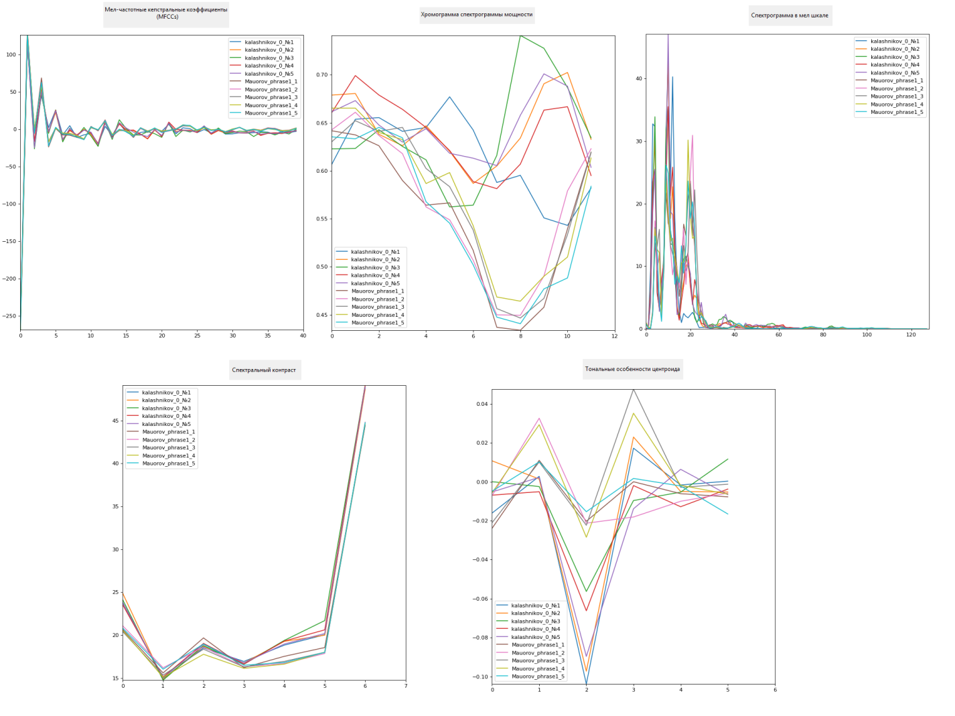

Figure 20 - Examples of differences in biometric parameters

The key metrics in VBAU performance, as mentioned earlier, are the total probability of Type I and Type II errors. Figure 21 shows examples of the distribution of distances between different users.

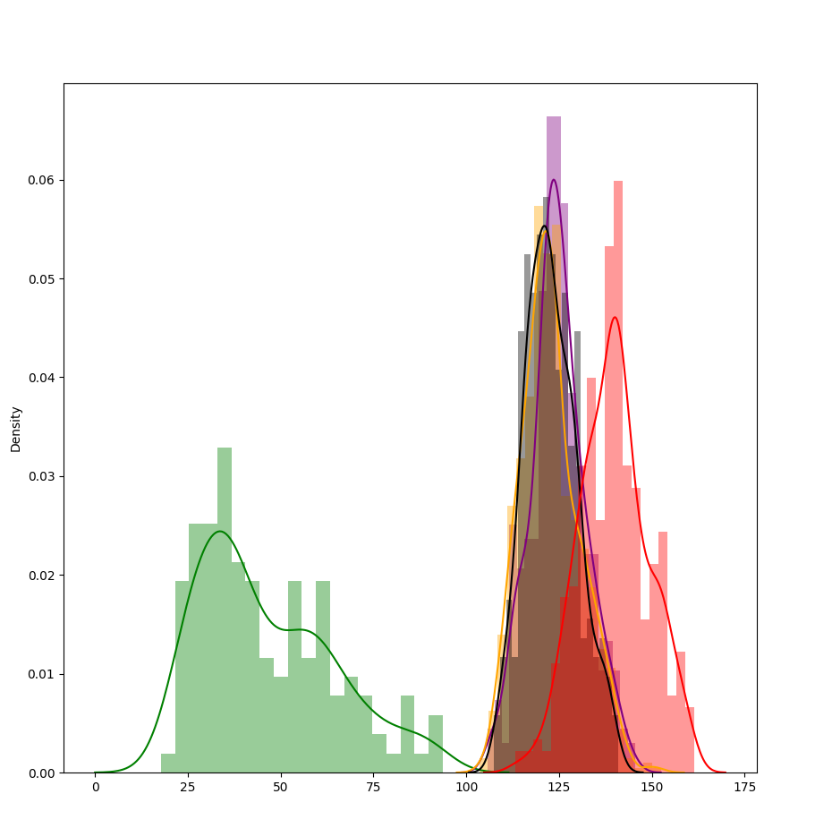

Figure 21 - An example of the distribution of distances between 5 users

Table E.1 in Appendix E shows the calculated distances for 17 users on 5 different recording devices.

Obviously, it is impossible to fit all the tested cases into a report, since this will take up 14,450 table rows. The purpose of showing this table is that when testing a large database of images, you can easily identify flaws and find a user whose biometric data was close to another user. Next, analyze, identify the reasons for further improvement of the entire VBAU.

From table E.1 it can be seen that long phrases have the best performance on a high-quality microphone No. 1. For clarity of presentation of distances, distributions for phrases from 1 to 6 inclusive and from 7 to 10 on all microphones are constructed. Distributions include ALL OWN images and ALL ALLIENCES images obtained from the full database.

Since the table is incomplete, Figures 22, 23, 24, 25, 26, 27 show the distributions for each microphone.

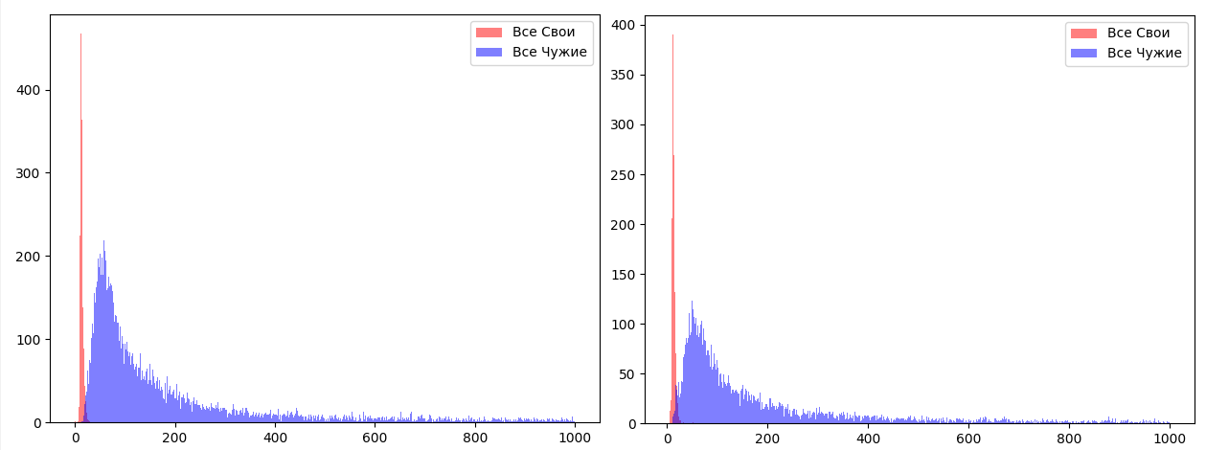

Figure 22 - Distributions "ALL OWN" and "ALL ALLIENCES" for microphone 1 for phrases No. 1-6 (left) and for phrases No. 7-10 (right)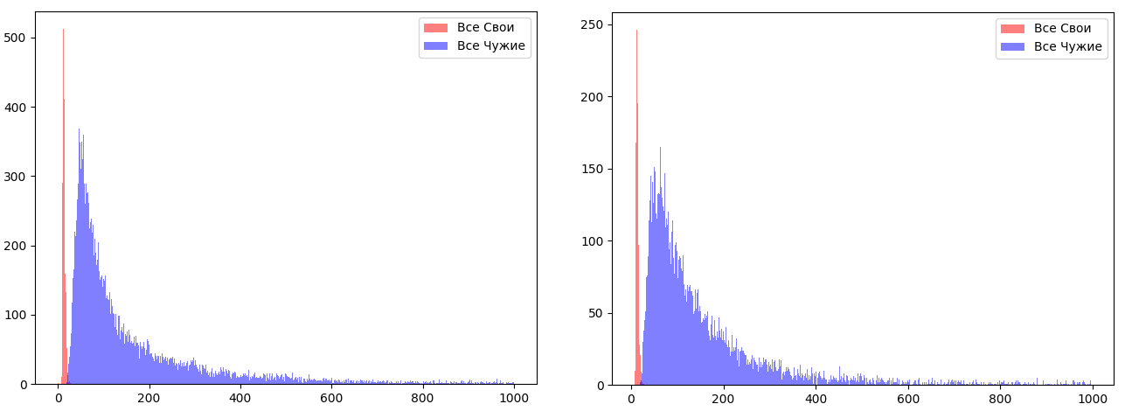

Figure 23 - Distributions "ALL OWN" and "ALL ALLIENCES" for microphone 2 for phrases No. 1-6 (left) and for phrases No. 7-10 (right)

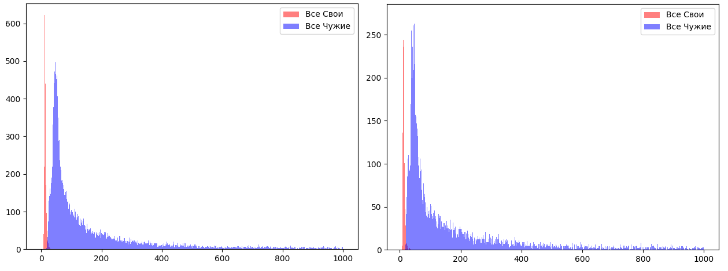

Figure 24 - Distributions "ALL OWN" and "ALL ALLIENCES" for microphone 3 for phrases No. 1-6 (left) and for phrases No. 7-10 (right)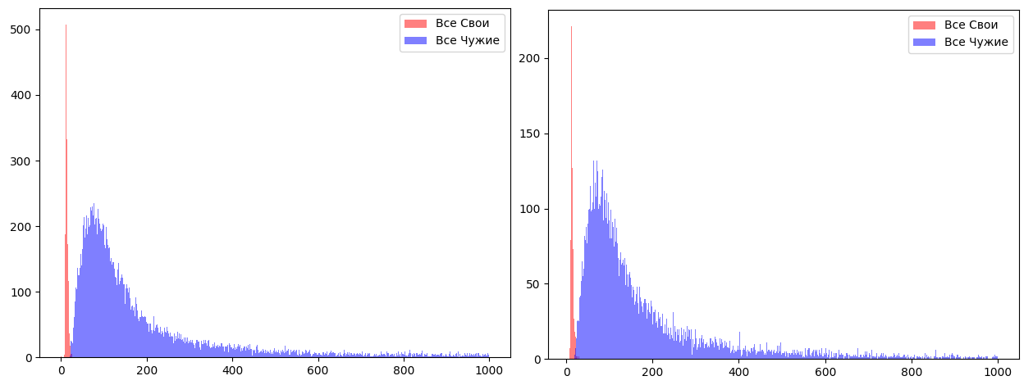

Figure 25 - Distributions "ALL OWN" and "ALL ALLIENCES" for microphone 4 for phrases No. 1-6 (left) and for phrases No. 7-10 (right)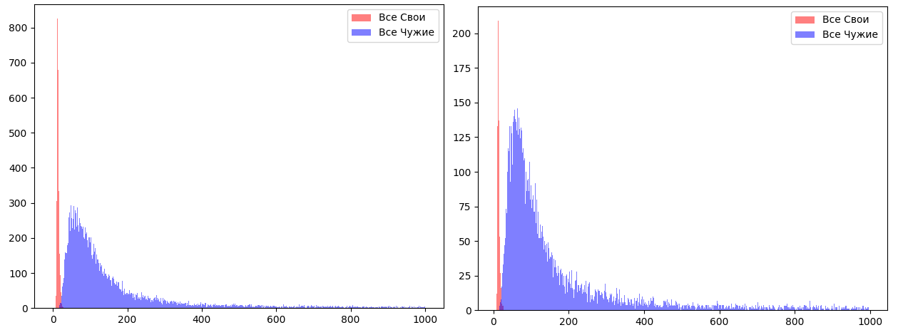

Figure 26 - Distributions "ALL OWN" and "ALL ALLIENCES" for microphone 5 for phrases No. 1-6 (left) and for phrases No. 7-10 (right)

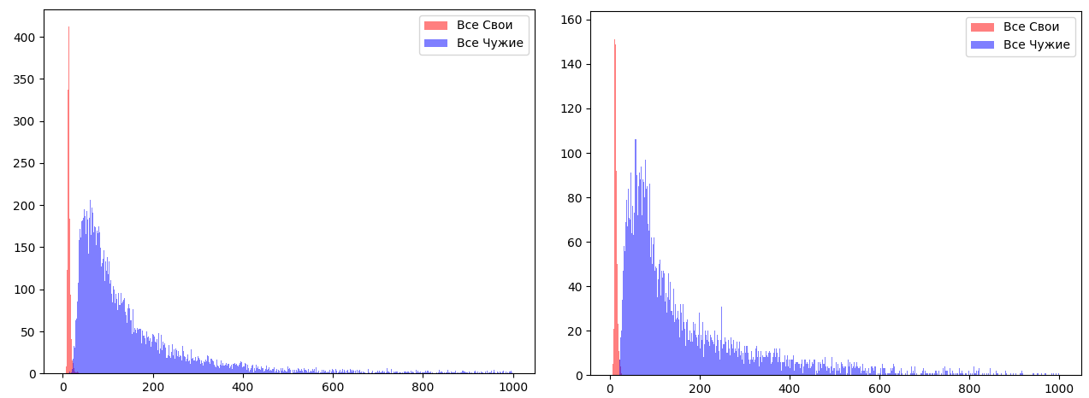

Figure 27 - Distributions "ALL OWN" and "ALL ALLIENCES" for microphone 6 for phrases No. 1-6 (left) and for phrases No. 7-10 (right)

In the following paragraphs, the probability of an error of the first and second kind will be estimated by setting a threshold between the distributions. From Figure 27, you can see that the "ALL ALLIENCES" distribution overlaps strongly with the "ALL OWN" distributions. After checking, a user was found who dictated phrases too eccentrically during the collection of databases. It was also found that some phrases on microphone 1 were recorded with distortion due to the enormous voltage on the laptop, which in turn influenced errors that other microphones lack. On all distributions, the significant influence of the length of the passphrase can be observed with the naked eye. For any microphone, the distance between the distributions increases, which indicates the correctness of the recommendation in the length of the password phrase = 7-10 words.

# **2.9.1 Estimation of the probability of a type I error**

The probability of type I error was calculated by taking a separate number of parameters from the test sample of an individual user, an individual phrase, and an individual microphone. Table E.1 shows the overall probability of a Type I error relative to a passphrase and relative to each recording device. The parameter N means the number of the training sample. Cases are considered when the number of the training sample was 6, 8, 10, 12 images.

From the table, it is noticed that the length of the passphrase has a strong effect on the final assessment, and the number of the training sample also strongly affects. Table 7 summarizes the final statistics of P1 regarding the microphone, phrase length and the number of training samples. The nature of the phrases themselves has little influence.

Table 4 - P1 statistics regarding the microphone, phrase length and the number of training sample

|  |  |  |  |
| --- | --- | --- | --- |
| P1 | N | Phrase 7-10 слов | Phrase 4-5 слов |
| Microphone№1 | 6 | 0,080468333 | 0,050035 |
| 12 | 0,099225 | 0,06191 |
| Microphone№2 | 6 | 0,104026667 | 0,050941667 |
| 12 | 0,126525 | 0,08022 |
| Microphone№3 | 6 | 0,081418333 | 0,044868333 |
| 12 | 0,0933875 | 0,07611 |
| Microphone№4 | 6 | 0,100965 | 0,054278333 |
| 12 | 0,1133475 | 0,0700625 |
| Microphone№5 | 6 | 0,096791667 | 0,051263333 |
| 12 | 0,0960975 | 0,0723125 |
| Microphone№6 | 6 | 0,096665 | 0,045763333 |
| 12 | 0,142305 | 0,08787 |

# **2.9.2 Estimation of the probability of a type II error**

Table E.2 shows the statistics of the probability of an error of the second kind for the length of the training sample of 8, 10, 12 and 20 images.

Similar to calculating P1, calculating P2 in Table 5.

Table 5 - P2 statistics regarding microphone, phrase length and number of training sample

|  |  |  |  |
| --- | --- | --- | --- |
| P2 | N | Phrase 7-10 слов | Phrase 4-5 слов |
| Microphone№1 | 8 | 0,000638333 | 4,70E-04 |
| 20 | 0,000953333 | 0,007375 |
| Microphone№2 | 8 | 0,00094 | 0 |
| 20 | 0,000953333 | 0,000225 |
| Microphone№3 | 8 | 0,00182 | 0,003365 |
| 20 | 0,00229 | 0,0054175 |
| Microphone№4 | 8 | 0 | 1,63E-04 |
| 20 | 0,000055 | 9,40E-04 |
| Microphone№5 | 8 | 0,000341667 | 0,00045 |
| 20 | 0,001093333 | 0,0006925 |
| Microphone№6 | 8 | 0,00026 | 0 |
| 20 | 0,000455 | 5,75E-04 |

# **2.9.3 OWN / ALLIEN speaker identification (without using a passphrase)**

If it is necessary to continuously check the speaker, it is possible to use the application of the above-described VBAU without using passphrase authentication. It has been proven that as the length of the passphrase increases, there is a clear decrease in the likelihood of recognition errors. The construction of biometric parameters is carried out on the full picture of the information received. The more variety of sounds in the passphrase, the more accurately the biometric data converges to one reference vector. You can achieve a wide variety of sounds by increasing the length of the spoken phrase. The classification algorithm studied in 2.10 provides a base of speakers, each of which provides 50 phrases, 15-20 seconds each, consisting of the speaker's speech.

Testing of voice identification on the OWN / ALLIEN system was carried out, as a result of which it was revealed that the use of this system is possible, however, the probability of an error of the second kind increases due to the variety of random phrases on which identification is carried out. If we take into account the purely technical component (do not take into account the possibility of compromising the speaker's voice due to the dictaphone, variations in the selection by the timbre of speech), then the general estimates of the probability of errors of the first and second kind are presented in Table 6.

Table 6 - Estimation of the probability of an error of the second kind on random voice phrases of a database of 1273 people.

|  |  |  |  |
| --- | --- | --- | --- |
|  | Training sample = 20 | Training sample = 40 | Training sample = 60 |
| number of incorrectly recognized errors | 246 из  1620529 | 91 из  1620529 | 38  из 1620529 |
| probability of error | 0,015% | 0,005% | 0,002 |

# **2.10 Algorithm for the classification of biometric voice images**

# **2.10.1 General information of world experience**

The method of classification of biometric voice images appeared on the Internet in 2018 among English-speaking users. Urban Sound provided a labeled base of 5,435 tagged sounds from 10 different classes (dog barking, air conditioning noise, engine idle, pistol shot, jackhammer, siren, children's voices, street music). Most of the classes are balanced, but there are two with low levels of representation. Most of them represent 11% of the data, but one represents only 5% and one only 4%. Then the company launched an Olympiad to create algorithms for the classification of these sounds. As a result, by 2020, algorithms were obtained whose accuracy ranged from 95%.

The first approach was to extract numeric functions from audio clips using the biometric parameters described in the paper to train a neural network (NN) model, and the second was to convert audio clips to images and use those images to train a convolutional neural network (CNN) model.

A dense layer feedforward neural network with two hidden layers was built using relu and softmax for 10 outputs. The model was compiled using Adam's optimizer and categorical loss cross-entropy. We tested a grid search with the best parameters for the number of neurons and dropout ratios for the layers and developed a model that predicted that test data had never met before with an accuracy of 93%.

The classification was tested on a subset of 13,000 voice clips ranging in length from 12 to 18 seconds. A feedforward neural network has been tested, as it is faster and gives the best accuracy for solving the problem. We used 115 different speakers, both men and women, where the minimum number of voice clips per speaker was 56, and the maximum - 166 (randomly selected). The standard deviation of the number of clips per speaker was about 16. These classes are considered balanced. The data was put into a neural network model with the same configuration as the Urban Challenge grid search model, and an accuracy of 99.8% was obtained. 1312 audio samples were predicted and classified by 115 speakers, and only two audio samples were in error. The model was formed in just 20 seconds and it was almost perfect, so it was decided that there was no need to make a CNN model.

# **2.10.2 Brief description of the structure of the neural network**

DNN is a two-phase structure: feature development and classification. The feature development process automatically extracts useful and non-linear features from the raw data using convolutional and merge layers, optimizing the W (or feature map) weights between layers. At the classification stage, useful functions are smoothed in the form of a vector, which is then transferred to a fully connected ANN. At this point, the DNN architecture shown in Figure 51 receives incoming voice MFCCs as 1D data. These functions are then passed to the convolutional layer, which consists of three layers of 32, 48 and 120 neurons, using ReLu as a nonlinear activation function. The concatenation (or downsampling) layer follows the regular layers using the max function to reduce the size of the resulting functions. Finally, such functions are smoothed as an input vector for a fully connected ANN, which is three dense layers of 128 neurons, 64 neurons using the ReLu function, and 2 output neurons representing the class of the input voice using the softmax function (i.e., the normalized probability functions). Two one-dimensional DNN models are used: a normalized deep convolutional neural network (DL_norm) and a deep convolutional neural network (DL). DNN parameter settings: 1000 epochs (or number of iterations), 25% dropout (or regularization), Adam's optimizer - 2 * 2.

# **2.10.3 Testing VBAU on General Classification**

The classification was tested in Russian, similar to clauses 2.8.1 and 2.8.2 on the database described in these clauses. The test results are presented in tables 7 and 8.

Table 6 takes:

1) training sample = 50% (10 speech patterns);

2) number of validation data = 25% (5 images);

3) test sample = 25% (5 images);

4) biometric images are normalized relative to the base "ALL ALLIENCES».

Table 7 - Estimation of the probability of classification error on normalized biometric data

|  |  |  |  |  |  |  |
| --- | --- | --- | --- | --- | --- | --- |
|  | Microphone№1 | Microphone№2 | Microphone№3 | Microphone№4 | Microphone№5 | Microphone№6 |
| Classification error | Classification error | Classification error | Classification error | Classification error | Classification error |
| Phrase 1 | 0.0% | 0.0% | 0.0% | 3.297% | 0.0% | 0.0% |
| Phrase 2 | 1.282% | 1.136% | 0.0% | 0.0% | 0.0% | 2.74% |
| Phrase 3 | 1.22% | 0.0% | 0.0% | 0.0% | 0.0% | 0.0% |
| Phrase 4 | 1.25% | 1.111% | 0.0% | 0.0% | 1.111% | 1.333% |
| Phrase 5 | 2.5% | 1.176% | 0.0% | 0.0% | 0.0% | 0.0% |
| Phrase 6 | 0.0% | 0.0% | 0.0% | 0.0% | 0.0% | 1.515% |
| Phrase 7 | 0.0% | 0.0% | 0.0% | 0.0% | 0.0% | 1.538% |
| Phrase 8 | 1.333% | 0.0% | 0.0% | 1.25% | 1.25% | 3.077% |
| Phrase 9 | 1.333% | 3.75% | 2.5% | 6.25% | 0.0% | 3.077% |
| Phrase 10 | 4.225% | 1.316% | 0.0% | 1.316% | 1.316% | 1.515% |
| Суммарно на длин. phraseх | 1.042% | 0.571% | 0.0% | 0.549% | 0.185% | 0.931% |
| Суммарно на коротк. phraseх | 1.723% | 1.266% | 0.625% | 2.204% | 0.641% | 2.302% |

Overall Classification error for long phrases = 0.543%;

Overall Classification error for short phrases = 1.46%.

Validation data is necessary so that the network does not overfit and is validated at each training epoch of the model. The maximum classification accuracy of the validation data is, on average, achieved at epoch 20. 100 epochs were used to create the model. Table 7 presents similar statistics on unnormalized data. When training the model, the function of the Python library "StandartScaller" was used. This function normalizes biometric data so that the mathematical expectation of each vector is 0 and the variance = 1.

Table 8 - Estimation of the probability of classification error on unnormalized biometric data

|  |  |  |  |  |  |  |
| --- | --- | --- | --- | --- | --- | --- |
|  | Microphone№1 | Microphone№2 | Microphone№3 | Microphone№4 | Microphone№5 | Microphone№6 |
| Classification error | Classification error | Classification error | Classification error | Classification error | Classification error |
| Phrase 1 | 0.0% | 1.099% | 1.099% | 3.297% | 0.0% | 0.0% |
| Phrase 2 | 1.282% | 1.136% | 0.0% | 0.0% | 0.0% | 2.74% |
| Phrase 3 | 0.0% | 0.0% | 0.0% | 0.0% | 0.0% | 0.0% |
| Phrase 4 | 1.25% | 2.222% | 0.0% | 0.0% | 1.111% | 1.333% |
| Phrase 5 | 1.25% | 1.176% | 0.0% | 0.0% | 1.176% | 0.0% |
| Phrase 6 | 1.316% | 0.0% | 0.0% | 0.0% | 0.0% | 1.515% |
| Phrase 7 | 2.667% | 0.0% | 0.0% | 0.0% | 0.0% | 1.538% |
| Phrase 8 | 0.0% | 1.25% | 0.0% | 1.25% | 1.25% | 3.077% |
| Phrase 9 | 1.333% | 1.25% | 2.5% | 6.25% | 0.0% | 4.615% |
| Phrase 10 | 2.817% | 1.316% | 1.316% | 1.316% | 0.0% | 1.515% |
| Суммарно на длин. phraseх | 0.85% | 0.939% | 0.183% | 0.549% | 0.381% | 0.931% |
| Суммарно на корот. phraseх | 1.704% | 0.954% | 0.954% | 2.204% | 0.312% | 2.686% |

Overall Classification error for long phrases = 0.63%;

Overall Classification error for short phrases = 1.469%.

It can be said that as a result of testing, the normalization of biometric data in relation to the ALL ALLIENCES database is not particularly significant, since the gain was only 0.087%. Testing has shown quite good indicators, since most of the detected errors turned out to be defectively recorded images. With an increase in the number of the training sample, real errors should be minimized, as evidenced by the following testing (Table 9).

1) training sample = 70% (14 speech patterns);

2) number of validation data = 5% (1 image);

3) test sample = 25% (5 images);

4) Biometric images are normalized relative to the "ALL ALLIENCES" base.

Table 9 - Estimation of the probability of classification error on normalized biometric data

|  |  |  |  |  |  |  |
| --- | --- | --- | --- | --- | --- | --- |
|  | Microphone№1 | Microphone№2 | Microphone№3 | Microphone№4 | Microphone№5 | Microphone№6 |
| Classification error | Classification error | Classification error | Classification error | Classification error | Classification error |
| Phrase 1 | 0.0% | 0.0% | 0.0% | 1.099% | 0.0% | 0.0% |
| Phrase 2 | 0.0% | 1.136% | 0.0% | 0.0% | 0.0% | 2.74% |
| Phrase 3 | 1.22% | 0.0% | 0.0% | 0.0% | 0.0% | 0.0% |
| Phrase 4 | 1.25% | 0.0% | 0.0% | 0.0% | 1.111% | 1.333% |
| Phrase 5 | 1.25% | 0.0% | 0.0% | 0.0% | 0.0% | 0.0% |
| Phrase 6 | 1.316% | 0.0% | 0.0% | 0.0% | 0.0% | 1.515% |
| Phrase 7 | 0.0% | 0.0% | 0.0% | 0.0% | 0.0% | 0.0% |
| Phrase 8 | 0.0% | 0.0% | 0.0% | 0.0% | 1.25% | 1.538% |
| Phrase 9 | 1.333% | 1.25% | 1.25% | 3.75% | 1.25% | 3.077% |
| Phrase 10 | 2.817% | 1.316% | 0.0% | 1.316% | 1.316% | 1.515% |
| Суммарно на длин.  phraseх | 0.839% | 0.189% | 0.0% | 0.183% | 0.185% | 0.931% |
| Суммарно на коротк. phraseх | 1.038% | 0.641% | 0.312% | 1.266% | 0.954% | 1.533% |

Overall Classification error for long phrases = 0.38%;

Overall Classification error for short phrases = 0.95%.

As the number of the training sample increases, the classification accuracy increases. So when adding only 4 speech patterns to the training sample, the accuracy increased almost 2 times. The revealed errors remained only on the defective recorded images and on the bad microphone # 6.

The accuracy of this classification system declared by the developer is 98.8% for a database of 116 people using random phrases. When analyzing the database on which the above-described figure was obtained, it was revealed that the database of images contains about 40 speech examples of each person with a length of about 15 seconds. However, it was also noticed that the microphones for each of the speakers are personally OWNS, which in turn simplifies the situation. The tests were carried out on independent phrases, that is, the pure feature of the voice parameters is taken into account. Further, testing was carried out when mixing password phrases for both the training set and the test set. So, for example, for the training, validation and test sample of 20 phrases, 2 images of each password phrase were taken on each separate speaker. The results are shown in Table 10.

Table 10 - Estimation of the probability of classification error on random voice phrases of a database of 17 people

|  |  |  |  |
| --- | --- | --- | --- |
|  | Training sample = 20 | Training sample = 40 | Training sample = 60 |
| number of incorrectly recognized errors | 45 из 2513 | 20 из 2193 | 12 из 1873 |
| вероятность ошибки | 1,79% | 0,91% | 0,64% |

The accuracy declared by the developer has also been verified and proved to be correct. In addition to the database of 1273 people (http://www.openslr.org/12/), the compiled database of Table 8, consisting of 17 people, was added. As a result, the following estimate, similar to Table 9, was obtained - Table 11.

Table 11 - an estimate of the probability of classification error on random voice phrases from a database of 1273 people.

|  |  |  |  |
| --- | --- | --- | --- |
|  | Training sample = 20 | Training sample = 40 | Training sample = 60 |
| number of incorrectly recognized errors | 4381 из 40470 | 593 и35316 | 294 из 30162 |
| вероятность ошибки | 10,82 | 1,67 | 0,97 |

After checking the incorrectly classified images, it was noticed that people who did not correctly pass the classification and people with whom this classification was adopted incorrectly turned out to be a poor sample. Poor sampling means the presence of voice images recorded from a different microphone from the common base, images on which there is a large amount of noise (below 30 dB) and, most importantly, short images lasting about 2-3 seconds instead of the required 15. Nevertheless, the accuracy is even for such a bad base it is very high, and this indicates the prospects of using voice authentication technology, even for people over 1000 people.

Based on the results, we can conclude that the classification system is applicable both using password phrases and random voice phrases. The recommended number of training sample = 60 phrases, 15 seconds long.

During the "moderation", the database of images was cleared of bad examples, noise speakers, and a zero estimate of the probability of recognition error was achieved for the base of speakers, consisting of 100 people. The

# **2.11 The possibility of using a throatophone in VBAU**

Laryngophone - a device similar to a microphone, but using mechanical vibrations of the skin in the larynx region that occur during conversation (example - Figure 28). It is used as part of headsets for speech transmission in conditions of increased external acoustic noise, in strong winds. In particular, it is used in tank and aircraft helmets; if such a helmet is combined with headphones, it is called a headset. It is also used in various spacesuits, when using a gas mask or a respirator mask.

Vibrations of the human throat skin are transmitted to the vibration converter into an electrical signal. The transducer itself can be based on different principles, for example, such as a carbon microphone or piezoelectric or electrodynamic transducers.

Historically, the first models of laryngophones were small carbon microphones (sometimes microphones of other types), arranged in pairs in a leather case with an elastic strap.

At present, the laryngophone is usually a relatively complex structure consisting of a microphone, a flexible hollow sound conduit similar to a medical stethoscope, and a sound transducer with a neck attachment.

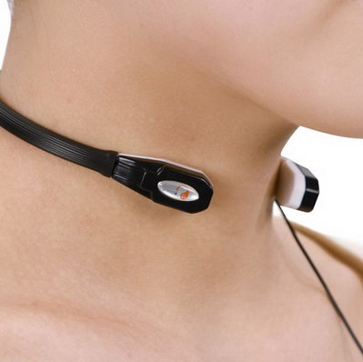

Figure 28 - Example of a laryngophone

Prices for laryngophones range from 1000 to 70 thousand. rubles and, like microphones, have a relative quality of speech recording. Obviously, the voice becomes robotic and poorly recognizable, nevertheless, there is a possibility of using a throatophone in VBAU. Figure 30 shows examples of differences in biometric parameters of two users.

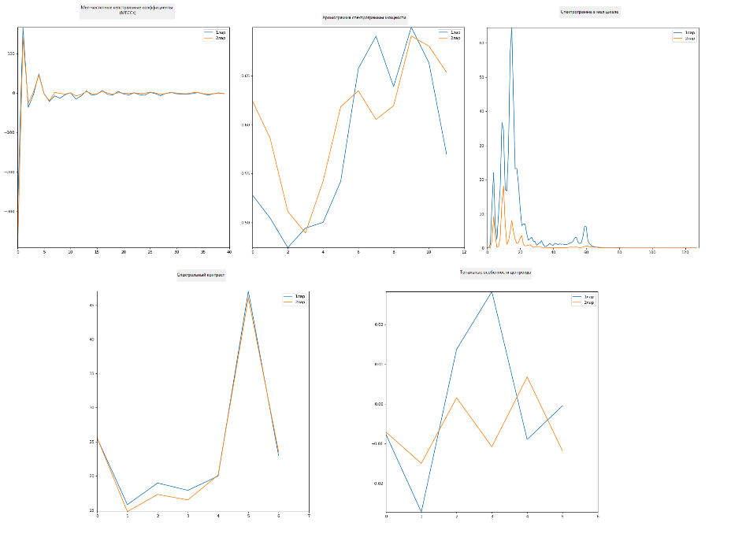

Figure 29 - Examples of differences in biometric parameters of the laryngophone

If we compare the difference between the differences between the biometric parameters of the microphone and the laryngophone, we can say that the difference is very large. However, the difference between the power chromogram, the chalk-scale spectrogram and the tonal features of the centroid is very huge. Only small differences in chalk frequency ratios and three spectral contrast ratios are visible.

The conclusion was made only on one laryngophone and perhaps on expensive analogs the differences will be more significant. If you use laryngophones in VBAU, you need to test the quality of biometric parameters and decide which parameters should be eliminated. Also, if each user has an OWN personal laryngophone, you can set separate settings on the walkie-talkie, which in turn will increase the difference in biometric parameters, since the slightest change in the amplifier leads to a complete change in the chalk frequency coefficients. However, in the described case, there is a risk of a high p2 error, provided that the walkie-talkie and laryngophone are stolen by an intruder and he also knows the password phrase.

As for the translation of speech into text, in this case it is necessary to adapt the model to the models of the laryngophone and walkie-talkies, since as a result of a little testing, the result turned out to be unsatisfactory compared to conventional microphones. Otherwise, you can limit the dictionary to 1000 words, or use fixed commands.

# **2.12 Protecting VBAU from compromising a speaker with a voice recorder**

If the attacker was able to record the voice of the announcer uttering the passphrase, there is a possibility that the attacker could hack the system by presenting the recording on a high-quality speaker. However, for this, most likely, it will be necessary to sort out a significant part of the reproducing technique with different equalizer settings, nevertheless, this case of hacking can be avoided in the following ways:

1. An additional request for the pronunciation of the speaker of random phrases on the monitor screen (captcha principle);

2. Conducting the authentication of words in a different order. In this case, an interactive change of the order of words in a passphrase and authentication of each individual word is proposed. With such a system, it is possible to construct a biometric vector of parameters for each word separately;

3. In the case of using VBAU in conjunction with face identification, use protection against dummies (user request to blink an eye, open his mouth, etc.)

**Conclusion**

Testing of the first version of VBAU showed very good results despite the fact that voice biometrics had poor security and quality indicators for a long time. Many global companies have proposed the use of voice biometrics as an auxiliary protection, however with today's methods of speech conversion, noise reduction and speech signal processing, VBAU may well be an independent authentication system. As shown in the report, there are many solutions to improve the system, depending on the conditions and objectives. The probabilities of errors of the first and second kind of the constructed system meet the requirements of neural network protection and authentication. Additional strengthening of biometric features with a passphrase increases the length of the output password tenfold (the length of the passphrase is 10-15 sec = 80 bits)

It has been proven that dependence on a passphrase can be eliminated under certain conditions both for speaker classification and for OWN / ALLIEN authentication.

Improvement of the general system can be achieved by building programs that analyze the quality of recorded images, adapting the model to certain conditions, as well as implementing methods in the C ++ language to improve the performance of programs.

**Appendix D**

**Ranges of distribution of quality of biometric parameters**

Table D.1 - Ranges of quality distribution of biometric parameters

|  |  |  |  |  |  |  |  |
| --- | --- | --- | --- | --- | --- | --- | --- |
| Номер биометриче-  ского параметра | Диапазон значений биометрического параметра | Математи-  ческое  ожидание распределения | Среднее стандартное отклонение распределения | Number of parameters[0..2] | Number of parameters[2..4] | Number of parameters[4..10] | Number of parameters>10 |
| 1 | [0.007,87.83] | 15.612 | 13.379 | 98 | 93 | 247 | 668 |
| 2 | [0.0,18.81] | 3.463 | 3.03 | 432 | 289 | 339 | 46 |
| 3 | [0.039,47.44] | 4.57 | 3.547 | 279 | 288 | 462 | 77 |
| 4 | [0.007,18.4] | 2.526 | 2.278 | 554 | 349 | 187 | 16 |
| 5 | [0.003,35.43] | 3.702 | 3.19 | 409 | 301 | 340 | 56 |
| 6 | [0.011,23.48] | 4.025 | 3.268 | 350 | 286 | 409 | 61 |
| 7 | [0.002,37.39] | 3.423 | 2.983 | 411 | 335 | 330 | 30 |
| 8 | [0.016,25.37] | 3.489 | 2.703 | 383 | 341 | 359 | 23 |
| 9 | [0.003,22.05] | 3.378 | 3.023 | 493 | 242 | 333 | 38 |
| 10 | [0.001,20.33] | 2.809 | 2.587 | 535 | 299 | 254 | 18 |
| 11 | [0.01,19.12] | 3.799 | 3.139 | 382 | 283 | 387 | 54 |
| 12 | [0.002,15.67] | 2.769 | 2.318 | 519 | 319 | 255 | 13 |
| 13 | [0.001,24.99] | 3.994 | 3.421 | 394 | 242 | 402 | 68 |
| 14 | [0.002,18.87] | 2.843 | 2.292 | 493 | 327 | 276 | 10 |
| 15 | [0.001,26.46] | 4.03 | 3.245 | 350 | 282 | 408 | 66 |
| 16 | [0.001,23.52] | 3.255 | 2.73 | 454 | 312 | 318 | 22 |
| 17 | [0.004,21.2] | 2.784 | 2.532 | 544 | 298 | 241 | 23 |
| 18 | [0.002,18.1] | 3.122 | 2.595 | 476 | 289 | 317 | 24 |
| 19 | [0.008,24.14] | 3.03 | 2.673 | 480 | 317 | 283 | 26 |
| 20 | [0.0,21.38] | 3.231 | 2.747 | 443 | 331 | 299 | 33 |
| 21 | [0.005,17.63] | 2.966 | 2.423 | 475 | 318 | 298 | 15 |
| 22 | [0.001,14.66] | 3.068 | 2.53 | 470 | 327 | 286 | 23 |
| 23 | [0.0,14.3] | 2.623 | 2.286 | 559 | 299 | 233 | 15 |
| 24 | [0.012,24.17] | 3.484 | 2.899 | 415 | 313 | 346 | 32 |
| 25 | [0.0,12.63] | 2.881 | 2.27 | 485 | 319 | 290 | 12 |
| 26 | [0.006,14.65] | 2.691 | 2.187 | 512 | 349 | 235 | 10 |
| 27 | [0.003,35.45] | 2.988 | 2.597 | 474 | 312 | 312 | 8 |
| 28 | [0.002,12.58] | 2.352 | 1.983 | 614 | 279 | 208 | 5 |
| 29 | [0.001,15.9] | 2.873 | 2.447 | 507 | 312 | 268 | 19 |
| 30 | [0.003,14.04] | 2.799 | 2.154 | 465 | 380 | 251 | 10 |
| 31 | [0.004,13.73] | 2.771 | 2.113 | 484 | 358 | 256 | 8 |
| 32 | [0.002,86.5] | 2.996 | 3.461 | 476 | 321 | 297 | 12 |
| 33 | [0.001,98.54] | 3.225 | 3.824 | 468 | 303 | 310 | 25 |
| 34 | [0.006,14.63] | 2.564 | 2.205 | 561 | 307 | 232 | 6 |
| 35 | [0.0,49.98] | 3.024 | 2.903 | 472 | 346 | 265 | 23 |
| 36 | [0.001,46.33] | 2.465 | 2.407 | 564 | 324 | 213 | 5 |
| 37 | [0.001,17.86] | 2.503 | 2.3 | 575 | 309 | 207 | 15 |
| 38 | [0.001,14.46] | 2.582 | 2.143 | 536 | 347 | 209 | 14 |
| 39 | [0.001,17.78] | 2.13 | 1.921 | 653 | 310 | 138 | 5 |
| 40 | [0.001,15.71] | 2.935 | 2.562 | 512 | 307 | 270 | 17 |
| 41 | [0.002,80.95] | 2.367 | 3.136 | 621 | 295 | 182 | 8 |
| 42 | [0.0,18.44] | 2.231 | 2.08 | 653 | 273 | 172 | 8 |
| 43 | [0.001,13.14] | 2.153 | 1.928 | 644 | 312 | 145 | 5 |
| 44 | [0.001,53.42] | 2.077 | 2.331 | 657 | 314 | 131 | 4 |
| 45 | [0.008,36.98] | 2.093 | 2.069 | 655 | 292 | 156 | 3 |
| 46 | [0.001,12.16] | 2.238 | 1.941 | 613 | 292 | 197 | 4 |
| 47 | [0.007,16.73] | 2.199 | 1.92 | 634 | 310 | 159 | 3 |
| 48 | [0.002,24.69] | 2.376 | 2.072 | 600 | 299 | 203 | 4 |
| 49 | [0.004,12.22] | 2.133 | 1.98 | 658 | 285 | 155 | 8 |
| 50 | [0.007,12.49] | 1.86 | 1.967 | 757 | 219 | 123 | 7 |
| 51 | [0.004,12.94] | 2.278 | 2.201 | 670 | 234 | 194 | 8 |
| 52 | [0.002,28.94] | 2.585 | 2.255 | 538 | 339 | 220 | 9 |
| 53 | [0.0,99.85] | 17.021 | 23.241 | 321 | 129 | 209 | 447 |
| 54 | [0.008,99.96] | 12.839 | 20.569 | 388 | 182 | 222 | 314 |
| 55 | [0.003,98.36] | 9.229 | 14.882 | 278 | 239 | 351 | 238 |
| 56 | [0.007,98.89] | 8.7 | 15.404 | 337 | 259 | 308 | 202 |
| 57 | [0.012,96.67] | 6.792 | 13.139 | 353 | 357 | 264 | 132 |
| 58 | [0.003,83.15] | 4.292 | 6.502 | 414 | 334 | 277 | 81 |
| 59 | [0.005,88.46] | 3.662 | 6.143 | 440 | 338 | 294 | 34 |
| 60 | [0.003,61.88] | 3.349 | 4.152 | 460 | 318 | 295 | 33 |
| 61 | [0.021,95.82] | 3.227 | 4.418 | 462 | 363 | 248 | 33 |
| 62 | [0.036,66.66] | 3.361 | 4.837 | 462 | 367 | 249 | 28 |
| 63 | [0.009,79.82] | 3.79 | 6.398 | 405 | 400 | 262 | 39 |
| 64 | [0.008,96.51] | 4.06 | 8.051 | 458 | 366 | 219 | 63 |
| 65 | [0.015,96.71] | 4.128 | 8.004 | 491 | 368 | 167 | 80 |
| 66 | [0.0,98.45] | 4.566 | 9.616 | 484 | 368 | 175 | 79 |
| 67 | [0.001,99.95] | 4.758 | 10.626 | 443 | 426 | 163 | 74 |
| 68 | [0.01,94.7] | 4.248 | 9.325 | 484 | 397 | 159 | 66 |
| 69 | [0.008,90.62] | 3.755 | 7.706 | 507 | 405 | 130 | 64 |
| 70 | [0.006,99.11] | 3.663 | 8.071 | 587 | 347 | 107 | 65 |
| 71 | [0.001,91.08] | 3.212 | 7.481 | 663 | 300 | 90 | 53 |
| 72 | [0.009,99.81] | 3.227 | 7.577 | 688 | 281 | 77 | 60 |
| 73 | [0.006,99.18] | 3.359 | 8.296 | 737 | 225 | 79 | 65 |
| 74 | [0.006,98.36] | 3.815 | 9.954 | 745 | 196 | 86 | 79 |
| 75 | [0.012,95.89] | 4.358 | 10.263 | 738 | 157 | 99 | 112 |
| 76 | [0.0,91.4] | 4.818 | 10.729 | 710 | 160 | 97 | 139 |
| 77 | [0.002,99.4] | 5.333 | 11.766 | 690 | 164 | 105 | 147 |
| 78 | [0.002,92.29] | 6.242 | 13.408 | 668 | 164 | 106 | 168 |
| 79 | [0.007,98.45] | 6.445 | 13.024 | 631 | 170 | 126 | 179 |
| 80 | [0.003,77.29] | 5.26 | 10.0 | 639 | 176 | 141 | 150 |
| 81 | [0.001,98.36] | 4.528 | 9.014 | 642 | 202 | 132 | 130 |
| 82 | [0.004,94.6] | 4.086 | 8.664 | 671 | 205 | 123 | 107 |
| 83 | [0.002,94.26] | 3.876 | 8.465 | 681 | 213 | 118 | 94 |
| 84 | [0.001,81.69] | 4.117 | 9.086 | 699 | 183 | 128 | 96 |
| 85 | [0.005,90.09] | 4.329 | 9.338 | 680 | 180 | 136 | 110 |
| 86 | [0.002,97.57] | 4.468 | 9.062 | 671 | 179 | 129 | 127 |
| 87 | [0.002,93.68] | 4.657 | 9.368 | 648 | 179 | 158 | 121 |
| 88 | [0.0,90.62] | 4.914 | 9.059 | 646 | 156 | 156 | 148 |
| 89 | [0.009,91.02] | 5.609 | 10.202 | 620 | 149 | 164 | 173 |
| 90 | [0.001,68.25] | 6.088 | 9.681 | 559 | 153 | 194 | 200 |
| 91 | [0.001,81.91] | 5.95 | 9.6 | 566 | 156 | 180 | 204 |
| 92 | [0.012,73.91] | 5.448 | 9.11 | 574 | 180 | 171 | 181 |
| 93 | [0.001,72.43] | 4.838 | 8.293 | 616 | 155 | 193 | 142 |
| 94 | [0.001,85.05] | 4.929 | 9.006 | 626 | 169 | 169 | 142 |
| 95 | [0.003,94.15] | 4.647 | 9.019 | 641 | 192 | 134 | 139 |
| 96 | [0.006,95.59] | 4.81 | 9.959 | 655 | 171 | 143 | 137 |
| 97 | [0.001,81.78] | 4.5 | 8.816 | 653 | 186 | 141 | 126 |
| 98 | [0.0,81.03] | 4.132 | 7.914 | 678 | 172 | 137 | 119 |
| 99 | [0.0,87.43] | 3.807 | 7.363 | 688 | 184 | 128 | 106 |
| 100 | [0.002,91.18] | 3.937 | 8.492 | 689 | 191 | 122 | 104 |
| 101 | [0.0,88.35] | 3.587 | 7.271 | 679 | 206 | 133 | 88 |
| 102 | [0.007,66.19] | 3.274 | 5.705 | 701 | 187 | 135 | 83 |
| 103 | [0.0,58.35] | 3.015 | 5.272 | 721 | 194 | 114 | 77 |
| 104 | [0.002,50.4] | 2.718 | 4.367 | 745 | 175 | 124 | 62 |
| 105 | [0.003,52.59] | 2.386 | 3.885 | 788 | 162 | 112 | 44 |
| 106 | [0.004,33.3] | 1.924 | 2.604 | 825 | 176 | 74 | 31 |
| 107 | [0.002,33.43] | 1.731 | 2.436 | 857 | 169 | 59 | 21 |
| 108 | [0.0,21.55] | 1.628 | 1.975 | 853 | 183 | 57 | 13 |
| 109 | [0.001,30.57] | 1.686 | 2.037 | 840 | 195 | 60 | 11 |
| 110 | [0.002,46.2] | 1.822 | 2.766 | 815 | 228 | 45 | 18 |
| 111 | [0.002,54.65] | 1.956 | 3.518 | 796 | 240 | 49 | 21 |
| 112 | [0.001,46.55] | 1.994 | 3.345 | 782 | 247 | 52 | 25 |
| 113 | [0.001,66.04] | 2.073 | 3.684 | 762 | 266 | 56 | 22 |
| 114 | [0.002,56.1] | 2.152 | 3.74 | 754 | 260 | 61 | 31 |
| 115 | [0.011,60.11] | 2.124 | 3.826 | 768 | 243 | 73 | 22 |
| 116 | [0.006,84.15] | 2.142 | 4.63 | 756 | 263 | 68 | 19 |
| 117 | [0.0,96.45] | 2.023 | 4.445 | 739 | 298 | 54 | 15 |
| 118 | [0.001,58.15] | 1.942 | 2.863 | 755 | 273 | 67 | 11 |
| 119 | [0.001,42.62] | 1.965 | 2.672 | 733 | 301 | 52 | 20 |
| 120 | [0.003,49.06] | 2.019 | 2.691 | 706 | 325 | 62 | 13 |
| 121 | [0.006,32.75] | 1.977 | 2.035 | 693 | 326 | 77 | 10 |
| 122 | [0.001,34.44] | 1.923 | 2.139 | 703 | 334 | 59 | 10 |
| 123 | [0.0,58.82] | 1.97 | 2.503 | 700 | 332 | 65 | 9 |
| 124 | [0.015,69.41] | 1.977 | 2.844 | 701 | 331 | 59 | 15 |
| 125 | [0.001,39.79] | 1.991 | 2.526 | 711 | 314 | 66 | 15 |
| 126 | [0.002,44.62] | 2.048 | 3.047 | 734 | 296 | 56 | 20 |
| 127 | [0.001,41.58] | 2.081 | 3.046 | 741 | 281 | 58 | 26 |
| 128 | [0.003,35.27] | 2.288 | 3.344 | 744 | 245 | 76 | 41 |
| 129 | [0.001,42.41] | 2.531 | 4.238 | 779 | 165 | 115 | 47 |
| 130 | [0.003,40.43] | 2.641 | 4.407 | 762 | 193 | 85 | 66 |
| 131 | [0.0,27.65] | 2.28 | 3.148 | 745 | 231 | 88 | 42 |
| 132 | [0.001,40.46] | 1.944 | 2.478 | 767 | 259 | 62 | 18 |
| 133 | [0.01,30.72] | 1.816 | 1.792 | 771 | 262 | 67 | 6 |
| 134 | [0.007,38.16] | 1.874 | 2.039 | 767 | 270 | 61 | 8 |
| 135 | [0.004,57.45] | 1.883 | 2.227 | 735 | 308 | 58 | 5 |
| 136 | [0.002,19.86] | 1.836 | 1.547 | 736 | 309 | 55 | 6 |
| 137 | [0.002,28.05] | 1.84 | 1.704 | 733 | 305 | 63 | 5 |
| 138 | [0.009,12.25] | 1.799 | 1.331 | 724 | 326 | 52 | 4 |
| 139 | [0.01,89.21] | 1.987 | 3.39 | 715 | 325 | 60 | 6 |
| 140 | [0.001,38.17] | 1.952 | 1.942 | 681 | 376 | 39 | 10 |
| 141 | [0.001,18.71] | 1.945 | 1.535 | 658 | 401 | 41 | 6 |
| 142 | [0.006,33.28] | 2.07 | 2.104 | 644 | 392 | 60 | 10 |
| 143 | [0.001,42.6] | 2.152 | 2.305 | 602 | 435 | 57 | 12 |
| 144 | [0.004,36.94] | 2.365 | 3.154 | 605 | 416 | 62 | 23 |
| 145 | [0.007,41.97] | 2.611 | 3.874 | 602 | 394 | 72 | 38 |
| 146 | [0.001,77.44] | 2.586 | 4.228 | 636 | 360 | 73 | 37 |
| 147 | [0.002,66.7] | 2.611 | 4.775 | 665 | 324 | 82 | 35 |
| 148 | [0.008,92.0] | 2.729 | 5.765 | 671 | 311 | 83 | 41 |
| 149 | [0.012,86.21] | 2.809 | 5.944 | 672 | 295 | 95 | 44 |
| 150 | [0.017,74.99] | 2.854 | 4.979 | 653 | 303 | 98 | 52 |
| 151 | [0.008,73.2] | 3.159 | 5.801 | 619 | 315 | 115 | 57 |
| 152 | [0.001,76.57] | 3.191 | 5.884 | 615 | 321 | 104 | 66 |
| 153 | [0.005,79.75] | 3.434 | 6.618 | 631 | 293 | 106 | 76 |
| 154 | [0.008,97.16] | 3.998 | 8.2 | 632 | 268 | 108 | 98 |
| 155 | [0.001,91.92] | 4.768 | 10.346 | 597 | 272 | 124 | 112 |
| 156 | [0.001,93.36] | 4.645 | 9.845 | 611 | 263 | 112 | 119 |
| 157 | [0.007,97.15] | 4.271 | 8.886 | 619 | 281 | 103 | 102 |
| 158 | [0.003,98.97] | 4.401 | 8.601 | 599 | 287 | 107 | 111 |
| 159 | [0.001,84.8] | 4.994 | 9.919 | 566 | 287 | 126 | 125 |
| 160 | [0.0,98.41] | 5.156 | 10.61 | 565 | 281 | 141 | 116 |
| 161 | [0.004,90.89] | 3.763 | 7.46 | 568 | 332 | 132 | 71 |
| 162 | [0.004,61.32] | 2.79 | 4.729 | 639 | 333 | 84 | 47 |
| 163 | [0.003,59.5] | 2.576 | 4.175 | 642 | 338 | 83 | 40 |
| 164 | [0.002,38.54] | 2.364 | 3.068 | 643 | 354 | 80 | 26 |
| 165 | [0.004,88.57] | 2.355 | 4.078 | 650 | 375 | 54 | 24 |
| 166 | [0.015,90.39] | 2.371 | 4.493 | 669 | 366 | 46 | 21 |
| 167 | [0.002,73.18] | 2.491 | 4.92 | 671 | 362 | 39 | 30 |
| 168 | [0.009,98.08] | 2.833 | 7.917 | 748 | 286 | 24 | 43 |
| 169 | [0.003,99.68] | 2.707 | 9.461 | 926 | 109 | 16 | 48 |
| 170 | [0.002,99.47] | 2.973 | 10.431 | 927 | 97 | 21 | 54 |
| 171 | [0.008,96.51] | 3.044 | 10.801 | 936 | 89 | 20 | 54 |
| 172 | [0.005,97.29] | 2.972 | 10.372 | 935 | 83 | 25 | 56 |
| 173 | [0.0,95.22] | 2.656 | 9.343 | 939 | 82 | 31 | 47 |
| 174 | [0.003,93.19] | 2.347 | 8.213 | 944 | 85 | 29 | 41 |
| 175 | [0.0,83.5] | 2.227 | 6.806 | 936 | 82 | 30 | 48 |
| 176 | [0.003,82.64] | 2.031 | 6.053 | 948 | 71 | 38 | 38 |
| 177 | [0.002,89.84] | 2.188 | 6.778 | 927 | 79 | 46 | 43 |
| 178 | [0.001,95.05] | 2.302 | 6.983 | 911 | 85 | 55 | 44 |
| 179 | [0.001,94.03] | 2.234 | 6.603 | 882 | 94 | 83 | 35 |
| 180 | [0.005,96.67] | 2.789 | 6.661 | 818 | 85 | 121 | 69 |
| 181 | [0.002,34.43] | 3.676 | 3.991 | 460 | 297 | 257 | 79 |
| 182 | [0.006,13.84] | 2.583 | 2.227 | 536 | 343 | 197 | 15 |
| 183 | [0.002,16.65] | 2.721 | 2.406 | 530 | 320 | 220 | 18 |
| 184 | [0.004,19.51] | 2.573 | 2.467 | 557 | 309 | 191 | 22 |
| 185 | [0.001,78.04] | 2.946 | 3.33 | 484 | 324 | 245 | 17 |
| 186 | [0.006,18.24] | 3.272 | 2.9 | 456 | 289 | 284 | 34 |
| 187 | [0.001,17.74] | 3.649 | 3.369 | 459 | 207 | 319 | 66 |
| 188 | [0.002,9.56] | 0.744 | 0.76 | 959 | 73 | 3 | 0 |
| 189 | [0.007,5.44] | 1.293 | 0.811 | 844 | 175 | 6 | 0 |
| 190 | [0.001,6.92] | 1.464 | 1.159 | 749 | 199 | 41 | 0 |
| 191 | [0.006,5.83] | 1.267 | 0.869 | 769 | 180 | 6 | 0 |
| 192 | [0.0,4.46] | 0.912 | 0.668 | 837 | 58 | 2 | 0 |
| 193 | [0.0,27.14] | 1.639 | 2.757 | 625 | 80 | 37 | 19 |

Appendix D

Table E.1 - Values of weighted Euclidean distances relative to users.

Test Pattern Distance Values Range

|  |  |  |
| --- | --- | --- |
| Phrase 1. Microphone1. User 1 OWN | 17.5 15.2 14.2 11.3 13.7 11.3 10.9 13.7 18.2 14.5 15.1 11.9 12.4 15.7 12.5 12.2 12.1 15.0 | [10.86,18.16] |
| User2 (ALLIEN) | 3309.4 671.1 866.0 554.6 706.0 987.0 479.6 607.6 651.1 119.9 246.1 444.6 428.8 471.4 255.5 1004.4 195.4 113.6 | [113.6,3309.41] |
| User 3 (ALLIEN) | 5383.8 7268.7 7199.1 5967.3 7613.6 8070.8 5614.6 6384.4 6522.3 7075.8 6288.7 5848.6 5844.7 6202.3 5441.8 5651.1 11820.0 6635.1 5280.5 7650.4 | [5280.51,  11819.95] |
| User4 (ALLIEN) | 4274.5 7286.1 15605.1 16222.3 12435.8 15152.4 14436.2 14039.1 12062.6 11102.5 13966.4 11560.4 9586.8 12970.5 10548.8 10665.1 11143.2 9953.0 9203.6 | [4274.46,  16222.28] |
| User5 (ALLIEN) | 2936.1 3693.4 6473.0 6775.3 3740.5 3539.3 7980.8 4575.5 5392.2 3516.1 5902.8 4531.1 1526.6 3059.4 3993.9 5161.5 3094.7 4573.8 4790.0 8373.0 | [1526.6,  8373.02] |
| User6 (ALLIEN) | 99.8 105.5 146.0 118.3 9836.4 692.7 148.2 237.7 183.8 155.6 228.7 130.7 133.1 3624.1 92.9 96.0 85.7 97.7 | [85.73,  9836.41] |
| User7 (ALLIEN) | 4667.7 7833.7 6597.7 8561.2 9742.4 16926.4 7817.3 7707.9 8817.0 8392.2 8810.1 5410.8 9605.3 8331.0 4578.6 5543.5 6928.2 7700.4 8465.4 9350.3 | [4578.56,  16926.42] |
| User8 (ALLIEN) | 390.3 368.8 527.3 564.5 487.1 466.3 404.1 389.1 336.6 1265.2 294.2 307.9 272.8 398.9 369.7 430.5 499.2 448.2 407.0 371.9 | [272.84,  1265.22] |
| User9 (ALLIEN) | 1786.7 517.3 792.0 1000.8 979.2 1169.0 475.2 534.8 1357.3 1179.2 893.6 1731.2 936.1 2278.6 1517.9 1785.0 2186.2 819.8 1012.9 1174.2 | [475.19,  2278.62] |
| User10 (ALLIEN) | 2693.1 47.1 52.0 49.0 43.7 53.6 78.7 58.5 50.7 72.9 86.7 84.1 63.8 116.6 59.2 55.6 66.9 76.3 54.2 59.2 | [43.75,  2693.07] |
| User11 (ALLIEN) | 5755.0 4949.5 5798.7 4693.2 4808.0 5145.0 5102.1 4822.5 5188.8 6631.9 6041.5 4843.2 4987.1 4389.2 4400.2 3777.6 4734.2 3653.3 3622.0 4328.8 | [3622.0,  6631.93] |
| User12 (ALLIEN) | 150.1 296.9 295.3 251.9 324.0 311.5 415.7 284.7 326.3 308.3 256.2 191.8 332.2 185.6 178.8 222.2 194.6 224.9 284.9 276.7 | [150.12,  415.68] |
| User13 (ALLIEN) | 247.2 337.2 322.1 437.5 447.0 287.6 346.9 323.3 313.5 343.8 373.9 270.8 306.0 417.6 413.1 343.2 371.6 515.8 391.3 409.6 | [247.15,  515.83] |
| User14 (ALLIEN) | 1356.6 1501.3 1136.2 939.2 1042.9 1372.5 1397.3 1215.2 1164.1 925.3 1015.7 1428.6 902.8 1459.9 1493.2 1750.2 1972.5 1642.3 1354.3 1560.6 | [902.77,  1972.47] |
| User15 (ALLIEN) | 600.1 250274.5 1124.3 13241.1 3734.4 1175.0 176.5 8290.4 205.2 166.5 9224.6 954.4 204.7 5905.4 302.2 3659.8 492.8 272.6 239.3 1121.9 | [166.48,  250274.47] |
| User16 (ALLIEN) | 667.1 4875.8 497.4 4535.1 359.3 731.4 19568.0 185.2 260.1 1913.4 995.0 181.0 192.6 3503.3 688.0 3793.3 507.3 297.8 1994.0 201.2 | [181.04,  19568.04] |
| Тестовый образ | Значения расстояний | Диапазон |
| Phrase 2. Microphone1. User 1 OWN | 20.2 15.4 12.3 10.6 12.3 12.1 9.9 15.7 13.6 | [9.88,  20.24] |
| User2 (ALLIEN) | 264.5 659.7 552.0 392.2 555.5 1801.2 546.9 477.1 240.0 298.6 750.9 177.1 239.4 522.3 333.6 149.1 183.8 127.0 306.0 215.1 | [127.03,  1801.19] |
| User 3 (ALLIEN) | 6701.4 6473.6 9033.8 7010.6 5591.3 6713.5 4709.3 4620.1 3792.6 3380.5 6596.1 5190.6 4503.3 5423.7 4699.9 4677.5 4707.4 4471.8 4649.6 5266.7 | [3380.46,  9033.84] |
| User4 (ALLIEN) | 15399.5 16216.6 16633.8 20147.9 17554.1 16170.3 20696.7 12923.4 12942.0 14313.4 19377.6 16126.5 16504.6 16172.3 18193.0 16484.7 20064.8 20221.9 18358.4 17893.0 | [12923.41,  20696.7] |
| User5 (ALLIEN) | 2986.8 9462.4 5380.1 13773.2 6830.0 8197.0 5201.1 5257.7 5366.5 3618.6 8378.1 8555.9 13053.6 7112.5 11939.7 7062.2 9621.5 6227.6 8930.1 6150.2 | [2986.78,  13773.17] |
| User6 (ALLIEN) | 124.5 107.4 99.8 125.7 115.3 105.6 100.8 128.4 140.7 102.3 91.1 113.0 121.9 100.4 150.8 142.3 139.9 128.9 113.8 85.8 | [85.77,  150.82] |
| User7 (ALLIEN) | 11380.4 8701.1 8420.6 8830.3 9781.7 7763.0 9594.4 8929.8 7968.6 6948.3 8769.5 11650.4 8764.2 12326.8 11854.7 10119.0 9813.4 8794.1 9544.0 8387.9 | [6948.26,  12326.76] |
| User8 (ALLIEN) | 287.0 593.1 108.8 161.2 467.0 288.5 366.7 219.9 184.7 191.2 167.8 101.7 167.9 138.6 201.6 165.0 152.3 133.5 435.5 428.9 | [101.71,  593.09] |
| User9 (ALLIEN) | 1280.8 1241.6 1168.1 1104.8 1267.0 1656.6 1400.9 1160.7 1183.9 655.3 842.2 1865.1 1403.1 1758.7 1672.0 1707.3 1570.1 1615.5 1896.3 590.2 | [590.2,  1896.3] |
| User10 (ALLIEN) | 69.4 141.7 122.1 85.9 97.2 2738.3 166.1 620.4 870.6 1835.2 988.6 81.9 495.6 95.1 98.6 117.2 112.1 123.7 120.9 192.1 | [69.39,  2738.3] |
| User11 (ALLIEN) | 6221.9 8661.7 8753.9 10495.2 9931.2 11701.1 12109.8 9284.1 9194.4 9813.0 9593.2 8160.2 8644.8 8286.4 8618.6 8161.6 9131.8 8643.6 8522.4 8120.5 | [6221.85,  12109.75] |
| User12 (ALLIEN) | 409.8 471.0 468.5 485.7 442.9 547.5 598.2 743.7 663.0 594.8 490.1 416.7 492.1 526.5 411.6 550.6 422.7 548.1 565.8 650.2 | [409.81,  743.74] |
| User13 (ALLIEN) | 358.9 435.8 386.7 380.2 513.8 673.2 993.8 738.7 671.9 441.9 692.6 525.5 539.5 623.0 619.2 766.3 393.3 630.5 648.4 724.8 | [358.88,  993.84] |
| User14 (ALLIEN) | 1204.2 906.5 1002.1 1373.4 1212.7 1664.8 1483.8 1170.2 1099.1 979.5 1427.2 1203.2 1624.7 1179.5 1138.8 1264.1 984.4 1486.9 1108.6 1887.0 | [906.46,  1886.97] |
| User15 (ALLIEN) | 283.0 317.1 192.1 232.9 292.8 376.8 272.3 228.0 249.2 218.8 189.2 232.6 147.0 308.1 242.1 282.0 215.3 196.1 338.7 369.1 | [147.0,  376.84] |
| User16 (ALLIEN) | 83.5 69.4 73.0 70.2 74.4 78.5 112.0 65.2 78.9 90.4 62.2 67.2 63.7 65.0 84.0 68.6 74.5 70.6 75.2 90.4 | [62.2,  112.02] |
| User17 (ALLIEN) | 20.2 15.4 12.3 10.6 12.3 12.1 9.9 15.7 13.6 | [9.88,  20.24] |
| Тестовый образ | Значения расстояний | Диапазон |
| Phrase 3. Microphone1. User 1 OWN | 24.2 19.4 13.6 15.7 13.0 10.2 11.1 10.0 9.7 11.1 9.6 14.1 10.3 13.6 11.2 19.4 12.0 10.0 15.3 | [9.64,24.2] |
| User2 (ALLIEN) | 150.2 478.1 189.4 987.9 513.4 338.0 595.5 284.8 160.8 166.7 189.8 475.5 92.1 415.5 651.9 296.5 553.3 346.3 731.9 1500.7 | [92.07,  1500.69] |
| User 3 (ALLIEN) | 6292.8 5981.8 6882.9 7470.9 7865.8 9865.7 9724.9 9471.3 10525.2 9558.7 7446.5 7951.4 10781.7 11936.6 10761.7 13123.7 10973.5 10759.8 8664.6 10145.8 | [5981.82,  13123.68] |
| User4 (ALLIEN) | 15047.2 20165.5 16346.2 15075.9 20793.0 19662.5 21249.4 22706.3 21859.7 23630.0 20118.8 23594.8 23879.6 24369.1 19900.2 21968.2 21018.8 21094.1 26335.9 28435.3 | [15047.19,  28435.33] |
| User5 (ALLIEN) | 6028.3 9345.0 6724.4 14869.1 5194.1 12871.8 6145.2 16115.7 8337.6 7333.9 18221.0 6455.3 13808.8 18807.6 13892.5 21841.9 14404.8 11225.9 28189.4 | [5194.13,  28189.4] |
| User6 (ALLIEN) | 95.9 147.8 181.8 144.4 183.3 169.2 145.7 169.9 160.2 278.2 160.8 103.9 156.1 140.6 130.6 207.8 161.2 154.8 108.4 130.6 | [95.87,  278.18] |
| User7 (ALLIEN) | 11312.2 10494.7 9865.3 13882.3 11809.0 12545.8 12653.9 12254.4 16932.3 13175.8 14133.0 11068.9 7233.3 10266.1 10853.0 11948.9 11299.5 10526.3 11494.2 11830.3 | [7233.25,  16932.28] |
| User8 (ALLIEN) | 324.2 242.7 245.8 254.2 287.7 232.6 286.5 399.2 278.9 239.2 243.7 312.5 257.0 463.0 354.2 4577.0 281.4 274.5 272.6 299.4 | [232.57,  4577.04] |
| User9 (ALLIEN) | 657.1 238.7 2903.1 1386.7 865.4 3003.0 2775.9 1169.3 398.8 445.6 936.2 1086.3 1096.7 403.9 853.9 2840.4 3468.1 788.4 862.5 3703.7 | [238.72,  3703.67] |
| User10 (ALLIEN) | 174.3 694.8 267.0 1133.5 490.2 372.1 1600.3 1004.7 509.1 373.9 312.4 195.1 840.4 76.8 146.1 327.1 236.2 191.1 845.7 1662.0 | [76.77,  1662.0] |
| User11 (ALLIEN) | 6952.3 7795.9 9364.4 9183.7 10908.5 11238.4 13897.6 14087.6 11196.7 8954.5 10288.3 7874.6 8969.0 7488.8 9006.4 5773.1 6781.8 6722.8 6212.2 9046.3 | [5773.12,  14087.65] |
| User12 (ALLIEN) | 145.4 219.6 174.2 190.7 153.5 189.7 210.8 129.2 167.4 185.4 165.4 186.4 136.5 171.3 180.6 162.9 148.2 204.4 221.7 169.7 | [129.25,  221.7] |
| User13 (ALLIEN) | 344.3 311.8 418.6 306.5 467.9 357.1 673.3 636.7 470.5 400.0 406.6 381.4 323.0 452.9 378.8 412.9 543.9 395.0 419.4 251.9 | [251.85,  673.34] |
| User14 (ALLIEN) | 1057.9 1254.9 1341.8 994.8 1125.2 1386.1 1371.4 1328.1 918.8 951.7 920.8 1692.4 1088.6 1591.2 1525.2 1485.6 1425.3 807.5 990.3 707.4 | [707.42,  1692.43] |
| User15 (ALLIEN) | 234.7 261.2 232.2 228.7 191.5 217.8 203.3 276.4 253.5 309.4 272.4 213.3 266.3 182.3 306.6 202.9 214.7 221.3 224.7 236.2 | [182.28,  309.43] |
| User16 (ALLIEN) | 273.1 87.9 79.3 62.2 81.1 83.5 91.9 85.7 95.8 84.8 460.2 126.2 83.3 111.1 163.3 95.7 90.6 80.5 596.1 99.2 | [62.24,  596.1] |
| Тестовый образ | Значения расстояний | Диапазон |
| Phrase 4. Microphone1. User 1 OWN | 13.7 14.3 12.1 11.4 12.5 13.9 13.3 18.7 12.0 9.1 10.0 11.2 10.7 17.8 23.5 14.3 12.8 11.1 | [9.09,  23.55] |
| User2 (ALLIEN) | 398.5 85.7 123.3 107.2 94.4 66.5 117.9 49.7 106.3 59.3 104.7 142.9 56.3 96.9 54.2 66.7 89.3 72.4 175.0 56.0 | [49.71,  398.46] |
| User 3 (ALLIEN) | 732.3 765.6 783.1 790.9 843.0 699.0 809.1 907.4 694.0 787.0 773.8 728.5 799.8 710.3 710.7 847.0 1023.0 831.7 1000.3 925.6 | [693.96,  1023.05] |
| User4 (ALLIEN) | 940.4 1040.7 1031.6 1304.1 1091.2 1391.8 1344.0 1400.6 1392.6 1667.0 1414.9 1261.6 1430.1 1465.7 1555.8 1642.0 1389.7 1832.8 1999.9 1666.5 | [940.36,  1999.87] |
| User5 (ALLIEN) | 494.1 677.1 1479.4 767.1 837.7 1055.6 686.1 630.1 920.4 514.2 848.6 1674.3 961.8 1008.5 810.1 839.3 1262.0 1505.4 740.5 1322.4 | [494.12,  1674.28] |
| User6 (ALLIEN) | 63.4 111.0 66.0 146.1 52.6 96.5 50.3 142.1 132.6 56.9 90.1 165.8 68.9 117.2 68.4 136.6 150.8 75.8 112.8 159.1 | [50.35,  165.78] |
| User7 (ALLIEN) | 1172.5 984.0 909.1 1026.5 917.0 788.3 992.8 875.8 749.6 753.1 806.9 838.0 802.3 821.3 798.3 793.1 696.1 1077.5 1024.6 904.7 | [696.1,  1172.55] |
| User8 (ALLIEN) | 133.4 1731.3 131.5 157.6 138.0 150.3 129.3 131.6 152.0 158.3 240.9 157.8 136.9 142.4 130.3 135.5 118.5 120.8 115.5 114.9 | [114.91,  1731.27] |
| User9 (ALLIEN) | 276.4 146.8 102.5 114.5 224.0 170.1 152.5 367.1 203.8 202.3 52.0 204.3 117.7 120.0 218.9 210.8 228.2 167.7 189.3 263.0 | [51.96,  367.12] |
| User10 (ALLIEN) | 67.4 64.5 69.1 64.3 129.2 83.2 95.5 89.2 60.9 86.3 156.0 392.9 67.1 59.7 97.6 87.3 84.0 99.4 67.5 120.1 | [59.74,  392.91] |
| User11 (ALLIEN) | 479.2 1083.3 1394.7 1095.4 1233.6 799.1 1024.5 1049.1 1455.2 961.1 1128.8 508.4 873.6 607.3 809.9 915.1 688.1 936.4 929.3 974.2 | [479.21,  1455.21] |
| User12 (ALLIEN) | 92.5 107.7 142.9 163.6 187.8 131.7 89.9 91.3 174.0 113.9 114.2 62.5 148.4 112.5 102.8 120.7 131.7 103.0 118.0 148.9 | [62.45,  187.78] |
| User13 (ALLIEN) | 78.5 79.7 76.9 75.3 79.1 78.6 99.6 62.9 111.0 63.3 100.2 82.2 94.9 141.5 115.2 76.2 98.3 109.6 71.1 95.1 | [62.92,  141.54] |
| User14 (ALLIEN) | 123.8 142.6 145.9 166.0 116.9 117.1 132.4 129.4 131.7 112.4 137.8 133.8 122.6 131.8 139.6 143.5 134.2 161.3 119.0 144.7 | [112.36,  165.98] |
| User15 (ALLIEN) | 127.6 900.5 173.5 367.6 214.8 211.0 572.1 116.9 176.4 1934.0 156.4 141.3 130.5 180.8 186.6 162.8 150.9 136.3 160.4 324.9 | [116.94,  1933.97] |
| User16 (ALLIEN) | 103.7 76.4 83.2 88.8 81.7 91.9 85.6 94.2 95.7 82.1 94.7 81.4 83.6 76.8 80.8 76.0 73.0 77.0 90.8 73.3 | [73.03,  103.69] |
| Тестовый образ | Значения расстояний | Диапазон |
| Phrase 5. Microphone1. User 1 OWN | 23.4 13.4 13.3 15.9 12.0 13.0 11.7 15.3 12.8 11.8 13.1 16.4 14.3 12.1 10.9 11.5 12.0 13.1 14.5 12.2 | [10.91,  23.36] |
| User2 (ALLIEN) | 150.2 86.3 112.0 71.2 109.9 184.3 217.9 73.5 157.6 212.8 391.7 88590.6 413.0 114.9 117.7 124.9 323.9 241.6 137.0 359.6 | [71.18,  88590.65] |
| User 3 (ALLIEN) | 24540.2 1037.5 999.4 1121.2 1294.0 1298.5 1011.2 1196.7 1006.7 1619.0 980.6 1266.1 1032.0 942.3 1157.6 990.6 1395.3 1274.8 1272.0 877.8 | [877.83,  24540.22] |
| User4 (ALLIEN) | 2970.5 5130.2 4270.0 365637.6 5214.2 5657.3 6252.5 75379.9 5893.2 5339.3 5166.4 4930.2 115519.5 38899.9 4479.7 24791.8 2572391.6 14224.3 6913.6 9275.5 | [2970.55,  2572391.64] |
| User5 (ALLIEN) | 1659.1 1587.1 2616.3 3206.9 3018.7 1802.6 1262.9 1551.0 2100.7 1532.2 1861.4 2051.7 1128.5 2486.7 2319.1 3834.9 1577.1 1480.0 1635.1 3192.3 | [1128.53,  3834.91] |
| User6 (ALLIEN) | 389.9 96.2 87.4 132.0 109.3 128.3 157.9 87.2 183.7 110.9 108.5 87.2 133.0 140.1 104.9 122.4 165.8 143.7 89.2 395.9 | [87.18,  395.94] |
| User7 (ALLIEN) | 1639.5 2464.6 1405.2 1141.2 1326.3 1329.0 1402.5 1441.5 2999.7 1349.3 1340.9 1503.0 1368.6 1514.1 1519.9 1560.7 1255.5 1404.1 1369.0 1387.0 | [1141.22,  2999.7] |
| User8 (ALLIEN) | 255.5 167.5 176.8 157.0 194.8 169.1 160.0 184.9 127.9 237.9 275.8 174.8 24326.6 191.4 173.4 111.9 124.7 215.3 135.4 344.2 | [111.86,  24326.62] |
| User9 (ALLIEN) | 236.8 245.0 111.5 749.1 90.8 159.4 170.6 191.3 516.0 111.7 261.2 204.7 460.3 281.4 296.4 161.9 218.9 336.1 283.6 287.0 | [90.82,  749.12] |
| User10 (ALLIEN) | 92.9 101.1 83.7 74.5 107.6 89.1 66.1 80.8 72.9 422.6 156.6 151.0 68.7 280.8 234.9 59.5 81.9 96.7 1278.2 341.4 | [59.47,  1278.2] |
| User11 (ALLIEN) | 985.5 1334.0 1162.1 1108.2 1319.3 1275.5 1585.7 1291.3 1691.9 1449.5 1488.3 1426.7 1356.0 1402.9 1351.7 1535.9 1214.5 1209.9 991.9 1287.8 | [985.46,  1691.88] |
| User12 (ALLIEN) | 126.4 66.7 75.6 79.9 127.4 71.7 86.1 78.0 76.7 88.2 105.0 112.7 681.8 105.2 106.1 110.7 114.2 95.4 80.4 87.2 | [66.67,  681.79] |
| User13 (ALLIEN) | 91.4 113.7 149.8 115.8 81.2 117.8 142.9 111.0 102.9 343.6 103.8 350.8 129.9 126.7 97.6 131.5 93.5 89.7 100.7 141.9 | [81.2,  350.79] |
| User14 (ALLIEN) | 194.1 192.9 241.3 180.8 281.8 238.6 214.3 226.4 170.1 224.8 200.1 175.5 181.7 152.7 152.9 174.8 257.8 185.4 182.8 169.4 | [152.69,  281.78] |
| User15 (ALLIEN) | 151.9 131.4 124.5 1027.6 838.9 104.2 347.0 865.7 1397.5 1997.9 761.5 100.8 5018.7 89.5 14524.6 107.8 657.9 571.0 120.6 122.6 | [89.51,  14524.57] |
| User16 (ALLIEN) | 112.1 127.1 146.5 89.6 107.3 91.8 81.3 75.6 82.3 361.8 150.2 2677.6 134.3 239.3 67.1 114.8 96.6 92.3 624.0 100.5 | [67.08,  2677.56] |
| Тестовый образ | Значения расстояний | Диапазон |
| Phrase 6. Microphone1. User 1 OWN | 11.1 11.7 13.0 14.9 14.0 15.0 12.4 8.9 13.1 11.5 14.8 18.4 16.5 12.6 12.2 14.6 12.9 15.6 10.7 19.5 | [8.88,  19.46] |
| User2 (ALLIEN) | 73.8 80.0 62.3 66.5 93.0 94.0 74.3 81.4 75.8 71.1 83.7 70.1 83.6 85.3 107.7 80.5 73.1 113.7 73.3 105.0 | [62.35,  113.67] |
| User 3 (ALLIEN) | 187.6 236.0 203.3 268.7 255.0 244.9 302.4 319.5 299.2 258.6 243.4 269.2 273.2 306.2 392.9 286.1 298.4 326.6 330.9 | [187.6,  392.91] |
| User4 (ALLIEN) | 43.8 62.3 73.3 73.7 65.8 95.8 75.1 103.4 84.1 111.4 111.6 93.5 102.9 113.3 115.9 89.3 101.4 117.0 128.3 130.6 | [43.84,  130.58] |
| User5 (ALLIEN) | 38.0 56.4 38.1 53.7 68.5 72.0 37.7 38.6 56.3 70.1 82.2 34.4 60.9 43.3 36.2 29.4 38.4 55.6 74.7 66.1 | [29.41,  82.24] |
| User6 (ALLIEN) | 115.2 107.4 95.4 114.1 100.9 115.6 130.4 109.9 115.9 103.6 83.2 125.7 127.4 115.3 96.6 99.5 110.8 121.8 104.7 110.7 | [83.15,  130.4] |
| User7 (ALLIEN) | 177.6 265.1 154.3 143.7 174.0 219.3 134.8 339.7 272.6 165.3 257.5 224.8 306.8 288.8 229.1 236.6 159.4 148.9 202.8 197.7 | [134.77,  339.71] |
| User8 (ALLIEN) | 27.7 60.4 45.2 57.5 33.9 41.8 69.1 27.3 57.0 68.3 39.1 45.1 91.6 33.6 25.2 38.2 20.5 60.9 73.4 59.2 | [20.53,  91.6] |
| User9 (ALLIEN) | 73.6 34.9 34.1 36.2 34.9 50.5 35.9 78.0 45.7 53.3 34.1 51.7 41.1 102.8 145.5 94.5 40.6 62.6 33.7 38.1 | [33.67,  145.55] |
| User10 (ALLIEN) | 115.5 126.0 133.3 108.2 105.3 78.3 103.7 125.3 105.5 85.2 88.2 140.4 106.7 149.8 156.5 125.3 127.1 139.8 103.0 66.7 | [66.71,  156.5] |
| User11 (ALLIEN) | 91.4 54.6 109.5 103.7 57.2 138.8 50.1 87.3 85.5 46.4 35.0 62.6 107.5 73.4 108.8 94.4 89.7 82.9 185.2 159.1 | [34.98,  185.22] |
| User12 (ALLIEN) | 63.1 32.3 28.0 29.5 36.0 30.8 29.2 29.0 67.3 81.8 41.1 42.6 25.5 74.5 42.7 27.3 33.9 24.9 53.2 32.2 | [24.88,  81.82] |
| User13 (ALLIEN) | 54.2 61.9 53.5 51.5 55.8 46.2 72.7 59.0 54.8 57.7 56.0 50.8 56.9 52.1 49.0 51.0 43.5 51.7 43.7 188.3 | [43.54,  188.27] |
| User14 (ALLIEN) | 77.7 79.7 57.8 57.4 66.7 51.6 74.1 51.3 46.9 46.2 65.3 53.0 56.3 49.7 50.9 47.9 52.9 70.8 62.1 62.9 | [46.21,  79.74] |
| User15 (ALLIEN) | 203.4 148.4 275.3 97.7 228.5 146.9 172.9 112.3 100.0 109.0 134.9 536.2 118.6 153.6 132.9 113.0 103.5 167.2 120.0 109.2 | [97.69,  536.23] |
| Тестовый образ | Значения расстояний | Диапазон |
| Phrase 7. Microphone1. User 1 OWN | 18.1 10.3 13.6 17.0 11.5 12.7 10.6 11.6 10.9 13.9 17.6 12.6 10.9 11.4 20.6 13.8 13.5 16.1 10.5 14.9 | [10.25,  20.56] |
| User2 (ALLIEN) | 222.4 71.4 110.6 150.2 164.7 120.4 79.2 143.1 123.6 69.0 120.4 153.8 102.7 218.8 127.2 117.9 96.4 122.4 116.5 92.9 | [68.98,  222.36] |
| User 3 (ALLIEN) | 168.4 180.1 170.5 168.5 196.7 176.1 136.8 188.7 172.6 166.5 189.7 294.0 299.2 207.4 176.4 205.7 155.5 183.9 153.6 166.3 | [136.78,  299.23] |
| User4 (ALLIEN) | 62.3 94.5 106.0 79.5 126.3 107.9 64.5 206.0 97.2 184.5 49.9 81.5 151.8 129.4 82.5 88.3 96.3 175.7 114.8 121.5 | [49.91,  205.97] |
| User5 (ALLIEN) | 150.7 101.3 93.5 161.5 81.8 108.4 48.1 70.8 124.3 91.9 172.4 131.8 73.2 65.4 87.5 101.0 62.9 201.1 65.6 36.2 | [36.18,  201.14] |
| User6 (ALLIEN) | 136.1 130.3 119.2 122.6 131.6 151.6 152.9 147.9 160.9 153.9 147.8 163.7 139.5 151.2 132.0 133.8 159.9 128.4 147.0 155.1 | [119.21,  163.68] |
| User7 (ALLIEN) | 315.4 269.8 138.9 325.8 218.4 172.0 135.4 177.0 254.1 123.1 149.4 224.6 153.7 392.3 226.1 176.0 178.4 254.7 145.8 150.7 | [123.13,  392.28] |
| User8 (ALLIEN) | 64.3 60.4 72.5 59.6 57.3 90.3 68.3 53.1 53.8 68.9 70.0 97.2 129.0 80.7 58.9 64.0 34.6 38.8 76.9 29.9 | [29.86,  129.04] |
| User9 (ALLIEN) | 65.7 56.2 99.4 56.8 86.5 100.9 72.9 105.7 68.4 61.8 113.3 71.6 83317.6 50.9 102.1 182.8 137.5 173.6 124.1 95.4 | [50.86,  83317.56] |
| User10 (ALLIEN) | 44.5 61.3 63.1 58.2 65.2 57.1 72.5 67.8 57.2 62.1 68.7 62.8 53.0 52.2 61.2 60.7 63.6 54.1 60.1 51.9 | [44.5,  72.47] |
| User11 (ALLIEN) | 106.8 142.6 135.9 203.7 271.1 194.8 297.0 126.1 108.6 305.5 233.8 127.1 321.2 178.0 101.6 77.5 222.2 187.7 122.7 92.2 | [77.53,  321.21] |
| User12 (ALLIEN) | 59.6 38.0 66.2 47.4 32.2 49.0 75.0 64.9 41.3 84.5 47.6 56.0 69.9 42.6 50.4 55.4 82.2 58.4 59.4 63.1 | [32.2,  84.47] |
| User13 (ALLIEN) | 79.7 80.1 76.3 89.4 77.3 65.2 67.1 76.9 64.0 92.2 81.0 85.5 76.9 82.4 86.5 81.2 121.1 111.7 88.0 93.0 | [64.01,  121.13] |
| User14 (ALLIEN) | 71.7 82.8 81.0 65.1 76.7 94.0 91.8 86.8 94.8 89.5 75.9 82.1 89.9 72.4 88.5 90.1 98.9 72.7 84.2 106.2 | [65.12,  106.2] |
| User15 (ALLIEN) | 88.6 92.5 97.4 102.5 117.5 214.4 80.2 107.2 179.8 234.9 113.7 95.5 109.5 86.5 102.1 93.0 90.5 87.6 92.2 89.5 | [80.22,  234.91] |
| Тестовый образ | Значения расстояний | Диапазон |
| Phrase 8. Microphone1. User 1 OWN | 17.3 12.4 9.5 12.6 15.3 17.9 16.1 13.2 11.7 10.9 13.2 14.6 19.2 11.1 11.7 13.9 10.5 13.0 14.1 15.0 | [9.5,19.15] |
| User2 (ALLIEN) | 70.7 90.7 210.1 198.4 187.9 204.7 117.1 120.1 143.9 140.4 89.4 101.7 95.1 107.0 141.1 153.3 114.9 101.6 116.9 126.2 | [70.71,  210.11] |
| User 3 (ALLIEN) | 64.7 90.8 103.7 111.0 135.4 107.9 99.9 238.6 142.7 100.0 147.5 128.1 130.2 198.7 76.9 196.7 118.8 128.2 118.0 156.4 | [64.67,  238.62] |
| User4 (ALLIEN) | 29.0 44.1 80.4 42.1 45.8 58.6 45.4 40.1 56.4 76.7 41.8 51.4 47.1 62.4 34.9 44.5 47.3 55.9 77.8 68.3 | [28.95,  80.35] |
| User5 (ALLIEN) | 120.7 36.9 73.0 127.8 405.0 79.2 43.6 33.1 61.2 39.6 59.7 58.5 45.7 50.8 120.3 41.4 83.2 53.6 61.3 146.9 | [33.07,  405.01] |
| User6 (ALLIEN) | 86.4 87.8 75.5 83.2 48.7 70.1 73.4 84.4 165.7 75.0 83.6 106.5 74.8 124.0 133.2 198.7 65.1 100.7 96.1 115.7 | [48.71,  198.71] |
| User7 (ALLIEN) | 136.3 365.5 571.3 412.4 144.2 163.0 225.6 112.3 136.6 196.8 136.2 144.3 414.0 164.2 329.0 261.4 226.3 864.4 107.5 188.7 | [107.55,  864.37] |
| User8 (ALLIEN) | 58.9 159.0 30.2 44.6 68.8 93.1 135.1 46.5 42.3 83.9 157.2 69.9 377.6 61.7 66.3 111.2 41.0 44.0 35.2 53.6 | [30.23,  377.6] |
| User9 (ALLIEN) | 140.4 29.0 36.3 53.3 27.5 29.7 33.5 39.0 34.5 29.4 35.7 124.4 35.0 73.8 78.6 64.0 73.9 52.1 41.0 95.7 | [27.46,  140.44] |
| User10 (ALLIEN) | 224.9 71.7 136.6 131.4 159.1 80.9 88.0 89.9 54.8 128.7 79.2 274.5 88.9 212.8 132.8 221.6 193.8 214.1 195.9 135.4 | [54.77,  274.51] |
| User11 (ALLIEN) | 95.7 65.0 105.5 75.9 56.5 93.5 109.7 53.8 62.8 90.2 107.3 78.1 50.6 101.3 86.6 88.3 89.1 88.4 123.8 90.3 | [50.61,  123.84] |
| User12 (ALLIEN) | 148.6 26.5 38.3 72.8 43.5 54.5 45.4 60.6 34.5 21.8 28.5 88.6 20.5 77.4 69.1 52.2 58.4 46.5 98.5 45.8 | [20.49,  148.63] |
| User13 (ALLIEN) | 133.7 153.7 149.9 105.8 198.8 224.4 161.6 220.5 133.7 296.2 130.9 96.2 120.8 130.1 81.9 107.5 135.2 102.7 145.5 151.4 | [81.95,  296.16] |
| User14 (ALLIEN) | 43.9 69.0 56.1 67.3 59.8 49.2 56.9 44.4 35.1 99.4 28.6 58.1 31.4 80.5 57.4 62.9 43.9 68.8 48.2 58.2 | [28.6,  99.43] |
| User15 (ALLIEN) | 74.4 72.7 75.9 69.0 69.8 77.9 77.9 71.1 76.9 92.3 73.0 93.1 96.4 78.7 95.9 82.3 97.4 93.4 74.1 87.8 | [69.0,  97.37] |
| Тестовый образ | Значения расстояний | Диапазон |
| Phrase 9. Microphone1. User 1 OWN | 12.1 12.6 11.4 13.5 14.3 13.0 14.3 16.9 14.3 11.6 11.7 10.9 8.9 11.3 11.7 21.8 14.6 15.5 12.4 19.0 | [8.9,21.83] |
| User2 (ALLIEN) | 87.5 46.6 37.6 44.1 44.4 59.1 41.1 44.2 85.0 40.8 39.6 43.8 40.6 45.6 93.8 54.9 61.7 55.6 61.0 56.1 | [37.55,  93.8] |
| User 3 (ALLIEN) | 253.9 179.4 115.8 212.0 154.3 161.3 143.3 207.4 174.2 166.7 174.1 153.8 165.0 108.1 93.3 105.7 75.7 | [75.69,  253.87] |
| User4 (ALLIEN) | 81.5 56.4 30.9 36.6 32.6 49.0 37.1 56.6 50.5 46.9 38.5 59.9 52.5 48.3 41.2 44.9 56.9 49.3 68.8 113.9 | [30.89,  113.91] |
| User5 (ALLIEN) | 47.0 30.4 30.6 37.0 40.8 22.5 70.1 51.9 35.9 53.3 25.2 28.8 21.5 24.9 52.6 56.6 41.9 24.2 38.7 22.5 | [21.54,  70.15] |
| User6 (ALLIEN) | 255.2 227.9 324.6 199.0 336.6 451.1 299.6 203.7 237.2 316.2 187.3 280.6 218.3 222.4 279.4 392.2 299.6 193.3 358.6 398.1 | [187.35,  451.1] |
| User7 (ALLIEN) | 113.7 344.5 361.7 696.4 467.3 246.9 878.1 843.8 1137.1 350.6 471.6 120.5 212.1 502.4 199.1 107.4 110.6 210.4 468.1 394.3 | [107.35,  1137.06] |
| User8 (ALLIEN) | 27.0 89.5 42.2 60.0 32.7 72.1 50.5 80.2 107.3 99.7 76.2 43.2 55.0 46.4 154.3 76.1 86.6 90.1 51.3 33.7 | [27.02,  154.26] |
| User9 (ALLIEN) | 57.6 25.6 26.3 35.9 65.4 33.3 26.4 43.3 55.6 196.8 53.5 93.2 44.7 74.4 39.3 83.3 33.9 91.5 34.7 32.3 | [25.55,  196.78] |
| User10 (ALLIEN) | 84.3 194.9 105.7 114.7 103.0 143.4 85.7 64.2 121.6 53.7 88.6 80.0 56.5 123.0 99.9 54.8 92.0 110.1 67.9 86.8 | [53.75,  194.9] |
| User11 (ALLIEN) | 67.4 151.1 59.6 68.0 82.4 115.1 69.6 169.0 93.2 110.5 102.9 55.0 53.2 86.8 88.8 87.4 89.4 65.4 75.6 75.7 | [53.2,  168.97] |
| User12 (ALLIEN) | 57.5 41.2 45.8 39.3 42.7 28.2 69.8 45.9 23.2 30.1 27.2 82.6 30.6 134.7 43.0 45.3 37.4 48.4 37.0 39.7 | [23.23,  134.68] |
| User13 (ALLIEN) | 232.8 320.9 322.5 318.1 302.9 346.2 425.6 392.1 263.7 268.5 236.9 181.9 257.9 177.0 226.9 351.4 351.9 348.9 377.4 336.1 | [176.97,  425.6] |
| User14 (ALLIEN) | 170.4 303.6 226.7 114.6 303.8 131.3 111.8 268.3 123.9 381.1 274.1 873.9 197.7 114.3 291.8 329.4 309.7 154.3 143.6 231.6 | [111.81,  873.87] |
| User15 (ALLIEN) | 64.9 69.6 68.8 72.5 73.4 71.6 67.9 72.1 77.1 60.6 73.8 73.2 74.7 69.9 69.5 72.6 73.1 75.0 67.3 73.2 | [60.64,  77.07] |
| Тестовый образ | Значения расстояний | Диапазон |
| Phrase 10. Microphone1. User 1 OWN | 18.2 10.9 14.3 13.0 13.7 14.6 13.2 18.1 14.0 13.6 12.1 12.0 12.0 10.6 13.4 15.7 12.7 10.5 15.7 16.4 | [10.55,  18.18] |
| User2 (ALLIEN) | 110.4 75.7 61.4 51.8 82.0 78.7 51.4 43.6 62.8 71.8 75.1 57.8 67.7 61.7 74.4 66.6 104.8 54.5 51.5 66.8 | [43.59,  110.38] |
| User 3 (ALLIEN) | 219.3 137.1 89.1 83.4 85.0 139.6 110.5 91.0 112.4 101.9 114.4 81.0 113.6 62.8 191.3 154.0 101.9 59.5 124.3 85.6 | [59.5,  219.26] |
| User4 (ALLIEN) | 284.5 373.8 425.8 232.1 184.4 214.7 194.7 453.1 94.4 280.6 883.9 148.8 247.7 283.6 332.8 102.4 361.3 167.1 200.1 46.5 | [46.55,  883.92] |
| User5 (ALLIEN) | 211.6 215.7 318.0 147.4 194.7 97.1 294.3 237.3 318.1 124.6 225.4 152.4 372.7 405.0 295.2 162.5 224.3 225.8 170.8 227.6 | [97.09,  405.03] |
| User6 (ALLIEN) | 348.8 288.6 263.6 1248.8 308.9 303.6 551.7 853.8 317.6 1141.0 263.5 231.1 276.9 450.2 394.6 443.2 222.6 440.8 289.2 465.5 | [222.59,  1248.76] |
| User7 (ALLIEN) | 47.5 59.4 101.4 299.6 74.2 38.4 238.2 81.5 185.7 240.2 266.8 94.6 39.9 206.3 133.0 132.2 56.2 443.3 659.9 211.8 | [38.39,  659.88] |
| User8 (ALLIEN) | 52.0 180.5 146.5 222.3 74.0 119.5 56.9 82.0 60.4 68.9 196.1 112.8 97.7 82.9 69.7 68.7 52.4 73.3 39.9 47.8 | [39.93,  222.34] |
| User9 (ALLIEN) | 161.8 49.2 57.5 85.2 57.7 49.0 61.5 70.4 59.2 40.1 83.8 163.9 99.2 94.3 113.0 53.9 41.9 56.7 118.9 43.0 | [40.08,  163.86] |
| User10 (ALLIEN) | 534.7 394.9 281.1 200.5 413.4 480.7 298.0 236.5 198.2 355.8 486.1 512.1 735.5 936.6 222.3 362.8 618.5 235.2 125.3 206.5 | [125.31,  936.56] |
| User11 (ALLIEN) | 54.9 80.2 89.5 89.9 77.9 59.0 90.7 49.8 68.0 93.0 79.9 92.8 42.9 58.7 58.2 63.5 57.6 57.0 70.7 83.7 | [42.91,  93.0] |
| User12 (ALLIEN) | 327.2 95.4 165.4 153.1 209.5 131.7 222.1 95.1 196.3 509.9 135.4 225.4 126.3 117.1 181.5 162.3 118.1 143.4 106.3 | [95.09,  509.89] |
| User13 (ALLIEN) | 83.0 81.1 78.2 80.0 103.8 118.5 80.7 89.4 66.2 74.1 100.2 72.1 220.8 54.9 101.0 159.5 157.1 175.5 71.3 66.5 | [54.9,  220.81] |
| User14 (ALLIEN) | 99.5 68.5 71.9 81.0 292.6 103.2 105.3 83.2 152.1 72.0 69.6 111.2 65.8 82.8 84.0 179.7 79.4 251.2 86.0 80.3 | [65.76,  292.63] |
| User15 (ALLIEN) | 18.2 10.9 14.3 13.0 13.7 14.6 13.2 18.1 14.0 13.6 12.1 12.0 12.0 10.6 13.4 15.7 12.7 10.5 15.7 16.4 | [10.55,  18.18] |
| User16 (ALLIEN) | 110.4 75.7 61.4 51.8 82.0 78.7 51.4 43.6 62.8 71.8 75.1 57.8 67.7 61.7 74.4 66.6 104.8 54.5 51.5 66.8 | [43.59,  110.38] |
| User17 (ALLIEN) | 219.3 137.1 89.1 83.4 85.0 139.6 110.5 91.0 112.4 101.9 114.4 81.0 113.6 62.8 191.3 154.0 101.9 59.5 124.3 85.6 | [59.5,  219.26] |
| Тестовый образ | Значения расстояний | Диапазон |
| Phrase 1. Microphone2. User 1 OWN | Microphone- Microphone(2- Bloody Gaming Audi phrase - phrase_0.txt user - Алексей Дмитриевич |  |
| User2 (ALLIEN) | 19.8 14.3 14.5 12.9 13.6 14.1 20.1 12.7 9.4 12.2 11.3 9.9 11.5 14.1 11.9 12.2 15.8 15.3 12.0 15.1 | [9.35,  20.11] |
| User 3 (ALLIEN) | 81.1 69.5 72.5 72.1 75.4 83.3 86.0 77.5 74.4 83.5 67.6 77.3 88.5 93.1 78.7 68.0 81.1 97.2 | [67.63,  97.2] |
| User4 (ALLIEN) | 133.8 126.4 97.4 112.9 101.2 76.4 157.6 96.5 118.1 148.5 115.7 122.8 140.4 113.1 82.6 58.0 70.9 95.4 | [58.04,  157.55] |
| User5 (ALLIEN) | 41.7 46.2 64.6 61.8 48.4 48.3 53.5 59.7 66.0 55.9 52.2 57.6 56.6 73.5 60.0 59.9 57.4 60.1 56.5 | [41.7,  73.54] |
| User6 (ALLIEN) | 44.6 43.2 41.3 41.3 42.6 48.7 50.7 46.0 47.6 46.9 46.1 51.7 48.2 53.3 46.3 52.3 47.6 45.2 55.1 47.4 | [41.26,  55.11] |
| User7 (ALLIEN) | 136.6 150.9 159.1 163.3 181.3 179.2 142.7 175.4 145.0 148.2 129.8 119.9 126.7 148.7 156.4 146.9 168.4 147.0 | [119.86,  181.3] |
| User8 (ALLIEN) | 91.6 85.7 138.6 90.8 145.4 87.6 62.3 103.2 57.0 81.4 75.3 81.9 105.8 79.9 193.6 76.3 86.6 89.9 85.2 78.7 | [57.0,  193.65] |
| User9 (ALLIEN) | 180.3 236.7 165.1 168.9 150.2 169.7 168.1 156.8 230.1 221.0 169.3 153.4 232.5 141.6 155.3 148.9 159.6 175.4 178.6 208.7 | [141.59,  236.65] |
| User10 (ALLIEN) | 49.1 86.1 68.1 59.2 70.7 50.0 99.7 109.1 87.4 64.1 68.7 84.7 66.7 45.9 50.6 47.1 45.9 83.1 73.7 56.9 | [45.9,  109.12] |
| User11 (ALLIEN) | 88.1 68.9 73.2 74.9 71.1 85.4 72.3 81.4 71.7 94.5 78.3 78.7 81.2 71.1 67.9 73.0 85.8 87.3 71.4 71.6 | [67.94,  94.47] |
| User12 (ALLIEN) | 107.2 86.3 73.9 72.5 71.0 74.9 82.3 91.5 82.4 73.6 76.1 100.3 75.2 103.8 83.4 91.7 103.3 95.9 100.9 82.9 | [70.99,  107.22] |
| User13 (ALLIEN) | 109.6 162.5 132.0 144.8 126.7 113.4 127.4 139.4 134.3 137.8 117.8 117.2 117.0 110.9 121.1 134.3 128.2 135.0 140.4 119.0 | [109.6,  162.51] |
| User14 (ALLIEN) | 80.1 70.6 57.2 65.5 63.6 68.1 71.8 74.6 70.4 70.6 73.2 69.5 75.4 60.0 64.7 69.8 66.9 63.3 73.9 63.8 | [57.19,  80.08] |
| User15 (ALLIEN) | 59.0 51.6 56.2 48.2 50.5 53.1 47.5 50.7 52.3 49.3 59.8 52.6 62.7 52.0 57.0 50.7 40.4 43.4 52.7 50.0 | [40.39,  62.7] |
| User16 (ALLIEN) | 81.7 78.2 79.4 78.5 75.1 77.4 71.6 80.6 77.2 72.9 80.9 73.9 81.9 69.4 74.4 58.6 71.7 64.0 72.8 73.3 | [58.6,  81.95] |
| User17 (ALLIEN) | 139.2 96.1 147.2 146.3 169.2 113.0 121.3 109.1 165.2 147.4 153.6 188.6 143.4 119.0 167.7 133.1 157.0 102.9 124.3 162.4 | [96.12,  188.62] |
| Тестовый образ | Значения расстояний | Диапазон |
| Phrase 1. Microphone3. User 1 OWN | 19.7 13.5 14.5 12.2 13.7 13.9 14.7 16.0 10.5 10.9 11.8 11.6 11.4 13.0 11.8 13.4 16.9 16.9 13.6 14.2 | [10.47,  19.71] |
| User2 (ALLIEN) | 159.3 120.5 118.2 140.5 135.6 125.7 153.5 123.1 130.7 145.0 110.8 126.1 139.5 159.7 123.8 92.7 134.8 150.2 | [92.72,  159.69] |
| User 3 (ALLIEN) | 76.0 73.8 52.8 75.3 58.5 50.6 74.5 53.6 73.6 88.9 59.7 56.4 64.6 62.9 54.9 44.3 53.3 113.3 | [44.33,  113.32] |
| User4 (ALLIEN) | 41.4 50.3 52.4 43.9 54.1 53.7 51.6 44.3 50.5 50.6 43.8 46.1 46.6 50.6 42.8 52.3 40.8 55.4 58.8 | [40.79,  58.83] |
| User5 (ALLIEN) | 43.7 42.3 39.5 38.9 42.4 50.0 46.7 42.9 42.5 46.4 47.7 48.7 58.6 51.9 45.0 46.8 49.5 44.8 50.3 43.7 | [38.9,  58.6] |
| User6 (ALLIEN) | 54.1 61.1 53.1 53.3 120.6 55.3 49.3 82.3 54.6 51.5 66.1 51.6 50.1 50.9 54.3 53.4 54.3 55.8 | [49.27,  120.56] |
| User7 (ALLIEN) | 136.9 127.8 171.0 126.5 132.3 113.7 126.4 147.5 104.6 121.8 144.5 125.1 163.9 149.5 267.2 117.6 94.7 115.7 103.2 100.3 | [94.7,  267.16] |
| User8 (ALLIEN) | 121.4 101.4 106.8 158.7 110.5 81.4 105.8 108.1 111.0 92.9 97.7 92.4 140.5 108.2 101.8 116.8 113.6 93.7 84.3 136.0 | [81.39,  158.73] |
| User9 (ALLIEN) | 45.3 76.6 47.1 52.4 49.1 44.8 57.0 56.5 48.4 46.0 45.0 109.4 42.8 47.1 42.0 40.1 42.1 65.1 65.5 54.8 | [40.12,  109.36] |
| User10 (ALLIEN) | 156.0 87.0 64.1 72.9 65.9 93.3 87.3 77.9 70.3 79.8 85.4 136.3 95.6 99.0 63.6 84.8 89.2 55.8 79.6 79.3 | [55.81,  155.96] |
| User11 (ALLIEN) | 81.7 70.1 62.9 62.8 59.8 64.9 83.9 73.0 74.6 64.9 57.7 75.7 67.9 84.9 69.8 75.0 81.9 88.5 93.7 74.9 | [57.68,  93.72] |
| User12 (ALLIEN) | 221.2 328.7 125.3 162.4 120.8 106.5 164.3 137.8 89.5 80.6 77.8 219.0 157.0 105.5 104.6 261.2 458.0 265.7 136.4 101.3 | [77.81,  457.96] |
| User13 (ALLIEN) | 49.6 47.4 46.4 48.6 47.0 48.2 48.5 47.7 48.5 49.5 50.9 47.3 48.8 47.5 46.7 48.8 47.3 49.0 48.3 47.2 | [46.41,  50.93] |
| User14 (ALLIEN) | 51.0 43.9 43.9 43.8 50.7 47.4 42.3 46.8 45.0 41.4 57.2 49.5 56.0 55.0 41.3 41.6 36.5 36.4 44.7 39.0 | [36.41,  57.16] |
| User15 (ALLIEN) | 46.7 67.9 61.0 69.2 75.6 70.1 76.3 67.3 60.0 54.0 65.9 45.1 61.7 69.0 58.4 50.0 57.6 52.3 55.6 51.7 | [45.07,  76.3] |
| User16 (ALLIEN) | 143.6 233.9 322.2 283.5 316.2 192.7 155.5 216.5 214.4 142.2 257.1 133.0 136.8 134.7 259.7 366.2 388.9 213.1 114.8 211.5 | [114.84,  388.85] |
| User17 (ALLIEN) | 117.2 90.8 133.0 135.3 135.7 133.5 140.9 62.3 78.9 86.4 62.1 138.4 54.6 93.6 86.2 78.6 99.5 86.5 69.9 84.5 | [54.56,  140.89] |
| Тестовый образ | Значения расстояний | Диапазон |
| Phrase 1. Microphone4. User 1 OWN | 21.9 14.2 14.9 12.9 12.9 13.4 14.5 11.6 10.0 18.0 10.8 9.6 12.5 12.8 13.1 12.3 16.8 14.3 11.6 14.2 | [9.61,  21.92] |
| User2 (ALLIEN) | 98.3 81.3 82.0 95.5 93.6 101.6 113.7 96.1 93.6 103.5 80.5 95.6 110.5 132.3 95.3 83.4 102.8 120.1 | [80.53,  132.28] |
| User 3 (ALLIEN) | 98.9 98.2 79.3 85.3 88.7 77.1 105.4 89.8 106.4 109.9 102.6 100.1 114.0 103.2 92.2 89.9 73.7 108.9 | [73.69,  114.05] |
| User4 (ALLIEN) | 196.9 199.3 232.6 165.9 167.6 134.9 120.2 150.4 195.3 114.8 131.2 87.0 120.7 212.2 144.7 126.4 117.0 118.3 166.4 | [86.99,  232.56] |
| User5 (ALLIEN) | 57.1 53.0 53.6 49.0 49.8 53.1 54.1 52.9 54.1 74.3 53.5 62.1 58.4 65.5 53.4 65.4 57.5 51.6 58.1 62.1 | [49.03,  74.26] |
| User6 (ALLIEN) | 118.9 194.7 187.3 113.7 122.7 162.9 224.5 296.1 111.4 529.2 216.0 151.3 179.4 265.8 132.9 734.5 134.6 216.7 | [111.4,  734.46] |
| User7 (ALLIEN) | 91.9 94.2 83.9 101.2 174.5 162.2 197.7 123.5 162.0 129.2 127.7 154.1 150.1 130.5 228.9 126.0 155.6 152.5 146.9 133.3 | [83.9,  228.9] |
| User8 (ALLIEN) | 99.7 91.3 87.0 83.0 91.7 88.4 98.2 234.4 97.4 113.6 101.7 224.4 171.0 80.0 257.5 203.4 210.4 270.8 101.8 162.1 | [80.03,  270.78] |
| User9 (ALLIEN) | 132.5 202.3 218.8 223.5 232.5 138.5 168.6 129.3 457.7 112.0 100.1 438.1 114.9 249.6 191.1 189.3 219.9 116.8 180.1 93.2 | [93.19,  457.65] |
| User10 (ALLIEN) | 218.8 221.3 145.4 143.7 152.2 141.1 198.9 143.1 167.9 125.1 160.8 228.1 170.1 210.3 216.5 181.5 181.5 143.7 145.0 150.0 | [125.14,  228.08] |
| User11 (ALLIEN) | 96.8 140.5 175.4 170.2 126.8 196.8 137.9 126.7 139.7 122.7 128.1 135.4 142.9 124.8 130.7 186.3 125.2 141.6 176.7 156.2 | [96.82,  196.8] |
| User12 (ALLIEN) | 352.8 754.1 452.6 463.7 721.4 744.3 465.3 473.4 451.0 639.5 969.6 643.5 570.5 402.4 646.0 754.2 305.0 510.2 547.2 489.4 | [305.01,  969.58] |
| User13 (ALLIEN) | 95.5 146.9 167.7 113.2 113.5 115.6 135.6 137.5 110.2 120.3 130.0 112.2 109.5 106.1 111.0 105.1 107.2 113.4 139.4 181.6 | [95.55,  181.59] |
| User14 (ALLIEN) | 193.8 260.3 160.6 142.0 156.7 139.9 154.1 135.3 150.9 142.1 123.9 143.7 135.5 162.7 193.8 209.4 162.4 139.9 142.0 145.9 | [123.92,  260.31] |
| User15 (ALLIEN) | 61.9 54.6 49.6 51.3 51.0 51.1 49.3 50.8 49.2 49.6 49.2 53.3 49.1 55.7 49.8 93.6 52.3 48.2 51.9 49.5 | [48.16,  93.56] |
| User16 (ALLIEN) | 297.8 974.8 932.0 1092.2 634.9 655.4 549.5 581.7 504.5 573.0 459.1 1198.8 559.4 933.4 974.5 1117.1 811.2 663.0 898.7 921.3 | [297.84,  1198.82] |
| User17 (ALLIEN) | 371.9 354.7 540.0 238.0 367.1 278.8 492.1 375.1 187.3 311.5 232.9 216.0 164.9 227.7 234.3 413.0 361.5 390.6 277.6 307.5 | [164.89,  539.97] |
| Тестовый образ | Значения расстояний | Диапазон |
| Phrase 1. Microphone5. User 1 OWN | 20.5 13.8 14.4 13.2 14.3 15.5 14.6 12.6 8.7 12.7 12.1 9.9 11.9 13.4 11.8 12.3 15.4 13.1 18.2 14.7 | [8.71,  20.53] |
| User2 (ALLIEN) | 109.3 94.1 86.7 102.7 94.8 104.6 113.5 97.0 102.3 112.8 86.0 103.2 117.0 128.6 102.7 86.1 113.6 118.9 | [85.97,  128.6] |
| User 3 (ALLIEN) | 159.7 155.4 113.9 152.2 135.3 466.0 184.5 112.0 257.5 492.8 116.9 129.6 152.0 132.4 94.3 100.5 71.6 158.3 | [71.61,  492.79] |
| User4 (ALLIEN) | 73.0 104.9 151.6 102.2 155.2 184.0 431.7 114.2 271.4 135.8 157.0 112.2 117.4 145.4 96.8 186.8 86.4 140.8 199.3 | [72.96,  431.72] |
| User5 (ALLIEN) | 53.3 43.8 39.5 34.8 37.3 47.4 62.6 41.9 42.6 44.5 50.2 51.3 46.1 53.8 45.4 48.8 51.4 41.0 52.9 50.1 | [34.78,  62.59] |
| User6 (ALLIEN) | 152.3 211.6 211.4 197.4 1497.6 214.8 153.2 330.7 219.1 263.9 189.3 178.6 182.2 155.6 179.9 160.6 190.3 177.1 | [152.33,  1497.58] |
| User7 (ALLIEN) | 74.0 78.5 113.8 89.7 107.4 78.1 83.9 101.8 82.5 87.6 88.1 505.6 113.6 80.8 390.5 61.8 67.0 80.3 71.7 69.5 | [61.83,  505.61] |
| User8 (ALLIEN) | 142.6 139.8 3735.5 186.3 171.0 160.3 134.1 153.0 135.6 172.2 124.1 122.8 150.9 162.2 130.3 158.3 135.8 124.5 119.0 154.2 | [118.99,  3735.46] |
| User9 (ALLIEN) | 248.5 77.6 66.9 69.2 80.2 178.5 78.2 86.6 189.9 213.2 66.1 102.2 73.5 73.1 82.4 55.1 77.7 79.4 74.5 59.8 | [55.05,  248.48] |
| User10 (ALLIEN) | 163.1 237.1 227.3 243.0 208.9 122.0 158.4 183.7 222.2 212.6 202.4 267.8 302.5 315.4 248.3 262.1 189.4 187.9 189.3 210.4 | [121.99,  315.41] |
| User11 (ALLIEN) | 209.6 310.6 439.4 251.3 266.7 258.9 423.8 335.2 205.6 281.3 241.2 220.2 199.2 353.5 284.7 262.5 220.2 380.9 385.8 328.9 | [199.22,  439.39] |
| User12 (ALLIEN) | 1547.2 3058.0 1519.3 2300.3 2736.4 3833.7 1679.4 1934.6 1302.7 1693.0 1411.7 2408.1 1888.9 1097.4 899.1 1808.8 957.0 1446.1 1163.4 1714.1 | [899.08,  3833.7] |
| User13 (ALLIEN) | 382.4 970.5 681.6 486.3 433.7 387.6 707.9 716.3 472.4 1156.6 523.3 338.7 584.3 400.2 298.9 449.7 356.6 434.2 510.5 800.5 | [298.88,  1156.63] |
| User14 (ALLIEN) | 44.0 33.7 34.4 31.1 35.1 35.3 31.4 36.1 36.4 35.4 40.5 37.2 42.6 36.5 38.5 33.1 29.1 29.2 37.5 32.4 | [29.09,  43.98] |
| User15 (ALLIEN) | 85.9 234.4 202.0 152.1 78.0 153.9 4271.7 95.7 80.5 75.2 85.0 85.2 83.6 674.5 74.1 405.7 81.6 65.1 73.2 75.4 | [65.15,  4271.65] |
| User16 (ALLIEN) | 174.4 189.7 151.5 187.4 138.2 111.9 117.0 121.2 206.2 171.1 177.5 345.6 125.2 324.7 391.2 512.0 341.3 245.6 224.4 186.9 | [111.9,  512.01] |
| User17 (ALLIEN) | 136.2 70.2 85.8 66.2 89.6 62.1 52.2 60.3 58.3 91.1 61.1 98.8 69.1 126.3 95.8 57.8 131.3 494.4 120.9 84.8 | [52.24,  494.4] |
| Тестовый образ | Значения расстояний | Диапазон |
| Phrase 1. Microphone6. User 1 OWN | 14.9 8.7 13.0 19.5 9.1 18.4 11.0 12.0 11.7 13.8 14.6 15.5 9.9 18.6 14.8 10.9 18.0 11.0 14.8 9.9 | [8.66,19.48] |
| User2 (ALLIEN) | 39.3 41.8 41.1 40.4 40.9 39.0 42.1 41.8 41.2 40.2 41.3 43.9 40.5 45.5 40.6 41.3 39.2 43.7 | [38.99,  45.5] |
| User 3 (ALLIEN) | 55.9 65.1 55.9 60.0 60.2 71.2 75.7 63.8 49.9 52.2 50.0 47.2 52.2 59.0 44.4 59.8 53.7 64.2 | [44.39,  75.7] |
| User4 (ALLIEN) | 60.5 60.3 91.4 92.7 56.0 58.4 79.3 70.1 87.3 57.0 54.2 44.9 55.0 64.6 68.5 54.9 57.0 66.0 70.6 | [44.87,  92.71] |
| User5 (ALLIEN) | 91.9 93.3 36.4 1005.8 81.5 61.5 72.1 71.8 53.4 43.6 110.3 58.8 53.1 65.3 3066.9 994.0 69.9 98.3 | [36.42,  3066.92] |
| User6 (ALLIEN) | 43.6 40.2 35.0 36.0 36.5 35.3 33.2 37.5 39.7 32.2 33.2 42.9 37.7 37.1 47.6 44.8 46.5 50.8 41.8 45.8 | [32.19,  50.77] |
| User7 (ALLIEN) | 268.8 320.3 299.9 199.3 240.9 360.3 298.8 217.0 500.0 580.6 370.7 215.0 320.3 152.0 157.5 138.7 144.6 161.6 223.5 277.7 | [138.73,  580.61] |
| User8 (ALLIEN) | 51.4 100.0 1110.1 260.8 69.8 60.1 103.1 319.3 40.2 171.9 407.7 277.6 27.4 45.4 43.1 60.0 52.7 34.6 31.9 175.3 | [27.42,  1110.05] |
| User9 (ALLIEN) | 66.1 54.5 52.4 62.3 51.8 57.2 55.4 53.7 63.2 76.9 60.1 59.8 66.0 59.4 53.3 48.9 59.6 68.6 50.0 51.4 | [48.93,  76.91] |
| User10 (ALLIEN) | 37.8 72.2 74.6 64.1 61.1 60.0 80.1 63.1 60.8 51.3 58.8 43.2 67.6 38.9 40.1 43.7 39.4 51.6 71.9 80.0 | [37.77,  80.11] |
| User11 (ALLIEN) | 92.3 79.8 76.3 82.1 68.7 77.7 63.0 60.5 80.7 83.9 68.3 73.4 59.2 88.6 78.4 81.8 69.4 62.4 71.5 84.8 | [59.23,  92.32] |
| User12 (ALLIEN) | 75.7 61.7 69.4 76.5 69.8 79.2 69.4 88.2 72.2 75.7 70.6 76.9 63.6 82.5 66.4 83.6 74.7 67.8 63.2 60.7 | [60.75,  88.19] |
| User13 (ALLIEN) | 41.2 37.2 40.2 39.1 43.3 40.2 40.1 40.8 40.3 38.9 45.7 39.7 46.1 40.1 40.3 38.5 37.4 37.8 41.2 37.2 | [37.16,  46.1] |
| User14 (ALLIEN) | 53.2 63.8 61.4 58.2 63.3 55.9 63.2 75.8 87.3 49.3 51.4 67.5 53.9 65.4 58.8 50.8 60.7 69.3 71.4 75.3 | [49.34,  87.28] |
| User15 (ALLIEN) | 51.4 64.2 53.6 84.1 59.5 46.2 65.4 99.7 62.6 65.4 76.6 76.3 78.0 68.7 57.7 88.6 53.6 65.5 76.0 45.0 | [45.04,  99.65] |
| User16 (ALLIEN) | 14.9 8.7 13.0 19.5 9.1 18.4 11.0 12.0 11.7 13.8 14.6 15.5 9.9 18.6 14.8 10.9 18.0 11.0 14.8 9.9 | [8.66,  19.48] |
| User17 (ALLIEN) | 39.3 41.8 41.1 40.4 40.9 39.0 42.1 41.8 41.2 40.2 41.3 43.9 40.5 45.5 40.6 41.3 39.2 43.7 | [38.99,  45.5] |

**Appendix E**

**Statistics for calculating the probability of errors of the first and second kind**Таблица Е.1 – Probabilities of Type I Error

|  |  |  |  |  |  |  |  |  |
| --- | --- | --- | --- | --- | --- | --- | --- | --- |
| Test images | N | P1 | N | P1 | N | P1 | N | P1 |
| Microphone1. Phrase 1 | 6 | 0,06912 | 8 | 0,06486 | 10 | 0,05229 | 12 | 0,05785 |
| Microphone1. Phrase 2 | 6 | 0,0939 | 8 | 0,08889 | 10 | 0,04 | 12 | 0,01667 |
| Microphone1. Phrase 3 | 6 | 0,09009 | 8 | 0,06316 | 10 | 0,05696 | 12 | 0,02381 |
| Microphone1. Phrase 4 | 6 | 0,08108 | 8 | 0,08421 | 10 | 0,06962 | 12 | 0,07937 |
| Microphone1. Phrase 5 | 6 | 0,0625 | 8 | 0,06771 | 10 | 0,0625 | 12 | 0,04688 |
| Microphone1. Phrase 6 | 6 | 0,08612 | 8 | 0,08939 | 10 | 0,10738 | 12 | 0,07563 |
| Microphone1. Phrase 7 | 6 | 0,11905 | 8 | 0,07222 | 10 | 0,06 | 12 | 0,06667 |
| Microphone1. Phrase 8 | 6 | 0,09524 | 8 | 0,07222 | 10 | 0,04667 | 12 | 0,05 |
| Microphone1. Phrase 9 | 6 | 0,11594 | 8 | 0,08475 | 10 | 0,08844 | 12 | 0,07692 |
| Microphone1. Phrase 10 | 6 | 0,06667 | 8 | 0,06587 | 10 | 0,05036 | 12 | 0,05405 |
| Microphone2. Phrase 1 | 6 | 0,10204 | 8 | 0,10526 | 10 | 0,05202 | 12 | 0,05109 |
| Microphone2. Phrase 2 | 6 | 0,09544 | 8 | 0,07843 | 10 | 0,07059 | 12 | 0,04412 |
| Microphone2. Phrase 3 | 6 | 0,12851 | 8 | 0,10329 | 10 | 0,0904 | 12 | 0,04255 |
| Microphone2. Phrase 4 | 6 | 0,132 | 8 | 0,14486 | 10 | 0,14607 | 12 | 0,09859 |
| Microphone2. Phrase 5 | 6 | 0,06303 | 8 | 0,06863 | 10 | 0,05294 | 12 | 0,02206 |
| Microphone2. Phrase 6 | 6 | 0,10314 | 8 | 0,10471 | 10 | 0,11321 | 12 | 0,04724 |
| Microphone2. Phrase 7 | 6 | 0,16071 | 8 | 0,10417 | 10 | 0,06875 | 12 | 0,08594 |
| Microphone2. Phrase 8 | 6 | 0,11161 | 8 | 0,09896 | 10 | 0,0625 | 12 | 0,0625 |
| Microphone2. Phrase 9 | 6 | 0,09502 | 8 | 0,09524 | 10 | 0,0828 | 12 | 0,08 |
| Microphone2. Phrase 10 | 6 | 0,13876 | 8 | 0,11173 | 10 | 0,07383 | 12 | 0,09244 |
| Microphone3. Phrase 1 | 6 | 0,06122 | 8 | 0,05742 | 10 | 0,04624 | 12 | 0,0438 |
| Microphone3. Phrase 2 | 6 | 0,13278 | 8 | 0,10784 | 10 | 0,05882 | 12 | 0,03676 |
| Microphone3. Phrase 3 | 6 | 0,08 | 8 | 0,07477 | 10 | 0,08427 | 12 | 0,04225 |
| Microphone3. Phrase 4 | 6 | 0,084 | 8 | 0,09813 | 10 | 0,08989 | 12 | 0,07746 |
| Microphone3. Phrase 5 | 6 | 0,05462 | 8 | 0,04902 | 10 | 0,02941 | 12 | 0,02206 |
| Microphone3. Phrase 6 | 6 | 0,07589 | 8 | 0,07812 | 10 | 0,06875 | 12 | 0,04688 |
| Microphone3. Phrase 7 | 6 | 0,10268 | 8 | 0,07812 | 10 | 0,08125 | 12 | 0,07812 |
| Microphone3. Phrase 8 | 6 | 0,07589 | 8 | 0,05208 | 10 | 0,05625 | 12 | 0,05469 |
| Microphone3. Phrase 9 | 6 | 0,10407 | 8 | 0,10582 | 10 | 0,09554 | 12 | 0,096 |
| Microphone3. Phrase 10 | 6 | 0,09091 | 8 | 0,07821 | 10 | 0,07383 | 12 | 0,07563 |
| Microphone4. Phrase 1 | 6 | 0,10612 | 8 | 0,07177 | 10 | 0,06358 | 12 | 0,05839 |
| Microphone4. Phrase 2 | 6 | 0,09544 | 8 | 0,08333 | 10 | 0,09412 | 12 | 0,08088 |
| Microphone4. Phrase 3 | 6 | 0,11245 | 8 | 0,0892 | 10 | 0,07345 | 12 | 0,04965 |
| Microphone4. Phrase 4 | 6 | 0,15139 | 8 | 0,15814 | 10 | 0,13408 | 12 | 0,0979 |
| Microphone4. Phrase 5 | 6 | 0,04622 | 8 | 0,05392 | 10 | 0,01176 | 12 | 0,00735 |
| Microphone4. Phrase 6 | 6 | 0,09417 | 8 | 0,06806 | 10 | 0,05031 | 12 | 0,0315 |
| Microphone4. Phrase 7 | 6 | 0,12054 | 8 | 0,08333 | 10 | 0,08125 | 12 | 0,10156 |
| Microphone4. Phrase 8 | 6 | 0,13839 | 8 | 0,05729 | 10 | 0,05 | 12 | 0,03906 |
| Microphone4. Phrase 9 | 6 | 0,11312 | 8 | 0,12698 | 10 | 0,11465 | 12 | 0,064 |
| Microphone4. Phrase 10 | 6 | 0,08134 | 8 | 0,06704 | 10 | 0,0604 | 12 | 0,07563 |
| Microphone5. Phrase 1 | 6 | 0,08163 | 8 | 0,07656 | 10 | 0,04624 | 12 | 0,0292 |
| Microphone5. Phrase 2 | 6 | 0,12033 | 8 | 0,09314 | 10 | 0,08824 | 12 | 0,05147 |
| Microphone5. Phrase 3 | 6 | 0,06827 | 8 | 0,06103 | 10 | 0,0565 | 12 | 0,02837 |
| Microphone5. Phrase 4 | 6 | 0,12698 | 8 | 0,13426 | 10 | 0,09444 | 12 | 0,09722 |
| Microphone5. Phrase 5 | 6 | 0,07143 | 8 | 0,06863 | 10 | 0,04118 | 12 | 0,01471 |
| Microphone5. Phrase 6 | 6 | 0,11211 | 8 | 0,12042 | 10 | 0,13208 | 12 | 0,08661 |
| Microphone5. Phrase 7 | 6 | 0,0625 | 8 | 0,05208 | 10 | 0,05625 | 12 | 0,0625 |
| Microphone5. Phrase 8 | 6 | 0,08036 | 8 | 0,08333 | 10 | 0,0875 | 12 | 0,07031 |
| Microphone5. Phrase 9 | 6 | 0,1267 | 8 | 0,08995 | 10 | 0,07643 | 12 | 0,064 |
| Microphone5. Phrase 10 | 6 | 0,11483 | 8 | 0,07821 | 10 | 0,08725 | 12 | 0,09244 |
| Microphone6. Phrase 1 | 6 | 0,02956 | 8 | 0,03468 | 10 | 0,04196 | 12 | 0,0177 |
| Microphone6. Phrase 2 | 6 | 0,11055 | 8 | 0,10714 | 10 | 0,07857 | 12 | 0,04464 |
| Microphone6. Phrase 3 | 6 | 0,09615 | 8 | 0,05618 | 10 | 0,03378 | 12 | 0,02542 |
| Microphone6. Phrase 4 | 6 | 0,10952 | 8 | 0,12778 | 10 | 0,09333 | 12 | 0,075 |
| Microphone6. Phrase 5 | 6 | 0,10714 | 8 | 0,08929 | 10 | 0,06429 | 12 | 0,05357 |
| Microphone6. Phrase 6 | 6 | 0,12707 | 8 | 0,14194 | 10 | 0,12403 | 12 | 0,05825 |
| Microphone6. Phrase 7 | 6 | 0,15385 | 8 | 0,07051 | 10 | 0,06154 | 12 | 0,06731 |
| Microphone6. Phrase 8 | 6 | 0,16484 | 8 | 0,13462 | 10 | 0,07692 | 12 | 0,06731 |
| Microphone6. Phrase 9 | 6 | 0,17318 | 8 | 0,18301 | 10 | 0,2126 | 12 | 0,16832 |
| Microphone6. Phrase 10 | 6 | 0,07735 | 8 | 0,05806 | 10 | 0,03876 | 12 | 0,04854 |
|  |  |  |  |  |  |  |  |  |

Таблица 8 – Статистика тестирования вероятности ошибки второго рода

|  |  |  |  |  |  |  |  |  |
| --- | --- | --- | --- | --- | --- | --- | --- | --- |
| Тестовые образы | N | P2 | N | P2 | N | P2 | N | P2 |
| Microphone1. Phrase 1 | 8 | 0 | 10 | 0.0 | 12 | 0 | 20 | 0.0 |
| Microphone1. Phrase 2 | 8 | 0,00235 | 10 | 0.00235 | 12 | 0,00235 | 20 | 0.00235 |
| Microphone1. Phrase 3 | 8 | 0,00107 | 10 | 0.00107 | 12 | 0,00205 | 20 | 0.00222 |
| Microphone1. Phrase 4 | 8 | 0,00016 | 10 | 0.00016 | 12 | 0,00016 | 20 | 0.00016 |
| Microphone1. Phrase 5 | 8 | 0 | 10 | 0.0 | 12 | 0 | 20 | 0.00074 |
| Microphone1. Phrase 6 | 8 | 0,00025 | 10 | 0.00025 | 12 | 0,00025 | 20 | 0.00025 |
| Microphone1. Phrase 7 | 8 | 8,00E-05 | 10 | 8,00E-05 | 12 | 8,00E-05 | 20 | 0.02647 |
| Microphone1. Phrase 8 | 8 | 0,00057 | 10 | 0.00057 | 12 | 0,00057 | 20 | 0.00057 |
| Microphone1. Phrase 9 | 8 | 0,00049 | 10 | 0.00049 | 12 | 0,00049 | 20 | 0.00058 |
| Microphone1. Phrase 10 | 8 | 0,00074 | 10 | 0.00106 | 12 | 0,0018 | 20 | 0.00188 |
| Microphone2. Phrase 1 | 8 | 0 | 10 | 0.0 | 12 | 0 | 20 | 0.0 |
| Microphone2. Phrase 2 | 8 | 0,00548 | 10 | 0.00548 | 12 | 0,00548 | 20 | 0.00548 |
| Microphone2. Phrase 3 | 8 | 0 | 10 | 0.0 | 12 | 8,00E-05 | 20 | 8,00E-05 |
| Microphone2. Phrase 4 | 8 | 0 | 10 | 0.0 | 12 | 0 | 20 | 0.0 |
| Microphone2. Phrase 5 | 8 | 0 | 10 | 0.0 | 12 | 0 | 20 | 0.0 |
| Microphone2. Phrase 6 | 8 | 0,00016 | 10 | 0.00016 | 12 | 0,00016 | 20 | 0.00016 |
| Microphone2. Phrase 7 | 8 | 0 | 10 | 0.0 | 12 | 0 | 20 | 0.00074 |
| Microphone2. Phrase 8 | 8 | 0 | 10 | 0.0 | 12 | 0 | 20 | 0.0 |
| Microphone2. Phrase 9 | 8 | 0 | 10 | 0.0 | 12 | 8,00E-05 | 20 | 0.00016 |
| Microphone2. Phrase 10 | 8 | 0 | 10 | 0.0 | 12 | 0 | 20 | 0.0 |
| Microphone3. Phrase 1 | 8 | 0 | 10 | 0.0 | 12 | 0 | 20 | 0.00108 |
| Microphone3. Phrase 2 | 8 | 0,00118 | 10 | 0.00118 | 12 | 0,00143 | 20 | 0.00143 |
| Microphone3. Phrase 3 | 8 | 0,00468 | 10 | 0.00477 | 12 | 0,00592 | 20 | 0.00592 |
| Microphone3. Phrase 4 | 8 | 0,00041 | 10 | 0.00041 | 12 | 0,00041 | 20 | 0.00041 |
| Microphone3. Phrase 5 | 8 | 0,00253 | 10 | 0.00253 | 12 | 0,00253 | 20 | 0.00253 |
| Microphone3. Phrase 6 | 8 | 0,00212 | 10 | 0.00212 | 12 | 0,00229 | 20 | 0.00237 |
| Microphone3. Phrase 7 | 8 | 0,00221 | 10 | 0.00221 | 12 | 0,00253 | 20 | 0.0027 |
| Microphone3. Phrase 8 | 8 | 0,0027 | 10 | 0.0027 | 12 | 0,0027 | 20 | 0.00294 |
| Microphone3. Phrase 9 | 8 | 0,00798 | 10 | 0.00807 | 12 | 0,0093 | 20 | 0.01267 |
| Microphone3. Phrase 10 | 8 | 0,00057 | 10 | 0.00057 | 12 | 0,00057 | 20 | 0.00336 |
| Microphone4. Phrase 1 | 8 | 0 | 10 | 0.0 | 12 | 0 | 20 | 0.0 |
| Microphone4. Phrase 2 | 8 | 0 | 10 | 0.0 | 12 | 0 | 20 | 8,00E-05 |
| Microphone4. Phrase 3 | 8 | 0 | 10 | 0.0 | 12 | 0,00016 | 20 | 0.00025 |
| Microphone4. Phrase 4 | 8 | 0 | 10 | 0.0 | 12 | 0 | 20 | 0.0 |
| Microphone4. Phrase 5 | 8 | 0 | 10 | 0.0 | 12 | 0 | 20 | 0.0 |
| Microphone4. Phrase 6 | 8 | 0 | 10 | 0.0 | 12 | 0 | 20 | 0.0 |
| Microphone4. Phrase 7 | 8 | 8,00E-05 | 10 | 8,00E-05 | 12 | 8,00E-05 | 20 | 8,00E-05 |
| Microphone4. Phrase 8 | 8 | 0,00057 | 10 | 0.00057 | 12 | 0,00057 | 20 | 0.00057 |
| Microphone4. Phrase 9 | 8 | 0 | 10 | 0.0 | 12 | 0 | 20 | 0.0 |
| Microphone4. Phrase 10 | 8 | 0 | 10 | 0.0 | 12 | 0 | 20 | 0.00311 |
| Microphone5. Phrase 1 | 8 | 0 | 10 | 0.0 | 12 | 0 | 20 | 0.0 |
| Microphone5. Phrase 2 | 8 | 8,00E-05 | 10 | 8,00E-05 | 12 | 8,00E-05 | 20 | 0.00025 |
| Microphone5. Phrase 3 | 8 | 0,00091 | 10 | 0.00132 | 12 | 0,0014 | 20 | 0.0014 |
| Microphone5. Phrase 4 | 8 | 0 | 10 | 0.0 | 12 | 0 | 20 | 0.00335 |
| Microphone5. Phrase 5 | 8 | 0 | 10 | 0.0 | 12 | 0 | 20 | 0.0 |
| Microphone5. Phrase 6 | 8 | 0,00106 | 10 | 0.00106 | 12 | 0,00106 | 20 | 0.00156 |
| Microphone5. Phrase 7 | 8 | 0,00033 | 10 | 0.00033 | 12 | 0,00033 | 20 | 0.00114 |
| Microphone5. Phrase 8 | 8 | 0,00106 | 10 | 0.00106 | 12 | 0,00106 | 20 | 0.00106 |
| Microphone5. Phrase 9 | 8 | 0,00041 | 10 | 0.00041 | 12 | 0,00041 | 20 | 0.00049 |
| Microphone5. Phrase 10 | 8 | 0 | 10 | 0.0 | 12 | 0 | 20 | 8,00E-05 |
| Microphone6. Phrase 1 | 8 | 0,00075 | 10 | 0.00075 | 12 | 0,00092 | 20 | 0.00092 |
| Microphone6. Phrase 2 | 8 | 0 | 10 | 0.0 | 12 | 0 | 20 | 0.0 |
| Microphone6. Phrase 3 | 8 | 0,00057 | 10 | 0.00057 | 12 | 0,00057 | 20 | 0.0014 |
| Microphone6. Phrase 4 | 8 | 0 | 10 | 0.0 | 12 | 0 | 20 | 0.0 |
| Microphone6. Phrase 5 | 8 | 0,00016 | 10 | 0.00016 | 12 | 0,00016 | 20 | 0.00016 |
| Microphone6. Phrase 6 | 8 | 8,00E-05 | 10 | 0.00025 | 12 | 0,00025 | 20 | 0.00025 |
| Microphone6. Phrase 7 | 8 | 0 | 10 | 0.0 | 12 | 0 | 20 | 0.0018 |
| Microphone6. Phrase 8 | 8 | 0 | 10 | 0.0 | 12 | 0 | 20 | 0.0 |
| Microphone6. Phrase 9 | 8 | 0 | 10 | 0.0 | 12 | 0,00041 | 20 | 0.0005 |
| Microphone6. Phrase 10 | 8 | 0 | 10 | 0.0 | 12 | 0 | 20 | 0.0 |

**Appendix G**

**Description of test microphones and phrases**

Microphone1 - Line 1 (Virtual Audio Cable) - a virtual microphone created by noise canceling microphone 4 using the Reaver program, which was described in paragraph 2.4. Average Signal to Noise Ratio = 45.950.

Microphone2 - A4Tech Bloody G501 (Figure 1). The speaker design uses neodymium magnets to achieve realistic sound. Attached to the left earcup is a noise-canceling gooseneck omnidirectional microphone.

Headphone frequency range (Hz) - 20 Hz - 20,000 Hz

Resistance (Ohm) - 32 Ohm

Microphone - Retractable, omnidirectional

Microphone frequency range (Hz) - 50 Hz - 16,000 Hz

Microphone sensitivity (dB) - 58 dB

**Connection, connectors – USB**

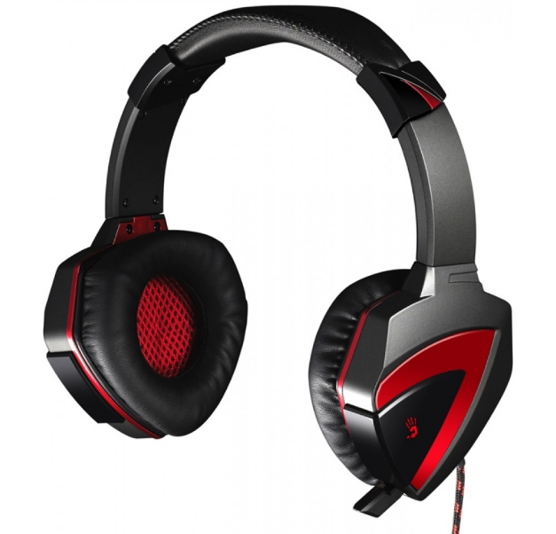

Drawing - A4Tech Bloody G501

Initial signal-to-noise ratio = 14.197.

Microphone3 - LOGITECH HD Webcam C270 - built-in Microphone with amplification.

Initial Signal to Noise Ratio = 28.776

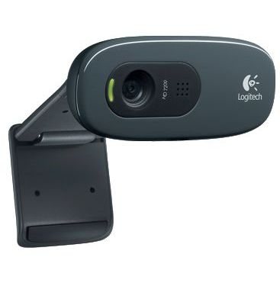

Figure - Web-camera LOGITECH HD Webcam C270

Microphone4 - RITMIX RDM-169 (picture)

Frequency range - 30Hz-20KHz;

Microphone type - condenser;

The directivity of the microphone is cardioid;

Connection type - wired USB;

Frequency range - 30Hz-20KHz;

Resistance - 1000 Ohm;

Sensitivity - 12 dB;

wind protection; pop filter.

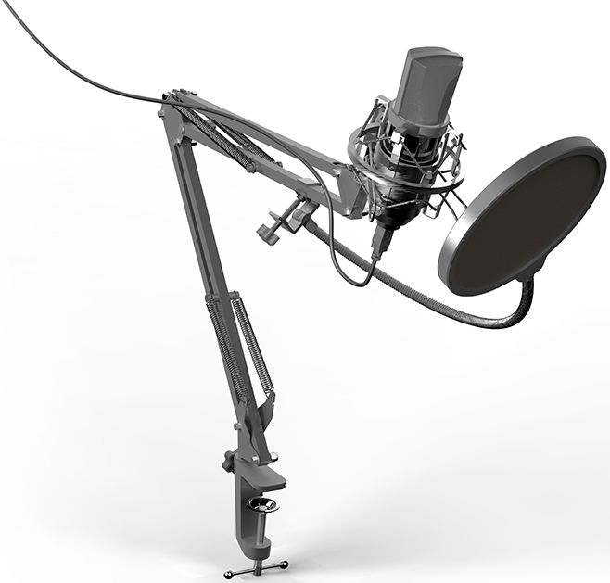

Figure - MicrophoneRITMIX RDM-169

Initial Signal to Noise Ratio = 24.149

Microphone5 - Defender MIC (picture)

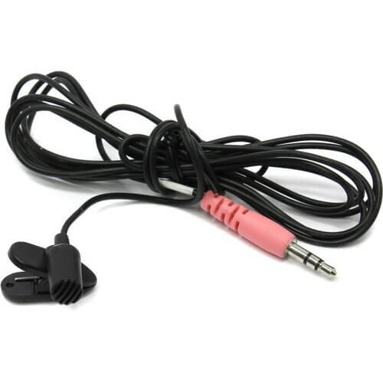

Figure - Defender MIC

RF frequency range: 2400 - 2483.5 MHz

Microphone: lavalier

Microphone directivity: omnidirectional

Nominal impedance: 32 Ohm

Frequency response: 35 - 14000 Hz

Sensitivity: -90dB

Signal to Noise Ratio: 84dB (depends on sound / motherboard)

Initial Signal to Noise Ratio = 34,100

Microphone6 Plantronics DSP - 100 (picture)

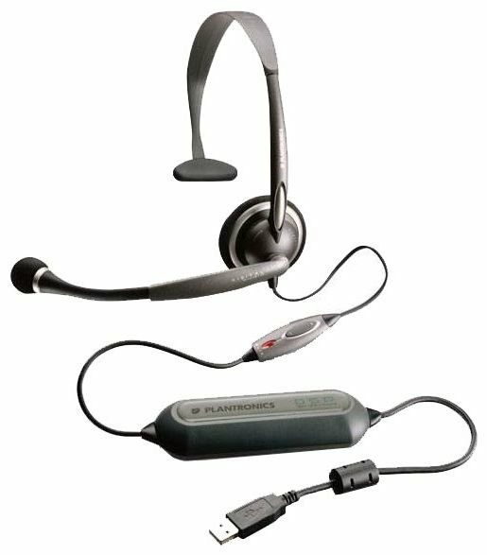

Figure - Plantronics DSP - 100

Headphone type - On-ear

Connection - Wired

Frequency response - 20 - 20,000 Hz

Resistance - 24 Ohm

Initial Signal to Noise Ratio = 29.530

Figure N shows examples of .wav files of the same image received from different microphones.

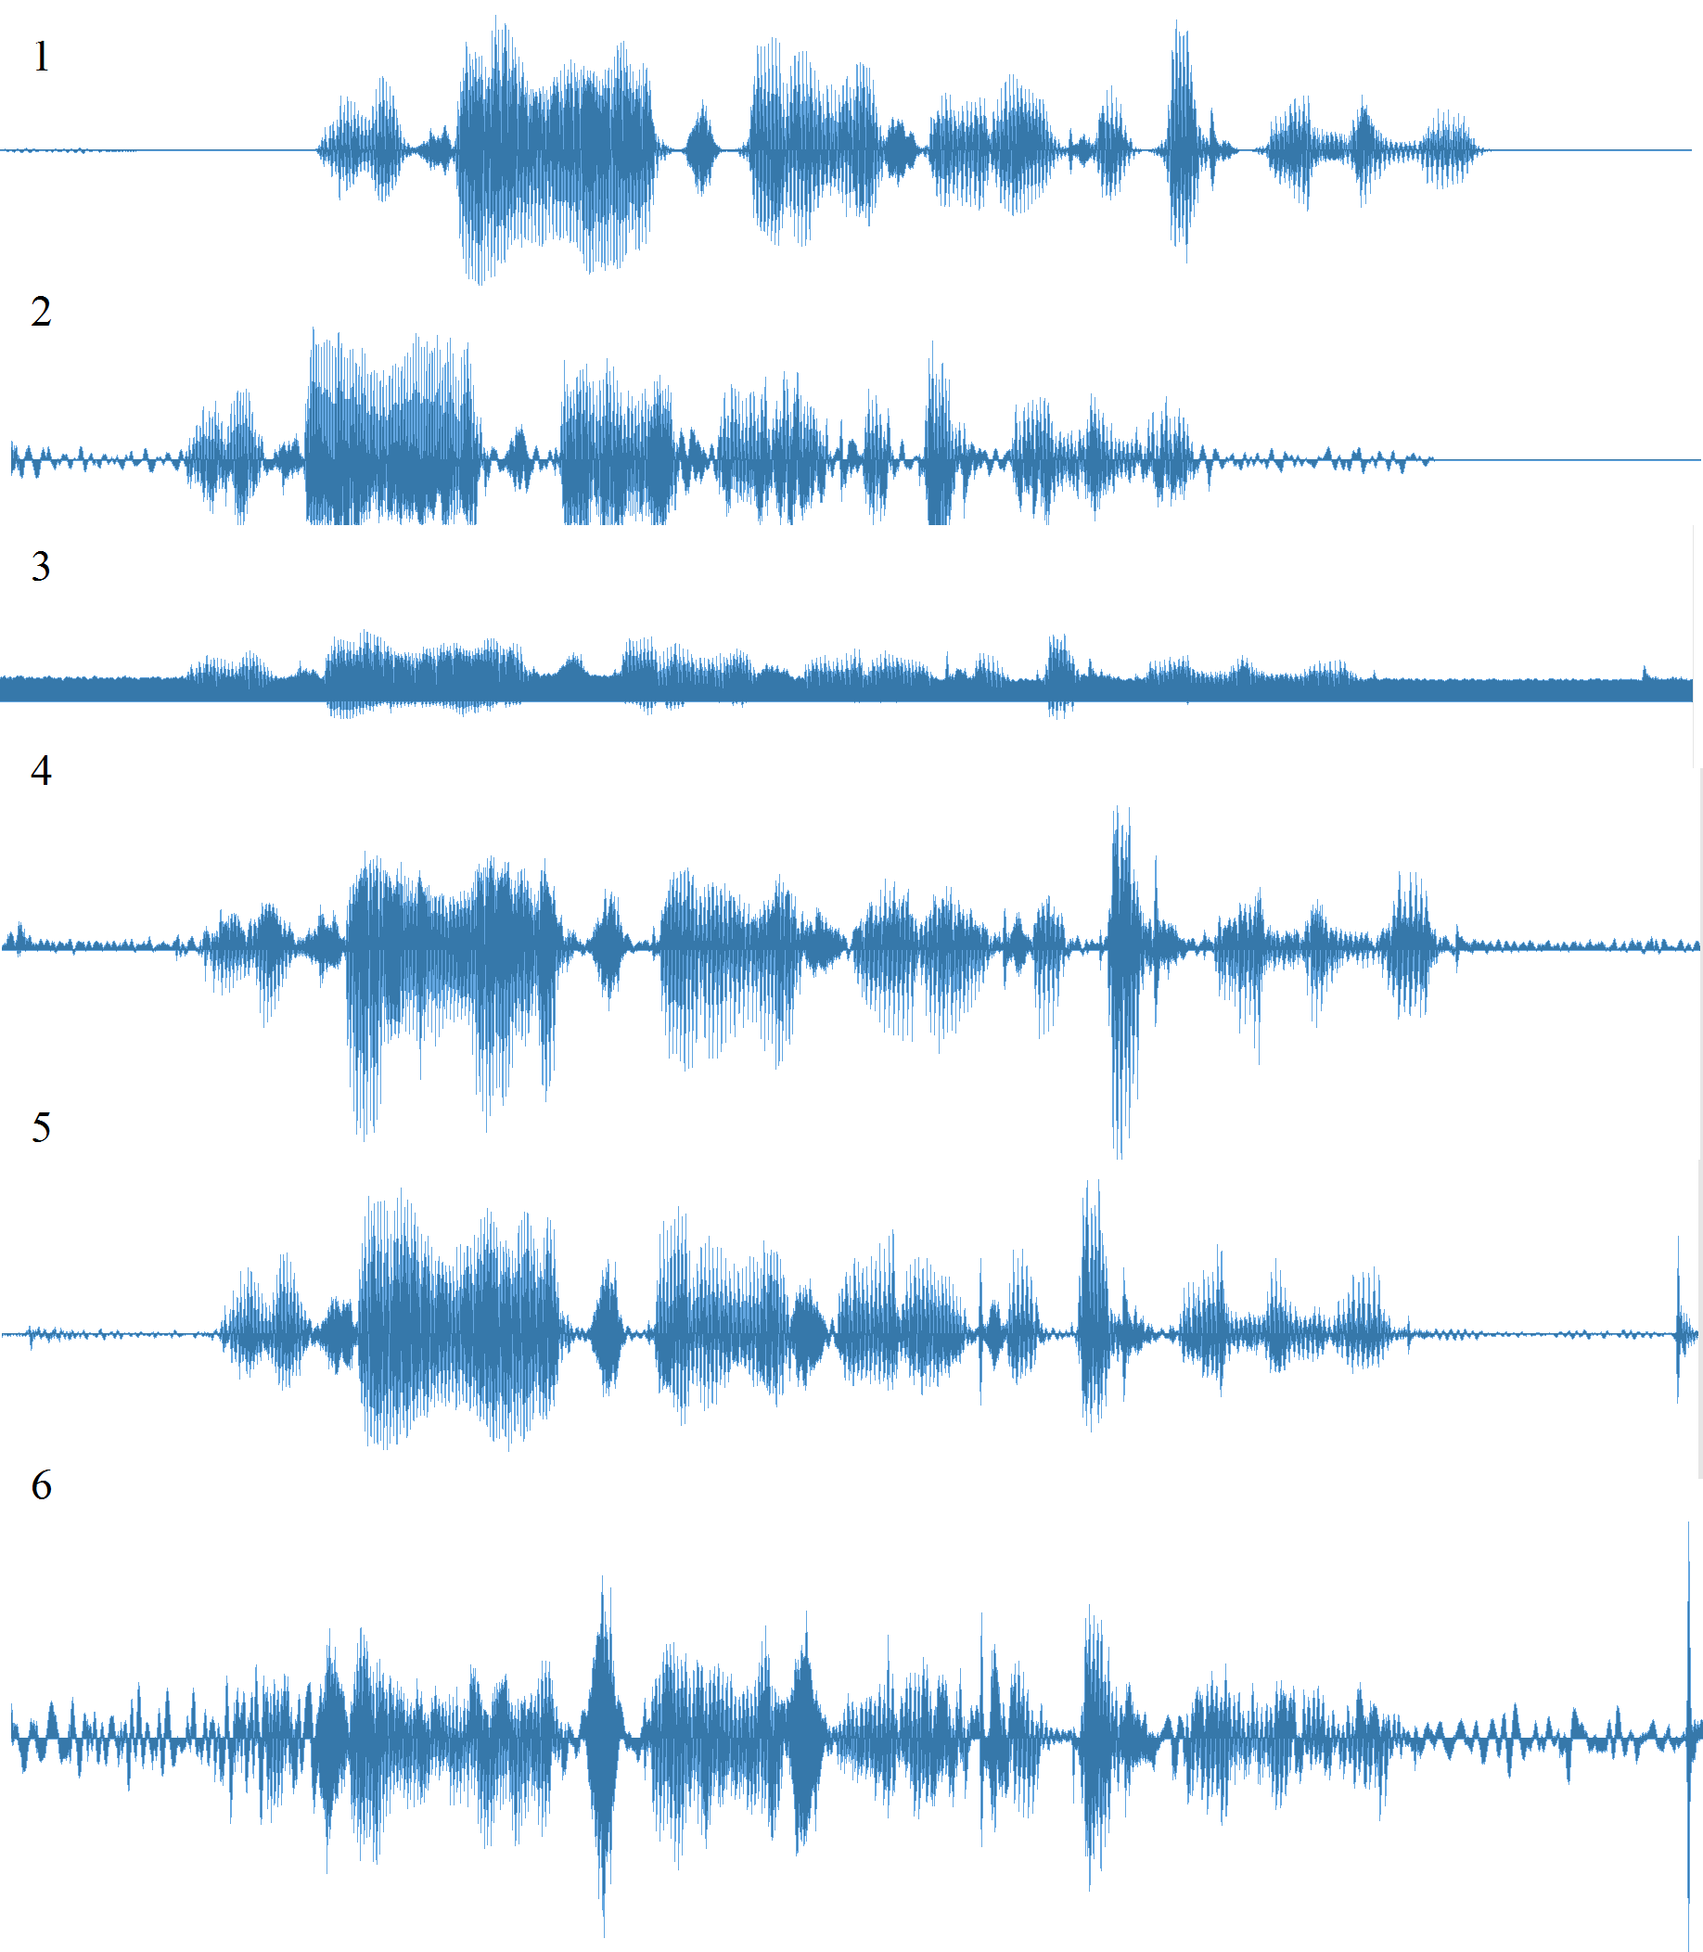

Figure N - examples of .wav images - phrase # 1 files on various microphones

**Test phrases:**

Phrase 1 – «Идентификационный номер четыре восемь орёл черепаха твёрдый знак»

Phrase 2 – «Разрешите доступ научный сотрудник имя фамилия комната номер семнадцать»

Phrase 3 – «Пропустите меня пожалуйста в лабораторию биометрических и нейросетевых технологий»

Phrase 4 – «Открыть дверь номер восемьсот девяносто три для исследовательской работы»

Phrase 5 – «Предоставить доступ в секретную комнату девятьсот девяносто восемьдесят шесть»

Phrase 6 – «Мишка косолапый по лесу идёт шишки собирает песенки поёт вдруг упала шишка прямо мишки в лоб»

Phrase 7 – Прошедший день затих и опустел

Phrase 8 – Готовясь к плену молчаливой ночи

Phrase 9 – Он гаснет эхом недопетых строчек

Phrase 10 – Вечерних песен между тёмных стен