Update prices for PIR and scheduling agreements
- Extract prices from SAP into excel file
Transaction SQ01
Launch query Z_23_PIR from user group Z_MM_23
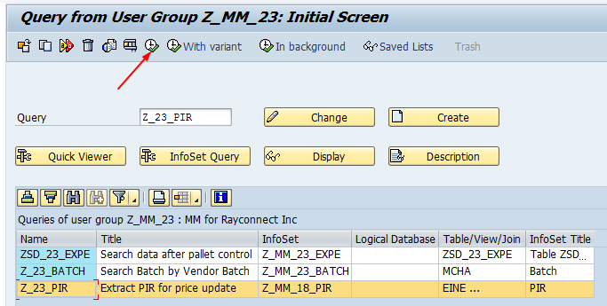
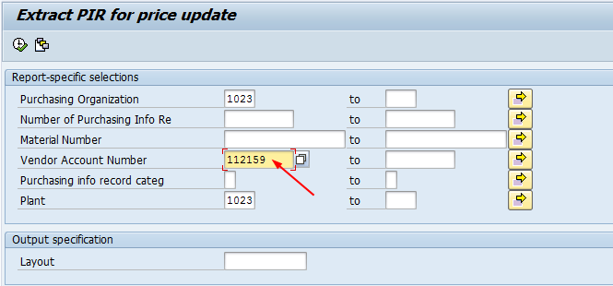
Enter vendor number
Execute
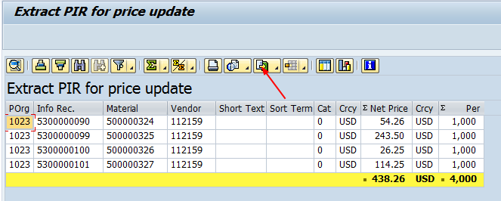
Transfer to csv file
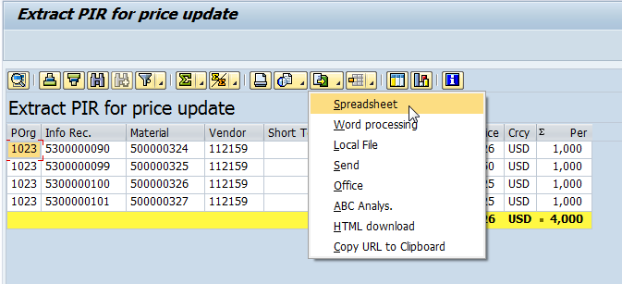
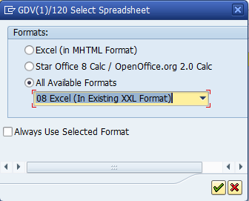
Enter
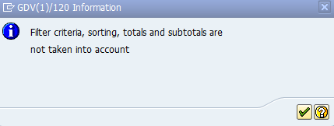
Enter
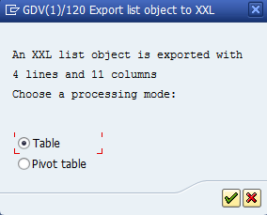
Enter
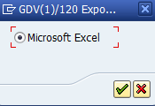
Enter
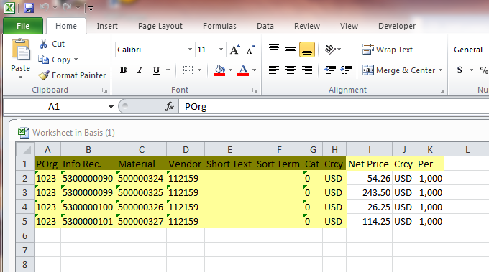
Save the excel file
- Change prices in excel file
Format the excel file as following
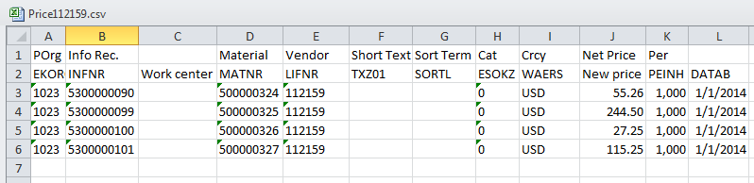
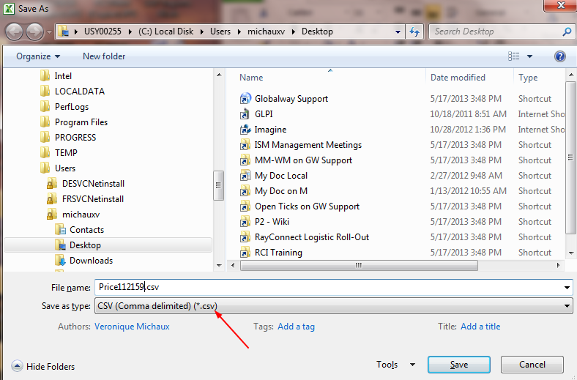
- Upload new prices for PIR into SAP
Transaction Z_MM_00_0715
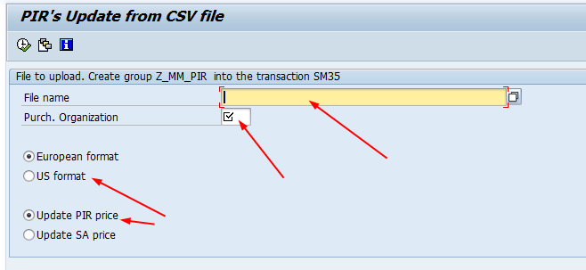
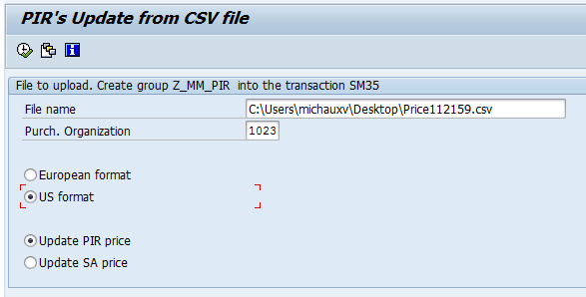
Execute
Important remark:
Please always launch a test file on GPP before doing it on GPR. There is no back mode.
Do not leave the file open during the upload, otherwise you will get an error message.
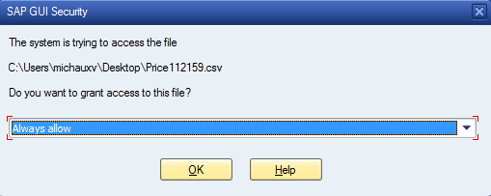
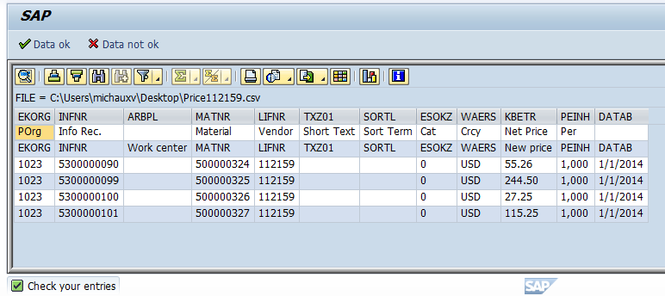
If your entries are correct, click on “Data ok”
Else click on “Data not ok” to correct the file and repeat these steps from beginning.
You get the following message with the number of lines contained in your .csv file:
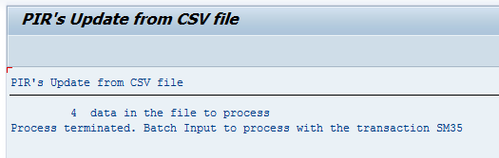
Transaction SM35
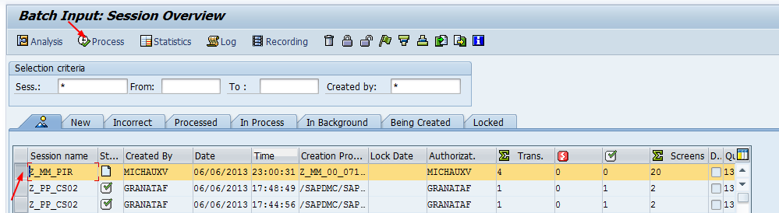
Select the line with your name and process
Choose “Background” and “Process”:

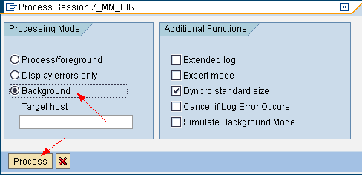
Then press Enter to refresh the screen
The Batch Input is fully completed when you have the green flag:
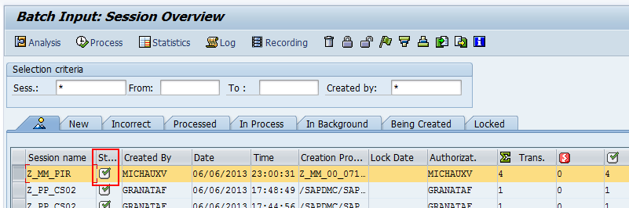
Check the updated data in the system. You can run the query (see step 1) to see the result.
Important remark: the specific transaction does not manage the scale price change if you have scales in your PIR.
- Upload new prices for Scheduling Agreements (SA) into SAP
Transaction Z_MM_00_0715

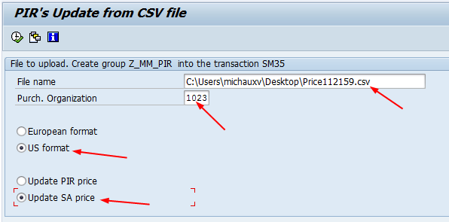
Execute
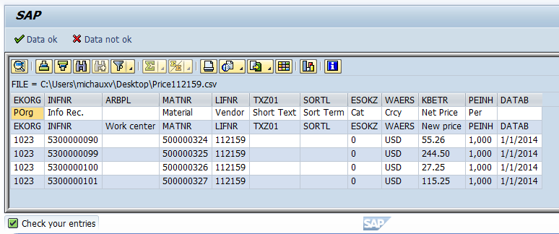
If your entries are correct, click on “Data ok”
Else click on “Data not ok” to correct the file and repeat these steps from beginning.
You get the following message:

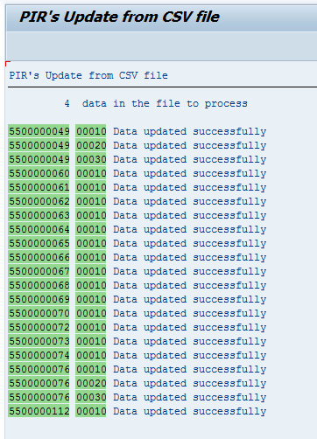
Go back to leave the transaction.
Check the updated data in the system.

