Area : | MM |  | Z_MM_00_0504
By : | Kai Goetzke | Date : | 11.01.2005

- Introduction

Statics data of inbound deliveries has to be collected for vendors for bonus-purposes. The statistics has to be computed for a relatively large time-intervall (say a year). The statistics must reflect movement data and has to have an option for plan data too.
Plant-specific and plant-spanning figures should be computable.

These features are put into practize with the program described here.

- Identifiers

Transaction: Z_MM_00_0504
Program: Z_MM_00_0504010

- Selection Screen

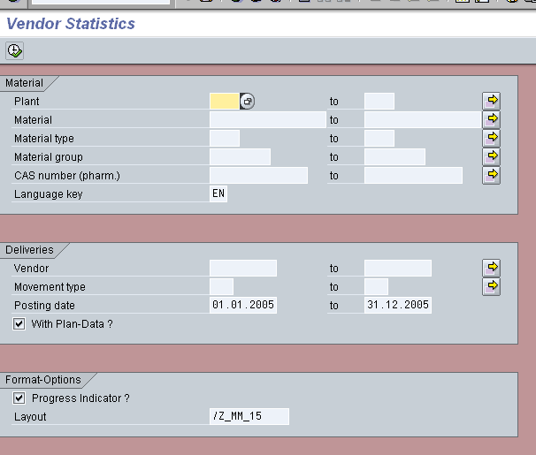

Field | Technical Field | Remarks
Plant | WERKS
Material | MARA-MATNR
Material type | MARA-MTART
Material group | MARA-MATKL
CAS number (pharm.) | MARC-CASNR | In Germany this field is used to store manufacturer-information in certain cases. In other subsidiaries the field is not maintained (at the moment). If the user enters restrictions for this field, the comparison is done against the German data, i.e. this field is treated in such a way if it would be a field of MARA !
Language Key | SPRAS | language for description of material  obligatory field  preset to logon-language
Vendor | LIFNR
Movement type | BWART | Only specified movement types will be considered during computation of movement data. Reason: Some movement types correspond to internal posting and should be neglected in this statistics
Posting date | MKPF-BUDAT | time-intervall  obligatory field  preset to current year  single value or intervall allowed (not full functionality of select-option)
With Plan-Data ? |  | plan-data will be selected and shown only if the checkbox is marked
Progress Indicator ? |  | if checked, progress of computation will be shown in the status line of the selection screen
Layout |  | ALV-Layout  preset to /Z_MM_15

- Checks at Selection Screen

After starting the selection (Button F8) the following checks are performed (after the automatic checks of SAP have succeeded, for example checking date-formats):

- Restriction for materials given ?
At least one restriction for the fields
- Material
- Material type
- Material group
- CAS number (pharm.)
has to be given. Dummy-restrictions (wildcard „*“) are accepted, however.

- Layout exists ?
If an ALV-layout has been specified, the system checks whether it exists.

If some check fails, an error-message can be found in the status line of the selection screen like the following:

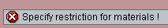

- Processing

After successfully passing the checks on the selection-screen the program goes on as follows:
- Selection of materials: The restrictions given for fields Material, Material type, Material group and CAS number (pharm.) lead to a set of materials. The program stores these materials. Plant-information (or vendor-information) is not considered at this first step.
- Next the program processes the materials one by one. For each material the movement data is collected followed by the plan data (if neeccessary). Figures are summed up and distributed to several rows according to the values for plant amd vendor. Values of plan data are distributed to columns corresponding to different months. Finally a check is done whether there is some non-zero value in the data record. Records only having zero-values are not shown.
- After all the statistics data has been collected, some peripheral data (name of vendor; description of material) is added.

- Progress Indicator

The job of the progress indicator is to support the user to estimate the duration of the selection process. Because a lot of data has to be turned normally, the user gets a clue when the program will offer its result. He or she may decide to abort the report and start it again with a samller set of materials.

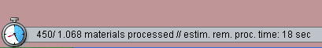

The progress indicator offers the following pieces of information:

- number of materials processed so far
- total number of materials to process
- estimated remaining time of processing (in seconds)

The progress indicator is refreshed each time 10 new materials have been processed. The remaining processing time is determined by performing a simple linear extrapolation. Be aware that there may be leaps in the estimation due to the distribution of data !

- Data Displayed

The data displayed depends on whether the user had decided to select plan data or not.

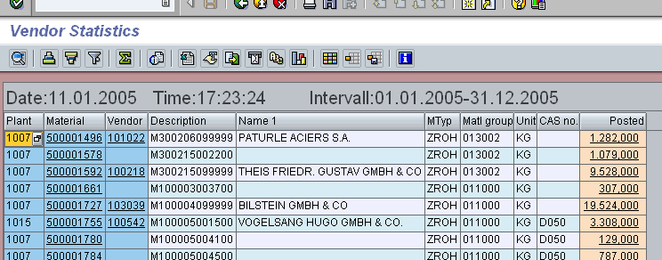

Without plan data we have the following columns:

Field | Technical Field | Remarks
Plant | WERKS | Primary Key Field
Material | MATNR | Primary Key Field
Vendor | LIFNR | Primary Key Field
Description | MAKT-MAKTX
Name 1 | LFA1-NAME1
Mtyp | MARA-MTART
Matl group | MARA-MATKL
Unit | MARA-MEINS | Unit for all quantity fields
CAS no. | MARC-CASNR | of German (WERKS=1015) data record !
Posted | Posted quantity in intervall respecting the sign of the posting

The 3 primary key fields (blue color) constitute the primary key of the table: 2 distinct data records of the table will never agree in all three columns.

With plan data there are additional fields:

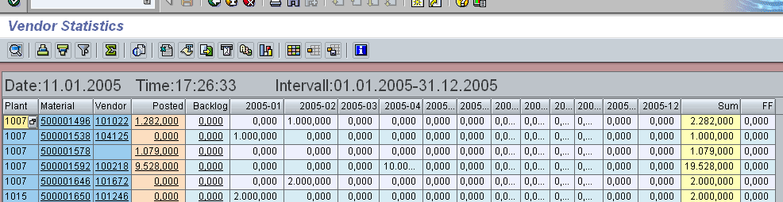

Generally only the open quantities of the plan data are shown. Open quantities are assigned to columns dependent on their dates. Up to twelve months are considered (besides backlog and further future). Vital columns are labelled with their months. Non-vital columns (outside the chosen intervall) are labelled with 0000-00.

Field | Remarks
Backlog | Open quantities of plan data with date < today
2005-01 (here) | open quantities in the current month excluding backlog
2005-02 (here) | open quantities in the following month
…
Sum | Sum of posted quantities, backlog and (up to ) 12 months
FF | Further future: future plan data outside the specified intervall

- Hotspots

The following hotspots are ready for usage:

Field | Navigation into | Remarks
Material | MM03 | with MATNR
Vendor | XK03 | with LIFNR
Posted | MB51 | with MATNR, LIFNR, WERKS
Backlog | special popup for plan data | with MATNR, LIFNR, WERKS

The popup may look like the following:

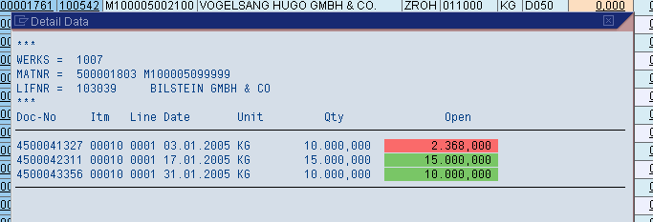

In the header area one finds information about the key-data (plant, material, vendor). All plan data items with open quantities are listed in the detail area of the popup. Different colors are used to highlight the date of the plan data items (backlog / future).

